Docking

Anti-tubercular Model
pBA = - 1.276219502 * MATS7s
- 2.787371275 * SM1_DzZ
- 3.848249858 * SpMin4_Bhv
+ 0.020733853 * TDB3v
+ 0.148823521 * RDF70v + 1.546675296
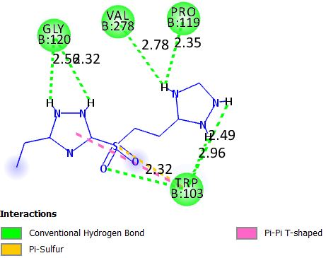
In silico
Design
QSAR

