Table 1: survival parameter and fistula parameter in all animals.

Animal | Survival time | Death reason | Tracheal Fistula (mm) | Esophagus fistula (mm)
1101 | 35 | Euthanasia
2101 | 5 | Acute smother | 8*8 | 8*8
2102 | 35 | Pneumonia | 7*5 | 6*6
2103 | 1 | Acute smother | 8*8 | 8*8
2104 | 32 | Pneumonia | 7*6 | 6*6
2105 | 35 | Euthanasia | 6*5 | 6*6
2106 | 3 | Acute smother | 8*8 | 8*8
3101 | 35 | Euthanasia | 4*2 | 4*3
3102 | 35 | Euthanasia | 5*4 | 4*4
3103 | 2 | Acute smother | 8*8 | 8*8
3104 | 35 | Euthanasia | 0 | 0
3105 | 35 | Euthanasia | 0 | 0
3106 | 35 | Euthanasia | 6*5 | 6*2

time | 1 week | 2 week | 3 week | 4 week | 5 week
Control group (2102) | 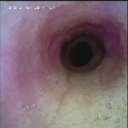 | 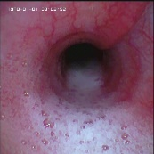 | 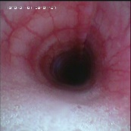 | 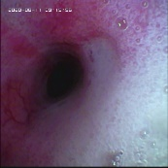 | 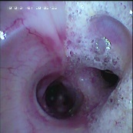
Stem cell group (3104) | 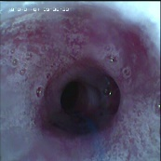 | 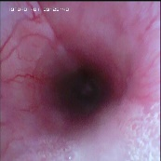 | 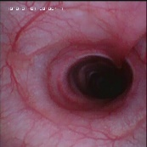 | 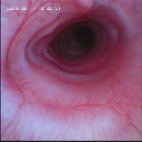 | 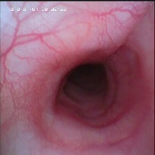
Table 2. the change of secretion in two animals from different group during experiment.

time | 1 week | 2 week | 3 week | 4 week | 5 week
Control group (2102) | 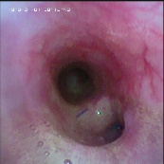 | 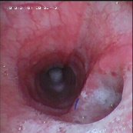 | 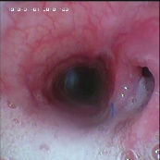 | 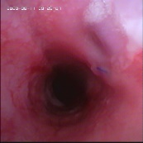 | 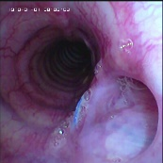
Stem cell group (3104) | 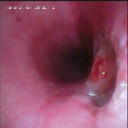 | 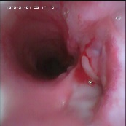 | 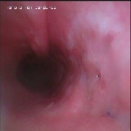 | 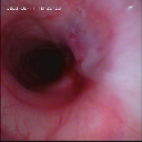 | 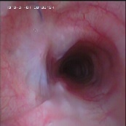
Table 3. the change of fistula in two animals from different group during experiment.

time | 1 week | 2 week | 3 week | 4 week | 5 week
Control group (2102) | 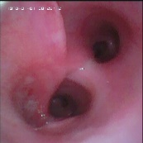 | 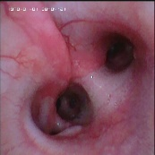 | 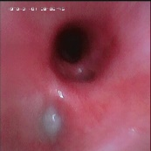 | 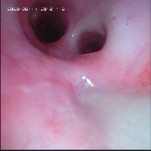 | 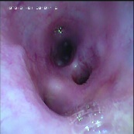
Stem cell group (3104) | 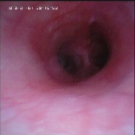 | 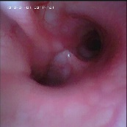 | 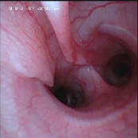 | 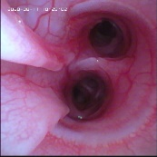 | 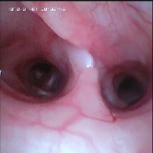
Table 4. the change of low lobs in two animals from different group during experiment.

