- Specificity of the scFv of C-CAR088 CAR

The scFv of C-CAR088 was derived from the human IgG1 antibody BCMA-20. The binding affinity (KD) of BCMA-20 to recombinant human BCMA was determined using a surface plasmon resonance sensor (Biacore Inc., Uppsala, Sweden). The results are shown in Supplemental Table 1. Epitope mapping experiments suggest that scFv has a high binding affinity for the extracellular domain of BCMA (Supplemental Figure 1).
To assess the specificity of scFv, tissue cross-reactivity assays were performed using a BCMA-20 scFv/rabbit Fc chimeric antibody (B20-scFv-rFc). A commercially available polyclonal antibody for BCMA, B0807-50G (US Biological), was used as a positive control, and a rabbit IgG was used as an isotype control. Thirty-two human tissues from three donors were stained with this chimeric antibody. The results are presented in Supplemental Table 2. Positive staining was observed in lymphocytes in the thymus, spleen, lymph nodes, bone marrow, thyroid glands, adrenal glands at the concentration of 20.0 μg/mL. Positive staining was also observed in plasma cells or lymph cells in the thymus, lymph nodes, and bone marrow. In addition, B20-scFv-rFc and B0807-50G-positive cells were scattered throughout the thyroid gland and adrenal gland (Supplemental Figures 2 and 3), suggesting the presence of plasma cells but not parenchymal cells. To confirm this hypothesis, C-CAR088 T cells were co-cultured with primary human thyroid epithelial cells (H-6040, Cell Biologics) or primary human adrenal cortical cells (P10482, Innoprot) overnight. IFN-γ was not detected in the supernatant of these primary cell lines by enzyme-linked immunosorbent assay (ELISA). In contrast, IFN-γ levels were high in the supernatant of C-CAR088 T cells co-cultured with BCMA positive cells (A549 BCMA OE and RPMI8226 cells)(Supplemental Figure 4).
Off-target screening was performed using a Membrane Proteome Array (Integral Molecular, Inc.), a protein library composed of >5,300 distinct human membrane proteins. The library was screened in duplicate in a matrix format to facilitate testing and analysis^{[3]}. TNFRSF17(BCMA), MAG, CR2, CXADR, and DDR2 had moderate binding affinity to B20-scFv-rFc at 20.0 μg/mL (Supplemental Figure 5). To exclude false-positive results, C-CAR088 T cells were co-cultured with 293T cells transfected with MAG, CR2, CXADR, or DDR2. 293T cells transfected with BCMA and an empty vector served as positive and negative controls, respectively. C-CAR088 cells were activated only by BCMA (Supplemental Figure 6).

- Construction of C-CAR088 CAR
The coding sequence of C-CAR088 CAR is composed of scFv against BCMA, components from the CD8a signaling and CD8a transmembrane regions, the intracellular domain of 4-1BB, and a CD3-ζ chain-derived signaling domain. The BCMA-specific CAR described by Kochendofer et al. (1) was used as a positive control in preclinical studies. The coding sequences of both CARs were cloned into a replication-defective lentiviral vector.

- Efficiency of C-CAR088 CAR transduction
The lentiviral vector containing C-CAR088 CAR was transfected into 293T cells for viral packaging, and the viral supernatant was collected and purified. Healthy donor PBMCs were activated with OKT-3 antibody and transduced with the lentiviral vector. Transduction efficiency was assessed by BCMA/Fc fusion protein staining (Supplemental Figure 7). Briefly, the extracellular domain of the BCMA protein was fused with the Fc fragment, and C-CAR088 CAR expressed on T cells was detected by the binding of the BCMA/Fc fusion protein and a secondary anti-Fc antibody.

- Activation and toxicity of C-CAR088 T cells in vitro
- CD137 was up-regulated on activated human C-CAR088 T cells activated by BCMA, as shown previously (2). CAR T cells were co-cultured with K562-BCMA+E7 (a K562 cell line stably expressing BCMA), stained with CD137 antibody, and analyzed by flow cytometry. C-CAR088 showed antigen-specific upregulation of CD137 expression in response to K562-BCMA+E7, a stably transduced K562 cell line expressing BCMA molecules. (Supplemental Figure 8).

- IFN-γ levels increased in C-CAR088 cells upon antigen stimulation. IFN-γ levels in the supernatant of C-CAR088 cells and T cells co-cultured with K562-BCMA+E7 were analyzed by ELISA. Antigen-specific IFN-γ levels were significantly higher in co-cultured cells than in T cells alone and K562 cells not expressing BCMA (Supplemental Figure 9).

- Toxicity of C-CAR088 in vitro
Cell proliferation assays and real-time cell analysis showed that C-CAR088 T cells had high cytotoxicity to BCMA-positive A549-BCMA-2E9 cells compared with BCMA-negative A549 cells, even at low effector to target ratios (Supplemental Figure 10B). Furthermore, the effect of C-CAR088 cells on BCMA-positive cells was not affected by soluble BCMA (R&D Systems) at concentrations of 100 ng/ml and 500 ng/ml. IFN-γ levels in the supernatant of C-CAR088 cells co-cultured with A549-BCMA-2E9 cells were not significantly affected by soluble BCMA (Supplemental Figure 10C).

- In vivo treatment experiments using a murine model
B-NDG (NOD-Prkdc^{scid} Il2rg^{tm1}/Bcgen) mice (Biocytogen Pharmaceuticals; Beijing, China) were subcutaneously injected with RPMI-8226 cells or K562-BCMA cells to establish a tumor model. Tumors were allowed to grow to a volume of approximately 100 mm³, and mice received a single intravenous infusion of 2.5-10.0 × 10⁶ human T cells transduced with a lentiviral vector expressing C-CAR088 CAR. CAR T cell treatment cured all mice, with dramatic regressions of all tumors occurring between day 6 and 15 after the T-cell infusion (Supplemental Figures 11 and 12). In contrast, tumor volume increased in mice treated with non-transduced T cells. Furthermore, mice receiving C-CAR088 T cells had no signs of toxicity during treatment.

Supplemental Table 1. Binding affinity (KD, in nM) of BCMA-20 to recombinant soluble B cell maturation antigen (BCMA).（Peter Kufer et al. Binding molecules for BCMA and CD3. US patent 2013/0156769 A1[P]. 2013）
Antibody | Human BCMA | Macaque BCMA
BCMA-20 | 0.0085 | 0.016

Supplemental Figure 1. Antigen-binding extracellular domain of B cell maturation antigen.（Peter Kufer et al. Binding molecules for BCMA and CD3. US patent 2013/0156769 A1[P]. 2013）
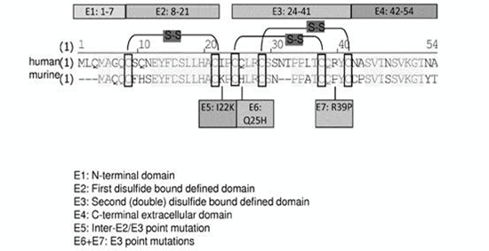

Supplemental Table 2. Tissue cross-reactivity assay results of normal human tissues using B20-scFv-rabbit Fc chimeric antibody
(a) Number of positive signals in three donors. (b) Staining intensity in positive cells and percentage of positive cells in each tissue. (–) no staining, (+) <10% of cells were stained, (++) 11–50% of cells were stained.
Staining site | Tissue | Concentration of B20-scFv-rabbit Fc
Staining site | Tissue | 5.0 μg/mL | 20.0 μg/mL
Nucleus | Esophagus, mucosal layer | 1/3ª, +^{b} | 1/3, +
Cytoplasm | Stomach, mucosal layer | 1/3, + | 2/3, +
Cytoplasm | Kidney, cortex | 1/3, + | 2/3, +
Cytoplasm | Bladder, mucosal layer | - | 1/3, +
Membrane | Thyroid | - | 3/3, +
Membrane | Thymus, cortex, medulla | 3/3, + | 3/3, +
Membrane | Spleen, splenic cord | 2/3, + | 3/3, +~++
Membrane | Lymph node, medulla | 3/3, + | 3/3, +
Membrane | Adrenal gland, cortex | - | 3/3, +
Membrane | Bone marrow | - | 3/3, +

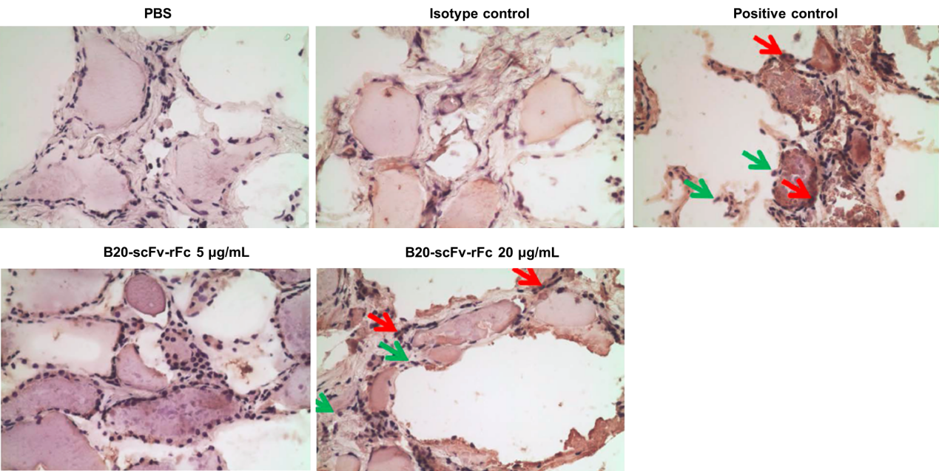

Supplemental Figure 2. IHC staining of fresh frozen thyroid gland sections. Isotype control，rabbit IgG (20 μg/mL)；Positive control, Rabbit anti-BCMA antibody (B0807-50G, 0.6 μg/mL).

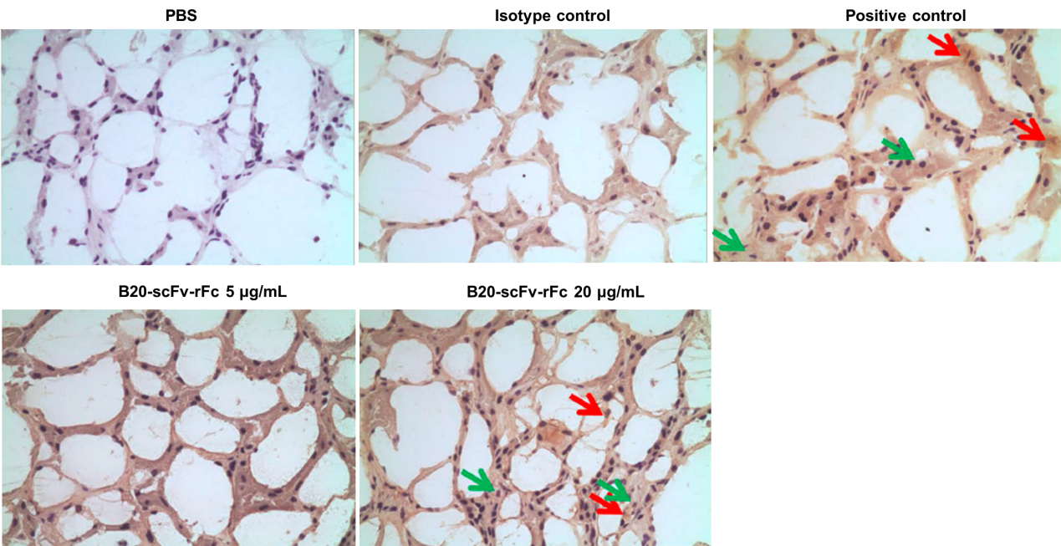
Supplemental Figure 3. IHC staining of fresh frozen adrenal gland sections. Isotype control，rabbit IgG (20 μg/mL)；Positive control, Rabbit anti-BCMA antibody (B0807-50G, 0.6 μg/mL).

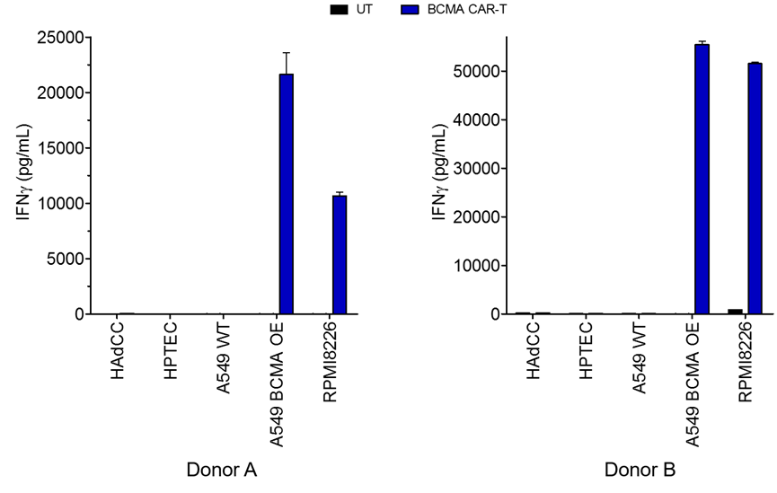

Supplemental Figure 4. IFN-γ levels in the supernatant of C-CAR088 co-cultured with different cell types. UT: untransduced T cell. BCMA CAR-T: BCMA-targeting C-CAR088 CAR T cells. HAdcc, human adrenal cortical cells. HPTEC, human primary thyroid epithelial cells. WT, wild type. A549 BCMA OE, a sable transduced cell line expressing BCMA molecules.

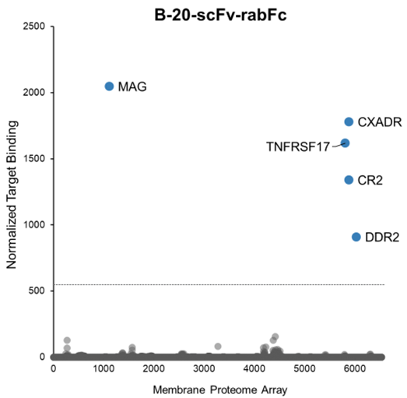
Supplemental Figure 5. Identification of specificity of B20-scFv-rabFc chimeric antibody using a membrane proteome array.

Supplemental Figure 6. C-CAR088 T cells co-cultured with 293T cells expressing MAG, CR2, CXADR, DDR2, or BCMA. Lower panel: Levels of IFN-γ, TNF, and IL-2 in T cells alone and co-cultures.
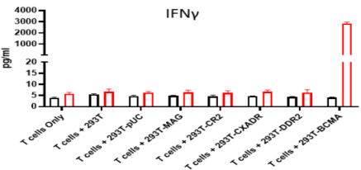
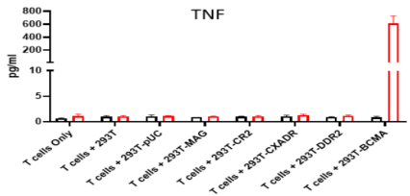
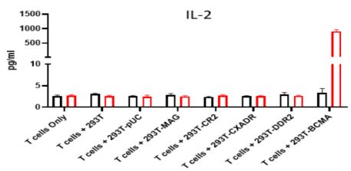
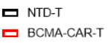
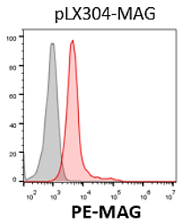
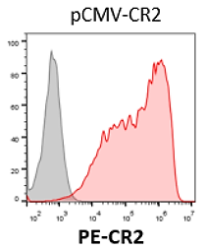
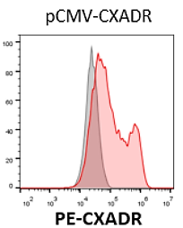
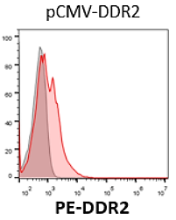
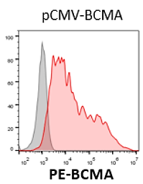

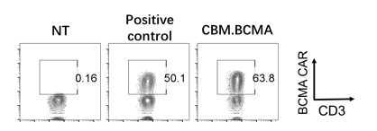
Supplemental Figure 7. Flow cytometry analysis of C-CAR088 CAR transduction efficiency. Healthy donor PBMCs were activated and transduced with a lentiviral vector expressing C-CAR088 CAR. Three days after transduction, CAR-transduced T cells (shown as CBM.BCMA) were stained with BCMA/Fc fusion protein. The anti-BCMA CAR T cells described by Kochendofer et al. (1) were used as a positive control.

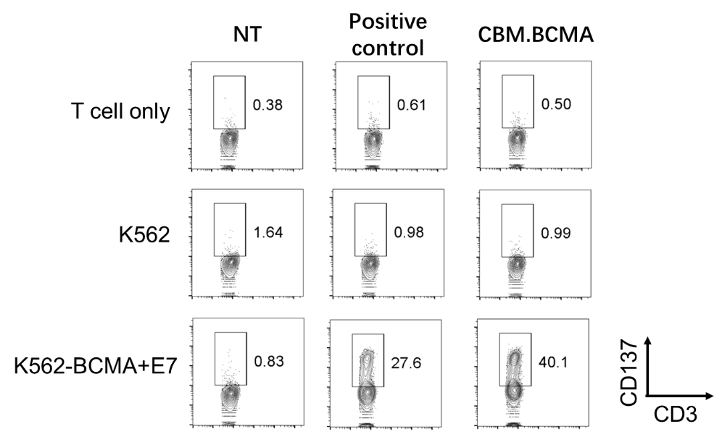

Supplemental Figure 8. Flow cytometry analysis of CD137 expression in activated C-CAR088 T cells, K562-BCMA+E7 (a K562 cell line stably expressing B cell maturation antigen [BCMA]) (positive control), and CAR T cells co-cultured with K562-BCMA+E7 (CBM.BCMA). Cells were stained with anti-CD137 and anti-CD3 antibodies.

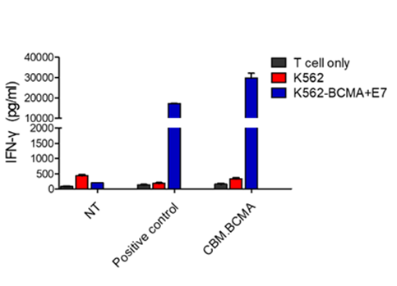

Supplemental Figure 9. IFN-γ levels in non-transduced T(NT) cells, K562-BCMA+E7 (a K562 cell line stably expressing B cell maturation antigen [BCMA]) (positive control), and C-CAR088 cells co-cultured with K562-BCMA+E7 (CBM.BCMA). Cytokine levels in culture supernatants were measured by enzyme-linked immunosorbent assay.

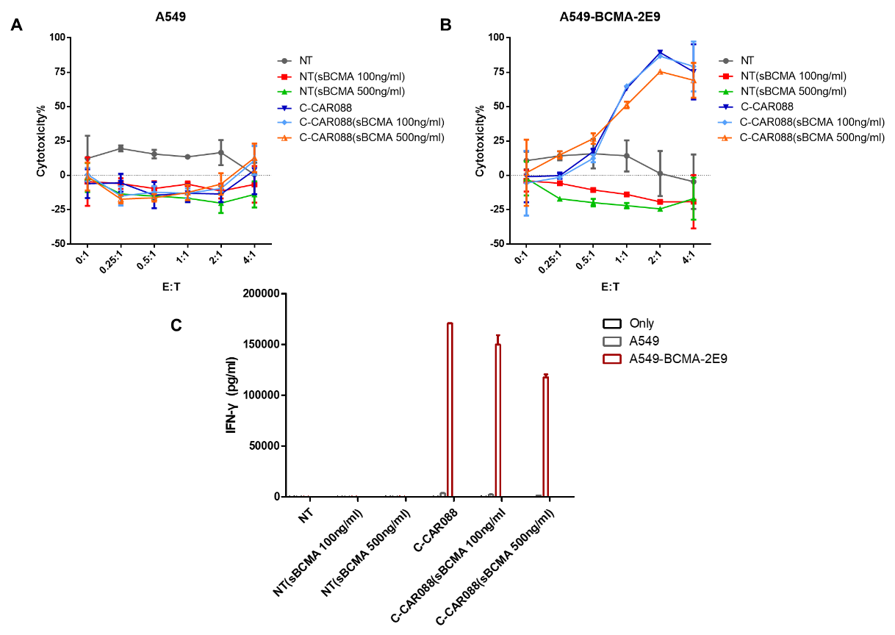
Supplemental Figure 10. Toxicity of C-CAR088 T cells in vitro. NT, non-transduced; sBCMA, soluble BCMA.

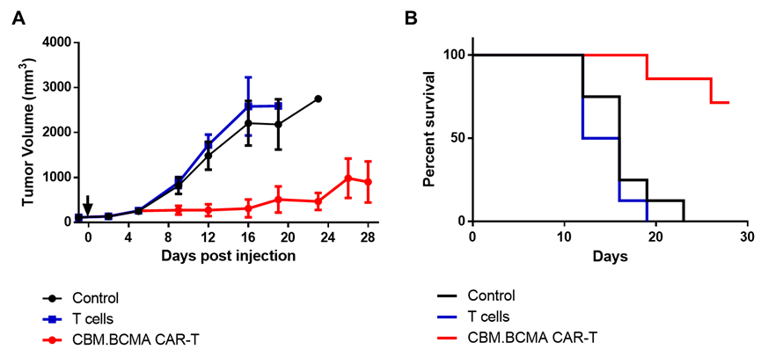

Supplemental Figure 11. Cytotoxicity of anti-BCMA C-CAR088 T cells to K562 cells stably expressing B cell maturation antigen in vivo.

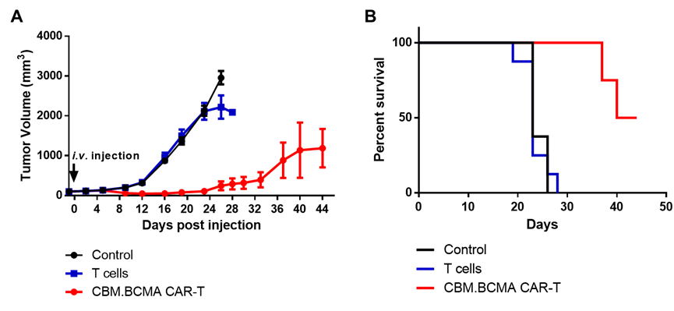
Supplemental Figure 12. Toxicity of C-CAR088 T cells to RPMI-8826 cells in vivo.

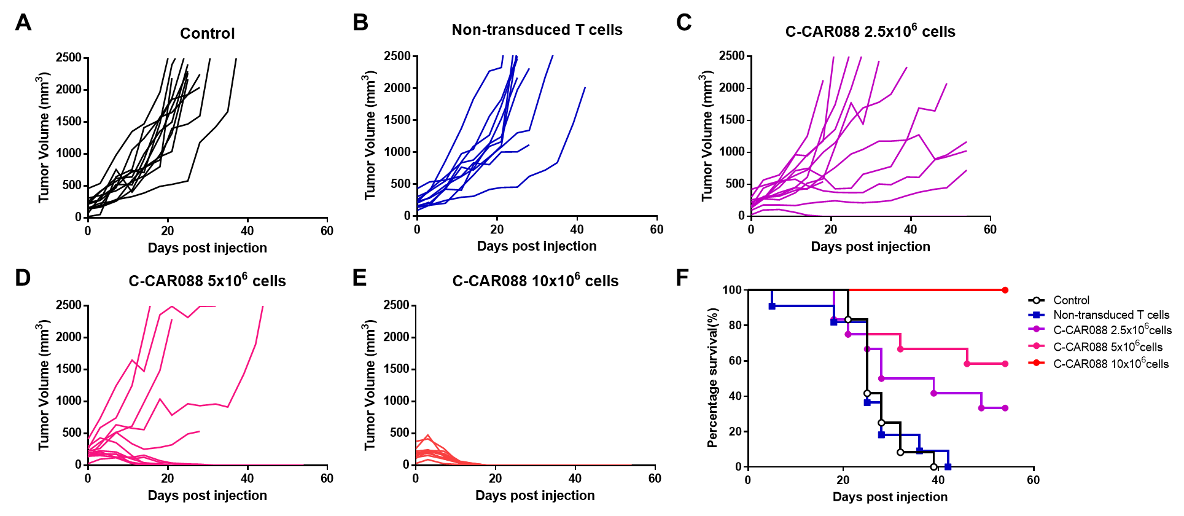
Supplemental Figure 13. Toxicity of C-CAR088 T cells to RPMI-8826 cells in vivo. B-NDG mice (aged 6-8 weeks) received a subcutaneous injection of 2.5 × 10⁶ RPMI-8226 cells to establish a tumor model. Tumors were allowed to grow to a volume of approximately 100 mm³, and mice received a single intravenous infusion of (A) vehicle control, (B) non-transduced T cells, or C-CAR088 CAR T cells at (C) 2.5× 10⁶ cells/mouse, (D) 5.0 × 10⁶ CAR cells/mouse, and (E) 10 × 10⁶ cells/mouse (E). Tumor volume was measured twice a week. F. Survival of RPMI-8226 tumor-bearing mice.

References：

- Carpenter. R.O., et al., B-cell Maturation Antigen Is a Promising Target for Adoptive T-cell Therapy of Multiple Myeloma. Clin Cancer Res; (2013) 19(8); 2048–60.
- Wolfl, M., et al. Activation-induced expression of CD137 permits detection, isolation, and expansion of the full repertoire of CD8_ T cells responding to antigen without requiring knowledge of epitope specificities. Blood. 2007;110: 201-210
- Tucker et al. Isolation of state-dependent monoclonal antibodies against the 12-transmembrane domain glucose transporter 4 using virus-like particles 2018. PNAS 115(22):E4990-E4999.

