Table S1 Primers used to resequencing of 21 kb region around the CCKAR
Name | Position on chromosome 4¹ | Forward primer (5’-3’) | Reverse primer (5’-3’)
CCKAR_up5k_O | 73195458-73196287 | CCCAAACATCCAACTTCCAA | TTTTGTTGTTTGACTCTTGCTCTT
CCKAR_up5k_N | 73196237-73197039 | AAAAGGGCCTGGAGATTATCA | CATTGTGTTGAGGGACATGG
CCKAR_up5k_M | 73196971-73197755 | CCATTCCAACTCTCCAAGCA | GTGAGAAGAGACCAACCCCA
CCKAR_up5k_K | 73197549-73198252 | AGTACAGAAAGGACATTGAGGTG | GGTCTTCCTCTGGATCTGCT
CCKAR_up5k_B | 73198149-73198848 | TCTGCTCTGCCCTTGTCAG | GGGTTTGTTGCCAGATCTTTC
CCKAR_up5k_C | 73198698-73199363 | TCCACAGAATCAATGGCCTT | GGGATGTTGGGAATTTTAGGCA
CCKAR_up5k_D | 73199217-73199906 | ACATTTCTCTAGACTACCTGCAG | CTGGCTCTTCATCTCAAAGGT
CCKAR_up5k_E | 73199766-73200417 | AATCCAGCTCAGTCCAGGAC | ATAGCTGAGACAAGGCTTCC
CCKAR_up5k_F | 73200254-73200889 | TGCCAGAAAGAACCAGGAGA | CTTCCATGAGCACTGTGGC
CCKAR_up5k_L | 73200644-73201569 | AAGAGATTGCTGCAGTTACGA | TACTCTGACCTGCTGCAAAC
CCKAR_up5k_H | 73201354-73201992 | ACGAAGCTGAAAACACATCCA | ATCCCAAACGTCTGAGTGGC
CCKAR_up5k_I | 73201830-73202452 | AGTTTTGGCATCTTAGACTGGA | ACTTGCAAACAGGATGTGCA
CCKARupstream | 73202367-73203453 | TACCCTTGAGGCTGGAAATG | ACCCTCTTCTGTTACTGGCC
CCKAR_exon1 | 73203262-73203789 | GTGGTGTTGGTTGAGAGACG | CAGCAAAGCAGTGATGTTGG
CCKAR_exon1b | 73203691-73204318 | AACCAGCCTTCTTCCTAGCAG | GTGCACTGCTCATTCACCAC
CCKAR_intron1 | 73203781-73204630 | GCTTTGCTGTGTGATATCCTCT | ACAATACAGCAGGATCCGGA
CCKAR_exon2 | 73204497-73204903 | GGCTTTTGAAAGGGTGTACCT | TTCTCACATACCCCACTGGTT
CCKAR_intron2D | 73204746-73205734 | TAATGCTCTGCCTCTTCTGC | GCTGAAATGTGCAGAATCGG
CCKAR_intron2B | 73205578-73206420 | GAACCAGTACAAATAAAGGCTGT | TGAAAGCAGAAGGAAGGCAC
CCKAR_intron2C | 73206231-73207058 | CACCAATCAAGCAGGACAAGT | AGCGTACATGTTTCCAGATGG
CCKAR_exon3 | 73206618-73207199 | CATTTGAAAACAGCAGAAGCA | TTACAGCAGGGGCTTAGCAG
CCKAR_intron3C | 73206857-73207748 | GCAAGCTGGTCCCTTTCAC | ACCTGTATCCTTCCTCCTCAC
CCKAR_intron3B | 73207573-73208420 | TGCTTCAACTGGTGCTGAGA | GCCTCAAGATGACTGCTCAC
CCKAR_exon4 | 73207950-73208628 | AGGCACTCCCCTTTAAGAGC | GGTCCTAATCCACAGCCAGA
CCKAR_intron4 | 73208327-73209281 | TTGATACCAGCCAGAGAAGATC | GTGTAGGACAGCAGGTGGAT
CCKAR_exon5 | 73208763-73209391 | AATACTGGTGGCCAGCAAAC | CTCTAATCACAGGCGGCTTC
CCKAR_exon5b | 73209117-73209622 | GGCCAAGAAACTTGTCATCC | CTCACAGCGTTTACTGTCAGC
CCKAR_3’UTR | 73209326-73210348 | GTTTCCGCATGGGTTTTCTA | TTCAGCCTTATCCCTGTGCT
CCKAR_down5k_A | 73210260-73211236 | CACCCATGCATGTAAAGGGC | GTCTCATCCTGCAGCCTGA
CCKAR_down5k_B | 73211174-73212124 | ACGGGATTTAGTTCGTAACAGTG | GTTACCAACCTGTTCTGCTCA
CCKAR_down5k_C | 73212061-73213031 | TCAGATACTGCTCTCGATGGA | AGGCTGCCTTGGATATCTACC
CCKAR_down5k_D | 73212892-73213891 | ATCAGCAGCCTCCACATCAT | TTCTGGGTAGTCTCGTGTGG
CCKAR_down5k_E | 73213797-73214742 | CAGGCAGAACGTAGCATTGT | TGCATTCAAAAGGGAAGGGA
CCKAR_down5k_F | 73214649-73215637 | AAAACAATGCAGTCCAGGGG | TTAAAACCATGCTGCTCCGG
CCKAR_down5k_H | 73215507-73216805 | TTCACCAACAGCCCACTAC | TGTATGAGGGAAGCTGCGC
¹Position of fragments is shown based on galGal6.0 chicken genome assembly.

Table S2 Information of variants within the 21 kb region around the CCKAR
order | Physical position on chromosome 4¹ | Position relative to CCKAR | dbSNP Access No. | High-growth allele² | Low-growth allele2 | Variants studied in reporter gene assay
1 | 73196337 | 5' flanking region | rs736847850 | T | C
2 | 73196383 | 5' flanking region | rs317607465 | G | T
3 | 73196641 | 5' flanking region | rs732495896 | T | C
4 | 73196708 | 5' flanking region | rs16434830 | C | G
5 | 73196743 | 5' flanking region | rs740521921 | C | T
6 | 73196745 | 5' flanking region | rs730956454 | T | C
7 | 73196779-73196780 | 5' flanking region | novel | TG | CA
8 | 73196831 | 5' flanking region | rs731668344 | C | G
9 | 73196845 | 5' flanking region | rs741200827 | C | T
10 | 73196891 | 5' flanking region | rs739070235 | A | G
11 | 73196961 | 5' flanking region | rs16434831 | G | A
12 | 73196979 | 5' flanking region | rs16434832 | G | A
13 | 73197038 | 5' flanking region | rs735487023 | T | C
14 | 73197046 | 5' flanking region | rs738864180 | C | T
15 | 73197067 | 5' flanking region | rs739505529 | A | G
16 | 73197317 | 5' flanking region | rs732507897 | A | T
17 | 73197353 | 5' flanking region | rs735868663 | G | C
18 | 73197354-73197355 | 5' flanking region | novel | CACTTGG | del
19 | 73197356 | 5' flanking region | novel | G | C
20 | 73197767 | 5' flanking region | rs741249832 | C | T
21 | 73197824 | 5' flanking region | rs732324989 | A | G
22 | 73198024 | 5' flanking region | rs14489886 | T | C
23 | 73198364 | 5' flanking region | rs738332766 | A | T
24 | 73198367 | 5' flanking region | rs741716927 | T | G
25 | 73198431 | 5' flanking region | rs731434187 | T | A
26 | 73198450 | 5' flanking region | rs738921885 | A | G
27 | 73198468 | 5' flanking region | rs739517525 | G | A
28 | 73198532 | 5' flanking region | rs739346556 | C | T
29 | 73198560 | 5' flanking region | rs736628093 | G | A
30 | 73198969 | 5' flanking region | rs735180511 | A | G
31 | 73199139 | 5' flanking region | novel | A | del
32 | 73199343 | 5' flanking region | rs732342426 | A | G | CSNP1
33 | 73199485 | 5' flanking region | rs740461407 | T | G
34 | 73199573 | 5' flanking region | rs14489888 | G | A | CSNP2
35 | 73199919 | 5' flanking region | rs734291116 | G | A
36 | 73199976 | 5' flanking region | rs733458406 | del | C
37 | 73200031 | 5' flanking region | rs741747714 | T | del
38 | 73200087 | 5' flanking region | rs741769582 | G | A
39 | 73200156 | 5' flanking region | rs731441446 | T | C
40 | 73200187 | 5' flanking region | rs315346474 | G | T
41 | 73200408 | 5' flanking region | rs731258025 | C | T
42 | 73200656 | 5' flanking region | rs735879555 | T | C
43 | 73200759 | 5' flanking region | rs740873708 |  | AAA
44 | 73200862 | 5' flanking region | rs731781640 | C | T
45 | 73200869 | 5' flanking region | rs736179655 | G | A
46 | 73201089 | 5' flanking region | rs739862145 | A | G
47 | 73201818 | 5' flanking region | rs317340954 | C | T | PSNP1
48 | 73201849 | 5' flanking region | rs312791200 | A | G | PSNP2
49 | 73202211 | 5' flanking region | rs80637605 | G | A | PSNP3
50 | 73202255 | 5' flanking region | rs80691628 | A | G | PSNP4
51 | 73202352 | 5' flanking region | rs735709526 | T | C | PSNP5
52 | 73202359 | 5' flanking region | rs80644257 | C | G | PSNP6
53 | 73202606 | 5' flanking region | rs312284610 | C | A | PSNP7
54 | 73202645 | 5' flanking region | rs316320621 | C | G | PSNP8
55 | 73202678 | 5' flanking region | rs314545738 | A | T | PSNP9
56 | 73202789 | 5' flanking region | rs315057890 | G | A | PSNP10
57 | 73202903 | 5' flanking region | rs313514148 | T | A | PSNP11
58 | 73202945 | 5' flanking region | rs317602219 | T | A | PSNP12
59 | 73203073 | 5' flanking region | rs315801080 | AC | TG | PSNP13
60 | 73203080 | 5' flanking region | rs313590990 | C | G | PSNP14
61 | 73203170 | 5' flanking region | rs794017713 | G | A | PSNP15
62 | 73203188 | 5' flanking region | rs80606852 | G | A | PSNP16
63 | 73203705 | 5'UTR | rs313822901 | A | C | PSNP17
64 | 73203819 | Exon1 | rs314084118 | T | C | PSNP18
65 | 73204044 | Intron1 | rs315176011 | C | T | PSNP19
66 | 73204457 | Intron1 | rs733514605 | T | G
67 | 73204458 | Intron1 | rs794546486 | G | A
68 | 73204544 | Intron1 | rs313134890 | A | C
69 | 73204550 | Intron1 | rs314414260 | T | C
70 | 73204977 | Intron2 | rs316160134 | C | G
71 | 73204990 | Intron2 | rs314874785 | C | G
72 | 73205026 | Intron2 | rs315156020 | C | T
73 | 73205061 | Intron2 | rs315703810 | T | C
74 | 73205162 | Intron2 | rs316781477 | C | A
75 | 73205164 | Intron2 | rs316193938 | T | A
76 | 73205380 | Intron2 | rs740298767 | T | C
77 | 73205652 | Intron2 | rs317439365 | A | G
78 | 73205673 | Intron2 | rs13774462 | A | C
79 | 73205750 | Intron2 | rs13774463 | C | T | CSNP3
80 | 73205766 | Intron2 | rs15616835 | A | G
81 | 73205821 | Intron2 | rs13774464 | T | C
82 | 73205867 | Intron2 | rs13774465 | T | C
83 | 73206071 | Intron2 | rs314128048 | A | G
84 | 73206185 | Intron2 | rs733004022 | A | T
85 | 73206488 | Intron2 | rs314082180 | T | C
86 | 73206650 | Intron2 | rs314888442 | G | A
87 | 73206696 | Exon3 | rs315278615 | C | T
88 | 73206714 | Exon3 | rs315131298 | C | T
89 | 73206958 | Intron3 | rs315744114 | G | A
90 | 73206972 | Intron3 | rs315844714 | G | A
91 | 73207405 | Intron3 | rs316313304 | T | C
92 | 73207592-73207605 | Intron3 | g.73207592-73207605 GATGTAAGATTTTAA>AAGATGTAAGAT | AAGATGTAAGAT | GATGTAAGATTTTAA
93 | 73207637 | Intron3 | rs317244862 | A | G
94 | 73207665 | Intron3 | rs317125667 | T | C
95 | 73207680 | Intron3 | rs734524617 | C | T
96 | 73207685 | Intron3 | rs736521747 | T | C
97 | 73207696 | Intron3 | rs317828971 | A | G
98 | 73207763 | Intron3 | rs318084470 | A | C
99 | 73207790 | Intron3 | rs317922543 | A | G | g.73207790A>G
100 | 73208653 | Intron4 | rs14489895 | T | C
101 | 73208701 | Intron4 | rs14489896 | G | A
102 | 73208771 | Intron4 | rs316271214 | T | C
103 | 73208780 | Intron4 | rs316578408 | G | A
104 | 73208826 | Intron4 | rs313367589 | del | T
105 | 73208894 | Intron4 | rs313682508 | G | A
106 | 73208913 | Intron4 | rs316541372 | G | A
107 | 73209189 | Exon5 | rs317682933 | C | T
108 | 73210442 | 3' downstream region | rs740051404 | T | C
109 | 73210665 | 3' downstream region | rs317824030 | A | G
110 | 73211281 | 3' downstream region | rs16434839 | A | G
111 | 73211321 | 3' downstream region | rs13774469 | T | C
112 | 73211362 | 3' downstream region | rs13774471 | G | T
113 | 73211482 | 3' downstream region | rs313642761 | C | A
114 | 73211972 | 3' downstream region | rs316810719 | T | C
115 | 73212017 | 3' downstream region | rs316133489 | A | C
116 | 73212039 | 3' downstream region | rs316773975 | G | A
117 | 73212039 | 3' downstream region | rs794449055 | G | A
118 | 73212050 | 3' downstream region | rs741772450 | C | A
119 | 73212572 | 3' downstream region | rs316576898 | T | A
120 | 73212588 | 3' downstream region | rs317722924 | A | G
121 | 73212595 | 3' downstream region | rs317608264 | C | T
122 | 73212671 | 3' downstream region | rs318192845 | G | A
123 | 73212782 | 3' downstream region | rs312286641 | T | C
124 | 73212799 | 3' downstream region | rs312783383 | C | A
125 | 73212803 | 3' downstream region | rs313438885 | C | A
126 | 73212862 | 3' downstream region | novel | G | C
127 | 73213423 | 3' downstream region | rs315186808 | T | G
128 | 73213450 | 3' downstream region | rs14489908 | G | A
129 | 73213479 | 3' downstream region | rs14489909 | C | T
130 | 73213609 | 3' downstream region | rs316100778 | T | C
131 | 73213614 | 3' downstream region | rs317332365 | G | A
132 | 73213728 | 3' downstream region | rs738691378 | C | T
133 | 73213730 | 3' downstream region | rs16434842 | T | C
134 | 73213732 | 3' downstream region | novel | A | C
135 | 73213740 | 3' downstream region | rs16434843 | A | T
136 | 73213756 | 3' downstream region | novel | C | T
137 | 73213758 | 3' downstream region | novel | A | T
138 | 73213822 | 3' downstream region | novel | A | C
139 | 73214036 | 3' downstream region | rs736432740 | T | C
140 | 73214037 | 3' downstream region | rs741144618 | G | A
141 | 73214104 | 3' downstream region | rs314260446 | C | T
142 | 73214106 | 3' downstream region | rs316589852 | C | T
143 | 73214540 | 3' downstream region | rs731882782 | T | C
144 | 73214886 | 3' downstream region | rs313925792 | G | A
145 | 73214983 | 3' downstream region | rs13774475 | T | C
146 | 73215008 | 3' downstream region | rs13774476 | A | G
147 | 73215026 | 3' downstream region | rs13774477 | G | A
148 | 73215300 | 3' downstream region | rs737890322 | G | A
149 | 73215333 | 3' downstream region | rs731102496 | T | C
150 | 73215349 | 3' downstream region | rs734486715 | T | C
151 | 73215352 | 3' downstream region | rs731723853 | C | T
152 | 73215400 | 3' downstream region | rs737837005 | T | C
153 | 73215404 | 3' downstream region | rs739853481 | A | T
154 | 73215409 | 3' downstream region | novel | TAA | CCT
155 | 73215430 | 3' downstream region | rs730883312 | C | G
156 | 73215448 | 3' downstream region | rs739641522 | G | A
157 | 73215528 | 3' downstream region | rs738315002 | G | A
158 | 73215540-73215541 | 3' downstream region | novel | TCGTCGGCT | del | CSNP4
159 | 73215738 | 3' downstream region | rs313971226 | C | T
160 | 73215877 | 3' downstream region | rs314426816 | G | A | CSNP5
161 | 73215889 | 3' downstream region | rs14489910 | T | C
162 | 73215916 | 3' downstream region | rs14489911 | T | C
163 | 73215980 | 3' downstream region | rs80599842 | A | G
164 | 73216019 | 3' downstream region | novel | del | GTTTT
165 | 73216035 | 3' downstream region | rs14489913 | A | G
166 | 73216077 | 3' downstream region | rs14489914 | A | G
167 | 73216106 | 3' downstream region | rs14489915 | A | G
168 | 73216117 | 3' downstream region | rs14489916 | G | A
169 | 73216147 | 3' downstream region | rs313442202 | G | A
170 | 73216150 | 3' downstream region | rs80613272 | C | T
171 | 73216246 | 3' downstream region | rs80649019 | G | C
172 | 73216279 | 3' downstream region | rs736014693 | AA | G
173 | 73216321 | 3' downstream region | rs736601394 | C | T
174 | 73216431-73216566 | 3' downstream region | novel | del | 136 bp sequence²
175 | 73216652 | 3' downstream region | rs734398941 | G | A
176 | 73216683 | 3' downstream region | novel | AC | GT
177 | 73216697 | 3' downstream region | novel | CT | GA
178 | 73216702 | 3' downstream region | rs731612315 | T | A
179 | 73216713 | 3' downstream region | rs738375545 | T | C
180 | 73216720 | 3' downstream region | rs741746296 | T | C
181 | 73216733 | 3' downstream region | rs731451820 | C | G
182 | 73216947 | 3' downstream region | rs313418816 | G | A
¹Physical positions of variants are given based on UCSC galGal6.0 genome assembly.
²The allele is present in the High-growth or Low-growth haplotypes, respectively.
³136 b sequence = ATCATAGAATCGCTAAGGTTGGAAAAGACCCACAGGATCATCCAGTCCAACCATCCGCCCTTCATCAATGGTTCTCGCTAAACCATGTCCCTCAACACAACATCCAAACGCTCTTTAAACACTACCAGGCTCGGTG

Figure S1
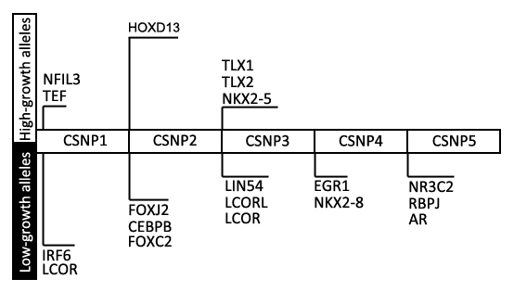
Figure S2
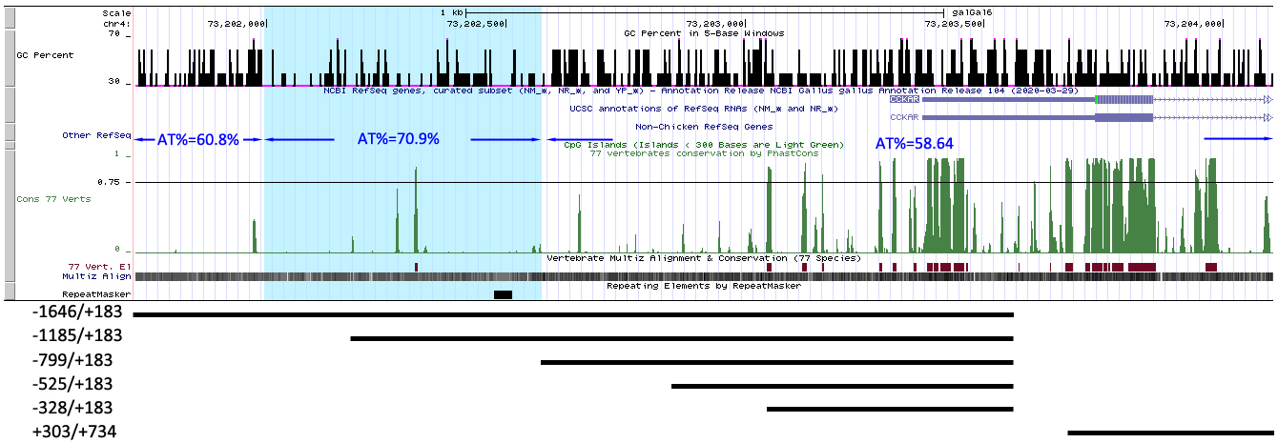
Figure S3
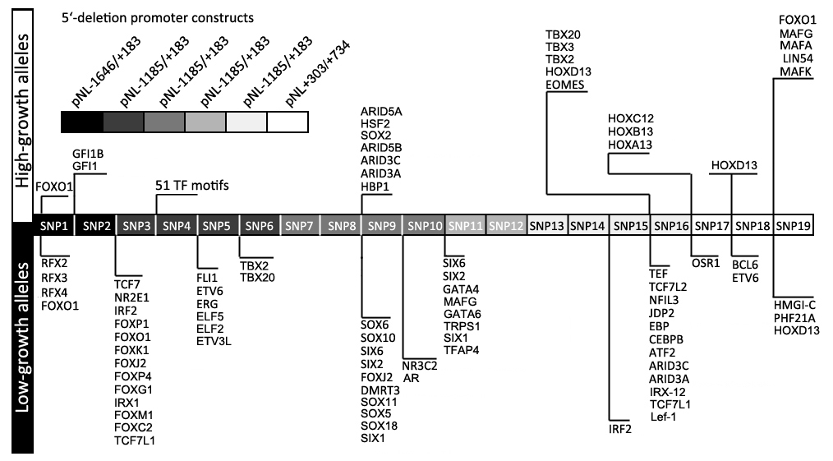
Figure S4
