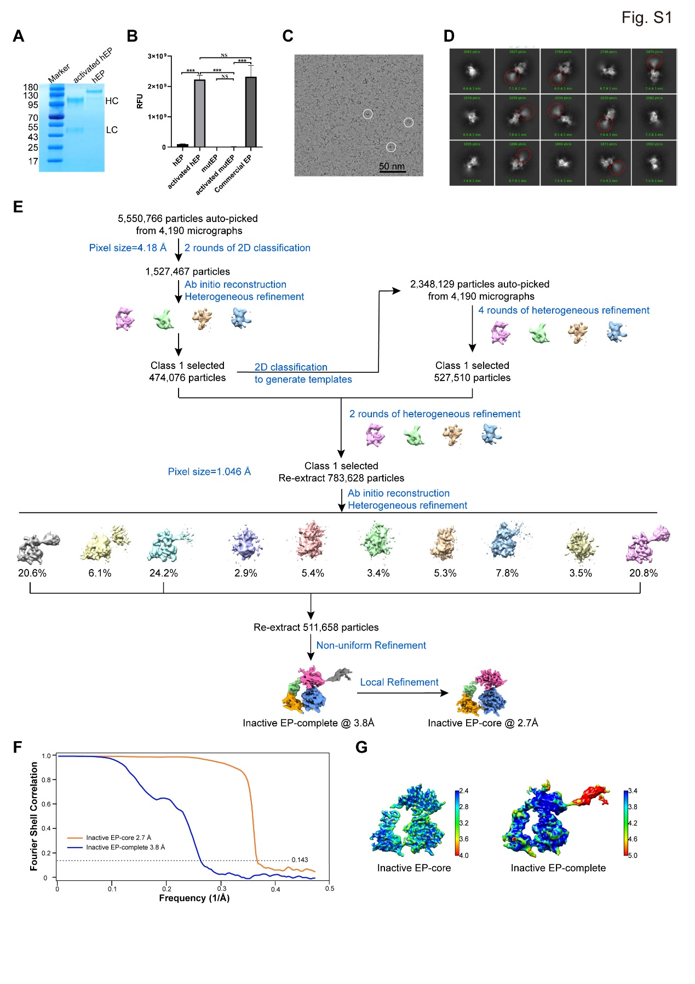
Fig. S1 Biochemical and cryo-EM analysis of hEP in the inactive state. (A) Identification of hEP by SDS-PAGE, followed by coomassie brilliant blue staining. EP activation is realized by trypsin cleavage into heavy chain (HC) and light chain (LC). (B) In vitro EP activity experiment. SDs (standard deviations) were calculated from at least three independent experiments. Significance was tested using one-way ANOVA; ***P<0.001, ^{NS}P>0.05. (C) Representative cryo-EM micrograph of the inactive hEP. For better visualization, the original data was low-pass filtered to enhance the contrast. The scale bar indicates 50 nm. (D) Representative reference-free 2D class averages for inactive EP particles. The fuzzy domains were circled by red ellipses. (E) Work flow for the processing of inactive EP data. (F) Resolution evaluation of the cryo-EM maps by Fourier shell correlation (FSC) 0.143 criterion. (G) Local resolutions of the cryo-EM maps determined using ResMap, with the color bar on the right labeling the resolutions (in Å).

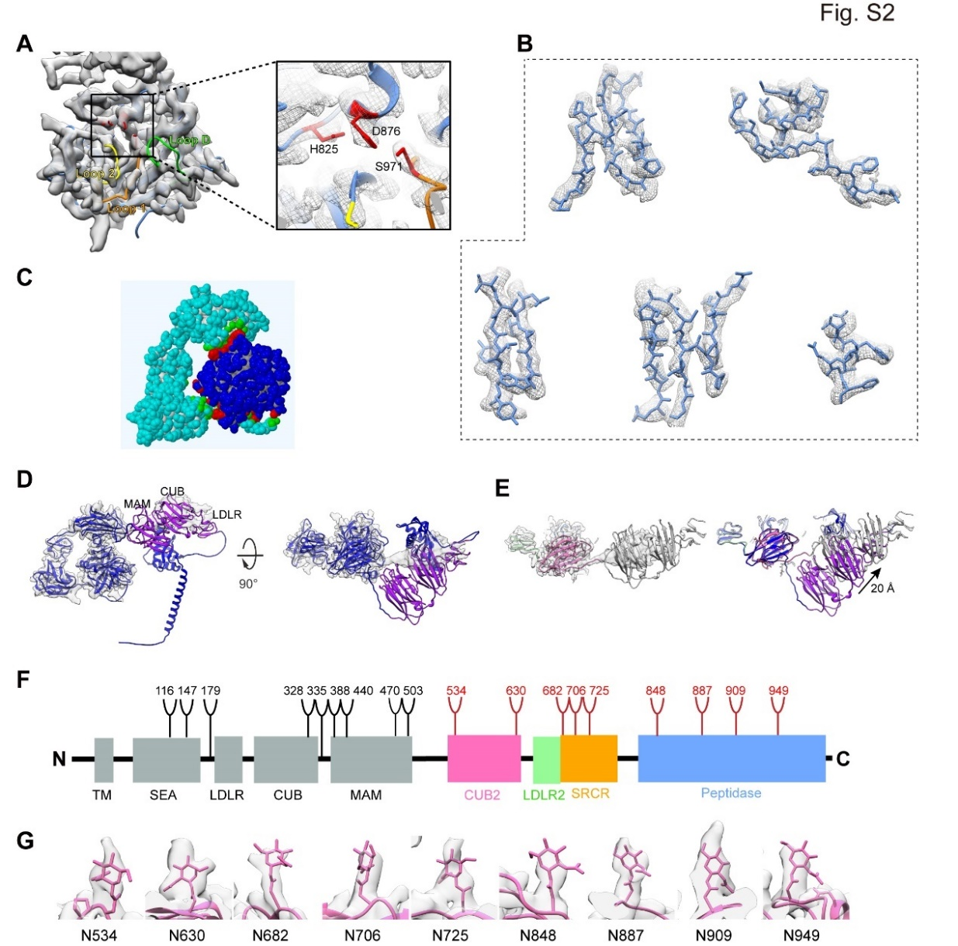
Fig. S2 Structural features of hEP in the inactive state. (A) Inactive EP map fitted with the corresponding pseudo-atomic model, with the catalytic triad colored in red and enlarged for clarity. The surface loops, L1, L2, and LD, are indicated. (B) The good fitting of β-strand and α-helix showing high resolution features. (C) The interaction mode between heavy and light chain, with the interacting residues colored in red. (D) The AF2 predicted full-length EP model fits in our inactive EP map. (E) Our EP-complete model fits in complete map. The overlaying of the model (grey) with the AF2 predicted model (with color) shows a slightly shift. (F) Schematic representation of N-linked glycans in EP. The positions of N-linked glycosylation sequins are shown as branches. 9 N-linked glycans detected in our cryo-EM are shown in red, the remaining undetected ones in black. (G) The good fitting of 9 N-linked glycans detected in our inactive EP.
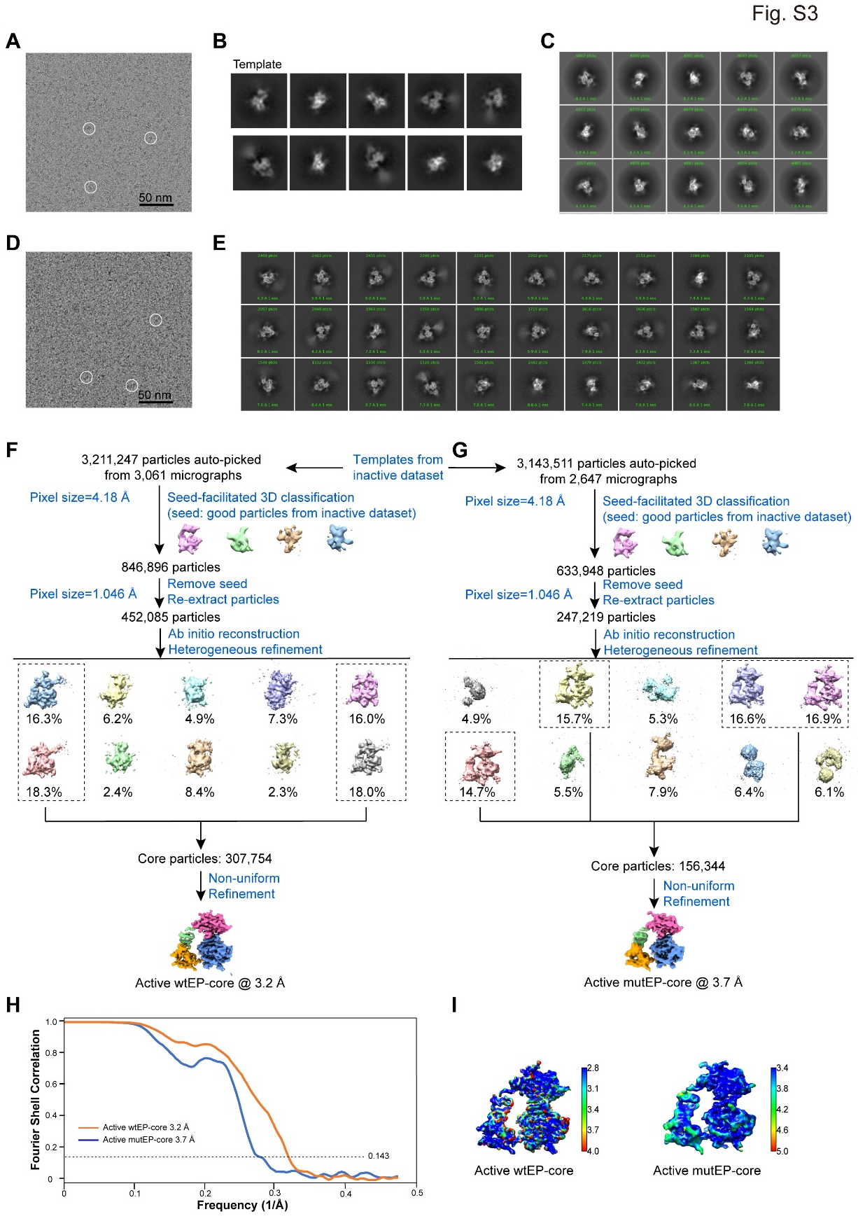
Fig. S3 Cryo-EM analysis of hEP in the active state. (A) Representative cryo-EM micrograph of the active wtEP. For better visualization, the original data was low-pass filtered to enhance the contrast. The scale bar indicates 50 nm. (B) Class-averages from the inactive dataset serving as the templates for autopicking. (C) Representative reference-free 2D class averages for active wtEP-core particles. (D) Representative cryo-EM micrograph of the active mutEP. For better visualization, the original data was low-pass filtered to enhance the contrast. The scale bar indicates 50 nm. (E) Representative reference-free 2D class averages for active mutEP particles. (F-G) Work flows for the processing of active wtEP (F) and mutEP (G) data. (H) Resolution evaluation of the cryo-EM maps by Fourier shell correlation (FSC) 0.143 criterion. (I) Local resolutions of the cryo-EM maps determined using ResMap, with the color bar on the right labeling the resolutions (in Å).

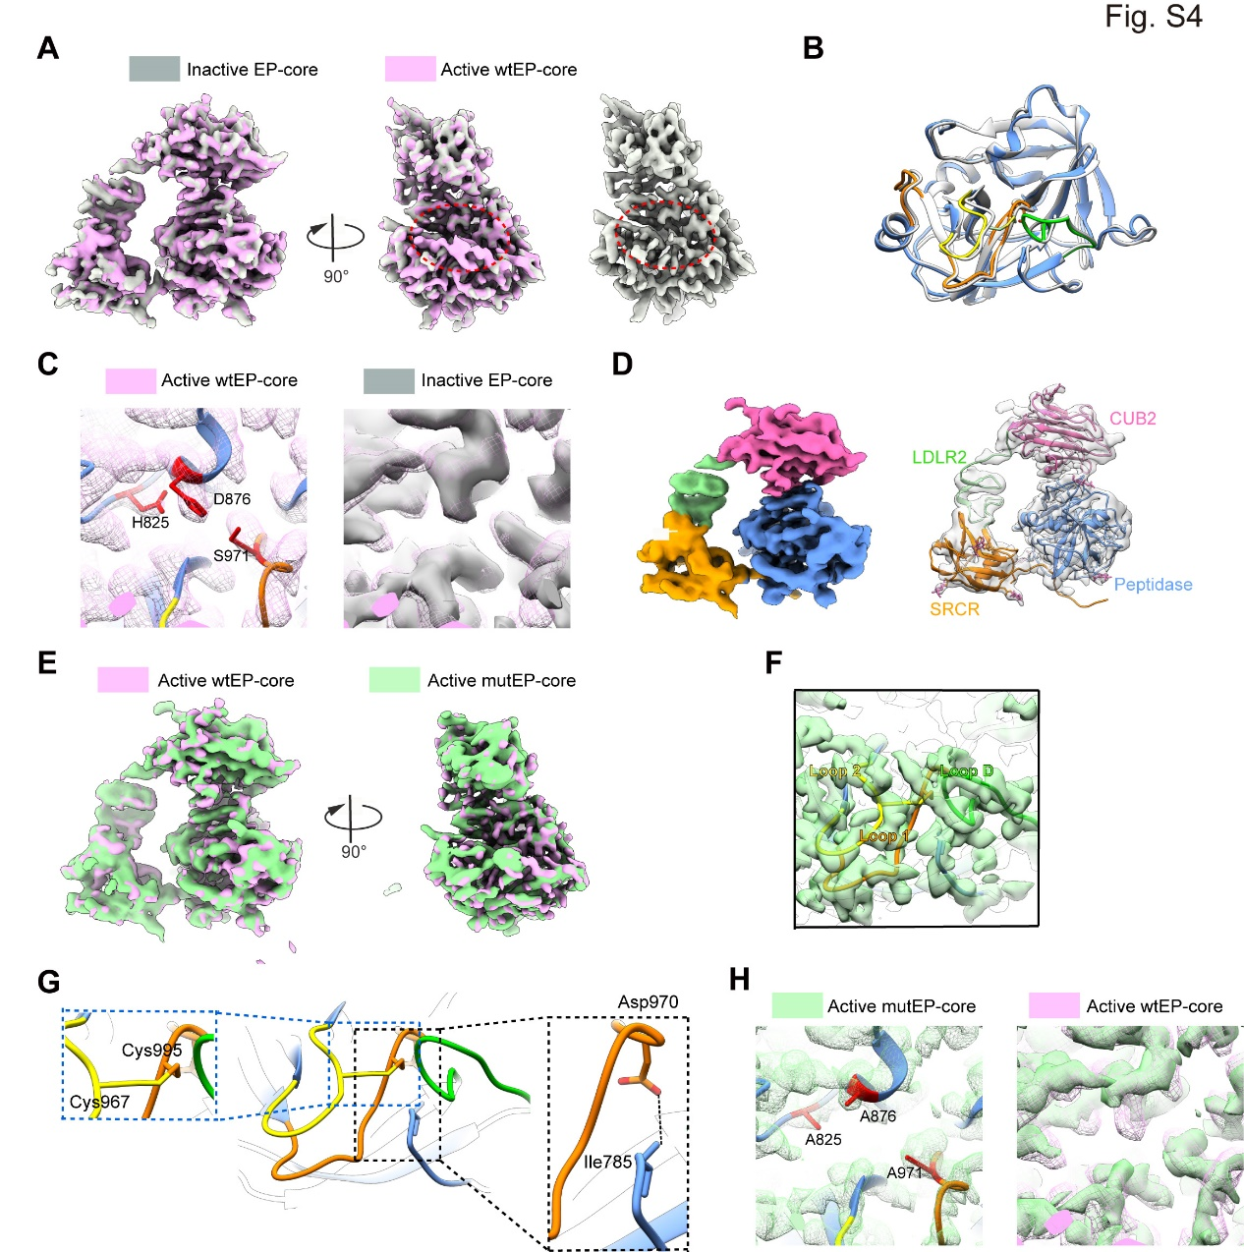
Fig. S4 Structural features of hEP in the active state. (A) Overlay of inactive EP-core (grey) with active EP-core (pink) maps, and the extra density near the active pocket were circled by a dashed red ellipse. (B) Structural overlaying between our structure (with different colors) and published model 4DGJ (grey) shows little variations. (C) The fitting of the catalytic triad in active wtEP-core map and the overlaying of this region with that in the inactive EP-core map. (D) Cryo-EM structure of active mutEP-core, with model fitted in. The detected 9 N-linked glycans were indicated by atomic view. (E) Overlay of active wtEP-core (pink) with active mutEP-core (light green) maps. (F) The fitting of the surface loops in active mutEP-core map. (G) The activation domain in active mutEP-core structure. The interdomain disulfide pair (Cys967-Cys995) and the Asp970:Ile785 salt bridge were enlarged for clarity. (H) The fitting of the mutated catalytic triad in active mutEP-core map and the overlaying of this region with that in the active wtEP-core map.

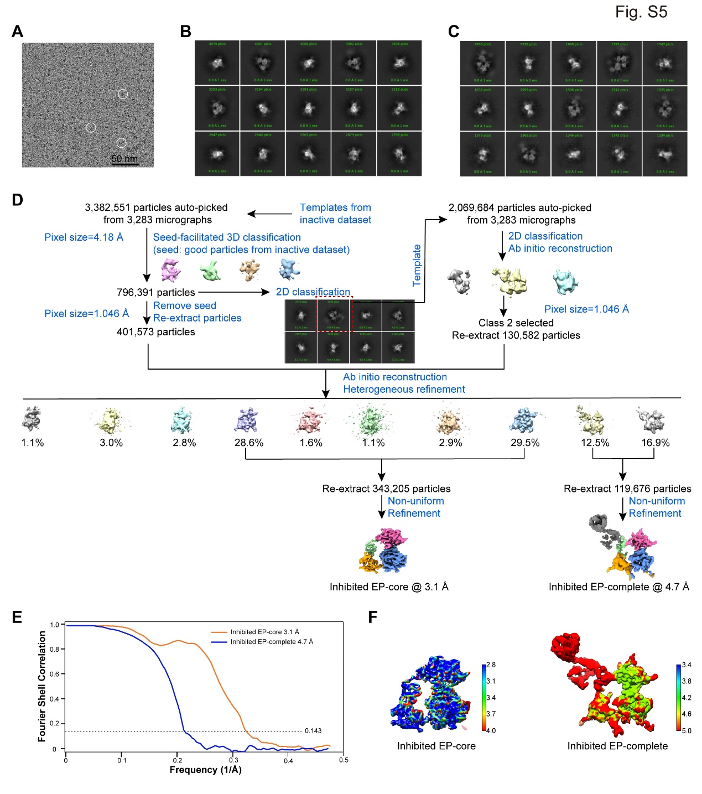
Fig. S5 Cryo-EM analysis of hEP in the inhibited state. (A) Representative cryo-EM micrograph of inhibited hEP. For better visualization, the original data was low-pass filtered to enhance the contrast. The scale bar indicates 50 nm. (B) Representative reference-free 2D class averages for inhibited EP-core particles. (C) Representative reference-free 2D class averages for inhibited EP-complete particles. (D) Work flow for the processing of inhibited hEP data. (E) Resolution evaluation of the cryo-EM maps by Fourier shell correlation (FSC) 0.143 criterion. (F) Local resolutions of the cryo-EM maps determined using ResMap, with the color bar on the right labeling the resolutions (in Å).
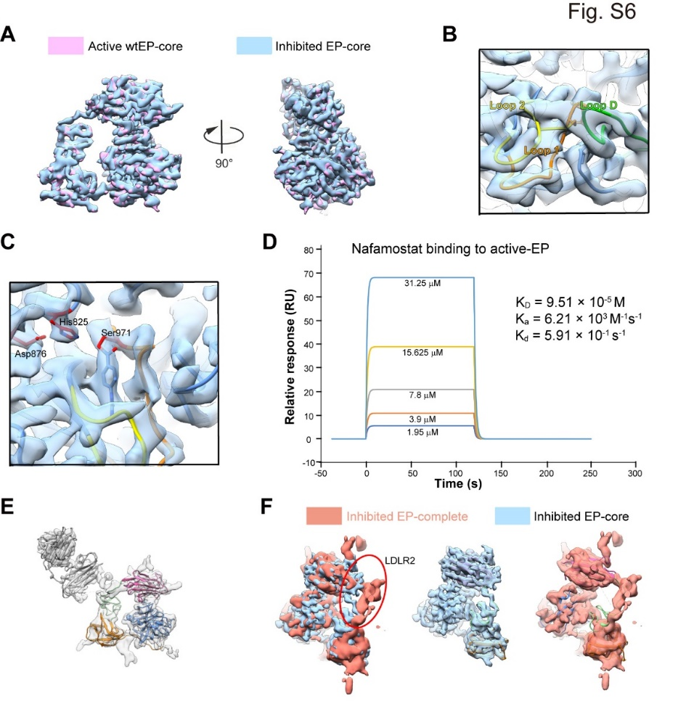
Fig. S6 Structural features of hEP in the inhibited state. (A) Overlay of inhibited EP-core (blue) with active wtEP-core (pink) maps. (B) The fitting of the surface loops in inhibited EP-core map. (C) Interactions between nafamostat and hEP. (D) Surface plasmon resonance analysis of hEP with nafamostat. (E) The structure model of the inhibited EP-complete, with the map in transparent. (F) The conformational change of LDLR2 due to the relocation of the LCM domains.

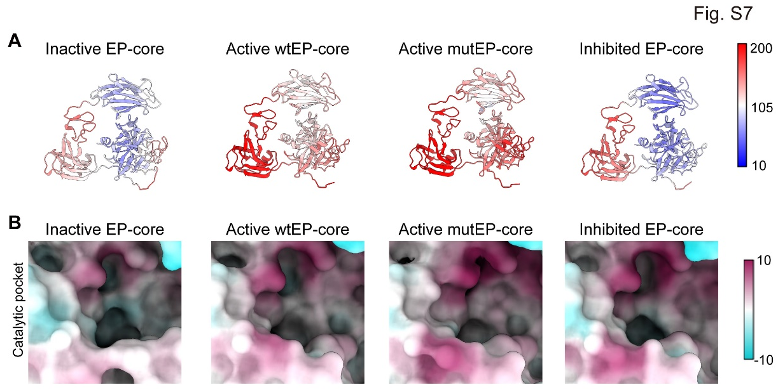
Fig. S7 A comparison of hEP conformations in different states. (A) Atomic models colored according to the B-factor distribution (ranging from 10 Å² (blue) to 200 Å² (red)). (B) Surface property of hEP, with the most distinct residues in catalytic pocket region indicated.

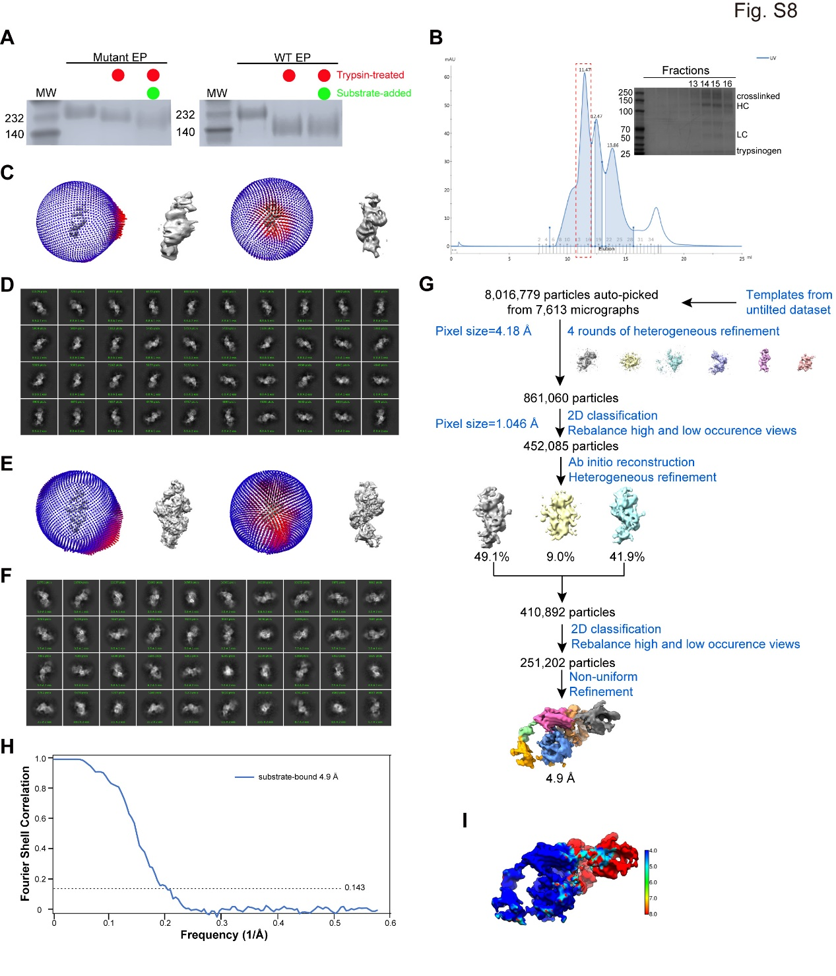
Fig. S8 Cryo-EM analysis of hEP in the substrate-engaged state. (A) The association of trypsinogen to the mutate EP monitored by a gel-shift assay. In the presence of substrate, the mutEP shows a distinct migration pattern, while no observable changes for the wtEP. (B) Different compositions of EP-trypsinogen were fractionated by size exclusion chromatography. Peak fractions were analyzed by SDS-PAGE. (C) The angle distributions of the substrate-engaged data without tilting. (D) The representative reference-free 2D class averages for the substrate-engaged data without tilting. (E) The angle distributions of the substrate-engaged data with 20 degrees tilting. (F) The representative reference-free 2D class averages for the substrate-engaged data with 20 degrees tilting. (G) Work flow for the processing of substrate-engaged data. (H) Resolution evaluation of the cryo-EM maps by Fourier shell correlation (FSC) 0.143 criterion. (I) Local resolutions of the cryo-EM map determined using ResMap, with the color bar on the right labeling the resolutions (in Å).
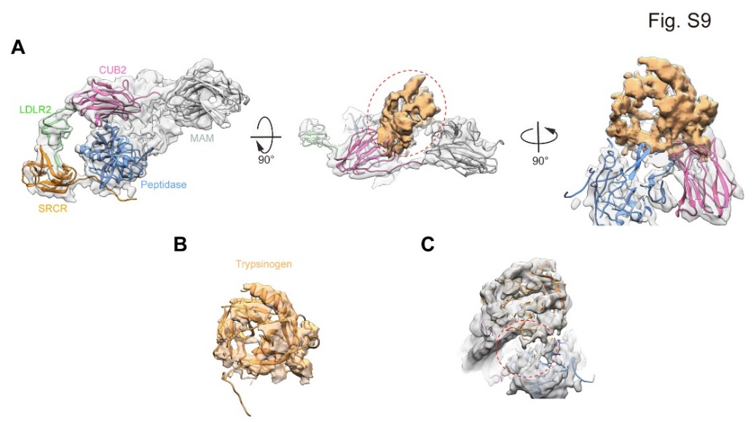
Fig. S9 Validation of the extra density to be trypsinogen in substrate-engaged map. (A) Model fitting of the substrate-engaged EP map showing the location of the extra density. The density was subtracted and colored in sandy brown. (B) Fitting of the trypsinogen model in the subtracted extra density. (C) Substrate enters the catalytic pocket, indicated by a red ellipse.
Table S1 Cryo-EM data collection, reconstruction, and refinement statistics.
