Supplementary Materials

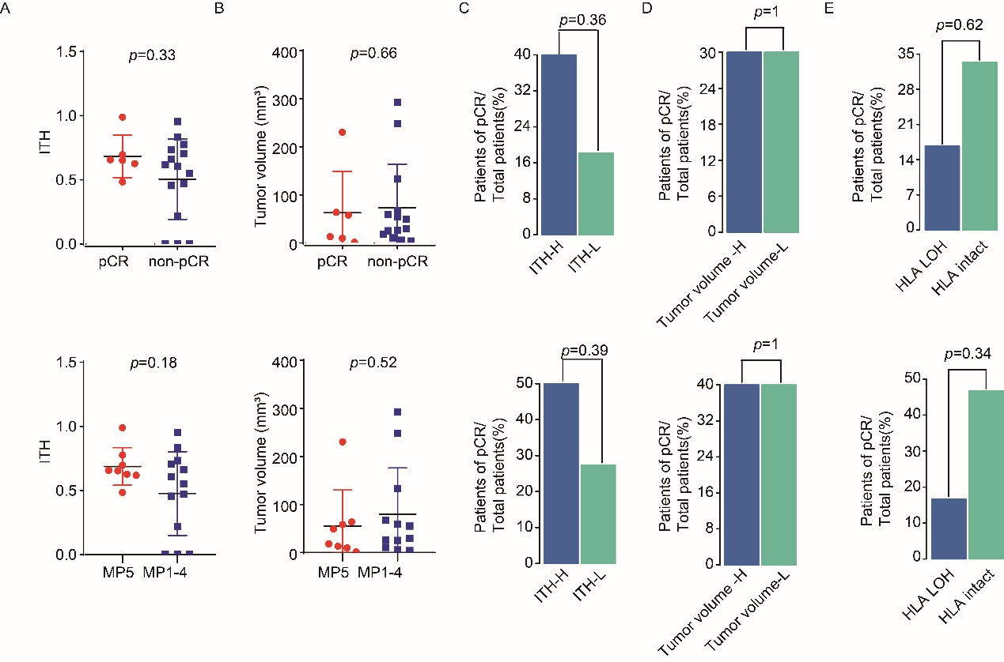

Supplementary Figure 1. ITH, tumor volume or HLA LOH could not predict the efficacy of NAC in TNBC patients. (A) and (B) Comparison of ITH (A) and tumor volume (B) between responders and non-responders. (C) Barplots of pCR rate and MP5 grade rate between ITH-H and ITH-L. (D) Barplots of pCR rate and MP5 grade rate between tumor volume-H and tumor volume-L. (E) Barplots of pCR rate and MP5 grade rate between HLA LOH and HLA intact.

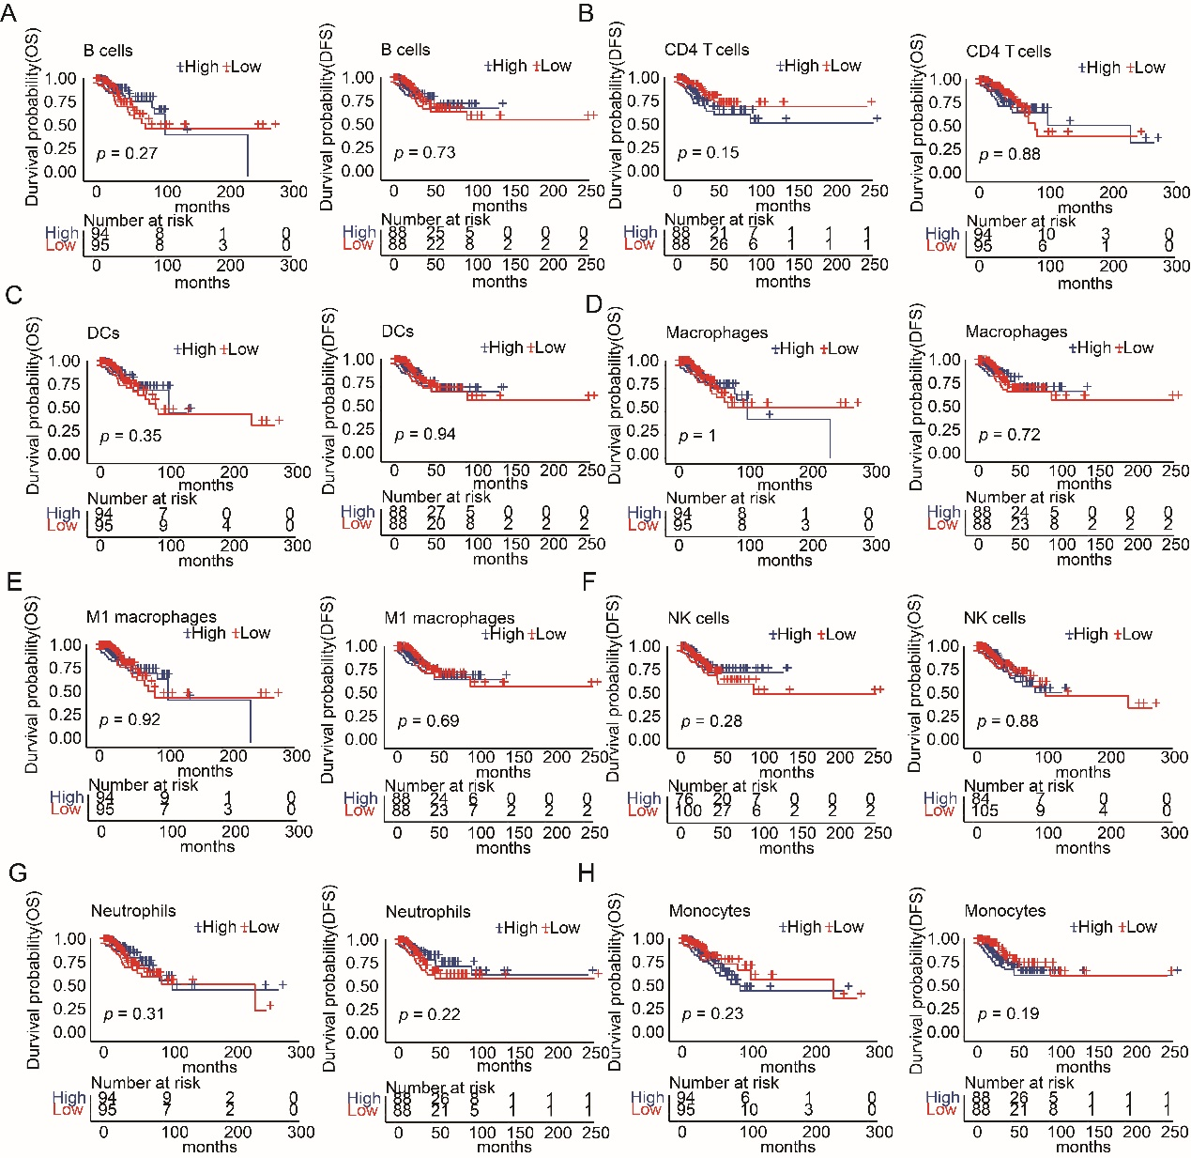

Supplementary Figure 2. B cells, CD4 T cells, DC, Macrophages, M1 macrophages, NK cells, Neutrophils and Monocytes could not predict the efficacy of chemotherapy in TNBC patients. Kaplan–Meier curves of OS and DFS comparing infiltrating lymphocyte- high with infiltrating lymphocyte- low, including B cells (A), CD4 T cells (B), DCs (C), Macrophages (D), M1 macrophages (E), NK cells (F), Neutrophils (G) and Monocytes (H).

Supplementary Table 1. Detailed clinical characteristics and molecular features for enrolled patients.

Supplementary Table 2. Somatic Mutations of WES for enrolled patients.

Supplementary Table 3. Somatic Mutations of 1267 genes targeted-panel sequencing for enrolled patients

