Appendix 2. Educational booklet for patients with chronic obstructive pulmonary disease



Federal University of São Carlos
Postgraduate of Physiotherapy

EDUCATIONAL BOOKLET FOR PATIENTS WITH CHRONIC OBSTRUCTIVE PULMONARY DISEASE

Ms. Marcela M. C. da Silva
Phd Juliano Ferreira Arcuri
Phd Valeria A. P. Di Lorenzo

*All images are the author's own source
What is COPD?
The chronic obstructive pulmonary disease (COPD) is characterized airway (where the air passes for us to breathe) inflammation and airflow obstruction, Causing breathing difficulties.
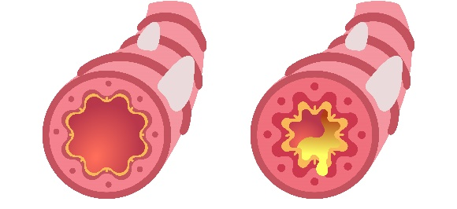
The main causes are smoking, wood or industrial stove fumes and harmful gases.
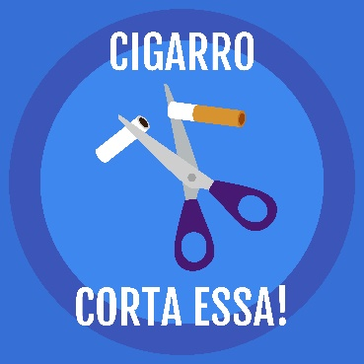

This condition causes the inflation of lung and other parts of the body such as head, upper and lower limbs.
SOME SYMPTOMS
- Air breathlessness,
- Feeling of retained air in the lungs,
-Cough with phlegm,
- Fatigue to execute physical activities,
- Weakness in legs and arms,
- Frequent infections,
- Forgetfulness, sadness and depression,
And others.

AND THE DIAGNOSIS?
The diagnosis is executed by the doctor, but exposure to toxic particles or gases, associated with symptoms of chronic cough, breathlessness is commonly present. The exam that confirms the diagnosis is a spirometry "breath test".
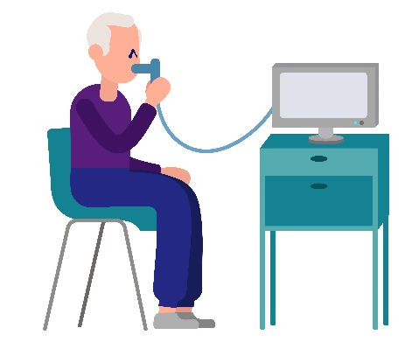

AND THE EXACERBATION?
The exacerbation is characterized by increase of the symptoms (breathlessness, cough with phlegm, fever, bluish nails, and others) main caused by infection.
*Pay attention, you need to see a doctor!
AND THE TREATMENT?
Multi-professional

There is an association of care that involves multi-professionals: physiotherapist, nurse, psychology, doctor, nutritionist, social assistance…
Acting in a preventive and curative way.
Stop smoking: Educative Program

Cigarettes cause bad offenses to your lungs. Let's stop with it?
- Try to reduce the number of cigarettes gradually. The doctor can prescribe a medication that facilitates the process. Do not forget to practice leisure and physical activities, which will help you a lot!
Vaccination (influenza and pneumococcus)

The doctor may ask you to get some vaccines to prevent pneumonia, for example.
Respiratory Support

As the disease progresses, you may have insufficient oxygen in your lungs / blood. You will need a supplementary oxygen.
If you have any exacerbation of disease it is commonly needed noninvasive ventilation (ventilation with a mask that sends air to breathe) or mechanical ventilation (breathing through a machine, with a tube that goes down to your lung).
Medication

The medication reduces your symptoms and prevents the obstruction of airway. Depending on your health condition, each person may have a different prescription. So, your medication programs are prescribed especially for you! If you have any questions about your medication, ask your doctor, pharmacist or nurse for further explanations.
Oral medication such as anti-inflammatory and corticosteroids may be indicated in addition to the inhalation route, such as brondilators, which you should pay special attention to the correct administration technique, in addition to the intravenous via in cases of acute disease.
ORIENTATION OF INALATION
Pressurized inhaler: how to use?
1. Remove the cap and shake vigorously;
2. Keep upright, with 4-5 cm from the mouth;
3. Start slow and deep inspiration and immediately activate the device;
4. Perform a 10-second pause;
5. Exhale normally and rinse your mouth to avoid absorption and systemic effects of the drug.
* If a new dose is prescribed, wait 15-30 sec.

Pressurized inhaler with spacer.
1. Remove the cap and shake vigorously;
2. Attach the aerosol to the spacer and keep it upright from the mouthpiece;
3. Adapt the mask, start slow and deep inspiration and immediately activate the device. Do 4-5 breathing cycles;
4. Take a 10 second pause on inspiration.

Spacer hygiene
Wash it in running water, then, in water with neutral soap and return under running water. Let it dry vertically.
Physical Activity

COPD patients may have low physical activity level and weakness which lead to low quality of life. When physical activity is executed daily you can improve or maintain these conditions!
BENEFITS
- It makes your heart stronger and healthier;
- Improves your muscle strength and weight;
- Improves your breathing;
- Reduces shortness of breath in day-to-day activities;
- Collaborates with the elimination of pulmonary secretion;
- Improves brain activity and mood;
- You will be more independent;
- Improves or maintains bone density;
- Strengthens the immune system.
- Benefits of physical activity.

CARE TO PERFORM PHYSICAL ACTIVITY
- Administrate the correct medication prescribed by the doctor in times of greater dyspnea;
- Stop if you have a fever or infection or any discomfort such as chest pain and dizziness and look for a professional;
- Frequency: 3 to 5 times a week;
- Duration: from 30 to 50 minutes;
- Intensity: For each exercise guided below, the physiotherapist will teach you what intensity you should maintain to be safe. Remember to achieve from most moderate to intense fatigue (Borg's Dyspnea Scale).

MODIFIED BORG SCALE- Krendrick et al.
0 | No breathlessness at all
0,5 | Very, very slight
1 | very slight
2 | Slight breathlessness
3 | Moderate
4 | Somewhat severe
5 | Severe breathlessness
6
7 | Very severe breathlessness
8
9 | Very, very severe
10 | Maximal

You must maintain a 4-5 fatigue.

HOME EXERCISE PROGRAM
STAR: / /
THE END: / /
The program is divided in steps.
Remember that you can take breaks between each step.

STEP 1: It is composed of warm up exercise: slow exercise such as walking during 3 to 5 minutes.
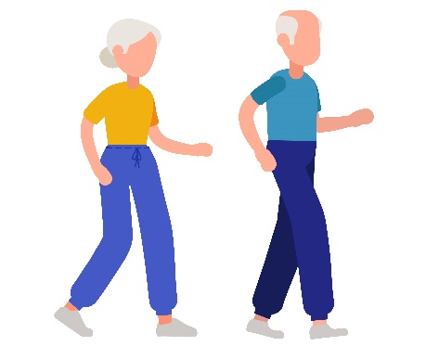
SLOW

Household report: _______________________________________________________________________________________________________________________________________________________________________________________________________________________________________________

BREAK: _____________________________________________________

STEP 2: It is composed of aerobic exercise.
WALKING: Perform on flat ground initially
Prescription
WEEKs | 1 | 2 | 3 | 4 | 5 | 6 | 7 | 8
Time
Distance walked

Household report
WEEK 1:___________________________________________
WEEK 2:___________________________________________
WEEK 3:___________________________________________
WEEK 4___________________________________________
WEEK 5:____________________________________________
WEEK 6:____________________________________________
WEEK 7:____________________________________________
WEEK 8:____________________________________________

BREAK: _____________________________________________________

STEP UP AND DOWN
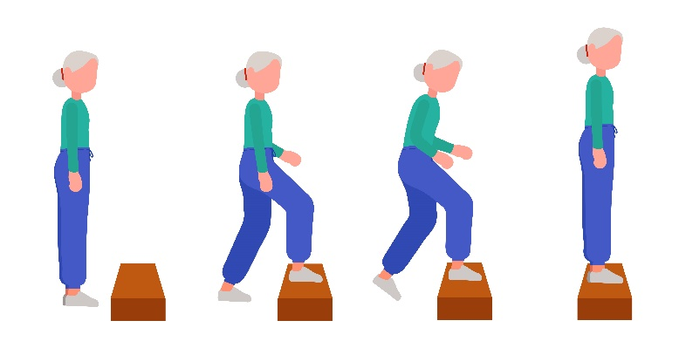
Prescription
WEEKs | 1 | 2 | 3 | 4 | 5 | 6 | 7 | 8
Time
Minimum number of repetitions

Household report
WEEK 1:____________________________________________
WEEK 2:____________________________________________
WEEK 3:____________________________________________
WEEK 4_____________________________________________
WEEK 5:____________________________________________
WEEK 6:____________________________________________
WEEK 7:____________________________________________
WEEK 8:____________________________________________

BREAK: ____________________________________________________

SIT TO STAND MOVIMENTS
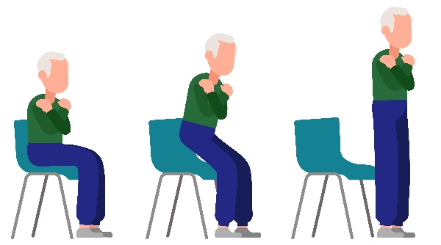

Prescription
WEEKs | 1 | 2 | 3 | 4 | 5 | 6 | 7 | 8
Time
Minimum number of repetitions

Household report
WEEK 1:____________________________________________
WEEK 2:____________________________________________
WEEK 3:____________________________________________
WEEK 4___________________________________________
WEEK 5:____________________________________________
WEEK 6:____________________________________________
WEEK 7:____________________________________________
WEEK 8:____________________________________________

BREAK: ____________________________________________________

STEP 3: Upper limbs strengthening
A. Use a food packages with equivalent weight: execute standing or sitting, performed in the diagonal of movement.
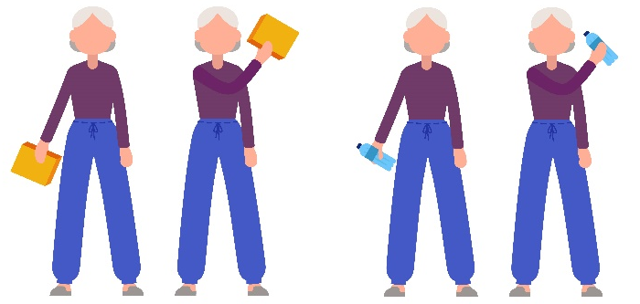

Prescription
WEEKs | 1 | 2 | 3 | 4 | 5 | 6 | 7 | 8
Weight
Repetition
Series

Household report
WEEK 1:____________________________________________
WEEK 2:____________________________________________
WEEK 3:____________________________________________
WEEK 4:____________________________________________
WEEK 5:____________________________________________
WEEK 6:____________________________________________
WEEK 7:____________________________________________
WEEK 8:____________________________________________

BREAK: _____________________________________________________

Complementary exercise: push-ups on the wall
Don`t forget to associate de respiratory exercise during the flexion (expiration) and extension (inspiration).
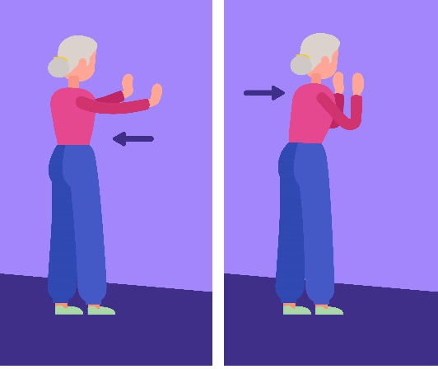

Prescription
WEEKs | 1 | 2 | 3 | 4 | 5 | 6 | 7 | 8
Repetition
Series

Household report
WEEK 1:____________________________________________
WEEK 2:____________________________________________
WEEK 3:____________________________________________
WEEK 4_____________________________________________
WEEK 5:____________________________________________
WEEK 6:____________________________________________
WEEK 7:____________________________________________
WEEK 8:____________________________________________

STEP 4: Stretching
Stay for 20 seconds in each position
In the sitting position, stretch cervical (“lateral neck movement”) upper limb ("arm to the side and arm back") and lower limbs (standing or lying position) ("hold the knees" and "hold the feet").

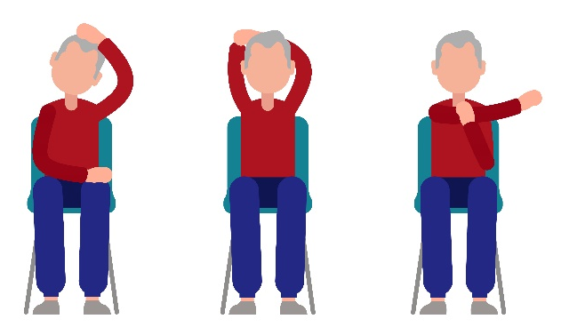
Neck
Upper limbs

Lower limbs

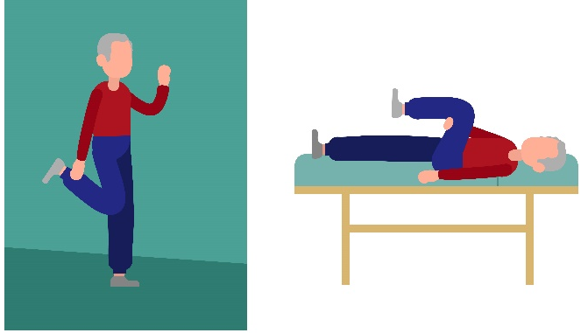
STEP 5: Relation
During 5 to 10 minutes rest in bed listening to a relaxing song and controlled respiration.

Lung hygiene techniques
Mucociliary activity (pulmonary cilia that help clear the secretion) can be affected by smoking, use of oxygen, and dehydration (always drink water properly!). If there is also a condition of lung infection, the airway may become inflamed and produce more secretion.
Excessive secretion can increase cough and fatigue and shortness of breath. If the secretion is not removed from the lung, it can cause further inflammation and damage to your lungs.
There are techniques that can help to remove this secretion from the lung, this subject should be discussed, guided or performed by a respiratory physiotherapist.
Huffing
Through forced exhalation with the open glottis (exhaling as if “puffing glasses”), the secretion is removed.
Cough
It is the effective way to remove the secretion, without making maximum efforts.
Then take a calm breath, then immediately execute a forced expiration. You will feel that the abdominal muscles will expel the secretion.

Doubts?
Contact your physiotherapist!

Appendix 3. Rehabilitation Protocol
Rehabilitation protocol
Patient name:
step height: |  |  | Walking place: |  |  | Strengthening sittng or standing:
STEPS | WEEK 1  Data: | WEEK 2  Data: | WEEK 3  Data: | WEEK 4  Data: | WEEK 5  Data: | WEEK 6  Data: | WEEK 7  Data: | WEEK 8  Data:
Warm up exercise | 3-5 minutes: light exercise | 3-5 minutes: light exercise | 3-5 minutes: light exercise | 3-5 minutes: light exercise | 3-5 minutes: light exercise | 3-5 minutes: light exercise | 3-5 minutes: light exercise | 3-5 minutes: light exercise
Prescription

INTERVAL ____minutes
AEROBIC EXERCISE: Keep the BORG scale 3-5 points
Walk | 5 minutes 80% | 8 minutes 80% | 10 minutes 90% | 12 minutes 100% | 13 minutes 100% | 15 minutes 100% | 15 minutes 100% | 15 minutes 100%
Prescription

INTERVAL
Up and down step | 5 minutes 80% | 6 minutes 80% | 7 minutes 90% | 8 minutes 100% | 9 minutes 100% | 10 minutes 100% | 11 minutes 100% | 12 minutes 100%
Prescription

INTERVAL ____minutes
Sit to stand | 1 minutes 80% | 2 minutes 80% | 2 minutes 90% | 3 minutes 90% | 3 minutes 100% | 4 minutes 100% | 5 minutes 100% | 5 minutes 100%
Prescription

INTERVAL ____minutes
Upper limbs strengthening | 50%10RM | 50%10RM | 75%10RM | 75%10RM | 75%10RM | 100%10RM | 100%10RM | 100%10RM
Prescription

INTERVAL ____minutes
Flexiono on the wall
Prescription

Stretching
Relaxation

Appendix 4. Supervised session: monitoring regarding
WEEK | PRE |  |  |  | POST WALKING |  |  | POST STEP |  |  | POST SIT TO STAND |  |  | POST STRENGTHENING |  |  | POST
WEEK | RR | SpO2 | BORG | Arterial pressure | RR | SpO2 | BORG | RR | SpO2 | BORG | RR | SpO2 | BORG | RR | SpO2 | BORG | RR | Arterial pressure | SpO2 | BORG
1
2
3
4
5
6
7
8

appendix 5: Aproval financial support
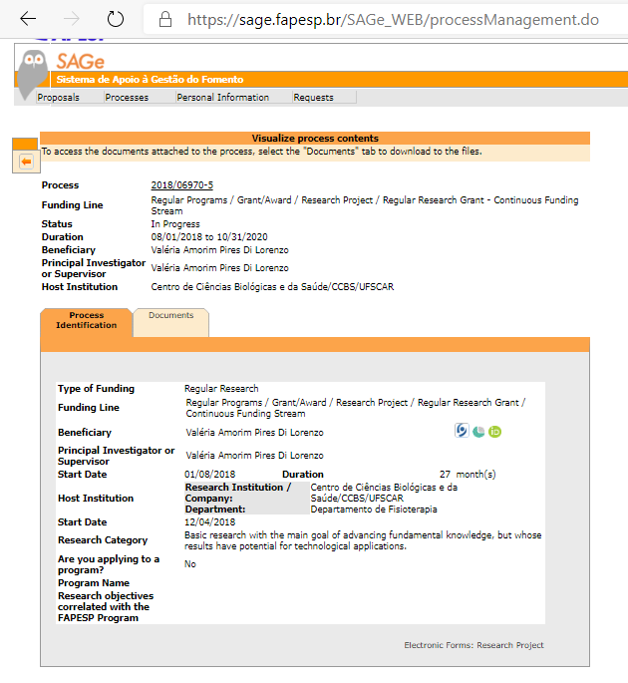

List of abbreviation
Chronic obstructive pulmonary disease (COPD)
pulmonary rehabilitation programs (PRP)
Physical Therapy Laboratory of the Federal University of São Carlos (UFSCar).
Brazilian Clinical Trials Registry (ReBec)
on six-minute walk test (6MWT)
Standard Protocol Items: Recommendations for Interventional Trials (SPIRIT)
Modified Medical Research Council (mMRC)
Kilograms/ metres squared (kg / m2)
six-minute step test (6MST)
One minute sit to stand test (1MST)
Saint George Respiratory Questionnaire (SQRQ)
COPD Assessment Test (CAT)
Physical Activity daily living (PADL)
instruction group (IG)
supervised group (SG)
Statistical Package for the Social Sciences (SPSS)
Fundação de Amparo à Pesquisa do Estado de São Paulo (FAPESP)
Coordenação de Aperfeiçoamento de Pessoal de Nível Superior (CAPES)

