SUPPLEMENTARY INFORMATION

Innovations in Acheulean biface production at la Noira (France) during Middle Pleistocene in Western Europe

Paula García-Medrano^{1,2,3,4,*}, Jackie Despriée¹, Marie-Hélène Moncel¹

¹ UMR 7194 Département Homme et Environnement, Museum National d’Histoire Naturelle, Paris, France
² Dept. Britain, Europe and Prehistory, British Museum, Frank House, 56 Orsman Road N1 5QJ, London, UK
³ Institut Català de Paleoecologia Humana i Evolució Social (IPHES-CERCA), Zona Educacional 4, Campus Sescelades URV (Edifici W3), 43007 Tarragona, Spain.
⁴ Universitat Rovira i Virgili, Departament d’Història i Història de l’Art, Avinguda de Catalunya 35, 43002 Tarragona, Spain

* Corresponding author: pgarciamedarno@gmail.com

SI Part 1. Technological analysis: the WEAP Method (García-Medrano et al., 2020)
WEAP Method proposes a uinfied method of analysis, drawing together a selection of criteria considered significant from previous research methodologies applied to the western Acheulean record, including typological, technological and processual issues, together with new proposals on morphometrics. It represents a common and unified methodological approach, selecting the most significant technological and metrical features from the classical approaches. WEAP’s method is based on three main premises: 1) standardizing and simplifying terminology; 2) avoiding the classification of tools before analysis; 3) analysing each tool in two different ways: as a complete unit, from a morphotechnical point of view, and as the sum of three different parts (distal, middle and proximal areas). Due to the recent development of innovative technologies, it is timely to move research forward to make more detailed comparisons between sites.

- The tool as a single unit: technological features and linear measures
- Blank type is a key feature. Shaping can start on blocks (broken from bedrock), nodules (eroded from bedrock, SI Fig. 1A), cobbles (from river gravels, SI Fig. 1B) and large flakes (SI Fig. 1C). The use of flakes implies two stages with the production of the flake (débitage) and its shaping (façonnage). When shaping is intensive, blank type cannot be identified and is designated as unknown (SI Fig. 1D).
- Number of faces. Handaxes and cleavers have one (unifacial, SI Fig. 1E) or two shaped faces (bifacial, SI Fig. 1F) and the shaping is face by face or alternate. When shaping is long and flexible, and adapted to the raw material form, sometimes trifacial rough-outs are produced (SI Fig. 1G; García-Medrano, et al. 2019). A trifacial tool is not always the main aim, just a consequence of the shaping process.

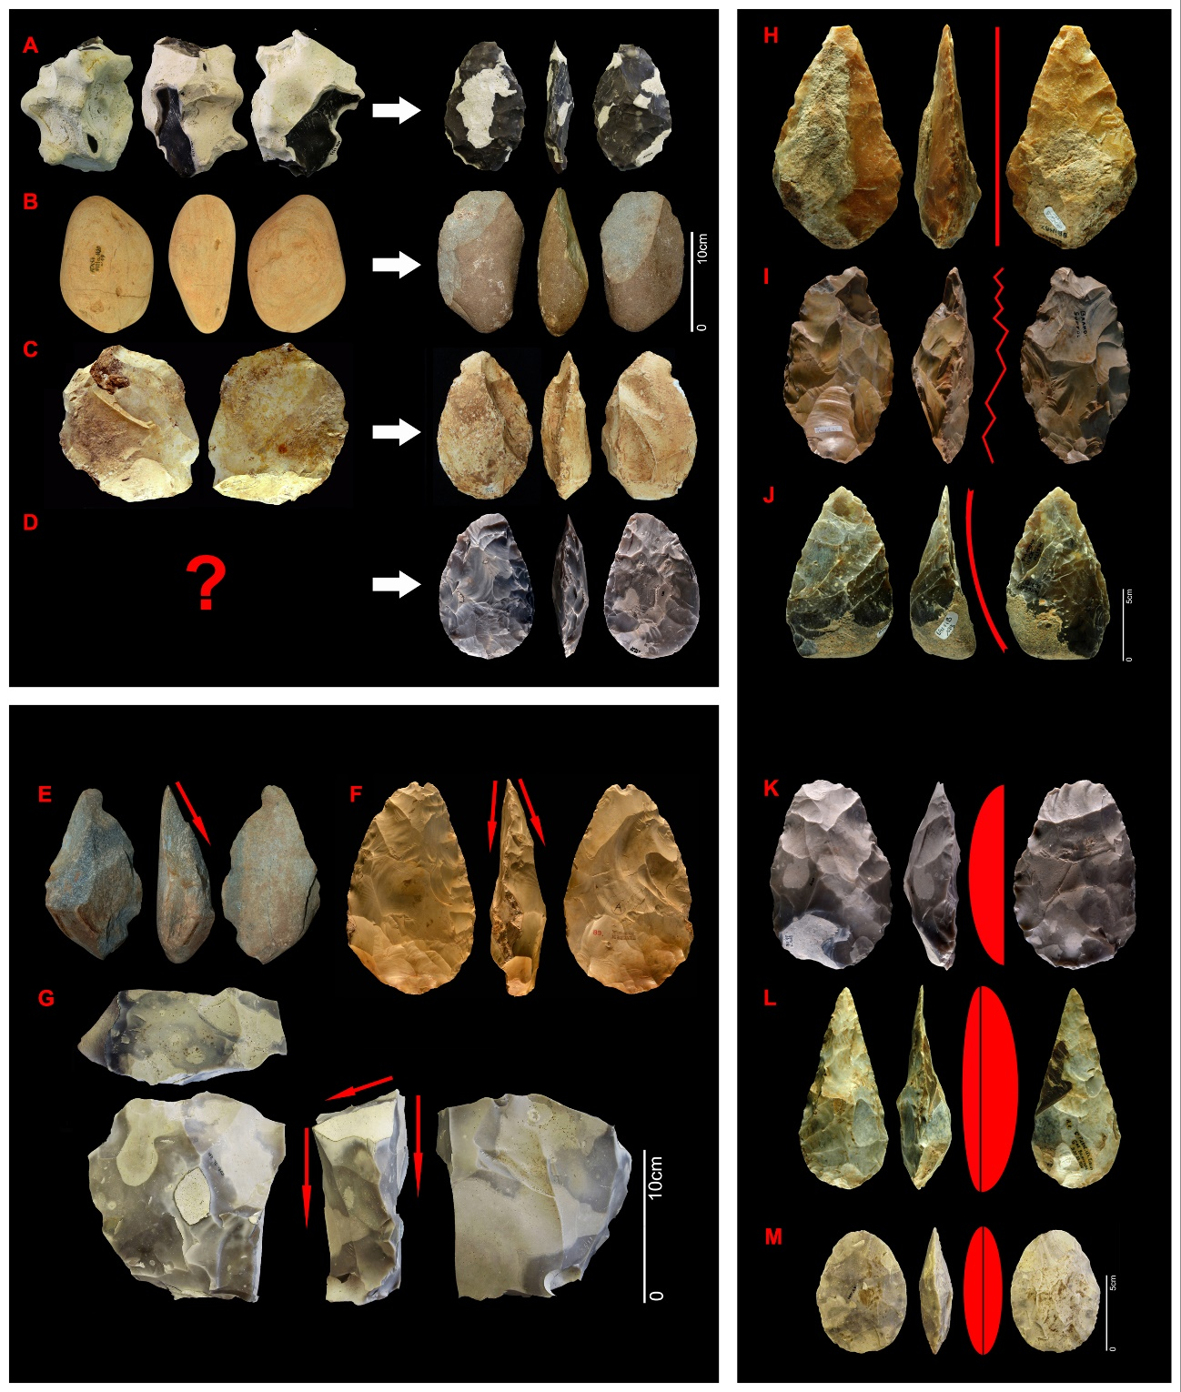
SI Figure 1. Type of blank: a) nodule (Boxgrove_Q1B_1753); b) cobble (Galería, Ata17_GIIIa_H20_19); c) flake (Galería, ATA95_TN2B_E27_1); d) unknown blank. Final tools, from top to bottom: Boxgrove Q1B 7097; Galería, ATA94_TN2B_F27_2; Galería, ATA96_TZ_GIIc_L2_48; Boxgrove_Q1B_5162; Faciality: e) unifacial (Galería, ATA94_TN2B_G22_5, tool on quartzite); f) bifacial (Elveden, Sturge_89, tool on flint); g) trifacial (Boxgrove_Q1B_505, rough-out on flint); Edge delineation: h) straight (La Noira_Upper_VIb_116); i) sinuous (Brandon Fields 15); j) incurved (La Noira_Upper_179); Symmetry: k) plan-convex (Boxgrove_Q1B_1418); l) non-symmetric (S.Pierre-lès-Elbeuf_D38.23.7540); m) symmetric (Boxgrove_Q1B_11080). Modified from García-Medrano et al., 2020.

- Cortex location is given according to the metrical division of the tool (butt, middle or tip, or in more than one area), without face distinction (Fig. 2A-F).
- The edge is analysed by the delineation (profile), which can be straight (Fig. 1H), sinuous (SI Fig. 1I) or curved (SI Fig. 1J). A pronounced form of sinuous edge is a twisted profile, which on some British sites seems to be intentional (White et al. 2019; SI Fig. 2J).
- Tools are categorised as symmetrical (SI Fig. 1L) or non-symmetrical (SI Fig. 1M), and plano-convex, according to their profile (SI Fig. 1K).
- The number of scars on each face includes all removals larger than 10 mm, according to the technical length of the removal (from the impact point to the most distant point). This attribute has been used to measure reduction intensity. Here we have used the Scar Density Index (SDI), calculated by the number of scars (≥ 10 mm) per surface area (cm²) (Shipton and Clarkson 2015a,b). However, recent studies point out the limits of this method and calculate reduction intensity according to the remaining mass and the metrical features of the associated flakes (Lombao et al. 2019a,b) or according to the Flaked Area Index (Li et al. 2015).

b. Tool as the sum of three different parts, in a functional sense
- Type of hammer. In most cases, the identification of the type of hammer used is not easy. If possible, the assignment depends on the combination of several features, such as the depth of removals on the edge, the invasiveness on the surface, the thickness of removals and the angle of blows. The most traditional assignment suggests that low angles, with high invasiveness ratios and marginal modification on edges could be ascribed to the use of soft hammer. On the contrary, high angle values, with thick removals and deep effect on edges could be related to the use of hard hammer. Nevertheless, the limit between them are sometimes very diffuse. Hard (Fig. 2A,C), soft (Fig. 2B,F) or the combination of both.
- Removal sequence is the number of discrete sequences of flake removals on a sector of a handaxe. The simplest is one series (Fig. 2G), with two series sometimes recognisable and/or with the addition of final retouch. First removal sequence may be partially or completely erased by subsequent series (Fig. 2H), although they might be identified towards the centre of a tool. Secondary sequences are often distributed on a smaller area of the tool, while final retouch can be even more localised such as a tip (e.g. Fig. 2I) or edge. A specific form of retouch is a tranchet removal across the surface of the tip to create a fresh, unretouched edge on one of the faces (Fig. 2I), or shallow retouch, which aims to reduce the thickness of the piece and the irregularities of the surface. Removal series have a direct effect on the edge of the tool, steepness and the surface of each face (invasiveness).
- Depth of removals, refers to the concavity generated by a removal in a tool’s frontal planform. Deep scars (Fig. 2M) generate an irregular edge, whereas marginal scars leave the edge largely unchanged and are usually from soft-hammer use (Fig. 2N).
- Invasiveness of the removals can either be non-invasive when the removals are short, concentrated on the edge of the tool (Fig. 2O), or invasive when they affect around the 50% or more of the tool’s surface (Fig. 2P). Final retouch should also be defined as invasive and non-invasive, as some forms such as tranchet removal may affect larger areas of a sector (Fig. 2I).
- General type of shaping, as a general description. Once all those features are recorded, we can assess if the different areas of the tool were treated in a similar way (Fig. 2J), or with a different combination of removals (Fig. 2K) or with application of final retouch, covering the rest of the removal series (Fig. 2L).
- Differences in patination and staining can distinguish instances of reuse of tools after protracted lengths of time (Fig. 2Q). The number and location of different patinas are counted.

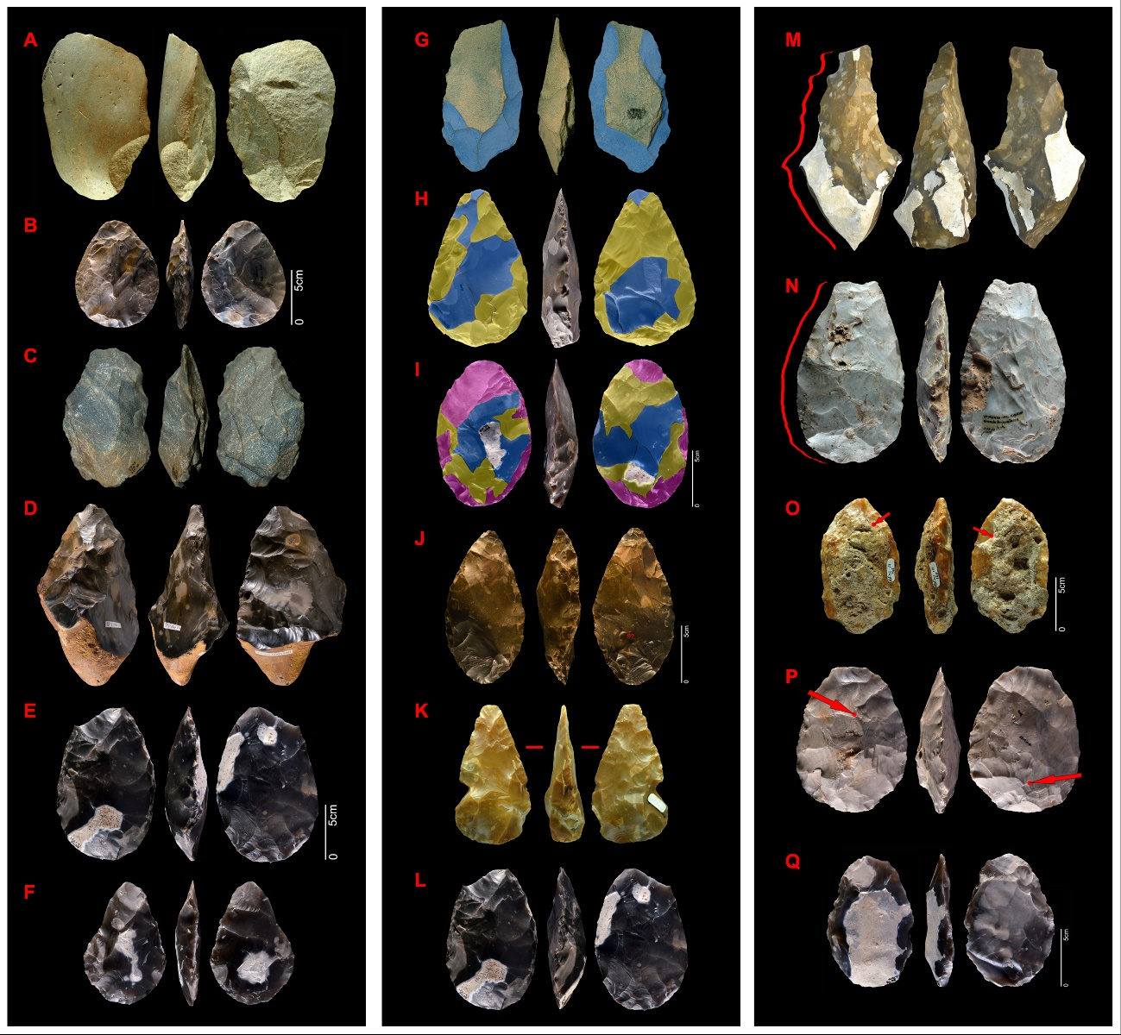
Figure 2. Localization of cortex: A) total cortical (Menez Dregan, MD1_7_115638); B) non cortical (Boxgrove_ Q1B_Unit4_10575; C) cortical butt (Galeria_Ata93_GIIb_TN5_G25_30); D) cortex at mid-proximal part (Brandon Fields_Sturge_14); E) cortex at mid-distal part (Boxgrove_Q1B_Unit4_1731; F) cortex at mid part (Boxgrove_Q1B_Unit4_1090); Type of hammer: hard (A,C) and soft (B,F); Number of removal series: G) one removal sequence (Galería_Ata88_GIIIa_TG10A_G17_83); H) two removal sequences (Boxgrove_Q1B_Unit4_L1191); I) two removal sequences plus final retouch concentrated on tip (Boxgrove_Q1B_Unit4_L1097); Shaping strategies on one tool: J) the same strategy on the whole tool (Elveden_Sturge_92); K) one area with a specific treatment (La Noira_Upper_BFN_VI_62); L) final retouch covering the previous sequence of removals (Boxgrove_Q1B_Unit4_L1731); Depth of scars on edge: a) deep (Cagny La Garenne_CA_Gar87_CAF); b) marginal (Saint Pierre_LA_D_38.23.7519); Invasiveness, scars on tool’s surface: c) non-invasive (La Noira_Lower_BFNIII_156); d) invasive (Boxgrove_Q1B_Unit4_6135); Double patinas on one tool: e) Boxgrove_Q1B_Unit4_L141). Modified from García-Medrano et al., 2020.

References Part 1.
Bordes, F. Typologie du Paléolithique Ancien et Moyen. Bordeaux: Delmas (1961).

García-Medrano, P., Ollé, A., Roberts, M.B. & Ashton, N. The mental template in handaxe manufacture: new insights into Acheulean lithic technological behaviour at Boxgrove, Sussex, UK. Journal of Archaeological Method and Theory. 26, 396–422 (2019).

García-Medrano, P., Ashton, N., Moncel, M., Ollé, A. The WEAP Method: a New Age in the Analysis of the Acheulean Handaxes. Journal of Paleolithic Archaeology. https://doi.org/10.1007/s41982-020-00054-5 (2020).

Li, H., Kuman, K. & Li, C. Quantifying the Reduction Intensity of Handaxes with 3D Technology: A Pilot Study on Handaxes in the Danjiangkou Reservoir Region, Central China. PLoS ONE. 10(9), e0135613 (2015).

Lombao, D., Cueva-Temprana, A., Rabuñal, J. R., Morales, J. I. & Mosquera, M. The effects of blank size and knapping strategy on the estimation of core's reduction intensity. Journal of Archaeological and Anthropological Sciences. 11(10), 5445-5461 (2019a).

Lombao, D., Rabuñal, J. R., Cueva-Temprana, A., Morales, J. I. & Mosquera, M. A new method to infer the reduction intensity on cores and handaxes: the Volumetric Reconstruction Method (VRM). Proceedings of the European Society for the study of Human Evolution (ESHE). 8, 111 (2019b).

Roe, D.A. British Lower and Middle Palaeolithic Handaxe Groups. Proceedings of the Prehistoric Society. 34, 1–82 (1968).

White, M., Ashton, N. & Bridgland, D. Twisted Handaxes in Middle Pleistocene Britain and their Implications for Regional-scale Cultural Variation and the Deep History of Acheulean Hominin Groups. Proceedings of the Prehistoric Society. 85, 61-81 (2019).

 | UN |  | BF |  | SOFT |  | HARD |  | H/S |  | 1 |  | 2 |  | 1+FR |  | 2+FR |  | CO_Butt |  | CO_Butt+M |  | CO_All |  | CO_Mid |  | NC
a_Slab | 0 | 0,00 | 20 | 100,00 | 1 | 5,00 | 13 | 65,00 | 6 | 30,00 | 4 | 20,00 | 8 | 40,00 | 5 | 25,00 | 3 | 15,00 | 1 | 5,00 | 11 | 55,00 | 8 | 40,00 | 0 | 0,00 | 0 | 0,00
a_Flake | 0 | 0,00 | 7 | 100,00 | 1 | 14,29 | 3 | 42,86 | 2 | 28,57 | 1 | 14,29 | 3 | 42,86 | 2 | 28,57 | 1 | 14,29 | 0 | 0,00 | 4 | 57,14 | 1 | 14,29 | 2 | 28,57 | 0 | 0,00
a_Unknown | 0 | 0,00 | 4 | 100,00 | 0 | 0,00 | 2 | 50,00 | 1 | 25,00 | 0 | 0,00 | 2 | 50,00 | 0 | 0,00 | 2 | 50,00 | 0 | 0,00 | 1 | 25,00 | 1 | 25,00 | 1 | 25,00 | 1 | 25,00
a_Millst. | 0 | 0,00 | 31 | 100,00 | 2 | 6,45 | 18 | 58,06 | 10 | 32,26 | 5 | 16,13 | 13 | 41,94 | 7 | 22,58 | 6 | 19,35 | 1 | 3,23 | 17 | 54,84 | 9 | 29,03 | 3 | 9,68 | 1 | 3,23
TOTAL | 0 | 0,00 | 31 | 100,00 | 2 | 6,45 | 18 | 58,06 | 10 | 32,26 | 5 | 16,13 | 13 | 41,94 | 7 | 22,58 | 6 | 19,35 | 1 | 3,23 | 17 | 54,84 | 9 | 29,03 | 3 | 9,68 | 1 | 3,23
c_Slab | 0 | 0,00 | 18 | 100,00 | 12 | 66,67 | 5 | 27,78 | 1 | 5,56 | 2 | 11,11 | 7 | 38,89 | 1 | 5,56 | 8 | 44,44 | 3 | 16,67 | 10 | 55,56 | 4 | 22,22 | 0 | 0,00 | 1 | 5,56
c_Flake | 0 | 0,00 | 13 | 100,00 | 6 | 46,15 | 3 | 23,08 | 4 | 30,77 | 2 | 15,38 | 3 | 23,08 | 2 | 15,38 | 6 | 46,15 | 1 | 7,69 | 6 | 46,15 | 2 | 15,38 | 2 | 15,38 | 2 | 15,38
c_Unknown | 0 | 0,00 | 16 | 100,00 | 9 | 56,25 | 5 | 31,25 | 2 | 12,50 | 2 | 12,50 | 5 | 31,25 | 2 | 12,50 | 7 | 43,75 | 1 | 6,25 | 4 | 25,00 | 0 | 0,00 | 3 | 18,75 | 8 | 50,00
c_Millst. | 0 | 0,00 | 20 | 100,00 | 11 | 55,00 | 7 | 35,00 | 2 | 10,00 | 4 | 20,00 | 5 | 25,00 | 3 | 15,00 | 8 | 40,00 | 1 | 5,00 | 9 | 45,00 | 5 | 25,00 | 1 | 5,00 | 4 | 20,00
c_Flint | 0 | 0,00 | 24 | 100,00 | 15 | 62,50 | 5 | 20,83 | 4 | 16,67 | 1 | 4,17 | 10 | 41,67 | 1 | 4,17 | 12 | 50,00 | 4 | 16,67 | 9 | 37,50 | 1 | 4,17 | 4 | 16,67 | 6 | 25,00
TOTAL | 0 | 0,00 | 44 | 100,00 | 26 | 59,09 | 12 | 27,27 | 6 | 13,64 | 5 | 11,36 | 15 | 34,09 | 4 | 9,09 | 20 | 45,45 | 5 | 11,36 | 18 | 40,91 | 6 | 13,64 | 5 | 11,36 | 10 | 22,73
 | Str |  | Sin |  | Inc |  | SIM |  | NSIM |  | Pl-cx |  | TOTAL
a_Slab | 4 | 20,00 | 12 | 60,00 | 4 | 20,00 | 2 | 10,00 | 18 | 90,00 | 0 | 0,00 | 20
a_Flake | 4 | 57,14 | 3 | 42,86 | 0 | 0,00 | 0 | 0,00 | 6 | 85,71 | 1 | 14,29 | 7
a_Unknown | 3 | 75,00 | 0 | 0,00 | 1 | 25,00 | 2 | 50,00 | 1 | 25,00 | 1 | 25,00 | 4
a_Millst. | 11 | 35,48 | 15 | 48,39 | 5 | 16,13 | 4 | 12,90 | 25 | 80,65 | 2 | 6,45 | 31
TOTAL | 11 | 35,48 | 15 | 48,39 | 5 | 16,13 | 4 | 12,90 | 25 | 80,65 | 2 | 6,45 | 31
c_Slab | 9 | 50,00 | 5 | 27,78 | 4 | 22,22 | 2 | 11,11 | 16 | 88,89 | 0 | 0,00 | 18
c_Flake | 9 | 69,23 | 2 | 15,38 | 2 | 15,38 | 10 | 76,92 | 2 | 15,38 | 1 | 7,69 | 13
c_Unknown | 7 | 43,75 | 7 | 43,75 | 2 | 12,50 | 1 | 6,25 | 15 | 93,75 | 0 | 0,00 | 16
c_Millst. | 9 | 45,00 | 6 | 30,00 | 5 | 25,00 | 2 | 10,00 | 18 | 90,00 | 0 | 0,00 | 20
c_Flint | 15 | 62,50 | 7 | 29,17 | 2 | 8,33 | 3 | 12,50 | 20 | 83,33 | 1 | 4,17 | 24
TOTAL | 24 | 54,55 | 13 | 29,55 | 7 | 15,91 | 5 | 11,36 | 38 | 86,36 | 1 | 2,27 | 44
SI PART 2. Technological Information

SI Table 2. Technological features considered to analyze each TOOL AS ONE UNIT: UF, unifacial; BF, bifacial; Hard, hard percussion; Soft, soft percussion; H/S, combined; 1, one removal series; 2, two removal series; 1+FR, one plus Final Retouch; 2+FR, two plus Final Retouch; CO_Butt, cortex in butts; CO_Butt+Mid, cortex in butts and mid parts; CO_All, cortex in the whole instrument; CO_Mid, Cortex in the mid parts; NC, no cortex; Str, straight edges; Sin, sinuous edges; Inc, incurved edges; SIM, symmetric profile; NSIM, non-symmetric profile; Pl-cx, Plano-convex profile.

 | GR_Shap |  | SPC_Shap |  | FR_Shap |  | ≤40 |  | ˃ 40 ≤ 90 |  | ˃ 90 |  | NC |  | 1 |  | 2 |  | 1+FR |  | 2+FR |  | FR |  | Hard |  | Soft |  | H/S
L_Slab | 7 | 35,00 | 7 | 35,00 | 6 | 30,00 | 7 | 35,00 | 1 | 5,00 | 0 | 0,00 | 12 | 60,00 | 6 | 30,00 | 4 | 20,00 | 5 | 25,00 | 1 | 5,00 | 4 | 20,00 | 6 | 30,00 | 6 | 30,00 | 2 | 10,00
L_Flake | 0 | 0,00 | 4 | 57,14 | 3 | 42,86 |  | 0,00 | 1 | 14,29 | 0 | 0,00 | 6 | 85,71 | 2 | 28,57 | 3 | 42,86 |  | 0,00 |  | 0,00 | 2 | 28,57 |  | 0,00 | 2 | 28,57 |  | 0,00
L_Unknown | 2 | 50,00 | 1 | 25,00 | 1 | 25,00 | 1 | 25,00 |  | 0,00 | 0 | 0,00 | 3 | 75,00 |  | 0,00 | 2 | 50,00 | 1 | 25,00 |  | 0,00 | 1 | 25,00 |  | 0,00 | 2 | 50,00 |  | 0,00
L_Millstone | 9 | 29,03 | 12 | 38,71 | 10 | 32,26 | 8 | 25,81 | 2 | 6,45 | 0 | 0,00 | 21 | 67,74 | 8 | 25,81 | 9 | 29,03 | 6 | 19,35 | 1 | 3,23 | 7 | 22,58 | 6 | 19,35 | 10 | 32,26 | 2 | 6,45
TOTAL | 9 | 29,03 | 12 | 38,71 | 10 | 32,26 | 8 | 25,81 | 2 | 6,45 | 0 | 0,00 | 21 | 67,74 | 8 | 25,81 | 9 | 29,03 | 6 | 19,35 | 1 | 3,23 | 7 | 22,58 | 6 | 19,35 | 10 | 32,26 | 2 | 6,45
U_Slab | 6 | 33,33 | 4 | 22,22 | 8 | 44,44 | 4 | 22,22 | 0 | 0,00 | 0 | 0,00 | 14 | 77,78 | 2 | 11,11 | 7 | 38,89 |  | 0,00 | 1 | 5,56 | 8 | 44,44 | 5 | 27,78 | 12 | 66,67 | 0 | 0,00
U_Flake | 3 | 23,08 | 6 | 46,15 | 4 | 30,77 | 1 | 7,69 | 0 | 0,00 | 0 | 0,00 | 12 | 92,31 | 2 | 15,38 | 3 | 23,08 | 2 | 15,38 |  | 0,00 | 6 | 46,15 | 2 | 15,38 | 10 | 76,92 | 0 | 0,00
U_Unknown | 2 | 12,50 | 9 | 56,25 | 5 | 31,25 |  | 0,00 | 0 | 0,00 | 0 | 0,00 | 16 | 100,00 | 2 | 12,50 | 3 | 18,75 | 2 | 12,50 |  | 0,00 | 9 | 56,25 | 5 | 31,25 | 11 | 68,75 | 0 | 0,00
U_Millst. | 8 | 34,78 | 5 | 21,74 | 10 | 43,48 | 4 | 17,39 | 0 | 0,00 | 0 | 0,00 | 19 | 82,61 | 5 | 21,74 | 5 | 21,74 | 2 | 8,70 |  | 0,00 | 11 | 47,83 | 7 | 30,43 | 15 | 65,22 | 0 | 0,00
U_Flint | 3 | 12,50 | 14 | 58,33 | 7 | 29,17 | 1 | 4,17 | 0 | 0,00 | 0 | 0,00 | 23 | 95,83 | 1 | 4,17 | 8 | 33,33 | 2 | 8,33 | 1 | 4,17 | 12 | 50,00 | 5 | 20,83 | 18 | 75,00 | 0 | 0,00
TOTAL | 11 | 23,40 | 19 | 40,43 | 17 | 36,17 | 5 | 10,64 | 0 | 0,00 | 0 | 0,00 | 42 | 89,36 | 6 | 12,77 | 13 | 27,66 | 4 | 8,51 | 1 | 2,13 | 23 | 48,94 | 12 | 25,53 | 33 | 70,21 | 0 | 0,00
 | Deep |  | Marginal |  | 1_Inv. |  | 1_Non-inv. |  | 2_Inv. |  | 2_Non-inv. |  | FR_Inv. |  | FR_  Non-inv. |  | FR_  Tranchet |  | TOTAL
L_Slab | 11 | 55,00 | 9 | 45,00 | 13 | 65,00 | 6 | 30,00 | 1 | 5,00 | 5 | 25,00 | 2 | 10,00 | 5 | 25,00 |  | 0,00 | 20
L_Flake | 3 | 42,86 | 4 | 57,14 | 4 | 57,14 | 1 | 14,29 | 1 | 14,29 | 2 | 28,57 | 1 | 14,29 |  | 0,00 | 1 | 14,29 | 7
L_Unknown | 1 | 25,00 | 3 | 75,00 | 4 | 100,00 |  | 0,00 |  | 0,00 | 2 | 50,00 |  | 0,00 | 1 | 25,00 |  | 0,00 | 4
L_Milestone | 15 | 48,39 | 16 | 51,61 | 21 | 67,74 | 7 | 22,58 | 2 | 6,45 | 9 | 29,03 | 3 | 9,68 | 6 | 19,35 | 1 | 3,23 | 31
L_Milestone | 15 | 48,39 | 16 | 51,61 | 21 | 67,74 | 7 | 22,58 | 2 | 6,45 | 9 | 29,03 | 3 | 9,68 | 6 | 19,35 | 1 | 3,23 | 31
U_Slab | 4 | 22,22 | 13 | 72,22 | 9 | 50,00 |  | 0,00 |  | 0,00 | 6 | 33,33 | 6 | 33,33 | 3 | 16,67 | 3 | 16,67 | 18
U_Flake | 5 | 38,46 | 8 | 61,54 | 6 | 46,15 | 2 | 15,38 | 1 | 7,69 | 2 | 15,38 | 1 | 7,69 | 6 | 46,15 | 2 | 15,38 | 13
U_Unknown | 8 | 50,00 | 8 | 50,00 | 10 | 62,50 |  | 0,00 |  | 0,00 | 3 | 18,75 | 2 | 12,50 | 7 | 43,75 | 3 | 18,75 | 16
U_Millst. | 8 | 34,78 | 14 | 60,87 | 10 | 43,48 | 2 | 8,70 | 1 | 4,35 | 2 | 8,70 | 6 | 26,09 | 6 | 26,09 | 4 | 17,39 | 23
U_Flint | 9 | 37,50 | 15 | 62,50 | 15 | 62,50 |  | 0,00 |  | 0,00 | 9 | 37,50 | 3 | 12,50 | 10 | 41,67 | 4 | 16,67 | 24
TOTAL | 17 | 36,17 | 29 | 61,70 | 25 | 53,19 | 2 | 4,26 | 1 | 2,13 | 11 | 23,40 | 9 | 19,15 | 16 | 34,04 | 8 | 17,02 | 47

SI Table 3. Technological features considered to analyze TIP OF TOOLS. GR_shap., general shaping; SPC_shap., specific shaping; FR_shap., Final Retocuh shaping; Cortex remaining (≤40, ˃40≤90, ˃90); NC, No cortex; 1, one removal series; 2, two removal series; 1+FR, one plus Final Retouch; 2+FR, two plus Final Retouch; FR, Final Retouch; Hard, hard percussion; Soft, soft percussion; H/S, combined; Deep, deep effect on edges; Marginal, marginal effect on edges; 1_Inv., first invasive removal series; 1_Non-inv., first non-invasive removal series; 2_Inv., second invasive removal series; 2_Non-inv., second non-invasive removal series; FR. Inv., invasive Final Retouch; FR. Non-inv., non-invasive Final Retouch; FR_Tranchet, Distal tranchet Final Retouch.

 | ≤40 |  |  | ˃ 40 ≤ 90 |  | ˃ 90 |  | NC |  |  | 1 |  | 2 |  | 1+FR |  | 2+FR |  | FR |  | Hard |  | Soft |  | H/S
a_Slab | 13 |  | 65,00 | 6 | 30,00 |  | 0,00 | 1 | 5,00 |  | 13 | 65,00 | 7 | 35,00 |  | 0,00 |  | 0,00 |  | 0,00 | 8 | 40,00 |  | 0,00 | 1 | 5,00
a_Flake | 6 |  | 85,71 | 1 | 14,29 |  | 0,00 |  | 0,00 |  | 5 | 71,43 | 2 | 28,57 |  | 0,00 |  | 0,00 |  | 0,00 | 1 | 14,29 |  | 0,00 |  | 0,00
a_Unknown | 4 |  | 100,00 |  | 0,00 |  | 0,00 | 1 | 25,00 |  |  | 0,00 | 4 | 100,00 |  | 0,00 |  | 0,00 |  | 0,00 | 2 | 50,00 |  | 0,00 | 1 | 25,00
a_Millstone | 22 |  | 70,97 | 7 | 22,58 |  | 0,00 | 2 | 6,45 |  | 18 | 58,06 | 13 | 41,94 |  | 0,00 |  | 0,00 |  | 0,00 | 11 | 35,48 |  | 0,00 | 2 | 6,45
TOTAL | 22 |  | 70,97 | 7 | 22,58 |  | 0,00 | 2 | 6,45 |  | 18 | 58,06 | 13 | 41,94 |  | 0,00 |  | 0,00 |  | 0,00 | 11 | 35,48 |  | 0,00 | 2 | 6,45
c_Slab | 14 |  | 77,78 | 1 | 5,56 |  | 0,00 | 1 | 5,56 |  | 3 | 16,67 | 12 | 66,67 | 1 | 5,56 | 2 | 11,11 |  | 0,00 | 5 | 27,78 | 12 | 66,67 |  | 0,00
c_Flake | 9 |  | 69,23 | 1 | 7,69 |  | 0,00 | 2 | 15,38 |  | 5 | 38,46 | 7 | 53,85 |  | 0,00 | 1 | 7,69 |  | 0,00 | 2 | 15,38 | 8 | 61,54 | 1 | 7,69
c_Unknown | 7 |  | 43,75 |  | 0,00 |  | 0,00 | 9 | 56,25 |  | 3 | 18,75 | 11 | 68,75 | 1 | 6,25 | 1 | 6,25 |  | 0,00 | 7 | 43,75 | 8 | 50,00 |  | 0,00
c_Millstone | 15 |  | 65,22 | 2 | 8,70 | 0 | 0,00 | 6 | 26,09 |  | 8 | 34,78 | 12 | 52,17 | 1 | 4,35 | 2 | 8,70 | 0 | 0,00 | 8 | 34,78 | 13 | 56,52 |  | 0,00
c_Flint | 15 |  | 62,50 |  | 0,00 | 0 | 0,00 | 9 | 37,50 |  | 3 | 12,50 | 18 | 75,00 | 1 | 4,17 | 2 | 8,33 | 0 | 0,00 | 6 | 25,00 | 15 | 62,50 | 1 | 4,17
TOTAL | 30 |  | 63,83 | 2 | 4,26 | 0 | 0,00 | 15 | 31,91 |  | 11 | 23,40 | 30 | 63,83 | 2 | 4,26 | 4 | 8,51 | 0 | 0,00 | 14 | 29,79 | 28 | 59,57 | 1 | 2,13
 | Deep |  |  | Marginal |  | 1_Inv. |  | 1_Non-inv. |  |  | 2_Inv. |  | 2_Non-inv. |  | FR_Inv. |  | FR_  Non-inv. |  | FR_  Tranchet |  | TOTAL
a_Slab | 18 | 90,00 |  | 2 | 10,00 | 11 | 55,00 | 9 |  | 45,00 |  | 0,00 | 7 | 35,00 |  | 0,00 |  | 0,00 |  | 0,00 | 20
a_Flake | 6 | 85,71 |  | 1 | 14,29 | 4 | 57,14 | 3 |  | 42,86 |  | 0,00 | 2 | 28,57 |  | 0,00 |  | 0,00 |  | 0,00 | 7
a_Unknown | 3 | 75,00 |  | 1 | 25,00 | 3 | 75,00 | 1 |  | 25,00 |  | 0,00 | 3 | 75,00 |  | 0,00 |  | 0,00 |  | 0,00 | 4
a_Millstone | 27 | 87,10 |  | 4 | 12,90 | 18 | 58,06 | 13 |  | 41,94 |  | 0,00 | 12 | 38,71 |  | 0,00 |  | 0,00 |  | 0,00 | 31
TOTAL | 27 | 87,10 |  | 4 | 12,90 | 18 | 58,06 | 13 |  | 41,94 |  | 0,00 | 12 | 38,71 |  | 0,00 |  | 0,00 |  | 0,00 | 31
c_Slab | 10 | 55,56 |  | 8 | 44,44 | 17 | 94,44 | 1 |  | 5,56 | 1 | 5,56 | 13 | 72,22 | 1 | 5,56 | 2 | 11,11 |  | 0,00 | 18
c_Flake | 11 | 84,62 |  | 2 | 15,38 | 9 | 69,23 | 4 |  | 30,77 |  | 0,00 | 8 | 61,54 |  | 0,00 | 1 | 7,69 |  | 0,00 | 13
c_Unknown | 12 | 75,00 |  | 4 | 25,00 | 16 | 100,00 |  |  | 0,00 |  | 0,00 | 12 | 75,00 |  | 0,00 | 2 | 12,50 |  | 0,00 | 16
c_Millstone | 15 | 65,22 |  | 8 | 34,78 | 20 | 86,96 | 3 |  | 13,04 |  | 0,00 | 13 | 56,52 | 1 | 4,35 | 2 | 8,70 |  | 0,00 | 23
c_Flint | 18 | 75,00 |  | 6 | 25,00 | 22 | 91,67 | 2 |  | 8,33 |  | 0,00 | 20 | 83,33 |  | 0,00 | 3 | 12,50 |  | 0,00 | 24
TOTAL | 33 | 70,21 |  | 14 | 29,79 | 42 | 89,36 | 5 |  | 10,64 | 1 | 2,13 | 33 | 70,21 | 1 | 2,13 | 5 | 10,64 |  | 0,00 | 47

SI Table 4. Technological features considered to analyze MID PARTS OF TOOLS. Cortex remaining (≤40, ˃40≤90, ˃90); NC, No cortex; 1, one removal series; 2, two removal series; 1+FR, one plus Final Retouch; 2+FR, two plus Final Retouch; FR, Final Retouch; Hard, hard percussion; Soft, soft percussion; H/S, combined; Deep, deep effect on edges; Marginal, marginal effect on edges; 1_Inv., first invasive removal series; 1_Non-inv., first non-invasive removal series; 2_Inv., second invasive removal series; 2_Non-inv., second non-invasive removal series; FR. Inv., invasive Final Retouch; FR. Non-inv., non-invasive Final Retouch; FR_Tranchet, Distal tranchet Final Retouch.

 | GR_Shap. |  | SPC_Shap. |  | FR_Shap. |  | Non Shaped |  | ≤40 |  | ˃ 40 ≤ 90 |  | ˃ 90 |  | NC |  | 1 |  | 2 |  | 1+FR |  | 2+FR |  | FR |  | Hard |  | Soft |  | H/S
L_Slab | 16 | 80,00 | 1 | 5,00 |  | 0,00 | 3 | 15,00 | 6 | 30,00 | 11 | 55,00 | 3 | 15,00 |  | 0,00 | 16 | 80,00 | 1 | 5,00 |  | 0,00 |  | 0,00 |  | 0,00 | 14 | 70,00 |  | 0,00 |  | 0,00
L_Flake | 7 | 100,00 |  | 0,00 |  | 0,00 |  | 0,00 | 1 | 14,29 | 3 | 42,86 |  | 0,00 | 3 | 42,86 | 7 | 100,00 |  | 0,00 |  | 0,00 |  | 0,00 |  | 0,00 | 7 | 100,00 |  | 0,00 |  | 0,00
L_Unknown | 4 | 100,00 |  | 0,00 |  | 0,00 |  | 0,00 | 2 | 50,00 |  | 0,00 |  | 0,00 | 2 | 50,00 | 4 | 100,00 |  | 0,00 |  | 0,00 |  | 0,00 |  | 0,00 | 4 | 100,00 |  | 0,00 |  | 0,00
L_Millst. | 27 | 87,10 | 1 | 3,23 |  | 0,00 | 3 | 9,68 | 9 | 29,03 | 14 | 45,16 | 3 | 9,68 | 5 | 16,13 | 27 | 87,10 | 1 | 3,23 |  | 0,00 |  | 0,00 |  | 0,00 | 25 | 80,65 |  | 0,00 |  | 0,00
TOTAL | 27 | 87,10 | 1 | 3,23 |  | 0,00 | 3 | 9,68 | 9 | 29,03 | 14 | 45,16 | 3 | 9,68 | 5 | 16,13 | 27 | 87,10 | 1 | 3,23 |  | 0,00 |  | 0,00 |  | 0,00 | 25 | 80,65 |  | 0,00 |  | 0,00
U_Slab | 15 | 83,33 | 1 | 5,56 |  | 0,00 | 2 | 11,11 | 5 | 27,78 | 11 | 61,11 | 2 | 11,11 |  | 0,00 | 16 | 88,89 | 2 | 11,11 |  | 0,00 |  | 0,00 |  | 0,00 | 13 | 72,22 |  | 0,00 |  | 0,00
U_Flake | 10 | 76,92 | 2 | 15,38 |  | 0,00 | 1 | 7,69 | 5 | 38,46 | 4 | 30,77 | 1 | 7,69 | 3 | 23,08 | 11 | 84,62 |  | 0,00 |  | 0,00 | 1 | 7,69 |  | 0,00 | 8 | 61,54 | 1 | 7,69 | 1 | 7,69
U_Unknown | 15 | 93,75 |  | 0,00 |  | 0,00 | 1 | 6,25 | 4 | 25,00 |  | 0,00 | 1 | 6,25 | 11 | 68,75 | 14 | 87,50 | 1 | 6,25 |  | 0,00 |  | 0,00 |  | 0,00 | 13 | 81,25 |  | 0,00 |  | 0,00
U_Millst. | 20 | 111,11 |  | 0,00 |  | 0,00 | 3 | 16,67 | 8 | 44,44 | 7 | 38,89 | 3 | 16,67 | 5 | 27,78 | 17 | 94,44 | 2 | 11,11 |  | 0,00 | 1 | 5,56 |  | 0,00 | 15 | 83,33 |  | 0,00 | 1 | 5,56
U_Flint | 20 | 83,33 | 3 | 12,50 |  | 0,00 | 1 | 4,17 | 6 | 25,00 | 8 | 33,33 | 1 | 4,17 | 9 | 37,50 | 22 | 91,67 | 1 | 4,17 |  | 0,00 |  | 0,00 |  | 0,00 | 19 | 79,17 | 1 | 4,17 |  | 0,00
TOTAL | 40 | 95,24 | 3 | 7,14 |  | 0,00 | 4 | 9,52 | 14 | 33,33 | 15 | 35,71 | 4 | 9,52 | 14 | 33,33 | 39 | 92,86 | 3 | 7,14 |  | 0,00 | 1 | 2,38 |  | 0,00 | 34 | 80,95 | 1 | 2,38 | 1 | 2,38
 | Deep |  | Marginal |  | 1_Inv. |  | 1_Non-inv. |  | 2_Inv. |  | 2_Non-inv. |  | FR_Inv. |  | FR_Non-inv. |  | FR_Tranchet |  | TOTAL
L_Slab | 14 | 70,00 | 2 | 10,00 | 4 | 20,00 | 12 | 60,00 |  | 0,00 | 1 | 5,00 |  | 0,00 |  | 0,00 |  | 0 | 20
L_Flake | 6 | 85,71 | 1 | 14,29 | 1 | 14,29 | 6 | 85,71 |  | 0,00 |  | 0,00 |  | 0,00 |  | 0,00 |  | 0 | 7
L_Unknown | 3 | 75,00 | 1 | 25,00 | 3 | 75,00 | 1 | 25,00 |  | 0,00 |  | 0,00 |  | 0,00 |  | 0,00 |  | 0 | 4
L_Millst. | 23 | 74,19 | 4 | 12,90 | 8 | 25,81 | 19 | 61,29 |  | 0,00 | 1 | 3,23 |  | 0,00 |  | 0,00 |  | 0 | 31
TOTAL | 23 | 74,19 | 4 | 12,90 | 8 | 25,81 | 19 | 61,29 |  | 0,00 | 1 | 3,23 |  | 0,00 |  | 0,00 |  | 0 | 31
U_Slab | 16 | 88,89 |  | 0,00 | 7 | 38,89 | 9 | 50,00 |  | 0,00 | 2 | 11,11 |  | 0,00 |  | 0,00 |  | 0 | 18
U_Flake | 10 | 76,92 | 2 | 15,38 | 9 | 69,23 | 3 | 23,08 |  | 0,00 | 1 | 7,69 |  | 0,00 |  | 0,00 |  | 0 | 13
U_Unknown | 13 | 81,25 | 2 | 12,50 | 12 | 75,00 | 3 | 18,75 |  | 0,00 | 1 | 6,25 |  | 0,00 |  | 0,00 |  | 0 | 16
U_Millst. | 19 | 105,56 | 1 | 5,56 | 10 | 55,56 | 5 | 27,78 |  | 0,00 | 3 | 16,67 |  | 0,00 |  | 0,00 |  | 0 | 18
U_Flint | 20 | 83,33 | 3 | 12,50 | 15 | 62,50 | 8 | 33,33 |  | 0,00 | 1 | 4,17 |  | 0,00 |  | 0,00 |  | 0 | 24
TOTAL | 39 | 92,86 | 4 | 9,52 | 25 | 59,52 | 13 | 30,95 |  | 0,00 | 4 | 9,52 |  | 0,00 |  | 0,00 |  | 0,00 | 42

SI Table 5. Technological features considered to analyze BUTT OF TOOLS. GR_shap., general shaping; SPC_shap., specific shaping; FR_shap., Final Retouch shaping; Cortex remaining (≤40, ˃40≤90, ˃90); NC, No cortex; 1, one removal series; 2, two removal series; 1+FR, one plus Final Retouch; 2+FR, two plus Final Retouch; FR, Final Retouch; Hard, hard percussion; Soft, soft percussion; H/S, combined; Deep, deep effect on edges; Marginal, marginal effect on edges; 1_Inv., first invasive removal series; 1_Non-inv., first non-invasive removal series; 2_Inv., second invasive removal series; 2_Non-inv., second non-invasive removal series; FR. Inv., invasive Final Retouch; FR. Non-inv., non-invasive Final Retouch; FR_Tranchet, Distal tranchet Final Retouch.

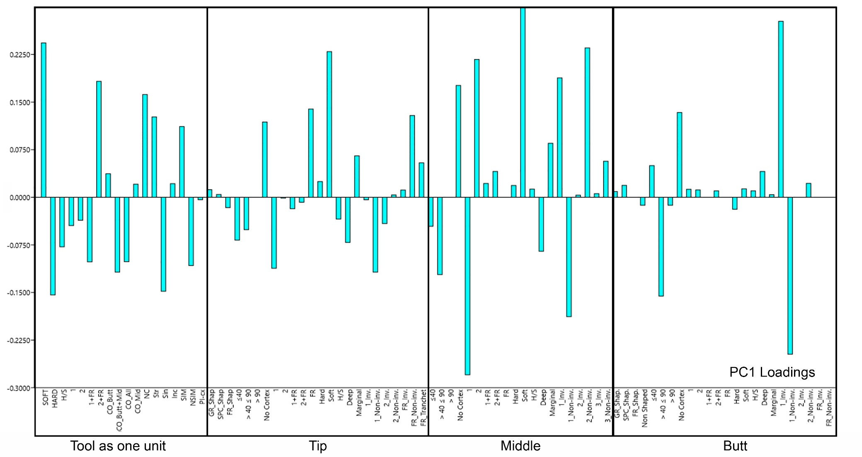
SI Figure 3. PC1 loadings of all the technological features included in the multivariate analyses, combining the information from tables 1, 2, 3 and 4.
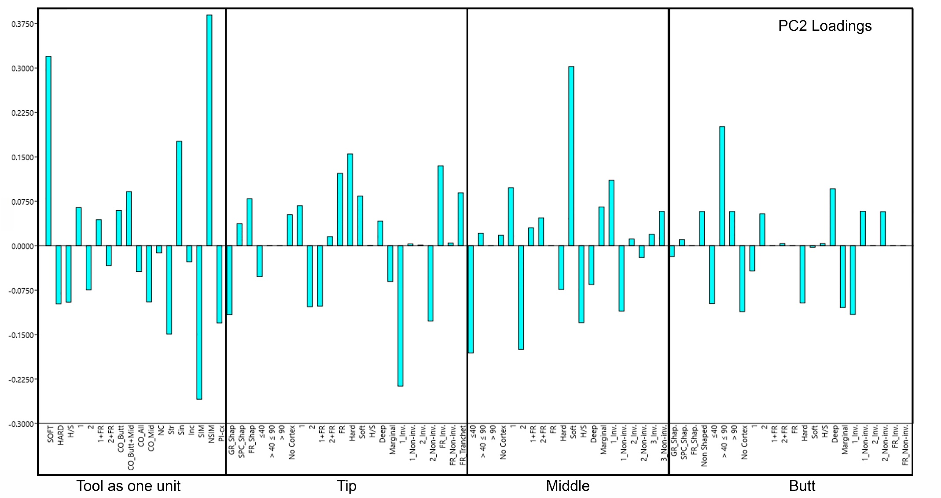
SI Figure 4. PC2 loadings of all the technological features included in the multivariate analyses, combining the information from tables 1, 2, 3 and 4.

 | LOWER | Slabs | Flakes | Unknown | Total LOWER | UPPER | Slabs | Flakes | Unknown | Millstone | Flint | Total UPPER
 | LEVELS |  |  |  |  | LEVELS
Length (L) | Mean | 126,01 | 124,42 | 129,05 | 128,14 | Mean | 117,73 | 119,05 | 115,02 | 116,45 | 113,96 | 115,02 | Length (L)
Length (L) | SD | 34,56 | 35,01 | 39,75 | 34,63 | SD | 20,87 | 21,48 | 24,09 | 22,09 | 22,79 | 24,09 | Length (L)
Length (L) | CV | 0,27 | 0,28 | 0,31 | 0,27 | CV | 0,18 | 0,18 | 0,21 | 0,19 | 0,2 | 0,21 | Length (L)
Width (m) | Mean | 79,08 | 78,05 | 79,62 | 79,73 | Mean | 70,05 | 70,35 | 68,55 | 68,42 | 68,12 | 68,55 | Width (m)
Width (m) | SD | 19,29 | 19,79 | 21,92 | 18,74 | SD | 10,9 | 10,78 | 12,28 | 11,78 | 11,99 | 12,28 | Width (m)
Width (m) | CV | 0,24 | 0,25 | 0,28 | 0,23 | CV | 0,16 | 0,15 | 0,18 | 0,17 | 0,18 | 0,18 | Width (m)
Thickness (e) | Mean | 39,94 | 39,06 | 40,89 | 39,83 | Mean | 34,2 | 35,86 | 33,93 | 34,33 | 33,64 | 33,93 | Thickness (e)
Thickness (e) | SD | 8,09 | 8,13 | 8,62 | 7,92 | SD | 11,53 | 12,2 | 11,34 | 11,39 | 11,25 | 11,34 | Thickness (e)
Thickness (e) | CV | 0,2 | 0,21 | 0,21 | 0,2 | CV | 0,34 | 0,34 | 0,33 | 0,33 | 0,33 | 0,33 | Thickness (e)
Width at mid L (n) | Mean | 74,8 | 73,82 | 73,39 | 74,41 | Mean | 61,2 | 61,84 | 60,33 | 59,81 | 59,8 | 60,33 | Width at mid L (n)
Width at mid L (n) | SD | 18,79 | 19,06 | 22,17 | 18,44 | SD | 12,38 | 12,93 | 13,32 | 12,71 | 12,78 | 13,32 | Width at mid L (n)
Width at mid L (n) | CV | 0,25 | 0,26 | 0,3 | 0,25 | CV | 0,2 | 0,21 | 0,22 | 0,21 | 0,21 | 0,22 | Width at mid L (n)
Base Length (a) | Mean | 59,1 | 58,29 | 60,71 | 58,97 | Mean | 39,41 | 40,5 | 38,49 | 38,51 | 38,02 | 38,49 | Base Length (a)
Base Length (a) | SD | 23,3 | 24,53 | 23,13 | 22,57 | SD | 12,83 | 13,72 | 13,52 | 13,1 | 13,08 | 13,52 | Base Length (a)
Base Length (a) | CV | 0,39 | 0,42 | 0,38 | 0,38 | CV | 0,33 | 0,34 | 0,35 | 0,34 | 0,34 | 0,35 | Base Length (a)
Distal Length (L-a) | Mean | 65,78 | 64,86 | 65,38 | 67,84 | Mean | 76,47 | 76,36 | 74,84 | 76,14 | 74,25 | 74,84 | Distal Length (L-a)
Distal Length (L-a) | SD | 23,54 | 23,84 | 27,35 | 24,66 | SD | 16,05 | 17,1 | 17,16 | 16,53 | 16,73 | 17,16 | Distal Length (L-a)
Distal Length (L-a) | CV | 0,36 | 0,37 | 0,42 | 0,36 | CV | 0,21 | 0,22 | 0,23 | 0,22 | 0,23 | 0,23 | Distal Length (L-a)
Distal width (B1) | Mean | 56,07 | 55,41 | 55,38 | 55,9 | Mean | 41,91 | 42,75 | 41,03 | 41,05 | 40,78 | 41,03 | Distal width (B1)
Distal width (B1) | SD | 15,11 | 15,44 | 17,5 | 14,66 | SD | 9,65 | 10,35 | 9,97 | 10,09 | 9,92 | 9,97 | Distal width (B1)
Distal width (B1) | CV | 0,27 | 0,28 | 0,32 | 0,26 | CV | 0,23 | 0,24 | 0,24 | 0,25 | 0,24 | 0,24 | Distal width (B1)
Prox width (B2) | Mean | 66,06 | 64,59 | 66,78 | 66,47 | Mean | 59,34 | 57,57 | 57,27 | 56,19 | 56,78 | 57,27 | Prox width (B2)
Prox width (B2) | SD | 13,17 | 13,21 | 13,82 | 12,83 | SD | 12,48 | 13,16 | 14,52 | 14,17 | 14,24 | 14,52 | Prox width (B2)
Prox width (B2) | CV | 0,2 | 0,2 | 0,21 | 0,19 | CV | 0,21 | 0,23 | 0,25 | 0,25 | 0,25 | 0,25 | Prox width (B2)
Distal Thick. (T1) | Mean | 18,78 | 19,16 | 18,66 | 18,92 | Mean | 13,73 | 14,14 | 14,01 | 14,05 | 13,89 | 14,01 | Distal Thick. (T1)
Distal Thick. (T1) | SD | 4,63 | 4,8 | 4,45 | 4,5 | SD | 8,21 | 9,72 | 8,56 | 9,07 | 8,62 | 8,56 | Distal Thick. (T1)
Distal Thick. (T1) | CV | 0,25 | 0,25 | 0,24 | 0,24 | CV | 0,6 | 0,69 | 0,61 | 0,65 | 0,62 | 0,61 | Distal Thick. (T1)
Elongat (L/m) | Mean | 1,59 | 1,59 | 1,62 | 1,61 | Mean | 1,68 | 1,69 | 1,68 | 1,7 | 1,67 | 1,68 | Elongat (L/m)
Elongat (L/m) | SD | 0,21 | 0,21 | 0,24 | 0,22 | SD | 0,2 | 0,22 | 0,22 | 0,21 | 0,22 | 0,22 | Elongat (L/m)
Elongat (L/m) | CV | 0,13 | 0,13 | 0,15 | 0,14 | CV | 0,12 | 0,13 | 0,13 | 0,12 | 0,13 | 0,13 | Elongat (L/m)
Refinement (m/e) | Mean | 1,99 | 2,01 | 1,95 | 2,01 | Mean | 2,05 | 1,96 | 2,02 | 1,99 | 2,02 | 2,02 | Refinement (m/e)
Refinement (m/e) | SD | 0,29 | 0,33 | 0,3 | 0,3 | SD | 0,56 | 0,51 | 0,55 | 0,51 | 0,56 | 0,55 | Refinement (m/e)
Refinement (m/e) | CV | 0,14 | 0,17 | 0,16 | 0,15 | CV | 0,27 | 0,26 | 0,27 | 0,25 | 0,28 | 0,27 | Refinement (m/e)
Weigth (gr.) | Mean | 383,02 | 370,19 | 398,68 | 393,52 | Mean | 246,51 | 256,28 | 233,42 | 235,26 | 227,72 | 233,42 | Weigth (gr.)
Weigth (gr.) | SD | 361,11 | 375,57 | 425,13 | 350,55 | SD | 124,09 | 131,07 | 144,25 | 130,33 | 128,45 | 144,25 | Weigth (gr.)
Weigth (gr.) | CV | 0,94 | 1,01 | 1,07 | 0,89 | CV | 0,5 | 0,51 | 0,62 | 0,55 | 0,56 | 0,62 | Weigth (gr.)
SI Table 6. Mean, Standard deviation and coefficient of variation of each measure, indices and weight of LCTs from la Noira Lower and Upper levels and raw materials.

