Supplementary Information

Hidden pathway for cytokine receptor activation: a marine sponge-derived lectin reveals sugar-mediated MPL activation

Hiromi Watari¹†, Hiromu Kageyama²†, Nami Masubuchi³, Hiroya Nakajima¹, Kako Onodera², Pamela J. Focia⁴, Takumi Oshiro⁵, Takashi Matsui^{5,6}, Yoshio Kodera^{5,6}, Tomohisa Ogawa², Takeshi Yokoyama², Makoto Hirayama⁷, Kanji Hori⁷, Douglas M. Freymann⁴, Norio Komatsu^{3,8,9}, Marito Araki³*, Yoshikazu Tanaka²*, Ryuichi Sakai¹*

*Corresponding authors. Email: Ryuichi Sakai <ryu.sakai@fish.hokudai.ac.jp>; Marito Araki <m-araki@juntendo.ac.jp>; Yoshikazu TANAKA <yoshikazu.tanaka@tohoku.ac.jp>
†These authors contributed equally to this work.

¹Graduate School of Fisheries Sciences, Hokkaido University; Hakodate, Japan.
²Graduate School of Life Sciences, Tohoku University; Sendai, Japan.
³Laboratory for the development of therapies against MPN, Juntendo University Graduate School of Medicine; Tokyo, Japan.
⁴Department of Biochemistry & Molecular Genetics, Feinberg School of Medicine, Northwestern University; Chicago, USA.
⁵Department of Physics, School of Science, Kitasato University; Sagamihara, Japan.
⁶Center for Disease Proteomics, School of Science, Kitasato University; Sagamihara, Japan.
⁹Department of Hematology, Juntendo University Graduate School of Medicine; Tokyo, Japan.

Table of contents
Table S1. Affinities and thermodynamic parameters of binding 3
Table S2. Data collection and refinement statistics 4
Table S3. Primers used for the construction of MPL derivatives 5
Supplementary note 6
Supplementary Fig. 1. Sequense determination of ThC 7
Supplementary Fig. 1. (continued) 8
Supplementary Fig. 1. (continued) 18
Supplementary Fig. 1. (continued) 19
Supplementary Fig. 2. Cell proliferation assay for Ba/F3 and Ba/F3-HuMpl cells in the presence or absence of ligand 20
Supplementary Fig. 3. Phylogenetic tree of ThC and putative bacterial fucose binding lectins and TPO 21
Supplementary Fig. 4. Relative cell growth by TPO in the presence of various sugars in Ba/F3-HuMpl cells 22
Supplementary Fig. 5. Stereo representation of superposition of nThC (green) and rThC (red) 23
Supplementary Fig. 6. Close-up view of carbohydrate binding site in complex with rThC and D-mannose 24
Supplementary Fig. 7. Affinity of rThC against carbohydrate-immobilized agarose gel 25
Supplementary Fig. 8. Results of ITC for rThC and mutants 26
Supplementary Fig.9. Effect of rThC G132 on cell proliferation of Ba/F3-HuMpl cells 27
Supplementary Fig.10. Structural comparison between ThC dimer, PA-IIL dimer (PDB ID 2JDP), and BC2L-C-CTD dimer (PDB ID 2XR4) 28
Supplementary Fig. 11. Results of ITC of BC2LC-CTD (top) and PA-IIL (bottom) 29
Supplementary Fig. 12. Effect of hypnin on Ba/F3 cell proliferation 30
Supplementary Fig. 13. Comparable STAT5 activation by TPO with MPL bearing N/Q mutation 31
Supplementary Fig. 14. Interference of the TPO-dependent internalization of MPL from cell surface by ThC 32

Table S1. Affinities and thermodynamic parameters of binding

Table S2. Data collection and refinement statistics

Table S3. Primers used for the construction of MPL derivatives

Supplementary note

Amino acid sequence determination.
We first identified a preliminary 131-amino acid sequence of native ThC (nThC) isolated from the sponge using mass spectrometry and Edman degradation after peptic digestion (Supplementary Fig. 1a). A draft ThC based on this sequence assigned lysine (K) to the 25th amino acid residue. However, unlike nThC, the draft ThC failed to promote the proliferation of MPL activation-dependent Ba/F3-HuMpl, even at high concentrations (Supplementary Fig. 1b). This lack of activity showed that at least one amino acid residue in the draft-ThC sequence was assigned incorrectly. Therefore, we performed X-ray crystal structure analysis of nThC and found that the 25th amino acid residue originally assigned as K in the draft-ThC sequence was glutamic acid (E) or glutamine (Q) (Supplementary Fig. 1c). An LC-MS/MS experiment unambiguously identified this residue as Q (Supplementary Fig. 1d-f), and the complete amino acid sequence of ThC was determined.

Supplementary Fig. 1
a
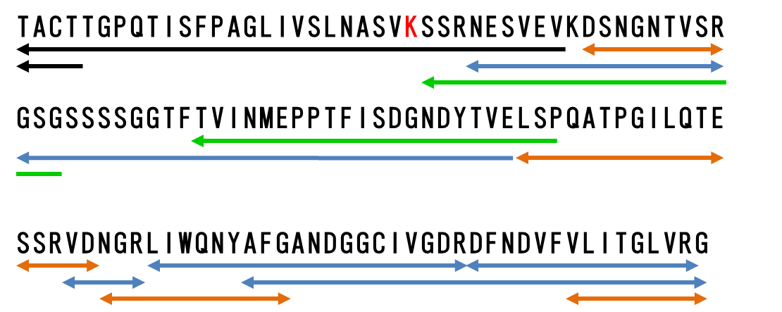
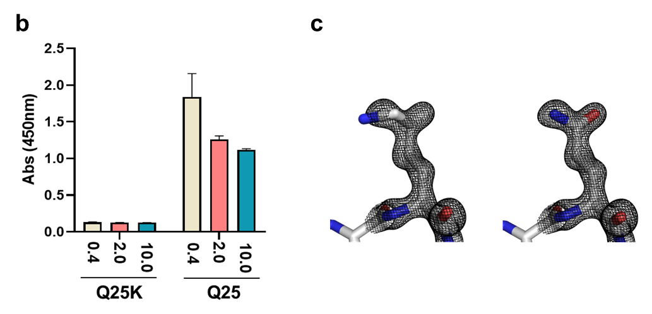

Supplementary Fig. 1. Sequense determination of ThC
a Draft amino acid sequence of nThC. Amino acid sequence of native ThC was first determined on the basis of Edman degradation (black line), and MALDI-TOF MS/MS de novo sequecing data of chymotrypsin (green), trypsin, (blue), and V8 protease (orange) digests. The 25th residue was assignes to by lysine (red letter) for draft nThC (d-ThC). b Effect of rThC (Q25) and d-ThC (Q25K) on cell proliferation of Ba/F3-HuMpl cells. c Electron density of the 25th residue. Atomic models of Lys (left) and Gln (right) are in the electron density of nThC. Gln fits well (right) whereas Lys does not with the electron density (left).

Supplementary Fig. 1d

Supplementary Fig. 1. (continued)
c The amino acid sequence of nThC was re-examined by using ultrahigh resolution LC-MS/MS de novo sequencing. Peptide fragments, of which amino acid sequence were determined, generated by trypsin or chymotrypsin and shown red and green, respectively. Cys residue was treated with iodoacetamide to prevent from S-S bond reformation thus Cys residue was searched as Cys carbamidomethylation.

Supplementary Fig. 1e

Supplementary Fig. 1. (continued)
d Mass spectrometry confirmation of the identified peptides of nThC compared with rThC. Extracted ion chromatograms (XICs) of the identified peptides of rThC and nThC were shown as black and red, respectively. MS spectra of the charged peptide ion from rThC (upper) and nThC (bottom) at the XIC peak are shown, respectively. RT, retention time; PD, the peptide identified by Proteome Discoverer (Thermo Scientific); PEAKS, the peptide identified by PEAKS studio X (Bioinformatics Solutions); Δppm, parts per million of the mass differences between observed and theoretical m/z values. The m/z, RT, and Δppm of the peptide identified by PD or PEAKS were indicated. Carbamidomethyl-Cys residue was shown as lower case.

Supplementary Fig. 1f.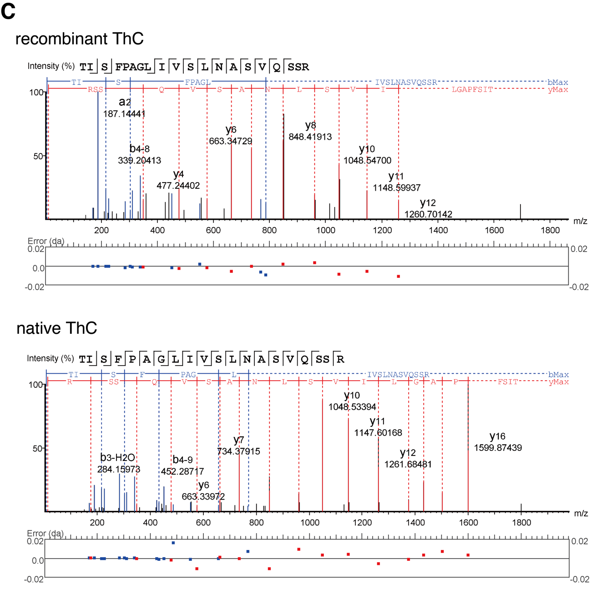

Supplementary Fig. 1. (continued)
f Annotated MS/MS fragmentation spectra for a putative N-terminal 9-28 residues, TISFPAGLIVSLNASVQSSR, derived from rThC (upper panel) and nThC (lower panel). MS/MS spectra were deconvoluted into singly charged ions from the observed spectra and theoretical m/z values for fragment ions were assigned for each peak. The identified matches for the N-terminal-containing ions are shown in blue and those for the C-terminal-containing ions in red. The m/z differences between theoretical and observed values for all assigned peaks were displayed in error map and were less than 0.02 Da. The MS/MS spectra confirmed that 25th residue was clearly assigned as Q. The exact masses and precursor isotope distribution of MS1 spectrum for the peptides derived from nThC and rThC (1-28 residues, 25Q) was also identical (B-1), in line with above sequence analyses confirming that 25th residue the N terminal sequence is Q, not E.

Supplementary Fig. 2

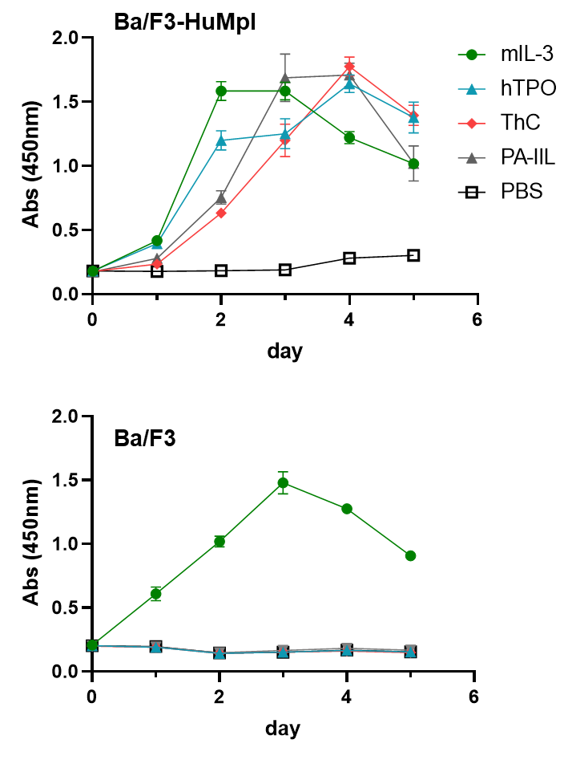

Supplementary Fig. 2. Cell proliferation assay for Ba/F3 and Ba/F3-HuMpl cells in the presence or absence of ligand
Cell proliferation assay of Ba/F3 and Ba/F3-HuMpl cells in the absence or presence of the indicated ligand. murineIL-3 (10 ng/mL), humanTPO (10 ng/mL), ThC (0.5 μg/mL), PA-IIL (30 μg/mL).
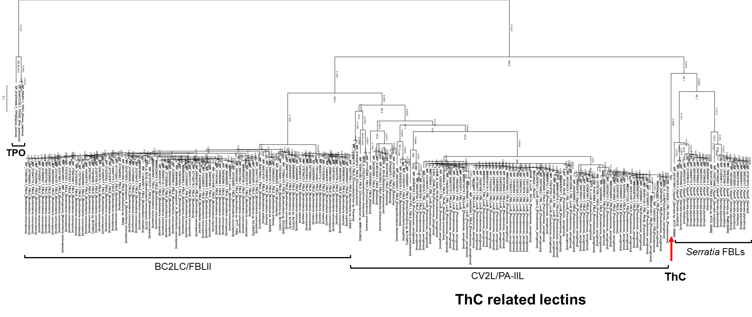

Supplementary Fig. 3

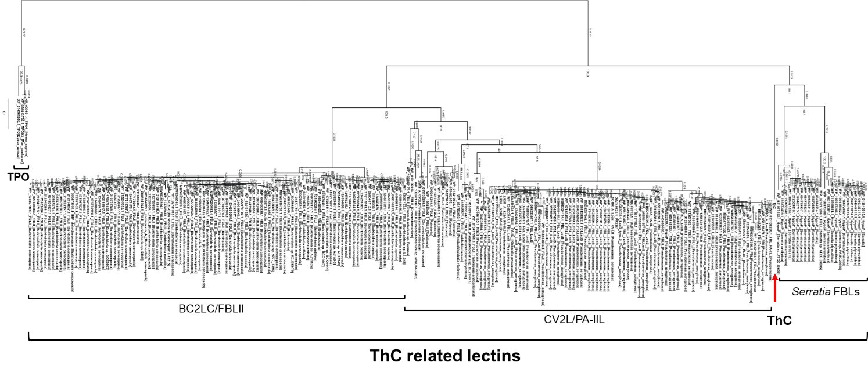

Supplementary Fig. 3. Phylogenetic tree of ThC and putative bacterial fucose binding lectins and TPO
Bootstrap probabilities of 1,000 replications are shown at each node. A scale bar indicates the genetic distance represented by the horizontal branches.

Supplementary Fig. 4

Supplementary Fig. 4. Relative cell growth by TPO in the presence of various sugars in Ba/F3-HuMpl cells
Positive control contains TPO (10 ng/mL) and negative control without agonist. Each 10 mM of sugar was present.

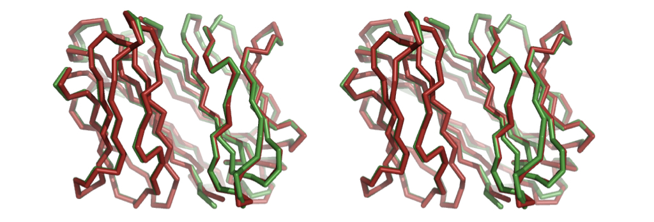
Supplementary Fig. 5

Supplementary Fig. 5. Stereo representation of superposition of nThC (green) and rThC (red)

Supplementary Fig. 6
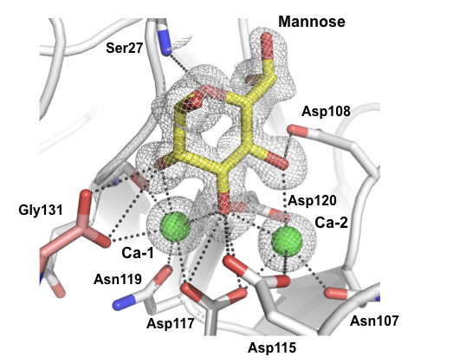

Supplementary Fig. 6. Close-up view of carbohydrate binding site in complex with rThC and D-mannose
Fo-Fc map of the carbohydrates and Ca²⁺ ions are shown. Individual protomers are shown gray and pink, respectively.

Supplementary Fig. 7

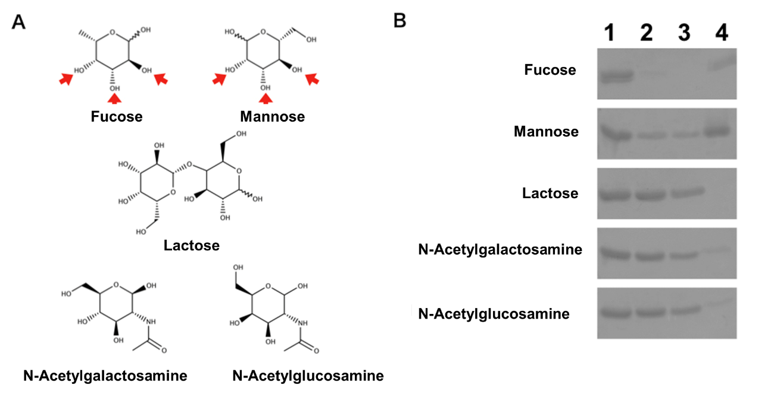

Supplementary Fig. 7. Affinity of rThC against carbohydrate-immobilized agarose gel
Chemical structure of the carbohydrates tested (A) and their binding with rThC (B). (A) fucose, mannose, lactose, N-acetylgalactosamine, and N-acetylglucosamine. Red arrows indicate hydroxyl groups which are recognized by rThC and Ca²⁺ ions. (B) Binding of rThC to the fucose-, mannose-, lactose, N-acetylglucosamine-, and N-acetylgalactosamine-immobilizing resin in the presence of 5 mM CaCl₂. Lane 1: rThC added to the resin, 2: flow through fraction, 3: wash fraction, 4: rThC bound on the resin.

Supplementary Fig. 8

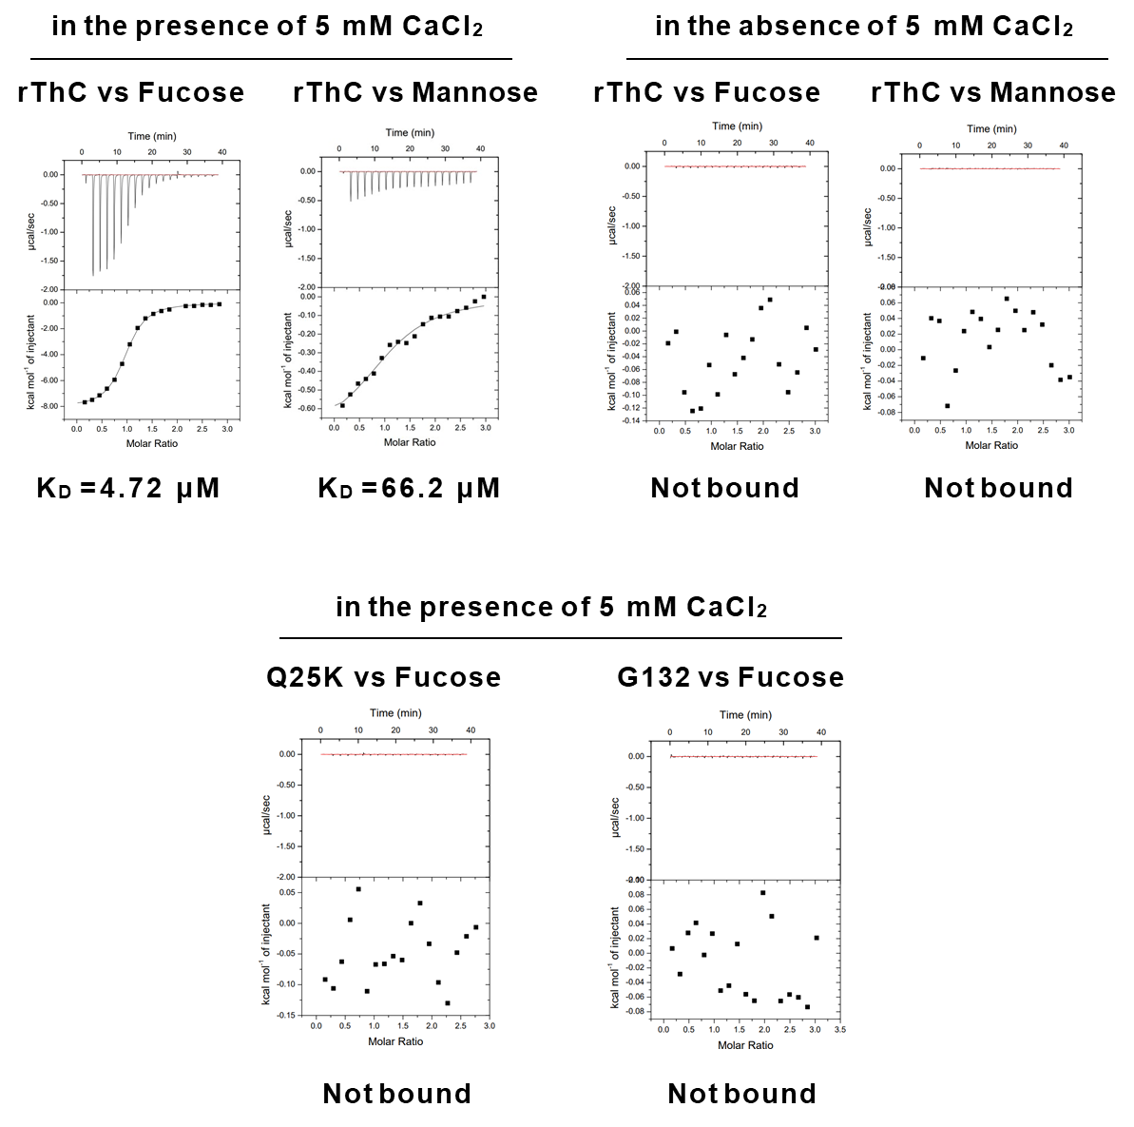

Supplementary Fig. 8. Results of ITC for rThC and mutants
rThC (top) and mutants (bottom). K_{D} values are shown at the bottom. Thermodynamic parameters are shown in Supplementary Table S1.

Supplementary Fig. 9

Supplementary Fig.9. Effect of rThC G132 on cell proliferation of Ba/F3-HuMpl cells
Cells were cultured with indicate concentration (μg/mL) ThC for 4 days.

Supplementary Fig. 10

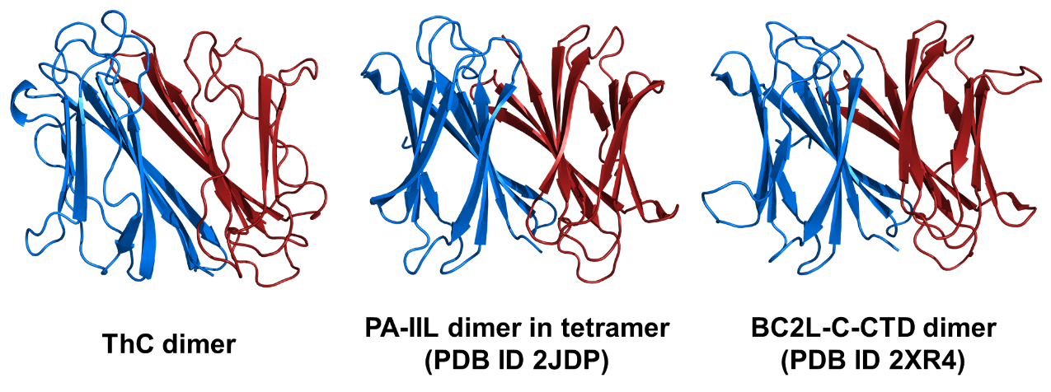

Supplementary Fig.10. Structural comparison between ThC dimer, PA-IIL dimer (PDB ID 2JDP), and BC2L-C-CTD dimer (PDB ID 2XR4)

Supplementary Fig. 11

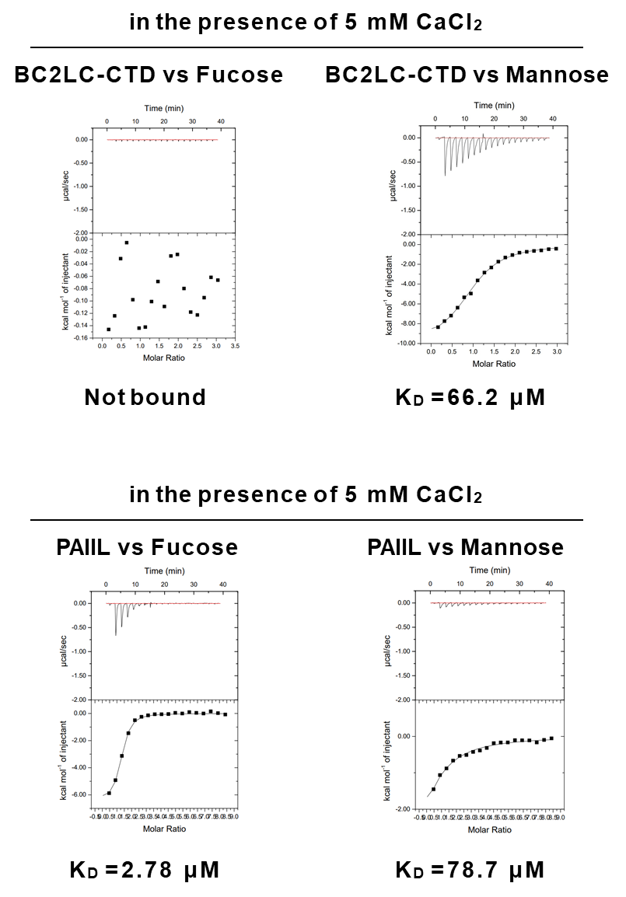

Supplementary Fig. 11. Results of ITC of BC2LC-CTD (top) and PA-IIL (bottom)
K_{D} values are shown at the bottom. Thermodynamic parameters are shown in Table S1.

Supplementary Fig. 12

Supplementary Fig. 12. Effect of hypnin on Ba/F3 cell proliferation
Cells were cultured with 10 ng/mL mIL-3 for 4 days. IC₅₀ > 47 μg/mL.

Supplementary Fig. 13

Supplementary Fig. 13. Comparable STAT5 activation by TPO with MPL bearing N/Q mutation
STAT5 reporter activity in HEK293T cells expressing a series of N/Q mutant constructs when stimulated by TPO (10 ng/mL). ns = no significance.

Supplementary Fig. 14

Supplementary Fig. 14. Interference of the TPO-dependent internalization of MPL from cell surface by ThC
0, 10, 30, 120 and 240min after the addition of ThC (0.1 μg/mL), ThC/TPO (0.1 μg/mL and 0.2 ng/mL, respectively), TPO (0.2 ng/mL) and control (No agonist), levels of cell surface MPL was determined and depicted.

