Supplement Materials for
Super-elasticity at 4K of Covalently Crosslinked Polyimide Aerogels with Ultrahigh Negative Poisson’s Ratio
Yang Cheng^{1, 2}, Xiang Zhang³, Yixiu Qin⁴,Pei Dong⁵, Wei Yao^{1,2}, John Matz⁵, Pulickel M. Ajayan³, Jianfeng Shen^{1*}, Mingxin Ye^{1*}
¹Institute of Special materials and Technology, Fudan University, Shanghai, P. R. China
²Department of Materials Science, Fudan University, Shanghai, P. R. China
³Department of Materials Science and Nanoengineering, Rice University, 6100 Main Street, Houston, TX 77005, USA
⁴State Key Laboratory of Molecular Engineering of Polymers, Fudan University, Shanghai, P. R. China
⁵Department of Mechanical Engineering, George Mason University, VA 22030, USA
*Corresponding Author. Email: mxye@fudan.edu.cn, jfshen@fudan.edu.cn

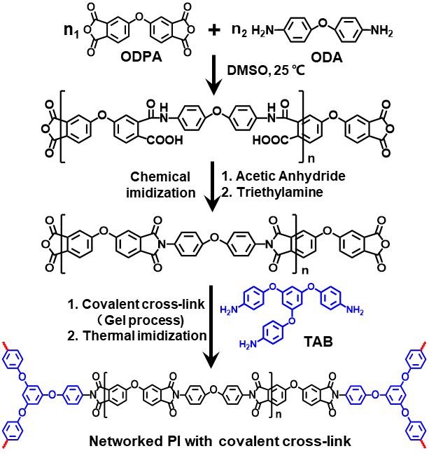
Supplementary Figure 1 Synthesis of covalently crosslinked polyimide from ODPA, ODA and TAB.
Supplementary Figure 2 Shear viscosity curves of DMSO solution containing PI oligomers with different molecular weight under increasing shear rate.
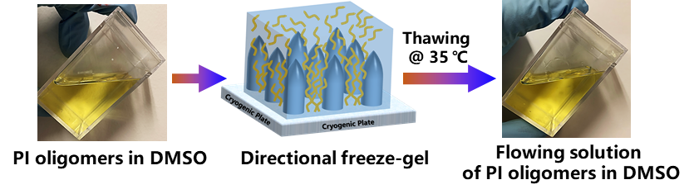
Supplementary Figure 3 Optical images after thawing frozen gel of PI oligomers without TAB.

Supplementary Figure 4 FT-IR spectra of PI aerogels with different crosslinking degree.
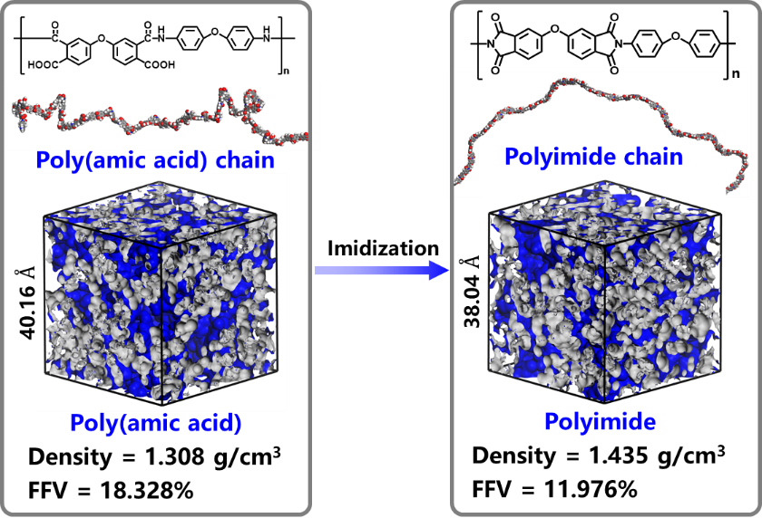
Supplementary Figure 5 Density and free volume of PAA precursor and PI simulated by Material Studio software.

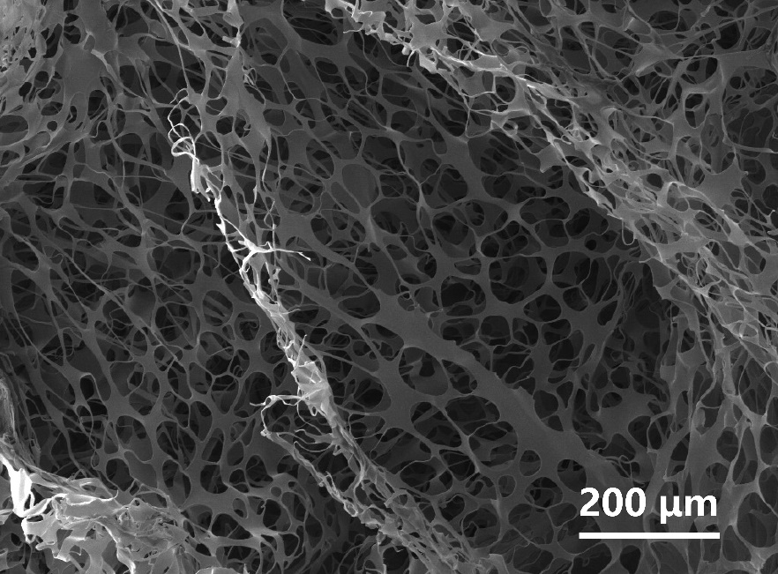
Supplementary Figure 6 SEM image of PI aerogel fabricated by ice templates assisted freeze-drying process from 1 wt% PAS aqueous solution.
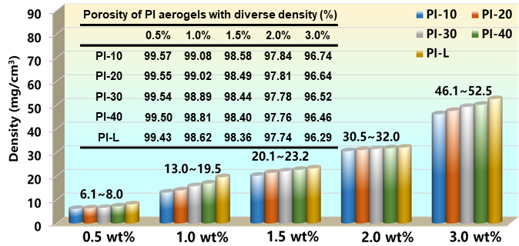
Supplementary Figure 7 Density and porosity of PI aerogels prepared from PI/TAB/DMSO with different solid contents.
$$Porosity=\left(1- \frac{ρ_{A}}{ρ_{PI}}\right)×100\%$$
Where $ρ_{A}$ represents the density of aerogels, and $ρ_{PI}$ represents the density of constituent PI ($ρ_{PI}=1.4\frac{g}{{cm}^{3}}$).

Supplementary Figure 8 Schematic diagram of the mold.

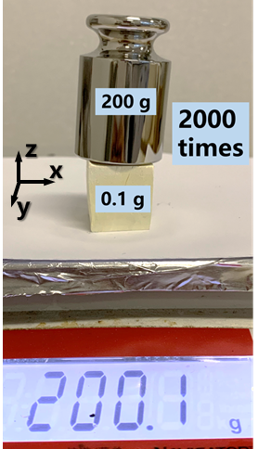
Supplementary Figure 9 Stiff properties of PI aerogel on z direction.

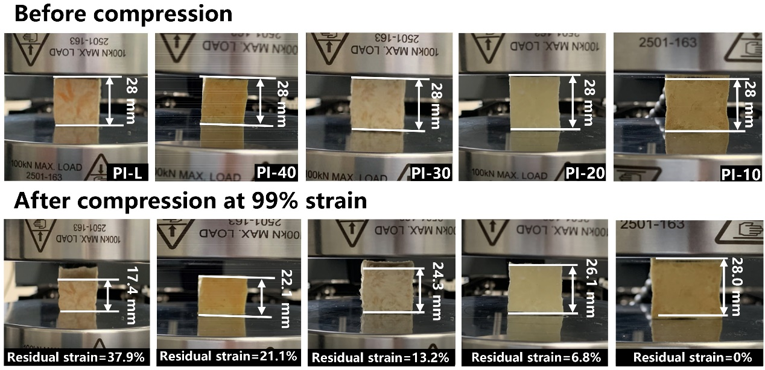
Supplementary Figure 10 Optical images of PI aerogels before and after compression at 99% strain.

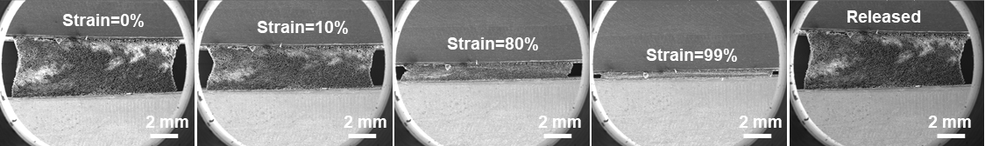
Supplementary Figure 11 Overview of PI-10 aerogels by In-situ SEM observations.

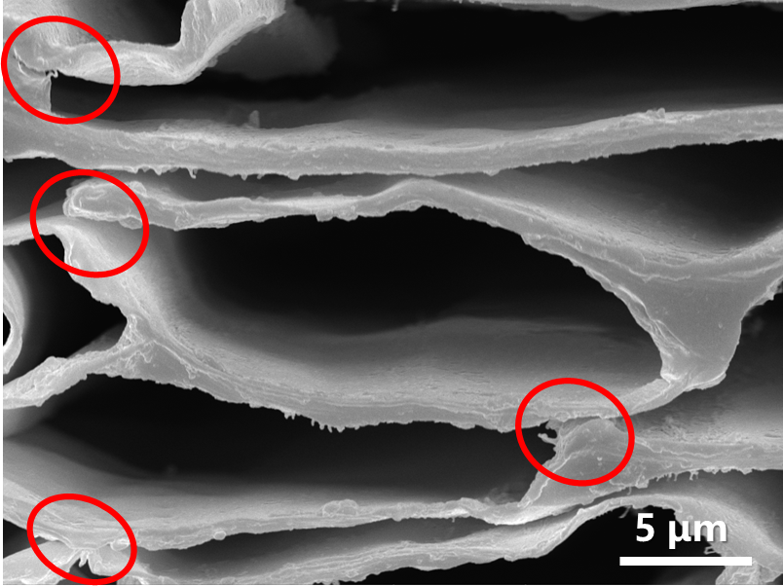
Supplementary Figure 12 SEM image of microstructure of PI-L aerogels after compression under 99% strain.

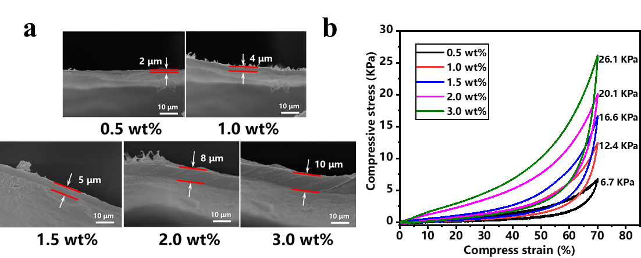
Supplementary Figure 13 (a) SEM images of PI-10 aerogels with different wall thickness, (b) Compressive stress-strain curves of PI-10 aerogels prepared from PI/TAB/DMSO mixtures with different solid content.

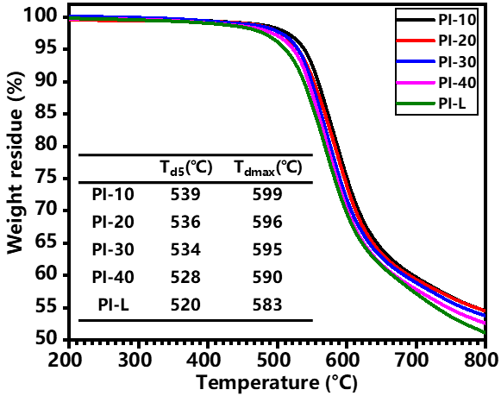
Supplementary Figure 14 TGA curves of PI aerogels with different crosslinking degree.

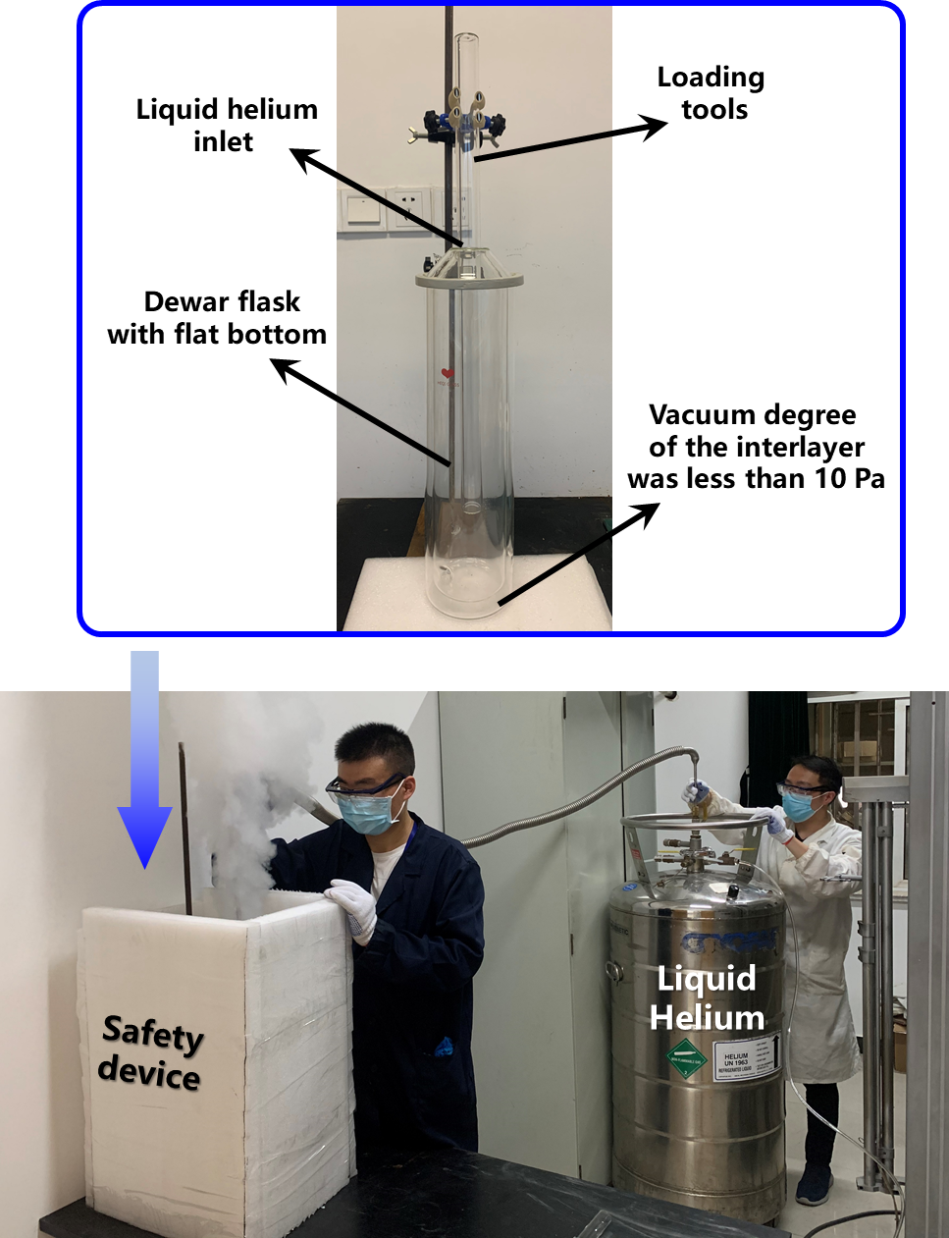
Supplementary Figure 15 Homemade apparatus for super-elastic tests of PI aerogels at 4 K.
Simulated mechanical properties of PI-10 (constituent materials of PI-10 aerogels)
- Build model
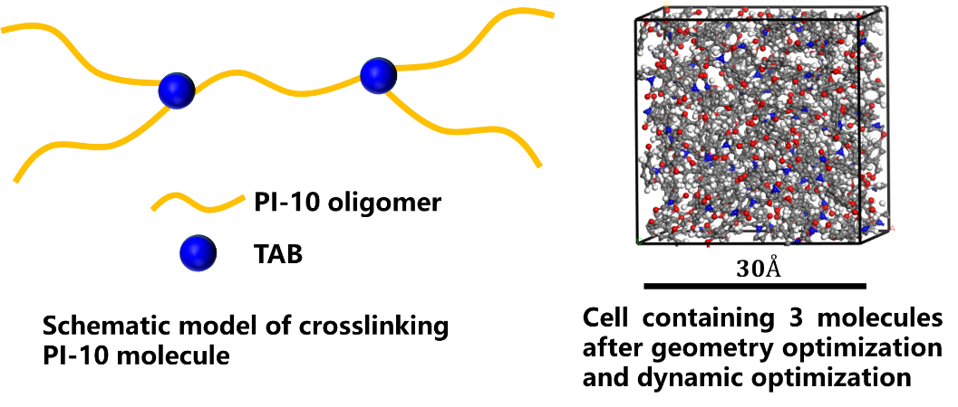L
Supplementary Figure 16 Model for simulated mechanical properties of PI-10.
- Constant matrix of elastic stiffness and elastic compliance
- Approximate calculation for shear modulus and bulk modulus
- Shear Modulus G (GPa)
Reuss: $G_{R}=\frac{15}{\left[4\left(C_{11}+C_{22}+C_{33}\right)-4\left(C_{12}+C_{23}+C_{31}\right)+3\left(C_{44}+C_{55}+C_{66}\right)\right]}$
Voigt:${15G}_{V}=\left(C_{11}+C_{22}+C_{33}\right)-\left(C_{12}+C_{23}+C_{31}\right)+3\left(C_{44}+C_{55}+C_{66}\right)$
Hill:$G_{H}=\frac{\left(G_{V}+G_{R}\right)}{2}$
- Bulk Modulus K (GPa)
Reuss:$K_{R}=\frac{1}{\left[\left(S_{11}+S_{22}+S_{33}\right)+2\left(S_{12}+S_{23}+S_{31}\right)\right]}$
Voigt:${9K}_{V}=\left(S_{11}+S_{22}+S_{33}\right)+2\left(S_{12}+S_{23}+S_{31}\right)$
Hill:$K_{H}=\frac{\left(K_{V}+K_{R}\right)}{2}$
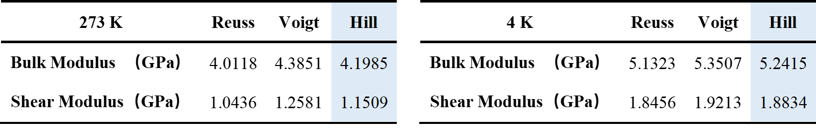
- Young modulus and Poisson’s ratio
Young modulus: $E=2G\left(1+μ\right)=3K\left(1-2μ\right)$
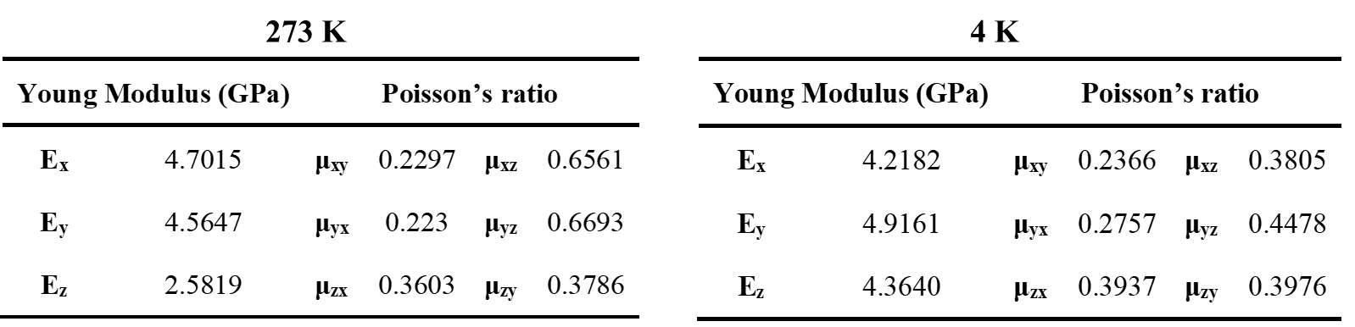

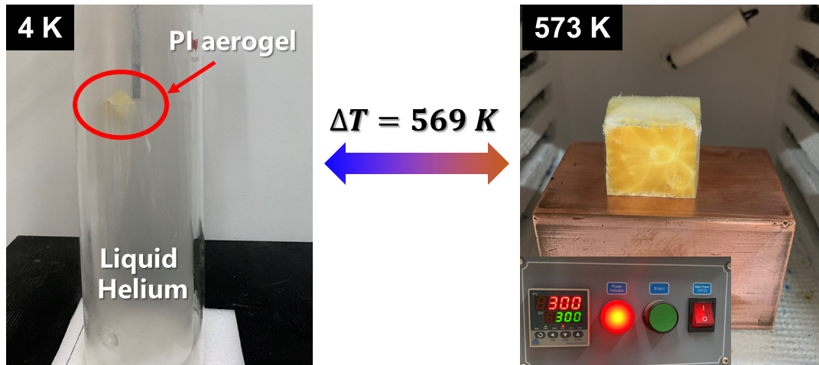
Supplementary Figure 17 Apparatus for thermal shock tests of PI aerogels.

