Title page:

Contrasting diversity and community composition of leaf- and root-associated bacterial communities from 13 tree species in a subtropical forest

Hao Yang¹, Yong Zheng¹*, Zhijie Yang^{1,2}, Quan-Cheng Wang¹, Peng-Peng Lü³, Hang-Wei Hu¹, Yusheng Yang^{1,2}, Ji-Zheng He^{1,2}

¹ Key Laboratory for Humid Subtropical Eco-geographical Processes of the Ministry of Education, Fujian Normal University, Fuzhou 350007, China.
² Sanming Forest Ecosystem National Observation and Research Station, Sanming 365002, China.
³ Lushan Botanical Garden, Chinese Academy of Sciences, Jiujiang 332900, China.

*Author for correspondence:
Yong Zheng
School of Geographical Sciences, Fujian Normal University, Fuzhou 350007, China
Tel.: +86 (0)591 8346 5214; Fax: +86 (0)591 8346 5397
E-mail: zhengy@fjnu.edu.cn

Running title: Tree compartments shape bacterial community composition

Supplementary Information

Figure legends

Figure S1. The distribution of bacterial phyla among total dataset and three sub-datasets of leaf, root, and soil habitats.
Figure S2. Rarefaction curves for the observed bacterial OTUs among the 13 tree species (A, with sample numbers) and among three habitats (B, with read/sequence numbers), and within leaf (C), root (D), and soil (E) sub-datasets in a subtropical forest. Plant species names: CCam, Cinnamomum camphora; CCar, Castanopsis carlesii; CL, Cunninghamia lanceolate; ED, Elaeocarpus decipiens; KB, Koelreuteria bipinnata; LCh, Liriodendron chinense; LCo, Lindera communis; LF, Liquidambar formosana; MM, Michelia macclurei; PM, Pinus massoniana; PS, Photinia serrulate; SM, Sapindus mukorossi; SS, Schima superba.
Figure S3. The bacterial Shannon-Wiener index comparison among 13 tree species for three habitats of leaf (A), root (B), and soil (C). Plant species names: CCam, Cinnamomum camphora; CCar, Castanopsis carlesii; CL, Cunninghamia lanceolate; ED, Elaeocarpus decipiens; KB, Koelreuteria bipinnata; LCh, Liriodendron chinense; LCo, Lindera communis; LF, Liquidambar formosana; MM, Michelia macclurei; PM, Pinus massoniana; PS, Photinia serrulate; SM, Sapindus mukorossi; SS, Schima superba.
Figure S4. The bacterial Simpson’s index comparison among 13 tree species for three habitats of leaf (A), root (B), and soil (C). Plant species names: CCam, Cinnamomum camphora; CCar, Castanopsis carlesii; CL, Cunninghamia lanceolate; ED, Elaeocarpus decipiens; KB, Koelreuteria bipinnata; LCh, Liriodendron chinense; LCo, Lindera communis; LF, Liquidambar formosana; MM, Michelia macclurei; PM, Pinus massoniana; PS, Photinia serrulate; SM, Sapindus mukorossi; SS, Schima superba.
Figure S5. The bacterial Pielou’s evenness index comparison among 13 tree species for three habitats of leaf (A), root (B), and soil (C). Plant species names: CCam, Cinnamomum camphora; CCar, Castanopsis carlesii; CL, Cunninghamia lanceolate; ED, Elaeocarpus decipiens; KB, Koelreuteria bipinnata; LCh, Liriodendron chinense; LCo, Lindera communis; LF, Liquidambar formosana; MM, Michelia macclurei; PM, Pinus massoniana; PS, Photinia serrulate; SM, Sapindus mukorossi; SS, Schima superba.

Fig. S1

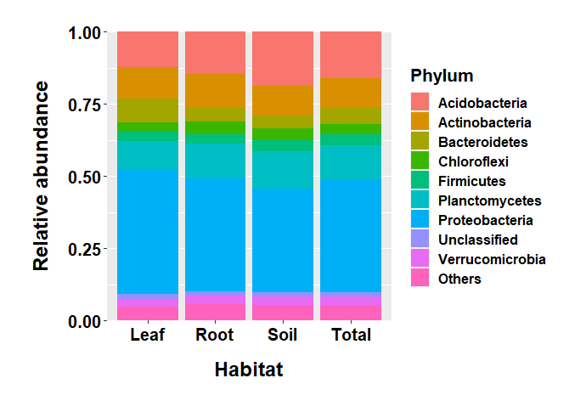

Figure S1. The distribution of bacterial phyla among total dataset and three sub-datasets of leaf, root, and soil habitats.

Fig. S2

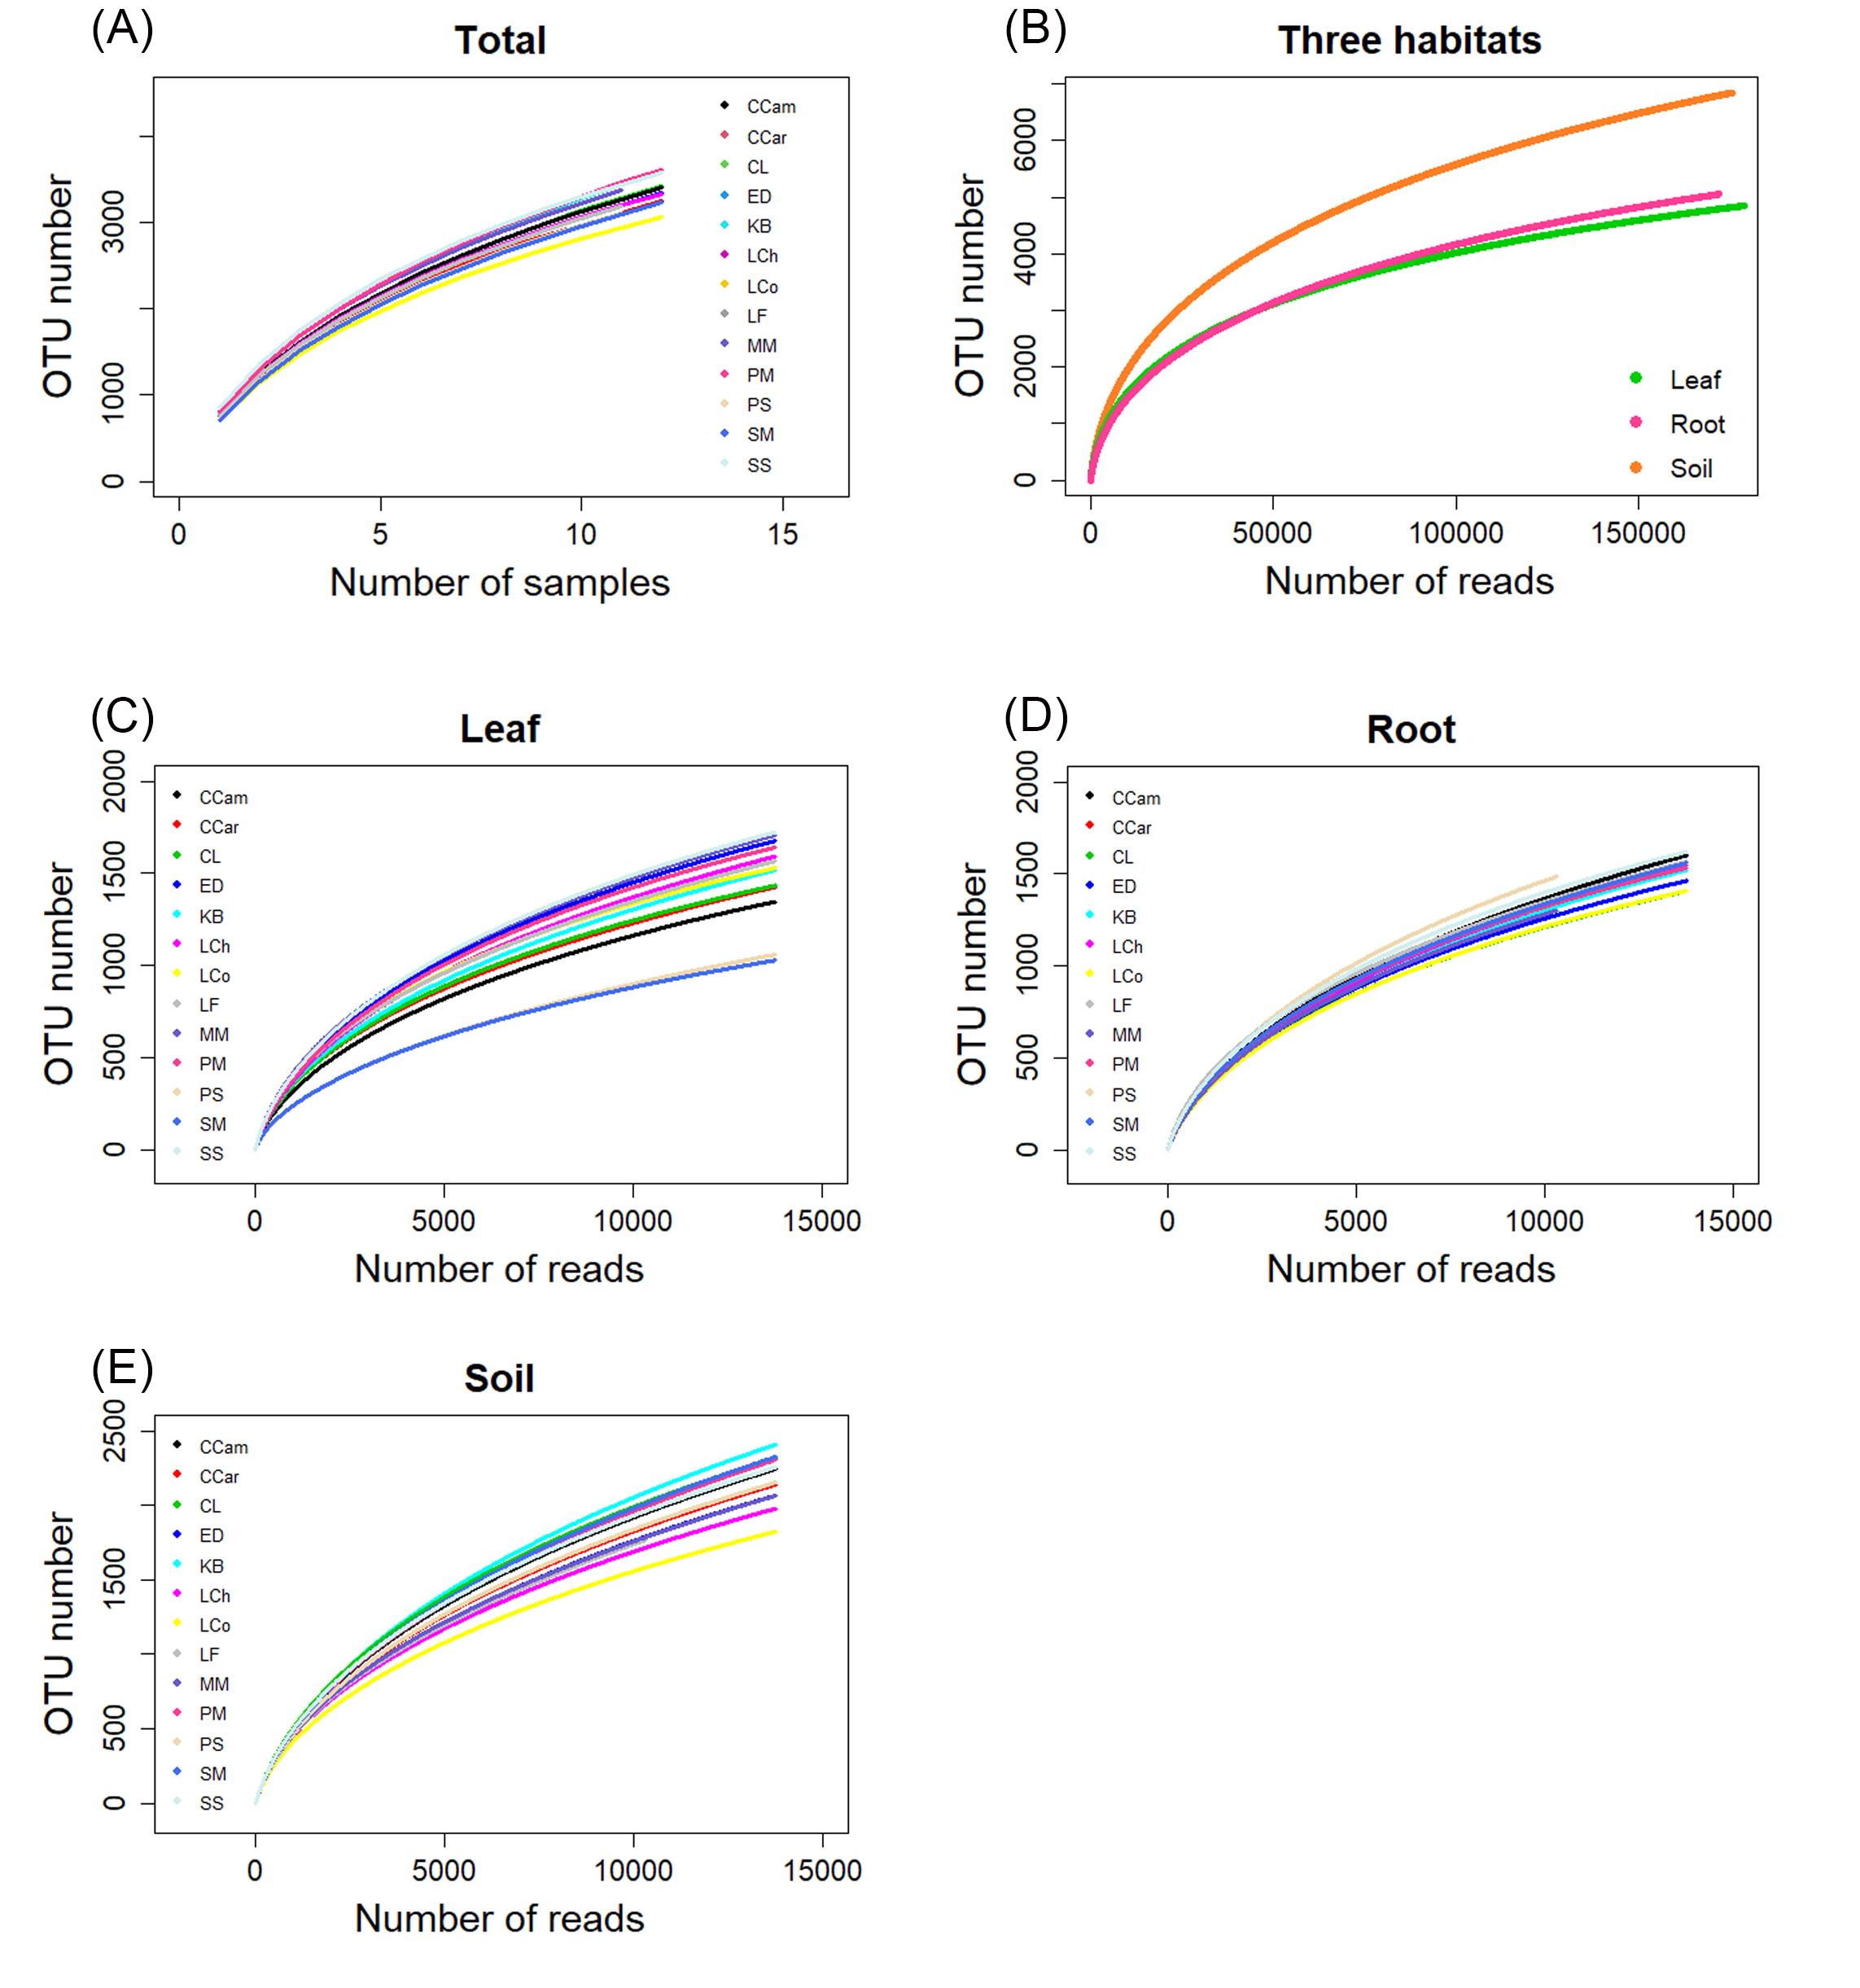

Figure S2. Rarefaction curves for the observed bacterial OTUs among the 13 tree species (A, with sample numbers) and among three habitats (B, with read/sequence numbers), and within leaf (C), root (D), and soil (E) sub-datasets in a subtropical forest. Plant species names: CCam, Cinnamomum camphora; CCar, Castanopsis carlesii; CL, Cunninghamia lanceolate; ED, Elaeocarpus decipiens; KB, Koelreuteria bipinnata; LCh, Liriodendron chinense; LCo, Lindera communis; LF, Liquidambar formosana; MM, Michelia macclurei; PM, Pinus massoniana; PS, Photinia serrulate; SM, Sapindus mukorossi; SS, Schima superba.

Fig. S3
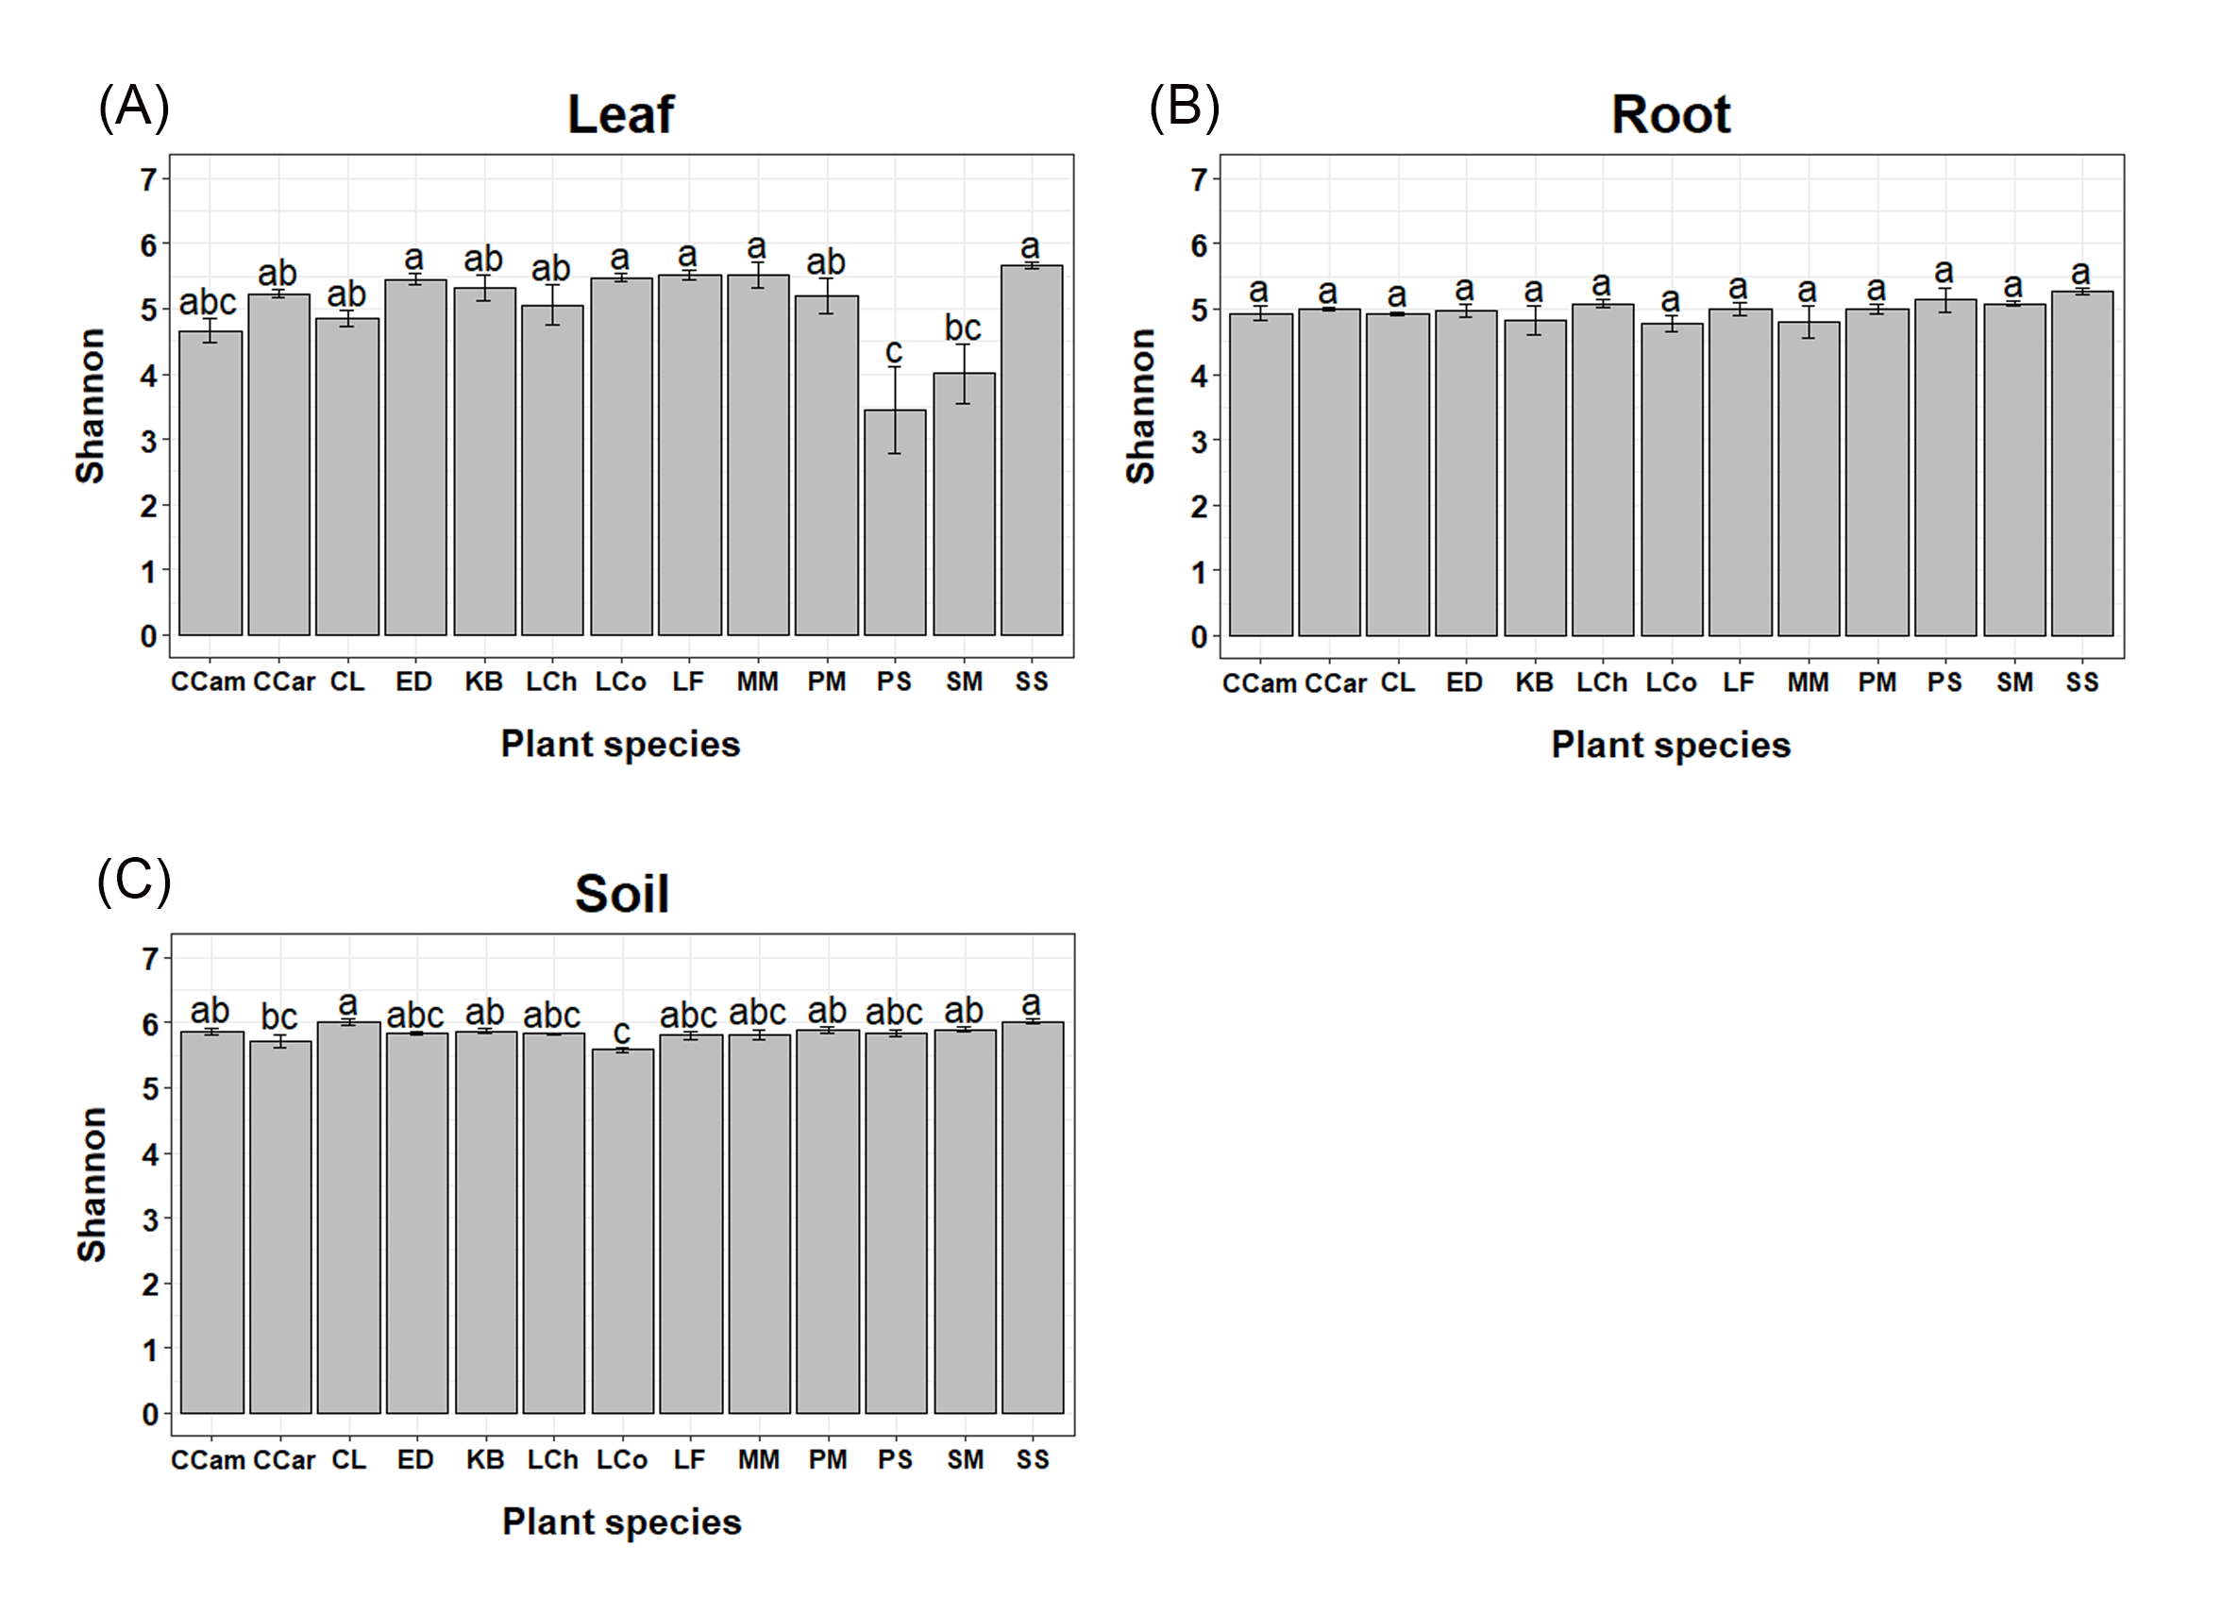
Figure S3. The bacterial Shannon-Wiener index comparison among 13 tree species for three habitats of leaf (A), root (B), and soil (C). Plant species names: CCam, Cinnamomum camphora; CCar, Castanopsis carlesii; CL, Cunninghamia lanceolate; ED, Elaeocarpus decipiens; KB, Koelreuteria bipinnata; LCh, Liriodendron chinense; LCo, Lindera communis; LF, Liquidambar formosana; MM, Michelia macclurei; PM, Pinus massoniana; PS, Photinia serrulate; SM, Sapindus mukorossi; SS, Schima superba.

Fig. S4
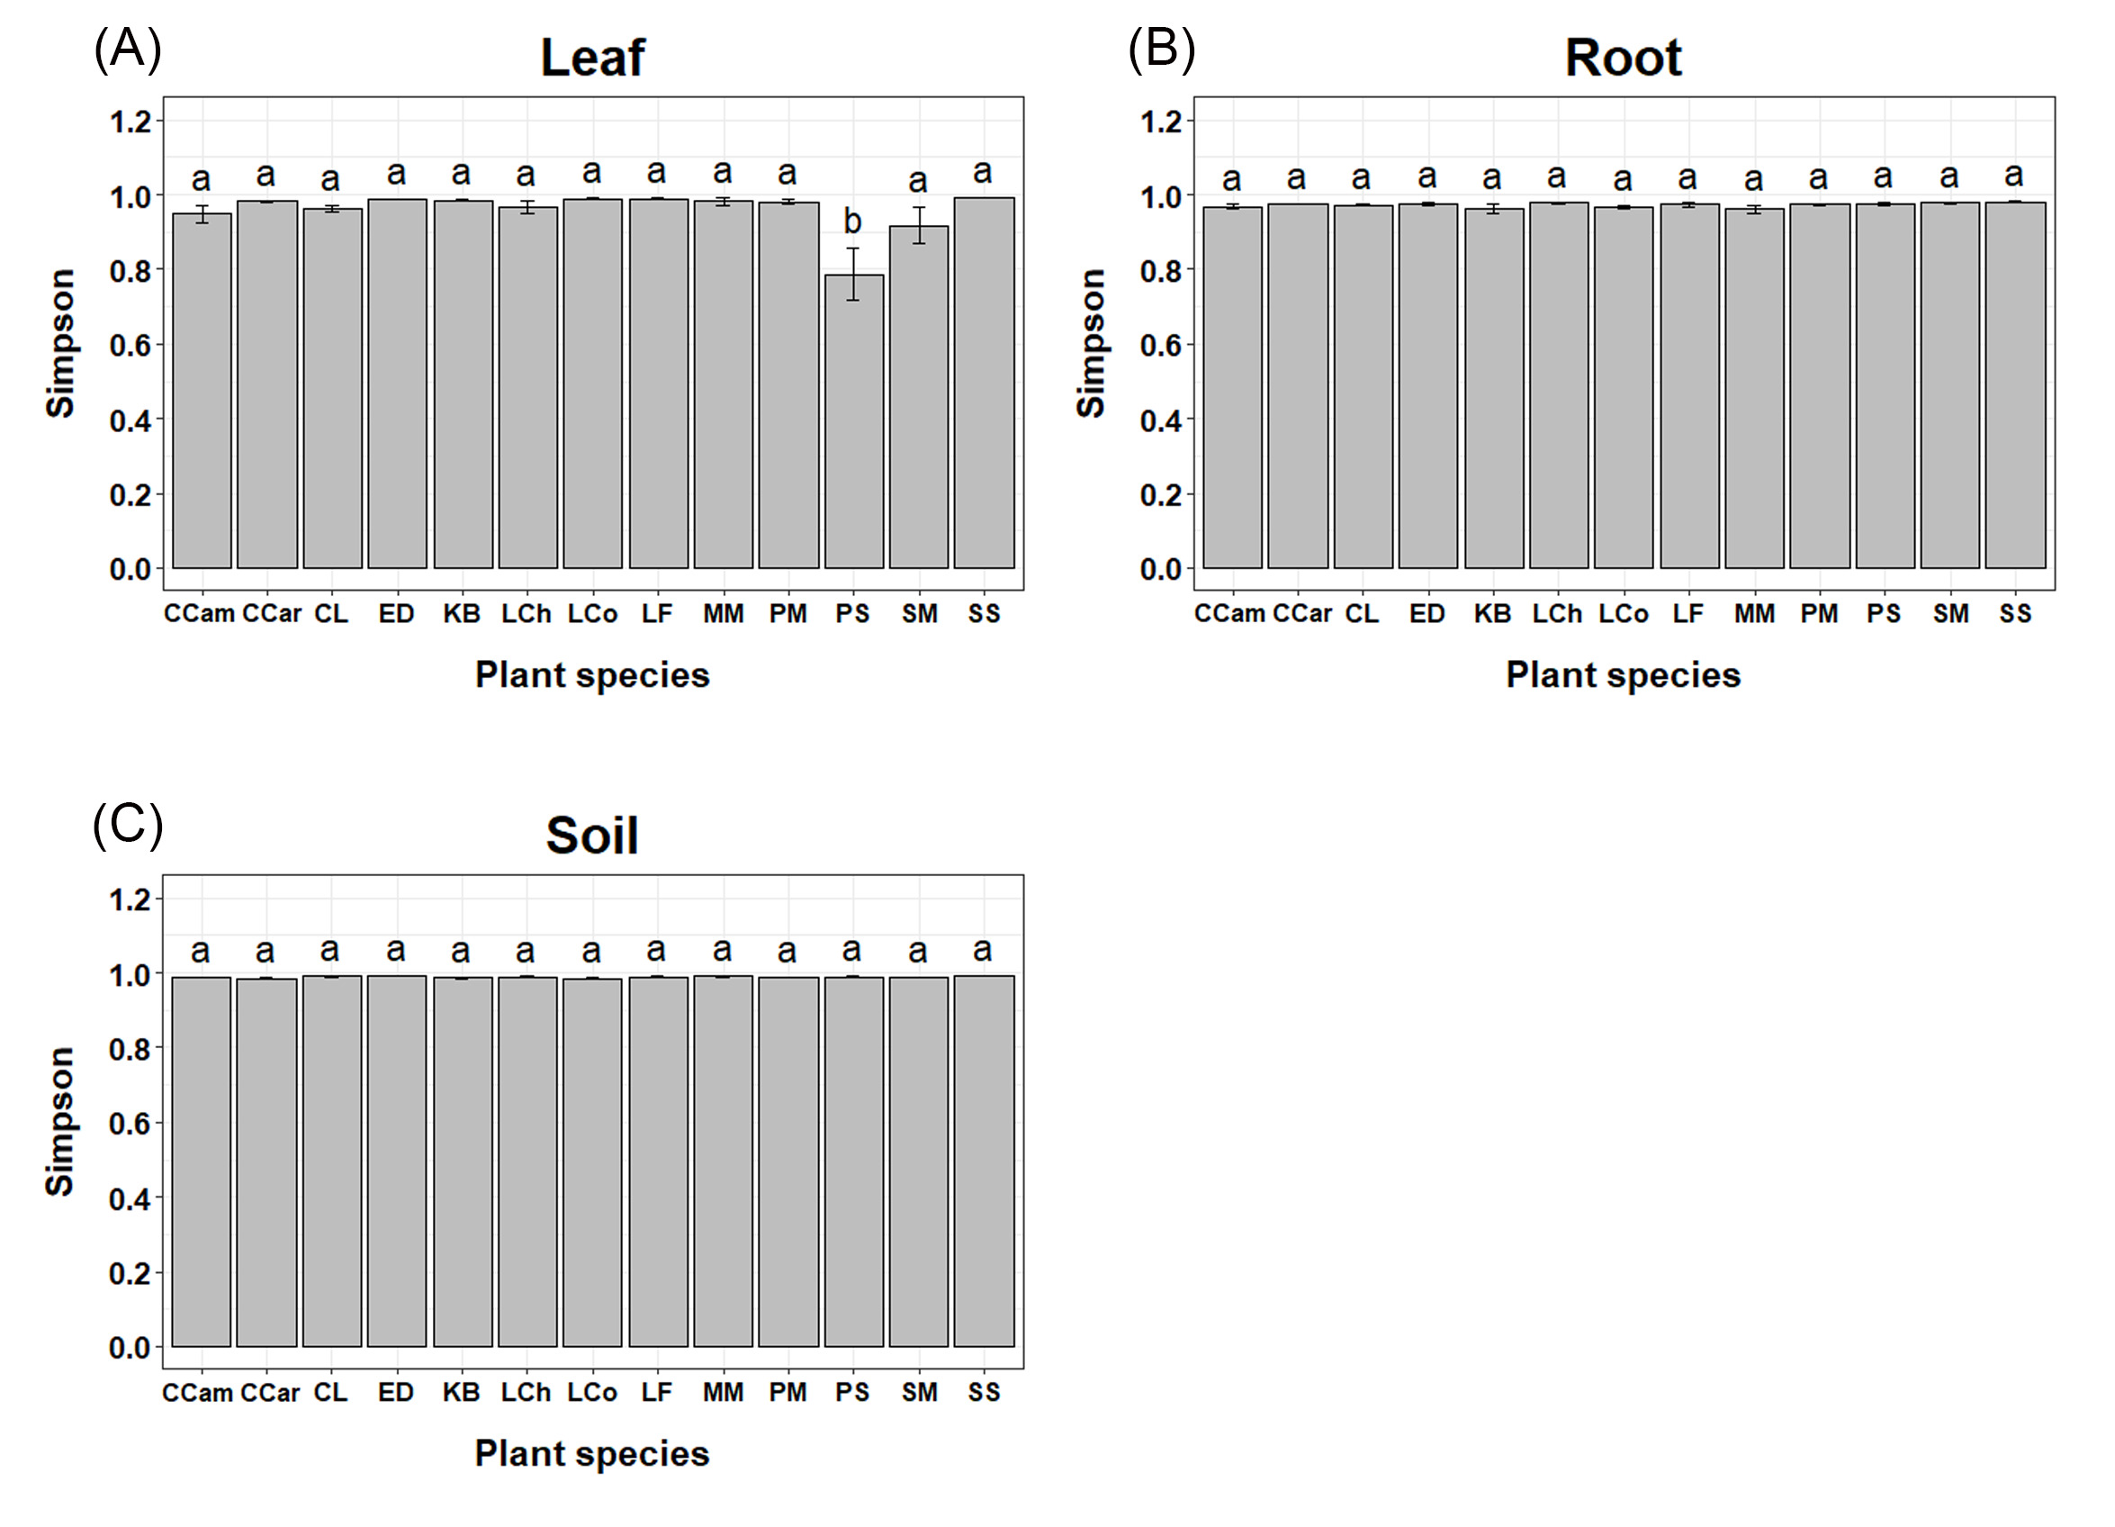
Figure S4. The bacterial Simpson’s index comparison among 13 tree species for three habitats of leaf (A), root (B), and soil (C). Plant species names: CCam, Cinnamomum camphora; CCar, Castanopsis carlesii; CL, Cunninghamia lanceolate; ED, Elaeocarpus decipiens; KB, Koelreuteria bipinnata; LCh, Liriodendron chinense; LCo, Lindera communis; LF, Liquidambar formosana; MM, Michelia macclurei; PM, Pinus massoniana; PS, Photinia serrulate; SM, Sapindus mukorossi; SS, Schima superba.

Fig. S5
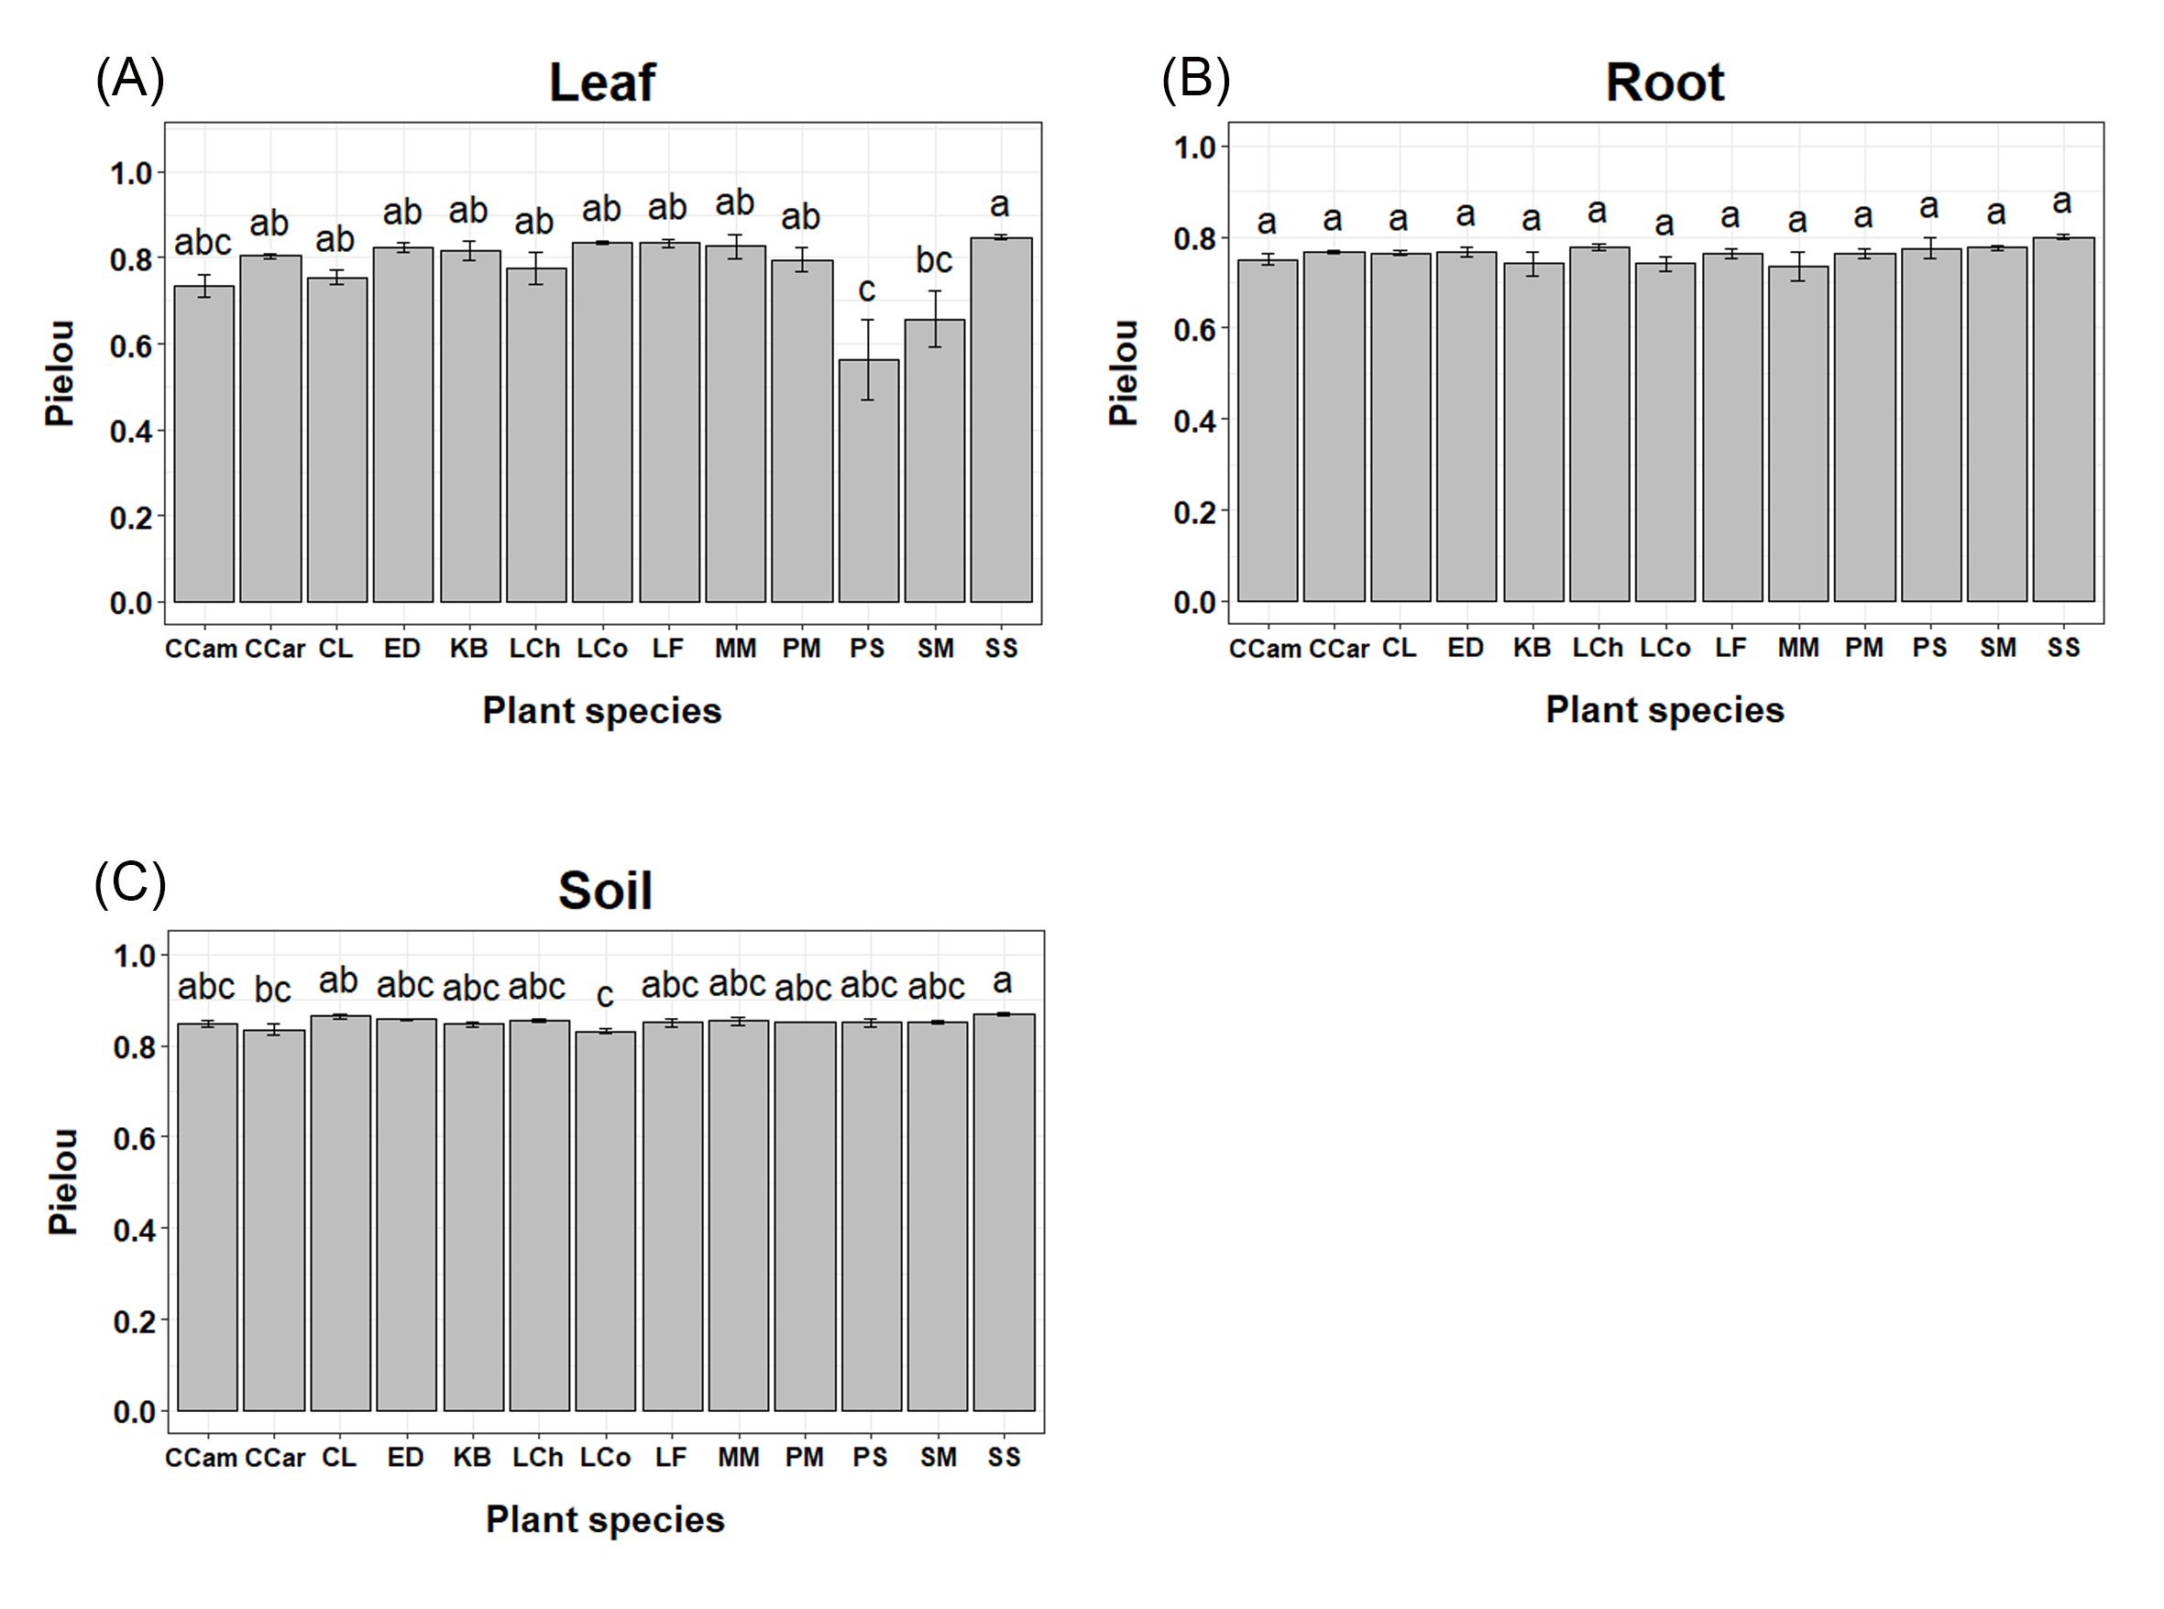
Figure S5. The bacterial Pielou’s evenness index comparison among 13 tree species for three habitats of leaf (A), root (B), and soil (C). Plant species names: CCam, Cinnamomum camphora; CCar, Castanopsis carlesii; CL, Cunninghamia lanceolate; ED, Elaeocarpus decipiens; KB, Koelreuteria bipinnata; LCh, Liriodendron chinense; LCo, Lindera communis; LF, Liquidambar formosana; MM, Michelia macclurei; PM, Pinus massoniana; PS, Photinia serrulate; SM, Sapindus mukorossi; SS, Schima superba.

Table S1.
Results of one-way ANOVA analyses for the alpha-diversities (richness, Shannon-Wiener and Simpson's indices, and Pielou's evenness) based on the whole, leaf, root, and soil datasets, respectively.
Dataset | Df | Richness |  |  | Shannon |  |  | Simpson |  |  | Pielou
 |  | F value | P value |  | F value | P value |  | F value | P value |  | F value | P value
Total data (habitat effect) | 2 | 150.3 | < 0.0001 |  | 49.92 | < 0.0001 |  | 190.8 | < 0.0001 |  | 29.38 | < 0.0001
Leaf | 12 | 6.535 | < 0.0001 |  | 5.736 | < 0.0001 |  | 4.869 | < 0.0001 |  | 5.069 | < 0.0001
Root | 12 | 1.401 | 0.209 |  | 1.407 | 0.206 |  | 1.301 | 0.259 |  | 1.574 | 0.142
Soil | 12 | 4.651 | < 0.001 |  | 4.431 | < 0.001 |  | 1.544 | 0.151 |  | 2.405 | 0.020

Table S2.
Summary of the PerMANOVA and beta dispersion analyses for the bacterial community compositions based on whole, leaf, root, and soil datasets, respectively.
Dataset (Effect origin) | PerMANOVA |  |  |  | Beta dispersion analysis
 | Df | R² | P value |  | Df | F value | P value
Total data (habitat effect) | 2 | 0.447 | 0.001 |  | 3 | 80.385 | < 0.0001
Leaf | 12 | 0.432 | 0.001 |  | 12 | 7.430 | < 0.0001
Root | 12 | 0.386 | 0.001 |  | 12 | 0.983 | 0.482
Soil | 12 | 0.281 | 0.002 |  | 12 | 1.526 | 0.157

