Supplementary information
Supplementary Figure S1 The recurrence rates of HCC patients who underwent liver resection in four subgroups. Showing a significant lower recurrence rates in the middle segment group compared with the other groups.
Supplementary Figure S2 Curves of RFS for HCC patients with BCLC 0 and A stage after hepatectomy and LT. The prognostic significance of the single-point scores for RFS in 126 HCC patients with BCLC 0 and A stage who underwent hepatectomy (A). Patients with BCLC 0 and A stage underwent hepatectomy were divided into three groups (0 point, 1-3 point, and 4-5 point) based on favorable median RFS in the Kaplan–Meier curves (B).

Supplementary Figure S1

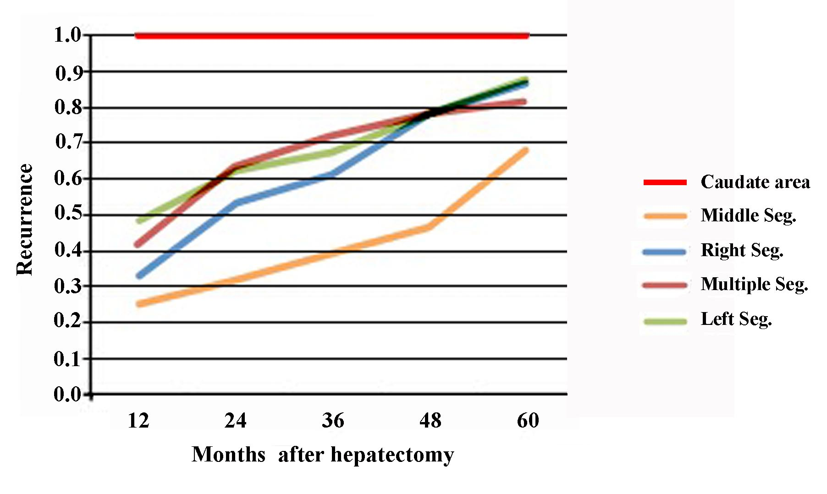

Supplementary Figure S2

Supplementary Table S1. Classification of the 211 HCC patients who underwent hepatectomy in the training cohort
 | Single segment-HCC (n=151) |  |  |  | Multiple segments-HCC  (n=60) | Single segment vs. Multiple segments  （P-value）
Variables | Left segment  (n=64) | Middle segment  (n=28) | Right segment  (n=58) | Caudate area  (n=1) | Multiple segments-HCC  (n=60) | Single segment vs. Multiple segments  （P-value）
Tumor size (cm) | 6.5±4.8 | 4.0±2.8 | 4.8±2.5 | 8.5 | 7.1±3.3 | 0.002
Tumor nodule number |  |  |  |  |  | ＜0.001
Single | 58(90.6%) | 24(85.7%) | 51(87.9%) | 1(100%) | 37(61.7%)
Multiple (≥2) | 6(9.4%) | 4(14.3%) | 7(12.1%) | 0 | 23(38.3%)
Capsulation formation |  |  |  |  |  | 0.540
Present | 39(60.9%) | 15(53.6%) | 34(58.6%) | 0 | 32(53.3%)
Absent | 25(39.1%) | 13(46.4%) | 24(41.4%) | 1(100%) | 28(46.7%)
Differentiation grade# |  |  |  |  |  | 0.801
Ⅰ-Ⅱ | 61(95.3%) | 25(89.3%) | 49(84.5%) | 1(100%) | 55(91.7%)
Ⅲ-Ⅳ | 3(4.7%) | 3(10.7%) | 9(15.5%) | 0 | 5(8.3%)
MVI |  |  |  |  |  | 1.000
Present | 18(28.1%) | 5(17.9%) | 16(27.6%) | 0 | 16(26.7%)
Absent | 46(71.9%) | 23(82.1%) | 42(72.4%) | 1(100%) | 44(73.3%)
Liver cirrhosis |  |  |  |  |  | 0.715
Present | 53(82.8%) | 18(64.3%) | 44(73.3%) | 0 | 50(83.3%)
Absent | 11(17.2%) | 10(35.7%) | 14(26.7%) | 1(100%) | 10(16.7%)
BCLC stage |  |  |  |  |  | 0.161
0&A | 34(53.1%) | 20(71.4%) | 44(73.3%) | 1(100%) | 27(45.0%)
B | 3(4.7%) | 4(14.3%) | 0 | 0 | 16(26.7%)
C | 27(42.2%) | 4(14.3%) | 14(26.7%) | 0 | 17(28.3%)
BCLC, Barcelona Clinic Liver Cancer; MVI, microvascular invasion; HCC, hepatocellular carcinoma. # Edmondson-Steiner grade

Supplementary Table S2. Operative data, postoperative complications and deaths of each groups in the training cohort
 | Single segment-HCC (n=151) |  |  |  | Multiple segments  -HCC (n=60) | Single segment vs.  Multiple segments  （P-value）
Variables | Left segment  (n=64) | Middle segment (n=28) | Right segment  (n=58) | Caudate area  (n=1) | Multiple segments  -HCC (n=60) | Single segment vs.  Multiple segments  （P-value）
Duration operation (min) | 205.2±83.8 | 201.4±70.3 | 203.4±84.3 | 620 | 241.0±86.5 | 0.017
Blood loss (ml) | 283.5±356.8 | 336.0±240.3 | 321.6±312.1 | 300 | 411.8±486.9 | 0.185
Blood transfusion |  |  |  |  |  | 0.635
Yes | 7(10.9%) | 9(32.1%) | 10(17.2%) | 0 | 12(20.0%) | －
No | 57(89.1%) | 19(67.9%) | 48(82.8%) | 1(100.0%) | 48(80.0%) | －
Surgical margin (cm) |  |  |  |  |  | 0.470
<1.0 | 20(31.3%) | 4(14.3%) | 9(15.5%) | 0 | 16(22.7%) | －
≥1.0 | 44(68.7%) | 24(85.7%) | 49(84.5%) | 1(100.0%) | 44(77.3%) | －
Overall complications | 17(26.6%) | 7(25.0%) | 14(17.2%) | 0(0%) | 14(23.3%) | 0.781
Wound infection (GradeⅠ) | 3(4.7%) | 1(3.6%) | 3(5.2%) | 0(0%) | 3(5.0%) | －
Ascites (GradeⅠ) | 9(14.1%) | 3(10.7%) | 8(13.8%) | 0(0%) | 6(10.0%) | －
Acute hepatic failure (GradeⅣ) | 1(1.6%) | 0(0%) | 0(0%) | 0(0%) | 1(1.7%) | －
Pulmonary inflammation (GradeⅡ) | 3(4.7%) | 3(10.7%) | 3(5.2%) | 0(0%) | 4(6.7%) | －
Haemorrhage (Grade Ⅳ) | 1(1.6%) | 0(0%) | 0(0%) | 0(0%) | 0(0%) | －
In-hospital mortality | 2(3.1%) | 0(0%) | 0(0%) | 0(0%) | 1(1.7%) | 0.850

Supplementary Table S3. Recurrence-free survival data for HCC patients
 |  | Recurrence-free survival (%)
Group* | n | 1-yr | 2-yr | 3-yr | 4-yr | 5-yr
Single segment | 151
Left | 64 | 51.6 | 37.5 | 32.8 | 21.9 | 12.5
Middle | 28 | 75.0 | 67.9 | 60.7 | 53.6 | 32.1
Right | 58 | 67.2 | 46.7 | 39.0 | 22.0 | 13.6
Caudate area | 1 | 0.0 | 0.0 | 0.0 | 0.0 | 0.0
Multiple segments | 60 | 58.3 | 36.7 | 28.3 | 21.7 | 18.3
* Takasaki segmentation

Supplementary Table S4. Univariate and multivariate Cox analysis of risk factors predicting recurrence-free survival of HCC
in the training cohort
 | Univariate analysis |  |  |  | Multivariate analysis
Variables | HR (95%CI) | P-value |  |  | HR (95%CI) |  | P-value
Tumor nodule number, Multiple/Single  Live cirrhosis, Presence/Absence  AFP (ng/ml), ≥ 400/< 400 | 1.742(1.050-2.892)  1.575(1.099-1.724)  1.765(1.122-2.775) | 0.032  0.123  0.014
Tumor size (cm), ≥ 5/<5 | 3.336(2.022-5.503) | ＜0.001 |  | 2.190(1.230-3.897) |  |  | 0.008
Differentiation grade #, Ⅲ-Ⅳ/Ⅰ-Ⅱ | 4.018(2.212-7.297) |  | ＜0.001 | 2.605(1.370-4.955) |  | 0.004
MVI,＋/－ | 2.472(1.568-3.898) |  | ＜0.001 | 1.840(1.126-3.007) |  | 0.015
Tumor location*, Multiple / Single Seg. | 1.603(1.038-2.476) |  | 0.033 | 1.636(1.018-2.628) |  | 0.042
Abbreviations: AFP, alpha-fetoprotein; MVI, microvascular invasion; HCC, hepatocellular carcinoma; HR, hazard ratio; CI, confidence interval.
# Edmondson-Steiner grade * Takasaki segmentation

Supplementary Table S5. Demographic characteristic of HCC patients with BCLC 0 and A stage
Variables | Hepatectomy (n=126) | LT (n=53) | P
Age (years) | 49.9±11.1 | 49.9±11.2 | 0.892
Gender, M/F | 121(96.0%)/5(4.0%) | 50(98.4%)/3(1.6%) | 0.671
AFP (ng/ml), ≤ 400/>400 | 82(65.1%)/34(34.9%) | 42(79.2%)/11(20.8%) | 0.243
HBV-DNA,＋/－ | 88(69.8%)/38(30.1%) | 26(49.1%)/27(50.9%) | 0.008
Prothrombin time (s) | 13.6±1.2 | 14.6±3.2 | 0.001
FIB-4 | 2.5±1.9 | 2.7±1.5 | 0.464
Tumor size (cm), <5/≥ 5 | 76(60.3%)/50(49.7%) | 28(52.8%)/25(47.2%) | 0.354
Tumor nodule number, Single / Multiple (≥2) | 122(96.8%)/4(3.2%) | 50(94.4%)/3(5.6%) | 0.433
MVI,＋/－ | 14(11.1%)/112(88.9%) | 16(30.2%)/37(69.8%) | 0.002
Differentiation grade#,Ⅰ-Ⅱ/Ⅲ-Ⅳ | 118(93.7%)/8(6.3%) | 47(88.7%)/6(11.3%) | 0.258
BCLC stage, 0/A | 20(15.9%)/106(84.1%) | 12(22.6%)/41(77.4%) | 0.281
HCC, hepatocellular carcinoma; BCLC, Barcelona Clinic Liver Cancer; LT, liver transplantation; AFP, alpha-fetoprotein; MVI, microvascular invasion; HCC, hepatocellular carcinoma. # Edmondson-Steiner grade

Supplementary Table S6. Demographic characteristic of 53 patients with CLLTs
Variables | Single segment  (n=38) | Multiple segments  (n=15) | P-value
Age (years) | 49.6±13.0 | 55.0±14.2 | 0.155
Gender, M:F | 37:1 | 15:0 | 0.526
Liver cirrhosis |  |  | 0.362
Present | 31(81.6%) | 12(80.0%) | －
Absent | 7(18.4%) | 3 (20.0%) | －
AFP (ng/ml) | 209.2±350.0 | 246.0±409.3 | 0.591
Tumor size (cm) |  |  | 0.560
<5 | 26(68.4%) | 9(66.7%) | －
≥ 5 | 12(31.6%) | 6(33.3%) | －
Tumor nodule number |  |  | 0.986
Single | 33(86.8%) | 13(86.7%) | －
Multiple (≥2) | 5(13.2%) | 2(13.3%) | －
MVI |  |  | 0.531
Present | 5(13.2%) | 3(20.0%) | －
Absent | 33(86.8%) | 12(80.0%) | －
Differentiation grade# |  |  | 0.879
Ⅰ-Ⅱ | 35(92.1%) | 14(93.3%) | －
Ⅲ-Ⅳ | 3(7.9%) | 1(6.7%) | －
Surgical methods |  |  | 0.328
Mesohepatectomy | 10(26.3%) | 6(100%) | －
Extended left/right hepatectomy | 28(73.7%) | 9(0%) | －
Duration operation (min) | 197.1±75.7 | 223.4±49.6 | 0.291
Blood loss (ml) | 296.0±220.9 | 403.6±621.6 | 0.362
Surgical margin (cm) |  |  | 0.713
<1.0 | 6(15.8%) | 3 (20.0%) | －
≥1.0 | 32(84.2%) | 12(80.0%) | －
Overall complications | 9(23.7%) | 4 (26.7%) | 0.820
Ascites (GradeⅠ) | 5(13.2%) | 3(20.0%) | －
Pulmonary inflammation (GradeⅡ) | 3(7.9%) | 1(6.7%) | －
Wound infection (GradeⅠ) | 1(2.6%) | 0(0%) | －
In-hospital mortality | 0(0%) | 0(0%) | －

Supplementary Table S7. Classification of CLLTs
Type | Tumor Location | Score | Hepatectomy
A | Middle segment* | 0-1 | AR: middle segment *
B | Part of left segment*  (segment Ⅳ&) | 0-1 | AR: segment Ⅳ&
C | Middle segment* | ＞1 | AR: MH  (middle segment*+ segment Ⅳ&)
C | Part of left segment  (segment Ⅳ&) | ＞1 | AR: MH  (middle segment*+ segment Ⅳ&)
C | Multiple segments  (middle segment* + segment Ⅳ&) | Any score | AR: MH  (middle segment*+ segment Ⅳ&)
Abbreviations: AR, anatomical resection; CLLTs, centrally located liver tumors; MH, mesohepatectomy. * Takasaki segmentation & Couinaud segmentation

