Supplementary information
Rational Design on Polymorphous Phase Switching in Molybdenum Diselenide-based Memristor Assisted by All-Solid-State Reversible Intercalation Toward Neuromorphic Application
Ling Lee^{1,2,3}, Chun-Hsiu Chiang^{1,2,3}, Ying-Chun Shen^{1,2,3}, Shu-Chi Wu^{1,2,3}, Yu-Chuan Shih^{1,2,3}, Tzu-Yi Yang^{1,2,3}, Yu-Chieh Hsu^{1,2,3}, Ruei-Hong Cyu^{1,2,3}, Yi-Jen Yu⁴, Shang-Hsien Hsieh⁵, Chia-Hao Chen⁵, Mikhail Lebedev⁶, and Yu-Lun Chueh^{1,2,3*}
¹Department of Materials Science and Engineering, National Tsing Hua University, Hsinchu 30013, Taiwan,
²Department of Physics, National Sun Yat-Sen University, Kaohsiung 80424, Taiwan.
³Frontier Research Center on Fundamental and Applied Sciences of Matters, National Tsing Hua University, Hsinchu 30013, Taiwan.
⁴Instrument Center, National Tsing Hua University, Hsinchu 30013, Taiwan
⁵National Synchrotron Radiation Research Center, Hsinchu 30076, Taiwan.
⁶Laboratory of functional films and coatings, Nikolaev Institute of inorganic chemistry SB RAS, Lavrent'ev ave. 3, Novosibirsk, 630090, Russia

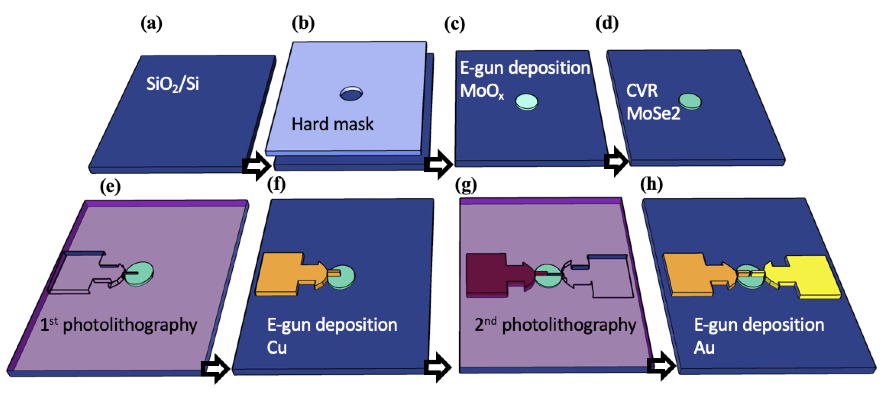
Figure S1 Schematic procedure flows. Fabrication steps preparing self-patterned MoSe₂ films, starting from a and b the selection of synthesized location, c the preparation of precursor, and d the selenization process, followed by the two-terminal memristor devices, starting from e and f for the active Cu electrode, and g and h for the Au electrode.

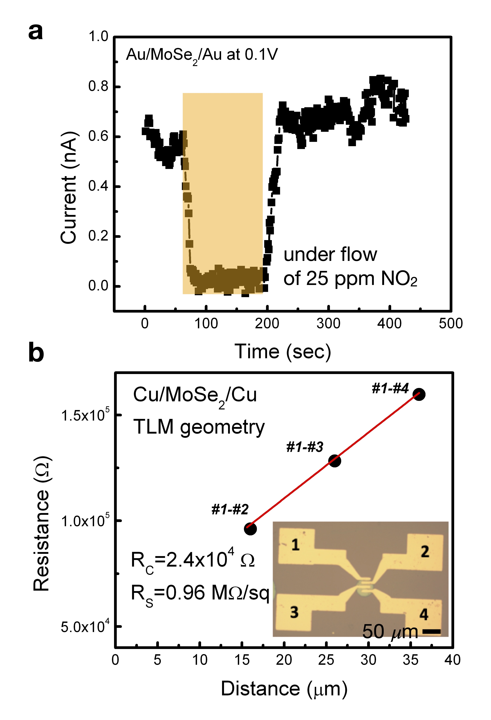
Figure S2 Fundamental electrical characteristics of vertical lamellar 1T-rich MoSe₂ films fabricated by PACVR. a The n-type characteristics proved by the reduction of temporal current under the ambient filled with oxidizing NO₂ gases. b The sheet resistance of MoSe₂ film extrapolated by the transmission line method (TLM).
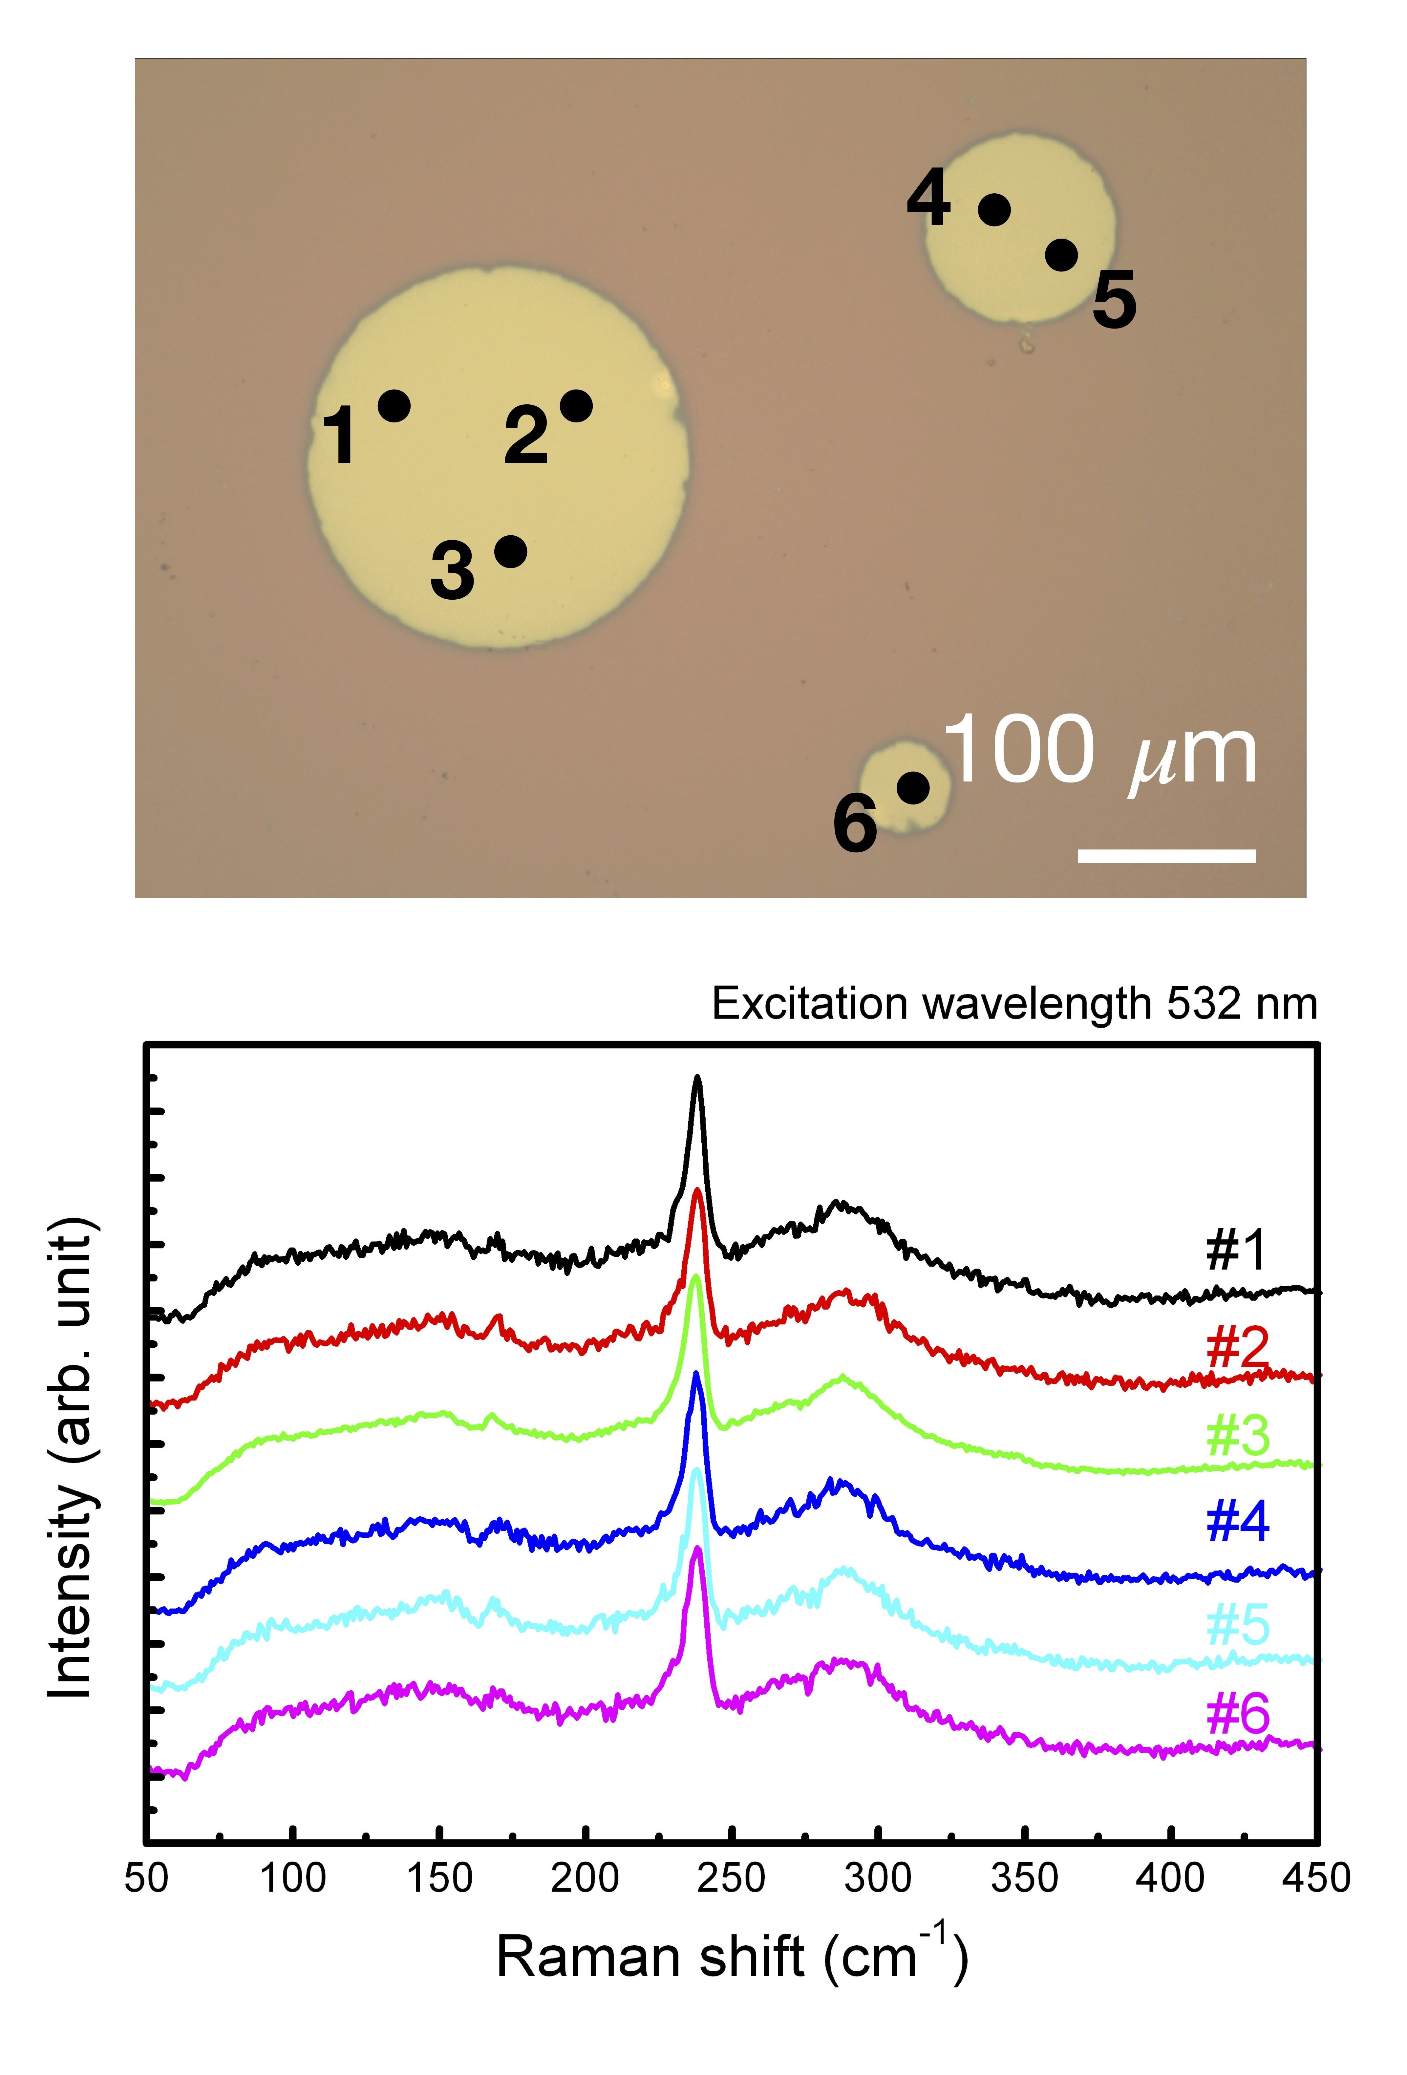
Figure S3 Self-patterning of large-scaled continuous MoSe₂ films. a Optical microscopy image of MoSe₂ patterns with various sizes fabricated by PACVR. b Raman spectra measured in each location illustrated in a.

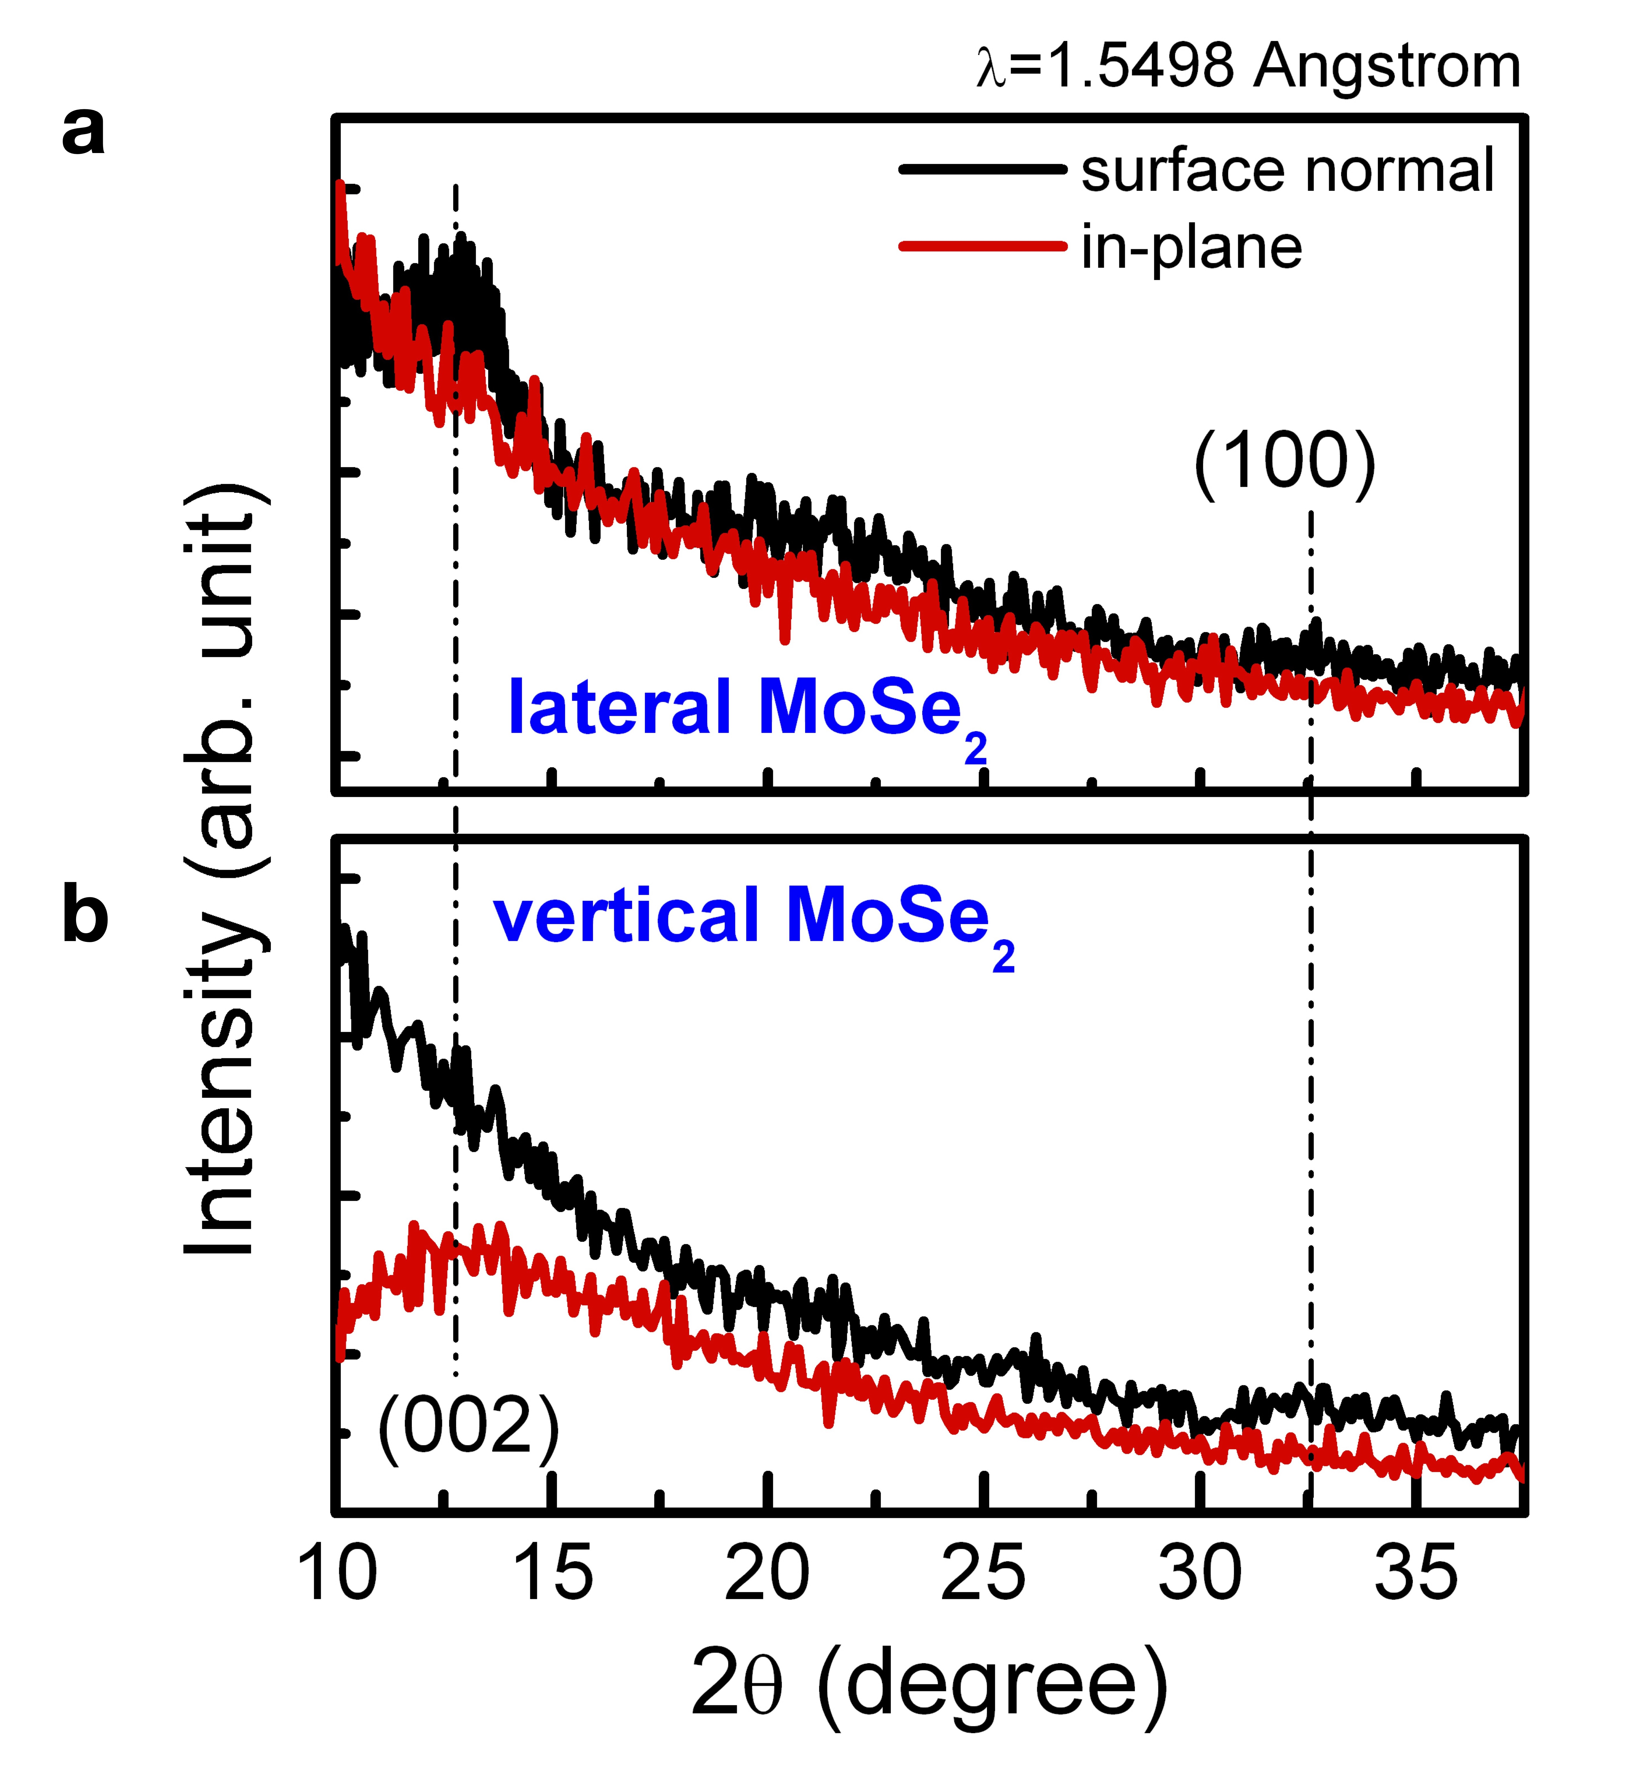
Figure S4 Evidence of controllable orientations in vertical lamellar MoSe₂ films. X-ray diffraction spectra of a lateral- and b vertical-aligned MoSe₂ films prepared by PACVR measured along the surface normal (black) and in-plane (red) orientation.

Figure S5 Stoichiometric investigations on copper distributions in Au/MoSe₂/Cu devices. a, b Plan-view scanning electron microscopy (SEM) images of as-deposited electrodes on MoSe₂. c Correlated EDX spectra and the atomic ratio of Cu in each region of interest (ROI) illustrated in a. d, e SEM images of annealed Cu electrode on MoSe₂. f Correlated EDX spectra in each ROI illustrated in d.

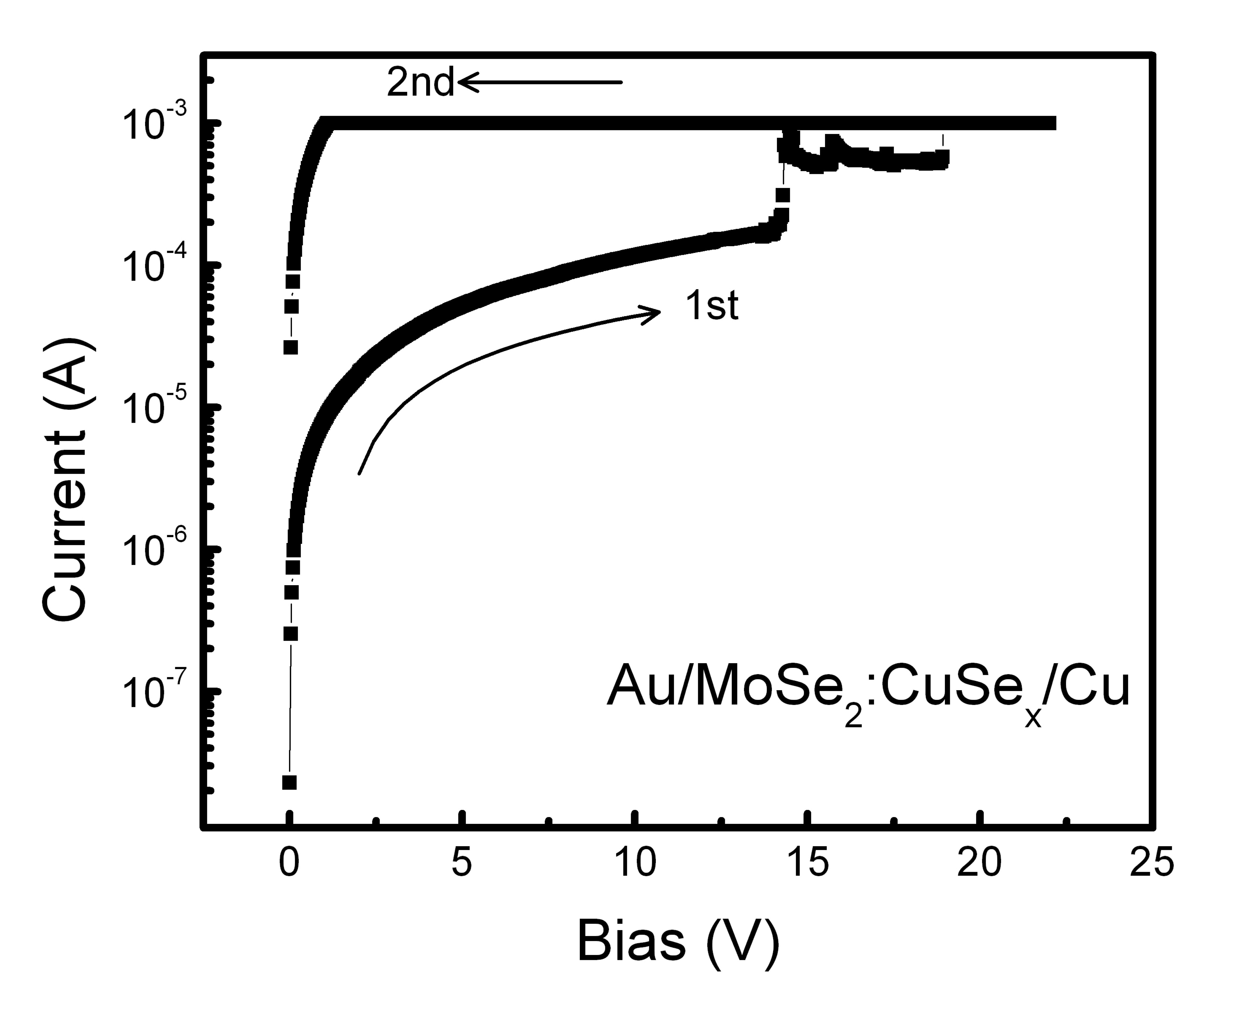
Figure S6 Forming process of vertical lamellar MoSe₂ film. The current-voltage relationship of a Au/MoSe₂:CuSe_{x}/Cu device with a forming process at 15 V.

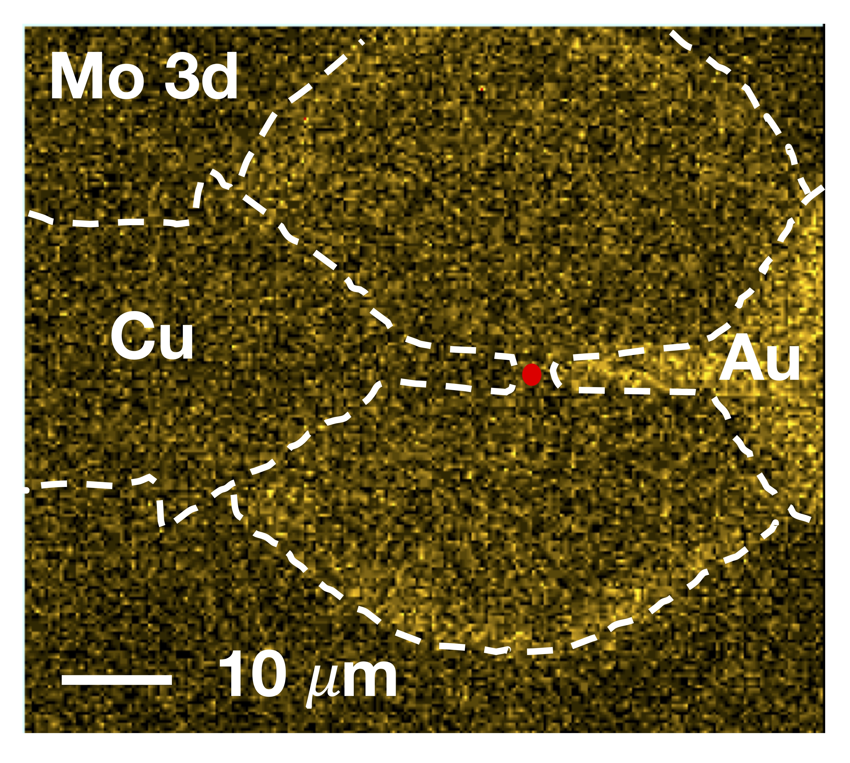
Figure S7 SPEM mapping image of memristor. The SPEM mapping of the Au/MoSe₂:CuSe_{x}/Cu channel. The red spot indicates the location for collecting pseudo-operando XPS spectra.

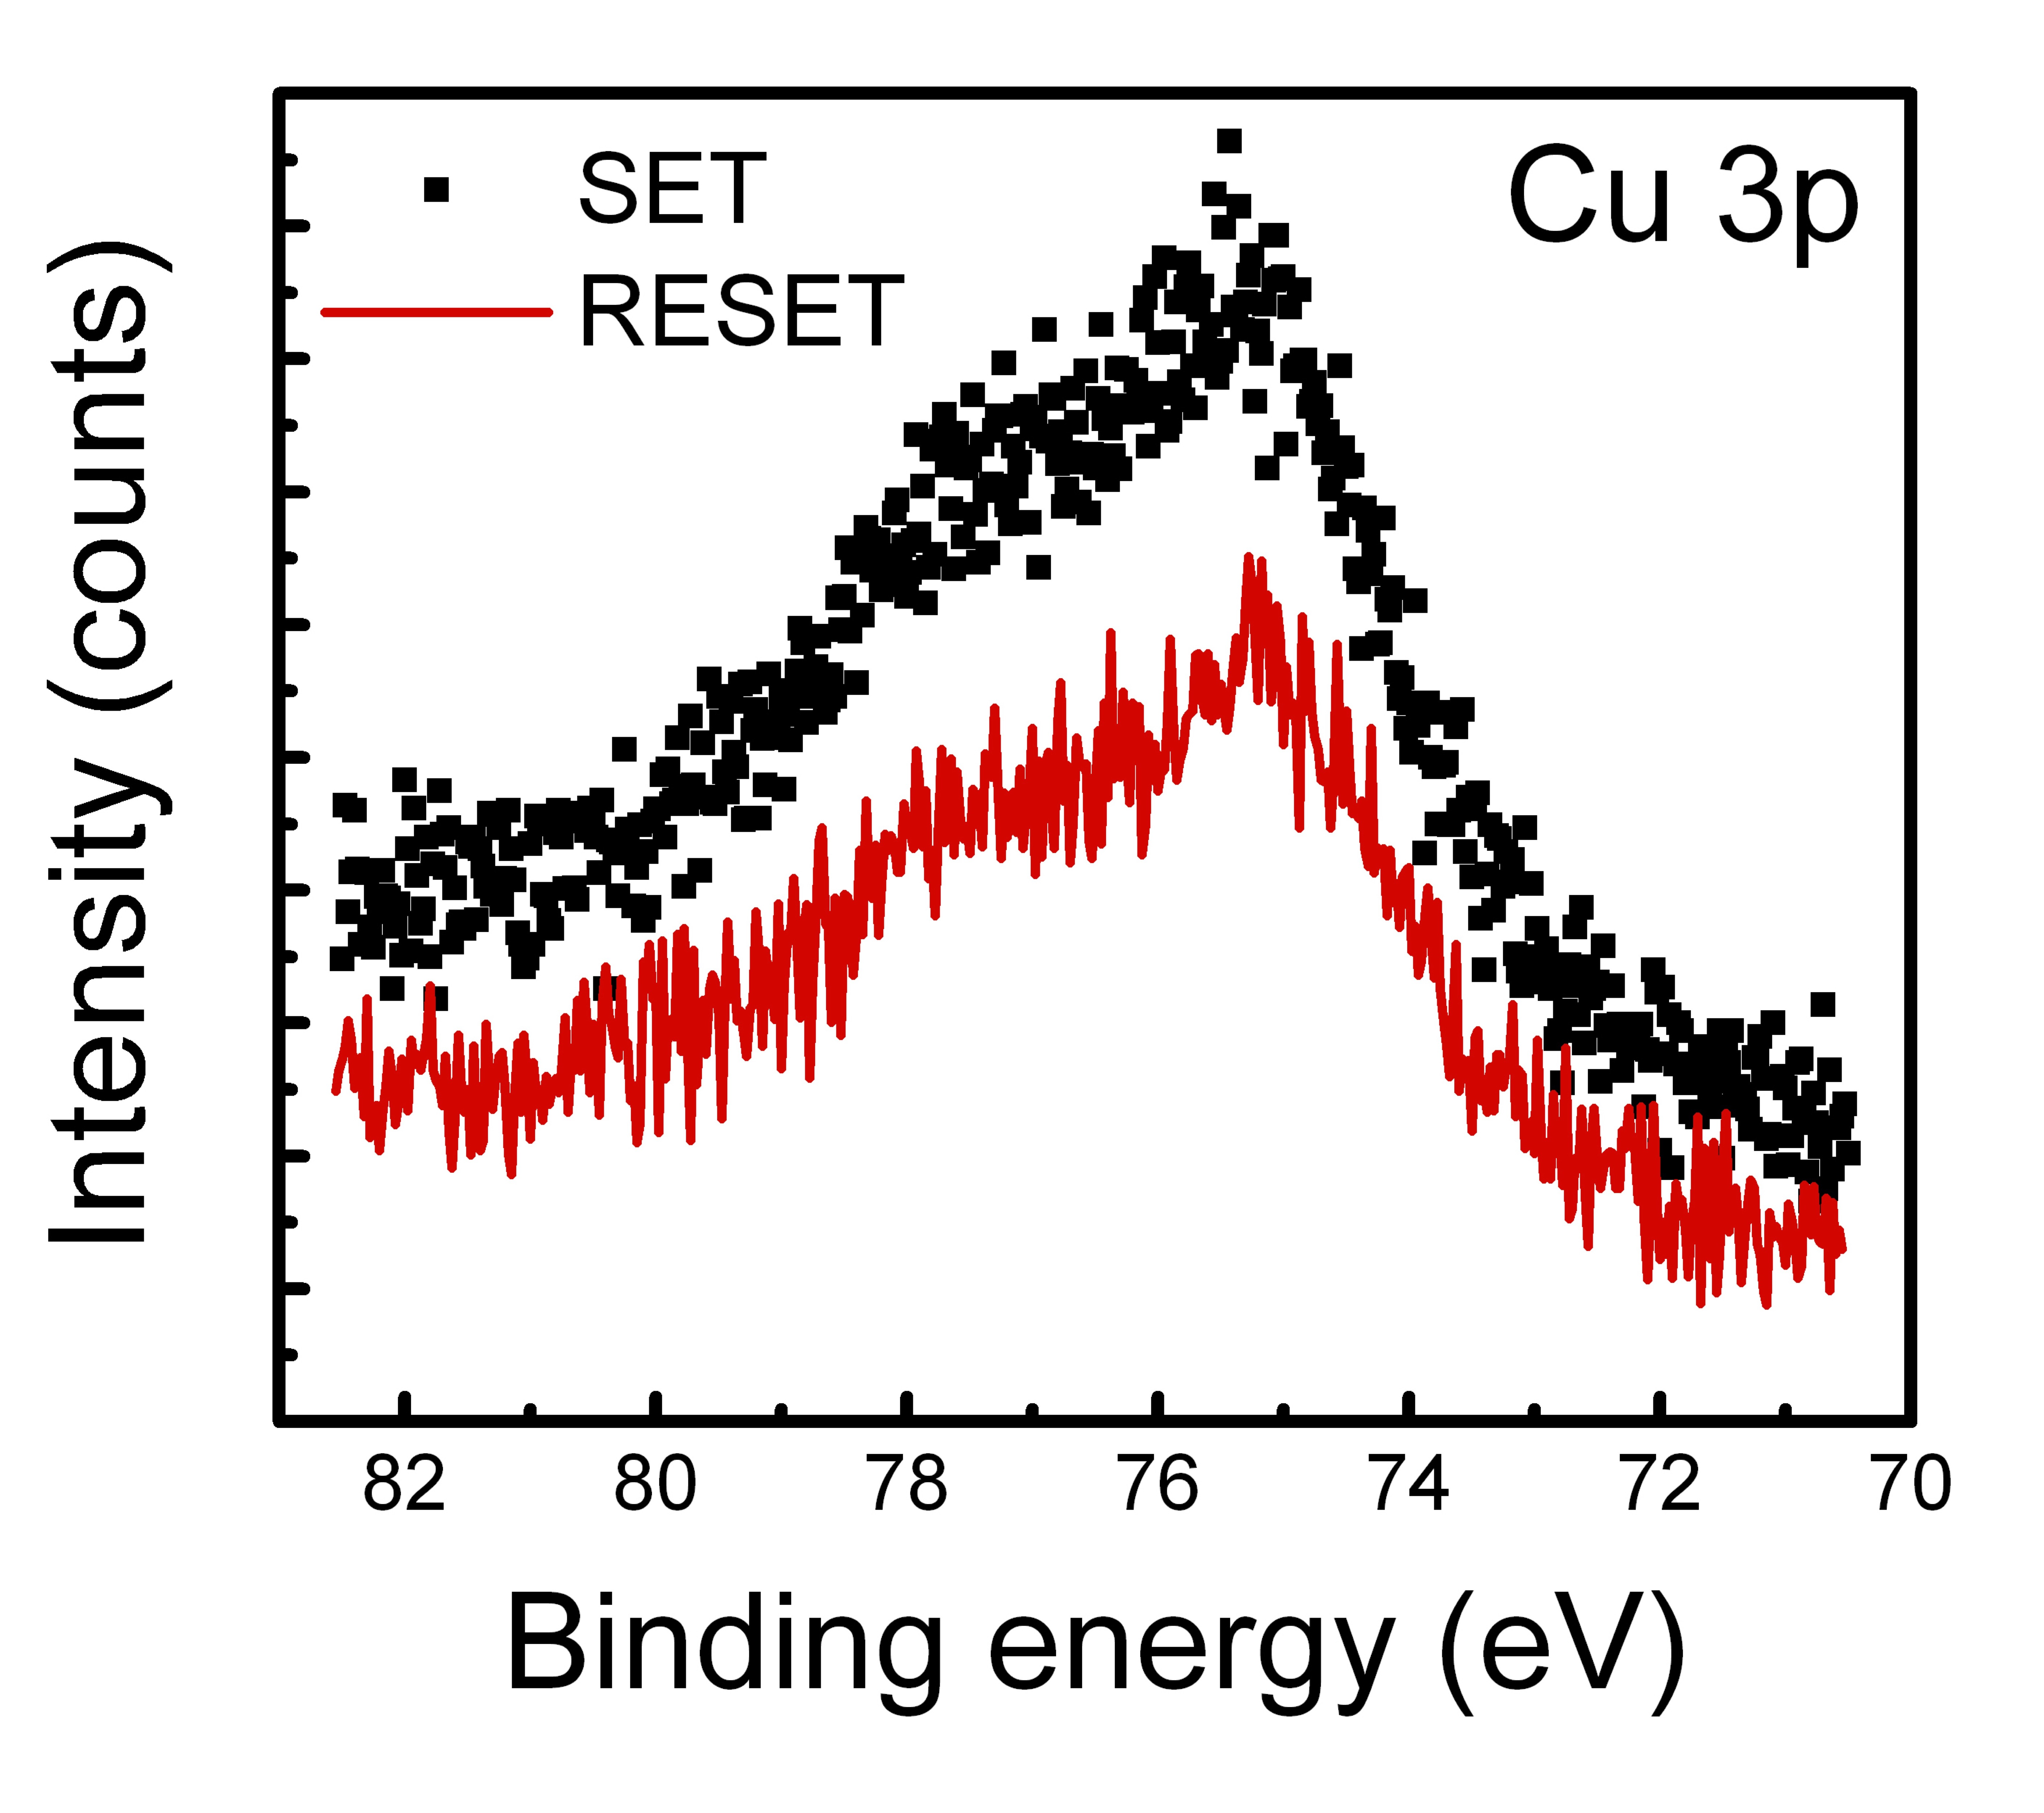
Figure S8 Stoichiometric evolution related to Cu. Pseudo-operando local XPS spectra at the center of Au/MoSe₂:CuSe_{x}/Cu channel after SET (black) and RESET (red) processes.

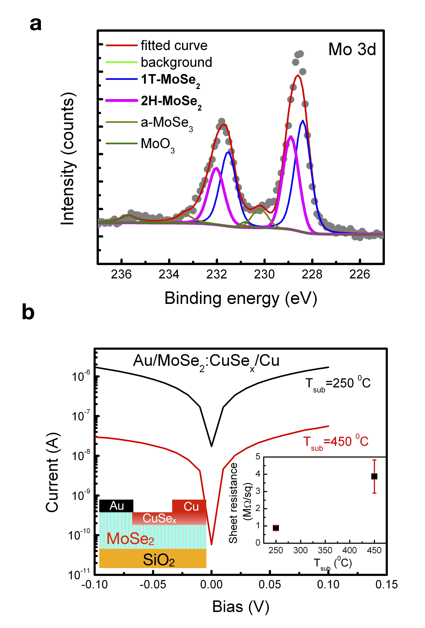
Figure S9 a priori information of MoSe₂ films regarding polymorphous phase-changed memristive behaviors. a The XPS spectra of the Mo 3d core level for a 2H-rich film synthesized at 450 ℃ together with fitting components from 1T phase (blue), 2H phase (pink), amorphous MoSe₃ (dark yellow), and MoO₃ (green). b Current-voltage relationships and sheet resistances of 1T-rich (250-℃-synthesized, black) and 2H-rich (450-℃-synthesized, red) MoSe₂ films.
Figure S10 Proposed model for phase and resistance switching. The schematic illustration of the current flow, the Cu intercalation, and the corresponding atomic geometry at a pristine condition, b after RESET, and c SET processes.

