Supplementary Material
Object-centered bias of sensorimotor torque control in the chronic stage following stroke
Thomas Rudolf Schneider^{1,2}* and Joachim Hermsdörfer¹
¹ Chair of Human Movement Science, Department of Sport and Health Sciences, Technical University of Munich, Georg-Brauchle-Ring 60/ 62 D-80992 Munich, Germany
² Department of Neurology, Cantonal Hospital of St. Gallen, Rorschacher Str. 95 CH - 9007 St. Gallen, Switzerland

List of Figures
Supplementary Figure S 1: Demographics and clinical test results in left- and right hemisphere stroke patients. 5
Supplementary Figure S 2: Coefficients of static friction as assessed by object slip trials. 6
Supplementary Figure S 3: Individual and group averaged trajectories of Tcom of all trials in the no cues condition depicted for each group. 8
Supplementary Figure S 4: Individual and group averaged trajectories of Tcom of all trials in the geometric cues condition depicted for each group. 9
Supplementary Figure S 5: Differences of torques at lift-off between CL, and SL patients with and without signs of apraxia in the blocked, geometric-cues condition. 9
Supplementary Figure S 6: Differences of ∆CoP at lift-off between CL, and SL patients with and without signs of apraxia in the blocked, geometric-cues condition. 10
Supplementary Figure S 7: Differences of GF at lift-off between CL, and SL patients with and without signs of apraxia in the blocked, geometric-cues condition. 11

List of Tables
Supplementary Table S 1: Demographic and clinical information for all participating stroke patients. 12
Supplementary Table S 2: Results of the linear mixed effects model (LMM) of Tcom/ External Torque of trials 4-8 in the no-cues, blocked condition 14
Supplementary Table S 3: Post-hoc t-tests of pairwise comparisons of the LMM of Tcom/ External Torque of trials 4-8 in the no-cues, blocked condition 14
Supplementary Table S 4: Results of the linear mixed effects model (LMM) of ∆CoP x GF/ External Torque of trials 4-8 in the no-cues, blocked condition 14
Supplementary Table S 5: Post-hoc t-tests of pairwise comparisons based on the LMM of ∆CoP x GF/ External Torque of trials 4-8 in the no-cues, blocked condition. 15
Supplementary Table S 6: Results of the linear mixed effects model (LMM) of ∆Fy x 0.5w/ External Torque of trials 4-8 in the no-cues, blocked condition 15
Supplementary Table S 7: Post-hoc t-tests of pairwise comparisons based on the LMM of ∆Fy x 0.5w/ External Torque of trials 4-8 in the no-cues, blocked condition. 15
Supplementary Table S 8: Results of the linear mixed effects model (LMM) of Tcom/ External Torque of the first trial following a CoM change in the no-cues, blocked condition. 16
Supplementary Table S 9: Post-hoc t-tests of pairwise comparisons based on the LMM of Tcom/ External Torque of the first trial following a CoM change in the no-cues, blocked condition. 16
Supplementary Table S 10: Results of the linear mixed effects model (LMM) of ∆CoP x GF/ External Torque of the first trial following a CoM change in the no-cues, blocked condition. 16
Supplementary Table S 11: Post-hoc t-tests of pairwise comparisons based on the LMM of ∆CoP x GF/ External Torque of the first trial following a CoM change in the no-cues, blocked condition. 17
Supplementary Table S 12: Results of the linear mixed effects model (LMM) of ∆Fy x 0.5w/ External Torque of the first trial following a CoM change in the no-cues, blocked condition. 17
Supplementary Table S 13: Post-hoc t-tests of pairwise comparisons based on the LMM of ∆Fy x 0.5w/ External Torque of the first trial following a CoM change in the no-cues, blocked condition. 18
Supplementary Table S 14: Results of the linear mixed effects model (LMM) of Tcom/ External Torque for the no-cues, pseudorandom condition. 18
Supplementary Table S 15: Post-hoc t-tests of pairwise comparisons based on the LMM of Tcom/ External Torque for the no-cues, pseudorandom condition. 19
Supplementary Table S 16: Results of the linear mixed effects model (LMM) of ∆CoP x GF/ External Torque for the no-cues, pseudorandom condition. 19
Supplementary Table S 17: Post-hoc t-tests of pairwise comparisons based on the LMM of ∆CoP x GF/ External Torque for the no-cues, pseudorandom condition. 20
Supplementary Table S 18: Results of the linear mixed effects model (LMM) of ∆Fy x 0.5w/ External Torque for the no-cues, pseudorandom condition. 20
Supplementary Table S 19: Post-hoc t-tests of pairwise comparisons based on the LMM of ∆Fy x 0.5w/ External Torque for the no-cues, pseudorandom condition. 21
Supplementary Table S 20: Results of the linear mixed effects model (LMM) of Tcom/ External Torque of trials 4-8 in the geometric cues, blocked condition. 21
Supplementary Table S 21: Post-hoc t-tests of pairwise comparisons based on the LMM of Tcom/ External Torque of trials 4-8 in the geometric cues, blocked condition. 22
Supplementary Table S 22: Results of the linear mixed effects model (LMM) of ∆CoP x GF/ External Torque of trials 4-8 in the geometric cues, blocked condition. 22
Supplementary Table S 23: Post-hoc t-tests of pairwise comparisons based on the LMM of ∆CoP x GF/ External Torque of trials 4-8 in the geometric cues, blocked condition. 23
Supplementary Table S 24: Results of the linear mixed effects model (LMM) of ∆Fy x 0.5w/ External Torque of trials 4-8 in the geometric cues, blocked condition. 23
Supplementary Table S 25: Post-hoc t-tests of pairwise comparisons based on the LMM of ∆Fy x 0.5w/ External Torque of trials 4-8 in the geometric cues, blocked condition. 23
Supplementary Table S 26: Results of the linear mixed effects model (LMM) of Tcom/ External Torque of the first trial following a CoM change in the geometric cues, blocked condition. 24
Supplementary Table S 27: Post-hoc t-tests of pairwise comparisons based on the LMM of Tcom/ External Torque of the first trial following a CoM change in the geometric cues, blocked condition. 24
Supplementary Table S 28: Results of the linear mixed effects model (LMM) of ∆CoP x GF/ External Torque of the first trial following a CoM change in the geometric cues, blocked condition. 24
Supplementary Table S 29: Post-hoc t-tests of pairwise comparisons based on the LMM of ∆CoP x GF/ External Torque of the first trial following a CoM change in the geometric cues, blocked condition. 25
Supplementary Table S 30: Results of the linear mixed effects model (LMM) of ∆Fy x 0.5w/ External Torque of the first trial following a CoM change in the geometric cues, blocked condition. 25
Supplementary Table S 31: Post-hoc t-tests of pairwise comparisons based on the LMM of ∆Fy x 0.5w/ External Torque of the first trial following a CoM change in the geometric cues, blocked condition. 26
Supplementary Table S 32: Results of the linear mixed effects model (LMM) of Tcom/ External Torque for the geometric cues, pseudorandom condition. 26
Supplementary Table S 33: Post-hoc t-tests of pairwise comparisons based on the LMM of Tcom/ External Torque for the geometric cues, pseudorandom condition. 27
Supplementary Table S 34: Results of the linear mixed effects model (LMM) of ∆CoP x GF/ External Torque for the geometric cues, pseudorandom condition. 27
Supplementary Table S 35: Post-hoc t-tests of pairwise comparisons based on the LMM of ∆CoP x GF/ External Torque for the geometric cues, pseudorandom condition. 28
Supplementary Table S 36: Results of the linear mixed effects model (LMM) of ∆Fy x 0.5w/ External Torque for the geometric cues, pseudorandom condition. 28
Supplementary Table S 37: Post-hoc t-tests of pairwise comparisons based on the LMM of ∆Fy x 0.5w/ External Torque for the geometric cues, pseudorandom condition. 29
Supplementary Table S 38: Results of the linear mixed effects model (LMM) of ∆CoP_{lift off} of trials 4-8 in the no-cues, blocked condition 30
Supplementary Table S 39: Post-hoc t-tests of pairwise comparisons between stroke patient- and hand-matched control groups based on the marginal means of the LMM of ∆CoP_{lift off} of trials 4-8 in the no-cues, blocked condition with Holm-Bonferroni correction for multiple testing applied 30
Supplementary Table S 40: Results of the linear mixed effects model (LMM) of ∆CoP_{lift off} for the no-cues, pseudorandom condition. 30
Supplementary Table S 41: Post-hoc t-tests of pairwise comparisons based on the LMM of ∆CoP_{lift off} for the no-cues, pseudorandom condition. 31
Supplementary Table S 42: Results of the linear mixed effects model (LMM) of ∆CoP_{lift off} of trials 4-8 in the geometric cues, blocked condition. 31
Supplementary Table S 43: Post-hoc t-tests of pairwise comparisons based on the LMM of ∆CoP_{lift off} of trials 4-8 in the geometric cues, blocked condition. 32
Supplementary Table S 44: Results of the linear mixed effects model (LMM) of ∆CoP_{lift off} for the geometric cues, pseudorandom condition. 32
Supplementary Table S 45: Post-hoc t-tests of pairwise comparisons based on the LMM of ∆CoP_{lift off} for the geometric cues, pseudorandom condition. 33
Supplementary Table S 46: Results of the linear mixed effects model (LMM) of GF_{lift off} of trials 4-8 in the no-cues, blocked condition 33
Supplementary Table S 47: Post-hoc t-tests of pairwise comparisons between stroke patient- and hand-matched control groups based on the marginal means of the LMM of GF_{lift off} of trials 4-8 in the no-cues, blocked condition with Holm-Bonferroni correction for multiple testing applied. 34
Supplementary Table S 48: Results of the linear mixed effects model (LMM) of GF_{lift off} for the no-cues, pseudorandom condition. 34
Supplementary Table S 49: Post-hoc t-tests of pairwise comparisons based on the LMM of GF_{lift off} for the no-cues, pseudorandom condition. 34
Supplementary Table S 50: Results of the linear mixed effects model (LMM) of GF_{lift off} of trials 4-8 in the geometric cues, blocked condition. 35
Supplementary Table S 51: Post-hoc t-tests of pairwise comparisons based on the LMM of GF_{lift off} of trials 4-8 in the geometric cues, blocked condition. 35
Supplementary Table S 52: Results of the linear mixed effects model (LMM) of GF_{lift off} for the geometric cues, pseudorandom condition. 35
Supplementary Table S 53: Post-hoc t-tests of pairwise comparisons based on the LMM of GF_{lift off} for the geometric cues, pseudorandom condition. 36

Supplementary Figures
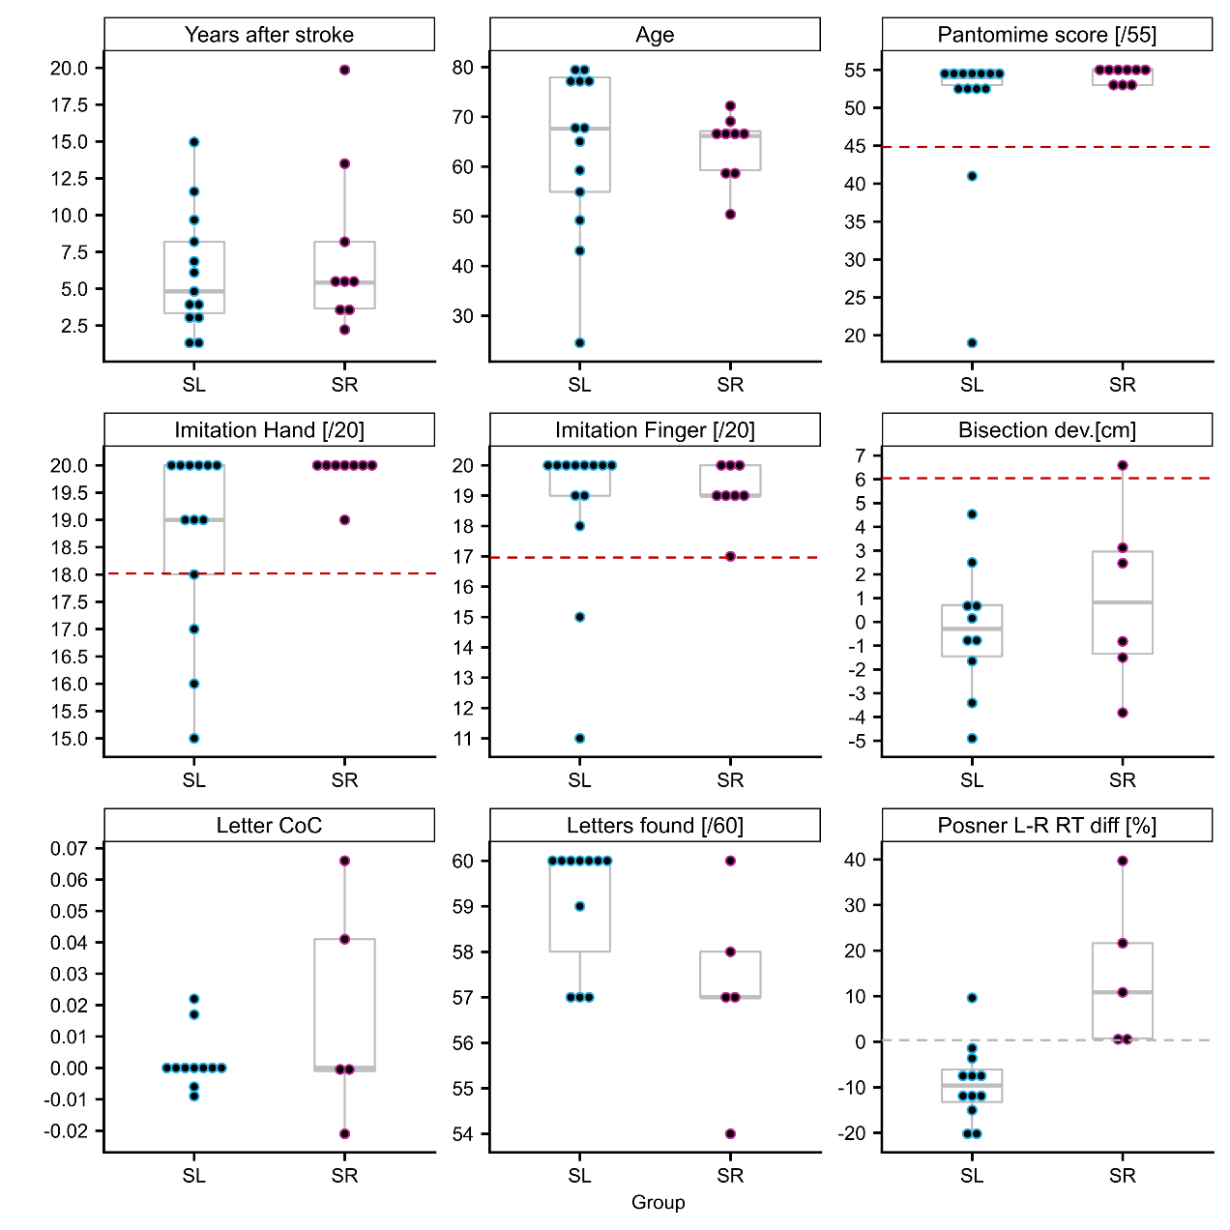
Supplementary Figure S 1: Demographics and clinical test results in left- and right hemisphere stroke patients. Red dashed lines delineate the boundaries of the normal range (inclusive). All participants performed within the normal range in the letter cancellation test (CoC ≤ 0.083).

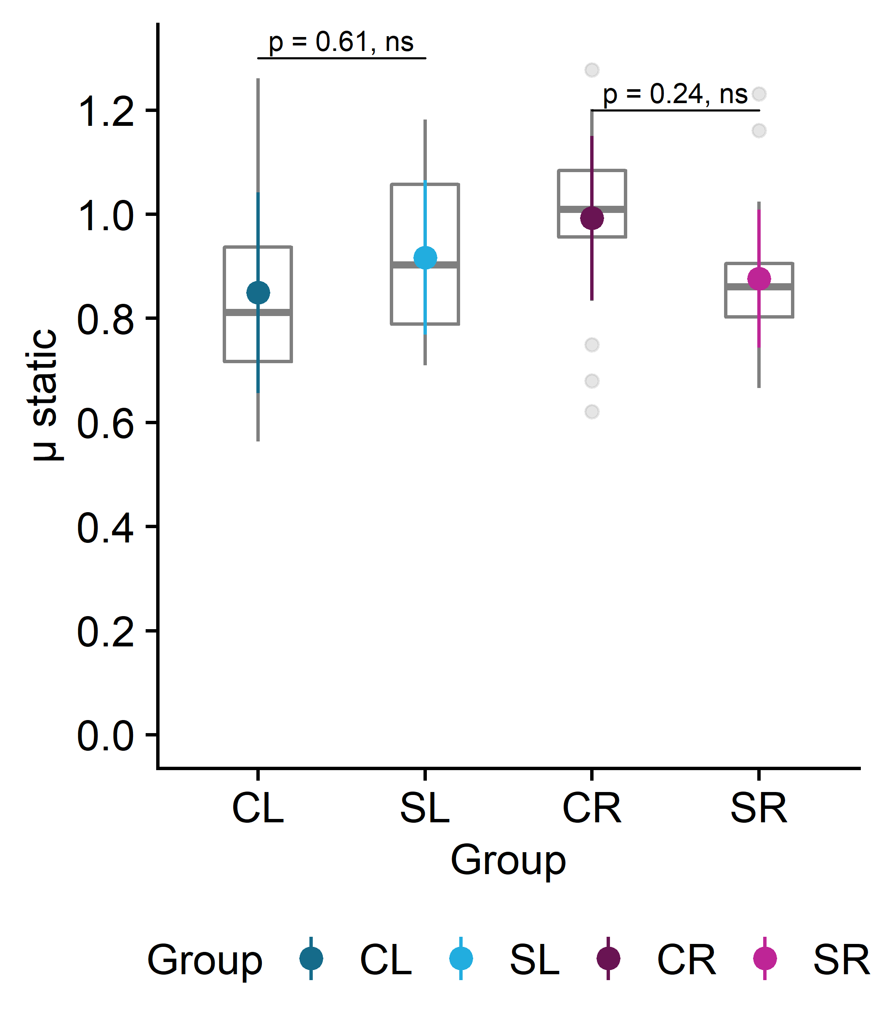
Supplementary Figure S 2: Coefficients of static friction as assessed by object slip trials. Holm-adjusted p-values of post-hoc t-tests of pairwise differences between controls and left- respectively right-hemispheric stroke patients. The groups’ mean coefficients of friction did not significantly differ.

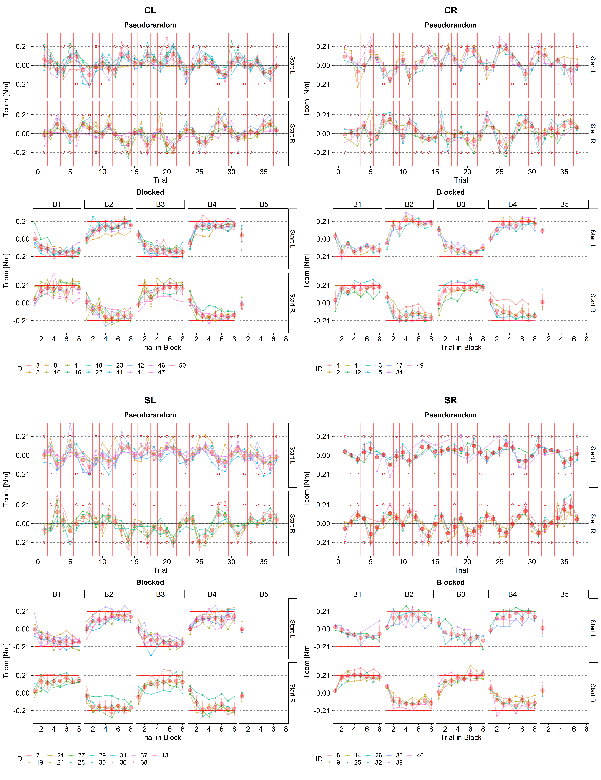Supplementary Figure S 3: Individual and group averaged trajectories of Tcom of all trials in the no cues condition depicted for each group (CL: Controls, left hand, CR: Controls, right hand; SL: Left hemispheric stroke; SR: Right hemispheric stroke).
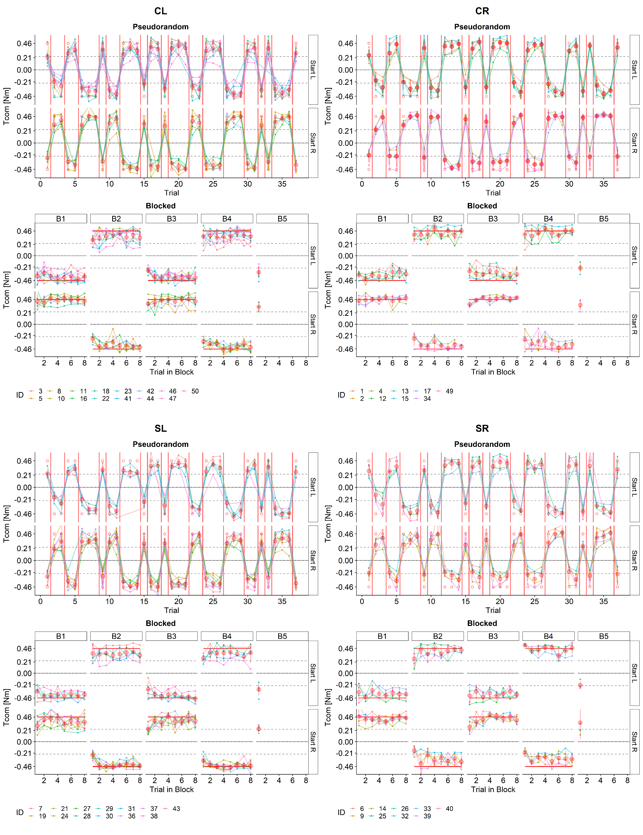Supplementary Figure S 4: Individual and group averaged trajectories of Tcom of all trials in the geometric cues condition depicted for each group (CL: Controls, left hand, CR: Controls, right hand; SL: Left hemispheric stroke; SR: Right hemispheric stroke).
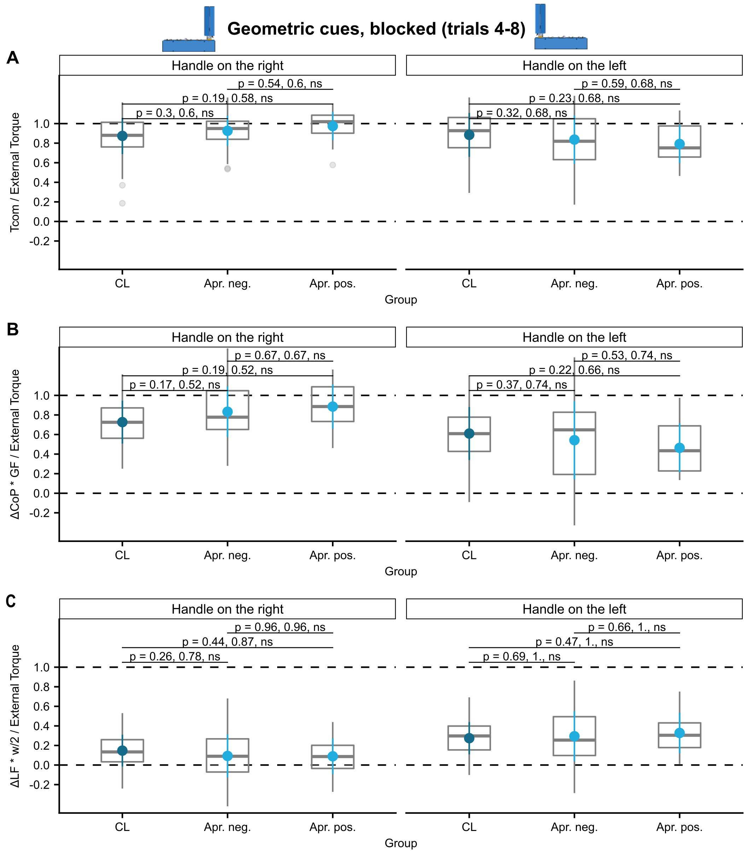
Supplementary Figure S 5: Differences of torques at lift-off between CL, and SL patients with and without signs of apraxia in the blocked, geometric-cues condition. (A), ΔCoP * GF / External Torque (B), and ΔFy * 0.5*w / External Torque (C) for trials 4 to 8 of blocks in the ‘no cues’ condition are depicted for each group together with unadjusted- and Holm-adjusted p-values of post-hoc t-tests of pairwise differences.

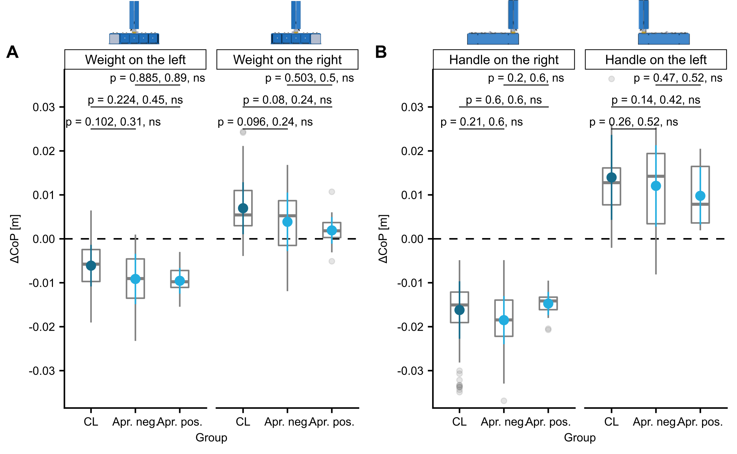
Supplementary Figure S 6: Differences of ∆CoP at lift-off between CL, and SL patients with and without signs of apraxia in the blocked, geometric-cues condition. (A) , ΔCoP * GF / External Torque (B), and ΔFy * 0.5*w / External Torque (C) for trials 4 to 8 of blocks in the ‘no cues’ condition are depicted for each group together with unadjusted- and Holm-adjusted p-values of post-hoc t-tests of pairwise differences.

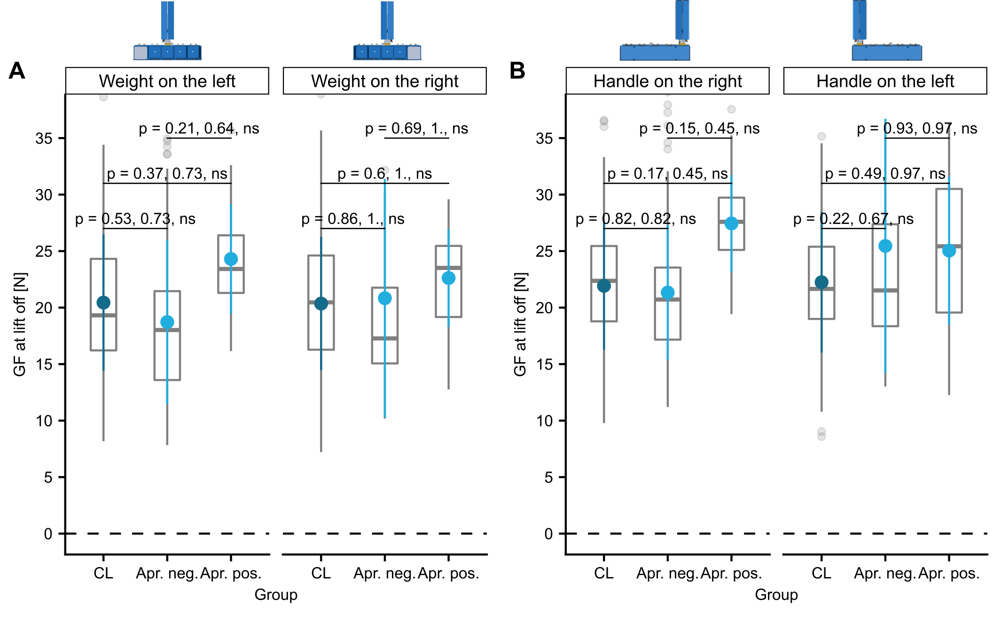
Supplementary Figure S 7: Differences of GF at lift-off between CL, and SL patients with and without signs of apraxia in the blocked, geometric-cues condition. (A) , ΔCoP * GF / External Torque (B), and ΔFy * 0.5*w / External Torque (C) for trials 4 to 8 of blocks in the ‘no cues’ condition are depicted for each group together with unadjusted- and Holm-adjusted p-values of post-hoc t-tests of pairwise differences.

Supplementary Tables
Supplementary Table S 1: Demographic and clinical information for all participating stroke patients, including results from hand-and finger imitation and pantomime of tool-use test of G.Goldenberg as well as results of line bisection-, letter cancellation- and a Posner type reaction time tests. Clinical and radiological data were summarized from the available medical reports.
Abbreviations: YOS: years since onset of stroke. Type: i = ischemic; h = hemorrhagic (ICH: intracerebral hemorrhage, SAH: subarachnoid hemorrhage); if two types are given, the first indicates the primary stroke type and the second a subsequent complication (e.g. i, h: ischemic stroke and post ischemic hemorrhage; Side: SL left hemispheric stroke, SR: right hemispheric stroke. Cort./subc.: cort. Cortex is affected, subc.: subcortical structures affected. Location: ACA: anterior cerebral artery, MCA: medial cerebral artery, PCA: posterior cerebral artery, part. = partial, inc. = incomplete, compl. = complete, terr. = territoritorial infarction in in the supply area of the respective artery, i.c. = internal capsule, put. = putamen, post. c. = post central, op. = opercular, f.b. =fronto-basal, ins. = insular, p. = parietal, t.p. = temporo-parietal, t.o. = temporo-occipital, p.o. = parietooccipital, cort. = cortex, pall. = pallidum, med. l. = medullary layer, BG = basal ganglia, periv. = periventricular, , th. = thalamus, Letter: Letter cancellation test, CoC: Center of Cancellation, Posner: Posner reaction time test, median reaction time for stimuli on left (L) and right (R). Protocol: Experimental Protocol indicating order of visual (V) and no-cue (N) conditions as well as first side of CoM in the first trial of the respective experimental condition (L: left, R: right).

ID | Gender | Age | YOS | Stroke Lesion |  |  |  | mRS | Pantomime |  | Imitation |  | Bisect. Dev. | Letter |  | Posner |  | Protocol | Max GF
 |  |  |  | Type | Side | cort./ subc. | Location: |  | Correct items [/20] | Score [/55] | Hand [/20] | Finger [/20] | [mm] | CoC | found [/60] | L [ms] | R [ms] |  | [N]
7 | f | 67.9 | 4.2 | i | SL | subc. | i.c., put. | 2 | 19 | 54 | 20 | 20 | 0.15 | 0.000 | 60 | 467.5 | 573.5 | VLNR | 43.4
19 | m | 59.2 | 8.2 | i | SL | cort., subc. | Part. MCA terr. (post.c.-,op.-,f.b.-ins.cort., BG, pall., med. l.) | 2 | 20 | 55 | 19 | 19 | 2.50 | 0.000 | 60 | 329.5 | 383.0 | VRNL | 98.5
21 | f | 65.0 | 15.0 | h, i | SL | subc. | Part. MCA terr. (BG, med. l. ) | 3 | 20 | 55 | 20 | 20 | 0.76 | -0.009 | 59 | 558.0 | 566.0 | NRVR | 34.7
24 | f | 67.6 | 3.7 | i | SL | cort., subc. | Inc. MCA terr. (fr., p., t.p.-lobes, periv., med. l., i.c.) | 3 | 11 | 41 | 16 | 16 | NA | NA | NA | 943.0 | 978.0 | NLVR | 57.7
27 | m | 77.9 | 6.9 | i | SL | cort., subc. | Inc. MCA terr. | 4 | 3 | 19 | 15 | 15 | -3.41 | 0.017 | 57 | 677.5 | 828.5 | VRNR | 59.0
28 | f | 43.1 | 9.7 | i | SL | cort., subc. | Part. MCA terr. (op. cort., BG) | 2 | 20 | 53 | 20 | 20 | -1.65 | NA | NA | 312.5 | 335.5 | NRVL | 51.0
29 | m | 78.0 | 6.1 | i, h | SL | cort., subc. | Part. MCA terr. (t.o. lobe (h)) | 1 | 19 | 54 | 19 | 19 | 4.53 | -0.006 | 57 | 561.5 | 628.0 | VRNR | 72.4
30 | m | 49.2 | 2.7 | i | SL | cort., subc. | MCA terr. | 2 | 18 | 53 | 20 | 20 | NA | 0.000 | 60 | 382.5 | 431.0 | NLVL | 69.2
31 | m | 79.1 | 3.4 | i | SL | cort., subc. | Part. MCA terr. (p.-, t. lobes , BG) | 3 | 19 | 54 | 20 | 20 | -0.82 | 0.022 | 57 | 461.0 | 499.5 | VLNL | 94.8
36 | m | 54.9 | 1.5 | iI | SL | cort., subc. | Part. PCA terr. | 2 | 20 | 55 | 20 | 20 | 0.58 | 0.000 | 60 | 485.0 | 520.0 | VRNL | 97.2
37 | f | 76.3 | 4.8 | i | SL | cort., subc. | Inc. MCA terr. | 3 | 20 | 55 | 19 | 19 | -4.90 | 0.000 | 60 | 486.5 | 552.0 | NLVR | 55.2
38 | m | 79.8 | 1.1 | i | SL | subc. | Part. MCA terr (i.c.) | 2 | 18 | 53 | 18 | 18 | -0.74 | 0.000 | 60 | 741.5 | 673.5 | VLNL | 83.0
43 | f | 24.5 | 11.6 | h, i | SL | cort., subc. | Part. MCA terr. | 2 | 17 | 52 | 17 | 17 | NA | 0.000 | 60 | NA | NA | NLVR | 63.0
6 | f | 59.3 | 3.7 | h | SR | subc. | ICB Th, SAB fr., p.o. lobe | 2 | 20 | 55 | NA | NA | NA | NA | NA | NA | NA | NRVR | 79.0
9 | f | 50.4 | 13.5 | i | SR | cort., subc. | Inc. MCA terr. | 2 | 20 | 55 | 20 | 20 | 6.59 | 0.000 | 60 | 538.0 | 433.0 | VRNR | 53.6
14 | m | 66.0 | 5.4 | i | SR | subc. | Pons | 1 | 20 | 55 | 20 | 20 | NA | NA | NA | 405.0 | 402.0 | NRVR | 93.3
25 | m | 72.2 | 2.2 | i | SR | cort., subc. | Inc. MCA terr. | 2 | 18 | 53 | 20 | 20 | -0.82 | 0.041 | 57 | NA | NA | NLVL | 67.4
26 | f | 69.1 | 5.2 | h | SR | subc. | t.p. lobe | 3 | 20 | 55 | 20 | 20 | -3.82 | NA | NA | 739.5 | 494.5 | VLNR | 37.8
32 | m | 66.4 | 3.5 | i | SR | cort., subc. | f.-, p.o. lobes | 1 | 20 | 55 | 20 | 20 | -1.50 | 0.066 | 54 | 460.5 | 459.0 | VRNL | 62.4
33 | f | 66.1 | 5.8 | I | SR | cort., subc. | Compl. MCA, PCA-, inc. ACA terr. | 4 | 18 | 53 | 20 | 20 | NA | NA | NA | NA | NA | NLVL | 63.3
39 | f | 67.1 | 19.9 | h | SR | cort., subc. | Compl. MCA terr. | 4 | 18 | 53 | 19 | 19 | 3.12 | -0.001 | 57 | NA | NA | VRNL | 60.1
40 | m | 58.0 | 8.2 | h | SR | subc. | BG, medull..l, | 1 | 20 | 55 | 20 | 20 | 2.47 | -0.021 | 58 | 428.0 | 384.0 | VLNR | 76.9

Supplementary Table S 2: Results of the linear mixed effects model (LMM) of Tcom/ External Torque of trials 4-8 in the no-cues, blocked condition
 | $$\frac{Tcom}{External Torque}$$
Predictors | Estimates | std. Error | CI | Statistic | p | df
(Intercept) | 0.723 | 0.042 | 0.640 – 0.807 | 17.367 | <0.001 | 54.215
Ext. Torque [0.21 Nm] | 0.049 | 0.029 | -0.008 – 0.107 | 1.686 | 0.092 | 858.017
Group [SL] | 0.051 | 0.061 | -0.072 – 0.174 | 0.834 | 0.408 | 54.215
Group [CR] | -0.071 | 0.068 | -0.207 – 0.066 | -1.041 | 0.302 | 54.407
Group [SR] | -0.236 | 0.068 | -0.373 – -0.098 | -3.442 | 0.001 | 55.429
Ext. Torque [0.21 Nm] x  Group [SL] | -0.158 | 0.043 | -0.242 – -0.074 | -3.689 | <0.001 | 858.017
Ext. Torque [0.21 Nm] x  Group [CR] | 0.198 | 0.048 | 0.104 – 0.291 | 4.133 | <0.001 | 858.058
Ext. Torque [0.21 Nm] x  Group [SR] | 0.288 | 0.049 | 0.193 – 0.384 | 5.922 | <0.001 | 858.168
Random Effects
σ² | 0.06
τ₀₀ _{ID} | 0.02
ICC | 0.23
N _{ID} | 46
Observations | 908
Marginal R² / Conditional R² | 0.116 / 0.323

Supplementary Table S 3: Post-hoc t-tests of pairwise comparisons between stroke patient- and hand-matched control groups based on the marginal means of the LMM of Tcom/ External Torque of trials 4-8 in the no-cues, blocked condition with Holm-Bonferroni correction for multiple testing applied
groups | external torque | df | t-statistic | p | p (Holm-adjusted) | p.adj.signif
CL, SL | -0.21 | 54.215 | -0.83 | 0.408 | 0.408 | ns
CR, SR | -0.21 | 55.340 | 2.15 | 0.036 | 0.071 | ns
CL, SL | 0.21 | 54.215 | 1.75 | 0.085 | 0.17 | ns
CR, SR | 0.21 | 55.444 | 0.97 | 0.338 | 0.338 | ns

Supplementary Table S 4: Results of the linear mixed effects model (LMM) of ∆CoP x GF/ External Torque of trials 4-8 in the no-cues, blocked condition
 | $$\frac{ΔCoP *GF}{External Torque}$$
Predictors | Estimates | std. Error | CI | Statistic | p | df
(Intercept) | 0.536 | 0.056 | 0.426 – 0.647 | 9.661 | <0.001 | 65.455
Ext. Torque [0.21 Nm] | 0.070 | 0.050 | -0.029 – 0.168 | 1.394 | 0.164 | 858.047
Group [SL] | 0.334 | 0.081 | 0.172 – 0.497 | 4.103 | <0.001 | 65.455
Group [CR] | -0.006 | 0.091 | -0.187 – 0.175 | -0.065 | 0.948 | 65.832
Group [SR] | -0.227 | 0.092 | -0.409 – -0.044 | -2.474 | 0.016 | 67.560
Ext. Torque [0.21 Nm] x  Group [SL] | -0.709 | 0.074 | -0.853 – -0.564 | -9.624 | <0.001 | 858.047
Ext. Torque [0.21 Nm] x  Group [CR] | 0.014 | 0.082 | -0.147 – 0.175 | 0.171 | 0.864 | 858.121
Ext. Torque [0.21 Nm] x  Group [SR] | 0.264 | 0.084 | 0.099 – 0.428 | 3.153 | 0.002 | 858.271
Random Effects
σ² | 0.19
τ₀₀ _{ID} | 0.03
ICC | 0.13
N _{ID} | 46
Observations | 908
Marginal R² / Conditional R² | 0.144 / 0.253

Supplementary Table S 5: Post-hoc t-tests of pairwise comparisons based on the LMM of ∆CoP x GF/ External Torque of trials 4-8 in the no-cues, blocked condition.
groups | external torque | df | t-statistic | p | p (Holm-adjusted) | p.adj.signif
CL, SL | -0.21 | 65.455 | -4.10 | <0.001 | <0.001 | ***
CR, SR | -0.21 | 67.442 | 2.16 | 0.035 | 0.035 | *
CL, SL | 0.21 | 65.455 | 4.59 | <0.001 | <0.001 | ****
CR, SR | 0.21 | 67.532 | -0.28 | 0.779 | 0.779 | ns
Supplementary Table S 6: Results of the linear mixed effects model (LMM) of ∆Fy x 0.5w/ External Torque of trials 4-8 in the no-cues, blocked condition
 | $$\frac{ΔFy*w/2}{External Torque}$$
Predictors | Estimates | std. Error | CI | Statistic | p | df
(Intercept) | 0.187 | 0.036 | 0.115 – 0.259 | 5.161 | <0.001 | 98.184
Ext. Torque [0.21 Nm] | -0.021 | 0.043 | -0.105 – 0.064 | -0.479 | 0.632 | 858.140
Group [SL] | -0.283 | 0.053 | -0.389 – -0.178 | -5.332 | <0.001 | 98.184
Group [CR] | -0.065 | 0.059 | -0.182 – 0.053 | -1.093 | 0.277 | 99.109
Group [SR] | -0.005 | 0.060 | -0.124 – 0.114 | -0.079 | 0.938 | 102.095
Ext. Torque [0.21 Nm] x  Group [SL] | 0.551 | 0.063 | 0.426 – 0.675 | 8.684 | <0.001 | 858.140
Ext. Torque [0.21 Nm] x  Group [CR] | 0.183 | 0.071 | 0.045 – 0.322 | 2.594 | 0.010 | 858.296
Ext. Torque [0.21 Nm] x  Group [SR] | 0.026 | 0.072 | -0.116 – 0.167 | 0.356 | 0.722 | 858.449
Random Effects
σ² | 0.14
τ₀₀ _{ID} | 0.01
ICC | 0.04
N _{ID} | 46
Observations | 908
Marginal R² / Conditional R² | 0.129 / 0.163

Supplementary Table S 7: Post-hoc t-tests of pairwise comparisons based on the LMM of ∆Fy x 0.5w/ External Torque of trials 4-8 in the no-cues, blocked condition.
groups | external torque | df | t-statistic | p | p (Holm-adjusted) | p.adj.signif
CL, SL | -0.21 | 98.184 | 5.33 | <0.001 | <0.001 | ****
CR, SR | -0.21 | 102.057 | -0.90 | 0.37 | 0.37 | ns
CL, SL | 0.21 | 98.184 | -5.03 | <0.001 | <0.001 | ****
CR, SR | 0.21 | 101.765 | 1.45 | 0.15 | 0.15 | ns

Supplementary Table S 8: Results of the linear mixed effects model (LMM) of Tcom/ External Torque of the first trial following a CoM change in the no-cues, blocked condition.
 | $$\frac{Tcom}{External Torque}$$
Predictors | Estimates | std. Error | CI | Statistic | p | df
(Intercept) | -0.170 | 0.057 | -0.284 – -0.056 | -2.954 | 0.004 | 95.447
Ext. Torque [0.21 Nm] | 0.054 | 0.070 | -0.085 – 0.193 | 0.764 | 0.446 | 132.120
Group [SL] | 0.171 | 0.084 | 0.004 – 0.338 | 2.028 | 0.045 | 95.447
Group [CR] | -0.172 | 0.094 | -0.358 – 0.014 | -1.833 | 0.070 | 95.447
Group [SR] | -0.081 | 0.095 | -0.270 – 0.108 | -0.847 | 0.399 | 98.375
Ext. Torque [0.21 Nm] x  Group [SL] | -0.133 | 0.103 | -0.337 – 0.071 | -1.288 | 0.200 | 132.120
Ext. Torque [0.21 Nm] x  Group [CR] | 0.239 | 0.115 | 0.012 – 0.466 | 2.080 | 0.039 | 132.120
Ext. Torque [0.21 Nm] x  Group [SR] | 0.268 | 0.117 | 0.036 – 0.499 | 2.289 | 0.024 | 132.120
Random Effects
σ² | 0.07
τ₀₀ _{ID} | 0.01
ICC | 0.14
N _{ID} | 46
Observations | 182
Marginal R² / Conditional R² | 0.132 / 0.256

Supplementary Table S 9: Post-hoc t-tests of pairwise comparisons based on the LMM of Tcom/ External Torque of the first trial following a CoM change in the no-cues, blocked condition.
groups | external torque | df | t-statistic | p | p (Holm-adjusted) | p.adj.signif
CL, SL | -0.21 | 95.447 | -2.03 | 0.045 | 0.091 | ns
CR, SR | -0.21 | 97.797 | -0.86 | 0.392 | 0.392 | ns
CL, SL | 0.21 | 95.447 | -0.45 | 0.653 | 0.653 | ns
CR, SR | 0.21 | 97.797 | -1.13 | 0.261 | 0.522 | ns

Supplementary Table S 10: Results of the linear mixed effects model (LMM) of ∆CoP x GF/ External Torque of the first trial following a CoM change in the no-cues, blocked condition.
 | $$\frac{ΔCoP *GF}{External Torque}$$
Predictors | Estimates | std. Error | CI | Statistic | p | df
(Intercept) | -0.134 | 0.080 | -0.292 – 0.024 | -1.673 | 0.097 | 126.196
Ext. Torque [0.21 Nm] | -0.020 | 0.113 | -0.244 – 0.203 | -0.181 | 0.857 | 132.220
Group [SL] | 0.329 | 0.117 | 0.097 – 0.561 | 2.807 | 0.006 | 126.196
Group [CR] | -0.043 | 0.130 | -0.302 – 0.215 | -0.333 | 0.739 | 126.196
Group [SR] | -0.049 | 0.133 | -0.312 – 0.214 | -0.367 | 0.715 | 128.690
Ext. Torque [0.21 Nm] x  Group [SL] | -0.521 | 0.166 | -0.849 – -0.193 | -3.145 | 0.002 | 132.220
Ext. Torque [0.21 Nm] x  Group [CR] | 0.002 | 0.184 | -0.363 – 0.366 | 0.008 | 0.993 | 132.220
Ext. Torque [0.21 Nm] x  Group [SR] | 0.244 | 0.188 | -0.128 – 0.615 | 1.298 | 0.196 | 132.220
Random Effects
σ² | 0.19
τ₀₀ _{ID} | 0.00
N _{ID} | 46
Observations | 182
Marginal R² / Conditional R² | 0.118 / NA

Supplementary Table S 11: Post-hoc t-tests of pairwise comparisons based on the LMM of ∆CoP x GF/ External Torque of the first trial following a CoM change in the no-cues, blocked condition.
groups | external torque | df | t-statistic | p | p (Holm-adjusted) | p.adj.signif
CL, SL | -0.21 | 126.196 | -2.81 | 0.0058 | 0.012 | *
CR, SR | -0.21 | 128.205 | 0.04 | 0.972 | 0.972 | ns
CL, SL | 0.21 | 126.196 | 1.64 | 0.1034 | 0.207 | ns
CR, SR | 0.21 | 128.205 | -1.60 | 0.1115 | 0.207 | ns

Supplementary Table S 12: Results of the linear mixed effects model (LMM) of ∆Fy x 0.5w/ External Torque of the first trial following a CoM change in the no-cues, blocked condition.
 | $$\frac{ΔFy*w/2}{External Torque}$$
Predictors | Estimates | std. Error | CI | Statistic | p | df
(Intercept) | -0.036 | 0.069 | -0.173 – 0.101 | -0.520 | 0.604 | 126.196
Ext. Torque [0.21 Nm] | 0.074 | 0.098 | -0.120 – 0.268 | 0.757 | 0.451 | 132.220
Group [SL] | -0.158 | 0.102 | -0.359 – 0.043 | -1.554 | 0.123 | 126.196
Group [CR] | -0.128 | 0.113 | -0.352 – 0.096 | -1.135 | 0.259 | 126.196
Group [SR] | -0.031 | 0.115 | -0.259 – 0.197 | -0.268 | 0.789 | 128.690
Ext. Torque [0.21 Nm] x  Group [SL] | 0.388 | 0.144 | 0.104 – 0.673 | 2.699 | 0.008 | 132.220
Ext. Torque [0.21 Nm] x  Group [CR] | 0.237 | 0.160 | -0.079 – 0.554 | 1.482 | 0.141 | 132.220
Ext. Torque [0.21 Nm] x  Group [SR] | 0.024 | 0.163 | -0.299 – 0.346 | 0.146 | 0.884 | 132.220
Random Effects
σ² | 0.14
τ₀₀ _{ID} | 0.00
N _{ID} | 46
Observations | 182
Marginal R² / Conditional R² | 0.130 / NA

Supplementary Table S 13: Post-hoc t-tests of pairwise comparisons based on the LMM of ∆Fy x 0.5w/ External Torque of the first trial following a CoM change in the no-cues, blocked condition.
groups | external torque | df | t-statistic | p | p (Holm-adjusted) | p.adj.signif
CL, SL | -0.21 | 126.196 | 1.55 | 0.123 | 0.246 | ns
CR, SR | -0.21 | 128.205 | -0.76 | 0.449 | 0.449 | ns
CL, SL | 0.21 | 126.196 | -2.26 | 0.025 | 0.051 | ns
CR, SR | 0.21 | 128.205 | 0.90 | 0.368 | 0.368 | ns

Supplementary Table S 14: Results of the linear mixed effects model (LMM) of Tcom/ External Torque for the no-cues, pseudorandom condition.
 | 𝐓_{𝐜𝐨𝐦}𝐄𝐱𝐭𝐞𝐫𝐧𝐚𝐥 𝐓𝐨𝐫𝐪𝐮𝐞
Predictors | Estimates | std. Error | CI | Statistic | p | df
(Intercept) | 0.396 | 0.031 | 0.335 – 0.457 | 12.852 | <0.001 | 236.900
Ext. Torque [0.21 Nm] | 0.045 | 0.039 | -0.032 – 0.121 | 1.147 | 0.252 | 1568.283
CoM inversed | -0.558 | 0.039 | -0.634 – -0.482 | -14.385 | <0.001 | 1568.125
Group [SL] | 0.077 | 0.045 | -0.012 – 0.166 | 1.695 | 0.091 | 236.900
Group [CR] | -0.088 | 0.050 | -0.187 – 0.012 | -1.736 | 0.084 | 239.527
Group [SR] | -0.005 | 0.051 | -0.106 – 0.095 | -0.103 | 0.918 | 246.201
Ext. Torque [0.21 Nm] x  CoM inversed | 0.072 | 0.055 | -0.036 – 0.180 | 1.305 | 0.192 | 1568.271
Ext. Torque [0.21 Nm] x  Group [SL] | -0.127 | 0.057 | -0.238 – -0.015 | -2.222 | 0.026 | 1568.198
Ext. Torque [0.21 Nm] x  Group [CR] | 0.259 | 0.063 | 0.135 – 0.384 | 4.081 | <0.001 | 1568.338
Ext. Torque [0.21 Nm] x  Group [SR] | 0.044 | 0.065 | -0.083 – 0.170 | 0.679 | 0.497 | 1568.346
CoM inversed x  Group [SL] | 0.027 | 0.057 | -0.085 – 0.138 | 0.468 | 0.640 | 1568.125
CoM inversed x  Group [CR] | -0.060 | 0.064 | -0.185 – 0.065 | -0.940 | 0.347 | 1568.633
CoM inversed x  Group [SR] | -0.033 | 0.064 | -0.159 – 0.094 | -0.504 | 0.614 | 1568.459
(Ext. Torque [0.21 Nm] x  CoM inversed x  Group [SL] | -0.027 | 0.081 | -0.185 – 0.131 | -0.338 | 0.735 | 1568.193
(Ext. Torque [0.21 Nm] x  CoM inversed x  Group [CR] | -0.141 | 0.090 | -0.317 – 0.036 | -1.561 | 0.119 | 1568.354
(Ext. Torque [0.21 Nm] x  CoM inversed x  Group [SR] | 0.055 | 0.092 | -0.124 – 0.235 | 0.604 | 0.546 | 1569.110
Random Effects
σ² | 0.10
τ₀₀ _{ID} | 0.00
ICC | 0.03
N _{ID} | 46
Observations | 1626
Marginal R² / Conditional R² | 0.437 / 0.453

Supplementary Table S 15: Post-hoc t-tests of pairwise comparisons based on the LMM of Tcom/ External Torque for the no-cues, pseudorandom condition.
groups | CoM action | external torque | df | t-statistic | p | p (Holm-adjusted) | p.adj.signif
CL, SL | CoM inversed | -0.21 | 236.900 | -2.28 | 0.023 | 0.046 | *
CR, SR | CoM inversed | -0.21 | 250.103 | -1.91 | 0.057 | 0.057 | ns
CL, SL | CoM inversed | 0.21 | 240.456 | 1.11 | 0.267 | 0.267 | ns
CR, SR | CoM inversed | 0.21 | 252.862 | -1.57 | 0.119 | 0.238 | ns
CL, SL | CoM retained | -0.21 | 236.900 | -1.70 | 0.091 | 0.183 | ns
CR, SR | CoM retained | -0.21 | 246.451 | -1.44 | 0.15 | 0.183 | ns
CL, SL | CoM retained | 0.21 | 238.062 | 1.10 | 0.271 | 0.271 | ns
CR, SR | CoM retained | 0.21 | 246.735 | 2.33 | 0.021 | 0.041 | *

Supplementary Table S 16: Results of the linear mixed effects model (LMM) of ∆CoP x GF/ External Torque for the no-cues, pseudorandom condition.
 | _{𝚫𝐂𝐨𝐏 ∗𝐆𝐅}𝐄𝐱𝐭𝐞𝐫𝐧𝐚𝐥 𝐓𝐨𝐫𝐪𝐮𝐞
Predictors | Estimates | std. Error | CI | Statistic | p | df
(Intercept) | 0.676 | 0.044 | 0.588 – 0.764 | 15.390 | <0.001 | 62.251
ExtTorque_F [0.46] | -0.062 | 0.031 | -0.121 – -0.002 | -2.018 | 0.044 | 1568.054
CoM inversed | -0.126 | 0.030 | -0.185 – -0.066 | -4.126 | <0.001 | 1568.085
Group [SL] | 0.104 | 0.065 | -0.025 – 0.233 | 1.612 | 0.112 | 62.423
Group [CR] | -0.087 | 0.072 | -0.231 – 0.056 | -1.218 | 0.228 | 61.963
Group [SR] | -0.076 | 0.072 | -0.220 – 0.067 | -1.063 | 0.292 | 62.195
ExtTorque_F [0.46] x  CoM inversed | 0.013 | 0.043 | -0.072 – 0.097 | 0.294 | 0.769 | 1568.041
ExtTorque_F [0.46] x  Group [SL] | -0.195 | 0.045 | -0.284 – -0.106 | -4.309 | <0.001 | 1568.431
ExtTorque_F [0.46] x  Group [CR] | 0.127 | 0.049 | 0.030 – 0.224 | 2.573 | 0.010 | 1568.021
ExtTorque_F [0.46] x  Group [SR] | 0.115 | 0.050 | 0.018 – 0.213 | 2.330 | 0.020 | 1568.044
CoM inversed x  Group [SL] | -0.075 | 0.045 | -0.163 – 0.012 | -1.683 | 0.093 | 1568.081
CoM inversed x  Group [CR] | -0.039 | 0.050 | -0.136 – 0.058 | -0.785 | 0.432 | 1568.055
CoM inversed x  Group [SR] | -0.029 | 0.050 | -0.126 – 0.069 | -0.573 | 0.566 | 1568.165
Ext. Torque [0.46 Nm] x  CoM inversed *  Group [SL] | 0.070 | 0.063 | -0.055 – 0.194 | 1.095 | 0.274 | 1568.117
Ext. Torque [0.46 Nm] *  CoM inversed x  Group [CR] | 0.035 | 0.070 | -0.102 – 0.172 | 0.501 | 0.617 | 1568.027
Ext. Torque [0.46 Nm] *  CoM inversed x  Group [SR] | -0.031 | 0.070 | -0.168 – 0.107 | -0.441 | 0.659 | 1568.083
Random Effects
σ² | 0.06
τ₀₀ _{ID} | 0.02
ICC | 0.26
N _{ID} | 46
Observations | 1626
Marginal R² / Conditional R² | 0.104 / 0.340

Supplementary Table S 17: Post-hoc t-tests of pairwise comparisons based on the LMM of ∆CoP x GF/ External Torque for the no-cues, pseudorandom condition.
groups | CoM action | external torque | df | t-statistic | p | p (Holm-adjusted) | p.adj.signif
CL, SL | CoM inversed | -0.21 | 528.961 | -4.22 | <0.001 | <0.001 | ****
CR, SR | CoM inversed | -0.21 | 549.995 | -1.42 | 0.157 | 0.157 | ns
CL, SL | CoM inversed | 0.21 | 536.541 | 4.79 | <0.001 | <0.001 | ****
CR, SR | CoM inversed | 0.21 | 547.405 | -1.67 | 0.096 | 0.096 | ns
CL, SL | CoM retained | -0.21 | 528.961 | -4.28 | <0.001 | <0.001 | ****
CR, SR | CoM retained | -0.21 | 545.217 | 0.09 | 0.932 | 0.932 | ns
CL, SL | CoM retained | 0.21 | 531.415 | 3.72 | <0.001 | <0.001 | ***
CR, SR | CoM retained | 0.21 | 546.011 | 0.65 | 0.517 | 0.517 | ns

Supplementary Table S 18: Results of the linear mixed effects model (LMM) of ∆Fy x 0.5w/ External Torque for the no-cues, pseudorandom condition.

 | $$\frac{ΔFy*w/2}{External Torque}$$
Predictors | Estimates | std. Error | CI | Statistic | p | df
(Intercept) | 0.092 | 0.033 | 0.028 – 0.157 | 2.809 | 0.005 | 528.961
Ext. Torque [0.21 Nm] | 0.057 | 0.047 | -0.035 – 0.148 | 1.217 | 0.224 | 1568.590
CoM inversed | -0.152 | 0.047 | -0.243 – -0.061 | -3.269 | 0.001 | 1568.283
Group [SL] | -0.162 | 0.048 | -0.257 – -0.067 | -3.349 | 0.001 | 528.961
Group [CR] | -0.123 | 0.054 | -0.229 – -0.017 | -2.272 | 0.023 | 534.519
Group [SR] | -0.035 | 0.055 | -0.143 – 0.072 | -0.650 | 0.516 | 543.759
Ext. Torque [0.21 Nm] x  CoM inversed | 0.027 | 0.066 | -0.102 – 0.157 | 0.412 | 0.680 | 1568.575
Ext. Torque [0.21 Nm] x  Group [SL] | 0.319 | 0.068 | 0.185 – 0.453 | 4.665 | <0.001 | 1568.426
Ext. Torque [0.21 Nm] x  Group [CR] | 0.265 | 0.076 | 0.116 – 0.415 | 3.480 | 0.001 | 1568.706
Ext. Torque [0.21 Nm] x  Group [SR] | 0.089 | 0.077 | -0.062 – 0.241 | 1.155 | 0.248 | 1568.721
CoM inversed x  Group [SL] | 0.031 | 0.068 | -0.103 – 0.164 | 0.447 | 0.655 | 1568.283
CoM inversed x  Group [CR] | 0.034 | 0.076 | -0.116 – 0.184 | 0.446 | 0.656 | 1569.289
CoM inversed x  Group [SR] | -0.046 | 0.077 | -0.197 – 0.106 | -0.590 | 0.555 | 1568.649
Ext. Torque [0.21 Nm] x  CoM inversed x  Group [SL] | 0.029 | 0.097 | -0.160 – 0.219 | 0.304 | 0.761 | 1568.419
Ext. Torque [0.21 Nm] x  CoM inversed x  Group [CR] | -0.106 | 0.108 | -0.318 – 0.106 | -0.981 | 0.326 | 1568.741
Ext. Torque [0.21 Nm] x  CoM inversed x  Group [SR] | 0.032 | 0.110 | -0.184 – 0.248 | 0.289 | 0.773 | 1569.578
Random Effects
σ² | 0.15
τ₀₀ _{ID} | 0.00
N _{ID} | 46
Observations | 1626
Marginal R² / Conditional R² | 0.134 / NA

Supplementary Table S 19: Post-hoc t-tests of pairwise comparisons based on the LMM of ∆Fy x 0.5w/ External Torque for the no-cues, pseudorandom condition.
groups | CoM action | external torque | df | t-statistic | p | p (Holm-adjusted) | p.adj.signif
CL, SL | CoM inversed | -0.21 | 528.961 | 2.72 | 0.0068 | 0.0136 | *
CR, SR | CoM inversed | -0.21 | 549.995 | -0.12 | 0.9048 | 0.9048 | ns
CL, SL | CoM inversed | 0.21 | 536.541 | -4.47 | <0.001 | <0.001 | ****
CR, SR | CoM inversed | 0.21 | 547.405 | 0.49 | 0.6215 | 0.6215 | ns
CL, SL | CoM retained | -0.21 | 528.961 | 3.35 | <0.001 | 0.0017 | **
CR, SR | CoM retained | -0.21 | 545.217 | -1.43 | 0.1542 | 0.1542 | ns
CL, SL | CoM retained | 0.21 | 531.415 | -3.25 | 0.0012 | 0.0025 | **
CR, SR | CoM retained | 0.21 | 546.011 | 1.45 | 0.1471 | 0.1471 | ns

Supplementary Table S 20: Results of the linear mixed effects model (LMM) of Tcom/ External Torque of trials 4-8 in the geometric cues, blocked condition.
 | $$\frac{Tcom}{External Torque}$$
Predictors | Estimates | std. Error | CI | Statistic | p | df
(Intercept) | 0.875 | 0.030 | 0.814 – 0.936 | 28.744 | <0.001 | 52.748
ExtTorque_F [0.46] | 0.010 | 0.020 | -0.029 – 0.049 | 0.498 | 0.618 | 859.036
Group [SL] | 0.063 | 0.045 | -0.027 – 0.152 | 1.403 | 0.167 | 52.664
Group [CR] | -0.098 | 0.050 | -0.198 – 0.002 | -1.976 | 0.053 | 52.814
Group [SR] | -0.110 | 0.050 | -0.209 – -0.010 | -2.202 | 0.032 | 52.995
ExtTorque_F [0.46] x  Group [SL] | -0.123 | 0.030 | -0.181 – -0.065 | -4.163 | <0.001 | 859.204
ExtTorque_F [0.46] x  Group [CR] | 0.209 | 0.033 | 0.145 – 0.273 | 6.387 | <0.001 | 859.049
ExtTorque_F [0.46] x  Group [SR] | 0.167 | 0.033 | 0.102 – 0.231 | 5.059 | <0.001 | 859.373
Random Effects
σ² | 0.03
τ₀₀ _{ID} | 0.01
ICC | 0.27
N _{ID} | 46
Observations | 909
Marginal R² / Conditional R² | 0.107 / 0.345

Supplementary Table S 21: Post-hoc t-tests of pairwise comparisons based on the LMM of Tcom/ External Torque of trials 4-8 in the geometric cues, blocked condition.
groups | external torque | df | t-statistic | p | p (Holm-adjusted) | p.adj.signif
CL, SL | -0.46 | 52.664 | -1.40 | 0.17 | 0.33 | ns
CR, SR | -0.46 | 52.998 | 0.20 | 0.84 | 0.84 | ns
CL, SL | 0.46 | 53.104 | 1.35 | 0.18 | 0.37 | ns
CR, SR | 0.46 | 52.867 | 0.97 | 0.34 | 0.37 | ns

Supplementary Table S 22: Results of the linear mixed effects model (LMM) of ∆CoP x GF/ External Torque of trials 4-8 in the geometric cues, blocked condition.
 | $$\frac{ΔCoP *GF}{External Torque}$$
Predictors | Estimates | std. Error | CI | Statistic | p | df
(Intercept) | 0.536 | 0.056 | 0.426 – 0.647 | 9.661 | <0.001 | 65.455
Ext. Torque [0.21 Nm] | 0.070 | 0.050 | -0.029 – 0.168 | 1.394 | 0.164 | 858.047
Group [SL] | 0.334 | 0.081 | 0.172 – 0.497 | 4.103 | <0.001 | 65.455
Group [CR] | -0.006 | 0.091 | -0.187 – 0.175 | -0.065 | 0.948 | 65.832
Group [SR] | -0.227 | 0.092 | -0.409 – -0.044 | -2.474 | 0.016 | 67.560
Ext. Torque [0.21 Nm] x  Group [SL] | -0.709 | 0.074 | -0.853 – -0.564 | -9.624 | <0.001 | 858.047
Ext. Torque [0.21 Nm] x  Group [CR] | 0.014 | 0.082 | -0.147 – 0.175 | 0.171 | 0.864 | 858.121
Ext. Torque [0.21 Nm] x  Group [SR] | 0.264 | 0.084 | 0.099 – 0.428 | 3.153 | 0.002 | 858.271
Random Effects
σ² | 0.19
τ₀₀ _{ID} | 0.03
ICC | 0.13
N _{ID} | 46
Observations | 908
Marginal R² / Conditional R² | 0.144 / 0.253

Supplementary Table S 23: Post-hoc t-tests of pairwise comparisons based on the LMM of ∆CoP x GF/ External Torque of trials 4-8 in the geometric cues, blocked condition.
groups | external torque | df | t-statistic | p | p (Holm-adjusted) | p.adj.signif
CL, SL | -0.46 | 51.032 | -1.93 | 0.059 | 0.12 | ns
CR, SR | -0.46 | 51.314 | -0.67 | 0.504 | 0.5 | ns
CL, SL | 0.46 | 51.403 | 1.43 | 0.159 | 0.32 | ns
CR, SR | 0.46 | 51.203 | -0.31 | 0.759 | 0.76 | ns

Supplementary Table S 24: Results of the linear mixed effects model (LMM) of ∆Fy x 0.5w/ External Torque of trials 4-8 in the geometric cues, blocked condition.
 | $$\frac{ΔFy*w/2}{External Torque}$$
Predictors | Estimates | std. Error | CI | Statistic | p | df
(Intercept) | 0.187 | 0.036 | 0.115 – 0.259 | 5.161 | <0.001 | 98.184
Ext. Torque [0.21 Nm] | -0.021 | 0.043 | -0.105 – 0.064 | -0.479 | 0.632 | 858.140
Group [SL] | -0.283 | 0.053 | -0.389 – -0.178 | -5.332 | <0.001 | 98.184
Group [CR] | -0.065 | 0.059 | -0.182 – 0.053 | -1.093 | 0.277 | 99.109
Group [SR] | -0.005 | 0.060 | -0.124 – 0.114 | -0.079 | 0.938 | 102.095
Ext. Torque [0.21 Nm] x  Group [SL] | 0.551 | 0.063 | 0.426 – 0.675 | 8.684 | <0.001 | 858.140
Ext. Torque [0.21 Nm] x  Group [CR] | 0.183 | 0.071 | 0.045 – 0.322 | 2.594 | 0.010 | 858.296
Ext. Torque [0.21 Nm] x  Group [SR] | 0.026 | 0.072 | -0.116 – 0.167 | 0.356 | 0.722 | 858.449
Random Effects
σ² | 0.14
τ₀₀ _{ID} | 0.01
ICC | 0.04
N _{ID} | 46
Observations | 908
Marginal R² / Conditional R² | 0.129 / 0.163

Supplementary Table S 25: Post-hoc t-tests of pairwise comparisons based on the LMM of ∆Fy x 0.5w/ External Torque of trials 4-8 in the geometric cues, blocked condition.
groups | external torque | df | t-statistic | p | p (Holm-adjusted) | p.adj.signif
CL, SL | -0.46 | 54.807 | 1.40 | 0.17 | 0.33 | ns
CR, SR | -0.46 | 55.210 | 1.27 | 0.21 | 0.33 | ns
CL, SL | 0.46 | 55.338 | -0.68 | 0.5 | 0.5 | ns
CR, SR | 0.46 | 55.051 | 1.57 | 0.12 | 0.24 | ns

Supplementary Table S 26: Results of the linear mixed effects model (LMM) of Tcom/ External Torque of the first trial following a CoM change in the geometric cues, blocked condition.
 | $$\frac{Tcom}{External Torque}$$
Predictors | Estimates | std. Error | CI | Statistic | p | df
(Intercept) | 0.630 | 0.052 | 0.528 – 0.733 | 12.194 | <0.001 | 90.959
ExtTorque_F [0.46] | 0.105 | 0.063 | -0.019 – 0.229 | 1.678 | 0.096 | 130.926
Group [SL] | 0.021 | 0.076 | -0.130 – 0.172 | 0.277 | 0.782 | 90.959
Group [CR] | -0.051 | 0.084 | -0.218 – 0.117 | -0.600 | 0.550 | 90.959
Group [SR] | -0.072 | 0.087 | -0.246 – 0.101 | -0.827 | 0.410 | 95.063
ExtTorque_F [0.46] x  Group [SL] | -0.168 | 0.091 | -0.348 – 0.013 | -1.835 | 0.069 | 130.525
ExtTorque_F [0.46] x  Group [CR] | 0.142 | 0.102 | -0.059 – 0.343 | 1.397 | 0.165 | 130.458
ExtTorque_F [0.46] x  Group [SR] | 0.077 | 0.105 | -0.131 – 0.285 | 0.730 | 0.467 | 136.201
Random Effects
σ² | 0.06
τ₀₀ _{ID} | 0.01
ICC | 0.16
N _{ID} | 46
Observations | 180
Marginal R² / Conditional R² | 0.090 / 0.239

Supplementary Table S 27: Post-hoc t-tests of pairwise comparisons based on the LMM of Tcom/ External Torque of the first trial following a CoM change in the geometric cues, blocked condition.
groups | external torque | df | t-statistic | p | p (Holm-adjusted) | p.adj.signif
CL, SL | -0.46 | 90.959 | -0.28 | 0.782 | 1. | ns
CR, SR | -0.46 | 94.274 | 0.22 | 0.824 | 1. | ns
CL, SL | 0.46 | 92.299 | 1.92 | 0.058 | 0.12 | ns
CR, SR | 0.46 | 93.416 | 0.91 | 0.366 | 0.37 | ns

Supplementary Table S 28: Results of the linear mixed effects model (LMM) of ∆CoP x GF/ External Torque of the first trial following a CoM change in the geometric cues, blocked condition.
 | $$\frac{ΔCoP *GF}{External Torque}$$
Predictors | Estimates | std. Error | CI | Statistic | p | df
(Intercept) | 0.506 | 0.060 | 0.386 – 0.625 | 8.381 | <0.001 | 94.527
ExtTorque_F [0.46] | -0.001 | 0.075 | -0.149 – 0.147 | -0.011 | 0.991 | 130.983
Group [SL] | 0.025 | 0.089 | -0.151 – 0.200 | 0.278 | 0.782 | 94.527
Group [CR] | -0.099 | 0.099 | -0.295 – 0.096 | -1.006 | 0.317 | 94.527
Group [SR] | -0.077 | 0.102 | -0.280 – 0.126 | -0.756 | 0.451 | 98.326
ExtTorque_F [0.46] x  Group [SL] | -0.257 | 0.109 | -0.473 – -0.041 | -2.352 | 0.020 | 130.562
ExtTorque_F [0.46] x  Group [CR] | 0.106 | 0.121 | -0.134 – 0.346 | 0.872 | 0.385 | 130.490
ExtTorque_F [0.46] x  Group [SR] | 0.069 | 0.126 | -0.179 – 0.318 | 0.552 | 0.582 | 136.365
Random Effects
σ² | 0.08
τ₀₀ _{ID} | 0.01
ICC | 0.14
N _{ID} | 46
Observations | 180
Marginal R² / Conditional R² | 0.070 / 0.202

Supplementary Table S 29: Post-hoc t-tests of pairwise comparisons based on the LMM of ∆CoP x GF/ External Torque of the first trial following a CoM change in the geometric cues, blocked condition.
groups | external torque | df | t-statistic | p | p (Holm-adjusted) | p.adj.signif
CL, SL | -0.46 | 94.527 | -0.28 | 0.782 | 1. | ns
CR, SR | -0.46 | 97.598 | -0.19 | 0.847 | 1. | ns
CL, SL | 0.46 | 95.886 | 2.60 | 0.011 | 0.021 | *
CR, SR | 0.46 | 97.020 | 0.13 | 0.897 | 0.897 | ns

Supplementary Table S 30: Results of the linear mixed effects model (LMM) of ∆Fy x 0.5w/ External Torque of the first trial following a CoM change in the geometric cues, blocked condition.
 | $$\frac{ΔFy*w/2}{External Torque}$$
Predictors | Estimates | std. Error | CI | Statistic | p | df
(Intercept) | 0.125 | 0.036 | 0.054 – 0.196 | 3.478 | 0.001 | 124.280
ExtTorque_F [0.46] | 0.107 | 0.051 | 0.006 – 0.209 | 2.101 | 0.038 | 131.440
Group [SL] | -0.004 | 0.053 | -0.108 – 0.101 | -0.067 | 0.947 | 124.280
Group [CR] | 0.048 | 0.059 | -0.067 – 0.164 | 0.828 | 0.409 | 124.280
Group [SR] | 0.007 | 0.061 | -0.113 – 0.128 | 0.119 | 0.906 | 124.280
ExtTorque_F [0.46] x  Group [SL] | 0.087 | 0.075 | -0.060 – 0.235 | 1.169 | 0.245 | 130.865
ExtTorque_F [0.46] x  Group [CR] | 0.034 | 0.083 | -0.130 – 0.199 | 0.415 | 0.679 | 130.768
ExtTorque_F [0.46] x  Group [SR] | 0.002 | 0.085 | -0.167 – 0.171 | 0.020 | 0.984 | 137.219
Random Effects
σ² | 0.04
τ₀₀ _{ID} | 0.00
N _{ID} | 46
Observations | 180
Marginal R² / Conditional R² | 0.133 / NA

Supplementary Table S 31: Post-hoc t-tests of pairwise comparisons based on the LMM of ∆Fy x 0.5w/ External Torque of the first trial following a CoM change in the geometric cues, blocked condition.
groups | external torque | df | t-statistic | p | p (Holm-adjusted) | p.adj.signif
CL, SL | -0.46 | 124.280 | 0.07 | 0.95 | 1. | ns
CR, SR | -0.46 | 124.280 | 0.61 | 0.54 | 1. | ns
CL, SL | 0.46 | 125.355 | -1.58 | 0.12 | 0.23 | ns
CR, SR | 0.46 | 126.277 | 1.11 | 0.27 | 0.27 | ns

Supplementary Table S 32: Results of the linear mixed effects model (LMM) of Tcom/ External Torque for the geometric cues, pseudorandom condition.
 | $$\frac{Tcom}{External Torque}$$
Predictors | Estimates | std. Error | CI | Statistic | p | df
(Intercept) | 0.837 | 0.036 | 0.765 – 0.908 | 23.412 | <0.001 | 63.580
ExtTorque_F [0.46] | 0.013 | 0.025 | -0.037 – 0.063 | 0.518 | 0.604 | 1568.057
CoM inversed | -0.137 | 0.025 | -0.187 – -0.088 | -5.420 | <0.001 | 1568.090
Group [SL] | 0.044 | 0.052 | -0.061 – 0.148 | 0.829 | 0.410 | 63.764
Group [CR] | -0.068 | 0.058 | -0.184 – 0.049 | -1.159 | 0.251 | 63.273
Group [SR] | -0.080 | 0.058 | -0.197 – 0.036 | -1.378 | 0.173 | 63.521
ExtTorque_F [0.46] x  CoM inversed | 0.009 | 0.036 | -0.062 – 0.079 | 0.241 | 0.810 | 1568.044
ExtTorque_F [0.46] x  Group [SL] | -0.106 | 0.038 | -0.180 – -0.033 | -2.826 | 0.005 | 1568.456
ExtTorque_F [0.46] x  Group [CR] | 0.207 | 0.041 | 0.126 – 0.287 | 5.016 | <0.001 | 1568.022
ExtTorque_F [0.46] x  Group [SR] | 0.139 | 0.041 | 0.058 – 0.220 | 3.358 | 0.001 | 1568.046
CoM inversed x  Group [SL] | -0.039 | 0.037 | -0.112 – 0.034 | -1.050 | 0.294 | 1568.085
CoM inversed x  Group [CR] | -0.043 | 0.041 | -0.124 – 0.038 | -1.045 | 0.296 | 1568.059
CoM inversed x  Group [SR] | -0.054 | 0.041 | -0.135 – 0.027 | -1.307 | 0.192 | 1568.175
Ext. Torque [0.46 Nm] x  CoM inversed x  Group [SL] | 0.035 | 0.053 | -0.069 – 0.139 | 0.661 | 0.509 | 1568.124
Ext. Torque [0.46 Nm] x  CoM inversed x  Group [CR] | -0.003 | 0.058 | -0.117 – 0.111 | -0.050 | 0.960 | 1568.029
Ext. Torque [0.46 Nm] x  CoM inversed x  Group [SR] | -0.021 | 0.058 | -0.136 – 0.093 | -0.364 | 0.716 | 1568.088
Random Effects
σ² | 0.04
τ₀₀ _{ID} | 0.01
ICC | 0.25
N _{ID} | 46
Observations | 1626
Marginal R² / Conditional R² | 0.161 / 0.372

Supplementary Table S 33: Post-hoc t-tests of pairwise comparisons based on the LMM of Tcom/ External Torque for the geometric cues, pseudorandom condition.
groups | CoM action | external torque | df | t-statistic | p | p (Holm-adjusted) | p.adj.signif
CL, SL | CoM inversed | -0.46 | 63.423 | -0.09 | 0.932 | 1. | ns
CR, SR | CoM inversed | -0.46 | 63.698 | 0.37 | 0.716 | 1. | ns
CL, SL | CoM inversed | 0.46 | 63.654 | 1.28 | 0.206 | 0.21 | ns
CR, SR | CoM inversed | 0.46 | 63.088 | 1.69 | 0.096 | 0.19 | ns
CL, SL | CoM retained | -0.46 | 63.764 | -0.83 | 0.41 | 0.82 | ns
CR, SR | CoM retained | -0.46 | 63.287 | 0.20 | 0.844 | 0.84 | ns
CL, SL | CoM retained | 0.46 | 65.242 | 1.19 | 0.238 | 0.44 | ns
CR, SR | CoM retained | 0.46 | 63.088 | 1.24 | 0.219 | 0.44 | ns

Supplementary Table S 34: Results of the linear mixed effects model (LMM) of ∆CoP x GF/ External Torque for the geometric cues, pseudorandom condition.
 | $$\frac{ΔCoP *GF}{External Torque}$$
Predictors | Estimates | std. Error | CI | Statistic | p | df
(Intercept) | 0.676 | 0.044 | 0.588 – 0.764 | 15.390 | <0.001 | 62.251
ExtTorque_F [0.46] | -0.062 | 0.031 | -0.121 – -0.002 | -2.018 | 0.044 | 1568.054
CoM inversed | -0.126 | 0.030 | -0.185 – -0.066 | -4.126 | <0.001 | 1568.085
Group [SL] | 0.104 | 0.065 | -0.025 – 0.233 | 1.612 | 0.112 | 62.423
Group [CR] | -0.087 | 0.072 | -0.231 – 0.056 | -1.218 | 0.228 | 61.963
Group [SR] | -0.076 | 0.072 | -0.220 – 0.067 | -1.063 | 0.292 | 62.195
ExtTorque_F [0.46] x  CoM inversed | 0.013 | 0.043 | -0.072 – 0.097 | 0.294 | 0.769 | 1568.041
ExtTorque_F [0.46] x  Group [SL] | -0.195 | 0.045 | -0.284 – -0.106 | -4.309 | <0.001 | 1568.431
ExtTorque_F [0.46] x  Group [CR] | 0.127 | 0.049 | 0.030 – 0.224 | 2.573 | 0.010 | 1568.021
ExtTorque_F [0.46] x  Group [SR] | 0.115 | 0.050 | 0.018 – 0.213 | 2.330 | 0.020 | 1568.044
CoM inversed x  Group [SL] | -0.075 | 0.045 | -0.163 – 0.012 | -1.683 | 0.093 | 1568.081
CoM inversed x  Group [CR] | -0.039 | 0.050 | -0.136 – 0.058 | -0.785 | 0.432 | 1568.055
CoM inversed x  Group [SR] | -0.029 | 0.050 | -0.126 – 0.069 | -0.573 | 0.566 | 1568.165
Ext. Torque [0.46 Nm] x  CoM inversed x  Group [SL] | 0.070 | 0.063 | -0.055 – 0.194 | 1.095 | 0.274 | 1568.117
Ext. Torque [0.46 Nm] x  CoM inversed x  Group [CR] | 0.035 | 0.070 | -0.102 – 0.172 | 0.501 | 0.617 | 1568.027
Ext. Torque [0.46 Nm] x  CoM inversed x  Group [SR] | -0.031 | 0.070 | -0.168 – 0.107 | -0.441 | 0.659 | 1568.083
Random Effects
σ² | 0.06
τ₀₀ _{ID} | 0.02
ICC | 0.26
N _{ID} | 46
Observations | 1626
Marginal R² / Conditional R² | 0.104 / 0.340

Supplementary Table S 35: Post-hoc t-tests of pairwise comparisons based on the LMM of ∆CoP x GF/ External Torque for the geometric cues, pseudorandom condition.
groups | CoM action | external torque | df | t-statistic | p | p (Holm-adjusted) | p.adj.signif
CL, SL | CoM inversed | -0.46 | 62.104 | -0.45 | 0.65 | 1. | ns
CR, SR | CoM inversed | -0.46 | 62.361 | -0.27 | 0.79 | 1. | ns
CL, SL | CoM inversed | 0.46 | 62.320 | 1.49 | 0.14 | 0.28 | ns
CR, SR | CoM inversed | 0.46 | 61.791 | 0.70 | 0.48 | 0.48 | ns
CL, SL | CoM retained | -0.46 | 62.423 | -1.61 | 0.11 | 0.22 | ns
CR, SR | CoM retained | -0.46 | 61.976 | -0.14 | 0.89 | 0.89 | ns
CL, SL | CoM retained | 0.46 | 63.804 | 1.40 | 0.17 | 0.33 | ns
CR, SR | CoM retained | 0.46 | 61.791 | 0.01 | 0.99 | 0.99 | ns

Supplementary Table S 36: Results of the linear mixed effects model (LMM) of ∆Fy x 0.5w/ External Torque for the geometric cues, pseudorandom condition.
 | $$\frac{ΔFy*w/2}{External Torque}$$
Predictors | Estimates | std. Error | CI | Statistic | p | df
(Intercept) | 0.161 | 0.023 | 0.115 – 0.206 | 6.951 | <0.001 | 114.984
ExtTorque_F [0.46] | 0.075 | 0.024 | 0.028 – 0.122 | 3.122 | 0.002 | 1568.163
CoM inversed | -0.012 | 0.024 | -0.059 – 0.035 | -0.496 | 0.620 | 1568.254
Group [SL] | -0.061 | 0.034 | -0.128 – 0.007 | -1.785 | 0.077 | 115.687
Group [CR] | 0.020 | 0.038 | -0.055 – 0.094 | 0.522 | 0.603 | 113.861
Group [SR] | -0.004 | 0.038 | -0.079 – 0.071 | -0.109 | 0.914 | 114.784
ExtTorque_F [0.46] x  CoM inversed | -0.004 | 0.034 | -0.070 – 0.062 | -0.121 | 0.904 | 1568.127
ExtTorque_F [0.46] x  Group [SL] | 0.089 | 0.036 | 0.019 – 0.158 | 2.497 | 0.013 | 1569.266
ExtTorque_F [0.46] x  Group [CR] | 0.079 | 0.039 | 0.003 – 0.156 | 2.044 | 0.041 | 1568.065
ExtTorque_F [0.46] x  Group [SR] | 0.023 | 0.039 | -0.053 – 0.099 | 0.591 | 0.555 | 1568.134
CoM inversed x  Group [SL] | 0.036 | 0.035 | -0.033 – 0.105 | 1.031 | 0.303 | 1568.242
CoM inversed x  Group [CR] | -0.004 | 0.039 | -0.081 – 0.072 | -0.109 | 0.913 | 1568.169
CoM inversed x  Group [SR] | -0.025 | 0.039 | -0.102 – 0.051 | -0.652 | 0.515 | 1568.498
Ext. Torque [0.46 Nm] x  CoM inversed x  Group [SL] | -0.034 | 0.050 | -0.132 – 0.063 | -0.691 | 0.490 | 1568.350
Ext. Torque [0.46 Nm] x  CoM inversed x  Group [CR] | -0.038 | 0.055 | -0.146 – 0.070 | -0.690 | 0.491 | 1568.086
Ext. Torque [0.46 Nm] x  CoM inversed x  Group [SR] | 0.010 | 0.055 | -0.098 – 0.118 | 0.174 | 0.862 | 1568.252
Random Effects
σ² | 0.04
τ₀₀ _{ID} | 0.00
ICC | 0.09
N _{ID} | 46
Observations | 1626
Marginal R² / Conditional R² | 0.085 / 0.167

Supplementary Table S 37: Post-hoc t-tests of pairwise comparisons based on the LMM of ∆Fy x 0.5w/ External Torque for the geometric cues, pseudorandom condition.
groups | CoM action | external torque | df | t-statistic | p | p (Holm-adjusted) | p.adj.signif
CL, SL | CoM inversed | -0.46 | 114.432 | 0.72 | 0.471 | 0.58 | ns
CR, SR | CoM inversed | -0.46 | 115.438 | 1.06 | 0.289 | 0.58 | ns
CL, SL | CoM inversed | 0.46 | 115.274 | -0.88 | 0.383 | 0.4 | ns
CR, SR | CoM inversed | 0.46 | 113.189 | 1.28 | 0.202 | 0.4 | ns
CL, SL | CoM retained | -0.46 | 115.687 | 1.78 | 0.077 | 0.15 | ns
CR, SR | CoM retained | -0.46 | 113.925 | 0.56 | 0.574 | 0.57 | ns
CL, SL | CoM retained | 0.46 | 121.010 | -0.82 | 0.416 | 0.42 | ns
CR, SR | CoM retained | 0.46 | 113.189 | 1.91 | 0.059 | 0.12 | ns

Supplementary Table S 38: Results of the linear mixed effects model (LMM) of ∆CoP_{lift off} of trials 4-8 in the no-cues, blocked condition
 | ∆CoP_{lift off}
Predictors | Estimates | std. Error | CI | Statistic | p | df
(Intercept) | -0.006 | 0.001 | -0.008 – -0.004 | -6.012 | <0.001 | 46.039
ExtTorque_F [0.21] | 0.013 | 0.000 | 0.012 – 0.014 | 29.966 | <0.001 | 858.002
Group [SL] | -0.003 | 0.001 | -0.006 – -0.000 | -2.100 | 0.041 | 46.039
Group [CR] | -0.000 | 0.002 | -0.004 – 0.003 | -0.182 | 0.856 | 46.101
Group [SR] | 0.002 | 0.002 | -0.001 – 0.006 | 1.383 | 0.173 | 46.475
ExtTorque_F [0.21] *  Group [SL] | -0.000 | 0.001 | -0.002 – 0.001 | -0.646 | 0.518 | 858.002
ExtTorque_F [0.21] *  Group [CR] | 0.001 | 0.001 | -0.000 – 0.002 | 1.364 | 0.173 | 858.017
ExtTorque_F [0.21] *  Group [SR] | -0.002 | 0.001 | -0.003 – -0.001 | -2.746 | 0.006 | 858.065
Random Effects
σ² | 0.00
τ₀₀ _{ID} | 0.00
ICC | 0.50
N _{ID} | 46
Observations | 908
Marginal R² / Conditional R² | 0.609 / 0.803

Supplementary Table S 39: Post-hoc t-tests of pairwise comparisons between stroke patient- and hand-matched control groups based on the marginal means of the LMM of ∆CoP_{lift off} of trials 4-8 in the no-cues, blocked condition with Holm-Bonferroni correction for multiple testing applied
groups | external torque | df | t-statistic | p | p (Holm-adjusted) | p.adj.signif
CL, SL | -0.21 | 46.039 | 2.10 | 0.041 | 0.083 | ns
CR, SR | -0.21 | 46.438 | -1.40 | 0.168 | 0.168 | ns
CL, SL | 0.21 | 46.039 | 2.38 | 0.022 | 0.043 | *
CR, SR | 0.21 | 46.488 | 0.20 | 0.844 | 0.844 | ns
Supplementary Table S 40: Results of the linear mixed effects model (LMM) of ∆CoP_{lift off} for the no-cues, pseudorandom condition.
 | ∆CoP_{lift off}
Predictors | Estimates | std. Error | CI | Statistic | p | df
(Intercept) | -0.003 | 0.001 | -0.005 – -0.001 | -3.691 | 0.001 | 50.158
ExtTorque_F [0.21] | 0.006 | 0.000 | 0.005 – 0.007 | 14.684 | <0.001 | 1568.012
CoM inversed | 0.004 | 0.000 | 0.004 – 0.005 | 10.614 | <0.001 | 1568.001
Group [SL] | -0.002 | 0.001 | -0.004 – 0.001 | -1.347 | 0.184 | 50.158
Group [CR] | 0.000 | 0.001 | -0.003 – 0.003 | 0.162 | 0.872 | 50.250
Group [SR] | -0.001 | 0.001 | -0.004 – 0.002 | -0.736 | 0.465 | 50.603
ExtTorque_F [0.21] x  CoM inversed | -0.009 | 0.001 | -0.010 – -0.007 | -14.323 | <0.001 | 1568.011
ExtTorque_F [0.21] x  Group [SL] | 0.001 | 0.001 | -0.001 – 0.002 | 0.828 | 0.408 | 1568.006
ExtTorque_F [0.21] x  Group [CR] | 0.001 | 0.001 | -0.001 – 0.002 | 0.878 | 0.380 | 1568.015
ExtTorque_F [0.21] x  Group [SR] | 0.000 | 0.001 | -0.001 – 0.002 | 0.322 | 0.747 | 1568.016
CoM inversed x  Group [SL] | 0.000 | 0.001 | -0.001 – 0.001 | 0.355 | 0.723 | 1568.001
CoM inversed x  Group [CR] | 0.001 | 0.001 | -0.001 – 0.002 | 0.918 | 0.359 | 1568.035
CoM inversed x  Group [SR] | 0.000 | 0.001 | -0.001 – 0.002 | 0.179 | 0.858 | 1568.049
ExtTorque_F [0.21] x  CoM inversed x  Group [SL] | -0.001 | 0.001 | -0.003 – 0.001 | -1.104 | 0.270 | 1568.006
ExtTorque_F [0.21] x  CoM inversed x  Group [CR] | -0.002 | 0.001 | -0.004 – -0.000 | -2.026 | 0.043 | 1568.016
ExtTorque_F [0.21] x  CoM inversed x  Group [SR] | 0.000 | 0.001 | -0.002 – 0.002 | 0.255 | 0.799 | 1568.123
Random Effects
σ² | 0.00
τ₀₀ _{ID} | 0.00
ICC | 0.46
N _{ID} | 46
Observations | 1626
Marginal R² / Conditional R² | 0.236 / 0.589
Supplementary Table S 41: Post-hoc t-tests of pairwise comparisons based on the LMM of ∆CoP_{lift off} for the no-cues, pseudorandom condition.
groups | CoM action | external torque | df | t-statistic | p | p (Holm-adjusted) | p.adj.signif
CL, SL | CoM inversed | -0.21 | 50.158 | 1.18 | 0.24 | 0.49 | ns
CR, SR | CoM inversed | -0.21 | 50.777 | 1.12 | 0.27 | 0.49 | ns
CL, SL | CoM inversed | 0.21 | 50.282 | 1.53 | 0.13 | 0.27 | ns
CR, SR | CoM inversed | 0.21 | 51.053 | -0.03 | 0.97 | 0.97 | ns
CL, SL | CoM retained | -0.21 | 50.158 | 1.35 | 0.18 | 0.37 | ns
CR, SR | CoM retained | -0.21 | 50.587 | 0.80 | 0.43 | 0.43 | ns
CL, SL | CoM retained | 0.21 | 50.199 | 0.95 | 0.35 | 0.61 | ns
CR, SR | CoM retained | 0.21 | 50.593 | 1.04 | 0.3 | 0.61 | ns
Supplementary Table S 42: Results of the linear mixed effects model (LMM) of ∆CoP_{lift off} of trials 4-8 in the geometric cues, blocked condition.
 | ∆CoP_{lift off}
Predictors | Estimates | std. Error | CI | Statistic | p | df
(Intercept) | -0.006 | 0.001 | -0.008 – -0.004 | -6.012 | <0.001 | 46.039
ExtTorque_F [0.21] | 0.013 | 0.000 | 0.012 – 0.014 | 29.966 | <0.001 | 858.002
Group [SL] | -0.003 | 0.001 | -0.006 – -0.000 | -2.100 | 0.041 | 46.039
Group [CR] | -0.000 | 0.002 | -0.004 – 0.003 | -0.182 | 0.856 | 46.101
Group [SR] | 0.002 | 0.002 | -0.001 – 0.006 | 1.383 | 0.173 | 46.475
ExtTorque_F [0.21] *  Group [SL] | -0.000 | 0.001 | -0.002 – 0.001 | -0.646 | 0.518 | 858.002
ExtTorque_F [0.21] *  Group [CR] | 0.001 | 0.001 | -0.000 – 0.002 | 1.364 | 0.173 | 858.017
ExtTorque_F [0.21] *  Group [SR] | -0.002 | 0.001 | -0.003 – -0.001 | -2.746 | 0.006 | 858.065
Random Effects
σ² | 0.00
τ₀₀ _{ID} | 0.00
ICC | 0.50
N _{ID} | 46
Observations | 908
Marginal R² / Conditional R² | 0.609 / 0.803
Supplementary Table S 43: Post-hoc t-tests of pairwise comparisons based on the LMM of ∆CoP_{lift off} of trials 4-8 in the geometric cues, blocked condition.
groups | external torque | df | t-statistic | p | p (Holm-adjusted) | p.adj.signif
CL, SL | -0.46 | 54.730 | 0.94 | 0.351 | 0.53 | ns
CR, SR | -0.46 | 55.130 | 1.13 | 0.263 | 0.53 | ns
CL, SL | 0.46 | 55.257 | 1.70 | 0.094 | 0.19 | ns
CR, SR | 0.46 | 54.972 | 0.36 | 0.717 | 0.72 | ns
Supplementary Table S 44: Results of the linear mixed effects model (LMM) of ∆CoP_{lift off} for the geometric cues, pseudorandom condition.
 | ∆CoP_{lift off}
Predictors | Estimates | std. Error | CI | Statistic | p | df
(Intercept) | -0.014 | 0.001 | -0.016 – -0.012 | -13.369 | <0.001 | 64.025
ExtTorque_F [0.46] | 0.027 | 0.001 | 0.025 – 0.028 | 36.587 | <0.001 | 1568.058
CoM inversed | 0.002 | 0.001 | 0.001 – 0.004 | 3.024 | 0.003 | 1568.092
Group [SL] | -0.001 | 0.001 | -0.004 – 0.002 | -0.535 | 0.595 | 64.213
Group [CR] | 0.003 | 0.002 | -0.001 – 0.006 | 1.648 | 0.104 | 63.711
Group [SR] | 0.001 | 0.002 | -0.003 – 0.004 | 0.424 | 0.673 | 63.965
ExtTorque_F [0.46] x  CoM inversed | -0.005 | 0.001 | -0.007 – -0.003 | -4.446 | <0.001 | 1568.044
ExtTorque_F [0.46] x  Group [SL] | -0.002 | 0.001 | -0.004 – 0.000 | -1.583 | 0.114 | 1568.464
ExtTorque_F [0.46] x  Group [CR] | -0.003 | 0.001 | -0.005 – -0.001 | -2.514 | 0.012 | 1568.023
ExtTorque_F [0.46] x  Group [SR] | -0.002 | 0.001 | -0.004 – 0.000 | -1.693 | 0.091 | 1568.047
CoM inversed x  Group [SL] | 0.001 | 0.001 | -0.001 – 0.003 | 0.971 | 0.332 | 1568.087
CoM inversed x  Group [CR] | 0.000 | 0.001 | -0.002 – 0.003 | 0.337 | 0.736 | 1568.060
CoM inversed x  Group [SR] | 0.000 | 0.001 | -0.002 – 0.003 | 0.414 | 0.679 | 1568.178
ExtTorque_F [0.46] x  CoM inversed x  Group [SL] | -0.001 | 0.002 | -0.004 – 0.002 | -0.353 | 0.724 | 1568.127
ExtTorque_F [0.46] x  CoM inversed x  Group [CR] | 0.000 | 0.002 | -0.003 – 0.003 | 0.014 | 0.989 | 1568.030
ExtTorque_F [0.46] x  CoM inversed x  Group [SR] | -0.001 | 0.002 | -0.004 – 0.003 | -0.464 | 0.643 | 1568.089
Random Effects
σ² | 0.00
τ₀₀ _{ID} | 0.00
ICC | 0.25
N _{ID} | 46
Observations | 1626
Marginal R² / Conditional R² | 0.740 / 0.804

Supplementary Table S 45: Post-hoc t-tests of pairwise comparisons based on the LMM of ∆CoP_{lift off} for the geometric cues, pseudorandom condition.
groups | CoM action | external torque | df | t-statistic | p | p (Holm-adjusted) | p.adj.signif
CL, SL | CoM inversed | -0.46 | 63.865 | -0.16 | 0.88 | 0.88 | ns
CR, SR | CoM inversed | -0.46 | 64.146 | 1.04 | 0.3 | 0.6 | ns
CL, SL | CoM inversed | 0.46 | 64.101 | 1.35 | 0.18 | 0.37 | ns
CR, SR | CoM inversed | 0.46 | 63.523 | 0.96 | 0.34 | 0.37 | ns
CL, SL | CoM retained | -0.46 | 64.213 | 0.53 | 0.59 | 0.59 | ns
CR, SR | CoM retained | -0.46 | 63.725 | 1.09 | 0.28 | 0.56 | ns
CL, SL | CoM retained | 0.46 | 65.723 | 1.67 | 0.1 | 0.2 | ns
CR, SR | CoM retained | 0.46 | 63.523 | 0.57 | 0.57 | 0.57 | ns
Supplementary Table S 46: Results of the linear mixed effects model (LMM) of GF_{lift off} of trials 4-8 in the no-cues, blocked condition
 | GF_{lift off}
Predictors | Estimates | std. Error | CI | Statistic | p | df
(Intercept) | 20.444 | 1.781 | 16.852 – 24.037 | 11.478 | <0.001 | 42.935
ExtTorque_F [0.21] | -0.087 | 0.378 | -0.829 – 0.655 | -0.230 | 0.818 | 858.000
Group [SL] | -0.435 | 2.614 | -5.707 – 4.837 | -0.167 | 0.869 | 42.935
Group [CR] | -1.435 | 2.909 | -7.302 – 4.432 | -0.493 | 0.624 | 42.950
Group [SR] | -0.751 | 2.910 | -6.621 – 5.118 | -0.258 | 0.797 | 43.040
ExtTorque_F [0.21] x  Group [SL] | 1.322 | 0.555 | 0.234 – 2.411 | 2.384 | 0.017 | 858.000
ExtTorque_F [0.21] x  Group [CR] | 0.571 | 0.618 | -0.643 – 1.785 | 0.924 | 0.356 | 858.004
ExtTorque_F [0.21] x  Group [SR] | 0.497 | 0.630 | -0.739 – 1.733 | 0.789 | 0.430 | 858.016
Random Effects
σ² | 10.71
τ₀₀ _{ID} | 46.52
ICC | 0.81
N _{ID} | 46
Observations | 908
Marginal R² / Conditional R² | 0.007 / 0.814
Supplementary Table S 47: Post-hoc t-tests of pairwise comparisons between stroke patient- and hand-matched control groups based on the marginal means of the LMM of GF_{lift off} of trials 4-8 in the no-cues, blocked condition with Holm-Bonferroni correction for multiple testing applied.
groups | external torque | df | t-statistic | p | p (Holm-adjusted) | p.adj.signif
CL, SL | -0.21 | 42.935 | 0.17 | 0.87 | 1 | ns
CR, SR | -0.21 | 43.030 | -0.21 | 0.83 | 1 | ns
CL, SL | 0.21 | 42.935 | -0.34 | 0.74 | 1 | ns
CR, SR | 0.21 | 43.044 | -0.19 | 0.85 | 1 | ns
Supplementary Table S 48: Results of the linear mixed effects model (LMM) of GF_{lift off} for the no-cues, pseudorandom condition.
 | GF_{lift off}
Predictors | Estimates | std. Error | CI | Statistic | p | df
(Intercept) | 22.581 | 1.811 | 18.932 – 26.230 | 12.468 | <0.001 | 44.311
ExtTorque_F [0.21] | -0.535 | 0.484 | -1.485 – 0.415 | -1.105 | 0.270 | 1568.003
CoM inversed | -0.873 | 0.484 | -1.821 – 0.076 | -1.805 | 0.071 | 1568.000
Group [SL] | -1.109 | 2.658 | -6.464 – 4.247 | -0.417 | 0.679 | 44.311
Group [CR] | -1.333 | 2.958 | -7.292 – 4.627 | -0.450 | 0.655 | 44.336
Group [SR] | -1.031 | 2.960 | -6.994 – 4.932 | -0.348 | 0.729 | 44.435
ExtTorque_F [0.21] x  CoM inversed | 0.599 | 0.686 | -0.747 – 1.946 | 0.873 | 0.383 | 1568.003
ExtTorque_F [0.21] x  Group [SL] | 0.539 | 0.710 | -0.854 – 1.932 | 0.759 | 0.448 | 1568.002
ExtTorque_F [0.21] x  Group [CR] | 1.503 | 0.792 | -0.050 – 3.056 | 1.899 | 0.058 | 1568.004
ExtTorque_F [0.21] x  Group [SR] | 0.879 | 0.805 | -0.700 – 2.457 | 1.092 | 0.275 | 1568.004
CoM inversed *  Group [SL] | 1.232 | 0.710 | -0.160 – 2.624 | 1.736 | 0.083 | 1568.000
CoM inversed x  Group [CR] | -0.406 | 0.794 | -1.964 – 1.153 | -0.511 | 0.610 | 1568.010
CoM inversed x  Group [SR] | 0.518 | 0.804 | -1.059 – 2.095 | 0.644 | 0.520 | 1568.015
ExtTorque_F [0.21] x  CoM inversed x  Group [SL] | -1.057 | 1.005 | -3.029 – 0.915 | -1.051 | 0.293 | 1568.001
ExtTorque_F [0.21] x  CoM inversed x  Group [CR] | -0.909 | 1.123 | -3.111 – 1.293 | -0.810 | 0.418 | 1568.004
ExtTorque_F [0.21] x  CoM inversed x  Group [SR] | -1.868 | 1.144 | -4.112 – 0.375 | -1.633 | 0.103 | 1568.037
Supplementary Table S 49: Post-hoc t-tests of pairwise comparisons based on the LMM of GF_{lift off} for the no-cues, pseudorandom condition.
groups | external torque | df | t-statistic | p | p (Holm-adjusted) | p.adj.signif
CL, SL | -0.21 | 44.311 | -0.05 | 0.96 | 1 | ns
CR, SR | -0.21 | 44.484 | -0.37 | 0.71 | 1 | ns
CL, SL | 0.21 | 44.345 | 0.15 | 0.88 | 1 | ns
CR, SR | 0.21 | 44.562 | 0.11 | 0.91 | 1 | ns
CL, SL | -0.21 | 44.311 | 0.42 | 0.68 | 1 | ns
CR, SR | -0.21 | 44.431 | -0.09 | 0.93 | 1 | ns
CL, SL | 0.21 | 44.322 | 0.21 | 0.83 | 1 | ns
CR, SR | 0.21 | 44.432 | 0.10 | 0.92 | 1 | ns
Supplementary Table S 50: Results of the linear mixed effects model (LMM) of GF_{lift off} of trials 4-8 in the geometric cues, blocked condition.
 | GF_{lift off}
Predictors | Estimates | std. Error | CI | Statistic | p | df
(Intercept) | 21.913 | 1.686 | 18.514 – 25.313 | 12.996 | <0.001 | 43.555
ExtTorque_F [0.46] | 0.334 | 0.453 | -0.556 – 1.223 | 0.736 | 0.462 | 859.005
Group [SL] | 0.831 | 2.475 | -4.158 – 5.820 | 0.336 | 0.739 | 43.543
Group [CR] | 2.001 | 2.754 | -3.550 – 7.553 | 0.727 | 0.471 | 43.564
Group [SR] | 2.499 | 2.754 | -3.053 – 8.051 | 0.907 | 0.369 | 43.590
ExtTorque_F [0.46] x  Group [SL] | 2.226 | 0.669 | 0.914 – 3.538 | 3.330 | 0.001 | 859.031
ExtTorque_F [0.46] x  Group [CR] | -0.977 | 0.741 | -2.431 – 0.477 | -1.319 | 0.188 | 859.007
ExtTorque_F [0.46] x  Group [SR] | -1.135 | 0.745 | -2.598 – 0.328 | -1.523 | 0.128 | 859.058
Random Effects
σ² | 15.36
τ₀₀ _{ID} | 41.10
ICC | 0.73
N _{ID} | 46
Observations | 909
Marginal R² / Conditional R² | 0.022 / 0.734
Supplementary Table S 51: Post-hoc t-tests of pairwise comparisons based on the LMM of GF_{lift off} of trials 4-8 in the geometric cues, blocked condition.
groups | external torque | df | t-statistic | p | p (Holm-adjusted) | p.adj.signif
CL, SL | -0.46 | 43.543 | -0.34 | 0.74 | 1. | ns
CR, SR | -0.46 | 43.591 | -0.16 | 0.87 | 1. | ns
CL, SL | 0.46 | 43.606 | -1.24 | 0.22 | 0.45 | ns
CR, SR | 0.46 | 43.572 | -0.11 | 0.91 | 0.91 | ns

Supplementary Table S 52: Results of the linear mixed effects model (LMM) of GF_{lift off} for the geometric cues, pseudorandom condition.
 | GF_{lift off}
Predictors | Estimates | std. Error | CI | Statistic | p | df
(Intercept) | 24.287 | 1.656 | 20.952 – 27.623 | 14.667 | <0.001 | 44.845
ExtTorque_F [0.46] | -0.567 | 0.488 | -1.524 – 0.390 | -1.163 | 0.245 | 1568.008
CoM inversed | -0.579 | 0.487 | -1.534 – 0.376 | -1.189 | 0.235 | 1568.013
Group [SL] | 1.607 | 2.430 | -3.288 – 6.503 | 0.661 | 0.512 | 44.868
Group [CR] | 0.704 | 2.703 | -4.742 – 6.149 | 0.260 | 0.796 | 44.808
Group [SR] | 0.995 | 2.704 | -4.451 – 6.442 | 0.368 | 0.715 | 44.838
ExtTorque_F [0.46] x  CoM inversed | 0.563 | 0.688 | -0.788 – 1.913 | 0.817 | 0.414 | 1568.006
ExtTorque_F [0.46] x  Group [SL] | 0.796 | 0.723 | -0.623 – 2.214 | 1.100 | 0.271 | 1568.067
ExtTorque_F [0.46] x  Group [CR] | 1.011 | 0.791 | -0.540 – 2.562 | 1.278 | 0.201 | 1568.003
ExtTorque_F [0.46] x  Group [SR] | 1.126 | 0.792 | -0.428 – 2.681 | 1.421 | 0.155 | 1568.007
CoM inversed x  Group [SL] | -0.223 | 0.713 | -1.622 – 1.176 | -0.313 | 0.755 | 1568.012
CoM inversed x  Group [CR] | -1.513 | 0.792 | -3.067 – 0.040 | -1.911 | 0.056 | 1568.008
CoM inversed x  Group [SR] | 0.006 | 0.795 | -1.554 – 1.566 | 0.007 | 0.994 | 1568.025
ExtTorque_F [0.46] x  CoM inversed x  Group [SL] | -0.085 | 1.015 | -2.077 – 1.906 | -0.084 | 0.933 | 1568.018
ExtTorque_F [0.46] x  CoM inversed x  Group [CR] | 0.790 | 1.119 | -1.404 – 2.985 | 0.706 | 0.480 | 1568.004
ExtTorque_F [0.46] x  CoM inversed x  Group [SR] | -0.904 | 1.121 | -3.103 – 1.295 | -0.806 | 0.420 | 1568.013
Random Effects
σ² | 15.70
τ₀₀ _{ID} | 39.36
ICC | 0.71
N _{ID} | 46
Observations | 1626
Marginal R² / Conditional R² | 0.015 / 0.719
Supplementary Table S 53: Post-hoc t-tests of pairwise comparisons based on the LMM of GF_{lift off} for the geometric cues, pseudorandom condition.
groups | external torque | df | t-statistic | p | p (Holm-adjusted) | p.adj.signif
CL, SL | -0.46 | 44.826 | -0.57 | 0.57 | 1. | ns
CR, SR | -0.46 | 44.860 | -0.60 | 0.55 | 1. | ns
CL, SL | 0.46 | 44.854 | -0.86 | 0.39 | 0.79 | ns
CR, SR | 0.46 | 44.785 | -0.08 | 0.94 | 0.94 | ns
CL, SL | -0.46 | 44.868 | -0.66 | 0.51 | 1. | ns
CR, SR | -0.46 | 44.809 | -0.10 | 0.92 | 1. | ns
CL, SL | 0.46 | 45.050 | -0.99 | 0.33 | 0.66 | ns
CR, SR | 0.46 | 44.785 | -0.13 | 0.89 | 0.89 | ns

