Supplementary Information
Magnetic, Synergistic interaction of SnO₂/ZnFe₂O₄ nanocomposite participated catalytic degradation performance of Coordination complex under UV light illumination
D. Venkatesh, R. Silambarasan, and K. Anbalagan*
Department of Chemistry, Pondicherry University, Pondicherry 605014, India
E-mail:venkichem23@gmail.com; Tel: +91 413 2654509
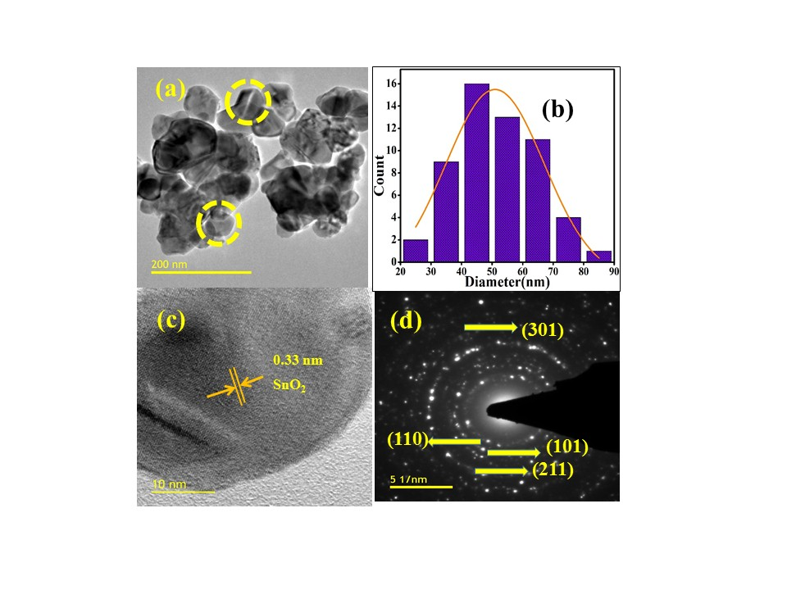

Fig. S1 TEM micrographs of SnO₂ nanoparticles (a) magnifications at 200 nm (b) particle size distribution histogram (c) lattice fringes (d) SAED pattern
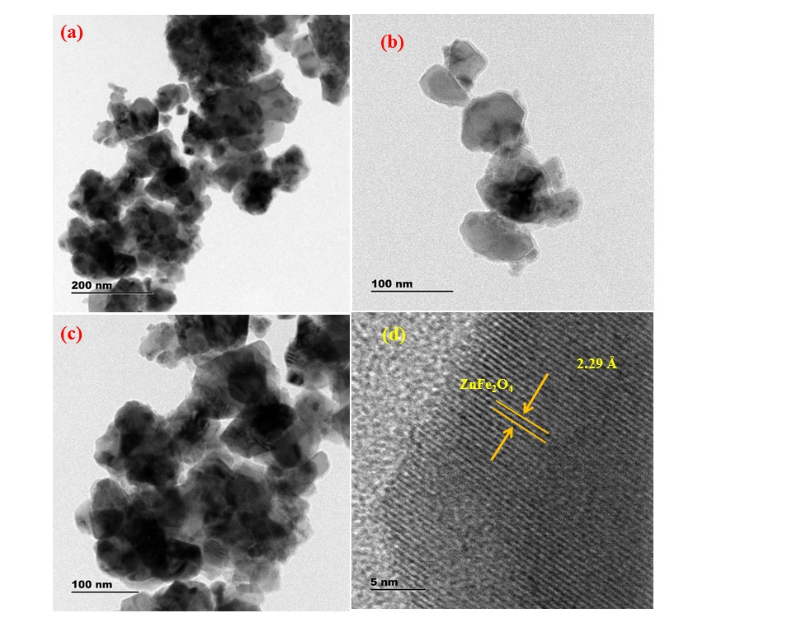

Fig. S2 TEM micrographs of ZnFe₂O₄ (a-c) magnifications at 200 nm and 100 nm, respectively distribution histogram (d) lattice fringes.

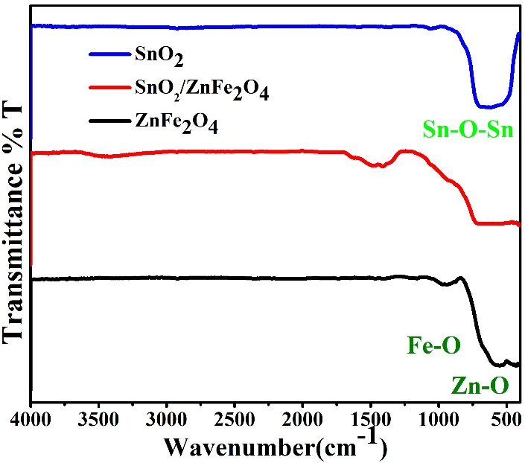

Fig. S3 FT-IR spectra of SnO₂/ZnFe₂O₄ nanocomposites, nano SnO_{2,} and ZnFe₂O₄ in the range 4000-400 cm⁻¹ at room temperature.
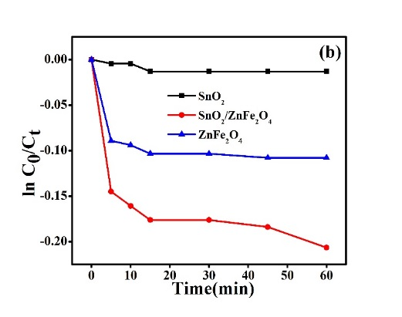
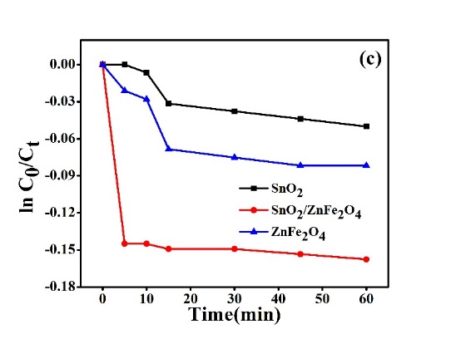
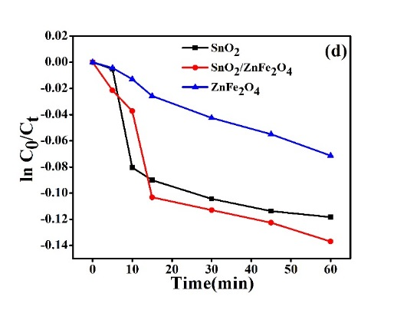
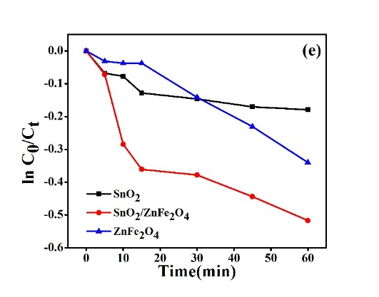
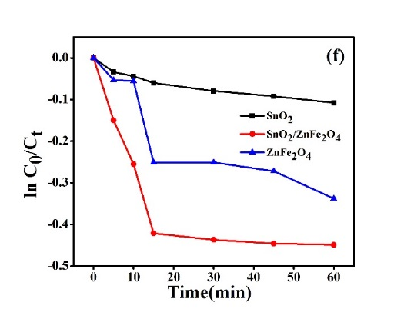
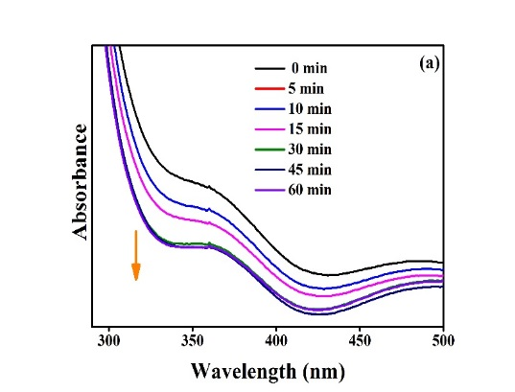

Fig. S4 Absorption spectral traces of cis-[Co(en)₂(Im)Cl]Cl₂ complex observed in the adsorption of cobalt(III) complex on SnO₂/ZnFe₂O₄ nanocomposite in A) H₂O: DMSO (70/30% v/v)). The rate constant of surface adsorption measurements in B) H₂O, C) H₂O: Pr^{i}OH, D) H₂O: CH₃CN, E) H₂O: DMSO, F) H₂O: Bu^{t}OH (70/30% v/v)) at room temperature. Ionic strength:1M NaNO₃. Dosage of catalyst: 300 mg/100ml. Concentration of Cobalt(III) Complex: 2.6 x 10⁻³ M.

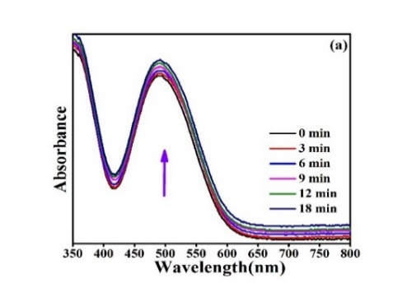
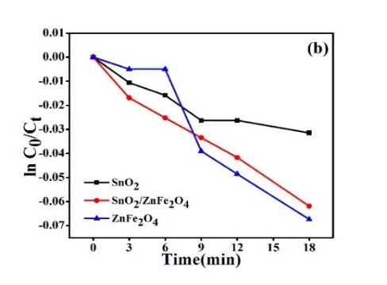
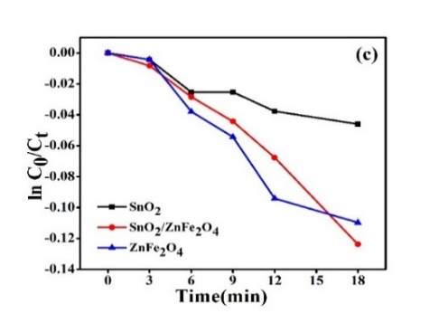
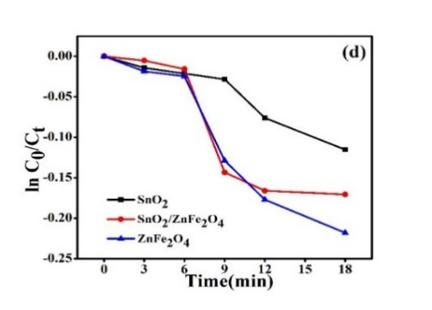
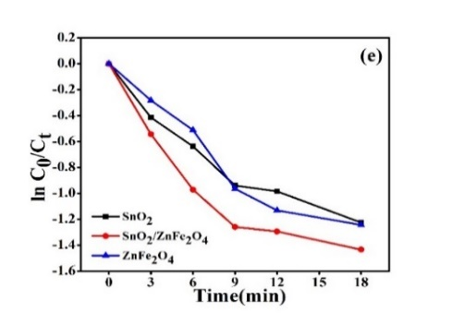
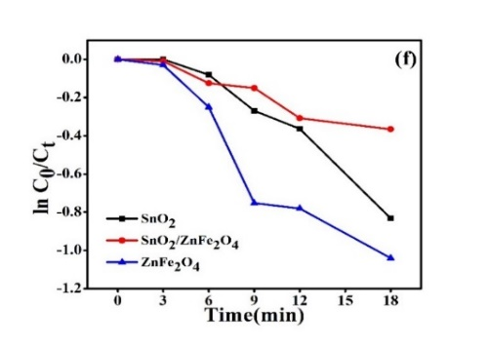

Fig. S5 Absorption spectral traces of cis-[Co(en)₂(Im)Cl]Cl₂ complex observed in the photochemical reduction of Cobalt(III) complex on SnO₂/ZnFe₂O₄ nanocomposite in a) neat water. The rate constant of surface adsorption measurements in b) H₂O, c) H₂O: Pr^{i}OH, d) H₂O: CH₃CN, e) H₂O: DMSO, f) H₂O: Bu^{t}OH at room temperature. Ionic strength:1M NaNO₃. Wavelength of excitation, λ = 365 nm; light intensity: 8.50 x10¹⁷ photon/sec; Dosage of catalyst: 300 mg/100ml. Concentration of Cobalt(III) Complex: 2.6 x 10⁻³ M.

Table T1 Room temperature of M-H loops of magnetic retentivity, Coercivity and saturated magnetism values of nano SnO₂, SnO₂/ZnFe₂O₄ nanocomposites, nano ZnFe₂O₄ at room temperature.

Sample | Hc, Oe | M_{R}, cm³.mol⁻¹ x 10⁻⁴ | Ms, (emu/g)
SnO₂ | 115.1542 | 1.3266 | 0.0115
SnO₂/ZnFe₂O₄ | 78.3654 | 0.5423 | 0.7128
ZnFe₂O₄ | 147.7164 | 0.0672 | 3.0698
Reaction conditions | Adsorbent | Time (min)
Reaction conditions | Adsorbent | 5 | 10 | 15 | 30 | 45 | 60
Reaction conditions | Adsorbent | Removal efficiency (%)
Water$ | SnO₂ | 0 | 0 | 1 | 1 | 1 | 1
Water$ | SnO₂/ZnFe₂O₄ | 13 | 15 | 16 | 16 | 17 | 19
Water$ | ZnFe₂O₄ | 9 | 9 | 10 | 10 | 10 | 10
H₂O: Pr^{i}OH@ | SnO₂ | 0 | 1 | 3 | 4 | 4 | 5
H₂O: Pr^{i}OH@ | SnO₂/ZnFe₂O₄ | 14 | 14 | 14 | 14 | 14 | 15
H₂O: Pr^{i}OH@ | ZnFe₂O₄ | 2 | 3 | 7 | 7 | 8 | 8
H₂O: CH₃CN@ | SnO₂ | 1 | 8 | 9 | 10 | 11 | 11
H₂O: CH₃CN@ | SnO₂/ZnFe₂O₄ | 2 | 4 | 10 | 11 | 12 | 13
H₂O: CH₃CN@ | ZnFe₂O₄ | 0 | 1 | 3 | 4 | 5 | 7
H₂O: DMSO@ | SnO₂ | 7 | 7 | 12 | 13 | 14 | 16
H₂O: DMSO@ | SnO₂/ZnFe₂O₄ | 7 | 25 | 30 | 31 | 36 | 40
H₂O: DMSO@ | ZnFe₂O₄ | 0 | 4 | 4 | 13 | 21 | 29
H₂O: Bu^{t}OH@ | SnO₂ | 3 | 4 | 6 | 8 | 9 | 10
H₂O: Bu^{t}OH@ | SnO₂/ZnFe₂O₄ | 14 | 23 | 34 | 35 | 36 | 36
H₂O: Bu^{t}OH@ | ZnFe₂O₄ | 5 | 5 | 22 | 22 | 24 | 29

Table T2 Time-dependent removal efficiency data of surface adsorption of cis-[Co(en)₂(im)Cl]Cl₂ complex using SnO₂/ZnFe₂O₄ nanocomposite and nano SnO₂ and nano ZnFe₂O₄ by varying ratio of solvents at room temperature. Ionic strength: 1 M NaNO₃; Dosage of catalyst: 300 mg/100ml. Concentration of Cobalt(III) Complex: 2.6 x 10⁻³ M.

$- triply distilled water; @- ratio of the solvent medium maintained 70:30% (v/v)

Table T3 Time-dependent photochemical degradation efficiency data of reduction of cis-[Co(en)₂(im)Cl]Cl₂ complex using SnO₂/ZnFe₂O₄ nanocomposite and nano SnO₂ and nano ZnFe₂O₄ by varying ratio of solvents at room temperature. Ionic strength: 1 M NaNO₃. wavelength of excitation, λ = 254 nm; light intensity: 8.50 x10¹⁷ photon/sec; Dosage of catalyst: 300 mg/100ml. Concentration of Cobalt(III) Complex: 2.6 x 10⁻³ M
Reaction conditions | Catalyst | Time (min)
Reaction conditions | Catalyst | 3 | 6 | 9 | 12 | 18
Reaction conditions | Catalyst | Photo efficiency (%)
Water$ | SnO₂ | 6 | 7 | 9 | 10 | 14
Water$ | SnO₂/ZnFe₂O₄ | 8 | 11 | 12 | 20 | 20
Water$ | ZnFe₂O₄ | 1 | 1 | 3 | 6 | 11
H₂O: Pr^{i}OH@ | SnO₂ | 4 | 7 | 9 | 17 | 21
H₂O: Pr^{i}OH@ | SnO₂/ZnFe₂O₄ | 0 | 8 | 24 | 30 | 56
H₂O: Pr^{i}OH@ | ZnFe₂O₄ | 8 | 13 | 14 | 19 | 23
H₂O: CH₃CN@ | SnO₂ | 8 | 9 | 9 | 10 | 13
H₂O: CH₃CN@ | SnO₂/ZnFe₂O₄ | 3 | 7 | 8 | 9 | 19
H₂O: CH₃CN@ | ZnFe₂O₄ | 3 | 5 | 8 | 17 | 17
H₂O: DMSO@ | SnO₂ | 1 | 1 | 4 | 5 | 5
H₂O: DMSO@ | SnO₂/ZnFe₂O₄ | 4 | 4 | 8 | 8 | 11
H₂O: DMSO@ | ZnFe₂O₄ | 0 | 1 | 4 | 6 | 9
H₂O: Bu^{t}OH@ | SnO₂ | 0 | 1 | 4 | 5 | 6
H₂O: Bu^{t}OH@ | SnO₂/ZnFe₂O₄ | 4 | 4 | 10 | 15 | 19
H₂O: Bu^{t}OH@ | ZnFe₂O₄ | 10 | 12 | 13 | 15 | 17

$- triply distilled water; @- ratio of the solvent medium maintained 70:30% (v/v)

Table T4 Time-dependent photochemical degradation efficiency data of reduction of cis-[Co(en)₂(im)Cl]Cl₂ complex using SnO₂/ZnFe₂O₄ nanocomposite and nano SnO₂ and nano ZnFe₂O₄ by varying ratio of solvents at room temperature. Ionic strength: 1 M NaNO₃. Wavelength of excitation, λ = 365 nm; Dosage of catalyst: 300 mg/100ml. Concentration of Cobalt(III) Complex: 2.6 x 10⁻³ M.
Reaction conditions | Catalyst | Time (min) |  |  |  |  | Rate constant  (k sec⁻¹) | R²
Reaction conditions | Catalyst | 3 | 6 | 9 | 12 | 18 | Rate constant  (k sec⁻¹) | R²
Reaction conditions | Catalyst | Photo efficiency (%) |  |  |  |  | Rate constant  (k sec⁻¹) | R²
Water$ | SnO₂ | 1 | 2 | 3 | 3 | 3 | 0.0020 | 0.8589
Water$ | SnO₂/ZnFe₂O₄ | 2 | 2 | 3 | 4 | 6 | 0.0035 | 0.9830
Water$ | ZnFe₂O₄ | 0 | 0 | 4 | 5 | 7 | 0.0048 | 0.8898
H₂O: Pr^{i}OH@ | SnO₂ | 1 | 3 | 3 | 4 | 5 | 0.0031 | 0.9074
H₂O: Pr^{i}OH@ | SnO₂/ZnFe₂O₄ | 1 | 3 | 9 | 17 | 27 | 0.0209 | 0.9185
H₂O: Pr^{i}OH@ | ZnFe₂O₄ | 1 | 12 | 14 | 26 | 31 | 0.0254 | 0.9267
H₂O: CH₃CN@ | SnO₂ | 1 | 2 | 3 | 7 | 11 | 0.0157 | 0.8991
H₂O: CH₃CN@ | SnO₂/ZnFe₂O₄ | 1 | 2 | 13 | 15 | 16 | 0.0075 | 0.9070
H₂O: CH₃CN@ | ZnFe₂O₄ | 2 | 2 | 12 | 16 | 20 | 0.0146 | 0.7566
H₂O: DMSO@ | SnO₂ | 3 | 5 | 8 | 11 | 11 | 0.0074 | 0.8178
H₂O: DMSO@ | SnO₂/ZnFe₂O₄ | 2 | 6 | 7 | 9 | 13 | 0.0079 | 0.9371
H₂O: DMSO@ | ZnFe₂O₄ | 1 | 4 | 6 | 11 | 13 | 0.0079 | 0.9030
H₂O: Bu^{t}OH@ | SnO₂ | 1 | 2 | 6 | 7 | 9 | 0.0073 | 0.9054
H₂O: Bu^{t}OH@ | SnO₂/ZnFe₂O₄ | 0 | 4 | 5 | 9 | 10 | 0.0076 | 0.9364
H₂O: Bu^{t}OH@ | ZnFe₂O₄ | 1 | 3 | 5 | 7 | 12 | 0.0075 | 0.9646

$- triply distilled water; @- ratio of the solvent medium maintained 70:30% (v/v)

