Supplementary material
The methanol electrooxidation and carbon monoxide tolerance for direct methanol fuel cells using strontium molybdate

Tzu Hsuan Chiang*, Jia-Wei Hsu
Department of Energy Engineering, National United University
No. 2, Lienda, Nan-Shi Li, Miaoli 36006, Taiwan (R.O.C.)
*thchiang@nuu.edu.tw
*Tel.: +886-37382385; Fax: +886-37382402
(b)
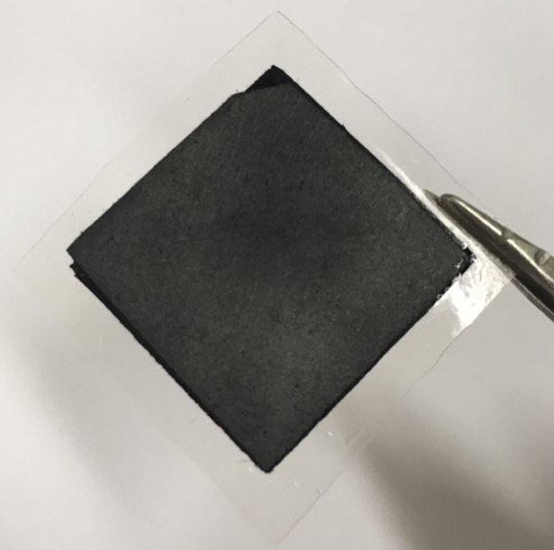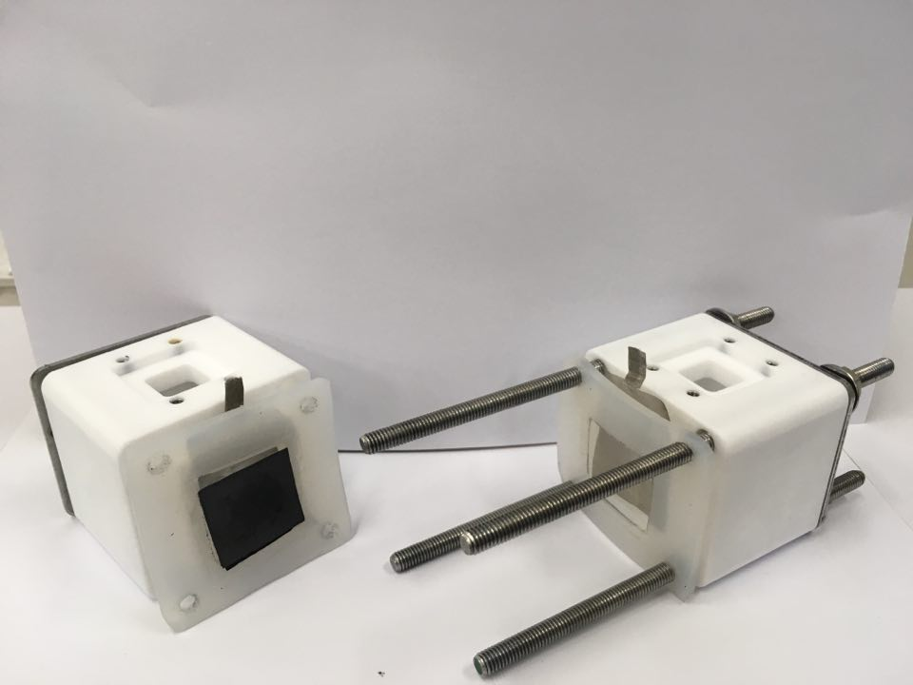
(a)
Figure S1. (a) MEA and (b) simple single DMFC assembly.
Figure S2. XRD of various electrocatalysts.

