Coherent consolidation of trillions of nucleations into a coplanar layer for a mono-atom step-level flat surface

Supplementary Information

Taewoo Ha^{1†}, Yu-Seong Seo^{2†}, Teun-Teun Kim^{3†}, Bipin Lamichhane⁴, Young-Hoon Kim⁵, Su Jae Kim⁶, Yousil Lee⁶, Miyeon Cheon⁶, Jong Chan Kim⁷, Sang Eon Park⁶, Kyung Ik Sim^{1,8}, Jae Hoon Kim⁸, Yong In Kim⁵, Seon Je Kim⁵, Hu Young Jeong^{7,9}, Young Hee Lee^{1,5}, Seong-Gon Kim^{4,}*, Young-Min Kim^{1,5,}*, Jungseek Hwang^{2,}* & Se-Young Jeong^{10,12,}*
¹Center for Integrated Nanostructure Physics, Institute for Basic Science, Sungkyunkwan University, Suwon 16419, Republic of Korea.
²Department of Physics, Sungkyunkwan University, Suwon 16419, Republic of Korea.
³Department of Physics, University of Ulsan, Ulsan 44610, Republic of Korea.
⁴Department of Physics and Astronomy, Mississippi State University, Mississippi State, MS 39762, USA.
⁵Department of Energy Science, Sungkyunkwan University, Suwon 16419, Republic of Korea.
⁶Crystal Bank Research Institute, Pusan National University, Busan 46241, Republic of Korea.
⁷School of Materials Science and Engineering, Ulsan National Institute of Science and Engineering, Ulsan 44919, Republic of Korea.
⁸Department of Physics, Yonsei University, Seoul 03722, Republic of Korea.
⁹UNIST Central Research Facilities, Ulsan National Institute of Science and Technology, Ulsan 44919, Republic of Korea.
¹⁰Department of Cogno-Mechatronics Engineering, Pusan National University, Busan 46241, Republic of Korea.
¹¹Department of Optics and Mechatronics Engineering, Pusan National University, Busan 46241, Republic of Korea.

*Corresponding authors.
E-mail: sk162@msstate.edu (S. G. Kim), youngmk@skku.edu (Y.-M. Kim); jungseek@skku.edu (J. Hwang); syjeong@pusan.ac.kr (S.-Y. Jeong)
† These authors contributed equally to this work.

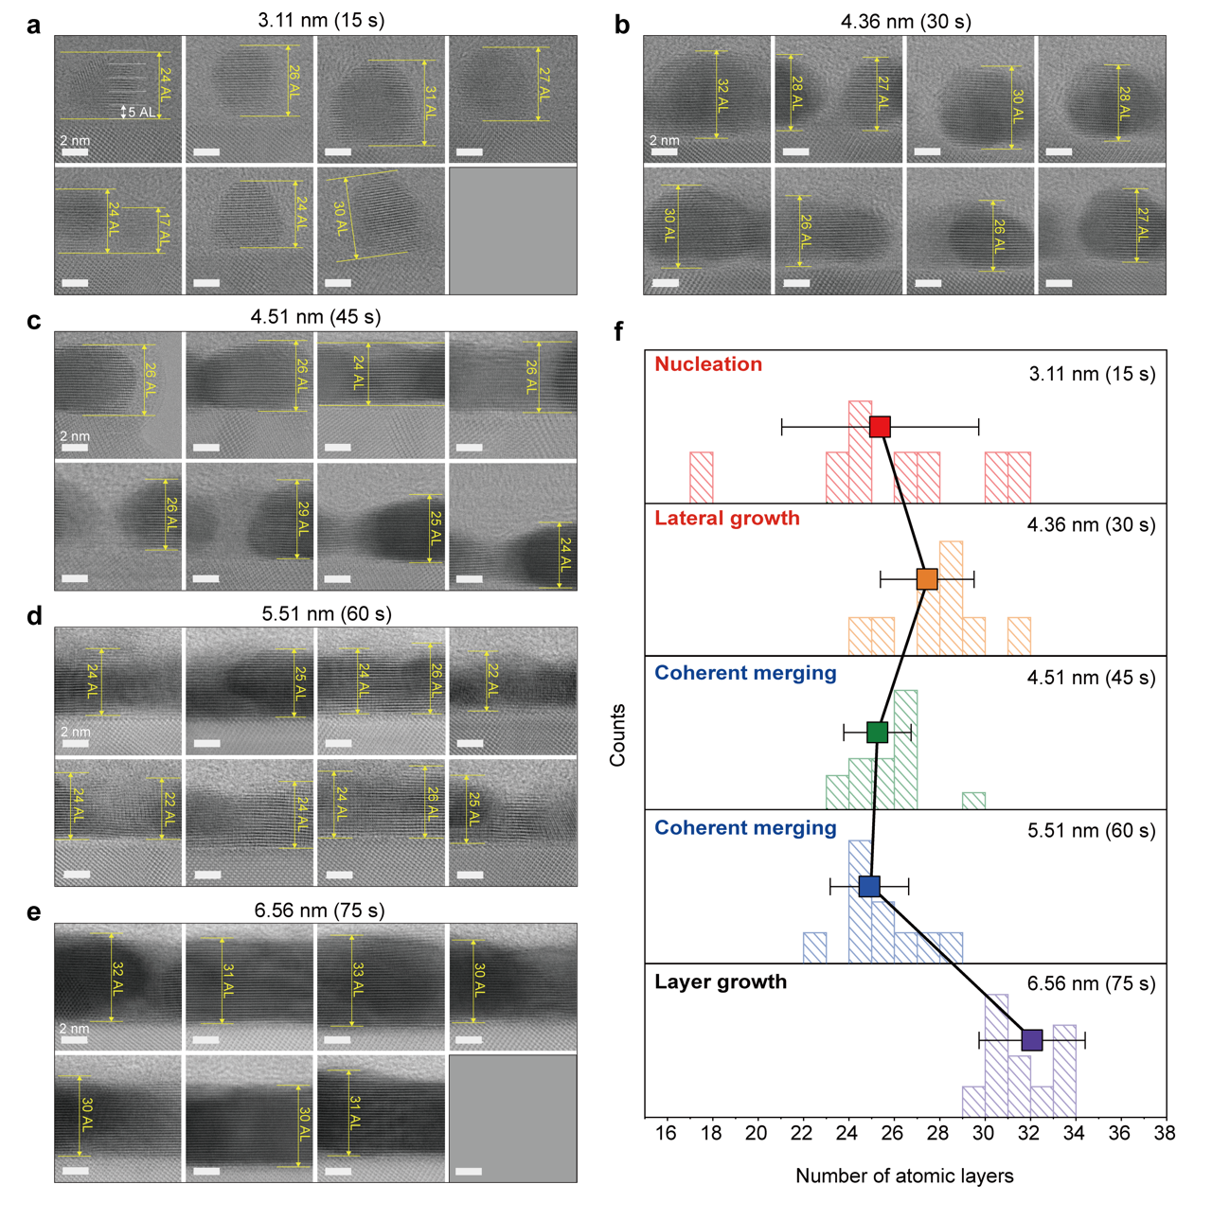
Fig. S1 │ Height distribution of single-crystal (SC) Cu(111) nucleation nanodroplets in the first two stages: I (15, 30, and 45 s) and II (60 and 75 s). a–e, Bright-field scanning transmission electron microscopy (BF-STEM) images of thin films and average thickness of each film, as measured by atomic force microscopy (AFM). a, 3.11 nm (15 s), b, 4.36 nm (30 s), c, 4.51 nm (45 s), d, 5.51 nm (60 s), and e, 6.56 nm (75 s). Numbers in parentheses are the deposition times of the films. A full list of the measured thicknesses as a function of deposition time is provided in Supplementary Table S1. f, Histogram and average numbers of atomic layers (height) for each deposition time (15–75 s).

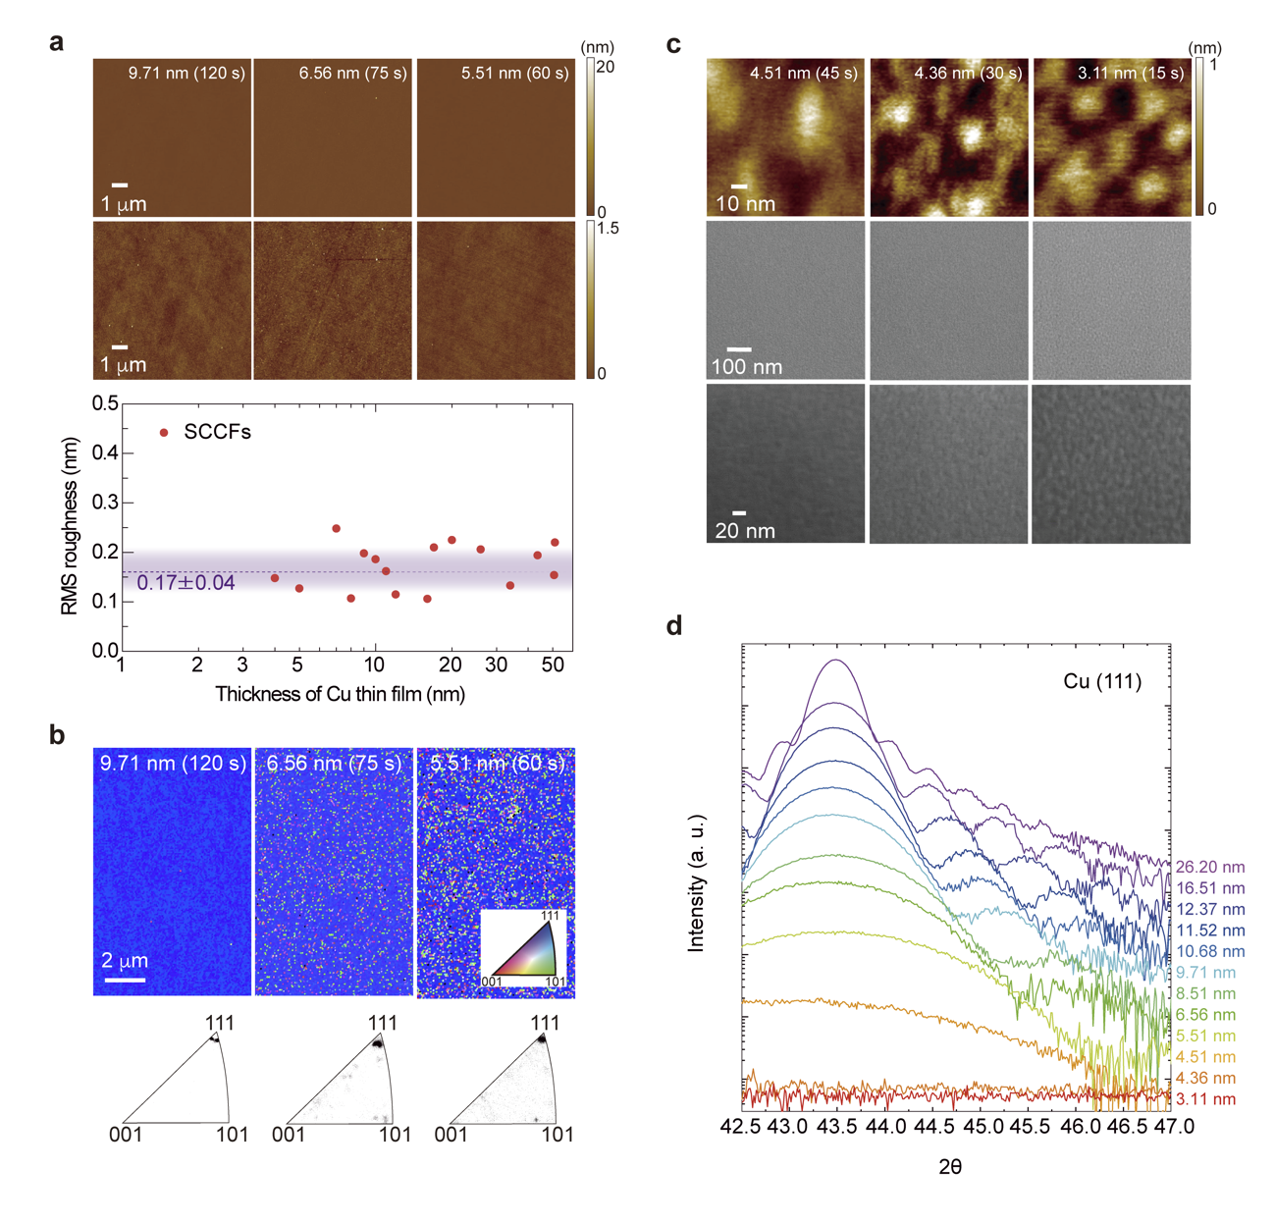
Fig. S2 | Structural characterisation using AFM, X-ray diffraction (XRD), and electron backscatter diffraction (EBSD). a, (top, 1st and 2nd rows) AFM images of films with thickness > 5 nm (9.71, 6.56, and 5.51 nm). (bottom) Root mean square (RMS) roughness as a function of film thickness. The average RMS roughness of films with thickness < 50 nm (purple dashed line) was 0.17 ± 0.04 nm. b, (top) EBSD images and (bottom) pole figures (PFs) of Cu thin films in stage II. c, (1st row) AFM and (2nd & 3rd rows) SEM images of Cu thin films in stage I with thickness < 5 nm (3.11, 4.36, and 4.51 nm). d, XRD spectra near the Cu(111) peak. Pendellösung oscillations were visible for thicknesses ranging from 6.56 to 26.20 nm, indicating that the Cu films have well-defined parallel surfaces.

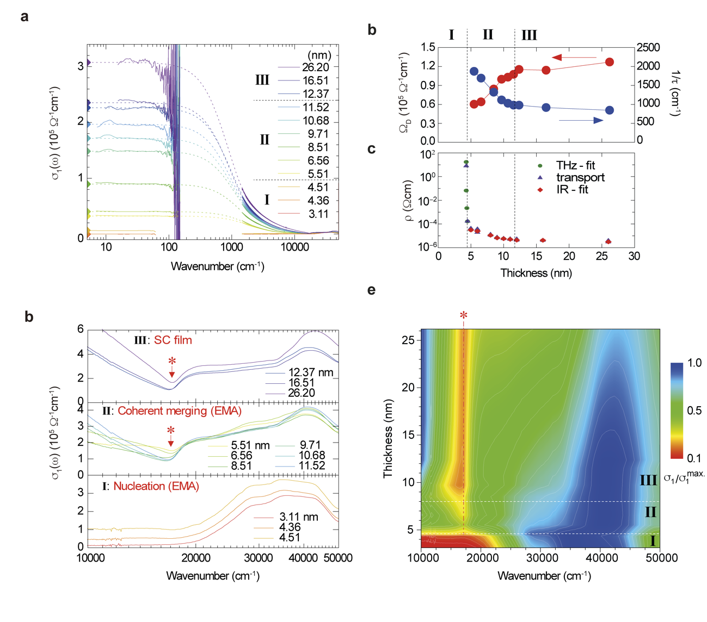
Fig. S3 | THz and optical spectra of samples in the three stages. a, Measured optical conductivity spectra of 12 Cu film samples along with THz spectra below 100 cm⁻¹ and Drude model fits (thin dashed lines). b, Thickness-dependent Drude fitting parameters including the plasma frequency ($Ω_{D}$) and impurity scattering rate ($1/τ$). c, Comparison of direct current (DC) resistivity obtained using Drude fitting parameters and parameters directly measured using the DC transport technique and obtained from THz spectra. d, Near-infrared and ultraviolet (NIR-UV) conductivity spectra above 10,000 cm⁻¹ in the three stages. e, Colour-coded diagram of the NIR-UV conductivity spectra of all 12 Cu film samples. Thickness-dependent plasma-edge evolution (along the dot-dot-dashed line) supported three distinct growth stages.

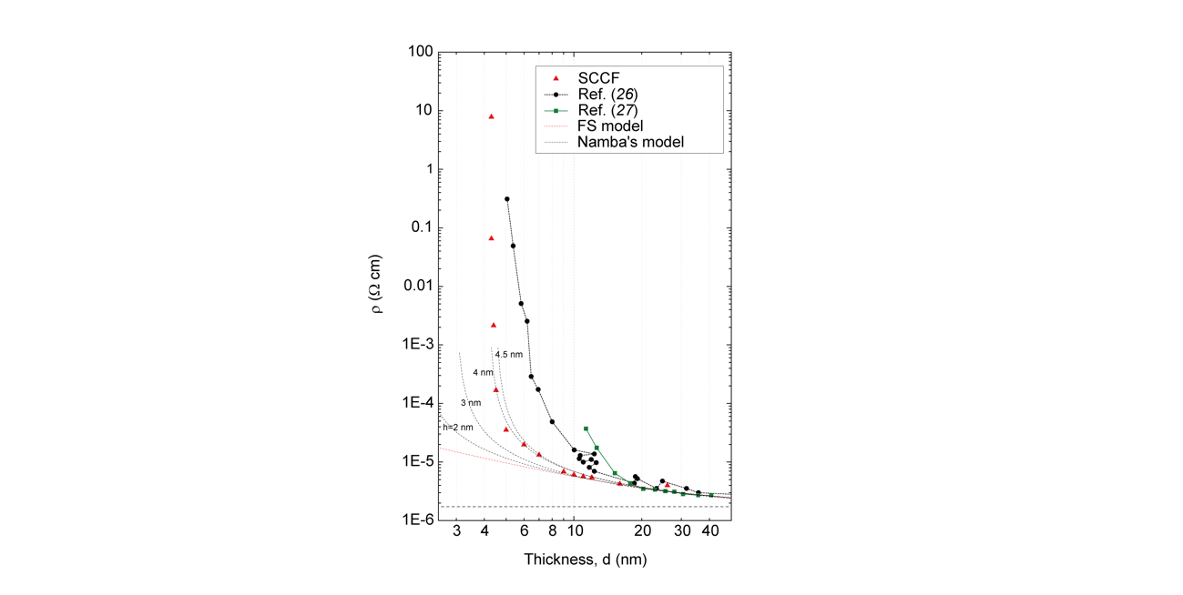
Fig. S4 | Conventional Fuchs–Sondheimer (FS) model fit and Namba model simulations for various roughness amplitudes (h = 2, 3, 4, and 4.5 nm). The Namba model matched our measured resistivity data well for a roughness amplitude of 4–4.5 nm, which was close to the size (height) of the Cu nanodroplets. However, the Namba model could not simulate the resistivity data (essentially infinite resistivity) in stage I with isolated Cu nanodroplets because this model was applicable only to the well-developed (or continuous) metallic thin films observed in stages II and III. The observed abrupt divergence in resistivity is not a common behaviour of (continuous) metallic thin films; therefore, another model is required to explain all of the measured resistivity (or conductivity) data, including the abrupt divergence in resistivity (or zero conductivity). Therefore, we used an effective medium approximation (EMA) model to fully describe the entire thickness range, including stage I with isolated Cu nanodroplets, using a volume fraction parameter.

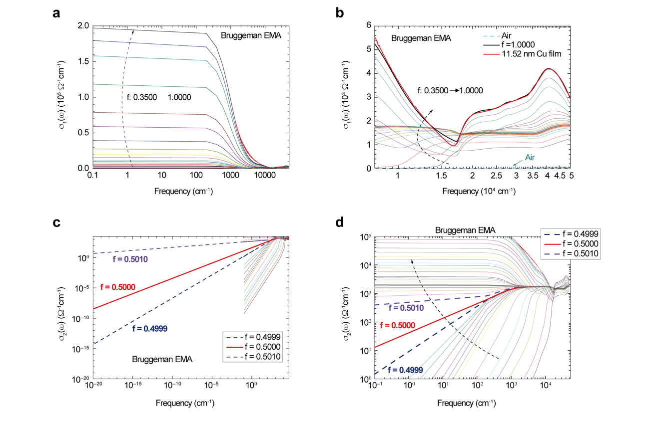
Fig. S5 | EMA analysis. a, Optical conductivity over a wide spectral range from 0.1 to 50,000 cm⁻¹ was simulated using the EMA model at various volume fractions from 0.3500 to 1.000. b, Magnified view of the simulated EMA optical conductivity in a high-frequency region. The optical conductivity of air is exactly zero over the entire frequency region. c, Examples of extrapolations to near-zero frequency (10⁻²⁰ cm⁻¹), which we used as the zero frequency for our DC conductivity estimates. d, Magnified view showing an abrupt slope change in EMA conductivity with respect to the frequency, which occurred at f = 0.5.

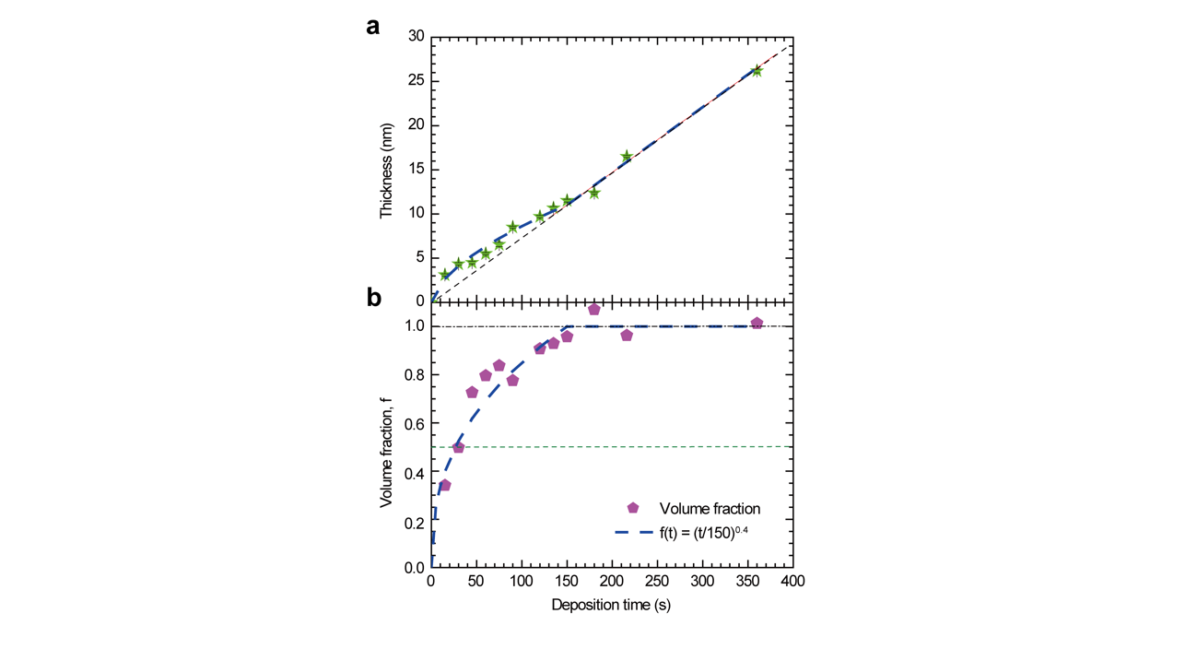
Fig. S6 | Estimates of the volume fractions (f) of Cu films based on the relationship between thickness and deposition time. a, Thickness vs. deposition time. b, Estimated volume fraction vs. deposition time. The thick blue dashed line is a guide for the eye. The measured thicknesses may include some uncertainties.

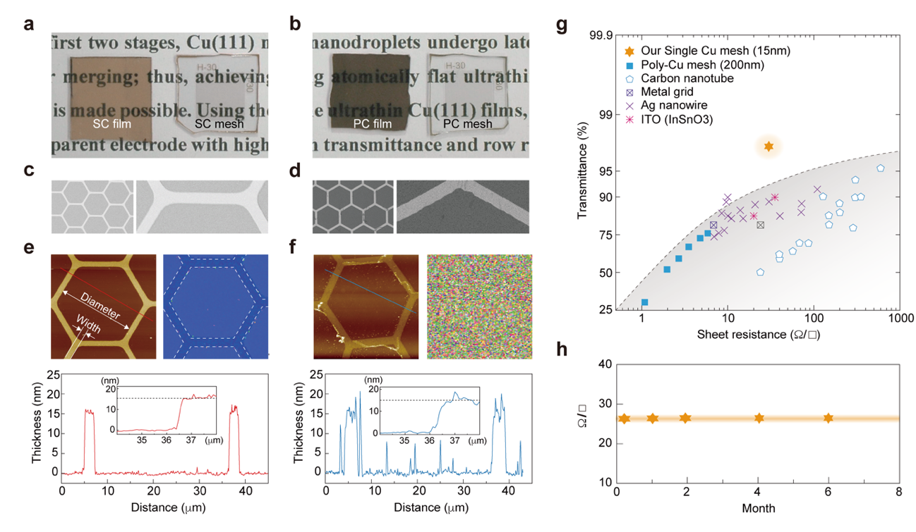
Fig. S7 | Transparent Cu mesh electrodes. a, A 15-nm-thick SCCF and SC honeycomb mesh electrode on a sapphire substrate. b, A PCCF and PC honeycomb mesh electrode with a thickness of 15 nm deposited on a glass substrate. c, d, SEM images of (c) SC and (d) PC meshes. Enlarged images are also displayed. e, (upper left) AFM image and (upper right) EBSD map of the SC mesh and (lower) its height profile along the indicated line, as obtained by AFM, along with (inset) a magnified view of part of the profile. f, Corresponding images and profile of the PC mesh. g, Comparison of the transmittance at 550 nm and sheet resistance of our SC mesh with those reported for other trichloroethylene materials, including carbon nanotubes, metal grids, Ag nanowires, and indium tin oxide³³. h, Sheet resistances (Ω/sq) of freshly prepared and 1-, 2-, 4-, and 6-month-old samples, which demonstrate the aging effect.

Supplementary Table S1. Atomic force microscopy thickness estimates.

Target thickness (nm) | Deposition time (s) | Thickness (nm) | Roughness (nm)
26 | 360 | 26.20 | 0.21
16 | 216 | 16.51 | 0.11
12 | 180 | 12.37 | 0.11
11 | 150 | 11.52 | 0.16
10 | 135 | 10.68 | 0.19
9 | 120 | 9.71 | 0.12
8 | 90 | 8.51 | 0.10
6 | 75 | 6.56 | 0.24
5 | 60 | 5.51 | 0.13
4 | 45 | 4.51 | 0.15
3 | 30 | 4.36 | 0.13
2 | 15 | 3.11 | 0.13

Supplementary Table S2. Comparison of Al₂O₃/Cu(111) interfaces.
Al₂O₃ surface | Surface energy  (J/m²) | Diffusion barrier for Cu atoms (eV) | Interface energy (J/m²) | Adhesion energy (J/m²)
Al-terminated | 1.59 | 0.23 | −24.51 | 0.68
O-terminated | 4.26 | 1.44 | −25.95 | 4.81
Difference | 2.67 | 1.21 | −1.44 | 4.10

