Healing of ROS-induced cerebral ischemia/reperfusion injury by sustainable drug “chiral gold nanoclusters”
Yang Yu^{1,2}, Peng-fei Zhuang¹ , Xiao-lei Shen¹², Ming-hao Ge^{1,2}, Zhi-ru Zou¹, Dao-yong Li^{1,2}, Zhen-xing Zhang²*, Chang Liu²*, Xi-fan Mei¹*, Dan Li¹*
1. Key Laboratory of Tissue Engineering of Liaoning Province, Jinzhou, PR China.
2. First Affiliated Hospital of Jinzhou Medical University, Jinzhou, PR China.
∗Corresponding author: Prof. Zhen-xing Zhang^{b}*, Prof. Chang Liu^{b}*, Prof. Xi-fan Meiª*, Prof. Dan Liª*

This PDF file includes:
Fig. S1. TEM image and HR-TEM of the GSH-AuNPs and GSH-AuNCs.
Fig. S2. XPS of GSH-AuNPs and GSH-AuNCs.
Fig. S3. Optical properties of GSH-AuNCs.
Fig. S4. Antioxidant ability of GSH,GSH-AuNCs and GSH-AuNPs.
Table.S1. The pharmacokinetic parameters of GSH-AuNCs.

Material and methods
Synthesis of GSH-AuNCs
250 μL of HAuCl4 (50 mM) and 150 μL of D-glutathione (GSH) (100 mM) were mixed with 4.7 mL of ultra-stilled water at room temperature. Then, the solution was transferred to a water bath and heated to 70 °C for 24 h. GSH-AuNCs were dialyzed with a dialysis tube (3500 MWCO) before use.

Synthesis of GSH-AuNPs
400 μL of HAuCl4 (25 mM) and 300 μL of D-glutathione (GSH) (100 mM) were mixed with 1.6 mL of ultra-stilled water at room temperature. The solution was adjusted to pH 6 with 0.1 M NaOH. Finally, 200 μL 100 mM NaBH4 and 2 mL water were added. After the reaction proceeded for 24 hours, the samples were dialyzed with a dialysis tube (3500 MWCO) before use.

Characterization of the materials
Transmission electron microscope (TEM) were obtained on a transmission electron microscope operated at 75 kV (FEI Tecnai G2 F30). The specimen was made by placing one drop of the purified sample in a water solution on a carbon thin-film coated TEM grid. X-ray photoelectron spectroscopy (XPS) measurements were investigated under ultrahigh vacuum (UHV) with 1.0×10-7 Torr (Thermo, ESCALAB 250Xi). The fluorescence spectra were measured by a fluorescence spectrometer (F-97).

Results
In the UV-vis characterization (Fig. S3a), no peak is observed at about 520 nm for the normal size gold nanoparticles. Gold nanoparticles are classified into three states: metallic (>2.3 nm), transition regime (from 2.3 and 1.7 nm), and non-metallic clusters (smaller than 1.7 nm) [1]. In a cluster with an ultra-small gold core, the plasmon-like resonance is confined in the metal core by the molecular layer [2]. Therefore, no plasmon resonance peak is observed. On the other hand, a unique fluorescence is observed (Fig. S3b). It can be seen that the GSH-AuNCs have a maximum excitation and emission at 413 nm and 609 nm respectively. However, the fluorescence was quite weak with a quantum yield smaller than 2%. Thus, for tracking the samples, highly fluorescent FITC was labeled on both GSH-AuNPs and GSH-AuNCs.

Reference
[1] Zhou M, Zeng C, Chen Y, Zhao S, Sfeir MY, Zhu M, Jin R. Evolution from the plasmon to exciton state in ligand-protected atomically precise gold nanoparticles. Nat Commun. 2016;7:13240.
[2] Malola S, Lehtovaara L, Enkovaara J, Hakkinen H. Birth of the localized surface plasmon resonance in monolayer-protected gold nanoclusters. ACS Nano. 2013;7(11):10263-70.

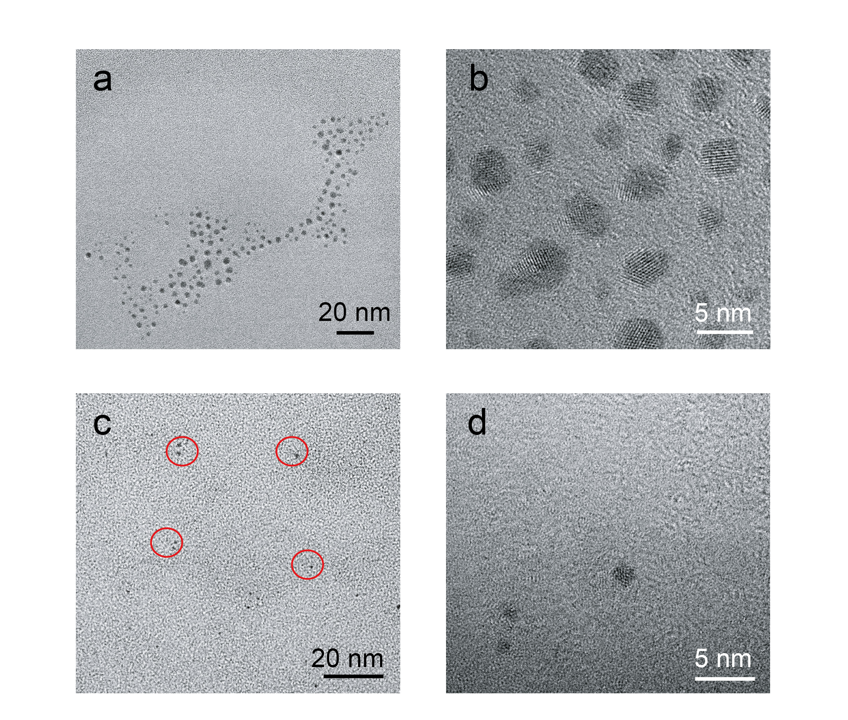
Fig S1. TEM (a, c) image and High-Resolution Transmission Electron Microscopy (HR-TEM) (b, d) of the GSH-AuNPs (a, b) and GSH-AuNCs (c, d). The scale bars represent 20 nm.

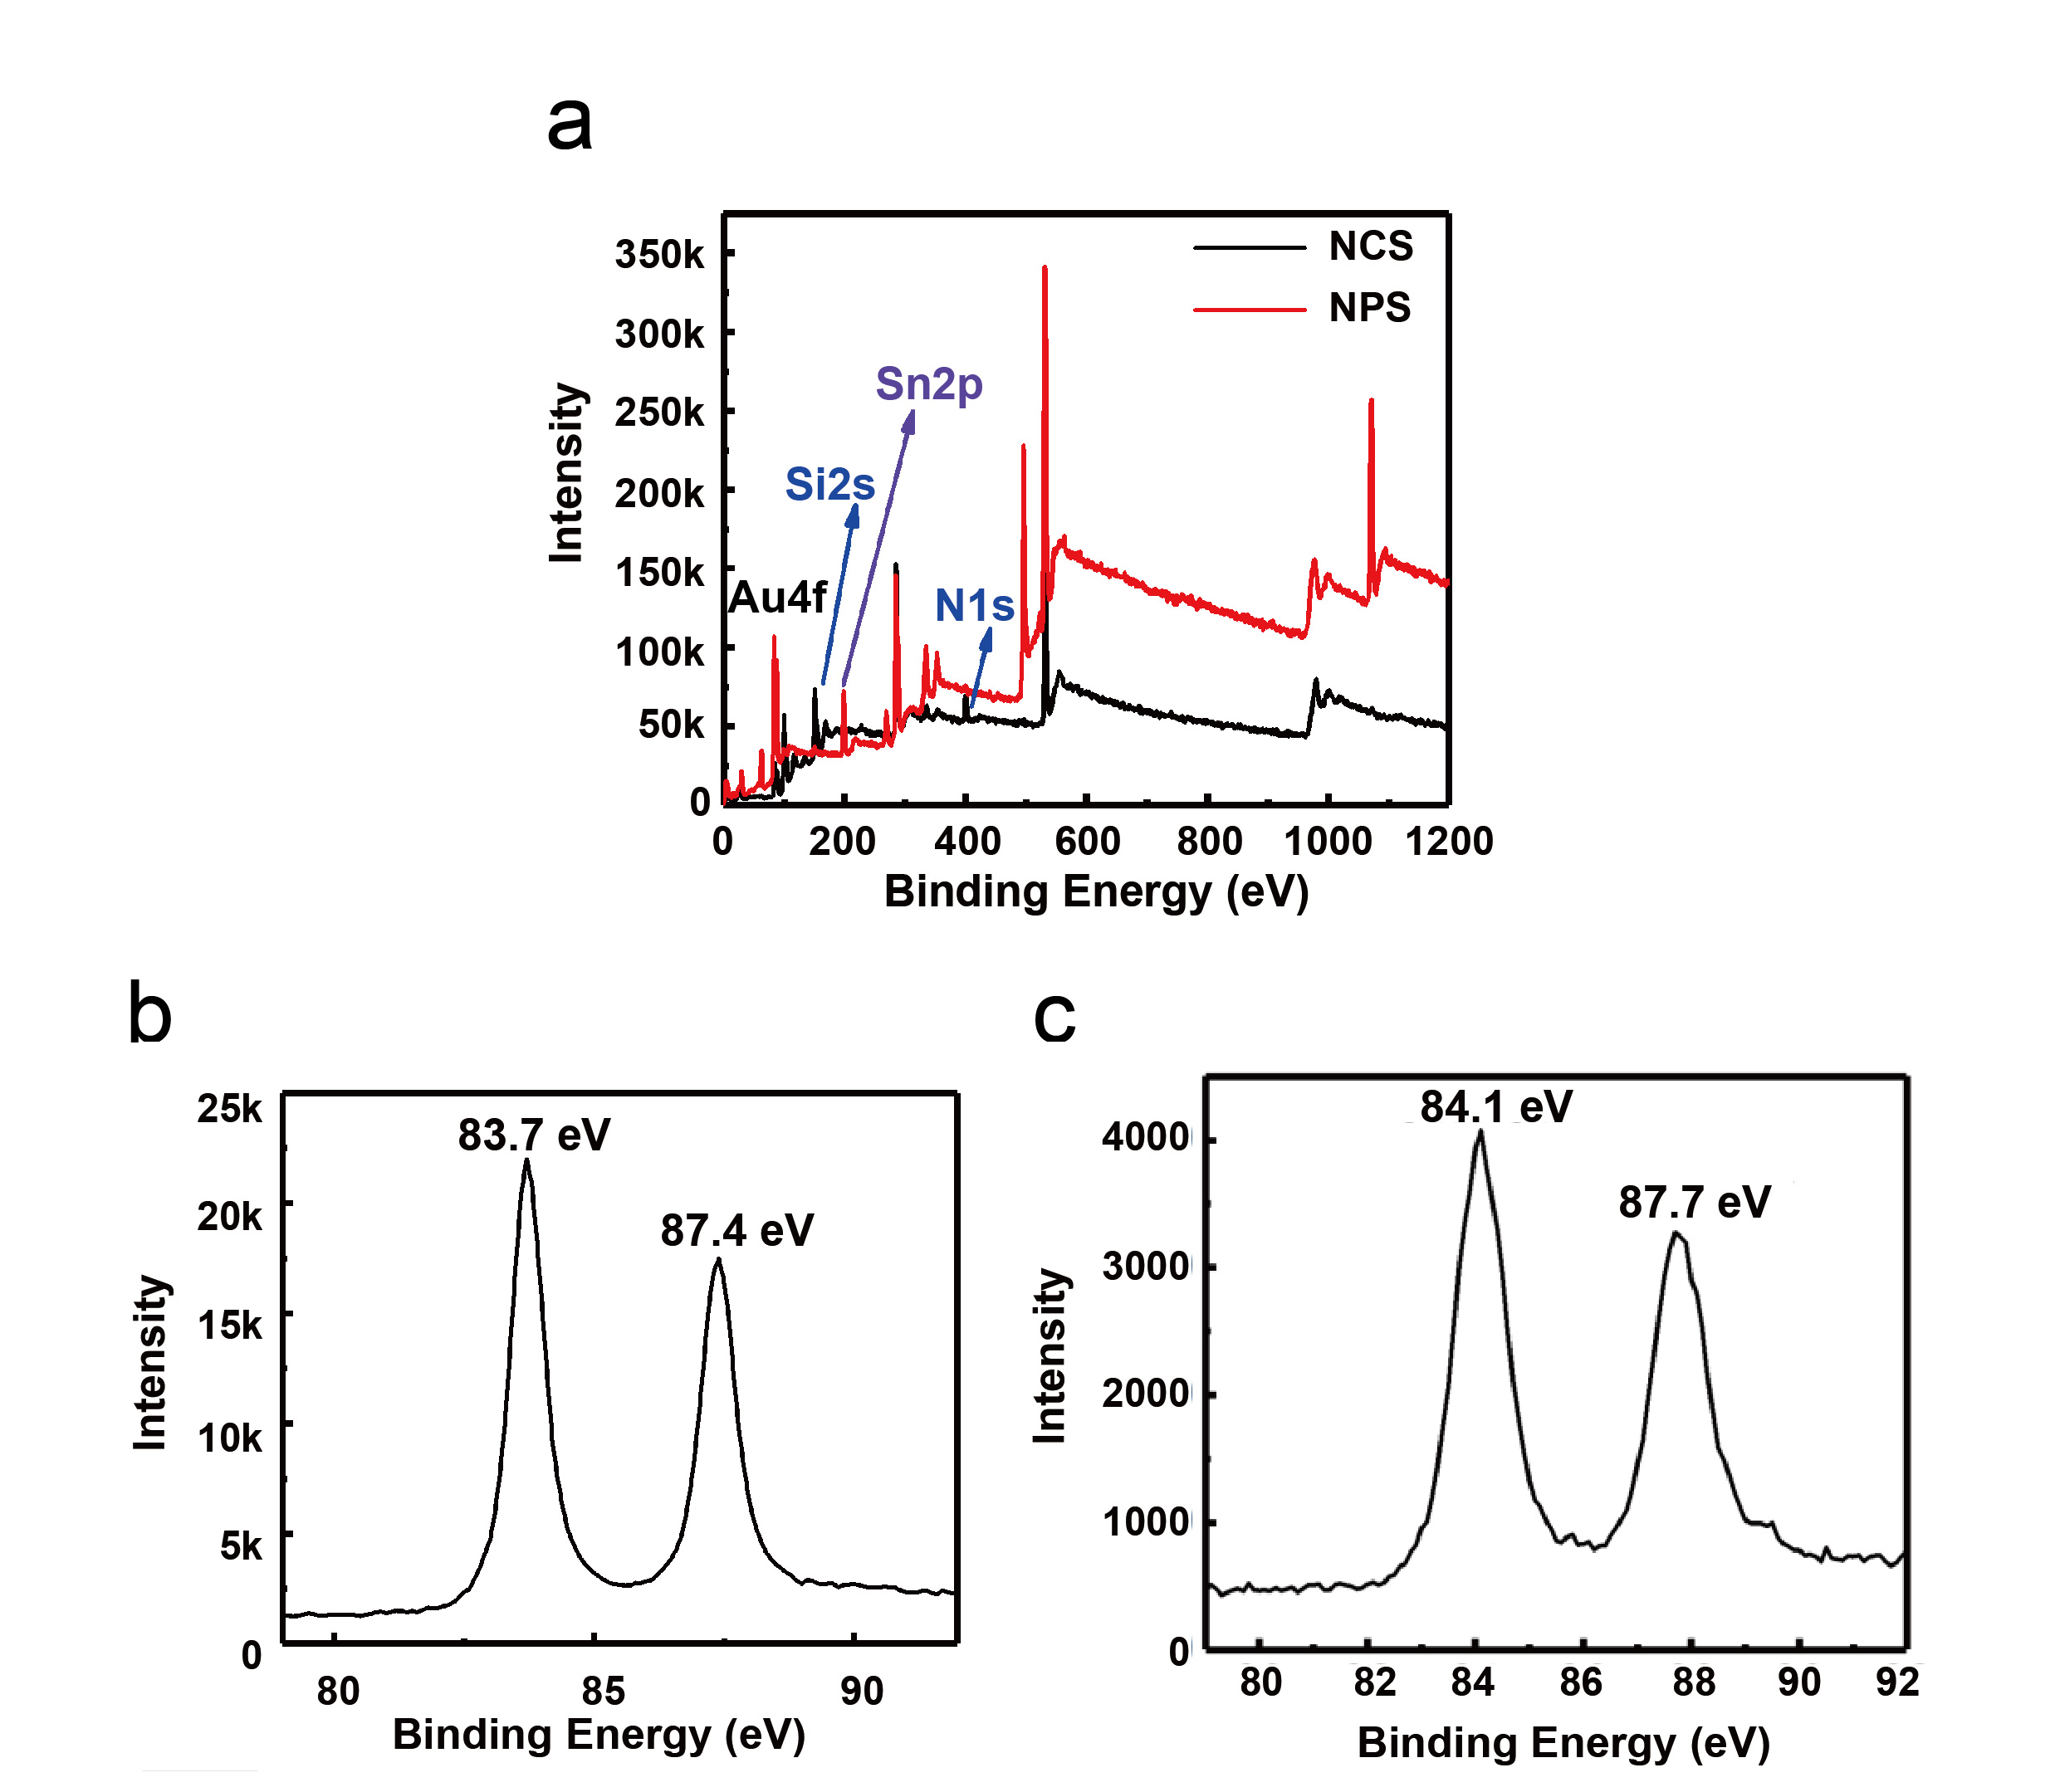
Fig S2. XPS survey (a) and Au 4f spectra (b, c) of GSH-AuNPs (a, b) and GSH-AuNCs (a, c). NCs and NPs indicate GSH-AuNCs and GSH-AuNPs respectively.

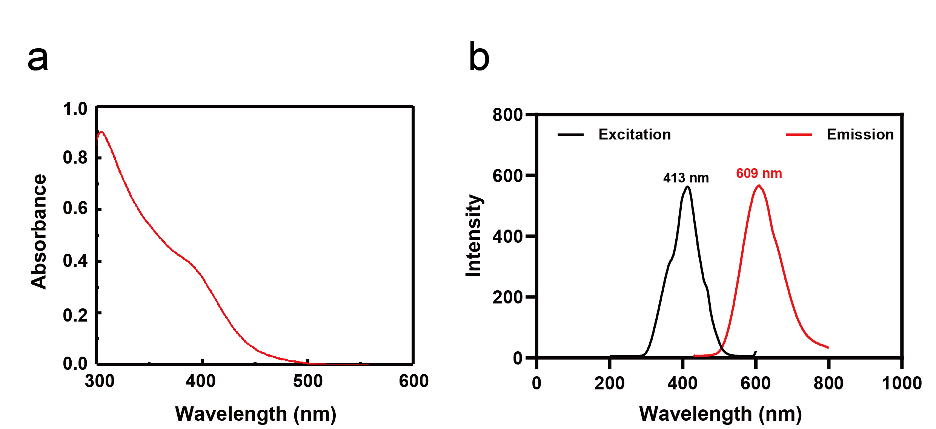
Fig S3. UV-vis (a), fluorescence excitation, and emission spectra (b) of GSH-AuNCs.

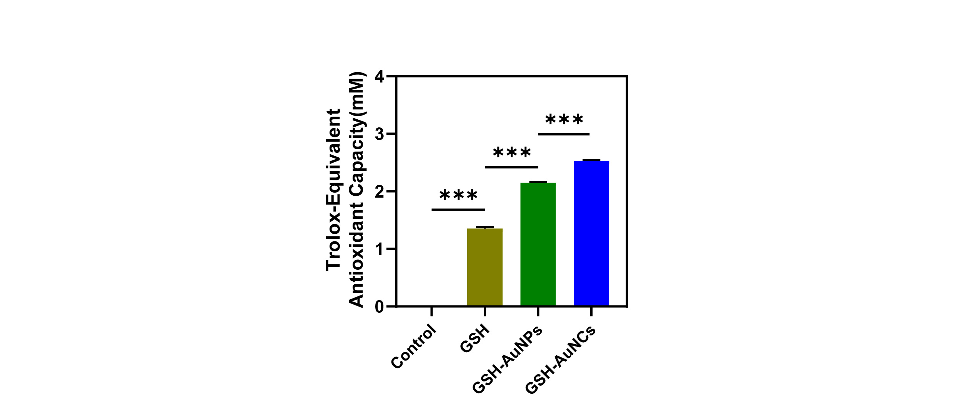
Fig S4. ABTS assay was used to determine the antioxidant ability of GSH, GSH-AuNCs and GSH-AuNPs.

Table S1. The pharmacokinetic parameters were calculated by dual-compartment analysis
 | GSH-AuNCs
T1/2α(h)  T1/2β(h)  AUC(0-∞)(mg/L×h)  C_{max}(mg/L)  CL(L/h/kg) | 0.191  4.654  3.737  2.245  5.352

