Extended Data Figures

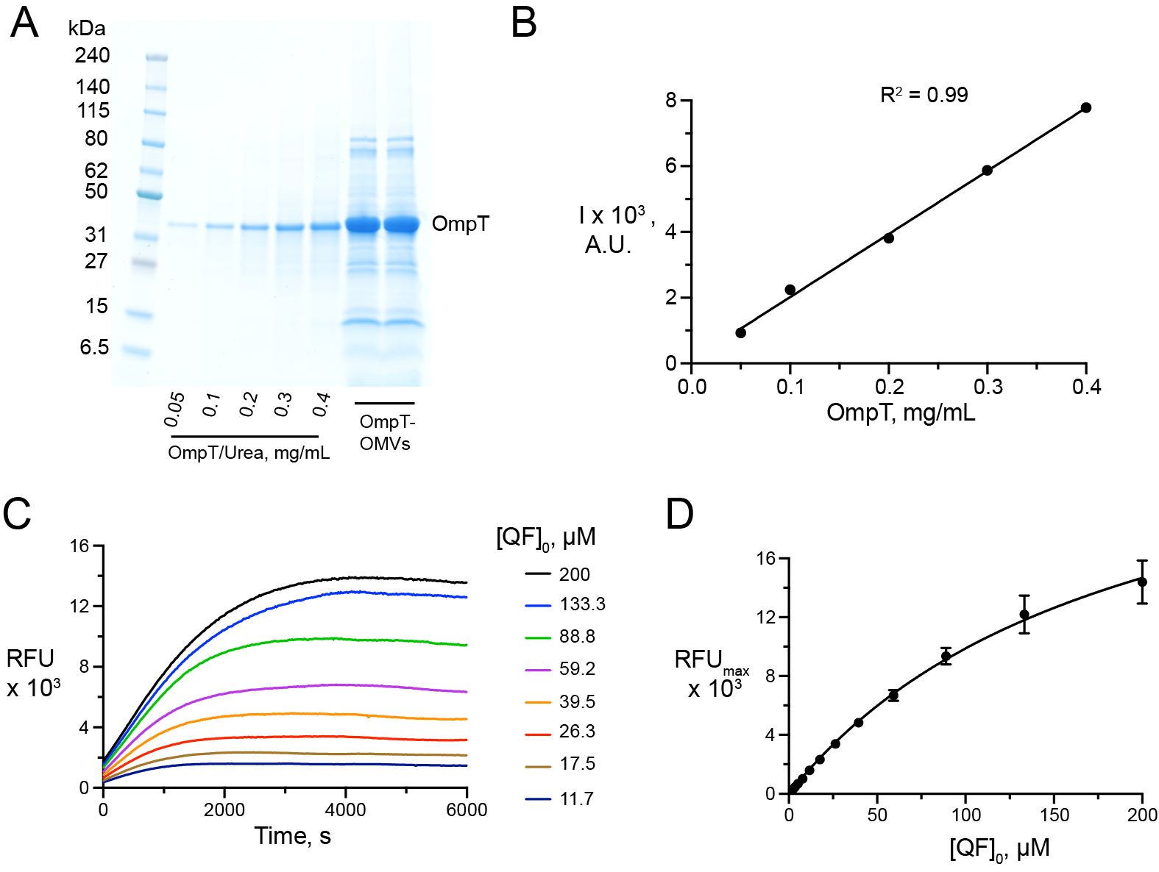

Extended Data Figure 1. Characterization of OmpT-OMVs. (A) SDS-PAGE of OmpT-OMVs along with pure OmpT in urea solution at known concentrations. (B) Linear fit to calibrate band intensities. (C) Fluorescence emitted after the cleavage of QF peptide by OmpT-OMVs using variable [QF]₀. (D) Scaling curve obtained from fitting the maximum fluorescence values from C.

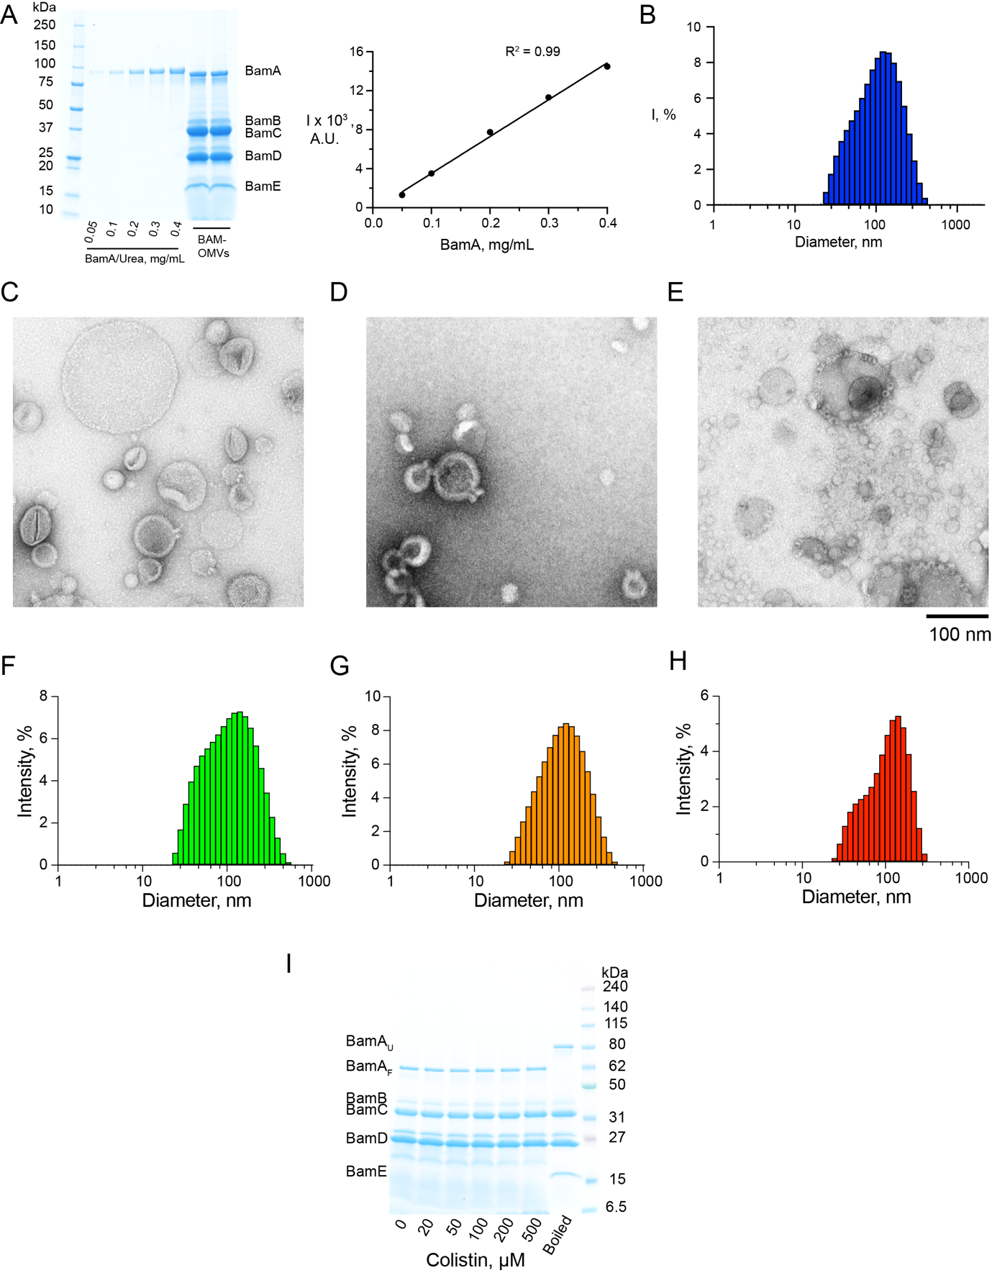

Extended Data Figure 2. Characterization of colistin-permeabilized BAM-OMVs. (A) SDS-PAGE of BAM-OMVs along with pure BamA in urea at known concentrations and a linear fit to calibrate band intensities. (B) Size distribution of OMVs as observed by dynamic light scattering (DLS). Negative staining EM images of BAM-OMVs incubated with variable colistin concentrations; (C) 20 µM, (D) 50 µM, and (E) 100 µM. The average size distribution of OMVs at (F) 20 µM, (G) 50 µM, and (H) 100 µM colistin as observed by DLS measurement. (I) SDS-PAGE gel-shift assay of BAM-OMVs treated with colistin concentrations up to 500 µM, demonstrating proper folding of BamA at all concentrations.

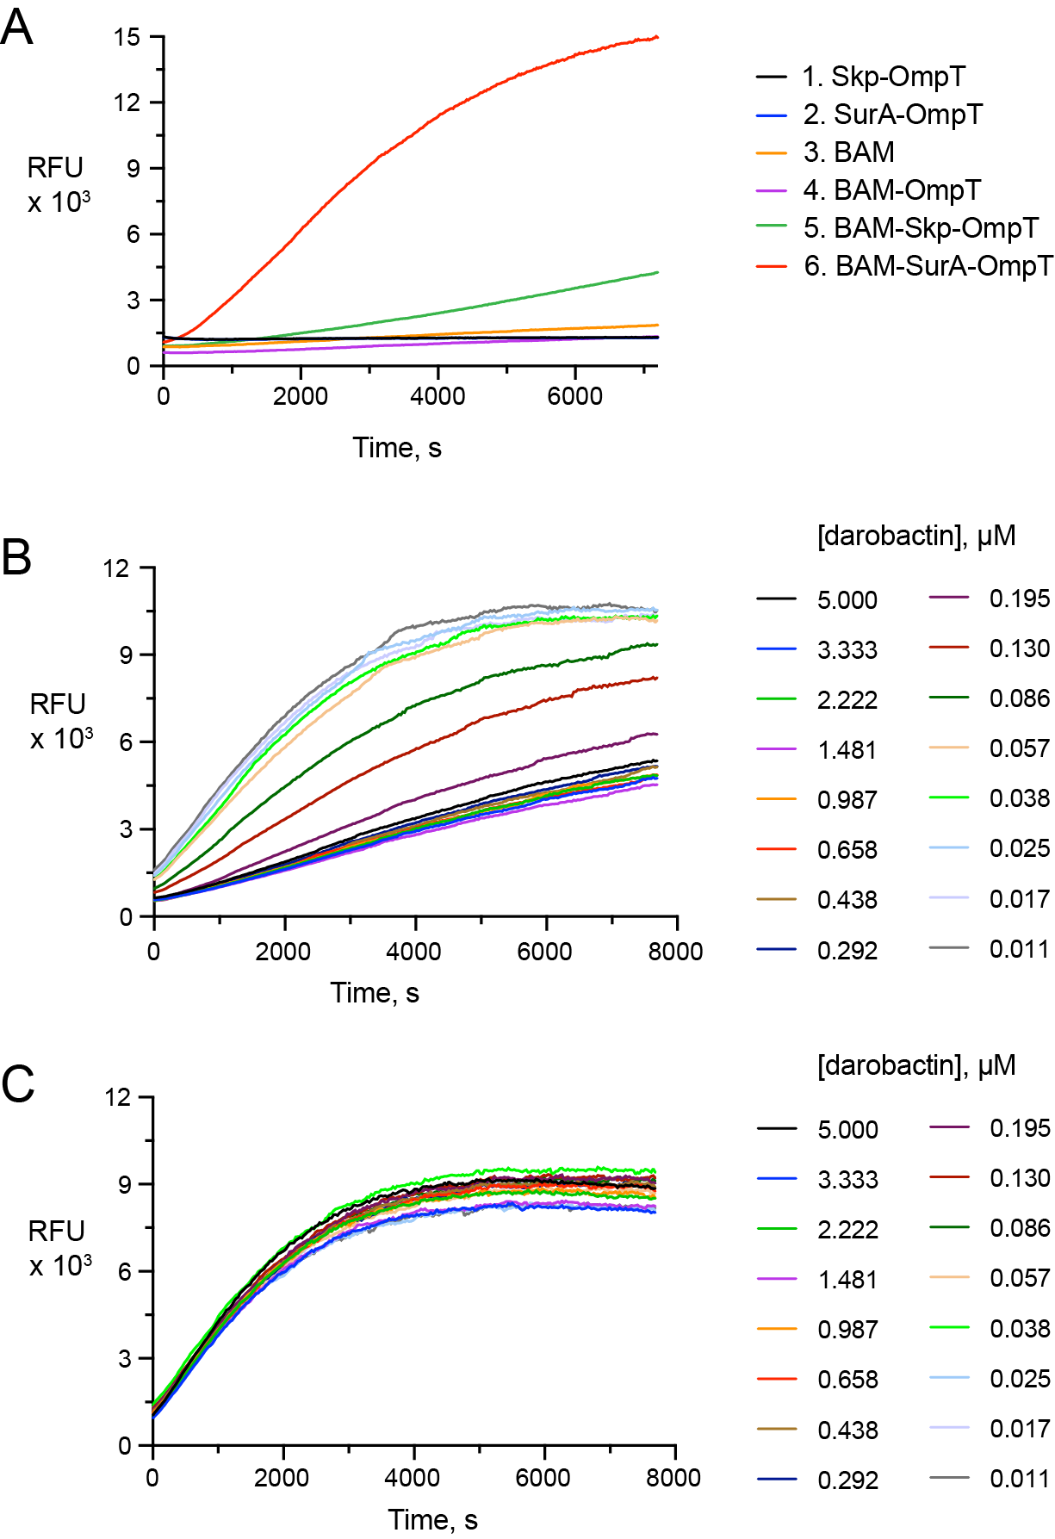

Extended Data Figure 3. Characterization of BAM-mediated folding of OmpT in OMVs. (A) Fluorescence emission for six different reaction mixes 1–6 as indicated. (B) Fluorescence emission of BAM-mediated OmpT folding at variable darobactin concentration. (C) Peptidase activity of OmpT in OmpT-OMVs at variable darobactin concentration.

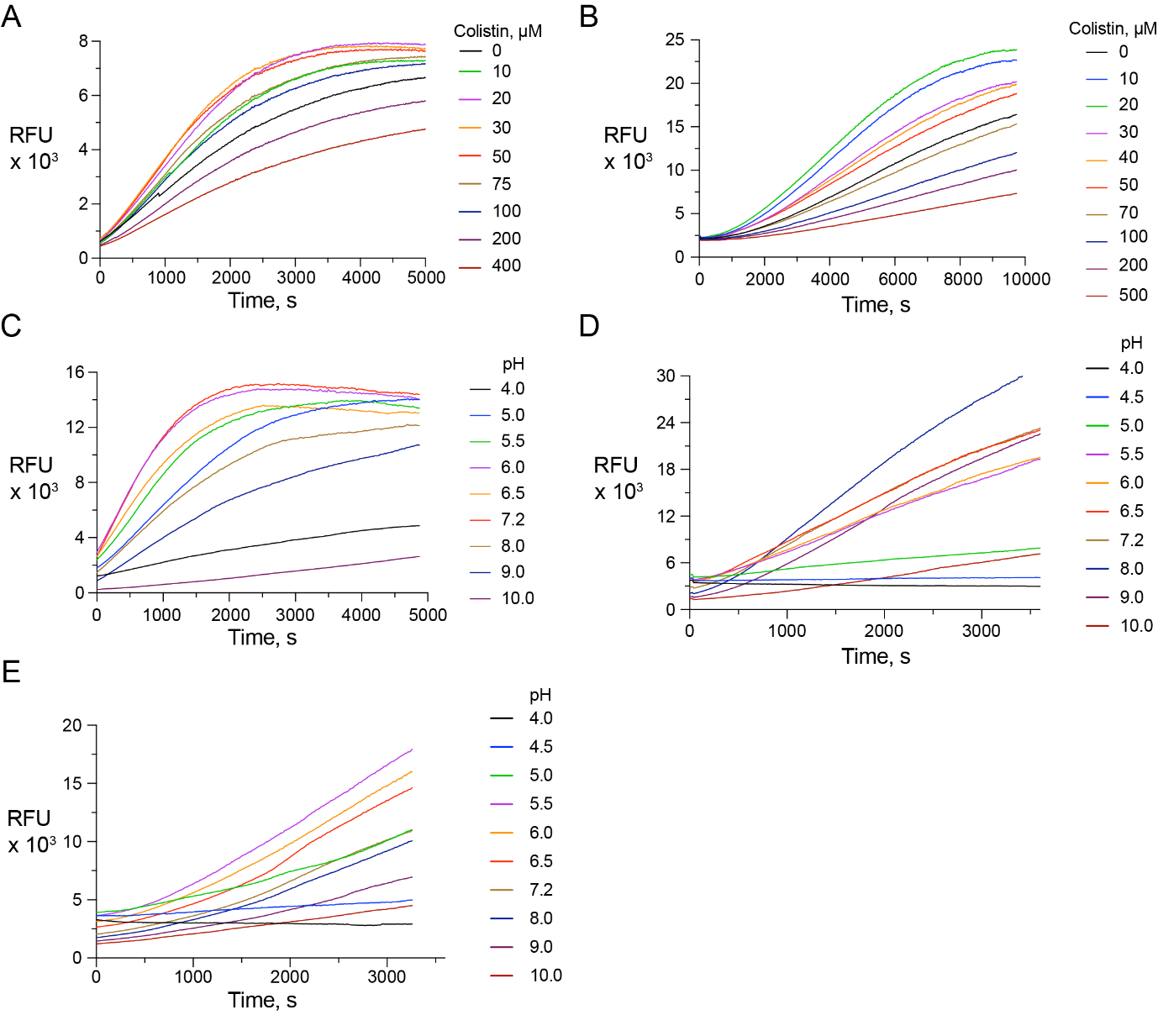

Extended Data Figure 4. Fluorescent emission for optimization of colistin concentration and reaction buffers. (A, B) Fluorescence emission of BAM-mediated OmpT activity in presence of (A) SurA with reaction mixture comprised of 16 nM BAM, 100 µM QF, 100 µm SurA and 2 µm OmpT and (B) Skp with reaction mixture comprised of 16 nM BAM, 500 µM QF, 50 µm Skp and 2 µm OmpT at variable colistin concentrations. (C) Fluorescence emission of OmpT activity at variable pH with reaction mixture comprised of 0.8 nM OmpT, 100 µM QF, 50 µm colistin. (D,E) Flourescence emission of BAM-mediated OmpT activity in presence of (D) SurA with reaction mixture comprised of 16 nM BAM, 500 µM QF, 50 µm colistin, 50 µm SurA and 2 µm OmpT and (E) Skp with reaction mixture comprised of 16 nM BAM, 500 µM QF, 50 µm colistin, 50 µm Skp and 2 µm OmpT at variable pH as indicated. The initial rates of the reactions were analyzed and plotted in Figure 3.

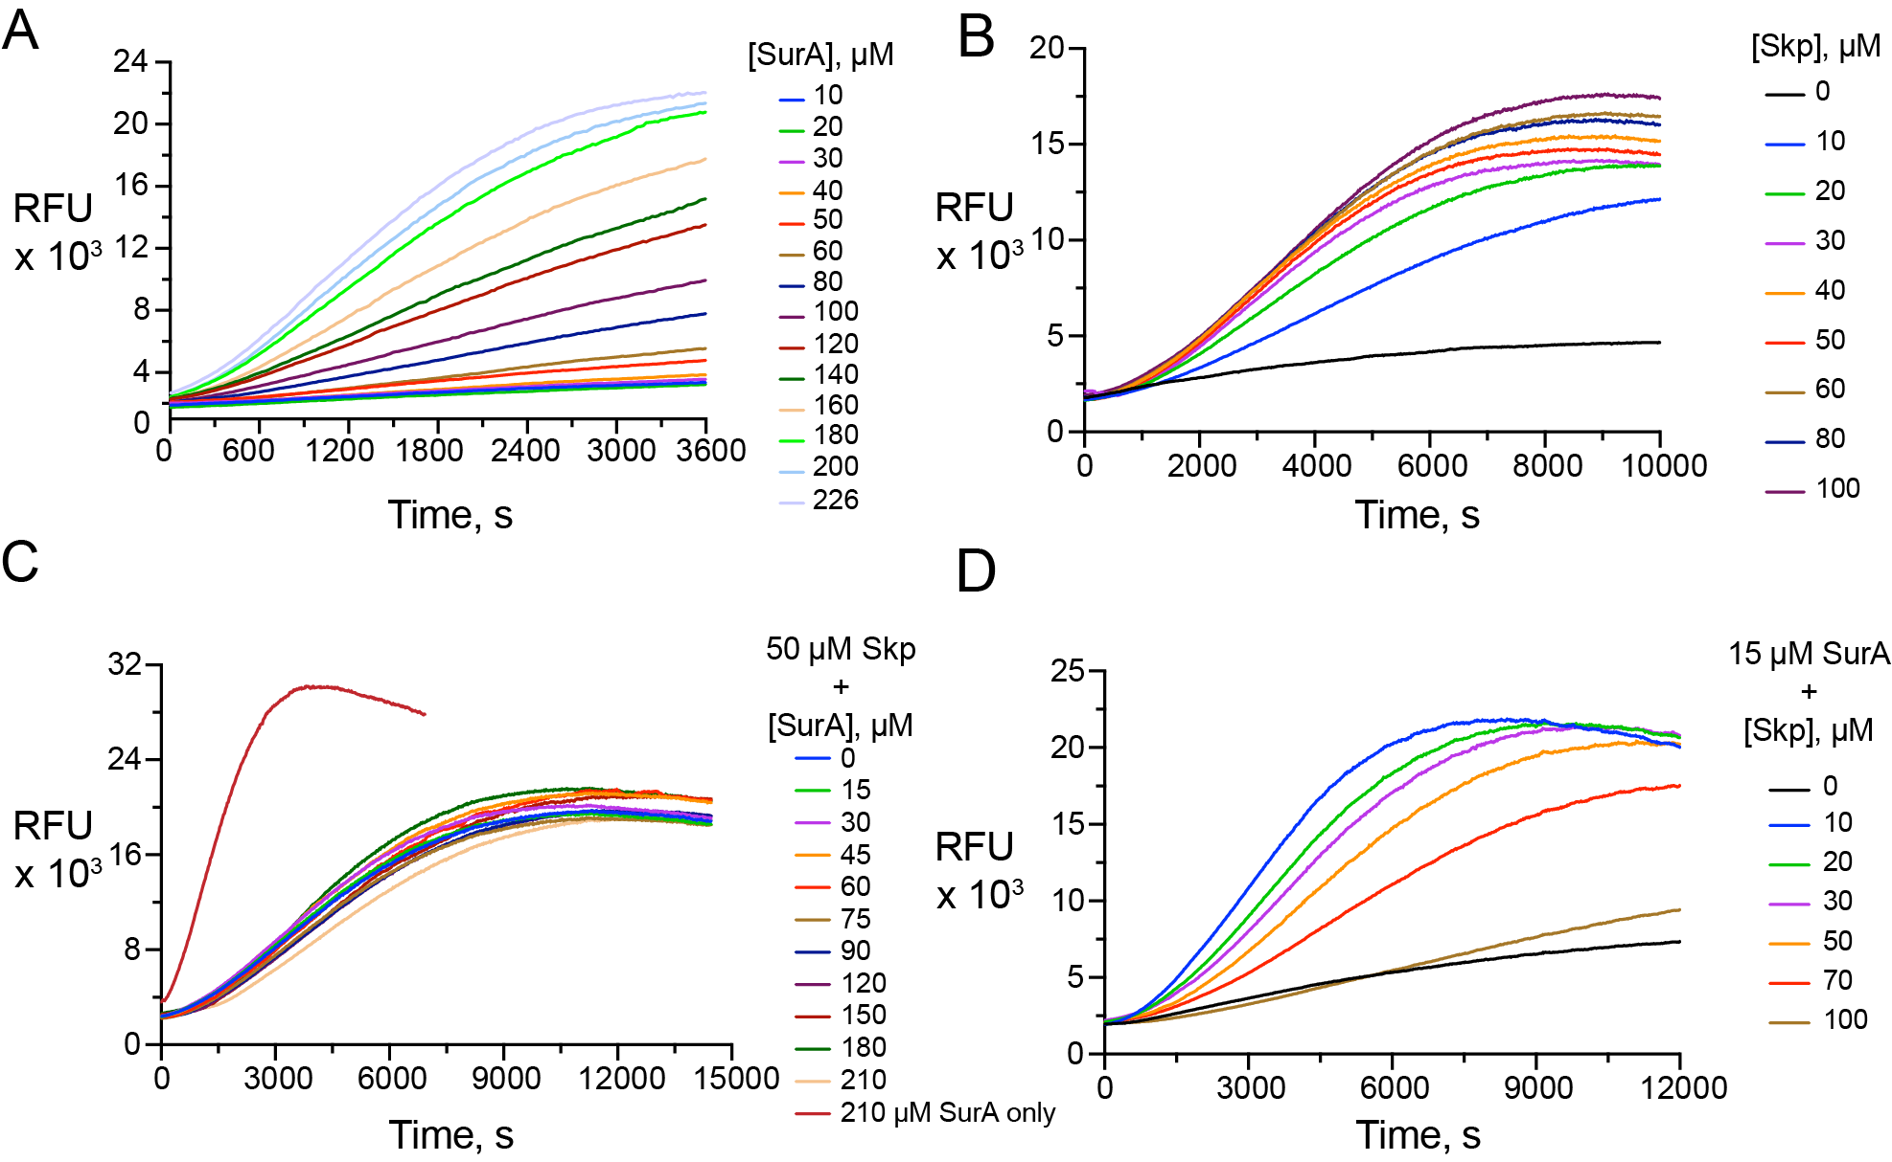

Extended Data Figure 5. Optimization of chaperone concentration and their competitive effect on BAM-mediated OmpT folding. (A, B) Fluorescence emission of BAM-mediated OmpT folding at variable (A) SurA and (B) Skp concentrations, as indicated. (C) Fluorescence emission of BAM-mediated OmpT activity at 50 µM Skp and variable SurA concentration, as indicated. (D) Fluorescence emission of BAM-mediated OmpT activity at 15 µM SurA and variable Skp concentration, as indicated. The initial rates of each reaction were analyzed and plotted in Figure 3.

