Supplemental Tables
Supplemental Table 1. Examples of eukaryotic viral DNA prevalences reported in virome studies
Study | Organ/  system | Sample type | Enrichment methods / pooling * | Library preparation + sequencing platforms | Cohort | Human DNA virus prevalence ca.
[1] | blood | whole blood | No enrichment / 6-sample pools | TruSeq Nano DNA HT kit + HiSeqX sequencer (Illumina) | 8240 healthy blood donors (0-102yr.) | 20%, HHV-7  15%, EBV  9%, TTV  5%, HHV-6B  1%, HHV-6A | 0.6%, MCPyV  0.4%, HCMV  <0.1% B19V, AdV, KSHV, HpyV
[2] | lung | BAL / OPW | VLP enrichment (filtration, concentration with 100kDa filter, nuclease treatment) +MDA | Nextera XT DNA library preparation kit + MiSeq (Illumina) | 6 lung transplant recipients; 3 HIV-positives without antitetroviral therapy | 100%, TTV  22%, HHV-7  11%, EBV  11%, HPV
[3] | lung | BAL | VLP enrichment (concentration with 100kDA filter, nuclease treatment) + MDA | Nextera XT DNA library preparation kit + HiSeq (Illumina) | Transplant patients (perioperative samples): 23 primary graft dysfunction, 23 healthy volunteers | 76%, TTV  2%, HCMV  2%, circoviridae
[4] | skin | skin swab |  | Library preparation unspecified + HiSeq2000 (Illumina) | 5 healthy individuals + one individual with previous MCC lesion | 100% β-HPV  83%, γ-HPV  83%, MCPyV  33%,circoviridae | 17%, HPyV6  17%, HPyV7  17%, HPyV9
[5] | skin | skin swab (multiple sites) |  | GAIIX platform (Illumina) | 102 healthy individuals | 77%, β-HPV  77%, γ-HPV  71%, other-HPV  41%, α-HPV  41%, HPyV | 18%, HHV-6/7  18%, AdV  12%, TTV  6%, HCMV
[5] | gut | stool |  | GAIIX platform (Illumina) | 102 healthy individuals | 5%, α-HPV  5%, AdV  5%, unclassified circovirus | 3%, HPyV  2%, HHV-6/7  2%, γ-HPV
[6] | skin | skin swab (multiple sites) |  | Nextera XT DNA library preparation kit + HiSeq (Illumina) | 27 patients with DOCK8-deficiency (17 adults and 10 children) | 100%, α-HPV  100%, β-HPV  100%, γ-HPV  100%, MCV  100%, α-PyV  100%, 𝛿 -PyV  93%, µ-HPV | 67%, β-PyV  41%, HSV-1/2  33%, EBV  22%, TTV  19%, HCMV  7%, HHV-6/7  4%, VZV
[7] | skin | skin swab |  | KAPA HyperPlus Library Preparation Kit (Kapa Biosystems) + HiSeq 2500 (Illumina) | 10 healthy individuals | 20 %, HPV
[7] | hair follicle | glue follicular biopsy |  |  | 20 healthy individuals | 10%, AAV
[8] | gut | stool | Sanger sequencing (384 clones were sequenced for each individual sample) | Big Dye terminator (v3.1)  with ABI 3730xl | 12 children with diarrhea from Australia or USA | 17%, AAV  17%, AdV
[9] | gut | stool |  | 454 Titanium FLX + sequencer (454 Life Sciences) | 49 children with acute diarrhea from Western Africa | 69%, TTV  24%, AAV  16%, HboV | 10%, AdV  4%, BuV  2%, HBV
[10] | gut | stool |  | GS FLX Titanium library preparation + GS Junior (454 Life Sciences) | 27 gastroenteritis patients from the Netherlands | 7%, TTV  4%, EBV  4%, BuV
[11] | gut | stool |  | ﻿454 GS FLX Titanium platform (454 Life Sciences) | 87 children with acute diarrhea from Australia | 43%, TTV  11%, AdV
[12] | gut | stool | VLP enrichment (filtration, nuclease-treatment) + WTA2-kit (Sigma Aldrich) / 2-5 sample pools | Nextera DNA Library Prep XT kit + NextSeq 500 (Illumina) | 221 children and adults from Cameroon | viral family (viridae) prevalence in pools  56%, anello  24%, parvo  24%, adeno  21%, circo |  | 2%, polyoma  2%, hepadna
[13] | urinary tract | urine | VLP enrichment (filtration, cesium cloride density gradient, Amicon YM-100 protein columns [Millipore], nuclease-treatment) +  MDA | Ion Plus Fragment Library Kit +  Ion Torrent Personal Genome Machine (PGM; Life Technologies) | 10 healthy and 10 with urinary tract infection | 95%, HPV
[14] | urinary tract | urine | VLP enrichment (centrifugation, ultracentrifugation, nuclease-treatment) | NEBNext DNA library prep kit for Illumina (New England BioLabs)  + HiSeq 2000 (Illumina) | 22 kidney transplant recipients (7 BK viremic and 15 BK non-viremic) | 72%, BKPyV  50%, AdV  27%, JCPyV  27%, TTV | 27%, β-HPV  9%, γ-HPV  5%, α-HPV  5%, HCMV
[15] | central nervous system | cerebrospinal fluid | VLP enrichment (filtering, cesium cloride density gradient, Amicon YM-100 protein columns [Millipore], nuclease-treatment) + MDA | Nextera XT DNA Library Prep kit + MiniSeq (Illumina) | 20 patients with various conditions (incl. but not limited to cancers, meningitis, encephalitis) | 15 % unspecified HHV
*Whole genome sequencing if not otherwise stated. MDA = multiple displacement amplification BAL= Bronchoalveolar lavage, OPW = Oropharyngeal wash, VLP = Viral-like particle, MCC = Merkel cell carsinoma, AAV= adeno-associated virus, AdV = adenovirus, HPyV = human polyomavirus, BKPyV = BK polyomavirus, JCPyV = JC polyomavirus, MCPyV = Merkel cell polyomavirus, HPV = human papillomavirus, HBV = hepatitis b virus HSV-1/2 = herpex simplex virus 1/2, VZV = varicella zoster virus, EBV = epstein-barr virus, HCMV = human cytomegalovirus, HHV = human herpesvirus, MCV = molluscum contagiosum virus, TTV = torque teno virus, HBoV = human bocavirus, BuV = bufavirus

Supplemental Table 2. Cohort Information.
individual | age | gender | cod | mod | other
1 | 85 | F | G30 | 1 | pharynx neoplasia
2 | 79 | M | W19 | 3
3 | 78 | M | C32.8 | 1 | larynx & esophagus carcinoma
4 | 77 | M | C34.37 | 2 | pulmonary carcinoma metastasis in brain, lymph nodes, liver
5 | 75 | M | X74 | 5
6 | 75 | M | I35.0 | 1
7 | 74 | M | W19 | 3
8 | 74 | F | W79 | 3
9 | 73 | M | I25.1 | 1
10 | 72 |  |  |  | mantle cell lymphoma stage IV, facial zoster rash and erythema multiforme of upper body 5 weeks prior
11 | 71 | M | I25 | 1
12 | 70 | M | I25.1 | 1
13 | 70 | M | F10.29 | 1
14 | 69 | M | I25.1 | 1
15 | 68 | M | I25.1 | 1
16 | 68 | M | T36# | 3
17 | 67 | F | I25.1 | 1
18 | 67 | M | I25.1 | 1
19 | 66 | M | I11 | 1
20 | 66 | M | W19 | 3
21 | 65 | F | F10.2 | 1
22 | 62 | M | K25.4 | 1
23 | 60 | M | I25.1 | 1
24 | 60 | F | I25.1 | 1 | pharyngeal  carcinoma operated
25 | 60 | F | J84.9 | 1
26 | 59 | M | I71.00 | 1
27 | 58 | M | I35.0 | 1
28 | 54 | F | J44.9 | 1
29 | 53 | M | F10.2 | 1
30 | 53 | F | F10.2 | 1
31 | 36 | F | F50.0 | 1
mod = manner of death 1=disease, 2=occupational disease, 3=injury, 5=suicide
cod = cause of death based on WHO International classification of diseases version 10 (ICD10) classification code (icd.who.int/browse10/2019/en).

Supplemental Table 3. Primers and Probes used for qPCRs
Target |  | Gene | ref
qPCRS | (Primer & Probe sequence (5’ – 3’))  Forward  Reverse(s)  Probe(s)
RNaseP | GAGGGAAGCTCATCAGTGGGG  CTTGGGAAGGTCTGAGACTAGGG  FAM-AGTGCGTCCTGTCACTCCACTC-BHQ1 | RNase P | [16]
HSV-1 | GTTGAGCTAGCCAGCGA  CGTTAAGGACCTTGGTGAGC  FAM-CGCGAACTGACGAGCTTTGTG-BHQ1 | UL42 | [17]
HSV-2 | CACACCACACGACAACAA  TAGTTCAAACACGGAAGCC  JOE-CGGCGATGACGGCAATAAA-BHQ1 | UL23 | [17]
VZV | GCGCAAGGCTATTAGAGC  ACATGGCAGAAATCCCTG  TxRd-CGCATACCCGGAAGTTCTTCAGAT-BHQ2 | ORF28 | [17]
EBV | CGGAAGCCCTCTGGACTTC  CCCTGTTTATCCGATGGAATG  FAM-TGTACACGCACGAGAAATGCGCC-BHQ1 | BALF5 | [17]
HCMV | GTGYTCCGTGAATCGTTAC  AGTCKACCTCGATATCACAAGTCG  TxRd-ACCCTGCTGCCGCCAGT-BHQ2 | UL54 | [17]
HHV-6A | CGGCCTCCAGAGTTGTAA  TGTCCCTTCAACTACTGAATC  FAM-AC[A]T[G]TTGC[T]A[G]AAA[G][A]CT-BHQ1 *  FAM-AC[A]T[G]TTGC[T]A[C]AAA[G][A]CT-BHQ1 | U90 | [17]
HHV-6B | TTTGACAGGAGTTGCTGAG  GGATTCAGGAAAAAGGTTCTAA  JOE-AGGAAGCGTTTCGGTACACTTGGAG-BHQ1 | U90 | [17]
HHV-7 | CTCGCAGATTGCTTGTTG  GCATACACCAACCCTACTGTAA  TxRd-TTAGGCATCACGTTGGCATTG-BHQ2 | U57 | [17]
KSHV | ATATACGGCGACACTGACTC  GAGCAGAAGGCACTTGAAG  JOE-CGGAGGAGCTAGCGTCAATCA-BHQ1 | ORF9 | [17]
B19V | CCACTATGAAAACTGGGCAATA  GCTGCTTTCACTGAGTTCTTCA  FAM-AATGCAGATGCCCTCCACCCAG-BHQ1 | NS1 | [16]
TTV | GTGCCGNAGGTGAGTTTA  GGACTGGCCGGGCT  GGTCTGGCCGGGCT  FAM-TCAAGGGGCAATTCGGGCT-BHQ1 | UTR | [18]
BKPyV | CCTTACCCAATTTCCTTTTTGCT  ATACATAGGCTGCCCATCCAC  TGACCTTATAAACAGGAGAACCC | VP1 | [19]
JCPyV | CTAAACACAGCTTGACTGAGGAATG  CATTTAATGAGAAGTGGGATGAAGAC  TAGAGTGTTGGGATCCTGTGTTTTCATCATCACT | LT | [20]
MCPyV | CCACAGCCAGAGCTCTTCCT  TGGTGGTCTCCTCTCTGCTACTG  FAM-TCCTTCTCAGCGTCCCAGGCTTCA-BHQ1 | LT | [21]
HPyV6 | TTGAGGAGCTGGACAAAGAGATT  TCTGGGAAGCTTTTGAATTGGT  FAM-AGGAAGATGCCTTGTCACAGAAAAGGAAATG-BHQ1 | VP2 | [22]
HPyV7 | GAGGAAGGAAACACTCCCCAGTA  TTCACTTCTTTTTGTAGCTCCTCAAG  FAM-ACTATACCTCAATGGATGCTTTTTGT-BHQ1 | VP2 | [22]
HPyV10 | TGAGAAGGCCCCGGTTCT  GAGGATGGGATGAAGATTTAAGTTG  FAM-CCTCATCACTGGGAGC-BHQ1 | LT | [23]
HBV | Hepatitis B Virus PCR Kit (Geneproof)
Luminex multiplex PCR | Reverse primers 5’ ends are biotinylated  Probes are 5’ amine-C12
BKPyV | ACAGAGGTTATTGGAATAACTAG  ACTCCCTGCATTTCCAAGGG  CTTAACCTTCATGCAGGGTC | VP1 | [24]
JCPyV | AATGAGGATCTAACCTGTGGAA  CTGCACCATTGTCATGAGTTGCTTG  ATGAATGTGCACTCTAATGG | VP1 | [24]
KIPyV | TTGGATGAAAATGGCATTGG  TAACCCTTCTTTGTCTAAAATGTAGCC  CTTGGAACAGCTAATAGTAGAATC | VP1 | [24]
WUPyV | TTGGATGAAAATGGCATTGG  TAACCCTTCTTTGTCTAAAATGTAGCC  GAGTACATACAGGGCTTTCCAG | VP1 | [24]
MCPyV | TTCCATCTTTATCTAATTTTGCTT  AGGCCTAGTTTTAGATTACCAGAC  GTAATAGGCCCACCATTTGT | VP1 | [24]
HPyV6 | TTGCTTCTGGATCCAATACTGC  GGCCTCAGGAATTTCAGGCAA  TGGATGCTGGTTCATCTCTG | VP1 | [24]
HPyV7 | AAGCAGCTACAACTGGGAACTT  GGCCTCAGGAATTTCAGGCAA  GCCTACCTTATCCTATGAGTG | VP1 | [24]
TSPyV | AGAATGTATGATGACAAAGGTAT  TCTGTAGTTTCCAGTTAGAAAC  TGAGGGAATGAATTTCCATATGTT | VP1 | [24]
HPyV9 | ATCTATGGCTCATCCTCAGG  GTAGAGCTAGCAACTAGGCCT  AGTGCAGGGTACCACTCTC | VP1 | [24]
HPyV10 | GTCCAGTTCCTACTAAAGTTCCT  TACATCATTGCCCATCCTTGGTT  GCCGGACACCACAATGACA | VP1 | [24]
HPyV11 | TGAATATGATCCGTGCCAAA  ACTGCATCAGGGCCTACTTG  CCTCCTCCAACATGTGTTCC | VP1 | [24]
HPyV12 | GTAATGGCACCCAAGAGGAA  GGGGATTTAGAAAGGCCTCA  CCCAGCAGTGTCCCTAAATT | VP1 | [24]
HPyV13 | TGTGTGCCAAAGAAGTGTCCT  TCTGTCACCTGTTGGAGCATT  CTGATGCTACTACTGAAATTGAA | VP1 | [24]
*Locked nucleic acids are inside brackets.

Supplemental Figures
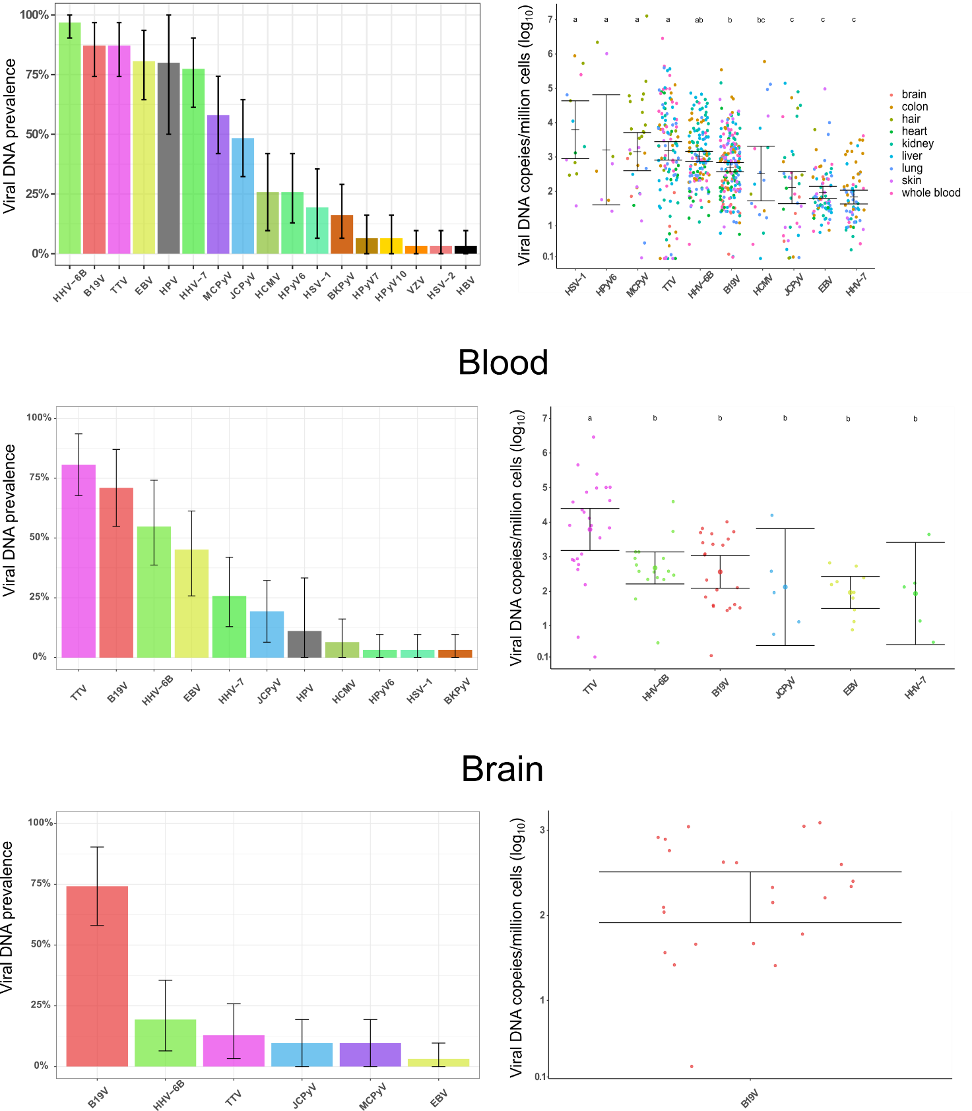

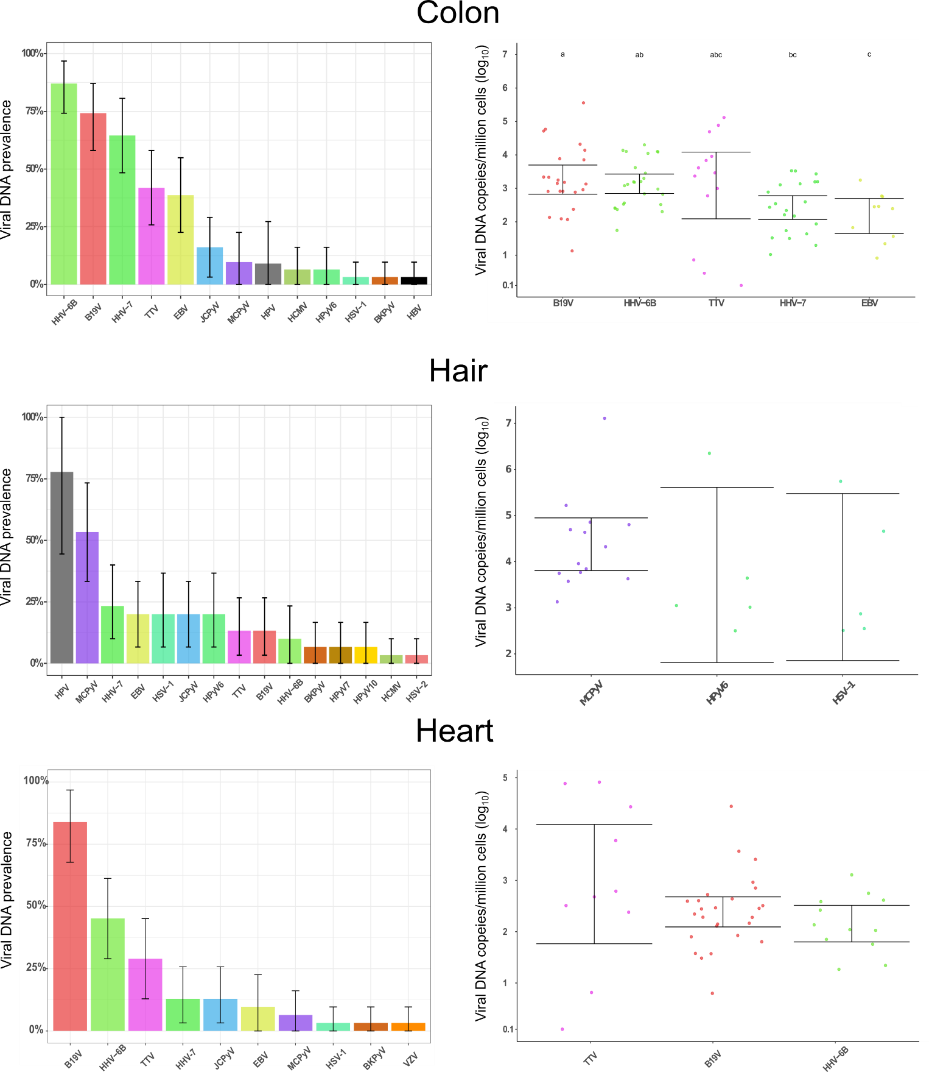
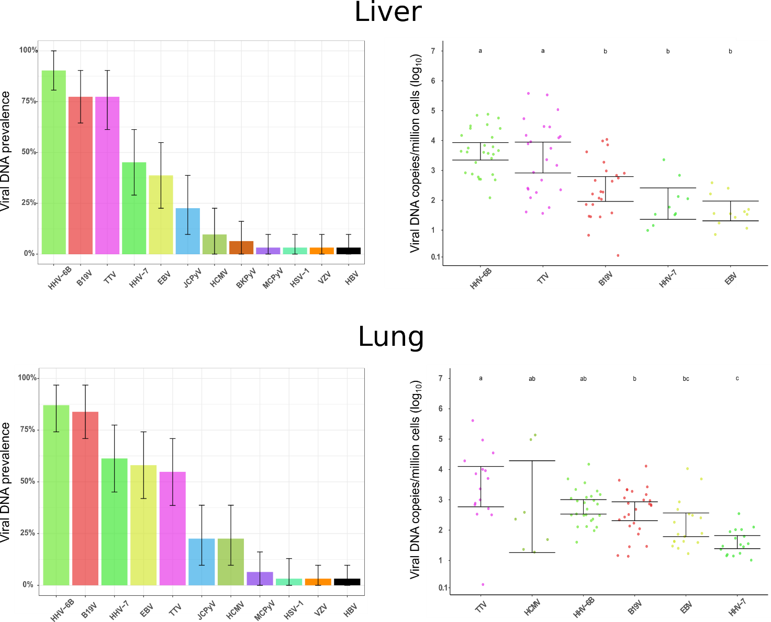
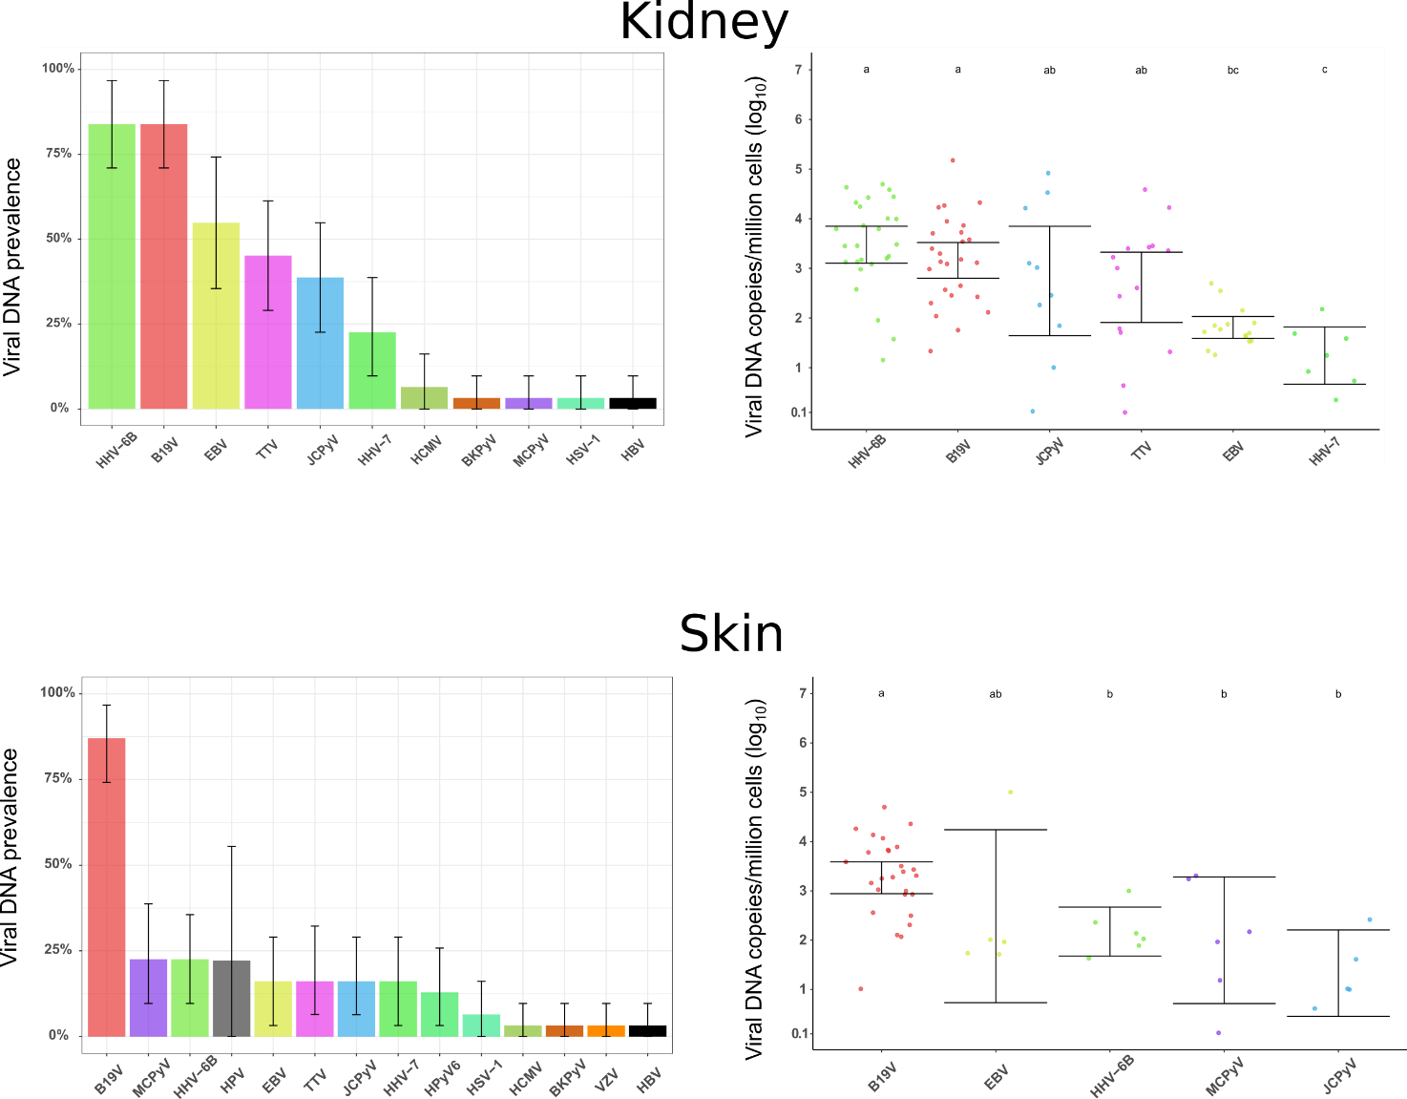

Supplemental Figure 1.Viral DNA prevalences and quantities. Viral prevalence in the body (top) and in different organs determined by qPCR and NGS, and quantities by qPCR. Quantities of a virus shown if at least 5 positive samples in a given organ. Error bars represent 95% confidence intervals. The geometric means of viral copies between viruses in different organs were compared with one-way ANOVA. When significant, step-wise group comparison was performed with REGWF. Different categories (marked a,b,c) had statistical significance (p<0.05).
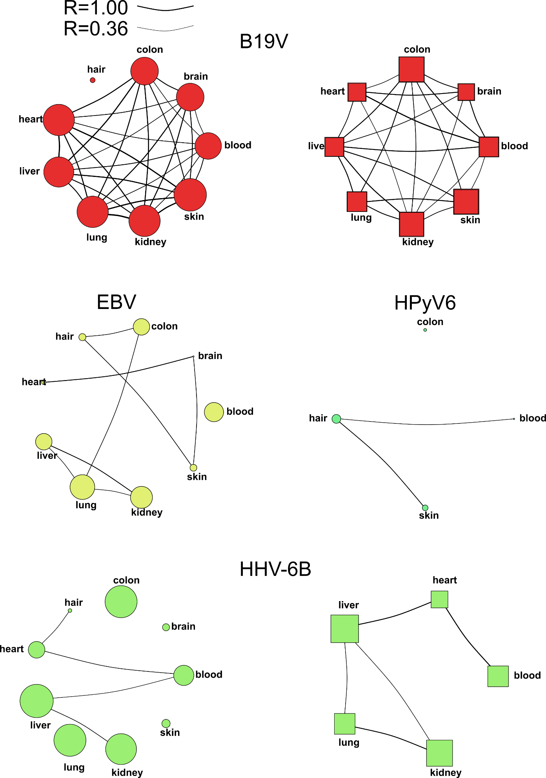

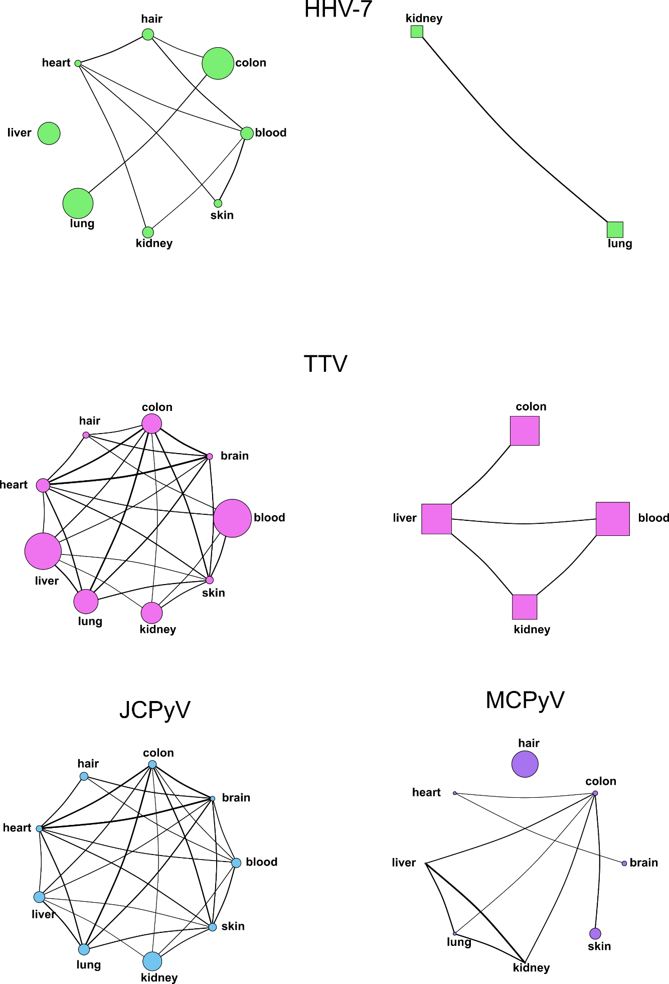
Supplemental Figure 2. Viral DNA intra-host correlation between organs. Weighted correlation network of statistically significant (p<0.05) viral prevalence (circles) and quantities (squares) between tissues as calculated by pairwise comparisons with φ coefficient or Spearman's ρ, respectively. The width of connecting lines (edges) represents the strength of correlation. The size of circles and squares (nodes) indicate percentage of viral prevalence and mean copies of viral DNA, respectively, in each organ.
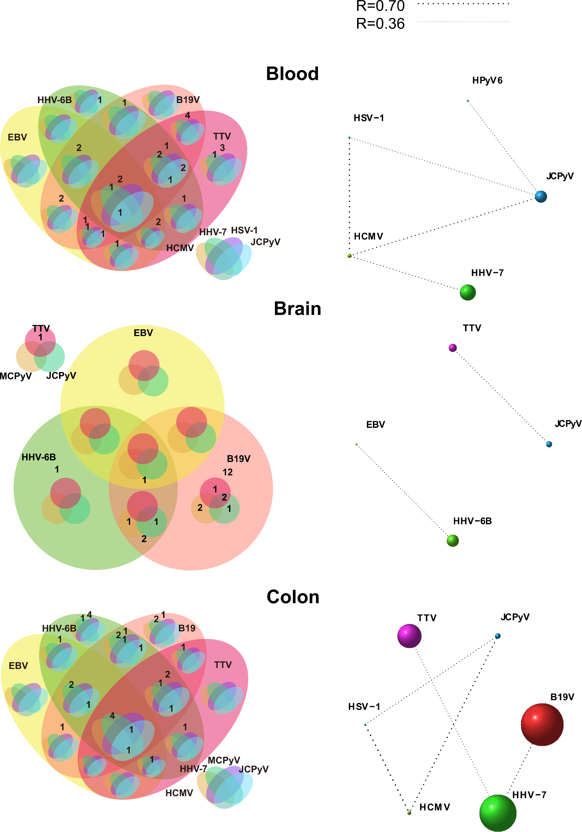
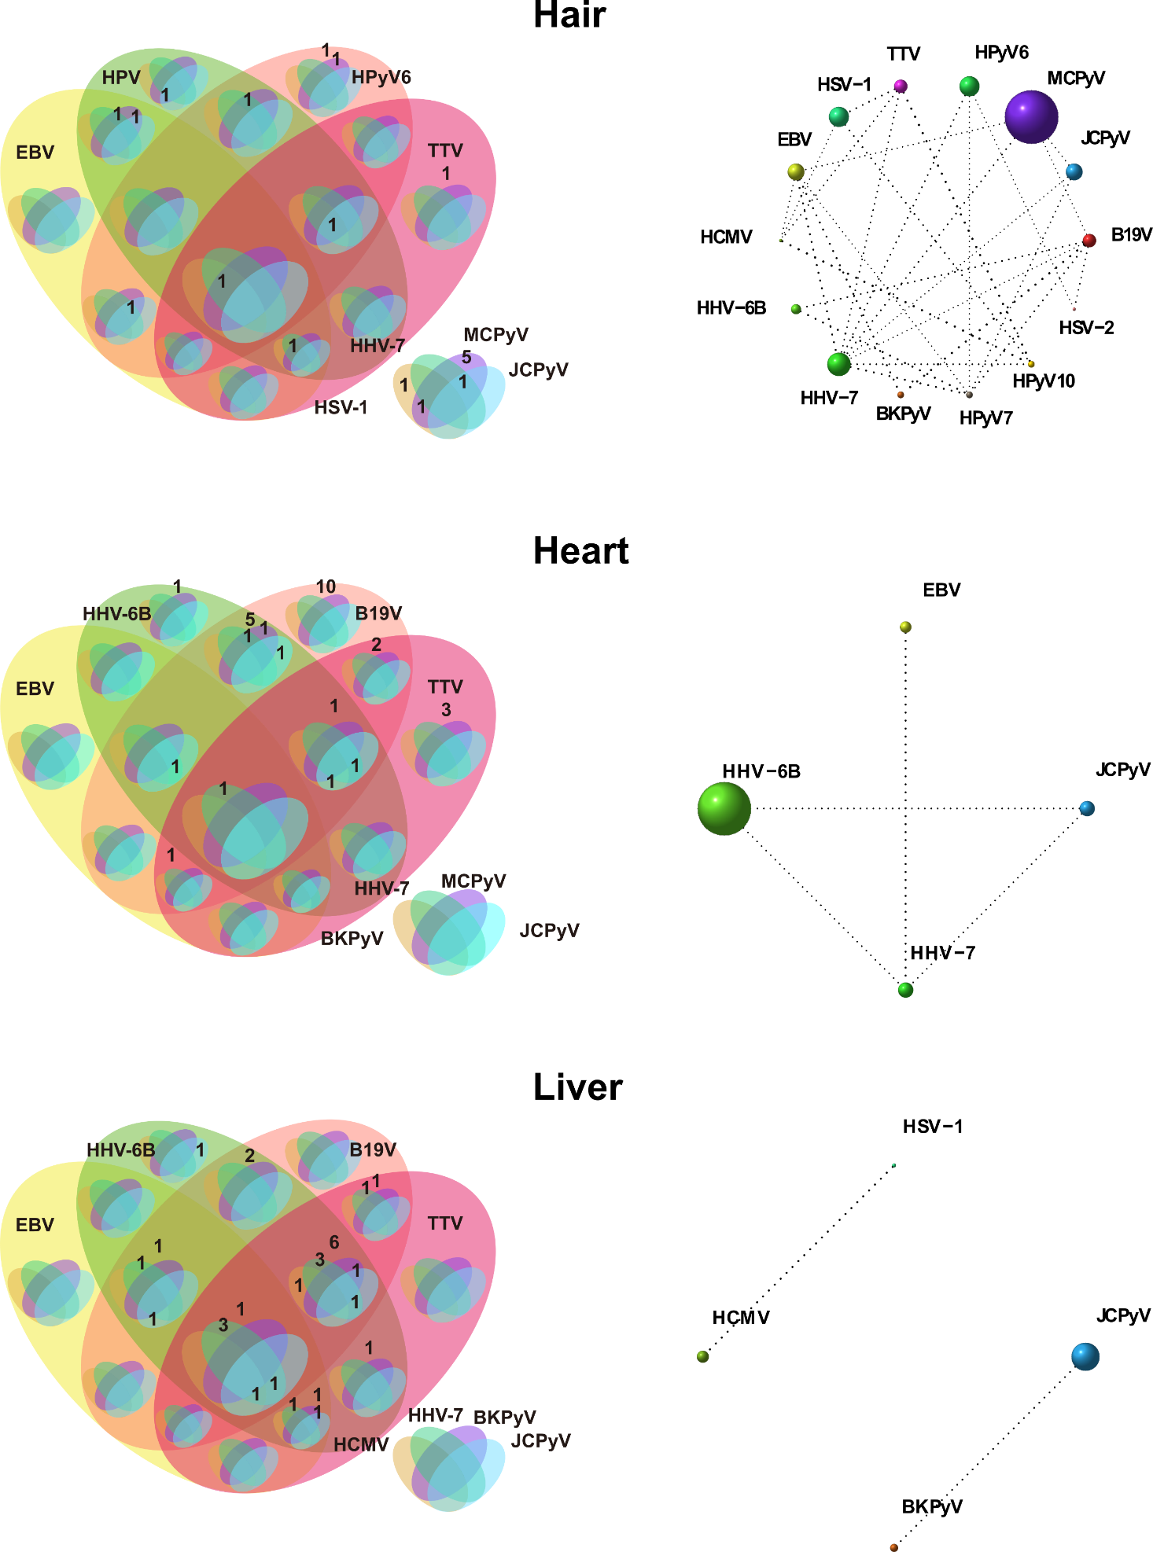

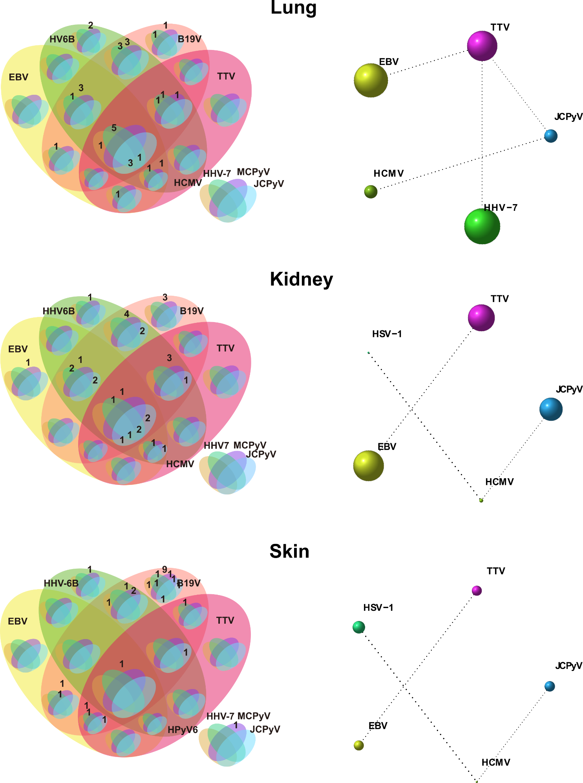
Supplemental Figure 3. Viral DNA co-occurrences in different organs. On the left are Venn diagrams of all the positive viral DNA findings in each tissue. On the right are the weighted networks of viral DNA correlations as calculated by φ coefficient (p<0.05). Correlation strength indicated by the width of the dashed line. Sizes of the spheres represent viral DNA prevalence in a given organ.
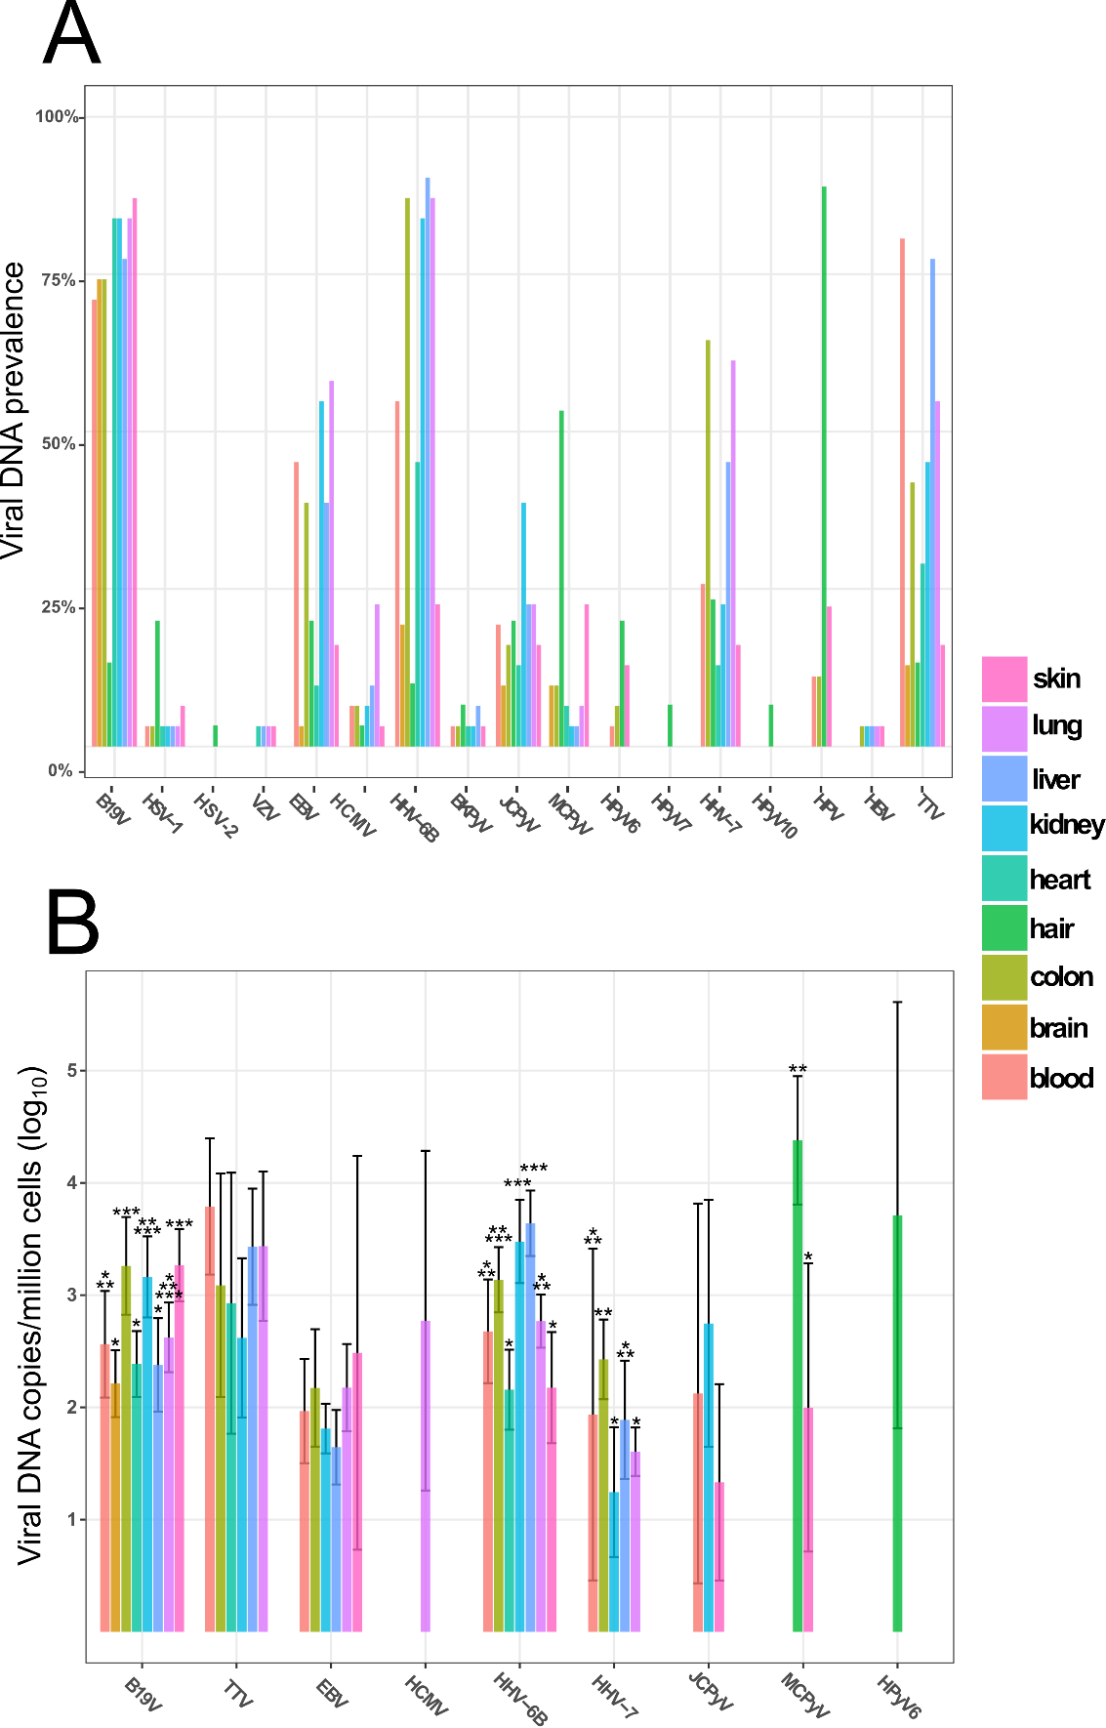
Supplemental Figure 4. Virus prevalence and quantities across organs. Side by side comparison of the A) prevalences and B) quantities of each of the viral DNAs in different organs. Statistical difference of the quantities was analyzed by One-way Anova and followed by REGW) for stepwise pairwise comparisons. Marked with asterisks are the different groups that showed statistical significance (p<0.05).
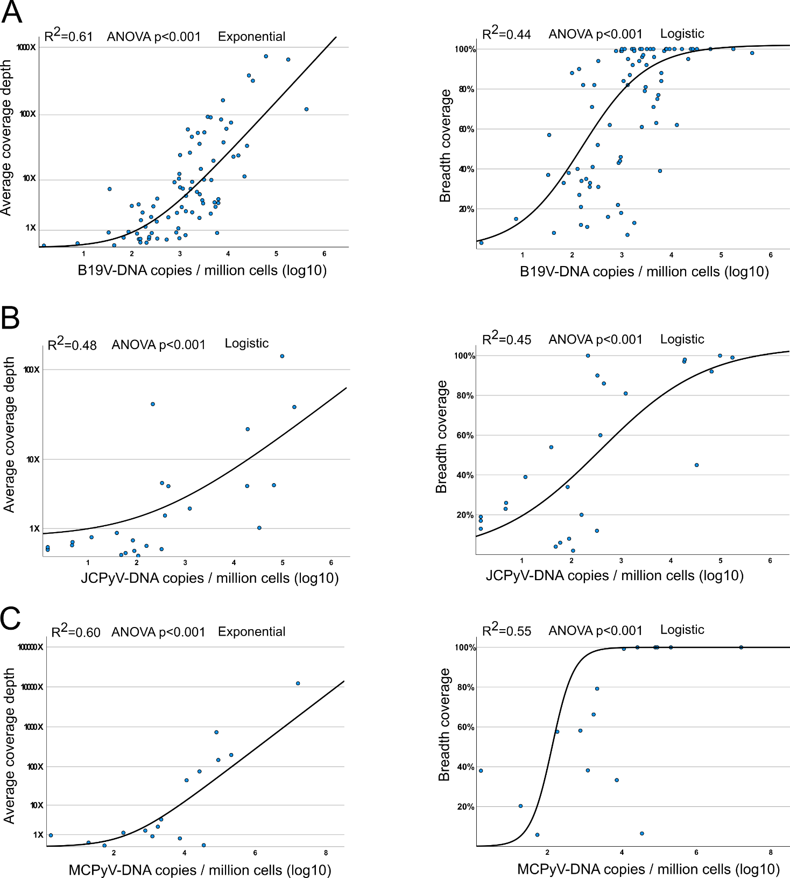

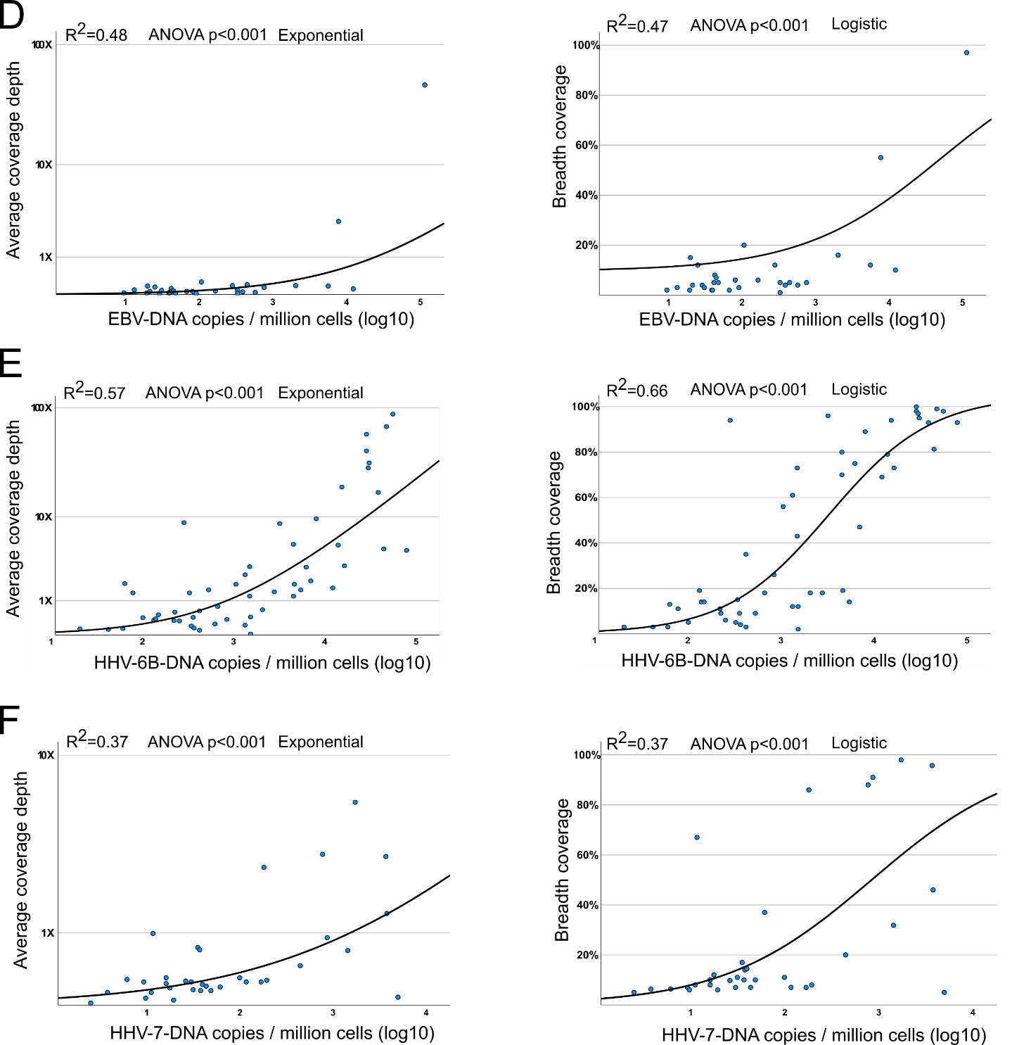
Supplemental Figure 5. Correlation of virus copies/million cells with mean coverage depth and breadth. A) B19V, B) JCPyV, C) MCPyV D) EBV, E) HHV-6b, F) HHV-7. Results were statistically significant (p<0.001) with ANOVA. R² represents coefficient of detemination.

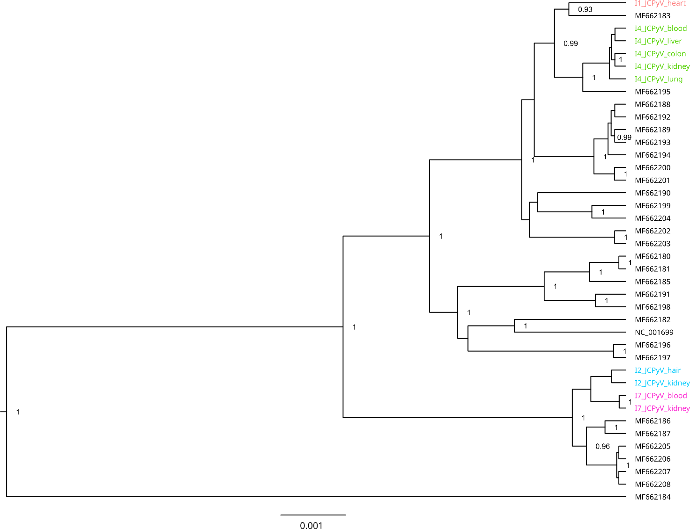
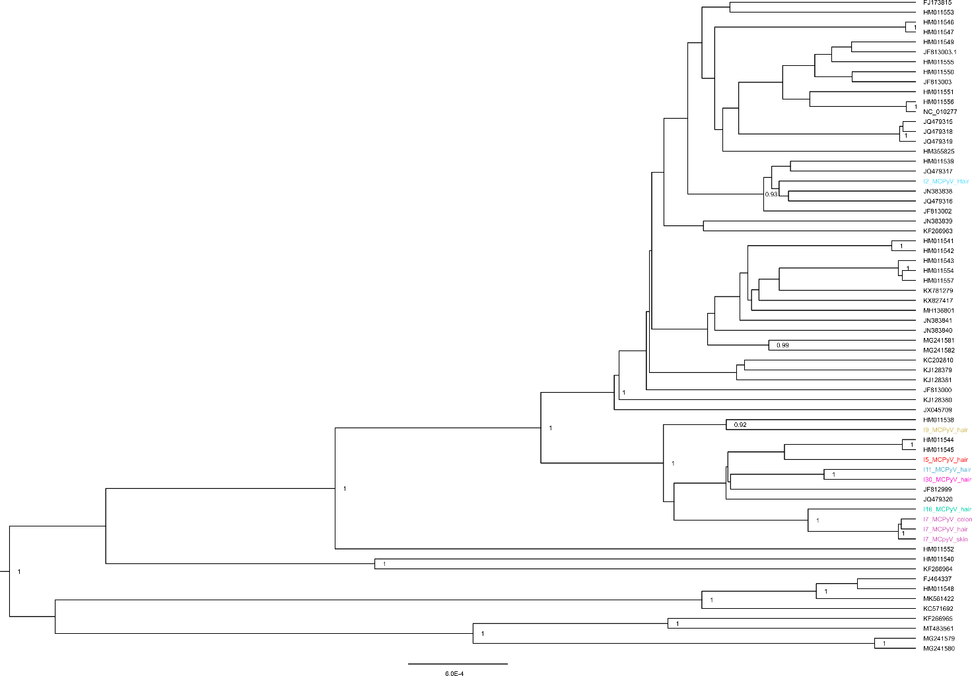
Supplemental Figure 6. Phylogenetic analysis of A) JCPyV, B) MCPyV and C) HHV-6B. Colors represents sequences from each of individuals of this study (>70% breadth), in black reference genomes from GenBank. For JCPyV the analysis was performed using 29 full-genome reference sequences from Finland and NC_001699 using Bayesian inference with Hasegawa-Kishono-Yano(HKY) substitution model. The phylogenetic analysis of MCPyV was performed using Bayesian inference with General Time Reversible GTR (121321) substitution model and that of HHV-6B with Bayesian inference with HKY. Only posterior probabilities >0.9 are shown.

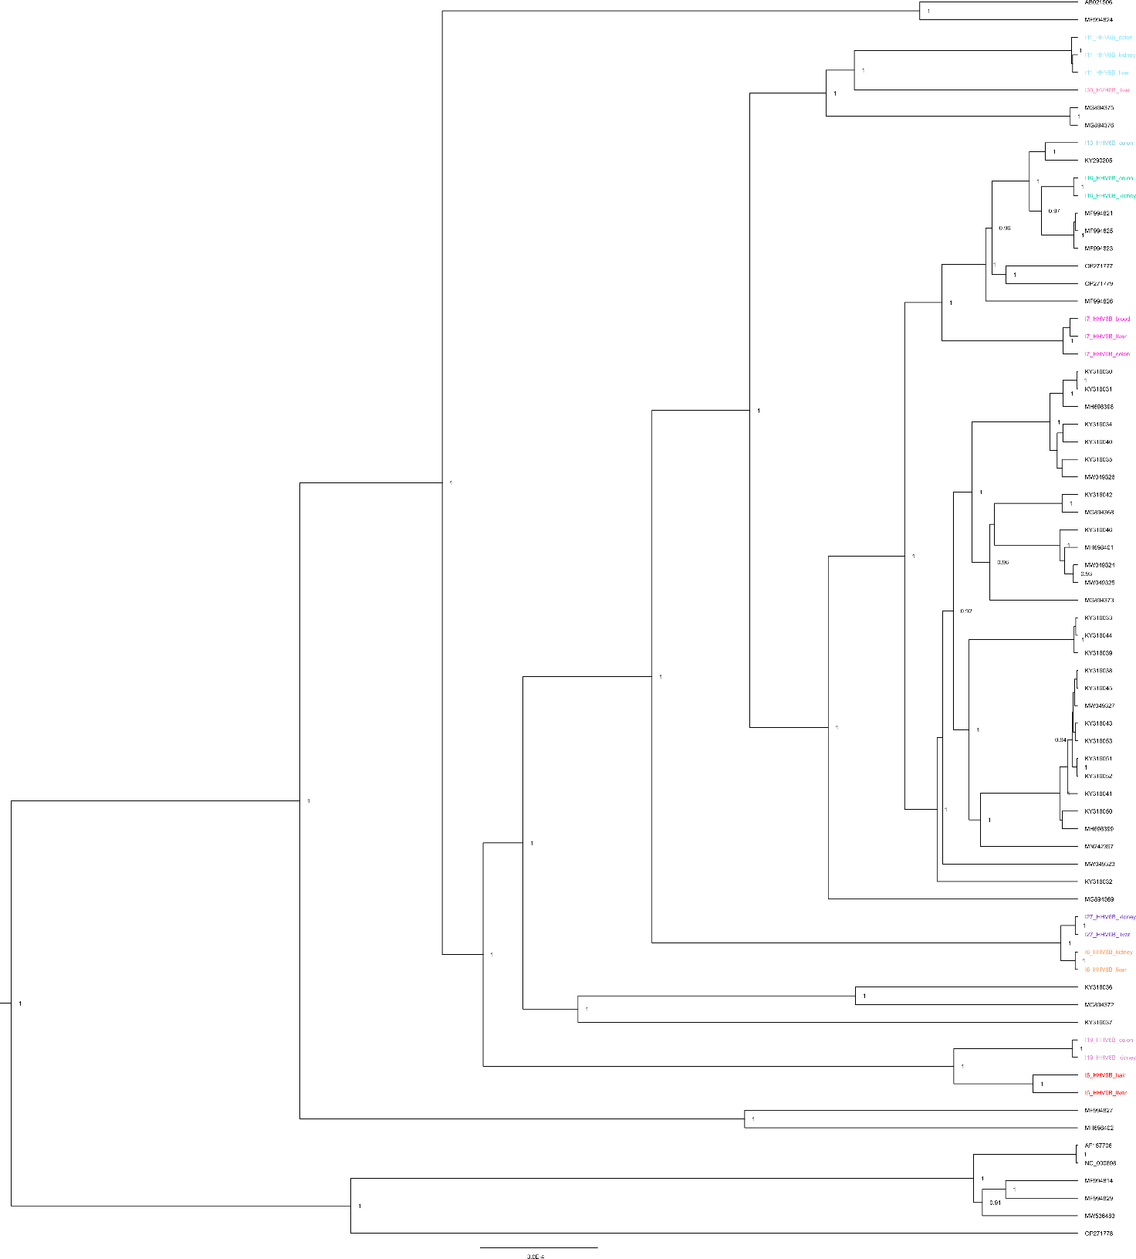

Supplemental reference list
1. Moustafa A, Xie C, Kirkness E, Biggs W, Wong E, Turpaz Y, et al. The blood DNA virome in 8,000 humans. Belshaw R, editor. PLoS Pathog. 2017;13:e1006292.
2. Young JC, Chehoud C, Bittinger K, Bailey A, Diamond JM, Cantu E, et al. Viral metagenomics reveal blooms of anelloviruses in the respiratory tract of lung transplant recipients. Am J Transplant. 2015;15:200–9.
3. Abbas AA, Diamond JM, Chehoud C, Chang B, Kotzin JJ, Young JC, et al. The Perioperative Lung Transplant Virome: Torque Teno Viruses Are Elevated in Donor Lungs and Show Divergent Dynamics in Primary Graft Dysfunction. Am J Transplant. 2017;17:1313–24.
4. Foulongne V, Sauvage V, Hebert C, Dereure O, Cheval J, Gouilh MA, et al. Human skin Microbiota: High diversity of DNA viruses identified on the human skin by high throughput sequencing. PLoS One. 2012;7:e38499.
5. Wylie KM, Mihindukulasuriya KA, Zhou Y, Sodergren E, Storch GA, Weinstock GM. Metagenomic analysis of double-stranded DNA viruses in healthy adults. BMC Med. 2014;12:71.
6. Tirosh O, Conlan S, Deming C, Lee-Lin SQ, Huang X, Barnabas BB, et al. Expanded skin virome in DOCK8-deficient patients. Nat Med. 2018;24:1815–21.
7. Hall JB, Cong Z, Imamura-Kawasawa Y, Kidd BA, Dudley JT, Thiboutot DM, et al. Isolation and Identification of the Follicular Microbiome: Implications for Acne Research. J Invest Dermatol. 2018;138:2033–40.
8. Finkbeiner SR, Allred AF, Tarr PI, Klein EJ, Kirkwood CD, Wang D. Metagenomic analysis of human diarrhea: Viral detection and discovery. PLoS Pathog. 2008;4:e1000011.
9. Phan TG, Vo NP, Bonkoungou IJO, Kapoor A, Barro N, O’Ryan M, et al. Acute Diarrhea in West African Children: Diverse Enteric Viruses and a Novel Parvovirus Genus. J Virol. 2012;86:11024–30.
10. Smits SL, Schapendonk CME, van Beek J, Vennema H, Schürch AC, Schipper D, et al. New viruses in idiopathic human diarrhea cases, the Netherlands. Emerg Infect Dis. 2014;20:1218–22.
11. Holtz LR, Cao S, Zhao G, Bauer IK, Denno DM, Klein EJ, et al. Geographic variation in the eukaryotic virome of human diarrhea. Virology. 2014;468:556–64.
12. Yinda CK, Vanhulle E, Conceição-Neto N, Beller L, Deboutte W, Shi C, et al. Gut Virome Analysis of Cameroonians Reveals High Diversity of Enteric Viruses, Including Potential Interspecies Transmitted Viruses. mSphere. 2019;4:e00585-18.
13. Santiago-Rodriguez TM, Ly M, Bonilla N, Pride DT. The human urine virome in association with urinary tract infections. Front Microbiol. 2015;6:14.
14. Rani A, Ranjan R, McGee HS, Metwally A, Hajjiri Z, Brennan DC, et al. A diverse virome in kidney transplant patients contains multiple viral subtypes with distinct polymorphisms. Sci Rep. 2016;6:33327.
15. Ghose C, Ly M, Schwanemann LK, Shin JH, Atab K, Barr JJ, et al. The Virome of Cerebrospinal Fluid: Viruses Where We Once Thought There Were None. Front Microbiol. 2019;10:2061.
16. Toppinen M, Norja P, Aaltonen LM, Wessberg S, Hedman L, Söderlund-Venermo M, et al. A new quantitative PCR for human parvovirus B19 genotypes. J Virol Methods. 2015;218:40–5.
17. Pyöriä L, Jokinen M, Toppinen M, Salminen H, Vuorinen T, Hukkanen V, et al. HERQ-9 Is a New Multiplex PCR for Differentiation and Quantification of All Nine Human Herpesviruses. mSphere. 2020;5:e00265-20.
18. Toppinen M, Pratas D, Väisänen E, Söderlund-Venermo M, Hedman K, Perdomo MF, et al. The landscape of persistent human DNA viruses in femoral bone. Forensic Sci Int Genet. 2020;48:102353.
19. Hoffman NG, Cook L, Atienza EE, Limaye AP, Jerome KR. Marked variability of BK virus load measurement using quantitative real-time PCR among commonly used assays. J Clin Microbiol. 2008;46:2671–80.
20. Dumoulin A, Hirsch HH. Reevaluating and optimizing polyomavirus BK and JC real-time PCR assays to detect rare sequence polymorphisms. J Clin Microbiol. 2011;49:1382–8.
21. Goh S, Lindau C, Tiveljung-Lindell A, Allander T. Merkel cell polyomavirus in respiratory tract secretions. Emerg Infect Dis. 2009;15:489–91.
22. Antonsson A, Bialasiewicz S, Rockett RJ, Jacob K, Bennett IC, Sloots TP. Exploring the prevalence of ten polyomaviruses and two herpes viruses in breast cancer. PLoS One. 2012;7:39842.
23. Siebrasse EA, Reyes A, Lim ES, Zhao G, Mkakosya RS, Manary MJ, et al. Identification of MW Polyomavirus, a Novel Polyomavirus in Human Stool. J Virol. 2012;86:10321–6.
24. Sadeghi M, Wang Y, Ramqvist T, Aaltonen LM, Pyöriä L, Toppinen M, et al. Multiplex detection in tonsillar tissue of all known human polyomaviruses. BMC Infect Dis. 2017;17:1–8.

