Supplementary materials

Methods

Region of interest (ROI) isolation
The Spatially-resolved Laser Activated Cell Sorter (SLACS) instrument comprises optical modules and mechanical modules for high-throughput retrieval of samples from the tissue. Two motorized stages exist for handling the retrieved targets. An X-Y axis motorized stage (ACS Motion Control, Migdal, Israel) was built to control the spatial location of the target. The device can be controlled automatically by communicating with a computer. One stage is for loading sample slides, and the other stage is for loading tubes to receive isolated cells. A charge-coupled device (CCD) camera (Jenoptik, Jena, Germany) was installed to observe where the laser pulse will be applied through the objective lenses. A neodymium-doped yttrium aluminum garnet (Nd:YAG) nanosecond laser was purchased from Continuum (Minilite™ Series ML II; Continuum, San Jose, CA). There is a slit located in the light path between the laser source and the objective lens to control the region to be isolated. The slit is controlled either manually or automatically to adjust the size of the laser pulse. Objective lenses with various magnifications were purchased from Mitutoyo. The long working distance allows more space between the lens and the sample for user convenience.

Communication system for SLACS
We designed two different pieces of software, which were written in Python scripts. The first was built for the user (a pathologist in our case) to select the cells to be isolated. We shared the whole-slide image with the user through a server, and the user ran the software to select the cells of interest while navigating the tissue image through the graphical user interface. After selection, the program produces two files: a text file with locational information about the region of interest and the image file with the selected targets is overlaid with transparent blue on the original image. Both files are required for the
automated isolation of the target cells. The second software enables the automatic control of the SLACS instrument. With this software, the users are able to control the slits, change the objective lenses, and move the motorized stages. It also enables automatic target isolation when two files from the first software are loaded. All tissue samples were isolated using an automatic function, while the cell line experiments were performed manually.

Cell culture
Human HEK 293T (cat # 21573), human IM-9 cells (cat # 10159), human HuT 78 cells (cat # 90078), and murine NIH3T3 cells (cat # 21658) were purchased from Korean Cell Line Bank (KCLB) and propagated according to the manufacturer’s instructions. HEK 293T cells were cultured in DMEM (Thermo Fischer Scientific, Massachusetts, USA) with 1% penicillin-streptomycin (Corning, New York, USA) and 10% foetal bovine serum (HyClone, Massachusetts, USA) at 37°C under 5% CO2 and 95% atmospheric air; IM-9 cells were cultured in RPMI 1640 (Thermo Fischer Scientific) with 1% penicillin-streptomycin (Corning, New York, USA) and 10% foetal bovine serum (FBS, HyClone) at 37°C under 5% CO2 and 95% atmospheric air; HuT cells were cultured in DMEM (Thermo Fischer Scientific, Massachusetts, USA) with 1% penicillin-streptomycin (Corning, New York, USA) and 10% FBS (HyClone, Massachusetts, USA) at 37°C under 5% CO2 and 95% atmospheric air. NIH3T3 cells were cultured in DMEM (Thermo Fischer Scientific) with 1% penicillin-streptomycin (Corning, New York, USA) and 10% bovine calf serum (HyClone) at 37°C under 5% CO2 and 95% atmospheric air. Adherent cells such as HEK 293 T cells and NIH3T3 cells were grown to a confluence of 50-80% and treated with TrypLE (Invitrogen, California, USA) for five min, quenched with an equal volume of growth medium, and spun down at 1500 rpm for 3 min. In addition, suspension cells such as IM-9 and HuT 78 cells were grown to a concentration of $2×{10}^{5}-5×{10}^{5}$ cells/mL and spun down at 1500 rpm for 3 min. Then, the supernatant was removed, and cells were resuspended in 1 mL of 1x PBS with 10 μl RNase Inhibitor (Invitrogen, California, USA) and re-spun at 1500 rpm for 3 min. The supernatant was again removed, cells were resuspended in 10 μl and spread on indium tin oxide (ITO) glass (Fine Chemicals Industry, Republic of Korea).
For paraformaldehyde (PFA) fixation, smeared cells were fixed with 4% PFA solution (Thermo Fischer Scientific, Massachusetts, USA) at 4°C for 15 min and washed with DPBS at room temperature; for methanol (MeOH) fixation, smeared cells were serially fixed with 70%, 90%, and 99% MeOH in distilled water for 30 sec and rehydrated by dipping for 30 sec in reverse order.

Tissue preparation
Tissue sections were acquired from the archives of the biorepository of Lab of Breast Cancer Biology at the Cancer Research Institute, Seoul National University. Preparation of tissue was approved by the Institutional Review Board of Seoul National University Hospital (SNUH, IRB No. 1405-088-580). For PFA fixation, we fixed the tissue sections with 4% PFA in PBS on ice for 15 min and then washed them twice with ice-cold PBS containing 1% recombinant RNase inhibitor (Takara, Japan). The section was air-dried on ice for 3 min. For MeOH fixation, we fixed the tissue section in rising methanol concentrations (75, 95, and 99% MeOH, 30 sec each) and air-dried them on ice for 1 min.
For haematoxylin and eosin (H&E) staining, we fixed the tissue sections with 4% PFA as described above, except for the air-drying process. Then, the tissue sections were stained with Mayer’s haematoxylin (Sigma-Aldrich, Germany) for 1 min and bluing buffer (Agilent Dako, US, California) for 30 sec followed by eosin (Sigma-Aldrich, Germany) for 10 sec. We washed the sample with distilled pure water for 30 sec between each buffer changing process during staining. Finally, we dipped the sample in 70% MeOH for 30 sec and air-dried the sample on ice for 1 min. For immunofluorescence staining, we fixed the tissue section with 4% PFA as described above, except for the air-drying process. Then, we blocked the sections in PBS with 1% BSA for 15 min on ice. We diluted primary antibodies (1:200) in blocking solution, incubated the slides with primary antibodies for 15 min on ice, and then washed them twice with ice-cold PBS. The tissue sections were air dried for 3 min on ice, and fluorescence images were acquired on a microscope (Nikon Eclipse Ti). We used primary antibodies against CD4 (Abcam, UK, ab181724), CD8 (Abcam, UK, ab251596), CD14 (Abcam, UK, ab230903), and CD19 (Abcam, UK, ab237772). We used the following fluorescence conjugate kits for each antibody: Alexa 488 (Abcam, UK, ab236553), TxRed (Abcam, UK, ab195225), Cy3 (Abcam, UK, ab188287), and Cy5 (Abcam, UK, ab188288).

Modified Smart-seq2
To lyse cells, isolated cells were added to a 0.2-ml thin-wall PCR tube containing 2 μl of a mild hypotonic lysis buffer composed of 0.2% Triton X-100 (Sigma-Aldrich, Germany) and 2U/μl of recombinant RNase inhibitor (40 U/μl, Takara, Japan), 1 μl of 10 mM oligo-dT primer (Macrogen, Republic of Korea, 5’- AAGCAGTGGTATCAACGCAGAGTACT₃₀VN-3’), and 1 μl of 10 mM dNTP mix (Takara, Japan) and were incubated at 72°C for 15 min and then immediately placed on iced. In the case of PFA-fixed samples, fixed cells were added to 0.2-ml thin-wall PCR tubes containing 2 μl of a enzymatic lysis buffer composed of 2.5 mg/ml Proteinase K (10 mg/ml, Sigma-Aldrich, Germany) in nuclease free water (Invitrogen, California, USA), 1 μl of oligo-dT primer, and 1 μl of dNTP mix (Takara, Japan), and then they were incubated at 50°C for 1 hour²⁰, 70°C for 10 min, and immediately placed on iced afterward.
cDNA obtained from extracted RNA was prepared as previously reported SMART-seq2 protocol ¹ with the following modifications: we prepared 6 μl of the first-strand reaction mix, containing 0.5 μl SuperScript II (200 U/μl, Invitrogen, California, USA), 0.25 μl recombinant RNase inhibitor (40 U/μl, Takara, Japan) 2 μl SuperScript II First-Strand Buffer (5×, Invitrogen, California, USA), 0.25 μl dichlorodiphenyltrichloroethane (DTT) (100 mM, Invitrogen, California, USA), 2 μl betaine (5 M, Sigma-Aldrich, Germany), 0.06 μl MgCl₂ (1 M, Sigma-Aldrich, Germany), 0.1 μl template switching oligo (TSO) (100 μM, Bioneer, Republic of Korea, 5′-AAGCAGTGGTATCAACGCAGAGTACrGrG+G-3′) and 0.59 μl nuclease-free water (Qiagen, Germany)
After reverse transcription and template switching, cDNA was amplified with an additional PCR mix composed of 12.5 μl of KAPA HotStart HIFI 2x Ready Mix (Kapa Biosystems, Switzerland), 0.25 μl of PCR primers (10 μM, Macrogen, Republic of Korea, 5′-AAGCAGTGGTATCAACGCAGAGT-3′), and 2.25 μl of nuclease-free water (Qiagen, Germany) for 20 or 25 cycles for RNA from single cells following the previously described program ¹. PCR products were purified using CeleMag beads (Celemics, Republic of Korea). The average fragment length of purified cDNA was determined by electrophoresis within a 1.2% agarose gel, and the concentration of cDNA was determined using the Qubit dsDNA High Sensitivity Assay Kit (Life Technologies, California, USA) according to the manufacturer’s protocol.

Next generation sequencing
The pTXB1 cloning vector, which introduced hyperactive E54K and L372P mutations into wild-type Tn5, was acquired from Addgene. pTXB1 Tn5 and its mutant were expressed and purified mainly according to a protocol published previously ². Then, 50-bp paired-end sequencing was performed on an Illumina NextSeq sequencing platform, resulting in an average read depth of approximately 600 M reads per sample.

Read alignment and gene quantification
We demultiplexed and trimmed the raw sequencing reads using Cutadapt ³. Then, we filtered out the reads with a sequencing quality less than 15 and a read length shorter than 25 bp. The remaining reads were aligned against the mouse genome (GRCm38) for mouse cell line samples and against the human genome (GRCh38) for human cell line samples and breast cancer samples using STAR aligner ⁴ with the default settings. The number of uniquely mapped reads of each sample was calculated using featureCounts with default parameters for downstream differential expression analysis and RNA-seq by expectation-maximization (RSEM) with default parameters for fragments per kilobase of transcript per million mapped reads (FPKM) count. To quantify and normalize the expression of genes, data from FeatureCounts⁵ were normalized using the normalization method implemented in DESeq2 ⁶.

Spatial gene expression visualization
The spatial gene expression was plotted in Python and matplotlib using the gene expression data from normalized FeatureCounts and matched positional information data of isolated samples that were selected and recorded by custom software before the isolation process.

Differential gene expression analysis
For analysis of differential gene expression between samples or selected spatial regions, we conducted differential gene expression analysis using DESeq2. Only genes with a log2-fold change > 1 and an adjusted p-value of <0.05 were considered positive differentially expressed genes.
Pathway analysis was performed using the R package gage ⁷ on the normalized expression counts using DESeq2, and the mapped pathway was visualized using the R package pathview ⁸. Gene expression levels were mapped to corresponding pathways by Kyoto Encyclopedia of Gene and Genomes (KEGG) enrichment or Molecular Signatures Database (MSigDB: http://www.broad.mit.edu/gsea) analysis. The optimal number of stable triple-negative breast cancer (TNBC) subtypes was determined by using the lists of gene sets followed by Lehmann TNBC subtypes.

Fluorescence in situ hybridization (FISH)
Stellaris® FISH RNA Probes (Human ERBB2 with Quasar® 570 Dye) and the other reagents were purchased from Biosearch Technologies (California, USA). Fresh-frozen dissected tissues at a thickness of 4-10 μm were mounted onto microscope slides. The slide-mounted tissue sections were immersed in fixation buffer (3.7% formaldehyde in RNase-free PBS) for 10 min at room temperature, washed twice with PBS for 5 min, permeabilized with 70% ethanol for 1 h at room temperature and immersed in wash buffer A for 5 min. The tissue sections were incubated with hybridization buffer containing the probe at 37°C for 4 h followed by counterstaining the nuclei with wash buffer A consisting of 5 ng/ml DAPI. The slides were rinsed with wash buffer B and mounted with aqueous mounting medium.

RNA velocity analyses
RNA velocity was calculated on the basis of spliced and unspliced transcript reads. Based on the velocyto pipeline, annotation of spliced and unspliced reads was performed using the Python script velocyto.py and run_smartseq2 options. Annotated reads were filtered based on the number of reads of exonic, intronic, spanning regions. Principal component analysis (PCA) and t-distributed stochastic neighbour embedding (t-SNE) analysis were performed using filtered reads, and RNA velocity was estimated using a gene-relative model with k-nearest neighbour cell pooling (k=10). Velocity was projected onto the embedding space of PCA or t-SNE. We used the standard R implementation of velocyto default settings with velocyto.R.

RNA editing analysis by REDItools
RNA editing sites were detected from STAR-aligned reads using REDItools following previously described methods ⁹. Harsh parameter settings (-c 10,10 -m 25,25 -v 3 -q 25,25 -e -n 0.1 -u -l -p) were applied for calling RNA editing events to reduce false positives. A list of known adenosine-to-inosine (A-to-I) editing sites was downloaded from the REDIportal database, and only the known editing sites were selected. In total, 20,367 editing sites were detected and applied to further A-to-I editing analysis.

TCR and BCR extraction
The TCR sequences and BCR sequences for each sample were assembled using TraCeR ¹⁰ and BraCeR ¹¹, which allowed the reconstruction of the TCR and BCR sequences from the RNA-seq data. With both software programs, we obtained the CDR3 sequence and the rearranged TCR and BCR genes from the sample that we spatially isolated. TraCeR and BraCeR both first made the reference file that has the possible combination of V and J genes. Then, RNA-seq reads from each cell were aligned against each reference file using the Bowtie2 aligner. The reads that aligned to the appropriate reference were assembled by Trinity RNA-seq assembly software. Finally, contigs assembled by Trinity were used as input to IgBlast, and the resulting output text files provided information about the CDR3 sequence and the rearranged TCR and BCR genes. To display rearranged TCR and BCR genes, we first filtered only those genes whose E value of the V gene was 5*10^-3 or less. Then, we reconstructed the genes with the V genes, D genes, and J genes that had the highest E value. The CDR3 region is displayed if the IgBlast output text file gives us information about the CDR3 region. We filtered the sequences with stop codons and poly A tail sequences in the end sequence. If there were more than 3 matching genes, we displayed the first 3 genes from IgBlast.

Public data processing
We obtained an additional 115 TNBC aligned RNA-seq files from TCGA¹² via the Genomic Data Commons Data Portal. The clinical data corresponding to each sample were obtained for survival analysis. The number of uniquely mapped reads of each sample was calculated using featureCounts with the same setting we used. Then, pathway analysis related to ferroptosis (hsa04216) was performed on each sample compared to the remaining 109 samples except for 6 samples from normal tissues. Samples with a positive number of statistics, in which ferroptosis-related genes were expressed more than other samples, were grouped as upregulated; those with a negative number of statistics were grouped as downregulated and those that were not grouped were divided into a negative group. The upregulated and downregulated groups included 70 and 39 samples, respectively. The density of frequency of A-to-I editing events in each group was expressed through a violin plot, and the black square indicates the median value of frequency. Based on these groups, we conducted survival analysis using the Lifelines python package (version 0.25.7) ¹³. We conducted Kaplan-Meier analysis comparing the upregulated and downregulated groups on OO patients, excluding those with <30 days of follow-up. Survival curves for the two groups were compared using the log-rank test (‘lifelines.statistics.logrank_test).

References
1. Picelli, S. et al. Full-length RNA-seq from single cells using Smart-seq2. Nat. Protoc. 9, 171–81 (2014).
2. Picelli, S. et al. Tn5 transposase and tagmentation procedures for massively scaled sequencing projects. Genome Res. 24, 2033–2040 (2014).
3. Martin, M. Cutadapt removes adapter sequences from high-throughput sequencing reads. EMBnet.journal 17, 10 (2011).
4. Dobin, A. et al. STAR: Ultrafast universal RNA-seq aligner. Bioinformatics 29, 15–21 (2013).
5. Liao, Y., Smyth, G. K. & Shi, W. FeatureCounts: An efficient general purpose program for assigning sequence reads to genomic features. Bioinformatics 30, 923–930 (2014).
6. Love, M. I., Huber, W. & Anders, S. Moderated estimation of fold change and dispersion for RNA-seq data with DESeq2. Genome Biol. 15, 1–21 (2014).
7. Luo, W., Friedman, M. S., Shedden, K., Hankenson, K. D. & Woolf, P. J. GAGE: Generally applicable gene set enrichment for pathway analysis. BMC Bioinformatics 10, 1–17 (2009).
8. Luo, W. & Brouwer, C. Pathview: an R/Bioconductor package for pathway-based data integration and visualization. Bioinformatics 29, 1830–1831 (2013).
9. Lo Giudice, C., Tangaro, M. A., Pesole, G. & Picardi, E. Investigating RNA editing in deep transcriptome datasets with REDItools and REDIportal. Nat. Protoc. 15, 1098–1131 (2020).
10. Stubbington, M. J. T. et al. T cell fate and clonality inference from single-cell transcriptomes. Nat. Methods 13, 329–332 (2016).
11. Lindeman, I. et al. BraCeR: B-cell-receptor reconstruction and clonality inference from single-cell RNA-seq. Nat. Methods 15, 563–565 (2018).
12. Weinstein, J. N. et al. The cancer genome atlas pan-cancer analysis project. Nature Genetics 45, 1113–1120 (2013).
13. Wulczyn, E. et al. Deep learning-based survival prediction for multiple cancer types using histopathology images. PLoS One 15, e0233678 (2020).

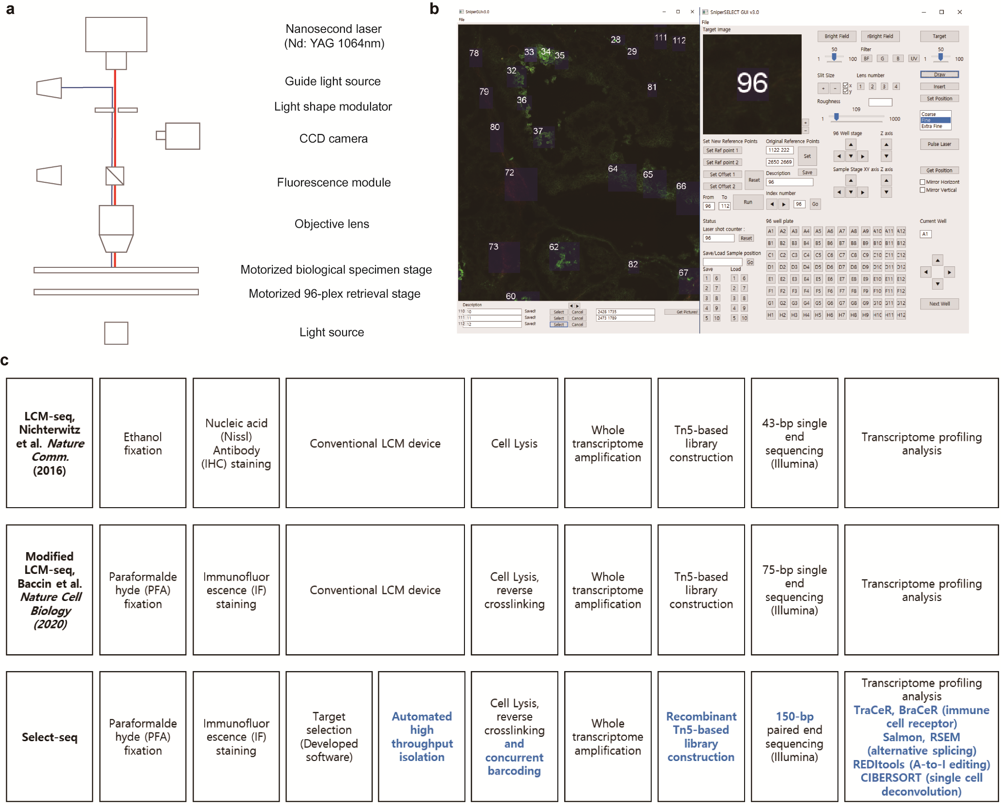
Supplementary Fig. 1. The Spatially-Resolved Laser-Activated Cell Sorting (SLACS) device. a, The SLACS device. b, Software for automatic isolation of the target regions of interest (ROIs). c, Comparison of Select-seq to previous methodologies that utilize laser capture microdissection.

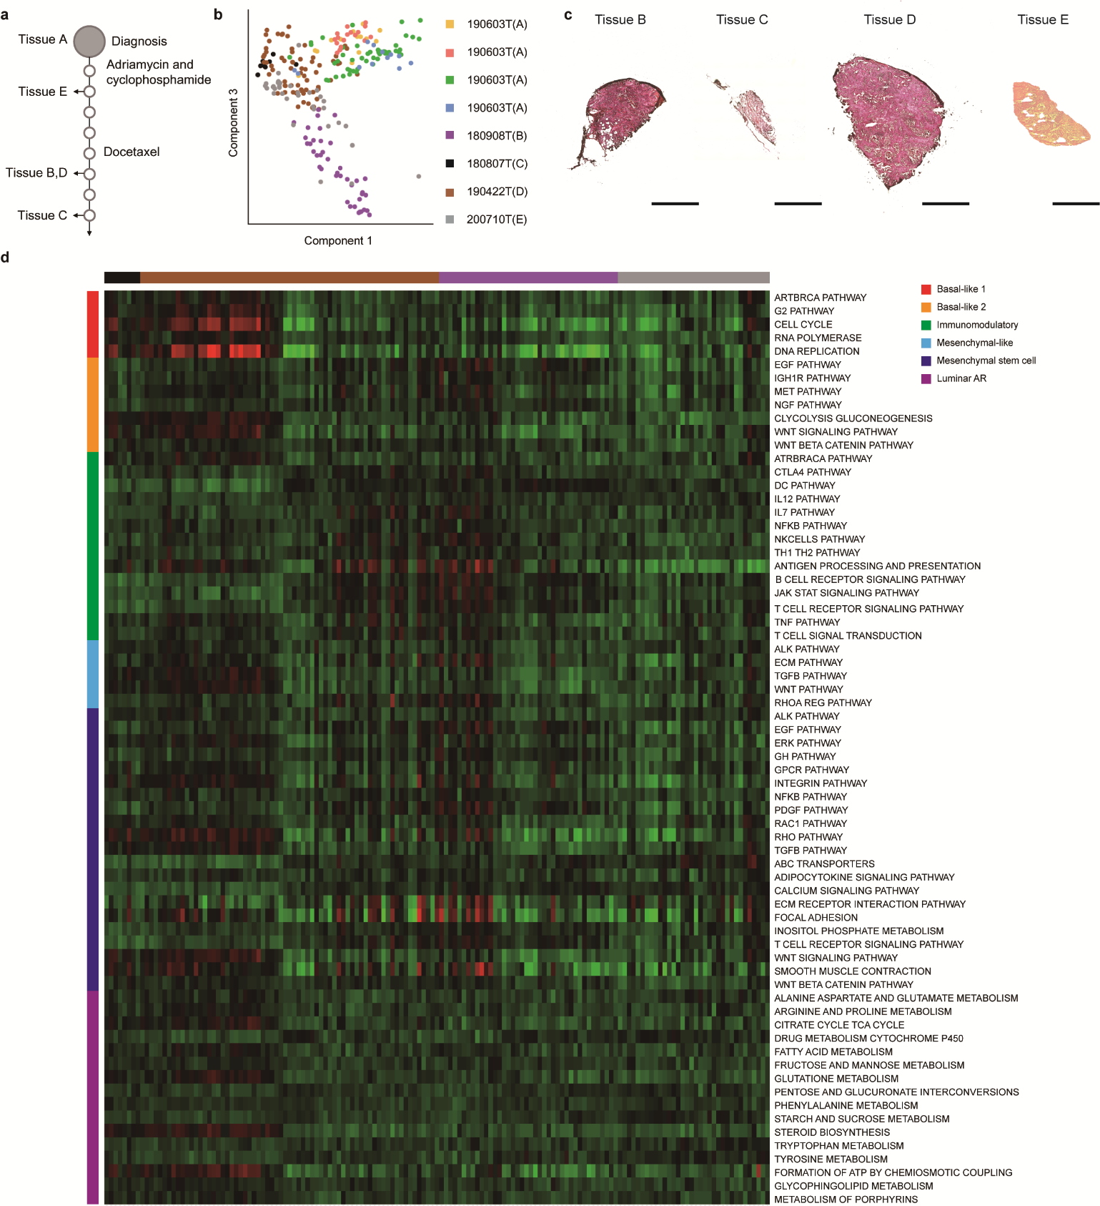
Supplementary Fig. 2. Image data of tissues from the five triple-negative breast cancer (TNBC) patients. Each tissue was stained using fluorophore-labelled antibodies to identify target cells, and the whole slides were scanned. a, Different clinical conditions for the five TNBC patients. b, PCA of the transcriptome data from the ROIs from the five TNBC patients. c, Hematoxylin and eosin (H&E) images for four other tissues from patients B, C, D and E. Scale bar, 500 µm. d, Gene set enrichment patterns according to Lehmann TNBC subtype in patients B, C, D, and E. Rows indicate the mean selected pathways based on Lehmann TNBC classification, and columns represent the total TNBC samples.

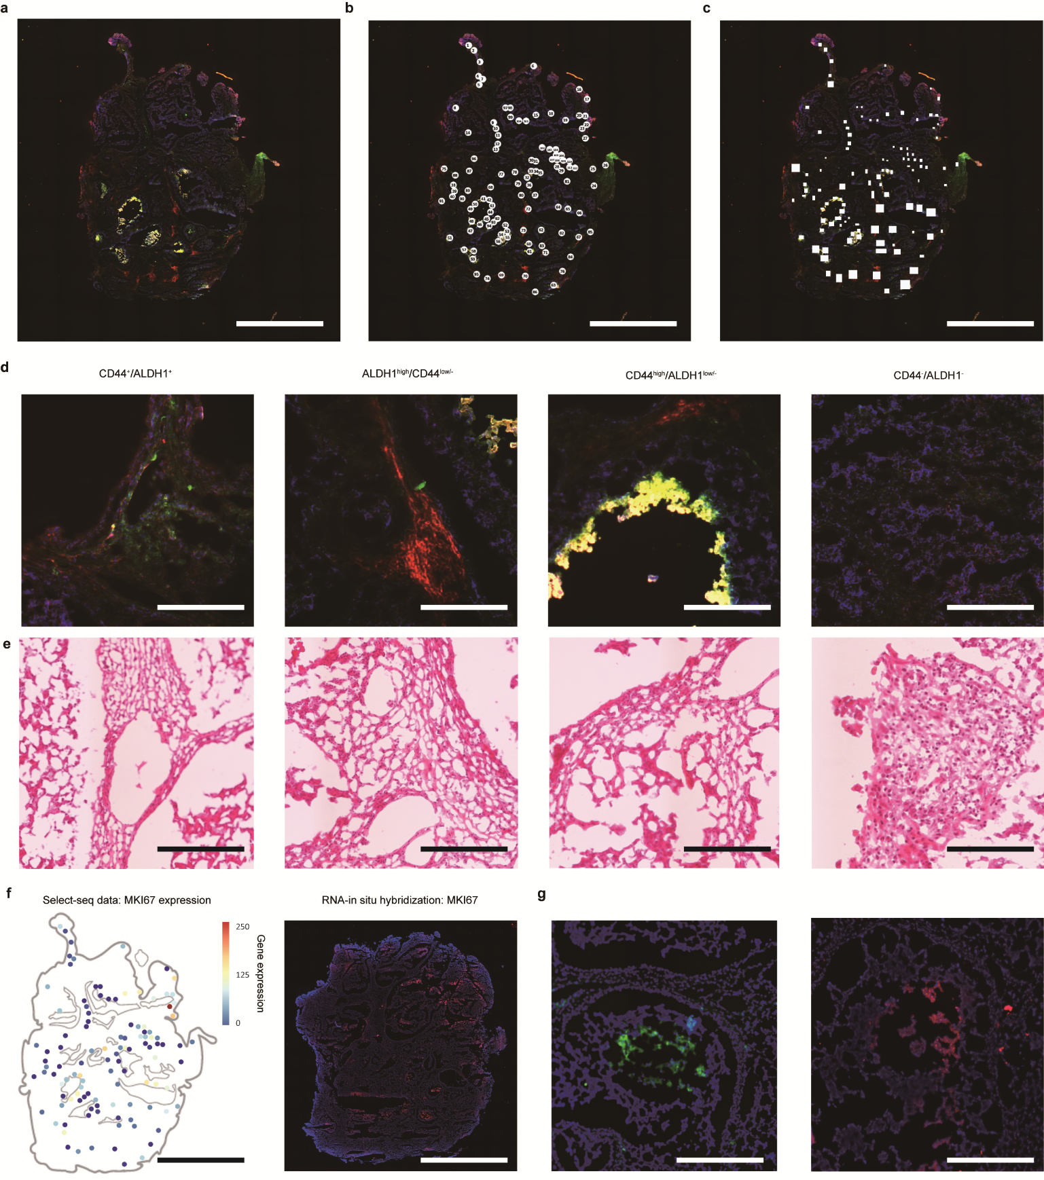
Supplementary Fig. 3. Image data of tissues from patient. Each tissue was stained using fluorophore-labelled antibodies to identify target cells, and the whole slides were scanned. a, Immunofluorescently stained image of tissue A. Scale bar, 500 µm. b, The numbering for the target ROIs from the same tissue. Scale bar, 500 µm. c, Target region area on the same tissue. Scale bar, 500 µm. d, Zoomed-in images of the 4 different staining groups. Scale bar, 100 µm. e, Corresponding H&E images for the zoomed-in images presented in d. Scale bar, 100 µm. f, Different clinical conditions for the five TNBC patients. Scale bar, 500 µm. g, H&E images for other four tissues. Scale bar, 100 µm.

Supplementary Fig. 4. Select-seq allows analysis of alternative splicing variants. a, Gene body coverage of isolated regions of tissue A with Select-seq. We obtained sufficient coverage to reach the isoform resolution even though the samples were fixed with PFA. b, PCA and number of detected isoforms in each staining modality group. The staining groups formed more distinct groups when clustered by gene counts than when clustered by transcripts. The median numbers of detected transcripts for the staining groups were 13,833, 14,674, 20,711 and 14,580. c, Correlation analysis of each staining modality group using transcripts. d, The number of transcripts in each functional annotation group. Select-seq recovered the full-length transcriptome and thus obtained various functionally different isoforms, including immune receptor-related isoforms and noncoding RNAs.

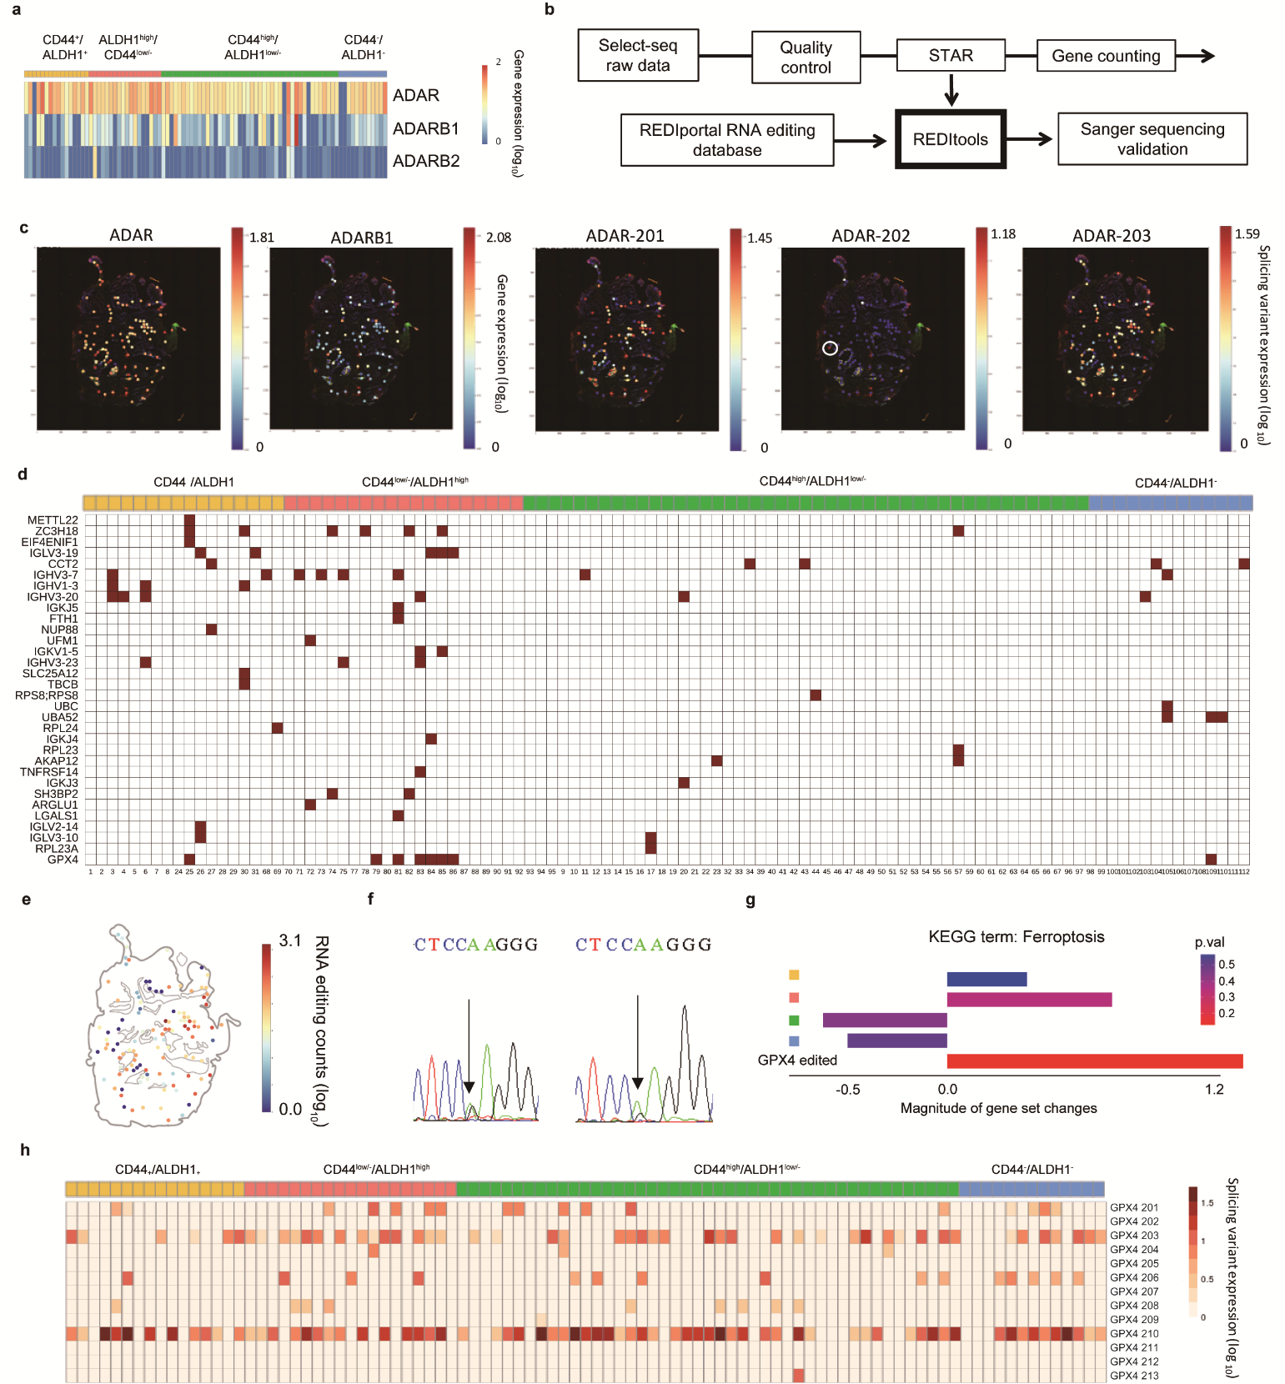
Supplementary Fig. 5. ADAR gene or transcript expression heatmap of the target regions and A-to-I editing events induced by ADAR. a, Gene expression heatmap of ADAR, ADARB1, and ADARB2. Green, red and blue marks indicate CD44-positive and ALDH1-negative/low; ALDH1-positive and CD44-negative/low; and CD44-low and ALDH1-low regions determined by IF. b, Workflow of deducing A-to-I editing events using REDItools. c, Spatial heatmap of expressed ADAR isoforms. The ADAR gene transcript variants mostly consisted of ADAR-201 and ADAR-203, but in some of the CD44^{low/-}/ALDH1^{high} regions that had high ADAR-201 and ADAR-203 expression, other transcript variants of ADAR, such as 204, 208, and 209, were also expressed. d, Heatmap of A-to-I editing events in exonic regions. e, Spatial mapping of the total number of A-to-I events in tissue A. f, Sanger sequencing validation examples. g, Gene set enrichment analysis (GSEA) between four staining groups and A-to-I edited samples using the Kyoto Encyclopedia of Genes and Genomes (KEGG) term ferroptosis. h, Expression heatmap of the alternative splicing variants of the GPX4 gene.

Supplementary Fig. 6. Correlation of ADAR expression with A-to-I editing for each ROI site. a, Number of genes detected for each ROI site. b, Number of A-to-I editing event for each ROI site. c, Correlation between the ADAR expression with A-to-I editing event for each ROI site. d, Correlation between the ADAR expression with A-to-I editing event for each IF group.
Supplementary Fig. 7. Spatial A-to-I editome landscape in four different tissues from four TNBC patients. A-to-I editome marks signature editing sites from different tissue and different group of microniches within the same tumour.

Supplementary Fig. 8. Spatial clustering result of each ROI site and differential expression analysis of spatial cluster groups. a, Hierarchy tree of agglomerative clustering results using both spatial position and gene expression of each ROI site. b, Embedded spatial cluster group on tissue A. c, Differential expression analysis results of spatial cluster group 1 versus the other spatial cluster groups. d, Differential expression analysis results of spatial cluster group 3 versus the other spatial cluster groups.

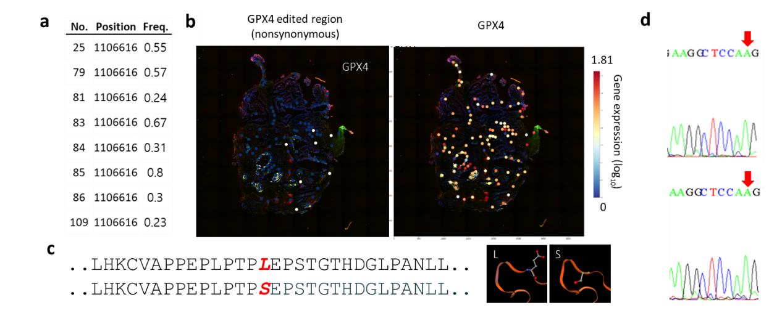
Supplementary Fig 9. GPX4 A-to-I editing characterization a, Different GPX4 expression frequencies. b, Distribution of GPX4 edited regions and GPX4 expression show little correlation. c, A-to-I edited amino acid residue and altered protein structure simulation. d, Genomic DNA validation shows only adenosine sequence at the site 1106616 of GPX4 gene.

Supplementary Fig. 10. A model for how A-to-I editing affects GPX4 gene expression and ferroptosis and assessment of TCGA data set. a, A model of how A-to-I editing of GPX4 affects ferroptosis. b, GPX4 1106616 variant comparison among patients with bulk transcriptome data in The Cancer Genome Atlas (TCGA) (n=109). The bulk transcriptomes with negative ferroptosis gene set enrichment values are grouped in blue, and those with positive values are grouped in red. c, Kaplan-Meier survival analysis of patients grouped the same as in b.

Supplementary Fig. 11. Correlation between survival of TNBC patients with various conditions. a, Correlation of ADAR1 expression with survival. TNBC patients were group based on the mean ADAR1 expression of total patients. b, Correlation of ADAR2 expression with survival. TNBC patients were group based on the mean ADAR2 expression of total patients. c, Correlation of ADAR3 expression with survival. TNBC patients were group based on the mean ADAR3 expression of total patients. d, Correlation of combination of ADAR expression with survival. ADAR groups were clustered by agglomerative clustering using ADAR expression. e, Correlation with A-to-I editing event with survival. TNBC patients were group based on the mean number of A-to-I event. f, Correlation with GPX4 with A-to-I editing and SNP. TNBC patients were group based on the exist of A-to-I event and SNP on GPX4. SNP status were identified based on the normal blood exome sequencing data of TCGA. g, Correlation with GPX4 A-to-I editing frequency.

Supplementary Table 1. Comparison of Select-seq to existing technologies.
Full-length transcriptome methods | LCM-seq  Nichterwitz, et al.  Nature communications (2016) | Geo-seq  Chen et al.  Nature protocols  (2017) | Advanced LCM-seq  Baccin et al.  Nature cell biology  (2020) | Select-seq  (this work)
Speed  (Throughput) | 3 targets in more than  1 HOUR¹ | 3 targets in more than  1 HOUR¹ | 3 targets in more than  1 HOUR¹ | 6,000 targets  Within 1 HOUR
Size  (Number of cells isolated from tissue) | 100-200 cells  (130 ~750 μm²) | up to 20 cells  (~1,000 μm²) | 200-300 cells  (14,500 μm²) | 5-10 cells  (10~100 μm²)
Quality of data  after staining  (Compatibility to conventional pathology) | X  (Ethanol fixation and Nucleic acid (Nissl)  Antibody (IHC)) | X  (Ethanol fixation and Nucleic acid (Nissl)) | O  (Paraformaldehyde fixation and immunofluorescence staining) | O  (Paraformaldehyde fixation and immunofluorescence staining)
Quality of data  (Sequencing reads  per cell) | ~ 10,000  (total 1 million reads) | ~ 25,000  (total 0.5 million reads) | ~ 5,000  (total 1 million reads) | 200,000  (total 1 million reads)

Supplementary Table 2. Spatial group list.
Spatial group number | Location | Immunofluorescence information
1 | 1, 2, 3, 4, 5, 6, 7, 8, | CD44⁺/ALDH1⁺
2 | 24, 25, 26, 27, 28, 29, 30, 31 | CD44⁺/ALDH1⁺
3 | 68 | CD44^{low/-}/ALDH1^{high}
4 | 69, 70, 71, 74, 83, 86, 95 | CD44^{low/-}/ALDH1^{high}
5 | 75 | CD44^{low/-}/ALDH1^{high}
6 | 72, 73, 77, 78, 79, 80 | CD44^{low/-}/ALDH1^{high}
7 | 81, 82, 84, 85 | CD44^{low/-}/ALDH1^{high}
8 | 9, 10, 11, 12, 13 | CD44^{high}/ALDH1^{low/-}
9 | 14, 15, 16, 17, 18, 19, 20, 21, 22, 23 | CD44^{high}/ALDH1^{low/-}
10 | 32, 33, 34 | CD44^{high}/ALDH1^{low/-}
11 | 39, 40 | CD44^{high}/ALDH1^{low/-}
12 | 41, 42, 43, 44, 45, 46, 47, 48, 49, 50 | CD44^{high}/ALDH1^{low/-}
13 | 51 | CD44^{high}/ALDH1^{low/-}
14 | 52, 53, 54, 55, 56 | CD44^{high}/ALDH1^{low/-}
15 | 57, 58, 59 | CD44^{high}/ALDH1^{low/-}
16 | 60, 61 | CD44^{high}/ALDH1^{low/-}
17 | 62 | CD44^{high}/ALDH1^{low/-}
18 | 63 | CD44^{high}/ALDH1^{low/-}
19 | 64, 65, 66, 67 | CD44^{high}/ALDH1^{low/-}
20 | 97, 98, 99, 100, 101 | CD44⁻/ALDH1⁻
21 | 102, 103, 104, 105, 106, 107, 108, 109, 110, 111, 112 | CD44⁻/ALDH1⁻

Supplementary Table 3. Tools for RNA-seq, Gene Ontology, T/B cell receptor and A-to-I editing analysis.
Tool | Functionality | Version
Cutadapt | Adapter trimming | 3.1
STAR | Sequence alignment to reference genome | 2.7.3a
RSEM | Transcript/Gene count (RPKM count) | 1.2.25
featureCounts | Transcript raw read count | 2.0.0
RSeQC | Gene coverage calculation | 2.6.4
Qualimap | Exon region percentage calculation | 2.2.1
DESeq2 | Differential gene expression analysis | 1.26
REDItools | A to I editing site calling | 2
TraCeR/BraCeR | T cell receptor/B cell receptor calling from RNA-seq | 0.6.0/x

