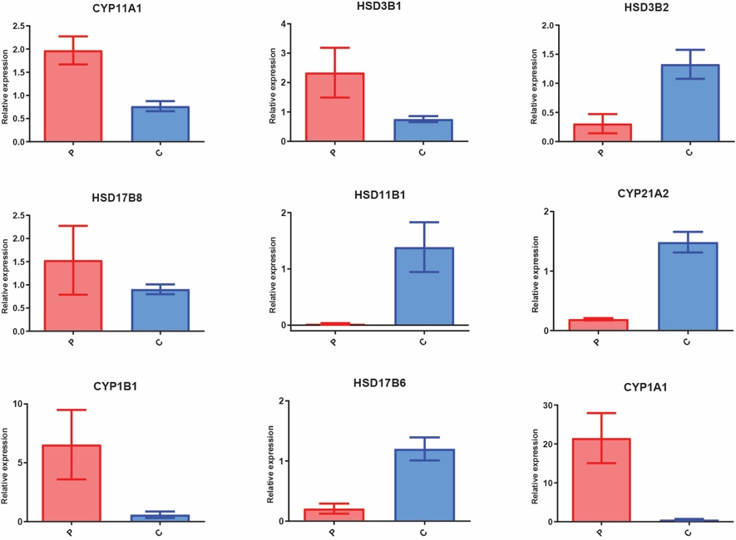
Supplement Figure 1. Validation of gene expression by qPCR. Histogram of nine important genes in placenta by qPCR validation. The red and blue histogram represent the PE and control group respectively.

