Supplementary information
Appendix S1. Parameter estimates from analyses of variation in fitness 2W as a function of body condition (Table S1), body mass (Table S2) and tarsus length (Table S3). Estimates obtained via NUTS MCMC sampling, resulting in 4500 posterior samples, and presented as posterior median and 95% credible interval (95% CrI). The rank-based convergence diagnostic $\hat{R}$, and the effective sample size $n_{\text{eff}}$ were used to assess chain convergence. $β_{1}=β_{1}^{'}-\ln\left(2\right)$ and $b_{1}=b_{1}^{'}-\ln\left(2\right)$ are the corrected intercepts because of fitting the model to 2W instead of W. $P_{0}$ is the proportion of posterior samples overlapping with zero. Period 1 corresponds to years 1991-1995 and Period 2 to 1996-1999, and N refers to population size.
Table S1. Parameter estimates from analyses of variation in fitness 2W as a function of body condition x.
Parameter | Median | 95% CrI | $$n_{\text{eff}}$$ | $$P_{0}$$
Model: $\ln{\text{E}\left(2W | x,N,ε\right)=β_{1}^{'}}+β_{2}x+β_{3}x^{2}-Ne^{α_{1}+α_{2}x}+ε$
$$β_{1}$$ | 0.196 | 0.037 – 0.347 | 4326 | 0.012
$$β_{2}$$ | 0.136 | 0.089 – 0.185 | 4369 | 0.000
$$β_{3}$$ | -0.037 | -0.069 – -0.009 | 4668 | 0.004
$$α_{1}$$ | -2.765 | -5.157 – -1.641 | 4476 | 0.000
$$α_{2}$$ | -0.531 | -1.487 – 0.004 | 4339 | 0.026
$$\ln\left(σ\right)$$ | -1.657 | -2.240 – -0.921 | 4426 | 0.000
Model: $\ln{\text{E}\left(2W | x,N,ε\right)=b_{1}^{'}}+b_{2}x+b_{3}x^{2}+ε$
Period 1 (low N)
$$b_{1}$$ | 0.268 | -0.153 – 0.647 | 3,237 | 0.062
$$b_{2}$$ | 0.069 | 0.008 – 0.130 | 4,238 | 0.015
$$b_{3}$$ | -0.044 | -0.084 – -0.006 | 4,672 | 0.011
$$\ln\left(σ\right)$$ | -1.206 | -1.994 – 0.069 | 3,725 | 0.031
Period 2 (high N)
$$b_{1}$$ | 0.089 | -0.195 – 0.379 | 2272 | 0.188
$$b_{2}$$ | 0.207 | 0.138 – 0.283 | 4464 | 0.000
$$b_{3}$$ | -0.021 | -0.068 – 0.021 | 4503 | 0.177
$$\ln\left(σ\right)$$ | -1.809 | -3.664 – -0.144 | 3348 | 0.017

Table S2. Parameter estimates from analyses of variation in fitness 2W as a function of body mass x.
Parameter | Median | 95% CrI | $$n_{\text{eff}}$$ | $$P_{0}$$
Model: $\ln{\text{E}\left(2W | x,N,ε\right)=β_{1}^{'}}+β_{2}x+β_{3}x^{2}-Ne^{α_{1}+α_{2}x}+ε$
$$β_{1}$$ | 0.219 | 0.036 – 0.390 | 4014 | 0.013
$$β_{2}$$ | 0.141 | 0.096 – 0.189 | 4168 | 0.000
$$β_{3}$$ | -0.036 | -0.067 – -0.009 | 4075 | 0.007
$$α_{1}$$ | -2.719 | -4.989 – -1.559 | 4034 | 0.000
$$α_{2}$$ | -0.572 | -1.405 – -0.097 | 4316 | 0.012
$$\ln\left(σ\right)$$ | -1.492 | -2.060 – -0.794 | 4658 | 0.000
Model: $\ln{\text{E}\left(2W | x,N,ε\right)=b_{1}^{'}}+b_{2}x+b_{3}x^{2}+ε$
Period 1 (low N)
$$b_{1}$$ | 0.281 | -0.074 – 0.643 | 3732 | 0.045
$$b_{2}$$ | 0.065 | 0.004 – 0.129 | 4692 | 0.019
$$b_{3}$$ | -0.040 | -0.079 – -0.004 | 4686 | 0.017
$$\ln\left(σ\right)$$ | -1.236 | -2.032 – -0.073 | 3768 | 0.020
Period 2 (high N)
$$b_{1}$$ | 0.144 | -0.310 – 0.615 | 2708 | 0.176
$$b_{2}$$ | 0.224 | 0.158 – 0.293 | 4558 | 0.000
$$b_{3}$$ | -0.026 | -0.072 – 0.017 | 4422 | 0.122
$$\ln\left(σ\right)$$ | -1.300 | -2.252 – 0.324 | 3986 | 0.050

Table S3. Parameter estimates from analyses of variation in fitness 2W as a function of tarsus length x.
Parameter | Median | 95% CrI | $$n_{\text{eff}}$$ | $$P_{0}$$
Model: $\ln{\text{E}\left(2W | x,N,ε\right)=β_{1}^{'}}+β_{2}x+β_{3}x^{2}-Ne^{α_{1}+α_{2}x}+ε$
$$β_{1}$$ | 0.185 | 0.003 – 0.356 | 3636 | 0.024
$$β_{2}$$ | 0.039 | -0.007 – 0.087 | 4625 | 0.053
$$β_{3}$$ | -0.014 | -0.044 – 0.014 | 4437 | 0.181
$$α_{1}$$ | -3.109 | -6.049 – -1.737 | 4207 | 0.000
$$α_{2}$$ | -0.316 | -1.604 – 1.271 | 4127 | 0.218
$$\ln\left(σ\right)$$ | -1.527 | -2.109 – -0.813 | 4402 | 0.000
Model: $\ln{\text{E}\left(2W | x,N,ε\right)=b_{1}^{'}}+b_{2}x+b_{3}x^{2}+ε$
Period 1 (low N)
$$b_{1}$$ | 0.227 | -0.181 – 0.651 | 2827 | 0.096
$$b_{2}$$ | -0.005 | -0.068 – 0.058 | 4440 | 0.443
$$b_{3}$$ | -0.006 | -0.042 – 0.027 | 4714 | 0.359
$$\ln\left(σ\right)$$ | -1.124 | -1.883 – 0.138 | 3968 | 0.034
Period 2 (high N)
$$b_{1}$$ | 0.116 | -0.329 – 0.556 | 2469 | 0.208
$$b_{2}$$ | 0.090 | 0.021 – 0.161 | 4343 | 0.005
$$b_{3}$$ | -0.017 | -0.063 – 0.025 | 4519 | 0.212
$$\ln\left(σ\right)$$ | -1.406 | -2.489 – 0.296 | 3343 | 0.046
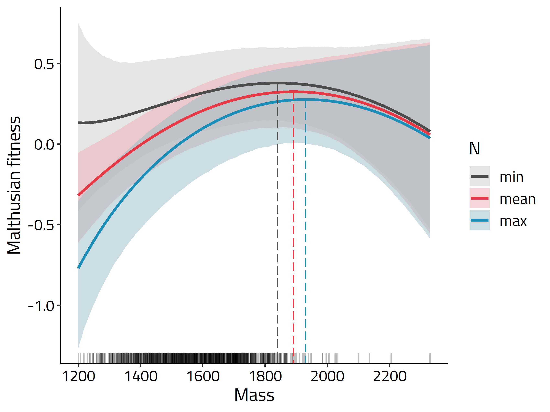
Figure S1. Malthusian fitness for values of body mass at the minimum (N = 566), mean (800) and maximum (1071) population size. Thick lines represent posterior means. Ribbons represent 95% credible intervals. Dashed lines refer to mass values maximizing fitness.
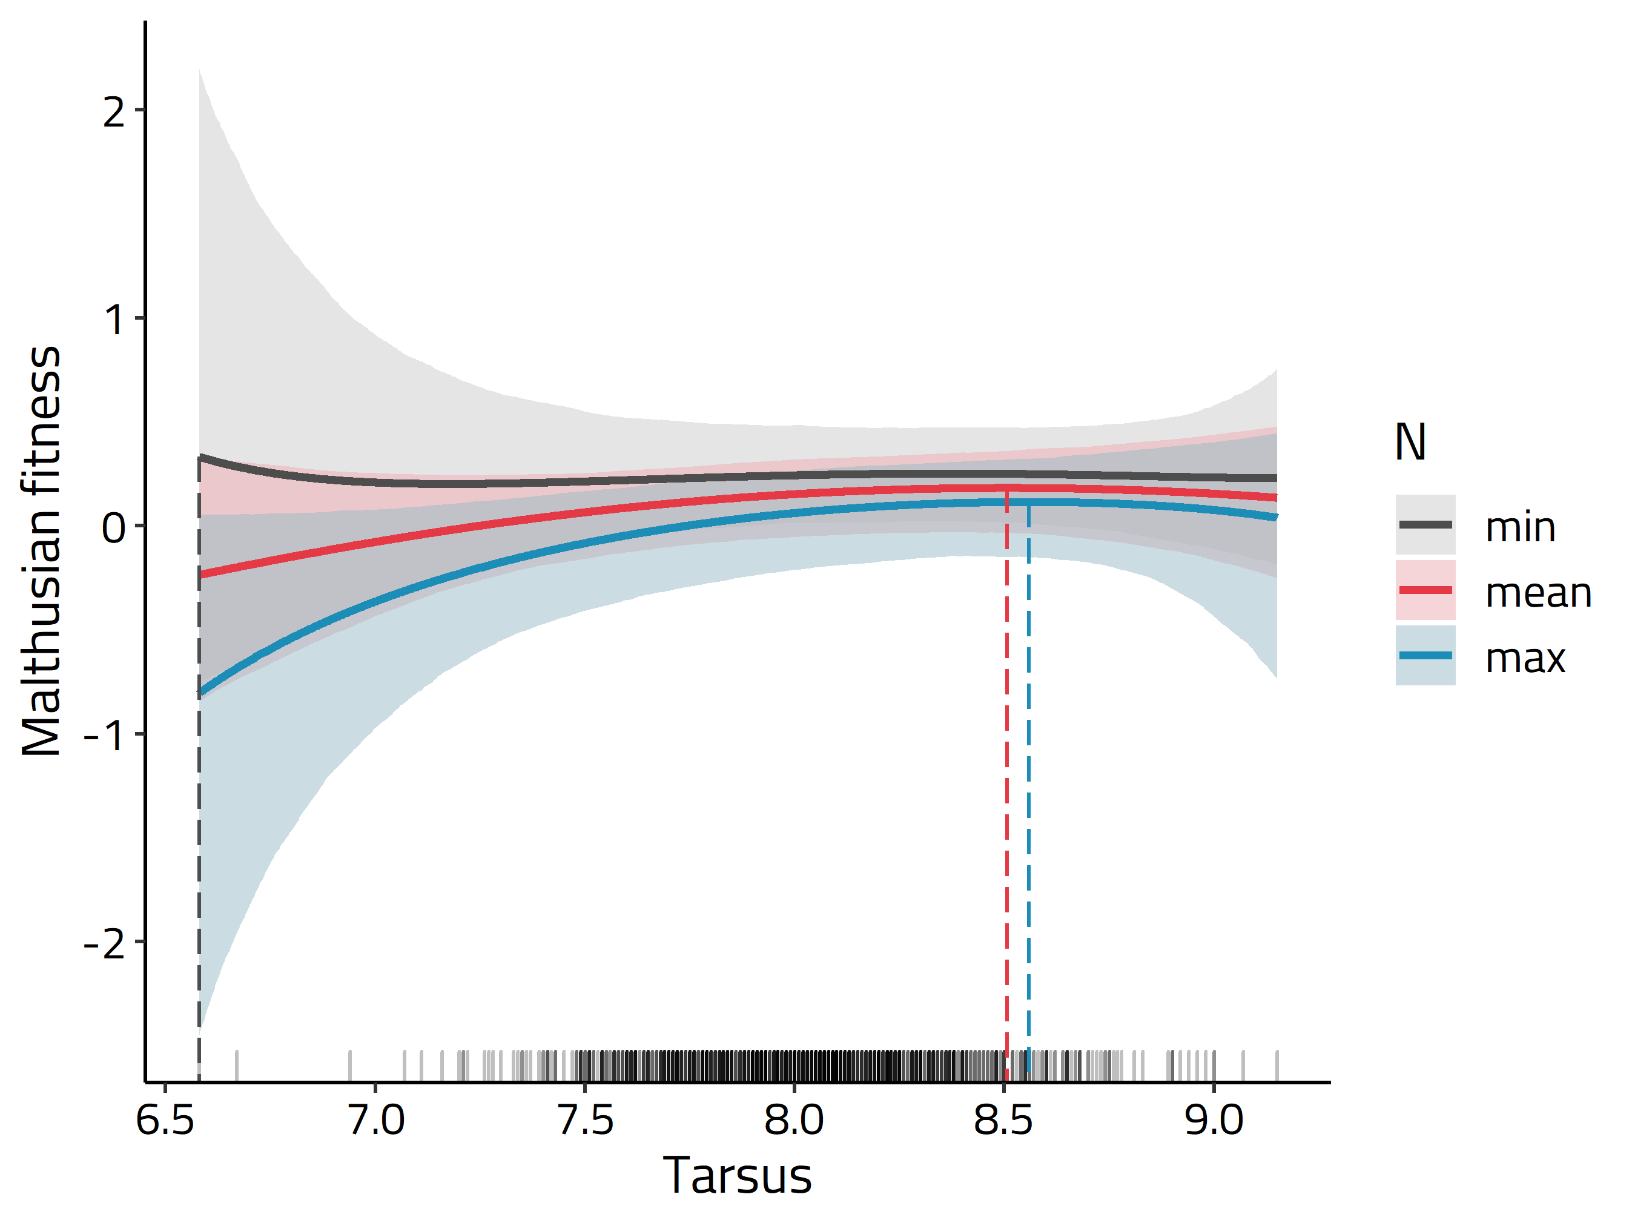

Figure S2. Malthusian fitness for values of tarsus length at the minimum (N = 566), mean (800) and maximum (1071) population size. Thick lines represent posterior means. Ribbons represent 95% credible intervals. Dashed lines refer to tarsus values maximizing fitness.

