Table 1 Elemental composition and ions monitored for BTR_{S}, BTH_{S} and BUV_{S} analyzed by GC-MS
Compound | Formula | Structure | Molecular Structure | Log K_{ow} ª | pK_{a} ^{b} | Retention time (min) | Characteristic ion(m/z)
BTH | C₇H₅NS | 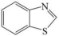 | 135.19 | 2.17 | 0.9 | 4.36 | 135,108
BTR | C₆H₅N₃ | 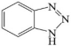 | 119.1 | 1.44 | 8.4 | 5.68 | 119,91
2-MeS-BTH | C₈H₇NS₂ | 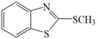 | 181.28 | 3.22 | 9.8 | 6.41 | 181,148
5-Cl-BTR | C₆H₄ClN₃ | 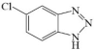 | 153.6 | 2.13 | 7.5 | 6.67 | 153,109
2-OH-BTH | C₇H₅NOS | 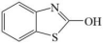 | 151.19 | 2.35 | 10.4 | 6.72 | 151,123
UV-P | C₁₃H₁₁N₃O | 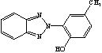 | 225.25 | 3.00 | 8.2 | 19.34 | 225,196
UV-PS | C₁₆H₁₇N₃O | 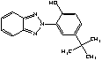 | 267.33 | 4.36 | 8.1 | 20.67 | 252,133
UV-320 | C₂₀H₂₅N₃O | 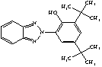 | 323.43 | 6.27 | 9.4 | 25.44 | 323,308
UV-350 | C₂₀H₂₅N₃O | 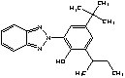 | 323.43 | 6.27 | 8.3 | 25.76 | 308,252
UV-326 | C₁₇H₁₈ClN₃O | 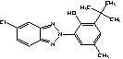 | 315.81 | 5.55 | 9.5 | 26.44 | 300,126
UV-329 | C₂₀H₂₅N₃O | 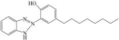 | 323.40 | 6.21 | 8.1 | 26.81 | 252,133
UV-328 | C₂₂H₂₉N₃O | 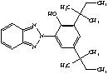 | 351.50 | 7.22 | 8.9 | 27.95 | 322,252
UV-327 | C₂₀H₂₄ClN₃O | 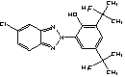 | 357.89 | 6.91 | 9.4 | 28.05 | 342,286
UV-234 | C₃₀H₂₉N₃O | 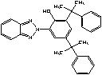 | 447.58 | 6.27 | 9.0 | 38.22 | 432,354
ª Value estimated using EPI Suite TM
^{b} Scififinder database: Calculated using Advanced Chemistry Development (ACD/Labs) Software V11.02(© 1994–2015 ACD/Labs)

