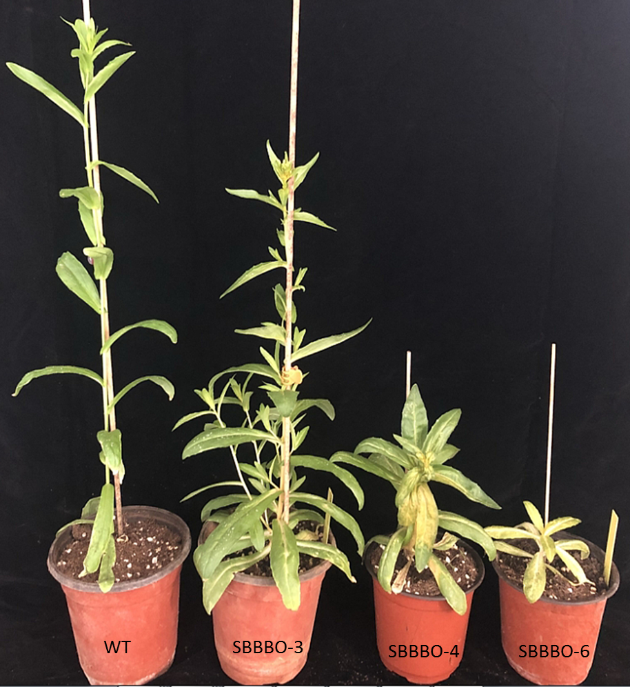
Supplement Figure 1. Phenotypes of wild-type (WT) and three different transgenic lines of T₁ SBBBO.
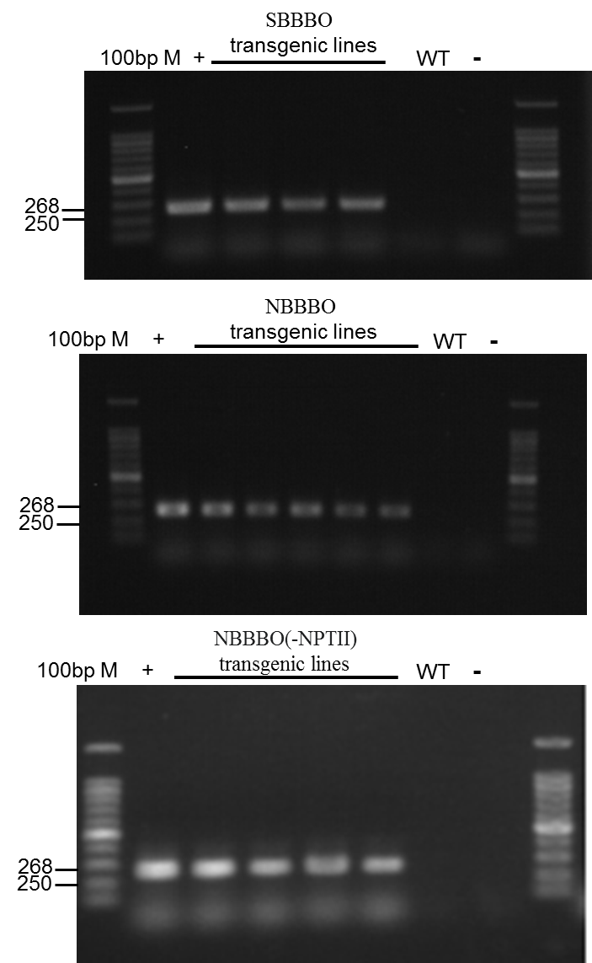
Supplement Figure 2. PCR analysis of exogenous gene CrBKT in SBBBO transgenic lines (1–3), NBBBO transgenic lines (1–5), NBBBO (-NPTII) transgenic lines (1–4) and WT.
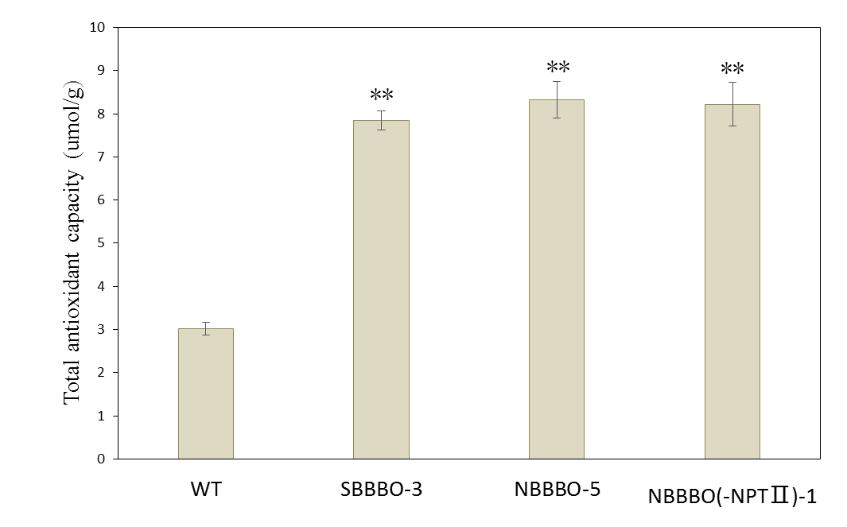
Supplement Figure 3. Total antioxidant activity capacity of WT and T₃ transgenic lines of SBBBO-3, NBBBO-5 and NBBBO (-NPTII)-1. The data represent average values of four individual measurements, **statistical significance, determined by Student’s t-test, P < 0.01.

Supplement Table 1 Primer pairs used for RT-qPCR and PCR detection. BKT primer pair was used for PCR detection of CrBKT, others were used for RT-qPCR
Gene name | Sequence
ACT-F | AGCACCCCATATACTCGTTTCA
ACT-R | TTGTCACAGACGAGTGGCTG
BKT-F | GAACCTGGCAGTGTGGTTC
BKT-R | AAAGGACTGCAGGCGGGATG
GGPP-F | CACTTAACTGGGACACAAACTGAT
GGPP-R | GTGAGACCAACTACCGCTGC
DXS-F | ACCATTGTCACCAGCACCATT
DXS-R | AGCAAATGCAGATGAAGCCAT
PSY-F | TGCTCTTTTGGAGAGAGAGACAACA
PSY-R | AGGAGCTGCAACCCATAACAC
PDS-F | ATGGATCGGATTCGGATTTGGA
PDS-R | TCTGACTCGGTTCAGCTGTG
ZDS-F | AAGCCCACTAAAACACAGTGG
ZDS-R | CTGGAGTTGCAGCGAAAACG
CYCb-F | CCACCCGTCCATCACCACTA
CYCb-R | TGAGGGACGAAAAATTCGAGC
CRTZ-F | ACAACAAGGGTTCTTCCACC
CRTZ-R | TGACGTGTTGTGTTTTGGTCC
LCYe-F | CAAAATGGATGTGGCGAGGG
LCYe-R | ACACACACAACAAACCTACGAGT
CYP97-F | TGAAACAGTGTCACCGAAGC
CYP97-R | AATCTGGGCTGACCCATGAC

