Evaluation of fiber and debris release of protective COVID-19 mask textiles and possible in vitro acute cytotoxicity effects

Philipp Meier¹, Mahsa Zabara², Cordula Hirsch¹, Alexander Gogos¹, Dominic Tscherrig³, Gilles Richner³, Bernd Nowack⁴, Peter Wick¹*

¹ Particles-Biology Interactions Laboratory, Empa - Swiss Federal Laboratories for Materials Science and Technology, St. Gallen 9014, Switzerland
² SVP Technology/ Science and Consumer Interface, Livinguard AG, Zug 6300, Switzerland
³ Federal Office for Civil Protection FOCP, Spiez Laboratory, Spiez 3700, Switzerland
⁴ Technology and Society Laboratory, Empa - Swiss Federal Laboratories for Materials Science and Technology, St. Gallen 9014, Switzerland

*Contact information corresponding author:
Peter Wick – Particles-Biology Interactions Laboratory, Empa - Swiss Federal Laboratories for Materials Science and Technology, St. Gallen 9014, Switzerland; orcid.org/0000-0002-0079-4344; Phone: +41 58 765 7684; Email: peter.wick@empa.ch

Supplementary information:

Fiber and particle release from masks and mask textiles

- Air-based Sheffield head extraction

Methodology described in chapter:
2.1. Air based debris extraction with Sheffield heads

Table S1: Fiber release quantification with Sheffield head design according to DIN EN 149 and EMPA designed filter holder at an air flow intensity of 850 L h⁻¹. Fiber amount average (n) of mask triplicate (n=3) is quantified with FiberApp and fiber amount is calculated per gram textile (n/g) accoding to the weight of the tested masks.
Fiber release (n=3) | Blank | SM A | SM A | PMTT | PMTT
Fiber amount average (n) | 6 | 11 | 17 | 23 | 334
Treatment | static | static | 8x moved | static | 8x moved
Weight mask (g) | n/a | 3.06 | 3.06 | 13.23 | 13.23
Average fiber per mass (n/g) | 6 | 4 | 6 | 2 | 25
Average fiber per mass (SD) | 4 | 1 | 1 | 1 | 7
Average Length distribution (µm) | 517 | 717 | 518 | 638 | 831
Median Length distribution (µm) | 256 | 378 | 310 | 434 | 660
25th percentile | 201 | 300 | 195 | 256 | 413
75th percentile | 768 | 840 | 650 | 787 | 1089

Table S2: Particle release quantification with Sheffield head in collaboration with the ABC Spiez Laboratory. The particle measurement (size range of 0.3-10 µm) took place with a Klotz analyzer once per minute for 6 seconds over a release duration of 8 h leading to a total of 4800 data points per measurement. An air flow intensity of 30.0 L min⁻¹ (1'800 L h⁻¹) was applied and subsequently the particle counts of all measurement points were summarized and calculated per gram mask according to their weight.
Single measurements | Number of Particles | Size of Particles [µm]
Sample | Total | 0.3 | 0.4 | 0.5 | 0.6 | 0.8 | 1.0 | 1.2 | 1.4 | 1.6 | 2.0 | 3.0 | 4.0 | 5.0 | 6.0 | 7.5 | 10.0
Blank 1/3 | 12231 | 8015 | 3504 | 468 | 162 | 45 | 12 | 8 | 5 | 4 | 3 | 4 | 1 | 0 | 0 | 0 | 0
Blank 2/3 | 1314 | 960 | 274 | 38 | 15 | 11 | 3 | 4 | 0 | 0 | 3 | 2 | 3 | 1 | 0 | 0 | 0
Blank 3/3 | 5885 | 4630 | 1081 | 120 | 29 | 10 | 4 | 2 | 1 | 2 | 3 | 2 | 1 | 0 | 0 | 0 | 0
SM A 1/3 | 279 | 152 | 58 | 18 | 23 | 10 | 3 | 1 | 5 | 2 | 1 | 2 | 4 | 0 | 0 | 0 | 0
SM A 2/3 | 908 | 685 | 136 | 26 | 23 | 10 | 5 | 1 | 4 | 5 | 7 | 2 | 2 | 1 | 0 | 1 | 0
SM A 3/3 | 1032 | 756 | 173 | 24 | 27 | 17 | 4 | 5 | 1 | 7 | 6 | 6 | 3 | 1 | 0 | 1 | 1
PMTT 1/3 | 1151 | 836 | 207 | 26 | 29 | 13 | 6 | 3 | 7 | 10 | 5 | 3 | 2 | 4 | 0 | 0 | 0
PMTT 2/3 | 872 | 639 | 155 | 32 | 21 | 9 | 2 | 2 | 2 | 2 | 6 | 0 | 2 | 0 | 0 | 0 | 0
PMTT 3/3 | 481 | 324 | 97 | 14 | 16 | 9 | 3 | 3 | 1 | 3 | 4 | 2 | 4 | 1 | 0 | 0 | 0
Average measurements | Number of Particles | SD | Weight
Sample | Total |  | g/mask
Blank | 6477 | 5482 | n/a
SM A (per mask) | 740 | 404 | 3.06
PMTT (per mask) | 835 | 337 | 13.23
Per g mask | Number of Particles | SD
Sample | Total
SM A | 242 | 132
PMTT | 63 | 25

- Liquid fiber and particle extraction

Methodology described in chapter:
2.2. Textile materials for liquid extractions

Table S3: Textile details and sample weight / laser cutter accuracy
Identifier | Detail | No. of layers | Average weight g m² | SD | Average weight g (10cmx4cm), n=12 | SD
RCT | Reference Cotton A, No. 210, Swissatest (180g/m2), plain, bleached w/o optical brightener | 1 | 175.5 | 1.3 | 0.702 | 0.005
SM A | Surgical mask A, Tengchuang Yiliao, CE; FDA label; no mask std.; mid efficiency | 3 | 75.5 | 1.7 | 0.302 | 0.007
SM A, o | Surgical mask A, outer (blue) | 1 | 25.2 | 1.4 | 0.101 | 0.006
SM A, m | Surgical mask A, middle (white) | 1 | 24.0 | 0.8 | 0.096 | 0.003
SM A, i | Surgical mask A, inner (white) | 1 | 26.3 | 1.0 | 0.105 | 0.004
SM B | Surgical mask B, Welan, CE; TypIIR (EN14683); BFE>98%; High efficiency | 3 | 83.6 | 0.9 | 0.334 | 0.004
SM B, o | Surgical mask B, outer (blue) | 1 | 26.1 | 0.5 | 0.104 | 0.002
SM B, m | Surgical mask B, middle (white) | 1 | 24.9 | 0.7 | 0.100 | 0.003
SM B, i | Surgical mask B, inner (white) | 1 | 32.6 | 0.5 | 0.130 | 0.002
PMTU | Pro Mask textile untreated, Livinguard | 3 | 281.9 | 1.8 | 1.128 | 0.007
PMTU, o | Pro Mask textile untreated, outer | 1 | 105.8 | 1.0 | 0.423 | 0.004
PMFT, m | Pro Mask filter textile, middle | 1 | 31.0 | 1.0 | 0.124 | 0.004
PMTU, i | Pro Mask textile untreated, inner | 1 | 145.1 | 1.5 | 0.581 | 0.006
PMTT | Pro Mask textile treated, Livinguard | 3 | 288.3 | 2.4 | 1.153 | 0.010
PMTT, o | Pro Mask textile treated, outer | 1 | 108.0 | 1.3 | 0.432 | 0.005
PMFT, m | Pro Mask filter textile, middle | 1 | 31.0 | 1.0 | 0.124 | 0.004
PMTT, i | Pro Mask textile treated, inner | 1 | 149.3 | 1.6 | 0.597 | 0.006
PMFT | Pro Mask filter textile, Livinguard | 1 | 31.0 | 1.0 | 0.124 | 0.004

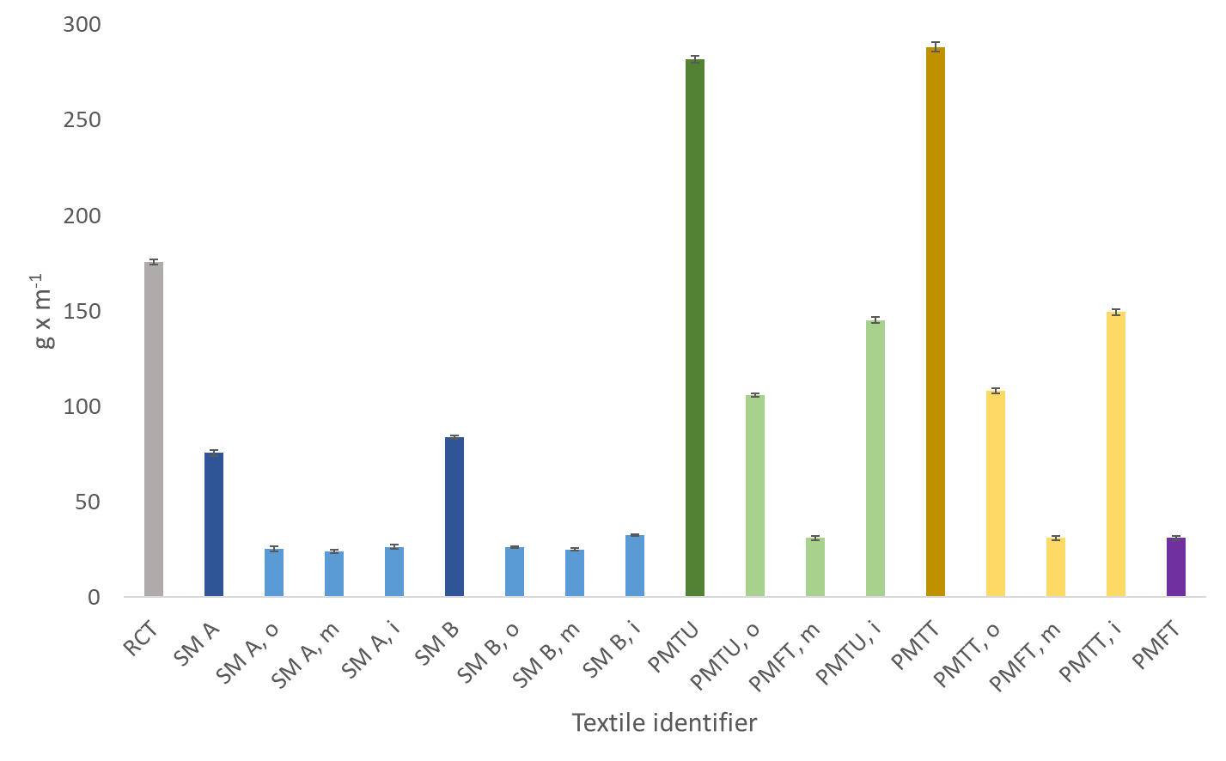
Figure S4: Textile sample average weight in g per m² (n=12).

Table S5: Fiber release of textiles during Gyrowash liquid extraction.
Fiber release (n=3) | Blank | RCT | SM A | SM B | PMTU | PMTT | PMFT
Fiber amount average (n) | 7 | 1746 | 125 | 276 | 1328 | 966 | 287
Volume counted (mL) | 120 | 6 | 120 | 120 | 6 | 6 | 12
Weight textile (g) | n/a | 2.106 | 0.302 | 0.334 | 1.128 | 1.153 | 0.372
Average fiber per mass (n/g) | 7 | 20728 | 519 | 1030 | 29452 | 20941 | 9638
Average fiber per mass (SD) | 3 | 591 | 153 | 115 | 1996 | 622 | 108
Average Length distribution (µm) | 618 | 669 | 313 | 230 | 525 | 518 | 290
Median Length distribution (µm) | 297 | 540 | 216 | 81 | 390 | 416 | 130
25th percentile | 135 | 270 | 108 | 78 | 189 | 234 | 78
75th percentile | 540 | 905 | 378 | 225 | 702 | 650 | 338

The average fiber amount released per mass textile (n/g) was calculated as followed:
= (Fiber amount average (n) / Weight textile (g)) x (Total volume (150mL) / Volume counted (mL))

Metal content of mask textiles

Methodology described in chapter:
2.5. Quantification of total and water-extractable metals in mask textiles via ICP-MS.

Figure S6: Leached metal element percentage from aqueous textiles washouts in comparison to the nitric acid dissolved mask textiles set to 100%. The of aqueous textile extracts (0.75 g L⁻¹ linear alkylbenzene sulfonic acid dissolved in ultrapure deionized water, pH 9.2) were performed in 50 mL plastic tubes on a Heidolph Polymax 1040 shaker for 60 min. and analyzed without further dilution.

Table S7: International atomic energy agency (IAEA-V-9) certified reference cotton cellulose ICP-MS detection. Three samples (n=3) were digested and analyzed using the same procedure as for the textile samples and subsequently recoveries for Cr, Cu, Fe, Mn, Ni and Pb were calculated.
ICP-MS detection (raw values) |  |  |  | 52 Cr [He] |  | 55 Mn [He] | 56 Fe [H2] | 59 Co [He] | 60 Ni [He] | 63 Cu [He] | 66 Zn [He] | 208 Pb [He]
Sample Name |  | Mass (mg) | Dilution Factor |  | Conc. [µg/L] | Conc. [µg/L] | Conc. [µg/L] | Conc. [µg/L] | Conc. [µg/L] | Conc. [µg/L] | Conc. [µg/L] | Conc. [µg/L]
BL_1 | n/a |  | 50 | <0.187 |  | <0.165 | <0.435 | <0.040 | <0.265 | <0.054 | 2.185 | 0.021
BL_2 | n/a |  | 50 | <0.187 |  | <0.165 | <0.435 | <0.040 | <0.265 | <0.054 | 1.853 | <0.019
IAEA-V-9_1 | 613.8 |  | 50 | 1.444 |  | 1.953 | 154.360 | 0.075 | 0.459 | 5.532 | 4.217 | 2.401
IAEA-V-9_2 | 600.4 |  | 50 | 1.785 |  | 2.047 | 166.683 | 0.064 | 0.509 | 11.935 | 10.536 | 1.671
IAEA-V-9_3 | 593.3 |  | 50 | 1.539 |  | 1.956 | 135.497 | 0.071 | 0.479 | 5.398 | 4.007 | 1.726
Calculated ICP-MS concentrations |  |  |  | Conc. [mg/kg] |  | Conc. [mg/kg] | Conc. [mg/kg] | Conc. [mg/kg] | Conc. [mg/kg] | Conc. [mg/kg] | Conc. [mg/kg] | Conc. [mg/kg]
IAEA-V-9_1 |  |  |  | 0.118 |  | 0.159 | 12.574 | 0.006 | 0.037 | 0.451 | 0.344 | 0.196
IAEA-V-9_2 |  |  |  | 0.149 |  | 0.170 | 13.881 | 0.005 | 0.042 | 0.994 | 0.877 | 0.139
IAEA-V-9_3 |  |  |  | 0.130 |  | 0.165 | 11.419 | 0.006 | 0.040 | 0.455 | 0.338 | 0.145
IAEA-V-9 Average |  |  |  | 0.132 |  | 0.165 | 12.625 | 0.006 | 0.040 | 0.633 | 0.520 | 0.160
Certified reference median concentration |  |  |  | 0.11 |  | 0.15 | 11 |  | 0.09 | 0.59 |  | 0.25
Recovery (%) |  |  |  | 120.0 |  | 109.9 | 114.8 |  | 44.5 | 107.3 |  | 64.0
Average Recovery = 93.4%

Acute in vitro toxicity of mask textile debris

Methodology described in chapter:
2.8. Cell viability assessment.

Table S8: In vitro acute toxicity A549 human epithelial lung cell culture tissue model applied for testing of mask textile fiber-/ particle debris and extracts. The released fiber-/ particle fractions ≥ 0.4 µm (D) in three concentrations (DH, DM, DL) and the SDE containing particles ≤ 0.4 µm were tested. The endpoint viability was assessed in three in-dependent colorimetric MTS assays (N=3) applying three independent extracts (n=3) of each textile.
Sample |  | NC 1 | PC Low | PC Medium | PC High | NC 2 Debris | NC 2 Extract | SM A | SM A | RCT | RCT | RCT | RCT
Description |  | cells & medium | Cad. 1 mM | Cad. 10 mM | Cad. 50 mM | wash w/o text. | wash w/o text. | Debris | Extract | D High | D Medium | D Low | Extract
Run 1 | mean | 100.0 | 80.5 | 3.5 | -0.2 | 97.2 | 92.7 | 93.8 | 100.5 | 95.3 | 87.7 | 89.2 | 93.9
 | SD | 1.6 | 7.7 | 1.0 | 0.6 | 3.1 | 6.0 | 4.2 | 1.5 | 4.5 | 7.5 | 8.7 | 0.6
Run 2 | mean | 100.0 | 83.3 | 4.4 | -2.0 | 94.9 | 87.0 | 86.4 | 93.1 | 94.8 | 89.4 | 88.4 | 96.6
 | SD | 3.7 | 4.7 | 2.7 | 0.5 | 2.2 | 6.4 | 8.3 | 2.4 | 4.7 | 7.8 | 6.8 | 1.7
Run 3 | mean | 100.0 | 85.6 | 4.5 | -0.4 | 103.5 | 95.8 | 94.5 | 101.1 | 101.5 | 95.9 | 97.9 | 104.7
 | SD | 3.3 | 6.2 | 0.9 | 1.0 | 4.1 | 10.9 | 8.0 | 4.1 | 3.8 | 11.4 | 9.1 | 4.6
Mean | N = 3, n = 3 | 100.0 | 83.1 | 4.2 | -0.9 | 98.6 | 91.8 | 91.6 | 98.3 | 97.2 | 91.0 | 91.8 | 98.4
 | SD | 2.9 | 6.2 | 1.5 | 0.7 | 3.1 | 7.8 | 6.8 | 2.7 | 4.4 | 8.9 | 8.2 | 2.3
Ttest |  |  | 0.00376 | 0.00001 | 0.00002 | 0.31679 | 0.04323 | 0.04150 | 0.28551 | 0.15901 | 0.03492 | 0.05795 | 0.33776
(1=95, 2=99, 3=99.9) |  |  | 2 | 3 | 3 |  | 1 | 1 |  |  | 1
Sample |  | PMTU | PMTU | PMTU | PMTU | PMTT | PMTT | PMTT | PMTT | PMFT | PMFT | PMFT | PMFT
Description |  | D High | D Medium | D Low | Extract | D High | D Medium | D Low | Extract | D High | D Medium | D Low | Extract
Run 1 | mean | 97.0 | 94.0 | 95.4 | 102.3 | 97.4 | 89.5 | 92.2 | 103.4 | 105.7 | 99.2 | 100.4 | 108.4
 | SD | 2.7 | 6.7 | 3.5 | 1.4 | 1.4 | 7.0 | 8.7 | 3.9 | 0.5 | 6.8 | 5.8 | 1.7
Run 2 | mean | 92.3 | 92.7 | 94.2 | 99.4 | 91.9 | 87.8 | 90.3 | 96.0 | 94.1 | 90.1 | 91.2 | 99.2
 | SD | 6.3 | 5.4 | 6.0 | 0.7 | 4.1 | 9.4 | 10.8 | 1.9 | 2.1 | 9.5 | 9.2 | 3.4
Run 3 | mean | 102.0 | 102.1 | 100.2 | 108.1 | 106.6 | 94.9 | 98.2 | 104.1 | 106.7 | 99.6 | 101.3 | 105.8
 | SD | 5.0 | 7.5 | 4.0 | 0.4 | 8.0 | 10.3 | 13.1 | 2.7 | 5.4 | 10.0 | 10.1 | 5.1
Mean | N = 3, n = 3 | 97.1 | 96.2 | 96.6 | 103.3 | 98.7 | 90.7 | 93.5 | 101.2 | 102.2 | 96.3 | 97.6 | 104.5
 | SD | 4.7 | 6.5 | 4.5 | 0.8 | 4.5 | 8.9 | 10.9 | 2.8 | 2.6 | 8.8 | 8.4 | 3.4
Ttest |  | 0.20271 | 0.16444 | 0.10029 | 0.16448 | 0.39144 | 0.02497 | 0.05624 | 0.34509 | 0.32205 | 0.17771 | 0.26725 | 0.12274
(1=95, 2=99, 3=99.9) |  |  |  |  |  |  | 1

