Table 1: Analysed archaeological samples.
ID Code | Stratigraphic unit | Fragment image | Stereo-microscopy image
C02 | SU 2176: small portion of a wall delimiting the grave 2175, probably coeval with the church (4th-6th AD) | 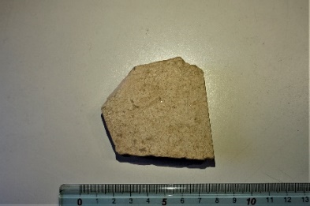 | 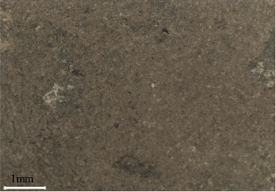
C03 | SU252: collapse / accumulation, destruction of the church or later (7th-8th?) | 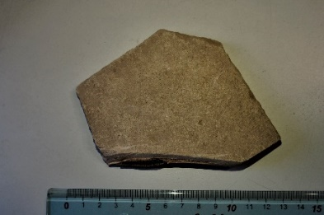 | 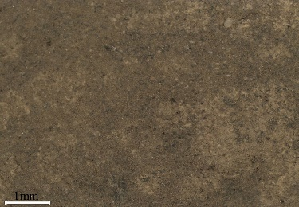
C06 | 2528: backfilling of the cut 2529, destruction of the Church or later (7th-8th?) | 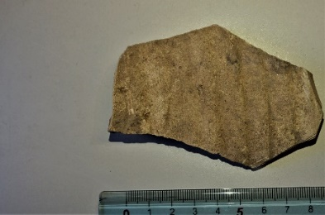 | 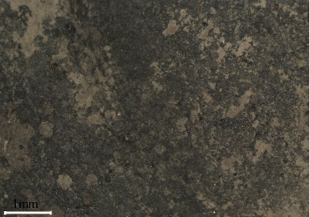
C07 | 6076: collapse of the room South to the apse of the “British Church” (7th-8th?) | 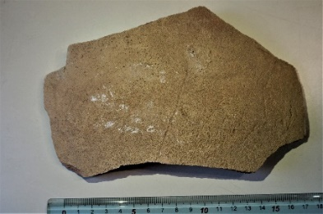 | 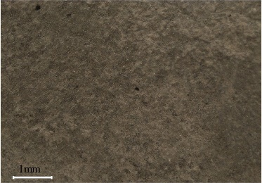
C08 | 6076: collapse of the room South to the apse of the “British Church” (7th-8th?) | 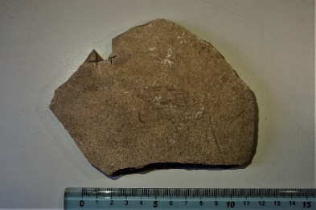 | 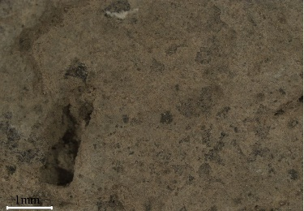
C09 | 6076: collapse of the room South to the apse of the “British Church” (7th-8th?) | 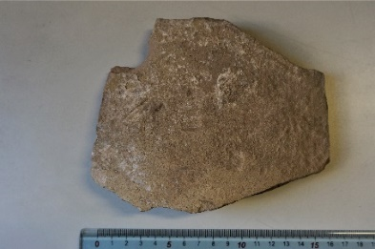 | 