E - Supplement

Optimal (lowest) transpulmonary driving pressure without esophageal pressure measurements
Grivans C¹, Stenqvist O²
1.Kungälvs hospital, Västra Götalandsregionen, Sweden. 2. Sahlgrenska Academy, Gothenburg University, Gothenburg, Sweden.
Corresponding author: Ola Stenqvist, Blockgatan 8, SE-26361 Viken, Sweden. Mobile: +46709747754, ola.stenqvist@aniv.gu.se

Background physiology of PEEP inflation
At FRC/ZEEP, transpulmonary pressure is positive, 5-10 cmH₂O, because the expansive chest wall has inflated the lung from Residual Volume to FRC and the pleural pressure becomes equally negative. It is important to realize that the negative pleural pressure is not the cause of lung inflation, but rather a consequence of the expansive chest wall pulling the lung open from RV to FRC. At FRC/ZEEP there is a balance between the expansive chest wall and the recoil of the lung and the expansive chest wall cannot pull the lung to a higher volume. However, the chest wall would move outwards until it reaches its resting volume at 70 – 80 % of total lung capacity (TLC) if not prevented by the lung recoil. Thus, if end-expiratory lung volume (EELV) is increased by PEEP, the chest wall will move out equally much at end-expiration. Thus, the chest wall complex does not impede end-expiratory lung volume change by PEEP and the increase in end-expiratory lung volume will only be related to lung elastance, ΔEELV = ΔPEEP/EL [1-5]. In pooled raw data from Stenqvist et al, Lundin eta l and Persson et al [1, 2, 4] measured and calculated (DPEEP/EL) correlated along the identity line, y = 1.03x, r² = 0.86 (Fig. S1).
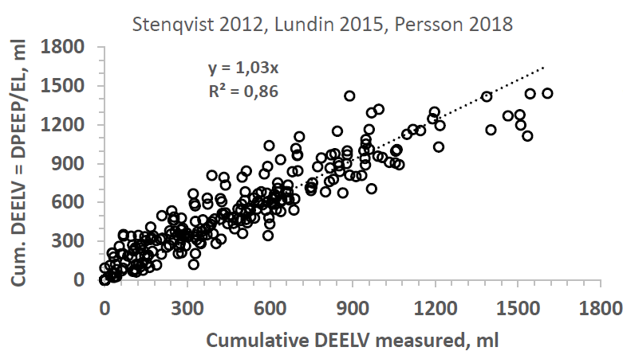
Fig. S1. Left panel: Comparison of ΔEELV measured as the cumulative expiratory tidal volume difference [2, 6] between baseline and increased PEEP level, with ΔEELV calculated as ΔPEEP/EL, where the transpulmonary driving pressure was obtained using esophageal pressure measurements, (ΔPAW – ΔPES)/ VT, in 13 pigs, 12 ARF patients and 24 patients with healthy lungs [1, 2, 4] .

The implication is that at a certain lung volume, transpulmonary pressure is the same, irrespective of whether this volume level has been reached by tidal or PEEP inflation and that end-expiratory transpulmonary pressure increases as much as PEEP is increased [1, 2, 4] (Fig. S2).
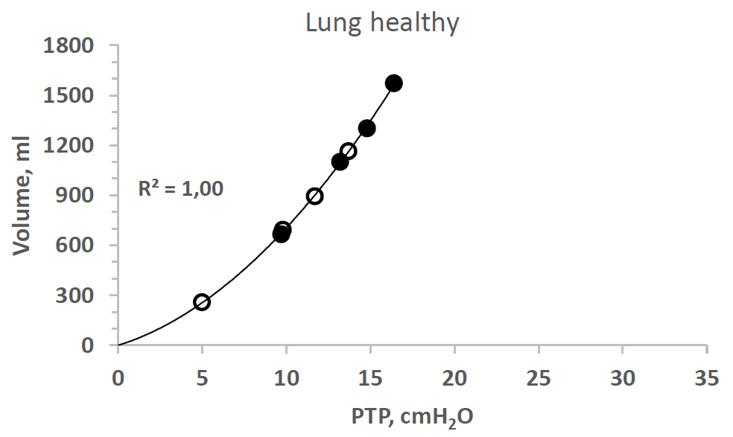
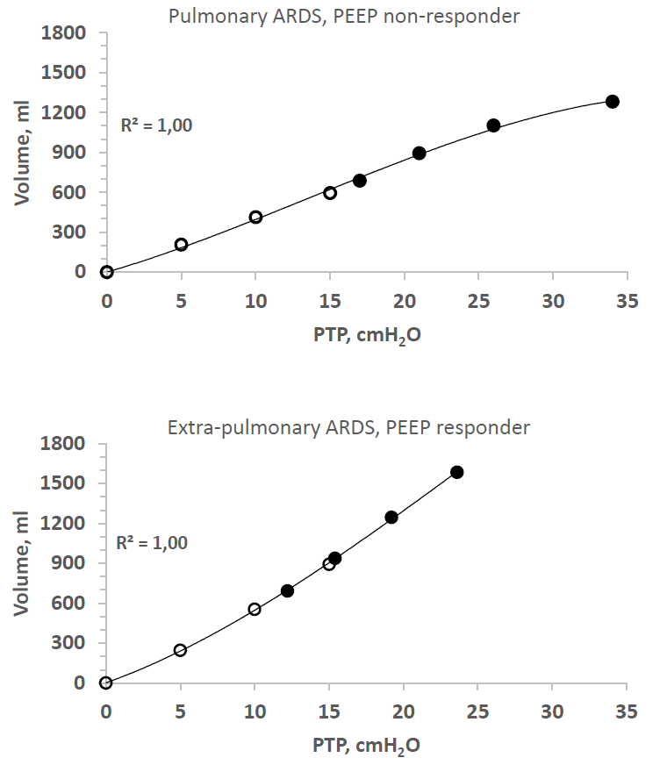

Fig. S2. Lung P/V curves in lung healthy patients from Persson et al, 2018 [2], extrapulmonary ARDS and pulmonary ARDS patients from Gattinoni et al, 1998 [7]. End-expiratory transpulmonary P/V points: open circles. End-inspiratory transpulmonary P/V points: filled circles. The increase in end-expiratory transpulmonary pressure between PEEP levels was calculated as ΔEELV x EL, where EL is determined as (ΔPAW – ΔPES)/VT at the lower PEEP level.
Note that end-expiratory and end-inspiratory lung P/V points are positioned along a single common lung P/V curve.

METHODS
End-expiratory lung volume change, ΔEELV
End-expiratory lung volume increase was determined by EIT (Dräger Medical, Lübeck, Germany) by a 16-electrode belt and ΔEELV was determined from the global EIT registration [8]. As the EIT signal is non-linear, i.e. the ratio of tidal impedance change (ΔZ) to tidal volume (ΔZ/ml) changes during a PEEP trial, the EIT signal was linearized by calibrating the inspiratory impedance signal (ΔZ) with the inspiratory tidal volume signal (ml) PEEP step by PEEP step. In this way, the change in end-expiratory lung volume during a PEEP step can be determined with a high precision during a PEEP step procedure (Table 1). To obtain the regional lung P/V curves, the regional changes in VT and ΔEELV are determined in principally the same way as the global changes in tidal volume and end-expiratory lung volume (fig 4). First, the regional ΔZ/VT at each PEEP level is determined. Second, the, the fraction of regional ΔZ/VT of the global ΔZ/VT is determined. Third, the global VT is divided per region according to the fraction of regional VT. Fourth, the regional ΔZ/ΔEELV is determined and fifth, the regional ΔEELV (ml) is calculated as the regional ΔZ/ΔEELV divided by the regional ΔZ/ml (Fig 1.).
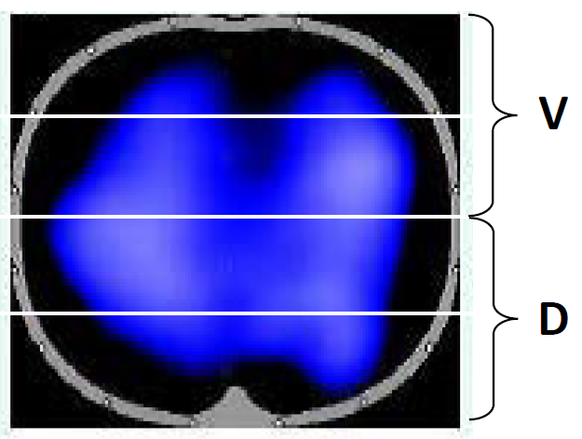
Fig. S3. Regions of interest (ROI) for analysis of EIT lung volume signal. V and D indicate upper, non-dependent, and lower, dependent lung halves.
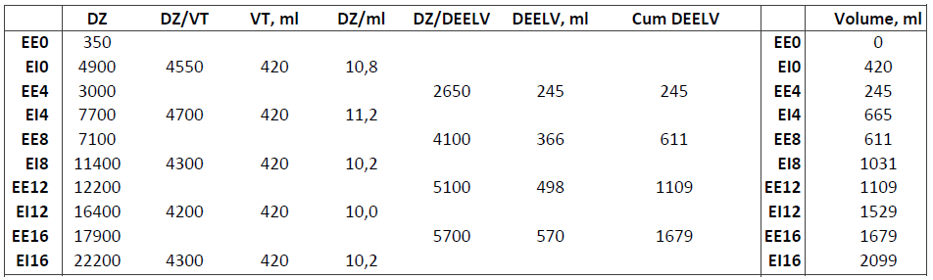
Table 1. Linearizing of ΔZ by the tidal volume (VT) from the ventilator. VT was 420 ml throughout the PEEP trial. The non-linearity of the ΔZ signal is seen in the ΔZ/ml column which a non-linearity of around 10 %. The end-expiratory and end-inspiratory volumes during the PEEP trial are shown in the far right column.

EIT traces the volume changes during a PEEP trial and an increasing number of breaths involved in establishing a new PEEP/EELV equilibrium reflects that lung elastance decreases PEEP step by PEEP step. The transpulmonary pressure at a certain lung volume are the same, independent of whether this volume has been reached by tidal inflation or PEEP inflation. Thus, by the calculation procedures described above (fig. 2, 4), the static steady state end-expiratory and end-inspiratory pressure and volume points were obtained for the whole PEEP trial from end-expiration at the lowest PEEP level to end-inspiration of the highest PEEP level (Fig. 2).
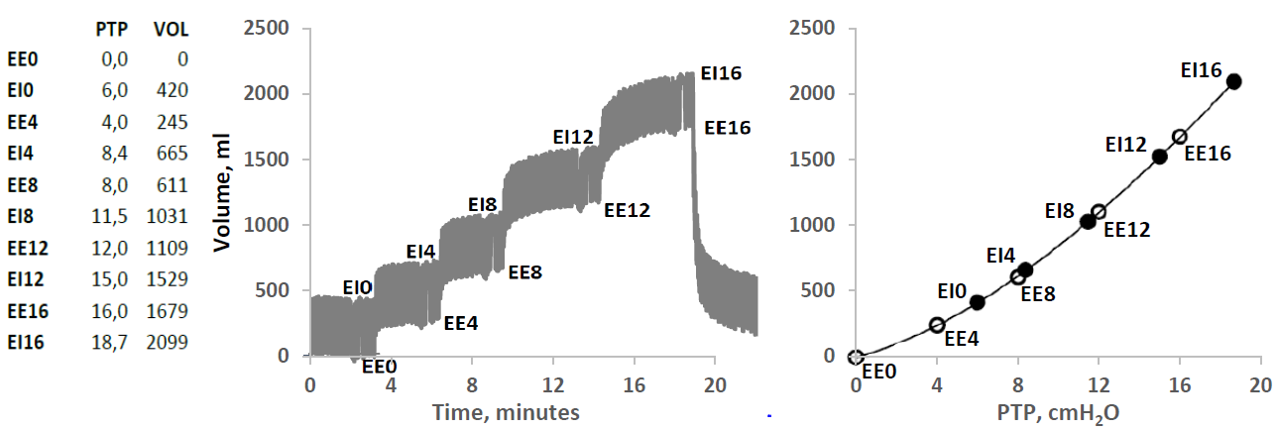
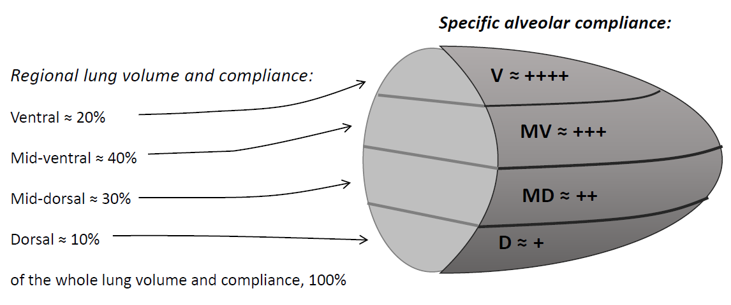
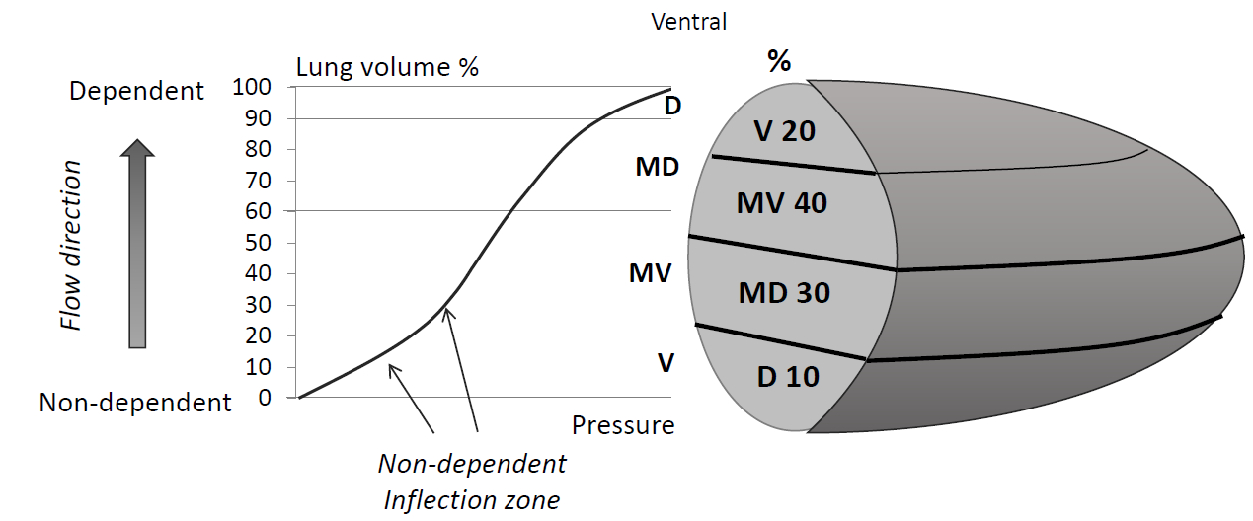
Fig. S4. Left panel: Table of transpulmonary pressure and volume by tidal volume calibrated EIT during PEEP steps 0-4-8-12-16 cmH₂O. EE: End-expiratory volume. EI: end-inspiratory volume. The digit denotes the PEEP level in cmH₂O. Mid panel: Lung volume changes by EIT during incremental PEEP steps. The indentations in the curve are caused by prolonged end-expiratory and end-inspiratory holds. Note that the end-expiratory lung volume is increasing almost like a square wave at low PEEP levels and taking longer times to reach a new steady state at high PEEP levels, indicating a decreasing lung elastance with increasing PEEP. Also note, that when PEEP is returned to baseline level, the end-expiratory volume has not returned to baseline after three minutes, in spite of the fact that a prolonged expiration of less than 15 seconds is enough for decreasing EELV from PEEP 15 to 5 cmH₂O. The slow process of decreasing EELV during tidal ventilation is a result of the expansive chest wall retarding all expirations during tidal ventilation [9, 10]. Right panel: Transpulmonary pressure plotted vs volume Open circles: End-expiratory P/V points. Filled circles: End-inspiratory P/V points. Note that end-expiratory and end-inspiratory P/V points are aligned on a single common lung P/V curve.

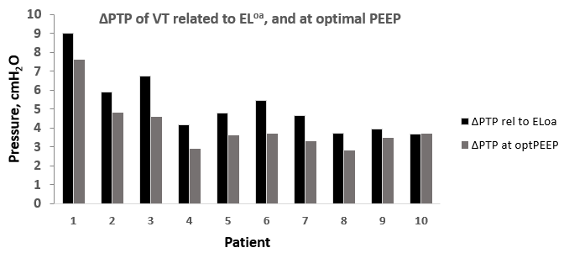
Fig. S5. Transpulmonary driving pressure calculated as the clinically used tidal volume times over-all lung elastance, VT x EL^{oa} and transpulmonary driving pressure at optimal PEEP level, i.e. with lowest ΔPTP.

Transpulmonary versus airway driving pressure
Transpulmonary driving pressure is highest at ZEEP and decreases in all patients when PEEP is increased stepwise to 4 and 8 cmH₂O, which is expected as there is a lower inflection zone below a PEEP of 8 cmH₂O. The ratio of transpulmonary to airway driving press, ΔPTP/ΔPAW (= EL/ERS) was 0.48 ± 0.13 varying between 0.28 and 0.76 in different patients at different PEEP levels. ΔPTP/ΔPAW changes with changes in PEEP. The PEEP level with lowest transpulmonary driving pressure coincided in three patients with the PEEP level where airway driving pressure was lowest. In the other patients, the PEEP level with lowest ΔPTP was 4-8 cmH₂O higher than for ΔPAW. When changing from PEEP 12 cmH₂O to 16 cmH₂O, ΔPTP and ΔPAW may even change in opposite direction (Fig. S6).

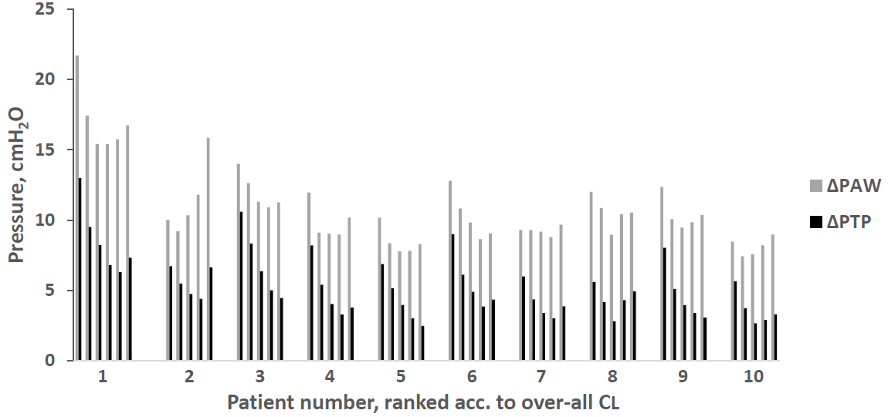
Fig. S6. Airway and transpulmonary driving pressure at PEEP levels 0 - 4 - 8 -12 – 16 (and 20 in patient 1). Patients are ranked according to over-all lung compliance from lowest value, 50 ml/cmH₂O, in patient 1 and highest, 137 ml/cmH₂O, in patient 10.

During PEEP changes, the ratio of lung elastance to respiratory elastance (EL/ERS) decreases similarly in both responders and non-responders at PEEP equal to or below 12 cmH₂O. During further PEEP increase, EL/ERS continues to decrease in responders, while it increases in non-responders. As EL = ΔPTP/VT and ERS = ΔPAW/VT, the ratio of lung elastance to respiratory system, EL/ERS = ΔPTP/ΔPAW, which means that airway and transpulmonary driving pressure are the same in all parts of the lung, but the regional tidal volume is inversely correlated to regional lung elastance (Fig. S7).
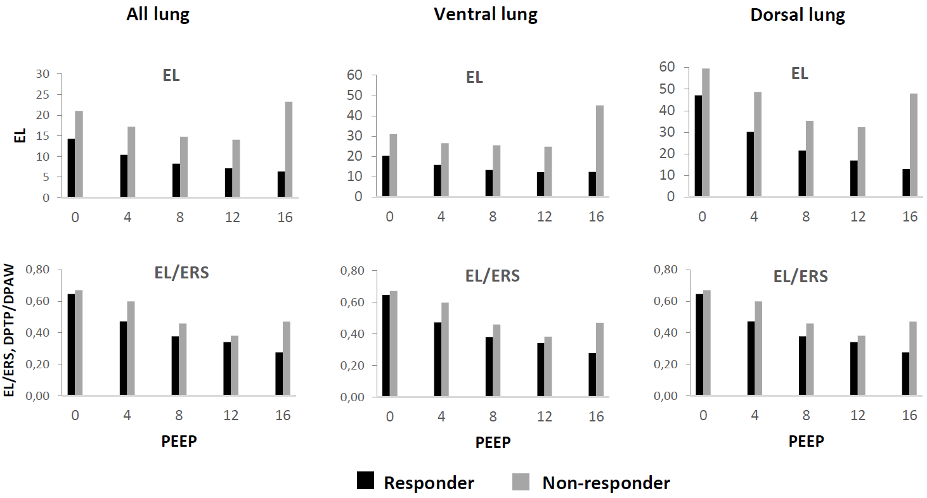
Fig. S7. Upper panels: Lung elastance (EL) in all lung, and in upper (ventral) and lower (dorsal) half of the lung in the PEEP responder and non-responder of figure 11 and 12. Lung elastance levels in the whole lung are generally lower in the responders than in the non-responder and this difference is pronounced at high PEEP levels, where lung elastance continues to decrease in the responders, while in contrast, it starts to increase in the non-responder. In the ventral lung half, the pattern is very similar to that of the whole lung. Lung elastance is lower at 16 cmH₂O PEEP than at ZEEP in the responder. In the non-responder, lung elastanceg is higher at 16 cmH₂O PEEP than at ZEEP. At 16 cmH₂O of PEEP, when tidal volume of ventral and dorsal lung are almost equal, lung elastance of both responders and non-responders are almost equal in ventral and dorsal lung.

PEEP response
Lung compliance increases with increasing PEEP in PEEP responders and is associated with higher over-all lung compliance, than in non-responders, where over-all lung compliance is low, as seen in the two most non-responsive patients (pat. 1 and 2) with CL^{oa} around 50 ml/cmH₂O, which is half the lung compliance seen in lung healthy individuals [2, 11]. The PEEP non-responders are characterized by decreasing lung compliance with an upper deflection point on the lung P/V curve at higher PEEP levels (Fig. S8).
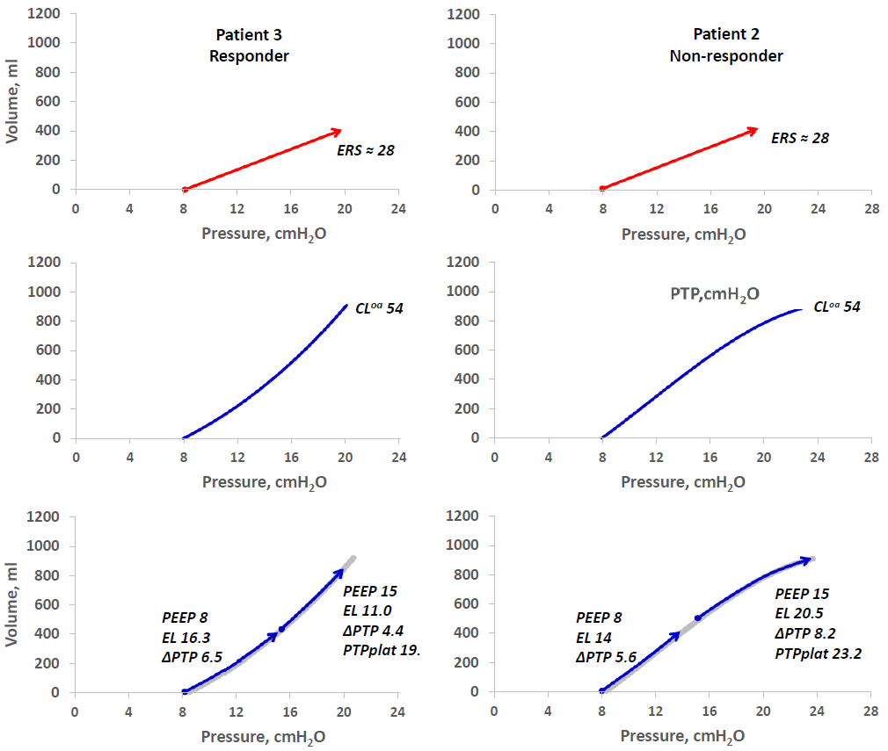
Fig. S8. Implementation of a short two-PEEP step procedure in two patients with the same respiratory system compliance at a baseline clinical PEEP of 8 cmH₂O (upper panels). PEEP is increased stepwise from 8 to 12 and 16 cmH₂O and the lung P/V curve (blue line) is determined from end-expiration of PEEP 8 to end-inspiration at PEEP 16 cmH₂O (mid panels). As the tidal lung P/V curve lies on the lung P/V curve, transpulmonary plateau and driving pressure (PTPplat, ΔPTP) can be calculated for any combination of PEEP and tidal volume. In this case PTPplat and ΔPTP is determined for a tidal volume of 400 ml at PEEP 8 and 15 cmH₂O, revealing that in patient 2 (right panels) this PEEP increase leads to a significant increase in ΔPTP and a high and possibly risky level of PTPplat. In patient 3 (left panels), the increase in PEEP from 8 to 15 cmH₂O results in a decrease in ΔPTP from 6.5 to 4.4 cmH₂O and a transpulmonary plateau pressure, which is well below VILI levels.

References

1. Lundin S, Grivans C, Stenqvist O, (2015) Transpulmonary pressure and lung elastance can be estimated by a PEEP-step manoeuvre. Acta anaesthesiologica Scandinavica 59: 185-196
2. Persson P, Stenqvist O, Lundin S, (2018) Evaluation of lung and chest wall mechanics during anaesthesia using the PEEP-step method. British journal of anaesthesia 120: 860-867
3. Stenqvist O, (2020) Transpulmonary driving pressure, without esophageal pressure measurements, instead of airway driving pressure. Intensive care medicine
4. Stenqvist O, Grivans C, Andersson B, Lundin S, (2012) Lung elastance and transpulmonary pressure can be determined without using oesophageal pressure measurements. Acta anaesthesiologica Scandinavica 56: 738-747
5. Stenqvist O, Persson P, Lundin S, (2018) Can we estimate transpulmonary pressure without an esophageal balloon?-yes. Ann Transl Med 6: 392
6. Grivans C, Lundin S, Stenqvist O, Lindgren S, (2011) Positive end-expiratory pressure-induced changes in end-expiratory lung volume measured by spirometry and electric impedance tomography. Acta anaesthesiologica Scandinavica 55: 1068-1077
7. Gattinoni L, Pelosi P, Suter PM, Pedoto A, Vercesi P, Lissoni A, (1998) Acute respiratory distress syndrome caused by pulmonary and extrapulmonary disease. Different syndromes? American journal of respiratory and critical care medicine 158: 3-11
8. Frerichs I, Amato MB, van Kaam AH, Tingay DG, Zhao Z, Grychtol B, Bodenstein M, Gagnon H, Bohm SH, Teschner E, Stenqvist O, Mauri T, Torsani V, Camporota L, Schibler A, Wolf GK, Gommers D, Leonhardt S, Adler A, group Ts, (2017) Chest electrical impedance tomography examination, data analysis, terminology, clinical use and recommendations: consensus statement of the TRanslational EIT developmeNt stuDy group. Thorax 72: 83-93
9. Odenstedt H, Lindgren S, Olegard C, Erlandsson K, Lethvall S, Aneman A, Stenqvist O, Lundin S, (2005) Slow moderate pressure recruitment maneuver minimizes negative circulatory and lung mechanic side effects: evaluation of recruitment maneuvers using electric impedance tomography. Intensive care medicine 31: 1706-1714
10. Lowhagen K, Lindgren S, Odenstedt H, Stenqvist O, Lundin S, (2011) Prolonged moderate pressure recruitment manoeuvre results in lower optimal positive end-expiratory pressure and plateau pressure. Acta anaesthesiologica Scandinavica 55: 175-184
11. Pelosi P, Cereda M, Foti G, Giacomini M, Pesenti A, (1995) Alterations of lung and chest wall mechanics in patients with acute lung injury: effects of positive end-expiratory pressure. American journal of respiratory and critical care medicine 152: 531-537

