Supplementary Information
Fossilized eukaryotes from 2.7 billion year old shales in Tanzania

Ioan V. Sanislav^{1,2,}*, Paul H.G.M. Dirks^{1,2}, Espen Knutsen^{2,3}, Kurt Konhauser⁴ and Shimba D. Kwelwa⁵

¹Economic Geology Research Centre (EGRU), Townsville, 4811, QLD, Australia. ²Department of Earth and Environmental Sciences, James Cook University, Townsville, 4811, QLD, Australia; ³Museum of Tropical Queensland, Queensland Museum Network, Townsville 4810, QLD, Australia; ⁴Department of Earth & Atmospheric Sciences, University of Alberta Edmonton, Alberta T6G 2E3 Canada. ⁵Geita Gold Mine, Geita, P.O. Box 532, Geita Region, Tanzania; *e-mail: Correspondence: ioan.sanislav@jcu.edu.au.

- Supplementary Information 1: Geological setting
The Tanzania craton consists of a core of high-grade mafic and felsic granulite (the Dodoman Supergroup) dated at >3.0 Ga, which is overlain by a volcano-sedimentary package dominated by mafic volcanics (the 2820-2700 Ma Nyanzian Supergroup), and younger (<2650 Ma), mostly coarse clastic sediment of the Kavirondian Supergroup (e.g. Gabert, 1990; Kuehn et al., 1990; Borg, 1992; Borg and Shackleton, 1997; Borg and Krogh, 1999; Manya et al., 2008; Cook et al., 2016). Rocks of to the Dodoman Supergroup are restricted to the southern part of the craton, with the northern part of the craton comprised of younger (<2.82 Ga), juvenile crust (Manya et al., 2008; Kabete et al., 2012a, b; Sanislav et al., 2018), variably interpreted as accretionary volcanic arc systems (Manya, 2016) or vertically accreted and chemically evolved oceanic plateaus (Cook et al., 2016; Sanislav et al., 2018) that docked with the older cratonic core during the Neoarchaean.
The Nyanzian and Kavirondian sequences in the northern part of the Tanzania Craton have been described from six greenstone belts (Fig. S1) clustered around the margins of Lake Victoria (Borg and Shackleton, 1997). Each of these greenstone belts comprises several greenstone domains grouped based on perceived stratigraphic correlations and geographic proximity (Borg et al., 1990), in spite of the presence of large shear zones that separate parts of each greenstone belt (e.g. Kabete et al., 2012a). Of the six greenstone belts, the Sukumaland Greenstone Belt is the largest, containing fragments that are large enough, and stratigraphically distinct enough to be categorized as greenstone belts in their own right. This includes a greenstone domain along the northern margin of the Sukumaland Greenstone Belt, termed the Geita Greenstone Belt (Fig. S2; Sanislav et al., 2015; Cook et al., 2016).
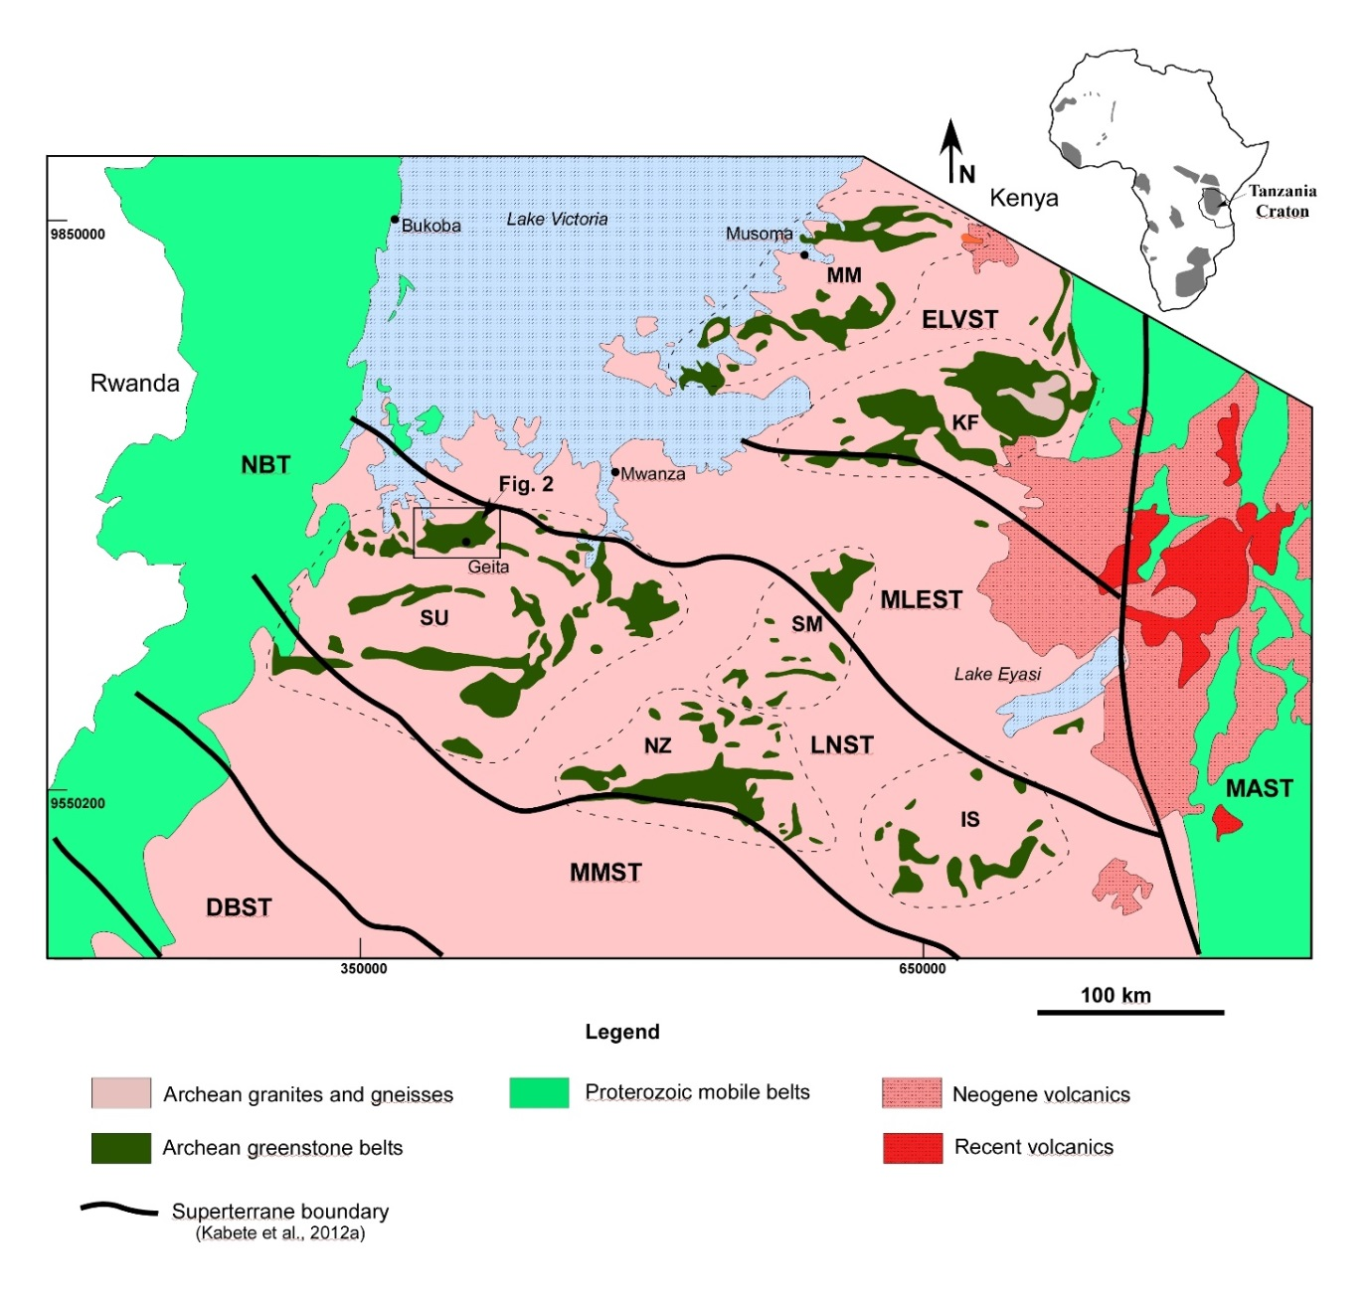
Figure S1. Geological map of the northern half of the Tanzania Craton showing the main geological and tectonic units. IS—Iramba-Sekenke Greenstone Belt; KF—Kilimafedha Greenstone Belt; MM—Musoma-Mara Greenstone Belt; NZ — Nzega Greenstone Belt; SM—Shinyanga-Malita Greenstone Belt; SU — Sukumaland Greenstone Belt. Super-terrane boundaries are as proposed by (Kabete et al., 2012a): DBST — Dodoma Basement; ELVST— East Lake Victoria; LNST — Lake Nyanza; MAST — Mbulu-Masai; MLEST —Mwanza Lake Eyasi; MMST —Moyowosi-Manyoni; NBT — Nyakahura-Burigi. The inset map of Africa shows the location of Archaean blocks. The figure has been adapted from Sanislav et al. (2015). The red square shows the study area as shown in Figure 2.

The Geita Greenstone Belt (GGB) consists of ~630 km² of mafic and felsic volcanic, volcanoclastic and sedimentary rocks, bounded to the S by a large, E-W trending shear zone that separates the belt from gneiss (Sanislav et al., 2018). To the N, E and W the greenstone lithologies were intruded by granitoid plutons dated at 2660-2620 Ma (Sanislav et al. 2015). The southern part of the GGB is composed of ~2823 Ma meta-basalt that forms the base of the supracrustal sequence in the GGB (Manya and Maboko 2008; Cook et al., 2016). The remainder of the greenstone belt is dominated by meta-sediments and volcanoclastics that are older than 2699 ± 9 Ma (Borg and Krogh, 1999, Sanislav et al., 2015). These units were intruded by syn-tectonic igneous complexes of dioritic to tonalitic composition between 2700-2680 Ma (Sanislav et al., 2015, 2018; Kwelwa et al., 2018).
Meta-ironstone units are exposed in three distinct NW-SE trending terrains separated by areas with little or no outcrop underlain by meta-sediments. The boundaries of these terrains are characterized by major lineaments visible on aero-magnetic datasets and interpreted as large shear zones (Fig. S2). These terrains are the Nyamulilima terrain to the W, the Central terrain in the middle, and Kukuluma terrain to the E (Fig. S2).
The fossils occur in the Kukuluma terrain, ~300 m ESE of a gold prospect called Area 3, and 1.6 km SE of an open pit gold mine called Kukuluma Pit (Fig 1 [main text], Fig. S2). The outcrops of fossiliferous sediments occur on the flank of a flat-topped mountain, ~200 m above the surrounding plateau. The top of this mountain is deeply weathered and underlain by >120m of regolith with near-complete oxidation of all rock types. The fossil locality occurs along a spur below the ridgeline, where the thick regolith has been largely removed by erosion, and outcrops of non-oxidized, relatively fresh rock can be found (Fig. S3).
The sedimentary sequence in the general vicinity of the fossil occurrences is composed of a volcano-sedimentary pile with a black, graphitic shale unit of undefined thickness at its base. This unit is well exposed at the bottom of the Kukuluma pit, and probably overlies metabasalt (Kwelwa et al., 2018). The black shale unit transitions into a well-layered meta-ironstone unit that is variable in thickness due to deformational effects. The meta-ironstone unit is widely distributed (Fig. 1 [main text]), and consists of regularly layered packages of magnetite-rich sandstone and siltstone interlayered with shale beds and silicified, quartzite beds. The meta-ironstone unit transitions into meta-greywacke comprised of laminated shale- siltstone and sandstone beds that are locally carbonaceous, with a typical bed thickness of 5-15 cm. These beds are inter-layered with fine-grained tuff horizons and volcanoclastics, some with ignimbrite characteristics. The sandstone layers are typically graded and locally contain small (<1cm), well-rounded chert pebbles or grit at their base. Some beds preserve low-angle hummocky cross stratification, and rare evidence of scouring. Locally, graded beds are interlayered with massive, non-structured, matrix supported conglomerate that contain mostly angular chert clasts, <3cm in diameter embedded in a coarse, sand matrix.
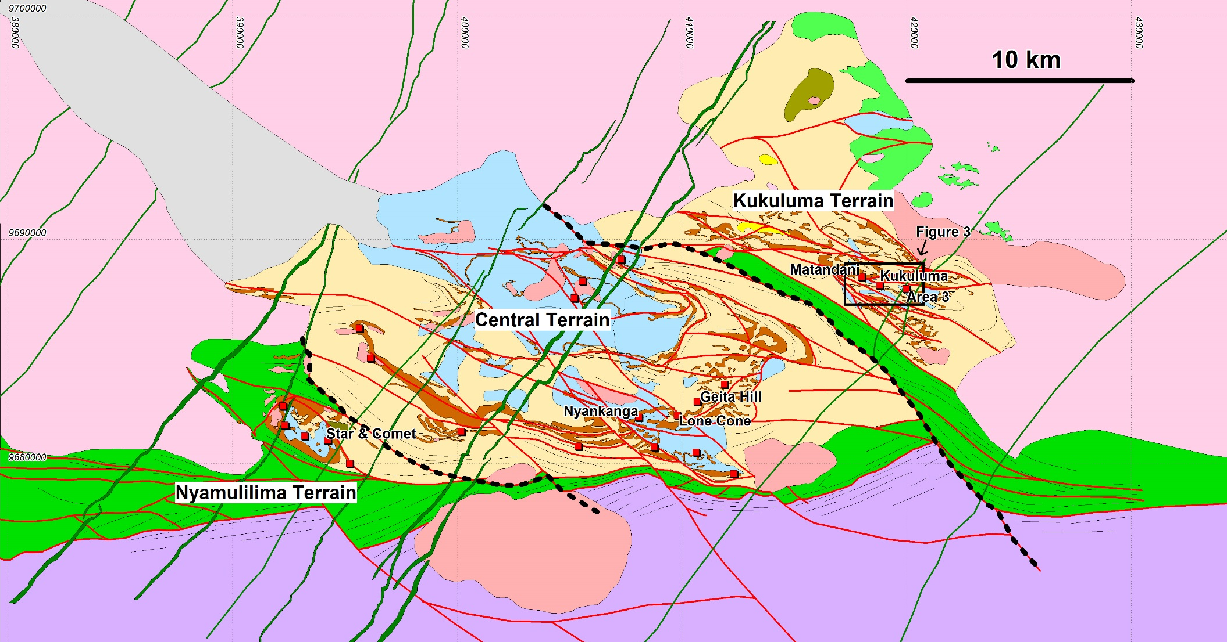  Study Area  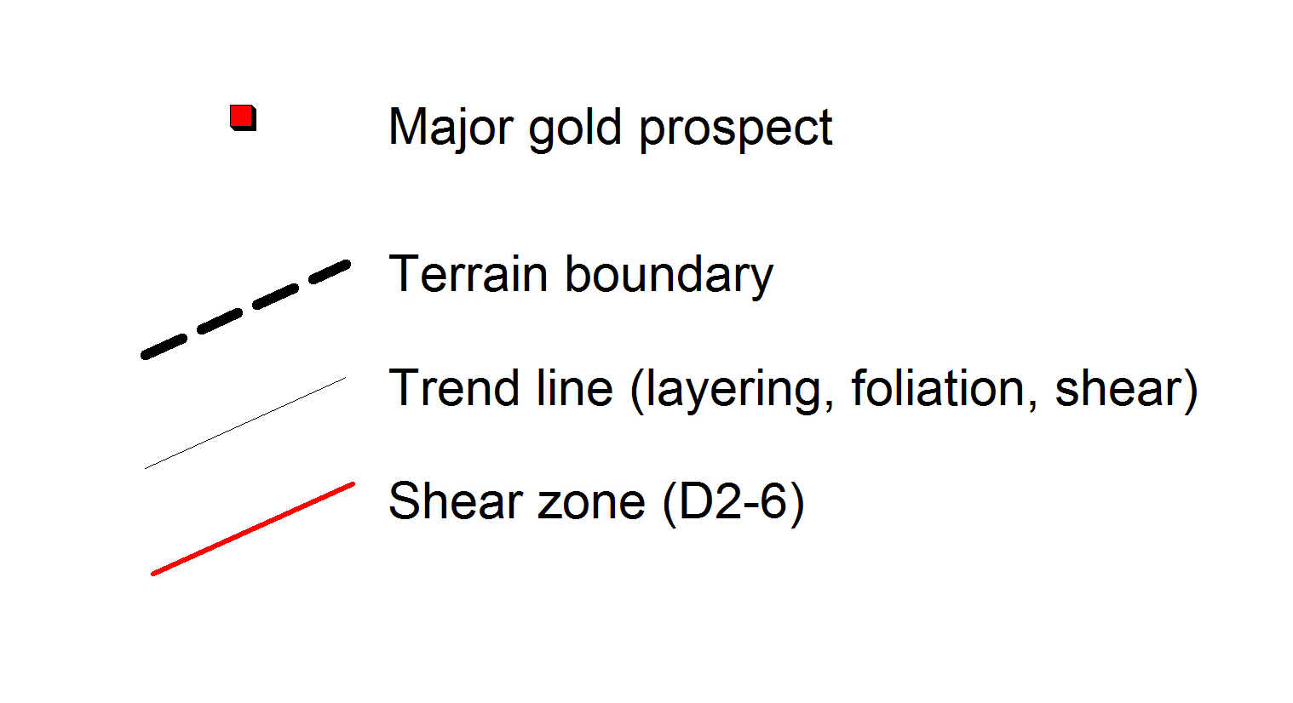 | Figure S2. Geological map of the Geita Greenstone belt showing the location of the major gold deposits and the main geological terrains, lithological units and structures (listed ages from Sanislav et al. 2015, 2018. The Insert shows the study area The grid is in UTM WGS84, zone 36S.
These deposits indicate high transport energies and a proximal source area. Graded bedding (fining upward with partial Bouma sequences), low-angle cross bedding (including hummocky cross stratification) and scour marks provide abundant younging indicators, and are indicative of deposition on the proximal parts of a marine fan-delta system with input of immature sediment near or above the storm wave base (e.g. Hofmann et al., 2001).
The fossils occur within a relatively finer-grained interval within the greywacke deposits near the stratigraphic top of the sedimentary sequence ascribed to the Upper Nyanzian. The rocks hosting the fossils form a series of low (up to 1 m high) disconnected outcrops that emerge from surrounding soils over a total strike length of ~15 m. The rocks consist of finely bedded, siltstone with thin mud intercalations that define planes along which beds part. Individual beds are 0.5-3 cm thick and characteristically show dark-coloured lamellae of carbonaceous material on top of a thin (<1mm) layer of slightly coarser-grained quartz-rich material. The carbonaceous layers is overlain by fine silt-clay material that is composed of mostly quartz, feldspar and white mice and shows little sorting or evidence of syn-sedimentary structures. Carbonaceous material occurs as sub-mm-scale, distributed patches and angular fragments throughout the layers, and is commonly, spatially associated with small grains of iron oxide (hematite).
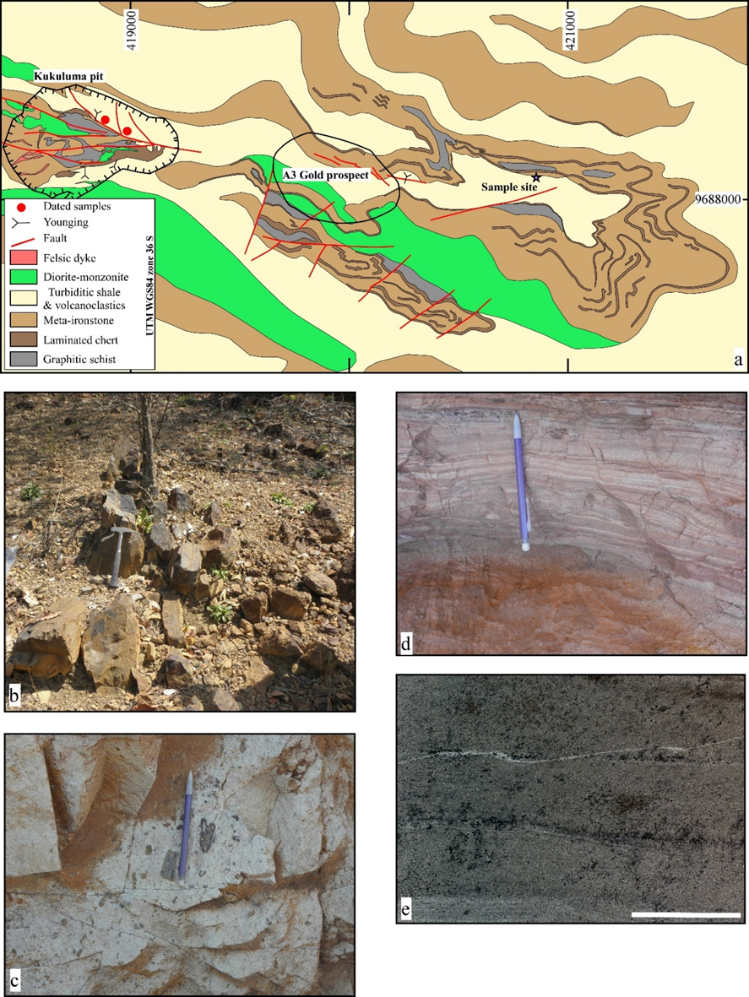

Figure S3. Geological map showing the main stratigraphic units and the location of the microfossil site (a). Photograph of the outcrop containing the microfossils (b). Volcanoclastic rocks that occurs within the stratigraphic horizon with the microfossils. A sample from this outcrop was used for dating and returned an age of 2724±12 Ma (c). An example of fine laminations of sandstone, siltstone and mudstone along strike from the microfossil site (d). Close-up of the fine carbonaceous laminations that host the microfossils-scale bar is 1 cm (e).

The mica-grains are poorly orientated, and the rocks shows no discernible tectonic fabric other than an alignment of the slightly ellipsoidal mm-sized graphite rich patches, which define a weak fabric at a 60 degree angle to the primary layering. If this fabric is a reflection of regional strain, it suggests that the outcrops occur near a fold hinge, where tectonic fabrics and primary layering occur at high angles to one another.
Overall, the rocks are very weakly strained, and primary textures are well preserved. The microfossils are concentrated along the carbonaceous lamellae near the base of individual layers, where they occur as individual spheres or clusters of spheres.

- Supplementary Information 2: U-Pb dating of intercalated volcaniclastics
The samples for U-Pb zircon dating were collected in the Kukuluma Pit, from a tuffaceous layer and an ignimbrite layer, which are interbedded with the sediments. The unit from which the dating samples were taken are an approximate stratigraphic correlative of the rocks containing the fossils, 1.8 km to the SE. The stratigraphic correlation is based on the presence of a characteristic chert bed, which forms a prominent stratigraphic marker horizon that can be traced along stratigraphy on surface and in geophysics (Fig. 1 [main text]). This chert marker horizon occurs ~20 m to the NE of the outcrop with fossils, and can be traced as a near-continuous horizon all the way to Kukuluma Pit, where it passes just N of the pit wall, stratigraphically ~40 m to the NE and above the locality from which the geochronology samples were taken (Fig. 1 [main text]). We are, therefore, confident that the fossil samples and geochronological samples come from more-or-less the same stratigraphic unit, and that the geochronological samples will provide good age constraints for the fossils.
The dating samples were split and the weathered surfaces were removed. The split fraction from each sample was milled with a tungsten carbide disc mill to a grain size of ≤ 500 μm. The 500 μm portion was run in water current on a Wilfley table and the heavy mineral fraction was collected and subsequently run through a Frantz magnetic separator. The non-magnetic fraction was further divided using heavy liquids from which the heavy fraction was run again through a Frantz magnetic separator. Zircons were hand-picked from the non-magnetic fraction and mounted into epoxy resin blocks and polished to about half of their thickness; first with a 3 μm diamond paste than with a 1 μm diamond paste.
Before the analysis, all zircon grains were imaged using a Jeol JSM5410LV with attached cathodoluminescence detector to identify growth domains and inherited cores within the grains (Fig. S4). U–Pb isotope analyses were obtained with a GeoLas 200 Excimer Laser Ablation System in a He ablation atmosphere, coupled to a Varian ICP-MS 820 series instrument. Laser parameters during the analyses include a repetition rate of 10 Hz, spot size of 32 µm and energy of 6.0 J/cm². Analyses involved 30 seconds of background measurement (gas blank) followed by 35 seconds of acquisition of U-Pb isotope data. U–Pb fractionation was corrected using the GJ-1 (ID-TIMS ²⁰⁷Pb/²⁰⁶Pb age = 608.5 ± 0.4Ma (Jackson et al., 2004) as the primary standard. FC-1 zircons (ID-TIMS ²⁰⁷Pb/²⁰⁶Pb age = 1099.0 ± 0.6Ma (Paces and Miller, 1993) and the Tem-2 zircons (ID-TIMS ²⁰⁶Pb/²³⁸U age = 416.8 ± 1.1Ma (Black et al., 2003) were used as secondary standards. Several zircon grains were excluded from analysis due to the metamict nature and small size of the grains. Analyses with high common Pb and/or significant discordance (>10%) were not included in the age calculations.
Data processing was done using the software package GLITTERTM (Jackson et al., 2004), and the age calculations were made using Isoplot (Ludwig, 2003). Over the duration of this study the reported weighted average age (errors at 95% confidence) for GJ-1 is 602 ± 3 Ma for ²⁰⁶Pb/²³⁸U and the concordia age is 602 ± 3 Ma. FC-1 gave a weighted average age of 1100 ± 10 Ma for ²⁰⁷Pb/²⁰⁶Pb and 1099 ± 10 Ma for the concordia age. Tem-2 weighted average during the analyses was 428 ± 16 Ma for ²⁰⁷Pb/²⁰⁶Pb and the concordia age was 414± 7 Ma. ²⁰⁷Pb/²⁰⁶Pb grain ages are used in this study.
Results and calculated ages are shown in Supplementary Table S1. The zircon grains from both samples are euhedral to subhedral in shape, have medium to low luminescence and in general show concentric growth zoning (Fig.S4). Ten zircon grains were analysed from each sample. All analysed zircons grains from sample KK11were less than 5% discordant. Their ²⁰⁷Pb/²⁰⁶Pb weighted average age is 2724±12 Ma with a similar concordia age of 2717±7 Ma. From sample KK12 eight zircon grains were less than 5% discordant and 2 zircon grains were less than 10% discordant. Their ²⁰⁷Pb/²⁰⁶Pb weighted average age is 2707±12 Ma with a similar concordia age of 2700±7 Ma. Both volcanoclastic samples sit along the same stratigraphic horizons with the rock containing the microfossils thus provide a secure Neoarchean age estimate for the rocks that contain the fossils.

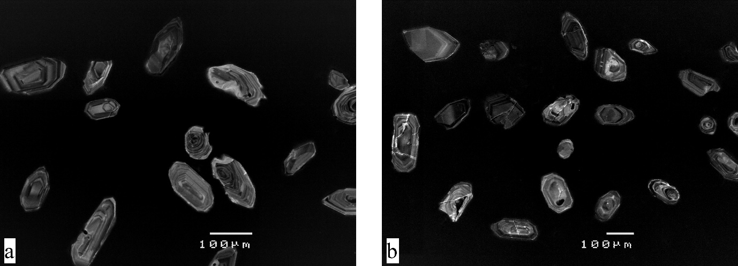
Figure S4. Cathodoluminescence images of zircon grains from sample KK11 (a) and KK12 (b).

Analysis | ²³⁸U/²⁰⁶Pb | Error (1σ) | ²⁰⁷Pb/²⁰⁶Pb | Error (1σ) | ²⁰⁷Pb/²³⁵U | Error (1σ) | ²⁰⁶Pb/²³⁸U | Error (1σ) | Rho | Age (Ma) ²⁰⁷Pb/²⁰⁶Pb | Error (1σ) | Age (Ma) ²⁰⁶Pb/²³⁸U | Error (1σ) | Discordance (%)
KK11-1 | 1.980 | 0.018 | 0.187 | 0.002 | 13.048 | 0.138 | 0.505 | 0.005 | 0.84 | 2720 | 20 | 2636 | 19 | 3
KK11-2 | 1.948 | 0.018 | 0.188 | 0.002 | 13.316 | 0.151 | 0.513 | 0.005 | 0.81 | 2726 | 21 | 2671 | 20 | 2
KK11-3 | 1.899 | 0.017 | 0.188 | 0.002 | 13.612 | 0.133 | 0.526 | 0.005 | 0.89 | 2721 | 18 | 2727 | 19 | 0
KK11-4 | 1.953 | 0.018 | 0.187 | 0.002 | 13.215 | 0.136 | 0.512 | 0.005 | 0.87 | 2718 | 19 | 2665 | 20 | 2
KK11-5 | 1.901 | 0.017 | 0.187 | 0.002 | 13.587 | 0.145 | 0.526 | 0.005 | 0.83 | 2720 | 20 | 2724 | 20 | 0
KK11-6 | 1.964 | 0.017 | 0.189 | 0.002 | 13.266 | 0.128 | 0.509 | 0.004 | 0.87 | 2734 | 18 | 2653 | 18 | 3
KK11-7 | 1.900 | 0.017 | 0.188 | 0.002 | 13.625 | 0.148 | 0.526 | 0.005 | 0.83 | 2723 | 20 | 2726 | 20 | 0
KK11-8 | 1.978 | 0.017 | 0.190 | 0.002 | 13.234 | 0.137 | 0.506 | 0.004 | 0.81 | 2741 | 20 | 2638 | 18 | 4
KK11-9 | 1.932 | 0.017 | 0.186 | 0.002 | 13.287 | 0.130 | 0.518 | 0.005 | 0.89 | 2709 | 18 | 2689 | 19 | 1
KK11-10 | 1.956 | 0.017 | 0.188 | 0.002 | 13.266 | 0.130 | 0.511 | 0.004 | 0.89 | 2727 | 18 | 2662 | 19 | 2
KK12-1 | 2.056 | 0.019 | 0.188 | 0.002 | 12.582 | 0.130 | 0.486 | 0.004 | 0.88 | 2722 | 19 | 2555 | 19 | 6
KK12-2 | 2.156 | 0.020 | 0.187 | 0.002 | 11.955 | 0.130 | 0.464 | 0.004 | 0.87 | 2716 | 19 | 2456 | 19 | 10
KK12-3 | 1.973 | 0.018 | 0.187 | 0.002 | 13.041 | 0.140 | 0.507 | 0.005 | 0.87 | 2713 | 19 | 2643 | 20 | 3
KK12-4 | 2.056 | 0.019 | 0.186 | 0.002 | 12.447 | 0.129 | 0.486 | 0.004 | 0.89 | 2704 | 19 | 2555 | 19 | 6
KK12-5 | 1.915 | 0.018 | 0.185 | 0.002 | 13.290 | 0.144 | 0.522 | 0.005 | 0.85 | 2695 | 20 | 2709 | 20 | -1
KK12-6 | 1.951 | 0.018 | 0.185 | 0.002 | 13.099 | 0.136 | 0.513 | 0.005 | 0.89 | 2702 | 19 | 2668 | 20 | 1
KK12-7 | 1.969 | 0.020 | 0.184 | 0.002 | 12.892 | 0.156 | 0.508 | 0.005 | 0.83 | 2691 | 21 | 2648 | 22 | 2
KK12-8 | 2.031 | 0.019 | 0.185 | 0.002 | 12.582 | 0.132 | 0.492 | 0.005 | 0.89 | 2702 | 19 | 2581 | 20 | 4
KK12-9 | 2.050 | 0.018 | 0.187 | 0.002 | 12.577 | 0.126 | 0.488 | 0.004 | 0.90 | 2716 | 18 | 2562 | 19 | 6
KK12-10 | 1.904 | 0.017 | 0.186 | 0.002 | 13.431 | 0.135 | 0.525 | 0.005 | 0.89 | 2703 | 18 | 2721 | 20 | -1

Supplementary Table S1. Table with the analytical results and the calculated ages for the ignimbrite and tuff samples.

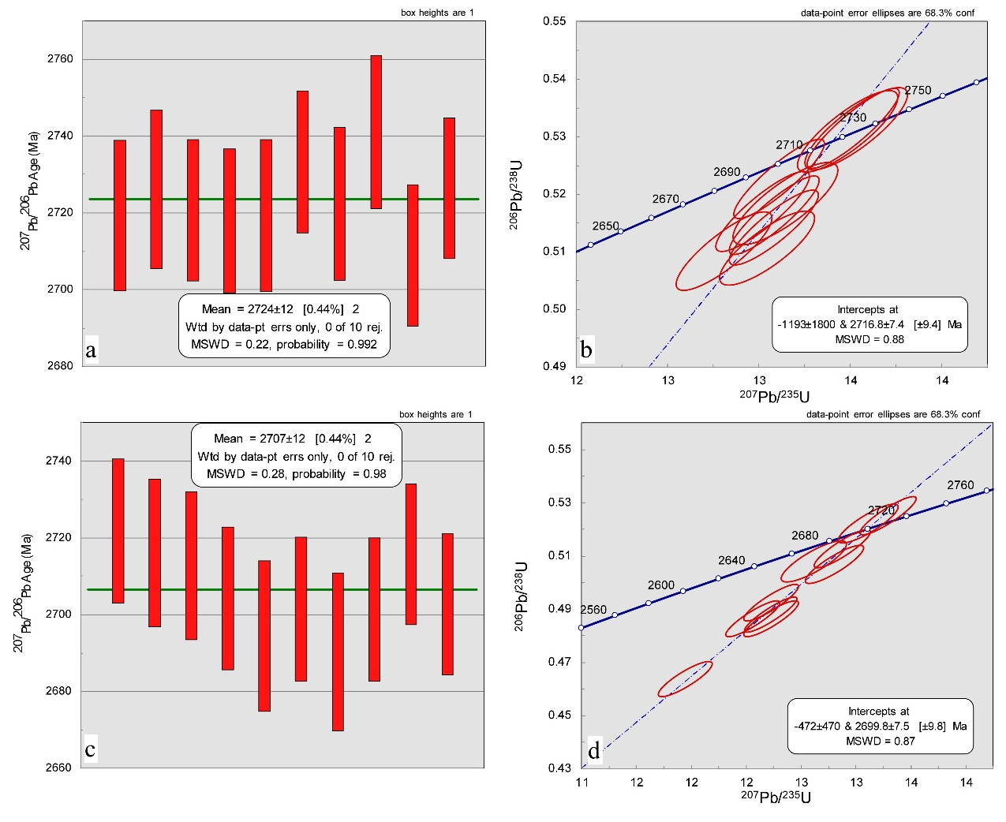

Figure S5. Diagrams showing the ²⁰⁷Pb/^{206Pb} weighted average age and the concordia age for samples KK11 (a and b) and KK12 (c and d).

- Supplementary Information 3: Further examples of microfossils
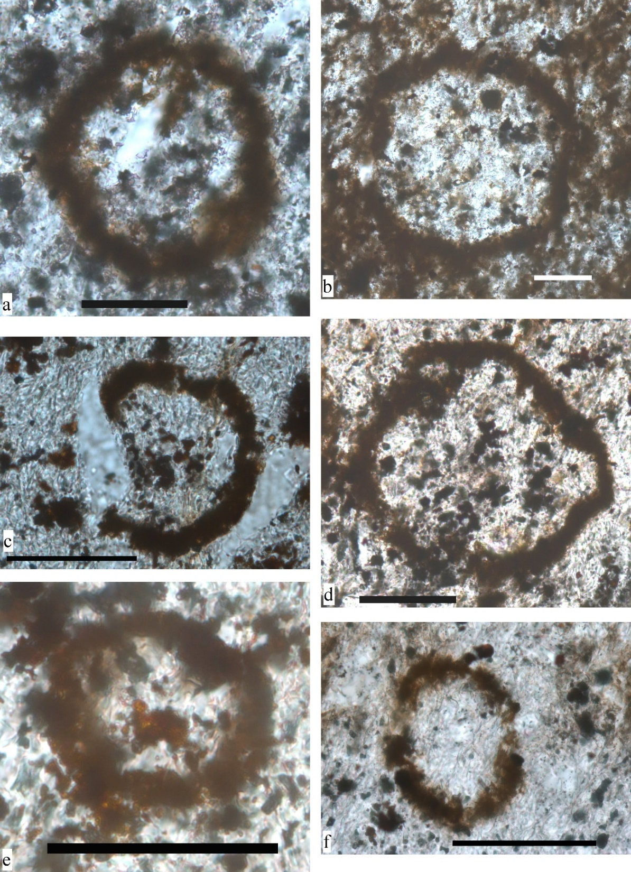

Figure S7. Microphotographs showing examples of spheroidal microfossils with a relatively simple wall structure. Note the relationship between the microfossil wall and the quartz grains in (c) which suggest a syn-sedimentary process. Scale bar is 100 µm.

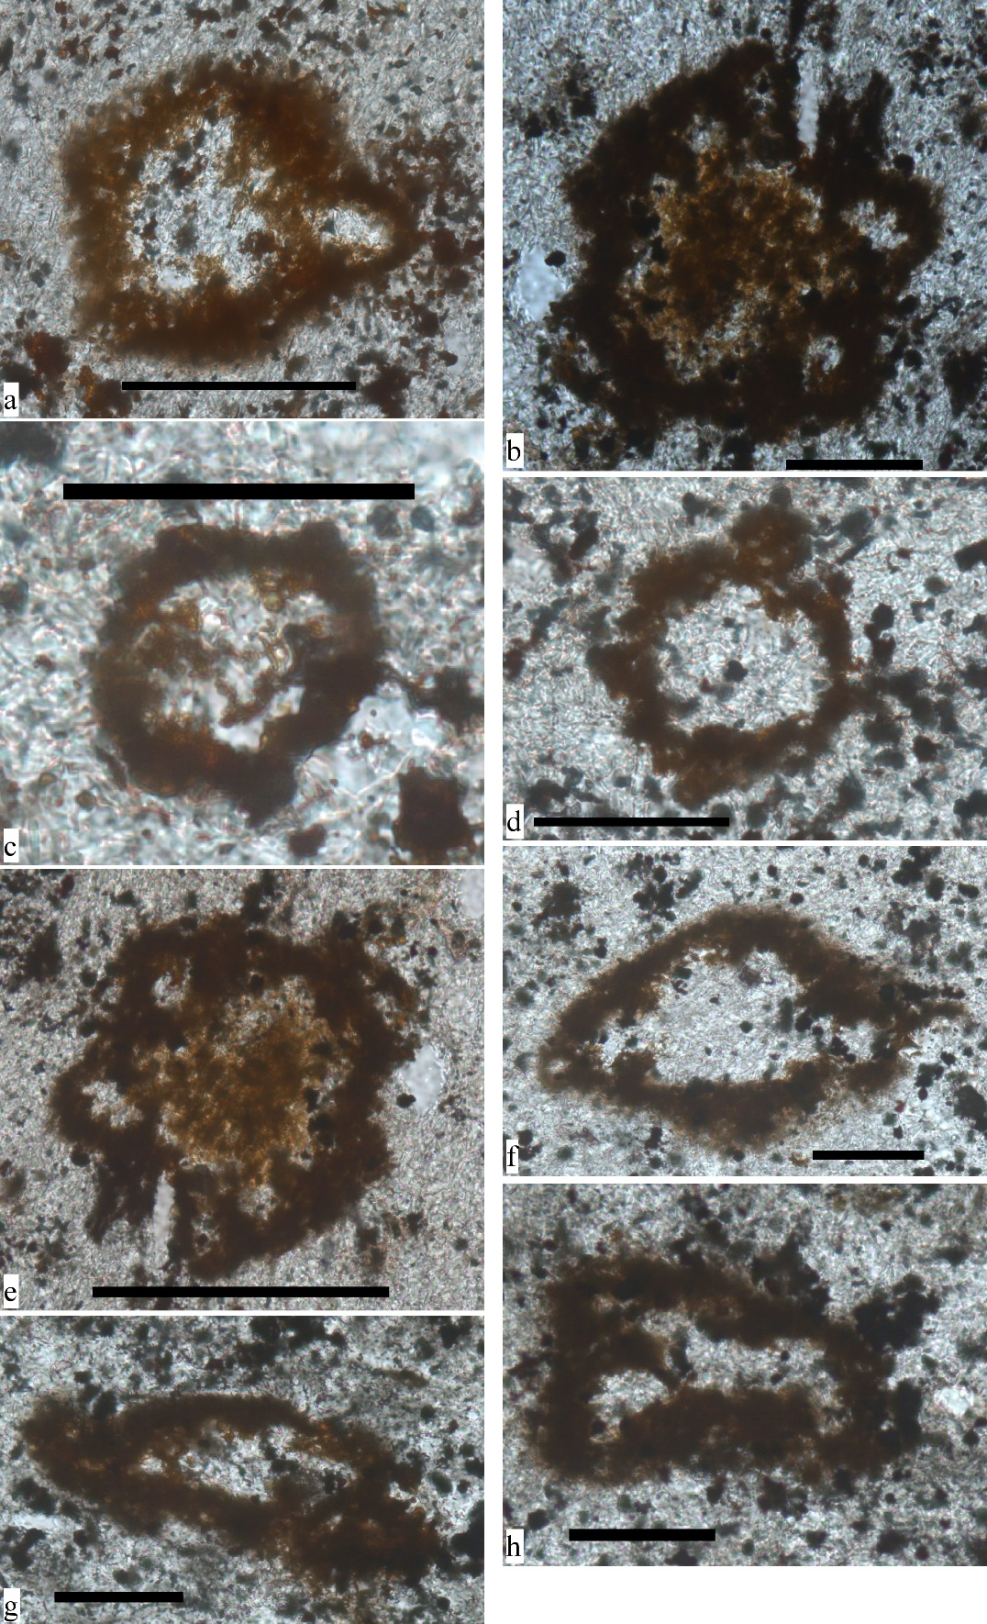
Figure S8. Microphotographs showing examples of microfossils with spheroidal shapes and locally more complex wall structures. The microfossils in f, g and h appear to have been flattened by deformation or may have experienced wall-collapse during deposition. Note that the quartz grains in b and e appear to be integrated in the walls of the microfossils suggesting syn-sedimentary processes. Scale bar is 100 µm in all photos.

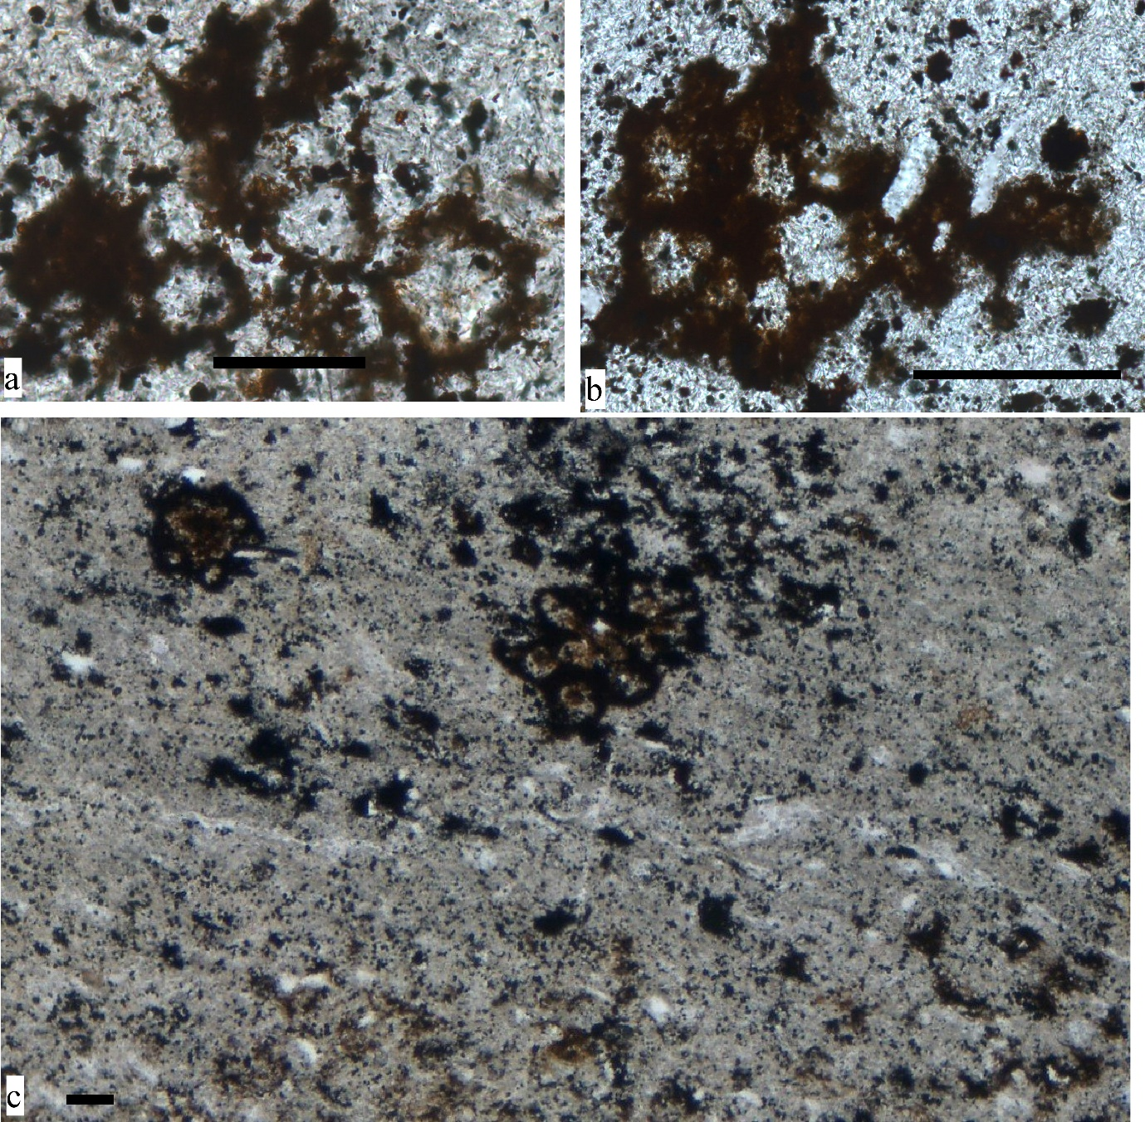
Figure S9. Microphotographs showing examples of clusters of microfossils. Note that the cluster of microfossils in (c) is transected by a quartz vein. Scale bar is 100 µm.

- Supplementary Information 4: Assessment of antiquity and biogenicity criteria

In this section we will assess a series of criteria of antiquity and biogenicity established in the literature (e.g. Wacey, 2009) for ancient microfossil-like structures, and investigate whether the structures we describe from the Upper Nyanzian near Kukuluma Mine meet these criteria or not. By taking this approach we aim to follow an established approach to assess putative microfossils and avoid potential subjective bias. Sections in italics provide possible arguments in support of the listed criterion and include an assessment of whether the criterion is met or not.
The list of antiquity and biogenicity criteria for ancient microfossils is adopted from Wacey (2009) who based his criteria on work by Schopf and Walter (1983), Buick (1990), Westall and Folk, (2003), Brasier et al. (2004, 2005), Hofmann (2004), McLoughlin et al. (2007) and Sugitani et al. (2007).

4.1 General antiquity criteria

(1) Structures must occur in rocks of known provenance; i.e., detailed location information must be presented so that independent re-sampling is possible.
Criterion met; sample is from rock outcrop of known location as shown in figure 1 [main text]. The GPS coordinates of the sample location can be provided by the authors on request from fellow scientists.

(2) Structures must occur in rocks of demonstrable or established age; i.e., the host rock must be dated directly by radiometric techniques, or the age of the rocks can be accurately inferred by correlation to nearby rocks that have been dated.
Criterion met; Rocks hosting the structures are securely dated at a time between 2700-2730 Ma; see “Supplementary Information 1: Geological Setting” and Supplementary Information 2: “U-Pb dating of intercalated volcaniclastics” for details.

(3) Structures must be indigenous to the primary fabric of the host rock; i.e., they must be physically embedded within the rock, not products of sample collection or preparation. They should, therefore, be present in petrographic thin sections of the rock. Other identification techniques such as acid maceration and acid etching are valuable accessory techniques but may accidentally incorporate post-depositional contaminants.
Criterion met; specimens can be identified in petrographic sections; occur along bedding planes; are filled with the same material as the matrix in which they are embedded; have been metamorphosed together with the matrix; are cut by healed microfractures; some specimen show evidence of soft rock deformation and/or compaction by diagenesis and metamorphism. .

(4) Structures must be syngenetic with the primary fabric of the host rock; i.e., they must not have been introduced by ancient or modern post-depositional fluids.
Criterion met: (a) specimens are found along carbon-rich lamellae that occur in the primary sedimentary layers within the rock; (b) the fossils are filled with the same material as the matrix in which they are embedded; (c) the fossils have been metamorphosed together with the matrix; (d) the fossils are not associated with veins or fluid alteration fronts. In addition, (e) some specimen show evidence of soft rock deformation and/or compaction by diagenesis and metamorphism.

(5) Following from 4; any structures found within meta-stable mineral phases, void filling cements, veins, or cross-cutting fabrics must be viewed with extreme caution.
Criterion met; structures are large and form an integral part of the sedimentary layering, and are fully enclosed by grains of detrital origin. Some specimen show evidence of soft rock deformation and/or compaction by diagenesis and metamorphism.

(6) Structures should not occur in high-grade metamorphic rocks, because delicate organic structures will not survive these extremes of pressure and/or temperature; the likelihood of non-biological artefacts in such rocks is substantially increased.
Criterion met; Raman spectrometry on the carbon structure indicates that the maximum temperature experienced by the rock did not exceed ~445 °C; the rocks are weakly strained and they contain no penetrative fabric, or display other evidence of significant flattening/compaction.

(7) The geological context of the host rock must be fully understood at a range of scales; i.e., the host unit must show geographical extent and fit logically within the regional geological history.
Criterion met; see “Supplementary Information: Geological setting”.

4.2 Additional antiquity criteria specific to microfossils

(8) Potential microfossils should not be significantly different in colour from that of particulate carbonaceous material in the remainder of the rock matrix. For example, brown ‘microfossils’ in a largely black carbonaceous chert would immediately be suspicious.
Criterion met; specimens are identical in appearance and colour to non-structured carbon fragments within the sample.

(9) There should be evidence for organo-sedimentary interaction, e.g., sediment grains trapped or supported by fossils, coatings of distinctive composition or texture precipitated around the fossils, or perhaps alternating layers of prostrate and erect filaments in stromatolite-like sediments.
Criterion met; specimens: occur along carbon-rich lamellae that occur in the primary sedimentary layers within the rock; are filled with the same material as the matrix in which they are embedded; consist of the same material as carbonaceous fragments embedded in the matrix, with which they have been metamorphosed together.

4.3 General biogenicity criteria

(10) Structures should exhibit a biological morphology that can be related to extant cells, sheaths, traces of activity or waste products. Ideally life cycle variants should be identifiable (reproductive stages), comparable to that found in morphologically similar modern or fossil microorganisms.
Criterion met; specimen structures show complex wall structures with carbonaceous membranes, connecting tubes and external exit ways reminiscent of modern microorganisms like radiolaria and/or foraminifera. Specimens vary in size and complexity of external geometry and internal structure, which may reflect more than one organism, or different developmental stages within the same organism.

(11) More than a single step of biology-like processing should be evident. These steps may take the form of biominerals (e.g., pyrite), geochemical fractionations of isotopes (e.g., carbon and sulphur), specific organic compounds (e.g., hopanoid biomarkers) or distinctive elemental ratios.
Criterion met; Carbonaceous structures are characterised by: strongly negative δ¹³C values ranging from -38.5‰ to -48.4‰; unstructured carbon as shown by Raman spectroscopy; concentration of P, Ca, and transition metals including Zn, Cu and Fe within the double-wall structures.

(12) Structures should occur within a geological context that is plausible for life; i.e., at temperatures and pressures that extant organisms are known to survive.
Criterion met; specimens occur in carbon-rich sediments deposited in a shallow-water, marine environment, relatively close to a paleo-shore line and within a volcanically active region with known hot-spring activity. (Sanislav et al., 2018).

(13) Structures should fit within a plausible evolutionary context.
Criterion met; simple organisms are known to exist in the Neo-Archaean, even though the size of such lifeforms is generally very much smaller and far less complex than the organism presented herein. The structures presented here could represent a eukaryotic life form new to the Archaean (see “Supplementary Information 6: Assessment of eukaryotic nature of putative fossils”; Eme et al., 2014; Butterfield, 2015).

(14) Structures should be abundant and ideally occur in a multi-component assemblage.
Criterion met; numerous specimens occur along specific sedimentary horizons.

(15) Following from 14, ideally they should show colonial/community behaviour.
Criterion met; specimens occur as single individuals and as groups of two or more spheroids forming complex, grape-bunch-like or floral arrangements.

(16) Following from 15, a preferred orientation indicating a role in the formation of biofabrics would be an additional bonus criterion.
Criterion met; the structures are concentrated along certain horizons within the sediments, but their shape is broadly equidimensional with no preferred body orientation. However, the structures show evidence of regular internal geometries with pentagonal and hexagonal shapes, and star-like arrangements (in cross section) of regularly spaced tubes connecting the inner chamber with the outside.

4.4 Additional biogenicity criteria specific to microfossils

(17) Microfossils should ideally be composed of kerogenous carbon. However, if mineralised this should be a result of microbially mediated precipitation. Later mineral replacement of carbonaceous material may also be permissible, but then doubts upon antiquity will be raised.
Criterion met; specimens preserve significant amounts of unstructured carbon as determined by Raman Spectroscopy

(18) Microfossils should be largely hollow. Cell walls and sheaths are by far the most likely parts of the microbe to be preserved; cellular constituents are rarely preserved in more modern examples. Mineral artefacts are unlikely to be hollow.
Criterion met; Specimens preserve: complex internal structures as imaged by Raman Spectroscopy and 3D synchrotron imaging; internal chambers connected to the outside and infilled with the same sedimentary material that forms the matrix to the fossils.

(19) Ideally the microfossils should show some sort of cellular elaboration; e.g., not just smooth cell walls.
Criterion met; the microfossils display complex internal structures with regular geometries and architectural components that repeat themselves from one structure to the next as illustrated in Figures 2,3, 4 and the supplementary information.

(20) Microfossils should show taphonomic degradation; i.e., collapse of cells, folding of films, fracturing. This may not occur in exceptional preservational circumstances, for example, in situ rapid silicification of living communities.
Criterion met; some specimens display evidence of degradation. Such specimens occur next to intact microfossils suggesting that degradation occurred prior to burial and compaction.

(21) The object must exceed the minimum size for independently viable cells (~0.25 μm diameter). Note: The recent discovery of nano-bacteria may modify this criterion to even smaller sizes.
Criterion met; individual special specimens attain sizes of up to 540 μm in diameter. Agglomerates of spheres can be significantly larger than that.

(22) Microfossils should be demonstrably dissimilar from potentially co-existing non-biological organic bodies (e.g., self-organising spherulitic structures), and should occupy a restricted biological morphospace.
Criterion met; structures occur: along carbonaceous lamellae within the sedimentary layering; display well-defined shapes with architectural components that are shared (with variations) between different structures; they are distinctly different from known non-biological features in similar environments such as coliform Fe-Mn aggregates or diagenetic pyrite clusters. Reference?

(23) Evidence of extra-cellular polymeric substances surrounding the putative microfossils would be an added bonus criterion.
Criterion potentially met; specimens occur along thin horizons rich in organic material which is similar in isotopic and chemical composition to the putative fossils, and may therefore have originated from the fossils.

The complex microstructures described from the Upper Nyanzian rocks near Kukuluma Mine, meet all antiquity and biogenicity criteria compiled by Wacey’s (2009), with no definitive exceptions. This provides strong support for an interpretation of these carbonaceous structures as microfossils.

- Supplementary Information 5: Size distribution
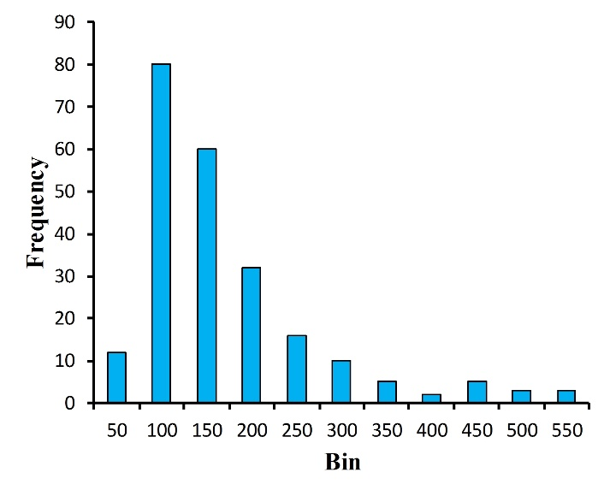
Figure S10. Diagram showing the size distribution of the microfossils.

- Supplementary Information 6: Raman geothermometry for carbonaceous material
Maximum metamorphic temperature conditions attained by a sedimentary rock, which contains carbonaceous material originating from a biological source, can be assessed with Raman spectrometry by measuring the relative amount of ordered versus unordered carbon (Beyssac et al., 2002; Rahl et al., 2005). The transformation of the carbon structure from an unordered carbonaceous precursor to an ordered graphite structure is irreversible, and not affected by retrograde metamorphism. The temperature obtained from carbonaceous material is, therefore, the maximum temperature experienced by the rock during its entire history of burial and exhumation.
Raman spectrometry was performed on thin sections of the carbonaceous, Upper Nyanzian sediments from the Kukuluma Terrain, to obtain Raman spectra for ordered and unordered carbon for geothermometry following the methodology described by Beysacc et al., (2002). Spectra were recorded with low laser power to avoid laser-induced modifications of the sampled material. Raman spectra for carbonaceous material show major peaks or bands at ~1350 cm⁻¹ (D1) and ~1580 cm⁻¹ (G) with a less pronounced band at ~1250 cm⁻¹ (D4), which shows on the shoulder of the D1 area, a wide peak at ~1510 cm⁻¹ (D3) and a further minor peak at ~1620 cm⁻¹ (D2) as a shoulder on G (Beyssac et al., 2002; Rahl et al., 2005).
The G peak represents well-ordered graphite and increases in size and width as a function of the maximum temperature attained by the sample. The D1, D2, D3 and D4 peaks all represent unordered carbon and are more pronounced with increased disorder in the carbon structure (Beyssac et al., 2002; Rahl et al., 2005), with the D1 peak area being the most conspicuous.
The Raman spectra obtained for carbonaceous material from the matrix and the microfossils are shown in Supplementary Fig. S11. For temperatures above 330°C, Beyssac et al. (2002) proposed that there exists a linear correlation between the band area ratio R2 = D1 / (D1 + G + D2) and the temperature T (°C), described by the equation T = - 445*R2 + 641, which can be used as a geothermometer. The area under the specific peaks has been determined at full width half maximum (FWHM), using PeakFit v4.12 with a Voigt function. The R2 ratios of the band areas measured for 16 samples of carbonaceous matrix material surrounding the microfossils range from 0.37 to 0.56 corresponding to an average maximum temperature of ~439 ± 25 °C. R2 ratios for 9 analyses on microfossils also range from 0.37 to 0.56 and return an average maximum temperature of ~441 ± 30 °C (Supplementary table S2). If outliers are removed, this reduces to ~441 ± 15 °C and ~445 ± 21 °C for matrix material and microfossils respectively.
The results indicate that the microfossils experienced a maximum metamorphic temperature of ~440 °C, which corresponds to lower greenschist facies conditions. There is no significant difference in the temperature values obtained from matrix material compared to the microfossil walls (Supplementary table S2), indicating that all carbonaceous material in the samples predates metamorphism and experienced similar conditions after deposition.

Analyses | D1 | G | D2 | R2 | T (°C)
Cmx | 126000 | 149000 | 0 | 0.46 | 437
Cmx | 234000 | 298000 |  | 0.44 | 445
Cmx | 87052 | 108000 |  | 0.45 | 442
Cmx | 158000 | 187000 |  | 0.46 | 437
Cmx | 69602 | 92830 |  | 0.43 | 450
Cmx | 68032 | 85068 |  | 0.44 | 443
Cmx | 11362 | 14873 |  | 0.43 | 448
Cmx | 2551 | 1916 | 1136 | 0.46 | 438
Cmx | 28455 | 1064 | 20978 | 0.56 | 390
Cmx | 49219 | 60476 |  | 0.45 | 441
Cmx | 185000 | 315700 |  | 0.37 | 477
Cmx | 235000 | 286000 |  | 0.45 | 440
Cmx | 122000 | 196000 |  | 0.38 | 470
Cmx | 7989 | 12491 |  | 0.39 | 467
Cmx | 6610 | 5353 |  | 0.55 | 395
Cmx | 8546 | 7205 |  | 0.54 | 400
Cm | 5682 | 7558 | 1391 | 0.39 | 468
Cm | 2750 | 3319 |  | 0.45 | 439
Cm | 9782 | 4754 | 3437 | 0.54 | 399
Cm | 350000 | 506000 |  | 0.41 | 459
Cm | 41682 | 62740 |  | 0.40 | 463
Cm | 41430 | 65966 | 3108 | 0.37 | 474
Cm | 62250 | 74611 |  | 0.45 | 439
Cm | 73807 | 92576 |  | 0.44 | 444
Cm | 57629 | 50877 |  | 0.53 | 405
Cm | 28455 | 1064 | 20978 | 0.56 | 390
Cm | 15977 | 25086 |  | 0.39 | 468

Supplementary table S2. Summary of calculated surface areas under the D1, G and D2 peaks as determined at full width half maximum, the R2 ratio and the calculated temperatures using the geothermometer of Beyssac et al., (2002). Cmx – carbonaceous material from the matrix; Cm – carbonaceous material from the microfossils wall.

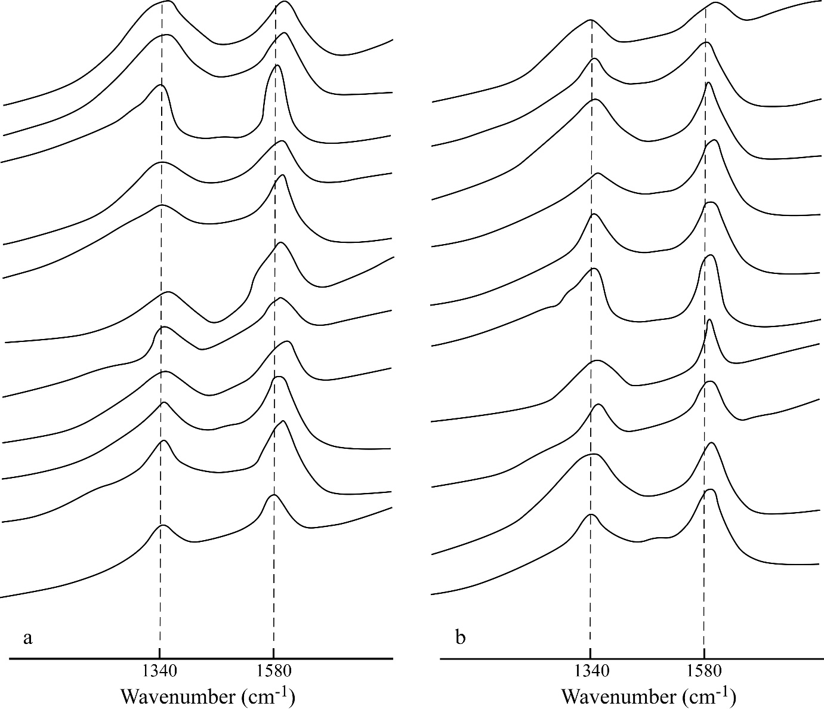
Figure S11. Representative Raman spectra of the carbonaceous material from the matrix (a) and from the microfossil walls (b).

- Supplementary Information 7: Assessment of eukaryotic nature of putative fossils

Fossils for which the morphology is preserved, can be identified as eukaryotic based on features that are thought to be diagnostic. The most compelling examples of Pre-Cambrian cells interpreted as eukaryotic are based on morphological arguments; i.e. through the identification of structural features known to be fashioned by eukaryotic groups, but unknown among bacteria or archaea (Javaux et al, 2003).
In this section we will systematically evaluate a series of criteria that have been used in the literature to determine if ancient microfossil-like structures resemble eukaryotic organisms or not (e.g. Eme et al, 2014; Butterfield, 2015). We will do this to assess whether the structures we describe from the Upper Nyanzian meet these criteria or not. Sections in italics provide possible arguments in support of the listed criterion and include an assessment of whether the criterion has been met or not.
The list of criteria used below has been compiled from benchmarks listed in Javeaux et al. (2003), Knoll et al. (2006), Eme et al. (2014) and Butterfield (2015), who base their criteria on work by Javeaux et al. (2004), Ueno et al. (2006), Cavalier-Smith (2002, 2013), Butterfield, 2009) and Rochette et al. (2014).

  - General criteria to identify Eukaryotes

- Large size (>100 microns); On average, the cells of eukaryotic organisms are substantially larger than those of Bacteria and Archaea.
Criterion met; individual microfossils reach sizes of up to 540 μm in diameter (n=228, median=116 µm, mean=147 µm). Clusters of microfossils can be significantly larger.

- Morphological complexity: a regular and well-defined macroscopic morphology.
Criterion met; microfossils display evidence of regular internal geometries with pentagonal and hexagonal shapes, and star-like arrangements (in cross section) of regularly spaced tubes connecting the inner chamber with the outside; architectural components that are shared (with variations) between different structures; clustered arrangements in the shape of floral (petal-like) structures.

- Morphological complexity: complex wall structure and surface ornamentation, including differentiated layers within cell walls (Javaux et al. 2004).
Criterion met; microfossils display complex wall structures with membranes of kerogenous carbon, draping a core largely composed of heamatite enriched in transition metals. The core displays a complex internal fabric defined by a scaffold-like arrangement of 5 μm - scale grains. Tubes connecting inner chambers to the outside worlds appear symmetrically arranged and provide a form of ornamentation to the microfossils.

- Morphological complexity: processes that extend from vesicle walls.
Criterion not met: no direct evidence for structural extensions away from the cell well were observed; note however that the matrix contains many fragments of organic material with similar composition to the microfossils. These fragments may be elements removed from microfossils.

- Morphological complexity: excystment structures (openings through which cysts liberate their cellular contents).
Criterion met; microfossils display tube-like structures that connect inner chambers to the outside.

- Wall chemistry (Carbon isotope values; transition metal concentrations; P-enrichment etc.).
Criterion met; Carbonaceous wall structures are characterised by: strongly negative δ¹³C values ranging from -38.5‰ to -48.4‰; unstructured carbon as shown by Raman spectroscopy; concentration of P, and transition metals including Zn, Cu and Fe within the dense inner core of the double-wall structures.

- The presence of methanogenic carbon insofar as methanogenesis is limited to a monophyletic Euryarchaeota (Rochette et al. 2014).
Criterion met; Carbonaceous wall structures are characterised by strongly negative δ¹³C values ranging from -38.5‰ to -48.4‰. Such light carbon isotope signatures are characteristic of methanogenesis (e.g. Hinrichs et al., 1999; Orphan et al., 2001).

- The presence of fossil biomarker molecules in the form of steranes.
This is a difficult technique prone to contamination and we have not tested this.

It is generally noted that few of the listed criteria are not definitive when considered in isolation. However, when a range of criteria are fulfilled in a combined manner they will provide a strong argument for interpreting the microfossil-like structures as eukaryotic (Eme et al., 2014; Butterfield, 2015). The microfossils described here meet all the criteria that have been tested for, noting that analyses for biomarkers like steranes are hard to achieve, and have not been attempted. Based on the fact that all morphological and chemical criteria that can be readily assessed are met, we propose that the putative microfossils display the characteristics of eukaryotic lifeforms.

References
Beyssac, O., Goffé, B., Chopin, C. & Rouzaud, J. N., 2002. Raman spectra of carbonaceous material in metasediments: a new geothermometer. Journal of Metamorphic Geology 20, 859–871.
Borg, G., & Krogh, T., 1999. Isotopic age data of single zircons from the Archaean Sukumaland greenstone belt, Tanzania. Journal of African Earth Sciences, 29, 301–312.
Borg, G., 1992. New aspects of the lithostratigraphy and evolution of the siga hills, an archaean granite-greenstone terrain in nw tanzania. Zeitschrift fur Angewandte Geologie 1992, 38, 89-93.
Borg, G.; Lyatuu, D.R.; Rammlmair, D., 1990. Genetic aspects of the geita and jubilee reef archean bif-hosted gold deposits, tanzania. Geologische Rundschau, 79, 355-371.
Borg, G.; Shackleton, R.M., 1997. The tanzania and ne-zaire cratons. Oxford University Press: Oxford.
Brasier, M. D., Green, O. R., and Mcloughlin, N., 2004, Characterization and critical testing of potential microfossils from the early Earth: the Apex ‘microfossil debate’ and its lessons for Mars sample return, International Journal of Astrobiology 3, 1–12.
Brasier, M. D., Green, O. R., Lindsay, J. F., McLoughlin, N., Steele, A., and Stoakes, C., 2005, Critical testing of Earth’s oldest putative fossil assemblage from the ~3.5 Ga Apex Chert, Chinaman Creek, Western Australia, Precambrian Research 140, 55–102.
Buick, R., 1990, Microfossil recognition in Archaean rocks: an appraisal of spheroids and filaments from 3500 M.Y old chert-barite at North Pole, Western Australia, Palaios 5: 441–459.
Butterfield N.J., 2009. Modes of pre-Ediacaran multicellularity. Precambrian Research, 173, 201–211.
Butterfield N.J., 2015. Frontiers in Palaeontology: Early evolution of Eukaryota. Palaeontology, Vol. 58, Part 1, 2015, pp. 5–17. doi: 10.1111/pala.12139.
Cavalier-Smith, T. 2002. The phagotrophic origin of eukaryotes and phylogenetic classification of Protozoa. International Journal of Systematic & Evolutionary Microbiology, 52, 297–354.
Cavalier-Smith, T., 2013. Early evolution of eukaryote feeding modes, cell structural diversity, and classification of the protozoan phyla Loukozoa, Sulcozoa, and Choanozoa. European Journal of Protistology, 49, 115–178.
Cook, Y.A.; Sanislav, I.V.; Hammerli, J.; Blenkinsop, T.G.; Dirks, P.H.G.M., 2016. A primitive mantle source for the neoarchean mafic rocks from the tanzania craton. Geoscience Frontiers, 7, 911-926.
Eme, L., Sharpe, S. C., Brown, M. W. and Roger, A. J. 2014. On the age of eukaryotes: evaluating evidence from fossils and molecular clocks. Cold Spring Harbor Perspectives in Biology. doi: 10.1101/cshperspect.a016139.
Gabert, G. Lithostratigraphic and tectonic setting of gold mineralization in the archean cratons of tanzania and uganda, east africa. Precambrian Research 1990, 46, 59-69.
Hofmann, A.; Dirks, P.H.G.M.; Jelsma, H.A., 2001. Late archaean foreland basin deposits, belingwe greenstone belt, zimbabwe. Sedimentary Geology, 141-142, 131-168.
Hofmann, H. J., 2004, Archean microfossils and abiomorphs, Astrobiology 4: 135–136.
Javaux, E. J., Knoll, A. H. and Walter, M. 2003. Recognizing and interpreting the fossils of early eukaryotes. Origins of Life & Evolution of the Biosphere, 33, 75–94.
Javaux, E. J., Knoll, A. H. and Walter, M., 2004. TEM evidence for eukaryotic diversity in mid-Proterozoic oceans. Geobiology, 2, 121–132.
Kabete, J.M.; Groves, D.I.; McNaughton, N.J.; Mruma, A.H. 2012a. A new tectonic and temporal framework for the tanzanian shield: Implications for gold metallogeny and undiscovered endowment. Ore Geology Reviews, 48, 88-124.
Kabete, J.M.; McNaughton, N.J.; Groves, D.I.; Mruma, A.H., 2012b. Reconnaissance shrimp U–Pb zircon geochronology of the tanzania craton: Evidence for neoarchean granitoid–greenstone belts in the central tanzania region and the southern east african orogen. Precambrian Research, 216-219, 232-266.
Knoll, A. H., Javaux, E., Hewitt, D. and Cohen, P. 2006. Eukaryotic organisms in Proterozoic oceans. Philosophical Transactions of the Royal Society B: Biological Sciences, 361, 1023–1038.
Kuehn, S.; Ogola, J.; Sango, P., 1990. Regional setting and nature of gold mineralization in tanzania and southwest kenya. Precambrian Research, 46, 71-82.
Kwelwa S.D., Sanislav, I.V., Dirks, P.H.G.M., Blenkinsop T.G., Kolling, S. L., 2018. Zircon U-Pb ages and Hf isotope data from the Kukuluma Terrain of the Geita Greenstone Belt, Tanzania Craton: implications for stratigraphy, crustal growth and timing of gold mineralization. Afr. J. Earth Sci., 139, 38-54. doi.org/10.1016/j.jafrearsci.2017.11.
Manya, S. Petrogenesis and emplacement of the TTG and K-rich granites at the buzwagi gold mine, northern tanzania: Implications for the timing of gold mineralization. Lithos 2016, 256-257, 26-40.
Manya, S.; Maboko, M.A.H., 2008. Geochemistry of the neoarchaean mafic volcanic rocks of the geita area, nw tanzania: Implications for stratigraphical relationships in the sukumaland greenstone belt. Journal of African Earth Sciences, 52, 152-160
Marone, F., and Stampanoni, M. 2012. Regridding reconstruction algorithm for real-time tomographic imaging. Journal of Synchrotron Radiation, 19:1029–1037.
McLoughlin, N., Brasier, M. D., Wacey, D., Green, O. R., and Perry, R. S., 2007, On biogenicity criteria for endolithic microborings on early Earth and beyond, Astrobiology 7: 10–26.
Rahl, J. M., Anderson, K. M., Brandon, M. T. & Fassoulas, C. 2005. Raman spectroscopic carbonaceous material thermometry of low-grade metamorphic rocks: Calibration and application to tectonic exhumation in Crete, Greece. Earth Planet Sci Lett 240, 339–354.
Rochette, N. C., Brochier-Armanet, C. and Gouy, M. 2014. Phylogenomic test of the hypotheses for the evolutionary origin of eukaryotes. Molecular Biology and Evolution, 31, 832–845.
Sanislav, I.V.; Blenkinsop, T.G.; Dirks, P.H.G.M., 2018. Archean crustal growth through successive partial melting events in an oceanic plateau-like setting in the tanzania craton. Terra Nova, 0, 1-10.
Sanislav, I.V.; Kolling, S.L.; Brayshaw, M.; Cook, Y.A.; Dirks, P.H.G.M.; Blenkinsop, T.G.; Mturi, M.I.; Ruhega, R., 2015. The geology of the giant nyankanga gold deposit, geita greenstone belt, tanzania. Ore Geology Reviews, 69, 1-16.
Schopf, J. W., and Walter, M. R., 1983, Archean microfossils: new evidence of ancient microbes. In: Schopf, J. W. (Ed.) Earth’s Earliest Biosphere, Its Origin and Evolution, Princeton University Press, Princeton, NJ, pp. 214–239.
Sugitani, K., Grey, K., Allwood, A., Nagaoka, T., Mimura, K., Minami, M., Marshall, C. P., Van Kranendonk, M. J. and Walter, M. R., 2007, Diverse microstructures from Archaean chert from the Mount Goldsworthy-Mount Grant area, Pilbara Craton, Western Australia: microfossils, dubiofossils, or pseudofossils? Precambrian Research 158: 228–262.
Ueno, Y., Yamada, K., Yoshida, N., Maruyama, S. and Isozaki , Y. 2006. Evidence from fluid inclusions for microbial methanogenesis in the early Archaean era. Nature, 440, 516–519.
Wacey, D. 2009. Early Life on Earth. A Practical Guide. Topics in Geobiology 31, (Springer) pp. 274.
Westall, F., and Folk, R. L., 2003, Exogenous carbonaceous microstructures in Early Archaean cherts and BIFs from the Isua Greenstone belt: implications for the search for life in ancient rocks, Precambrian Research 126: 313–330.

