Supplementary Figure 1. The proportion of DLBCL component in FL/DLBCL patients
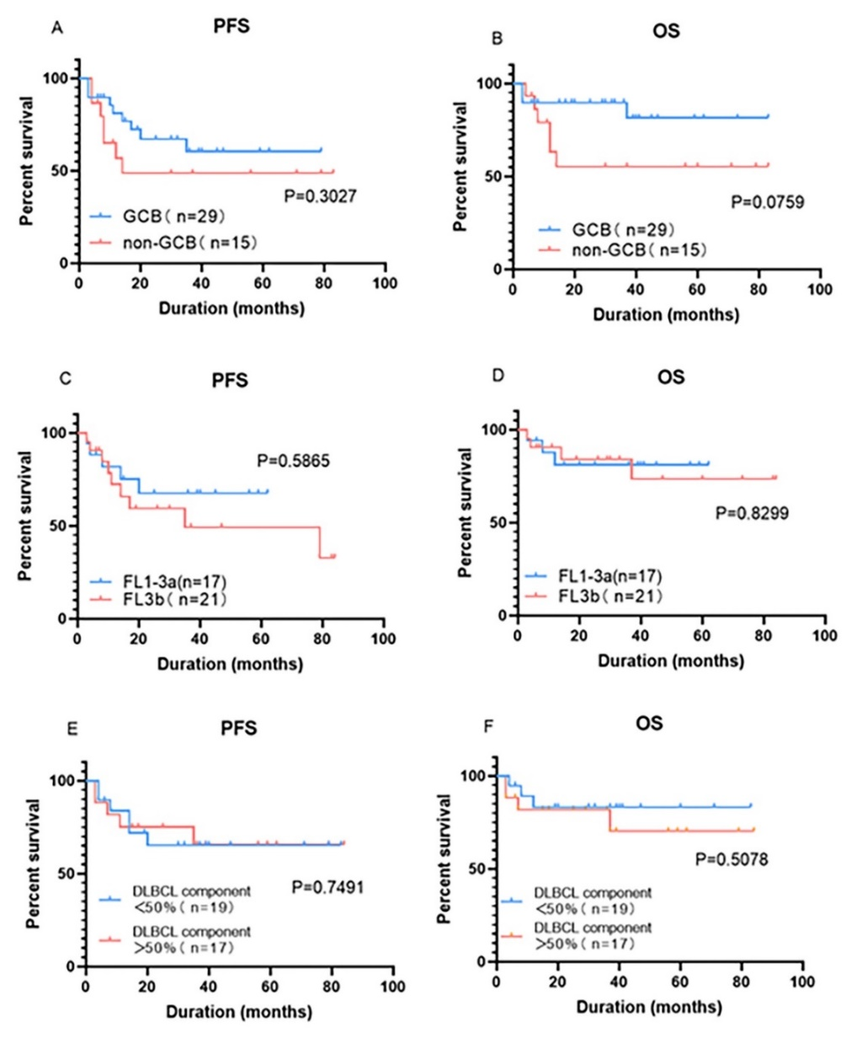
Supplementary Figure 2. Progression free survival (PFS) (A) and overall survival (OS) (B) of patients with germinal center B-cell-like (GCB) follicle lymphoma / diffuse large B-cell lymphoma (FL/DLBCL) and non-GCB FL/DLBCL; PFS (C) and OS (D) of patients with FL1-3a / DLBCL and FL3b/DLBCL; PFS (E) and OS (F) according to the proportion of DLBCL component in FL/DLBCL patients.

