Microbial predation accelerates granulation and modulates microbial community composition
Siew Herng Chan*,^{a,b} Muhammad Hafiz Ismail*,^{a,d} Chuan Hao Tan,^{a,c} Scott A. Rice,^{a,d,e#} and Diane McDougald^{a,e#}

ª Singapore Centre for Environmental Life Sciences Engineering, Nanyang Technological University, Singapore
^{b} Interdisciplinary Graduate School, Nanyang Technological University, Singapore
^{c} School of Materials Science and Engineering, Nanyang Technological University, Singapore
^{d} School of Biological Sciences, Nanyang Technological University, Singapore
^{e} The iThree Institute, University of Technology Sydney, Sydney, Australia
* Both authors contributed equally to this work
Running Head: Acceleration of granulation by microbial predation

#Corresponding author. Mailing address: The iThree Institute, University of Technology Sydney, Sydney, Australia, Building 4, Cnr Thomas and Harris Street, Ultimo NSW 2007. Email: Diane.McDougald@uts.edu.au
Singapore Centre for Environmental Life Sciences Engineering, Nanyang Technological University, Singapore, 60 Nanyang Drive, Singapore 637551. Email: rscott@ntu.edu.sg

Supplementary information
Table S1: PERMANOVA of factors on DNA based microbial community changes
 | Df | SumsOfSqs | MeanSqs | F. Model | r² | Pr(>F)
Counts | 1 | 0.09484 | 0.094837 | 33.145 | 0.27176 | 0.001 | ***
Phase | 2 | 0.12363 | 0.061814 | 21.604 | 0.35426 | 0.001 | ***
Reactor | 3 | 0.0132 | 0.0044 | 1.538 | 0.03782 | 0.184
Residuals | 41 | 0.11731 | 0.002861 |  | 0.33616
Total | 47 | 0.34898 |  |  | 1
Signif. codes: 0 ‘***’ 0.001 ‘**’ 0.01 ‘*’ 0.05 ‘.’ 0.1 ‘ ’ 1
Permutation: free, Number of permutations: 999
Call: adonis(formula = tgenus.bc2 ~ Counts + phase + reactor, data = samplesFile3, permutations = 999, parallel = 10)

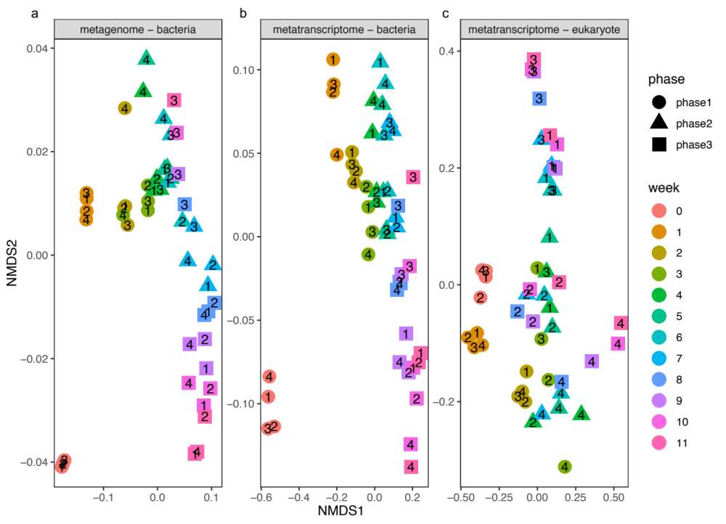
Figure S1: Non-metric multi-dimensional scaling (NMDS) plots for the microbial communities based on total metagenome (a) and total metatranscriptome (b, c) methods for 4 SBRs. The microbial abundance was ordinated using Bray-Curtis dissimilarity.
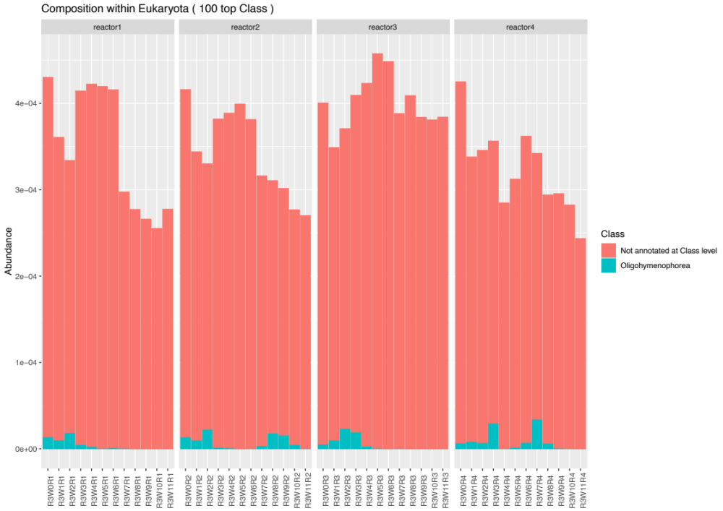
Figure S2: Relative abundance barplots of eukaryotic communities based on total metagenomic methods has a lack of annotation.

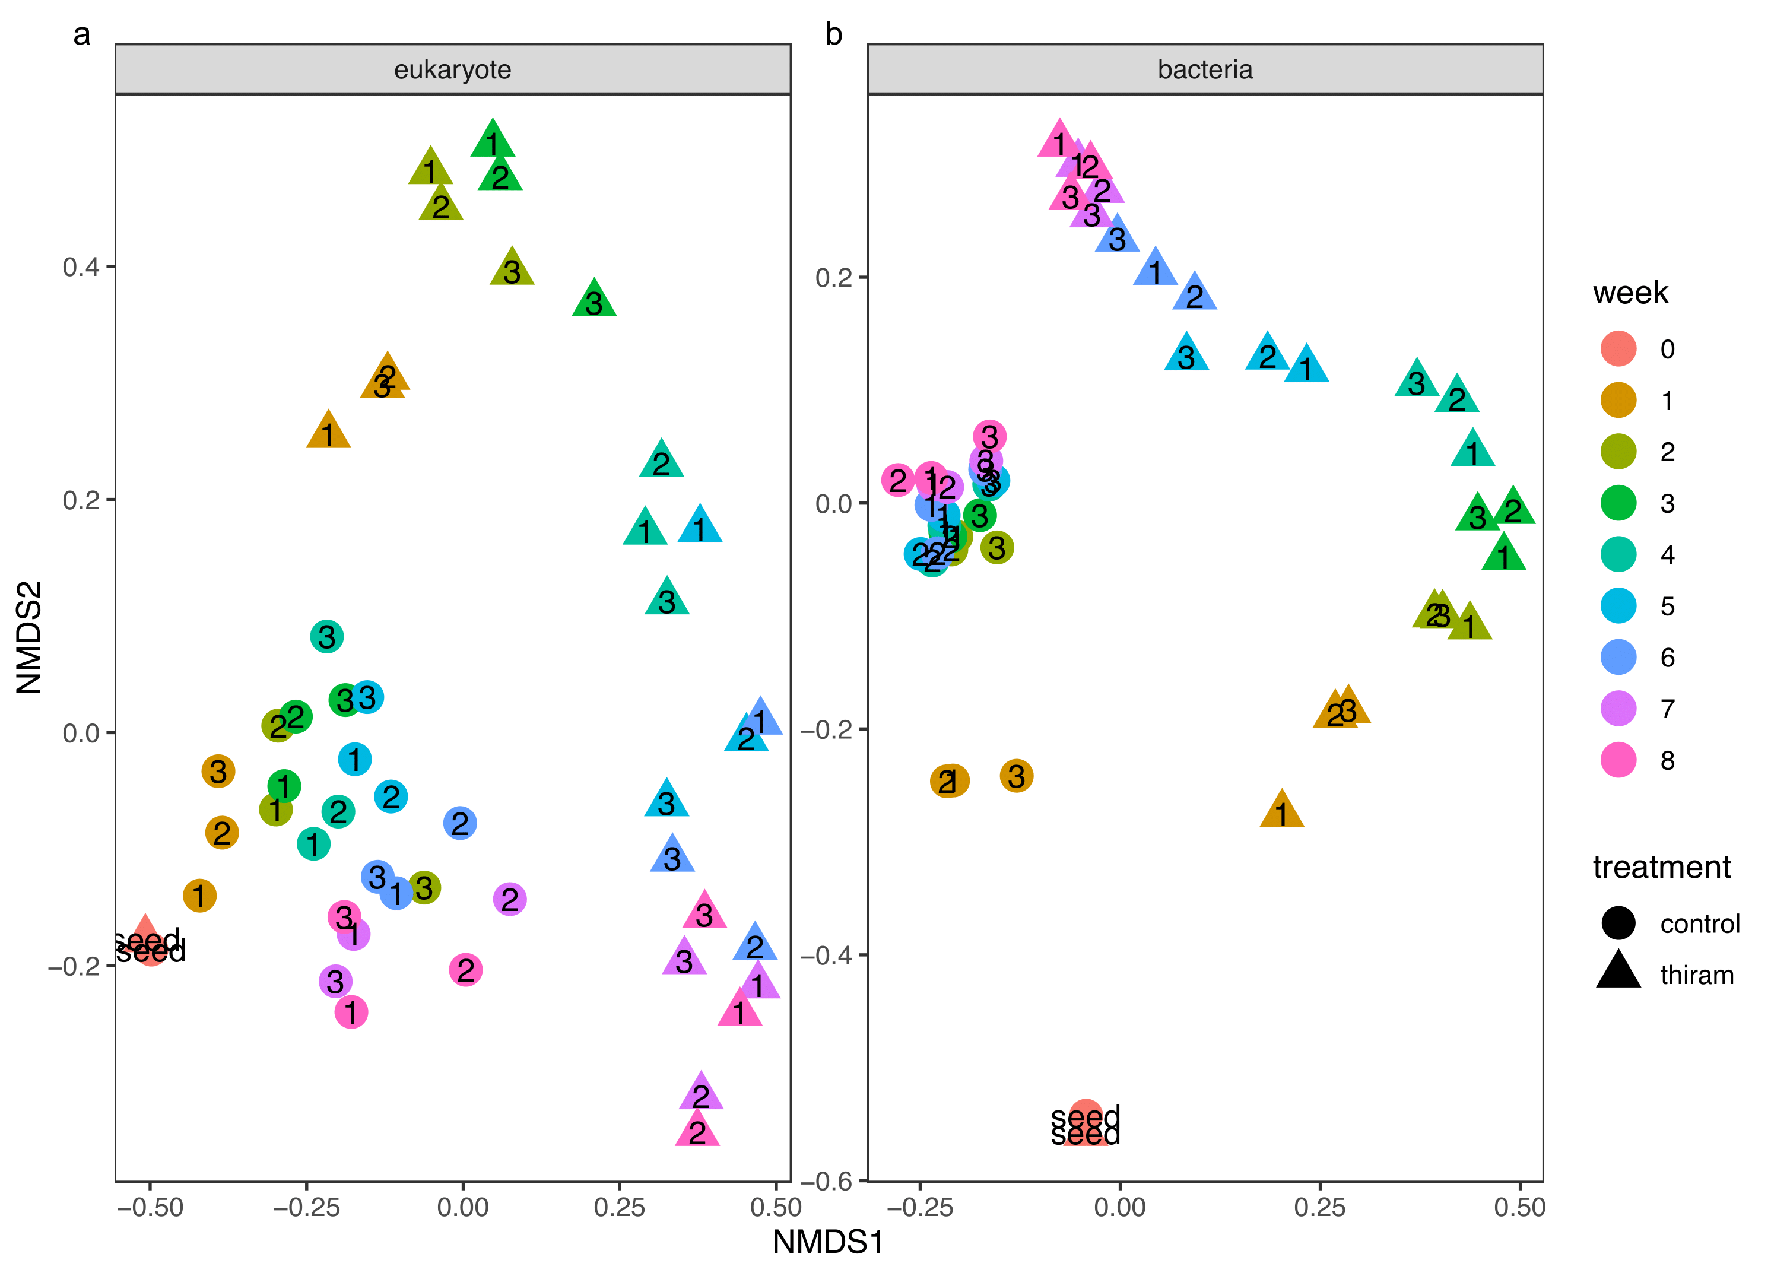
Figure S3: Non-metric multi-dimensional scaling (NMDS) plots for the (a) eukaryotic and (b) bacterial communities based on the total metatranscriptome method for control (●) and thiram-treated (▲) sludge in the mSBRs. The microbial abundance was ordinated using Bray-Curtis dissimilarity.

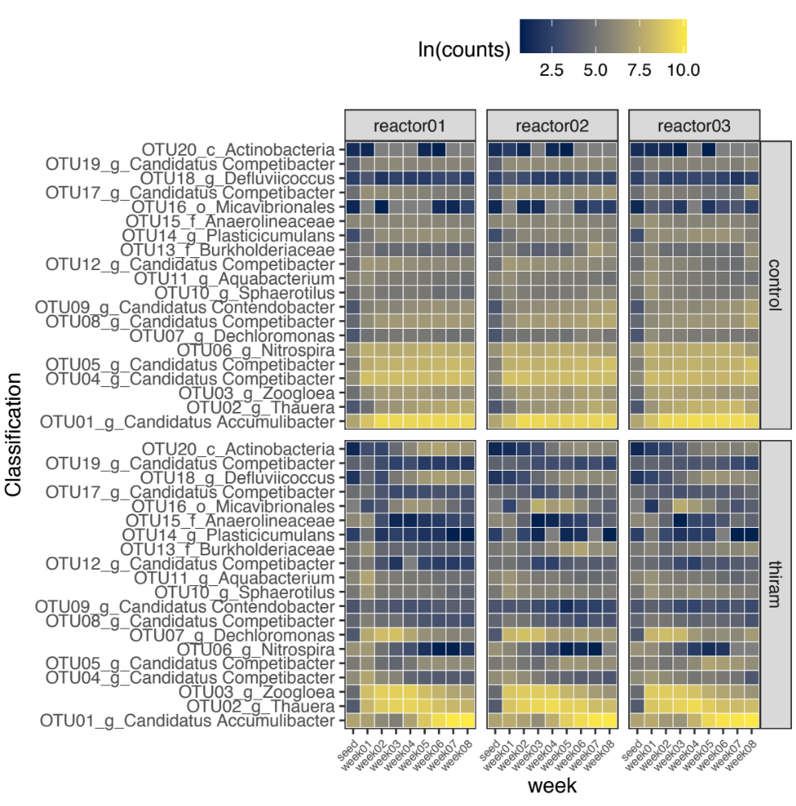
Figure S4: Abundance of microbial populations in the mSBRs over 8 weeks of operation. All reads counts are natural log transformed before analysis.

