Supplementary Material

Light-dependence of Formate (C₁) and Acetate (C₂) Transport and Oxidation in Poplar Trees
Kolby J. Jardine^{1*}, Joseph Lei¹, Suman Som¹, Daisy Souza², Chaevien S. Clendinen³, Hardeep Mehta³, Pubudu Handakumbura³, Markus Bill¹, Robert P. Young², Eoin Brodie¹

1*. Climate and Ecosystem Science Division, Lawrence Berkeley National Laboratory, Berkeley, CA, USA (kjjardine@lbl.gov)
2. Forest Management Laboratory, National Institute for Amazon Research, Manaus, Brazil
3. Environmental Molecular Sciences Laboratory, Pacific Northwest National Laboratory, Richmond, WA, USA

Supplementary Information Content
Supplementary Figure 1: Time series of headspace δ¹³CO₂ in a dynamic poplar branch enclosure during a DXSI experiment using a 10 mM solution of [¹³C]formate.

Supplementary Figure 2: Time series of headspace δ¹³CO₂ in a dynamic poplar branch enclosure during a DXSI experiment using a 10 mM solution of [¹³C]formate which is subsequently switched to a 50 mM solution of [¹³C]formate.

Supplementary Information

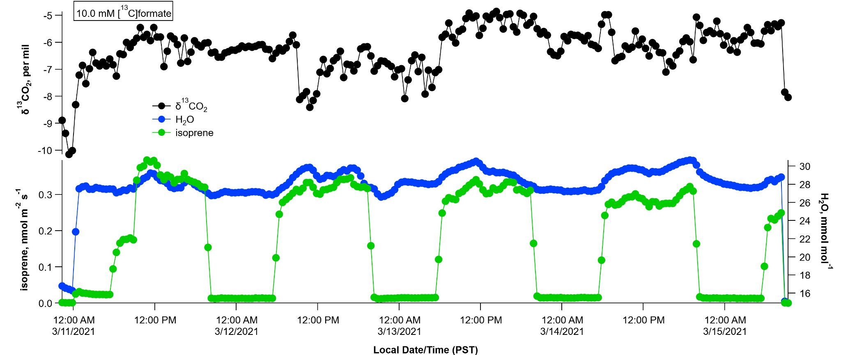
Figure S1: Time series of headspace H₂O water vapor concentrations, isoprene emissions, and headspace with δ¹³CO₂ in a dynamic poplar branch enclosure during a DXSI experiment using a 10 mM solution of [¹³C]formate. The first and last part of the time series is an empty branch chamber.

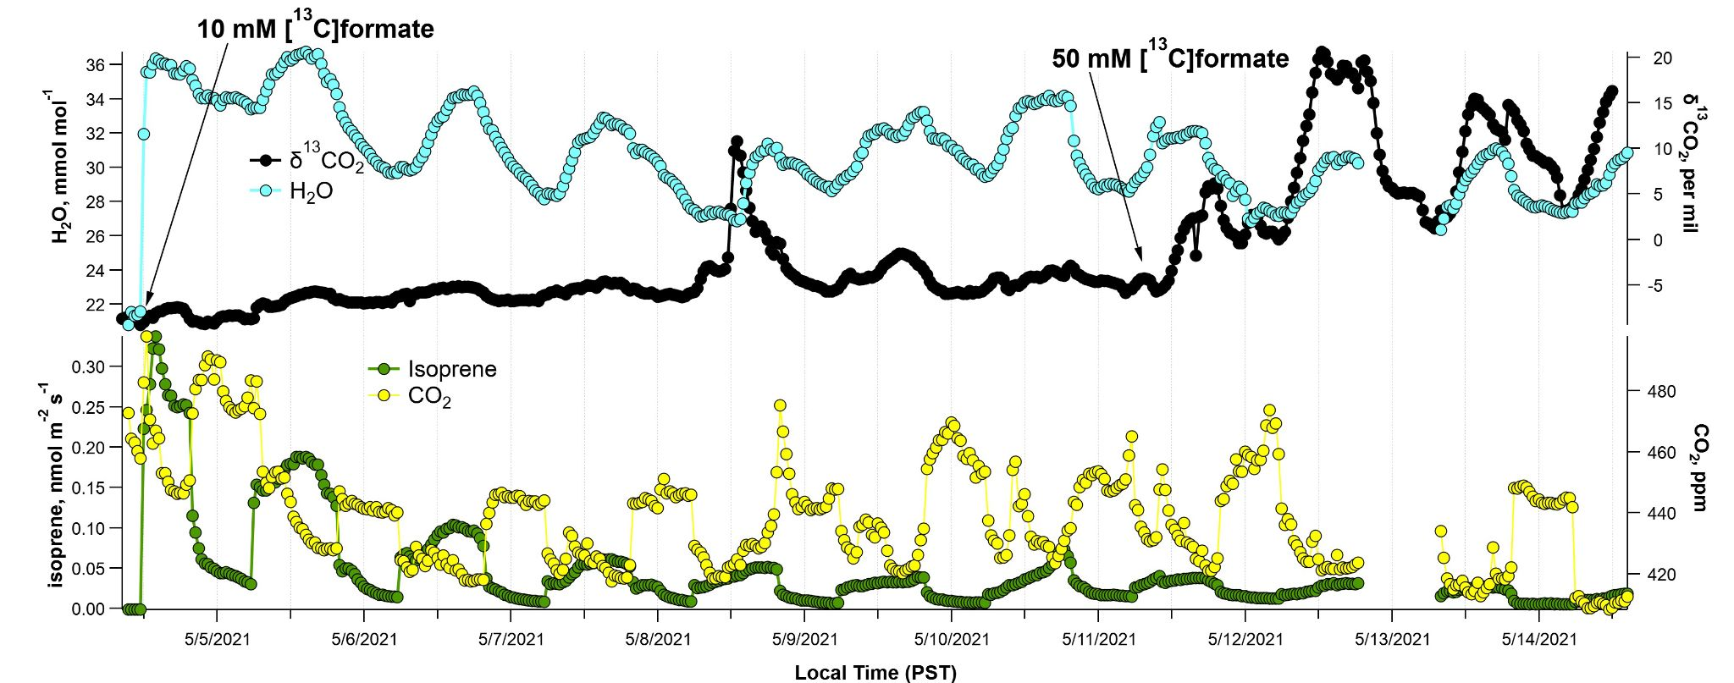
Figure S2: Time series of headspace H₂O water vapor concentrations, isoprene emissions, and headspace with δ¹³CO₂ in a dynamic poplar branch enclosure during a DXSI experiment using a 10 mM solution of [¹³C]formate which is switched to a 50 mM solution of [¹³C]formate (indicated by arrow). The first part of the time series is an empty branch chamber.

