Additional file 1
Inclusion criteria
- Age greater than or equal to 18 years;
- Being hospitalized in one of the intensive care units participating in the study, with a prospect of staying longer than 24 hours;
- Signature of informed consent, which could be done by a family member or carer, if the patient was not aware or with adequate conditions of discernment;
- Patient with clinical suspicion or with microbiological confirmation of infection, sepsis or septic shock;
Infection was defined by the clear expression of the suspicion of an infectious condition by the physicians, associated with the initiation of antimicrobial treatment and following a directed propaedeutic;
Sepsis was defined by the presence of at least one new organ dysfunction associated with infection, characterized by the variation of at least two points in the SOFA (Sequential [Sepsis-related] Organ Failure Assessment);
Septic shock was defined as persistent hypotension requiring vasopressors for maintenance of mean arterial pressure (MAP) greater than 65 mmHg associated with a lactate level greater than 2 mmol / L despite adequate volume resuscitation;
The microbiological confirmation of the infectious condition was defined by the isolation of at least one microorganism considered to be pathogenic, no more than 48 hours before inclusion in the study, and to which the physicians directed an antimicrobial therapy.
Exclusion Criteria
- Use of antibiotics supposedly or proven to be effective against the infectious process in question for more than 48 hours at the time of screening;
- Severely immunosuppressed patients (HIV infection with CD4 + lymphocytes <200 / mm3, severe neutropenia <500 / mL, post-transplantation of solid organ or bone marrow in immunosuppressive therapy, undergoing myelosuppressive chemotherapy in the last 28 days, patients with inflammatory diseases or autoimmune with chronic use of immunosuppressants, including previous use of corticosteroids - prednisone dose or equivalent greater than 10mg / day for ≥ 30 days or 40mg / day for ≥ 10 days - or in pulse therapy). Patients receiving corticosteroids for the treatment of septic shock were not excluded.
- Patients under full and exclusive palliative care;
- Patients with death expectancy for the next 24 hours;
- Patients who at the time of screening present a diagnosis of infections that would be known to require prolonged antibiotic therapy, such as bacteremia by Staphylococcus aureus or Candida spp; confirmed or strongly suspected bacterial endocarditis; chronic osteomyelitis; abscesses not drained;
- Patient with polytrauma in the last five days, due to changes in biomarker kinetics in the period related to trauma insult;
- Patient undergoing major surgery five days previous to the inclusion, due to changes in biomarker kinetics in the postoperative period related to surgical insult, except in cases of surgeries performed to control the infectious focus in question (eg exploratory laparotomy in patients with acute inflammatory abdomen).
Additional file 2
Antibiotic therapy time provided for the control (best practice) group
Infectious type or focus | Estimated time of Antibiotic Therapy
Community-acquired pneumonia | 7 days
Non-VAP hospital pneumonia | 7 days
VAP Pneumonia hospital | 7 days
Pyelonephritis | 7 days
Intra-abdominal infection - drained focus | 5 days
Bacteremia | 7 days
Non-fermenting MO pneumonia | 10 days
Pneumonia by KPC | 10 days
Necrotizing pneumonia ** | 14 days
VAP - mechanical ventilation associated pneumonia; MO - microorganism; KPC - gram negative bacteria producing carbapenemase. * Confirmed or highly suspected etiology due to prior colonization. ** Confirmed by chest computed tomography.

Additional file 3
Sample size calculation
A previous study comparing the duration of antibiotic therapy in septic patients under the guidance of CRP versus PCT revealed that the mean duration of treatment was 7.2 ± 3.5 days for the CRP group and 8.1 ± 3.7 days for the PCT group¹⁹. For the present study, the expected mean for the control group was estimated from the mean observed in the PCT group in the cited study (~ 8 days), and the expected days of treatment in the CRP group was reduced to 6 days, keeping the standard deviations (SDs) found and obtaining an effect size of 0.55 by t-test for independent samples. Thus, we estimated the need for 53 patients per group. Parametric tests were used for sample calculation. However, non-normal distribution of variables and the need to use nonparametric tests for the main statistical analyzes were expected. For this reason, we added a 15% correction totaling the sample size as 122 patients*. This calculation was done with 5% alpha error and 80% power.

* Method described in: Erich L. Lehmann, Nonparametrics: Statistical Methods Based on Ranks, Revised, 1998, ISBN = 9780139977350, pages 76-81.

Additional file 4 –
Definitions of the response variables
The definitions adopted for the response variables were:
Antibiotic use duration was assessed as follows: (1) duration of antimicrobial therapy of the episode index, measured as days of the therapeutic course for the focus that led to inclusion in the study; (2) total days of exposure to antibiotics considering all therapeutic courses during follow-up; (3) antibiotic free days during the follow-up, corrected for 100 days. An antibiotic day exposure was defined as the period of continuous administration of a single drug, with all doses administered at the expected intervals, without interruption for at least 24 hours. A day without antibiotics was defined as the period of at least 24 hours without the administration of antibiotics for a given patient (Oliveira et al., 2013; De Jong et al., 2016). In this study, a therapeutic course of antibiotics consisted of the administration of one or more antibiotics, being of the same or of different classes, but indicated for the same clinical reason, and without interruption for more than 24 hours. Topical administration of antibiotics was not considered in this analysis.
- Rate of therapeutic failure with recurrence of infection (in N recurrent infections per 100 patients). In this study we defined therapeutic failure and recurrence of infection as the persistence or recurrence of signs and symptoms of infection that motivated the resumption of the therapeutic course of antibiotics with less than 48 hours after the initial suspension of the same focus.
- Survival or death were evaluated during intensive care hospitalization and at 28 days of follow-up. Deaths were classified as related or not to sepsis.
- Time of mechanical ventilation, total follow-up time, and intensive care (full days).
- Rate of nosocomial infection (in N of nosocomial infections per 100 patients). Nosocomial infection is defined as infection acquired after the patient's hospitalization, and any clinical manifestation of infection is present after 48 hours after admission, when there is no clinical and / or laboratory evidence of infection at the time of admission (Garner et al., 1988). We documented the nosocomial infections that occurred after inclusion of the patient in the study and the beginning of follow-up of the patient during the follow-up.
- Infection with multiresistant bacteria (in clinical isolates per 100 patients). Multiresistance is defined as any organism that is resistant to at least three classes of antibiotics, without considering the classes to which it would be intrinsically resistant (e.g. MRSA) (Magiorakos et al., 2012). Infection by the multiresistant microorganism is defined by the isolation of the same accompanied by clinical criteria infectious that motivate the direction of the antimicrobial therapy.
- Sepsis-associated mortality: defined by the cause-of-death record made by the clinical assistants.

Additional file 5
Serial measurements of C-reactive protein concentrations in both study groups

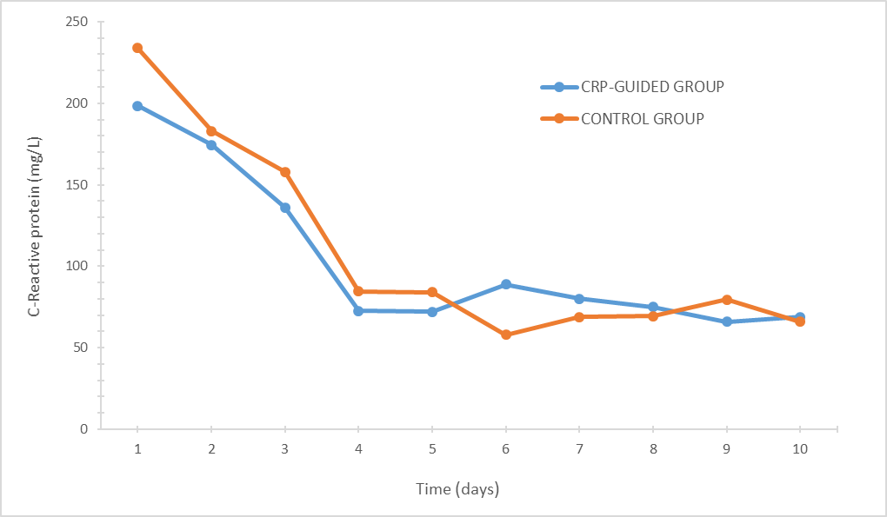

Additional file 6
Days of antibiotic therapy in the index infection episode according to the inclusion group - Intention-to-treat analysis

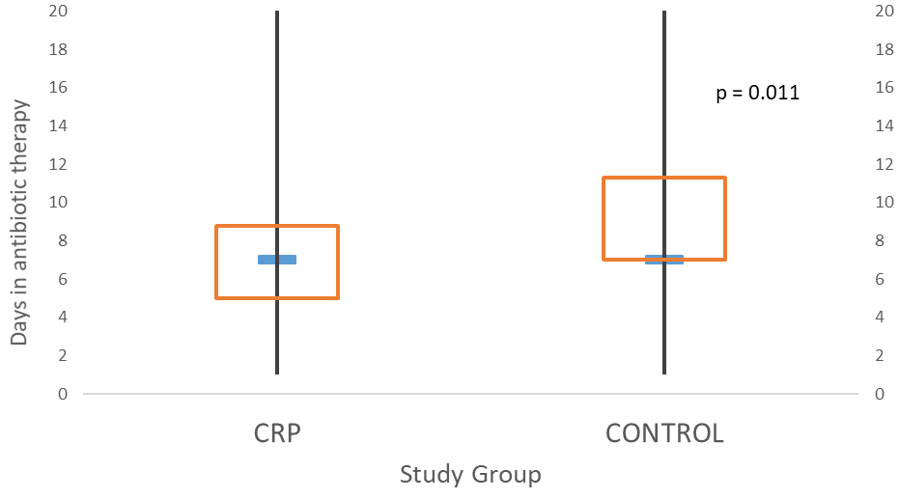
Box plots with median days of treatment, interquartile ranges and 10 and 90 percentiles according to inclusion group.

Additional file 7
Proportion of patients (%) on antibiotics during the first 14 days of follow-up
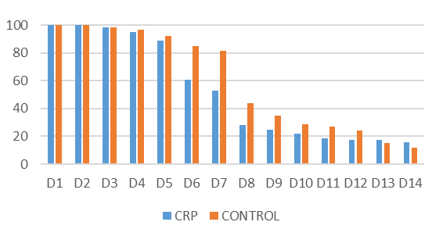

P-value for comparison of frequency between groups by the chi-square test:
Follow-up Day | OR (95% IC) | p value
Day 1 | * | *
Day 2 | * | *
Day 3 | 0.969 (0.059-15.834) | 0.983
Day 4 | 0.635 (0.103-3.934) | 0.623
Day 5 | 0.667 (0.2-2.223) | 0.508
Day 6 | 0.279 (0.12-0.654) | 0.002
Day 7 | 0.252 (0.114-0.558) | < 0.001
Day 8  Day 9  Day 10  Day 11  Day 12  Day 13  Day 14 | 0.499 (0.241-1.036)  0.623 (0.292-1.332)  0.693 (0.312-1.537)  0.615 (0.269-1.410)  0.649 (0.275-1.532)  1.162 (0.456-2.961)  1.343 (0.493-3.653) | 0.061  0.221  0.365  0.249  0.322  0.753  0.563

Additional file 8
Workflow of interventions and outcomes
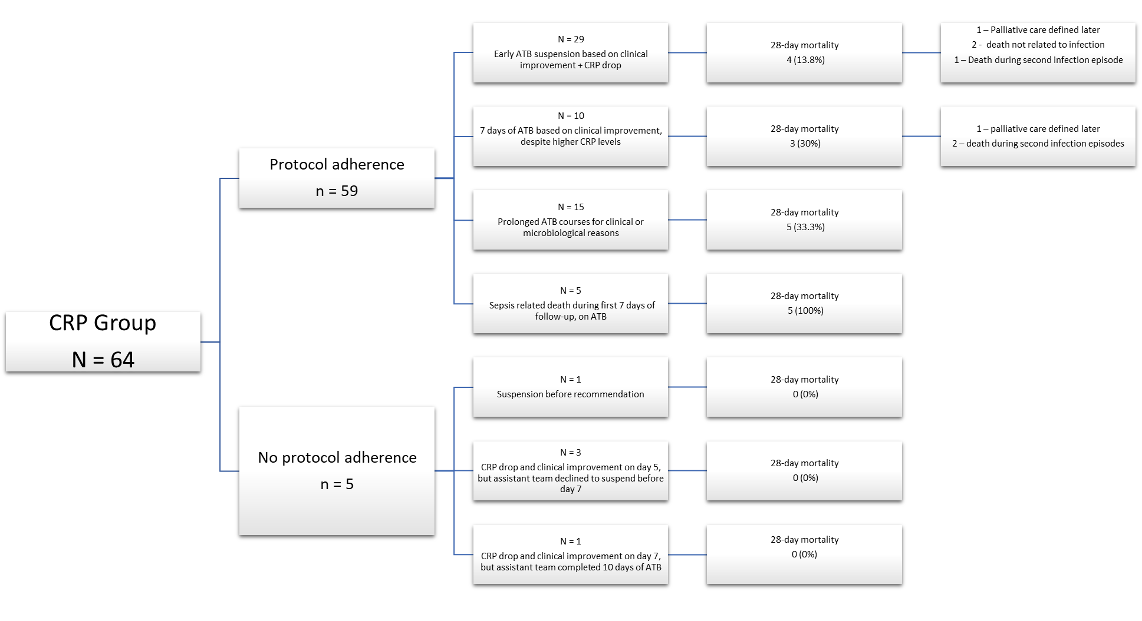
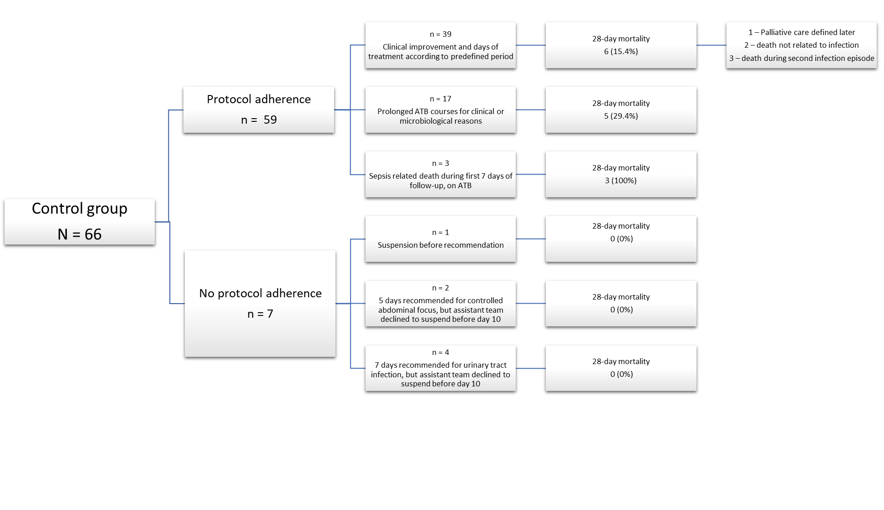

Additional file 9 - Duration of antibiotic therapy for the index infectious episode: analysis per protocol and other subgroups

Subgroups | Overall  (N)  (ATB days, mediam, Q1-Q3)  (ATB days, | CRP Group  (N)  (ATB days, median, Q1-Q3) | Control  (N)  (ATB days, median, Q1-Q3) | P value
Per-protocol  SAPS-3 ≤ 59  Community-acquired infection  Lower respiratory tract infection  Appropriate empirical therapy | 118  7 (5-9)  66  7 (5 – 8)  56  7 (5 – 7)  58  7 (5 – 8)  117  7 (5 – 8) | 59  6 (5 – 8)  30  6 (5 – 7)  25  6 (5 – 7)  27  6 (5 – 7)  58  6 (5 – 7) | 59  7 (7 – 10)  36  7 (7 – 10.5)  31  7 (6 – 8)  31  7 (7 – 8)  59  7 (7 – 9) | 0.011  0.003  0.008  0.032  0.009
ATB, Antibiotic therapy; CRP, C reactive protein; SAPS-3, Simplified Acute Physiology Score 3.

