Supplementary Information for

Human languages trade off efficiency against complexity
Alexander Koplenig, Sascha Wolfer, Peter Meyer
Correspondence to: koplenig@ids-mannheim.de

Contents

S1. Estimating entropy 4
S2. Ansatz functions 7
S3. Corpora 11
S3.1 Data preparation and compression 13
S3.2 Religious texts 15
S3.2.1 BibleNT (parallel) 15
S3.2.2 BibleOT (parallel) 17
S3.2.3 WatchtowerV1 (parallel) 18
S3.2.4 WatchtowerV2 (parallel) 19
S3.2.5 Quran (parallel) 20
S3.3 News/Web/Wikipedia crawls 21
S3.3.1 GlobalVoices (comparable) 21
S3.3.2 LCCnews/ LCCweb/ LCCwiki (comparable) 22
S3.4 Legalese texts 23
S3.4.1 UDHR (parallel) 23
S3.4.2 EUconst (parallel) 24
S3.4.3 Europarl (parallel) 25
S3.4.4 EUmed (parallel) 26
S3.4.5 UNPC (parallel) 28
S3.5 Subtitles 30
S3.5.1 MSub01 – MSub13 (parallel) 30
S3.5.2 TEDt01 – TEDt09 (parallel) 32
S3.6 Other 34
S3.6.1 Ubuntu (comparable) 34
S3.6.2 GoogleT (parallel) 36
S3.6.3 TatoebaV1 (comparable) 38
S3.6.4 TatoebaV2 (comparable) 39
S3.7 Wordlist: Crúbadán 40
S4. Code and data 42
S5. Coverage 47
S6. Correlation matrix 48
S7. Correlations between entropy rates and learning difficulty 49
S8. Relative standard deviations for h and r 51
S9. Evaluating the similarity of complexity rankings 52
S10. Comparing predictability across languages 53
S11. Testing different compression algorithms 54
S12. Differences across populations 56
S13. Individual regressions 65
References 72

Estimating entropy
For illustration purposes, we created a corpus of 2 million (henceforth: M) symbols based on a simple language toy-model that consists of three symbols: A, B and C that have (approximately) the same relative frequency. For the first 1M symbols, the three symbols are just randomly emitted. Thus, there is no contextual structure that the compressor can exploit, so the entropy rate should be log₂(3) ≈ 1.58. For the second 1M symbols, we added contextual structure to the data. The contextual probabilities are given in the inset of Supplementary Figure 1a. For example, if the context is “AA”, the probability that the next symbol is a “B” is 75%. It is easy to see that the entropy rate should be h = -(6/8$·$log₂(6/8) +1/8$·$log₂(1/8) +1/8$·$log₂(1/8)) ≈ 1.06. We then used the PPM algorithm to compress successively larger chunks of the resulting corpus, proceeding in steps of 1,000 symbols and calculated the local compression rate as the number of bits that PPM needs to compress the last 1,000 symbols. Supplementary Figure 1a shows the results. For the first 1M symbols, the local compression rate is on average 1.60 bits per symbol (bps) and therefore very close to the theoretical expectation. After 1M symbols, the compressor adapts very quickly to the injected contextual structure that can be exploited for prediction. Here the local compression rate is on average 1.10 bps, again very closely matching what we expected theoretically.
While h quantifies how difficult it is to predict, b quantifies how difficult it is to learn to predict (Takahira, Tanaka-Ishii & Dębowski 2016). Supplementary Figure 1b illustrates that lower b-values are indicative of slower convergence, i.e. learning is more difficult. By means of an example, Supplementary Figure 1c visualizes the approach outlined above for two series of compression rates. For both series, the chosen chunk size is m = 1,000, i.e. the text is compressed every 1,000 symbols: (i) 1,272,000 consecutive characters of the New Testament of the Christian Bible translated into South Bolivian Quechua (pink circles) and (ii) the same number of flips (heads/tails) of a fair coin (lavender circles). For the coin flips, the source entropy h is equal to H, given as $-\frac{1}{2}\left(\log_{2}{\frac{1}{2}+}\log_{2}{\frac{1}{2}}\right)=1.00$ (see Methods: equation (1) and (2)), so the extrapolated entropy rate comes very close to this value with h = 1.018. For the Bible text, the extrapolated entropy rate is similar (h = 1.015), so, in the limit, the statistical structure of the input can be used to make predictions with similar accuracy. However, the shape of both curves implies that it is easier for the algorithm to understand the structure of the coin flip corpus than the structure of the Bible text. In the former case, the compression rate converges very rapidly to the entropy rate. Correspondingly, r = 1.020 and h = 1.018 are practically equal. In the latter case, convergence is much slower; accordingly, $r = 1.342 ≫h=1.015$, indicating that the algorithm would still need much more input to learn the optimal compression scheme. As expected, the b-value is much higher in the case of the coin flips (b = 1.000) compared to the Bible text (b = 0.318), thus again demonstrating that higher b-values are indicative of faster learning. Visual inspection further reveals that in both cases, the ansatz function (see Methods: equation (6)) fits the data very well; the calculation of the model fit corroborates this impression (see Methods: equation (8)): for the coin flips (blue line), the mean absolute percentage error for the Τ = 128 held out data points amounts to Μ = 0.004%; for the Bible data (mint line), the model fit is also excellent at Μ = 0.042%.

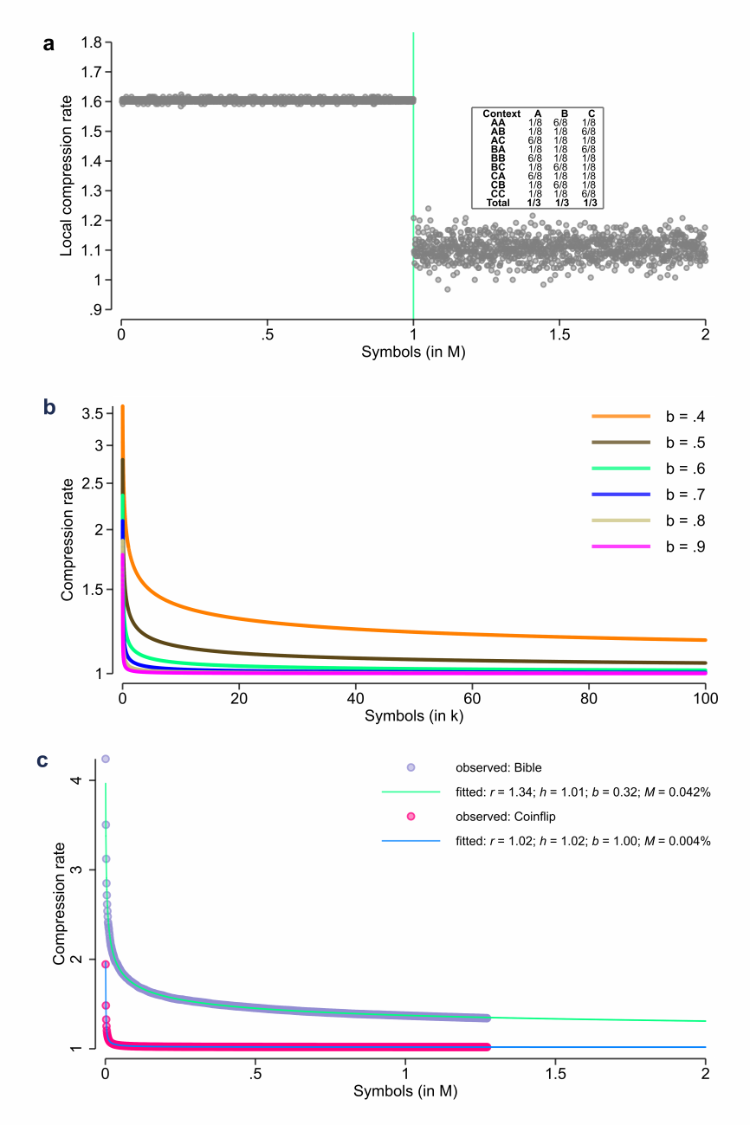
Supplementary Figure 1 | Illustrations of entropy estimation. (a) Local compression rate r_{i} as a function of the number of compressed symbols . The inset shows the contextual structure added for the second 1M symbols. (b)
Compression rate r_{l} as a function of the number of symbols (l) for different values of b. Compression rates are calculated as $r_{l}=exp\left(h'+1.40*{\log{l}}/{l^{b}} \right)$ where $h^{'}=log(1.00)$. As can be seen, higher values of b cause a faster decay indicating that it is less difficult to learn to predict (Takahira, Tanaka-Ishii & Dębowski 2016). (c) Illustration of the used modelling approach for two strings.

Ansatz functions
Since, as written above, the (probabilistic) relationship between (the convergence of) h and L is unknown, we tested several ansatzes that have been discussed in the literature (Schürmann & Grassberger 1996; Ebeling & Nicolis 1991; Takahira, Tanaka-Ishii & Dębowski 2016; Moscoso del Prado Martín, 2011) as summarized in Supplementary Table 1.
Each ansatz was fitted both with least-squares, i.e. by minimizing the sum of $ό_{l}^{2}={\left(r_{l}-\hat{r_{l}}\right)}^{2}$, and with log least-squares, i.e. by minimizing the sum of $ό_{l}^{2}={\left(\log{r_{l}}-\log{\hat{r_{l}}}\right)}^{2}= {\left[log⁡({r_{l}}/{\hat{r_{l}}})\right]}^{2}$.
To evaluate the performance of the different ansatzes with regard to our project, we used several criteria:
- The model fit, i.e. the prediction accuracy error between the held-out observed compression rates and the predicted ones (cf. Methods: equations (8)).
- The number of iterations that are needed for convergence, with the maximum number of possible iterations set to 100.
- The convergence rate, i.e. how many times (in %) convergence was achieved.
- The Spearman correlation between the extrapolated entropy rate h and the unigram entropy H (cf. Methods: equations (1)).
- The Spearman correlation between the extrapolated entropy rate h and the compression rate r at $Τ$.
- The lower quartile (25th percentile) for h.
Those criteria were tested for the following four corpora (cf. section S3):
- BibleOT (all five rounds, cf. section S3.2.2)
- Europarl
- UDHR
- Watchtower (Version 1)
Supplementary Table 2 summarizes the results. Criterion (i) shows that all three ansatzes have excellent model fits with an average accuracy ratio below 1% for all corpora but one. In general, using log least-squares turns out to be preferable compared to least-squares for all three ansatzes. In most cases, a2 has the best accuracy ratio followed by a3. Since our aim is to fit a lot of different texts with widely varying characteristics (especially in terms of text length) on both the level of characters and the level of words, convergence properties are highly relevant.

Supplementary Table 1 | Tested ansatzes. a3 is our own synthesis of a1 and a2.
Ansatz | Form | Fitted form | Source
a1 | $r_{l}=h+A*{\log{l}}/{l^{b}}$,  $h>0$, $A>0$, $b>0$ | $$r_{l}=exp⁡(h^{'})+exp⁡(A^{'}){*\log{l}}/{l^{exp⁡(b^{'})}}+ό_{l}$$ | (Schürmann & Grassberger 1996; Eq. 28)
a2 | $r_{l}=exp⁡(h^{*}+A*1/{l^{b}})$,  $A>0$, $b>0$, $h$=$exp⁡(h^{*})$ | $$r_{l}=exp\left(h^{*}+exp⁡(A^{'})*1/{l^{exp⁡(b^{'})}}\right)+ό_{l}$$ | (Takahira, Tanaka-Ishii & Dębowski 2016; Eq. 8)
a3 | $r_{l}=exp⁡(h^{*}+A*{\log{l}}/{l^{b}})$,  $A>0$, $b>0$, $h$=$exp⁡(h^{*})$ | $$r_{l}=exp\left(h^{*}+exp⁡(A^{'})*{\log{l}}/{l^{exp⁡(b^{'})}}\right)+ό_{l}$$ | -

In this context, criteria (ii) and (iii) show that a2 needs both more iterations to converge and does not converge at all in a substantial amount of the cases. Both a1 and a3 clearly outperform a2 here, needing fewer iterations to converge and converging in all cases. The idea of (iv) is based on a result of Bentz et al. (2017) who report a strong linear relationship between unigram entropies and entropy rates on the level of words and put this into perspective to the results of Montemurro and Zanette (2011). Using both a1 and a3, this positive relationship is replicated for all test datasets and on both symbolic levels. For a2, there is no emerging trend; on the contrary: while there are some datasets for which the statistical relationship between h and H is clearly positive, there are several cases for which the relationship is strongly negative. This is rather counterintuitive. For example, it would indicate that the harder it is to predict a word without knowledge of the context (i.e. higher H), the easier it is to predict when the preceding context is known (i.e. lower h). Criterion (v) further corroborates this result: while there is a (moderate to strong) positive relationship between h and r for both a1 and a3, the results again are very mixed for a2 with both strongly positive and strongly negative relationships. This gives rise to the impression that there might be a problem that occurs when estimating h based on a2. Therefore, we calculated the lower quartile for h for the four test datasets on both symbolic levels. Again, a2 clearly stands out, e.g. for 25% of the texts of the Bible and the Watchtower corpora, the limiting entropy rate based on a2 is effectively zero. This would indicate that once the optimal prediction scheme has been learned, it would be possible to predict subsequent words based on the preceding context with zero uncertainty. From a theoretical point of view, this result seems rather implausible. On the other hand, for both a1 and a3, all calculated lower quartiles have $h≫0$. In addition, the results seem to be much more plausible, e.g. between three and eleven guesses are needed on average to correctly predict the next word based on the context for 25% of the analysed texts.
In view of these considerations, we chose ansatz a3 with a log-normal error structure for all analyses presented in our paper. But, as written above, to avoid relying too strongly on an ansatz whose validity can only be verified numerically, we also use r as an unbiased upper bound estimate for h.
Supplementary Table 2 | Results for the different ansatzes. Values are rounded for illustration purposes only throughout this document.
Criterion | Corpus | Symbol | N | Ansatz a1 |  | Ansatz a2 |  | Ansatz a3
 |  |  |  | Least squares | Log least squares | Least squares | Log least squares | Least squares | Log least squares
(i) Accuracy ratio | BibleOT | Character | 1,270 | 0.075 | 0.059 | 0.048 | 0.040 | 0.071 | 0.058
(i) Accuracy ratio | Europarl | Character | 21 | 0.019 | 0.013 | 0.006 | 0.005 | 0.013 | 0.010
(i) Accuracy ratio | UDHR | Character | 452 | 0.998 | 0.593 | 0.435 | 0.320 | 0.503 | 0.378
(i) Accuracy ratio | WatchtowerV1 | Character | 142 | 0.162 | 0.105 | 0.111 | 0.076 | 0.165 | 0.111
(i) Accuracy ratio | BibleOT | Word | 1,270 | 0.074 | 0.053 | 0.046 | 0.038 | 0.081 | 0.060
(i) Accuracy ratio | Europarl | Word | 21 | 0.005 | 0.003 | 0.007 | 0.005 | 0.004 | 0.002
(i) Accuracy ratio | UDHR | Word | 452 | 1.289 | 0.605 | 0.352 | 0.265 | 0.852 | 0.449
(i) Accuracy ratio | WatchtowerV1 | Word | 142 | 0.197 | 0.110 | 0.130 | 0.084 | 0.222 | 0.134
(ii) Number of iterations | BibleOT | Character | 1,270 | 3.81 | 4.28 | 7.79 | 6.72 | 4.23 | 3.77
(ii) Number of iterations | Europarl | Character | 21 | 4.24 | 4.86 | 3.33 | 3.19 | 3.95 | 3.90
(ii) Number of iterations | UDHR | Character | 452 | 3.79 | 5.06 | 4.63 | 3.47 | 3.87 | 3.27
(ii) Number of iterations | WatchtowerV1 | Character | 142 | 4.65 | 5.38 | 11.32 | 7.39 | 5.48 | 3.94
(ii) Number of iterations | BibleOT | Word | 1,270 | 3.39 | 4.24 | 33.71 | 30.42 | 4.64 | 3.61
(ii) Number of iterations | Europarl | Word | 21 | 2.95 | 3.29 | 3.86 | 3.43 | 3.90 | 3.14
(ii) Number of iterations | UDHR | Word | 452 | 4.59 | 6.38 | 3.86 | 3.13 | 4.33 | 3.49
(ii) Number of iterations | WatchtowerV1 | Word | 142 | 4.14 | 5.76 | 44.29 | 34.82 | 6.85 | 4.15
(iii) Convergence rate (%) | BibleOT | Character | 1,270 | 100.0 | 100.0 | 97.9 | 98.3 | 100.0 | 100.0
(iii) Convergence rate (%) | Europarl | Character | 21 | 100.0 | 100.0 | 100.0 | 100.0 | 100.0 | 100.0
(iii) Convergence rate (%) | UDHR | Character | 452 | 100.0 | 100.0 | 99.8 | 100.0 | 100.0 | 100.0
(iii) Convergence rate (%) | WatchtowerV1 | Character | 142 | 100.0 | 100.0 | 97.9 | 98.6 | 100.0 | 100.0
(iii) Convergence rate (%) | BibleOT | Word | 1,270 | 100.0 | 100.0 | 75.4 | 78.0 | 100.0 | 100.0
(iii) Convergence rate (%) | Europarl | Word | 21 | 100.0 | 100.0 | 100.0 | 100.0 | 100.0 | 100.0
(iii) Convergence rate (%) | UDHR | Word | 452 | 100.0 | 100.0 | 100.0 | 100.0 | 100.0 | 100.0
(iii) Convergence rate (%) | WatchtowerV1 | Word | 142 | 100.0 | 100.0 | 67.6 | 76.1 | 100.0 | 100.0
(iv) Spearman correlation between h and H | BibleOT | Character | 1,270 | 0.25 | 0.23 | -0.14 | -0.14 | 0.17 | 0.15
(iv) Spearman correlation between h and H | Europarl | Character | 21 | 0.48 | 0.50 | 0.31 | 0.34 | 0.41 | 0.39
(iv) Spearman correlation between h and H | UDHR | Character | 452 | 0.67 | 0.63 | 0.30 | 0.25 | 0.55 | 0.49
(iv) Spearman correlation between h and H | WatchtowerV1 | Character | 142 | 0.28 | 0.23 | -0.35 | -0.39 | 0.21 | 0.16
(iv) Spearman correlation between h and H | BibleOT | Word | 1,270 | 0.48 | 0.35 | -0.69 | -0.71 | 0.62 | 0.54
(iv) Spearman correlation between h and H | Europarl | Word | 21 | 0.67 | 0.67 | -0.30 | -0.42 | 0.62 | 0.60
(iv) Spearman correlation between h and H | UDHR | Word | 452 | 0.86 | 0.83 | 0.85 | 0.78 | 0.88 | 0.84
(iv) Spearman correlation between h and H | WatchtowerV1 | Word | 142 | 0.88 | 0.71 | -0.52 | -0.68 | 0.91 | 0.87
(v) Spearman correlation between h and r | BibleOT | Character | 1,270 | 0.58 | 0.54 | -0.13 | -0.15 | 0.52 | 0.48
(v) Spearman correlation between h and r | Europarl | Character | 21 | 0.92 | 0.92 | 0.76 | 0.76 | 0.88 | 0.86
(v) Spearman correlation between h and r | UDHR | Character | 452 | 0.94 | 0.92 | 0.63 | 0.58 | 0.85 | 0.81
(v) Spearman correlation between h and r | WatchtowerV1 | Character | 142 | 0.58 | 0.45 | -0.36 | -0.49 | 0.55 | 0.43
(v) Spearman correlation between h and r | BibleOT | Word | 1,270 | 0.59 | 0.46 | -0.61 | -0.64 | 0.74 | 0.65
(v) Spearman correlation between h and r | Europarl | Word | 21 | 0.86 | 0.87 | -0.04 | -0.18 | 0.83 | 0.82
(v) Spearman correlation between h and r | UDHR | Word | 452 | 0.98 | 0.97 | 0.91 | 0.88 | 0.97 | 0.96
(v) Spearman correlation between h and r | WatchtowerV1 | Word | 142 | 0.94 | 0.79 | -0.42 | -0.61 | 0.96 | 0.93
(vi) Lower quartile for h | BibleOT | Character | 1,270 | 0.85 | 0.82 | 0.33 | 0.29 | 0.74 | 0.71
(vi) Lower quartile for h | Europarl | Character | 21 | 0.99 | 0.96 | 0.79 | 0.78 | 0.90 | 0.89
(vi) Lower quartile for h | UDHR | Character | 452 | 1.82 | 1.69 | 1.02 | 1.07 | 1.36 | 1.34
(vi) Lower quartile for h | WatchtowerV1 | Character | 142 | 0.93 | 0.83 | 0.29 | 0.18 | 0.79 | 0.71
(vi) Lower quartile for h | BibleOT | Word | 1,270 | 4.26 | 3.98 | 0.22 | 0.09 | 3.85 | 3.63
(vi) Lower quartile for h | Europarl | Word | 21 | 5.22 | 5.14 | 2.70 | 2.84 | 4.73 | 4.67
(vi) Lower quartile for h | UDHR | Word | 452 | 11.52 | 10.41 | 5.84 | 6.18 | 9.83 | 9.00
(vi) Lower quartile for h | WatchtowerV1 | Word | 142 | 5.12 | 4.17 | 0.17 | 0.01 | 4.55 | 3.82

Corpora
Supplementary Table 3 presents an overview of each corpus used in this study. Further details on each corpus are given in the subsequent sections.

Supplementary Table 3 | Overview of all corpora used in the study. 1st column: Name of the corpus. 2nd column: Text category (R – religious texts, NW – news/web/Wikipedia crawls, L – legalese texts, S – subtitles, O – other, W – word frequency list). 3rd column: Type of corpus (P – parallel, C – comparable, W – word frequency list). 4th column: source. 5th column: number of available translations. 6th column: number of different languages (ISO-639-3 codes). 7th/8th column: compression chunk size in words/characters. 9th/10th column: median text length in words/characters. 11th/12th column: median accuracy ratio for words/characters. 13th column: section cross reference for further details.
Corpus | Corpus category | Corpus type | Source | Translations | Languages | Chunk size |  |  | Length |  | Accuracy (%) |  | Cross reference
 |  |  |  |  |  | Words | Characters |  | Words | Characters | Words | Characters | Cross reference
BibleNT | R | P | (Mayer & Cysouw 2014) | 1,459 | 1,093 | 100 | 1,000 |  | 227,391 | 1,190,294 | 0.08 | 0.08 | S3.2.1
BibleOT | R | P | (Mayer & Cysouw 2014) | 254 | 147 | 1,000 | 10,000 |  | 642,772 | 3,259,354 | 0.08 | 0.08 | S3.2.2
WatchtowerV1 | R | P | (Mayer & Cysouw 2014) | 142 | 140 | 100 | 1,000 |  | 129,008 | 659,563 | 0.14 | 0.11 | S3.2.3
WatchtowerV2 | R | P | (Mayer & Cysouw 2014) | 265 | 260 | 5 | 50 |  | 7,194 | 35,608 | 0.24 | 0.16 | S3.2.4
Quran | R | P | http://tanzil.net/trans/; accessed 4/30/20 | 43 | 43 | 100 | 1,000 |  | 182,950 | 860,590 | 0.09 | 0.09 | S3.2.5
GlobalVoices | NW | C | http://casmacat.eu/corpus/global-voices.html; accessed 4/30/20 | 40 | 39 | 10 | 100 |  | 20,021 | 112,541 | 0.17 | 0.17 | S3.3.1
LCCnews | NW | C | (Goldhahn, Eckart & Quasthoff 2012) | 112 | 85 | 1,000 | 10,000 |  | 196,899 | 1,119,551 | 0.05 | 0.03 | S3.3.2
LCCweb | NW | C | (Goldhahn, Eckart & Quasthoff 2012) | 87 | 85 | 1,000 |  |  | 195,953 | 1,127,076 | 0.06 | 0.03 | S3.3.2
LCCwiki | NW | C | (Goldhahn, Eckart & Quasthoff 2012) | 171 | 171 | 1,000 |  |  | 185,770 | 1,038,774 | 0.07 | 0.04 | S3.3.2
UDHR | L | P | https://unicode.org/udhr/; accessed 4/30/20 | 452 | 399 | 10 | 100 |  | 1,978 | 10,822 | 0.44 | 0.34 | S3.4.1
EUconst | L | P | (Tiedemann 2012) | 21 | 21 | 100 | 1,000 |  | 92,607 | 620,502 | 0.15 | 0.10 | 0
Europarl | L | P | (Tiedemann 2012) | 21 | 21 | 1,000 | 10,000 |  | 5,362,935 | 31,959,314 | 0.00 | 0.01 | S3.4.3
EUmed | L | P | (Tiedemann 2012) | 22 | 22 | 1,000 | 10,000 |  | 3,241,844 | 18,714,208 | 0.09 | 0.10 | S3.4.4
UNPC | L | P | (Tiedemann 2012) | 6 | 6 | 50,000 for the 1st 1M symbols, then every 500,000 symbols |  |  | 341,723,872 | 879,903,168 | 0.01 | 0.00 | S3.4.5
MSub01 | S | P | (Levshina 2016) | 29 | 29 | 10 |  | 100 | 7,349 | 34,207 | 0.25 | 0.26 | S3.5.1
MSub02 | S | P | (Levshina 2016) | 26 | 26 |  |  | 100 | 9,695 | 43,988 | 0.24 | 0.27 | S3.5.1
MSub03 | S | P | (Levshina 2016) | 37 | 37 |  |  | 100 | 4,661 | 20,444 | 0.39 | 0.29 | S3.5.1
MSub04 | S | P | (Levshina 2016) | 16 | 16 |  |  | 100 | 12,690 | 60,718 | 0.21 | 0.23 | S3.5.1
MSub05 | S | P | (Levshina 2016) | 15 | 15 |  |  | 100 | 8,908 | 42,103 | 0.25 | 0.24 | S3.5.1
MSub06 | S | P | (Levshina 2016) | 27 | 27 |  |  | 100 | 7,832 | 34,262 | 0.30 | 0.28 | S3.5.1
MSub07 | S | P | (Levshina 2016) | 12 | 12 |  |  | 100 | 17,317 | 79,075 | 0.16 | 0.20 | S3.5.1
MSub08 | S | P | (Levshina 2016) | 9 | 9 |  |  | 100 | 9,598 | 46,148 | 0.26 | 0.25 | S3.5.1
MSub09 | S | P | (Levshina 2016) | 15 | 15 |  |  | 100 | 10,303 | 49,983 | 0.22 | 0.25 | S3.5.1
MSub10 | S | P | (Levshina 2016) | 28 | 28 |  |  | 100 | 10,937 | 53,059 | 0.22 | 0.21 | S3.5.1
MSub11 | S | P | (Levshina 2016) | 14 | 14 |  |  | 100 | 9,679 | 45,133 | 0.26 | 0.29 | S3.5.1
MSub12 | S | P | (Levshina 2016) | 30 | 30 |  |  | 100 | 5,516 | 25,804 | 0.35 | 0.27 | S3.5.1
MSub13 | S | P | (Levshina 2016) | 14 | 14 |  |  | 100 | 7,533 | 34,984 | 0.33 | 0.34 | S3.5.1
TEDt01 | S | P | https://amara.org/en/teams/ted/videos/; accessed 4/30/20 | 50 | 50 | 5 |  | 50 | 3,075 | 14,455 | 0.49 | 0.42 | S3.5.2
TEDt02 | S | P | https://amara.org/en/teams/ted/videos/; accessed 4/30/20 | 60 | 59 |  |  | 50 | 3,555 | 17,360 | 0.33 | 0.25 | S3.5.2
TEDt03 | S | P | https://amara.org/en/teams/ted/videos/; accessed 4/30/20 | 61 | 60 |  |  | 50 | 3,763 | 18,468 | 0.38 | 0.30 | S3.5.2
TEDt04 | S | P | https://amara.org/en/teams/ted/videos/; accessed 4/30/20 | 31 | 31 |  |  | 50 | 2,099 | 10,409 | 0.43 | 0.33 | S3.5.2
TEDt05 | S | P | https://amara.org/en/teams/ted/videos/; accessed 4/30/20 | 31 | 31 |  |  | 50 | 1,853 | 8,658 | 0.54 | 0.37 | S3.5.2
TEDt06 | S | P | https://amara.org/en/teams/ted/videos/; accessed 4/30/20 | 28 | 28 |  |  | 50 | 1,369 | 6,318 | 0.62 | 0.48 | S3.5.2
TEDt07 | S | P | https://amara.org/en/teams/ted/videos/; accessed 4/30/20 | 74 | 71 |  |  | 50 | 1,376 | 7,017 | 0.61 | 0.45 | S3.5.2
TEDt08 | S | P | https://amara.org/en/teams/ted/videos/; accessed 4/30/20 | 49 | 48 |  |  | 50 | 770 | 3,669 | 0.45 | 0.25 | S3.5.2
TEDt09 | S | P | https://amara.org/en/teams/ted/videos/; accessed 4/30/20 | 52 | 51 |  |  | 50 | 562 | 2,746 | 0.67 | 0.65 | S3.5.2
Ubuntu | O | C | (Tiedemann 2012) | 86 | 86 |  |  | 50 | 5,780 | 35,888 | 0.33 | 0.25 | S3.6.1
GoogleT | O | P | https://translate.google.com/; accessed 4/30/20 | 102 | 102 |  |  | 50 | 716 | 3,875 | 0.43 | 0.44 | S3.6.2
TatoebaV1 | O | C | https://tatoeba.org/eng/downloads; accessed 4/30/20 | 183 | 183 |  |  | 50 | 656 | 3,034 | 0.59 | 0.30 | S3.6.3
TatoebaV2 | O | C | https://tatoeba.org/eng/downloads; accessed 4/30/20 | 123 | 123 |  |  | 50 | 3,438 | 15,710 | 0.35 | 0.26 | S3.6.4
Crúbadán | W | W | (Scannell 2007) | 2,216 | 1,943 |  |  |  | 101,079 |  |  |  | S3.7

Data preparation and compression
Each text analyzed in this study is tokenized and Unicode normalized where necessary (see https://en.wikipedia.org/wiki/Unicode_equivalence#Normal_forms). All uppercase characters were lowered based on the closest language-specific ISO-639-3 code (henceforth: ISO). Unless otherwise specified, the word-break algorithm of the International Components for Unicode library (Unicode Consortium 2019; Annex #29) was used to detect word boundaries (in texts without spaces or marks between words, a dictionary lookup method is used by the algorithm (Koplenig 2018)). To use the PPMd algorithm on the level of words as symbols, each unique word type is replaced by one unique Unicode symbol. To determine the order of the 7-zip PPMd model, the full string is first compressed with several available options in the range of [2, 32]. As suggested by Takahira et al. (2016), the value that resulted in the best encoding rate is used for all further compressions, i.e. on both levels (words and characters) the resulting strings are compressed after every m symbols as described above and the compression rate in bits (minus the header) is stored resulting in the series of compression rates to which the ansatz function can be fit.
In general, languages are identified by their ISO-639-3 codes. Some corpora use ISO-639-2 codes. In those cases, we used a Wikipedia list to map the ISO-639-2 codes to ISO-639-3 codes available at https://en.wikipedia.org/wiki/List_of_ISO_639-2_codes.
In total, we analysed 41 different multilingual corpora by compressing ~30.2 million strings.

Religious texts

BibleNT (parallel)
The data are part of the Parallel Bible corpus (henceforth: PBC) made available by Mayer and Cysouw (2014) containing a total of 1,568 unique translations of the Bible in a very fine-grained parallel structure (regarding book, chapter and verse). Each translation is already tokenized and Unicode normalized and spaces are inserted between words as well as punctuation marks and non-alphabetic symbols by Mayer and Cysouw (2014). In addition, all texts were manually checked and corrected by Mayer and Cysouw (2014) where necessary (also see Bentz et al. 2017: Appendix A). In some texts without spaces or marks between words (e.g. for Khmer, Burmese, or Mandarin Chinese), we used the dictionary lookup method mentioned above to detect word boundaries with detected word tokens then being space-separated. Afterwards, we split each Bible translation into different books of the biblical canon and aggregated all books of the New Testament (only translations with available data for each New Testament (NT) book were included). Beside the actual text, each element of each line of each Bible translation document contains information about the book, chapter and verse number (Mayer & Cysouw 2014); we used that information to create five random verse orders that are used to randomize the verse order for every translation in a fully parallel way and thus effectively discard all supra-verse information.
For 1,459 translations, data for all 27 books of the NT was available, so we compressed a total of 1,459 x 5 different verse shuffles x 2 different symbolic levels = 14,590 texts. With a chunk size of m = 100 on the level of words and m = 1,000 on the level of characters, we compressed a total of 2,6315,705 different substrings.
Plot a of Supplementary Figure 2 visualizes the distribution of accuracy ratios on both symbolic levels (words/characters). In addition, plot b depicts the document with the worst fit (i.e. the document with the highest accuracy ratio) and the document whose accuracy ratio is closest to the upper quartile (75th percentile), i.e. 75% of the documents have a better accuracy ratio (i.e. a lower accuracy ratio). Separate plots are given for both symbol levels (words/characters). As can be seen, the fit is very good.
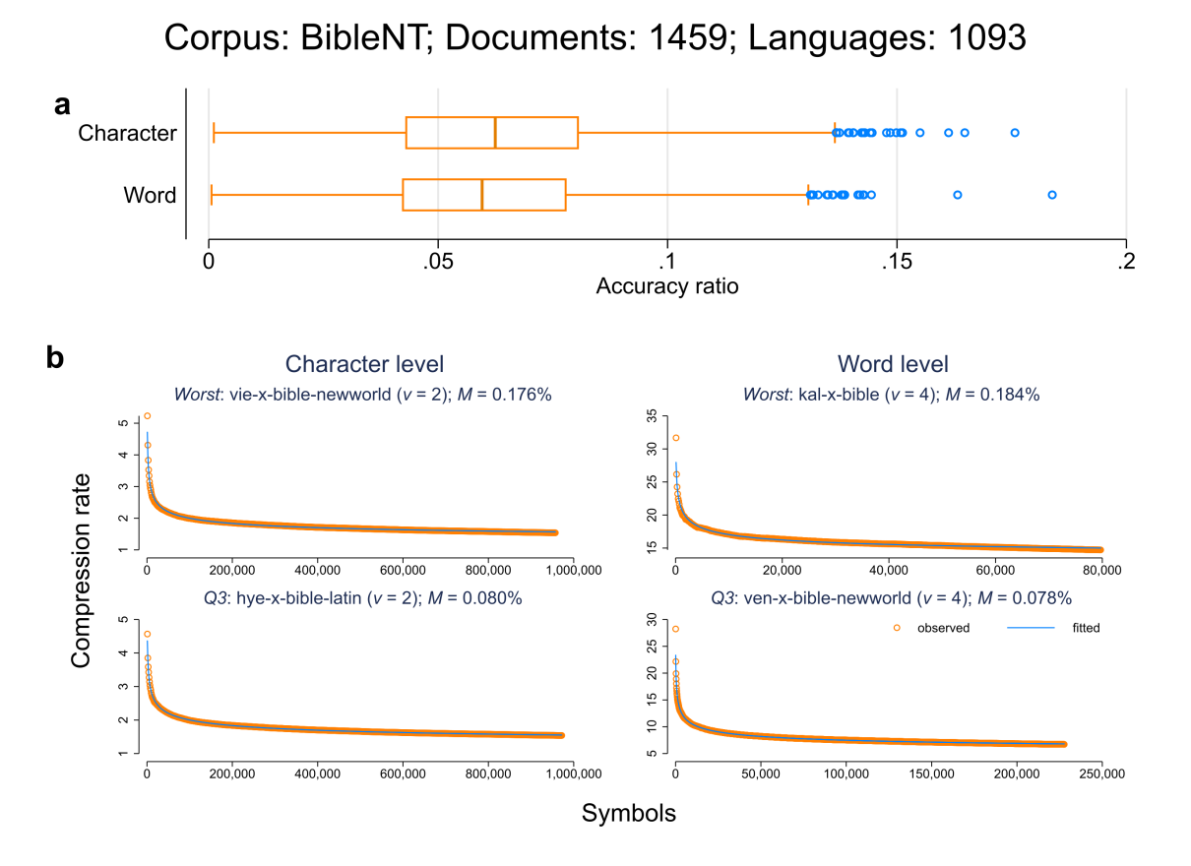
Supplementary Figure 2 | Corpus – BibleNT. Plot a – Distribution of accuracy ratios on both symbolic levels (words/characters). Plot b – First row: visualization for the document with the worst fit (i.e. maximal accuracy ratio). Second row: visualization for the document whose accuracy ratio is closest to the upper quartile (Q3, i.e. 75% of the documents have a better accuracy ratio). Left column: character level. Right column: word level.

BibleOT (parallel)
Source and setup in analogy to the BibleNT data (cf. section S3.2.1). Here, only translations where all 39 books of the Old Testament (OT) of the Christian biblical canon are available are used. In total, we compressed 254 x 5 different verse shuffles x 2 different levels = 2,540 texts. With a chunk size of 1,000 on the level of words and 10,000 on the level of characters, we compressed a total of 1,222,165 different substrings. Supplementary Figure 3 visualizes the model fits.

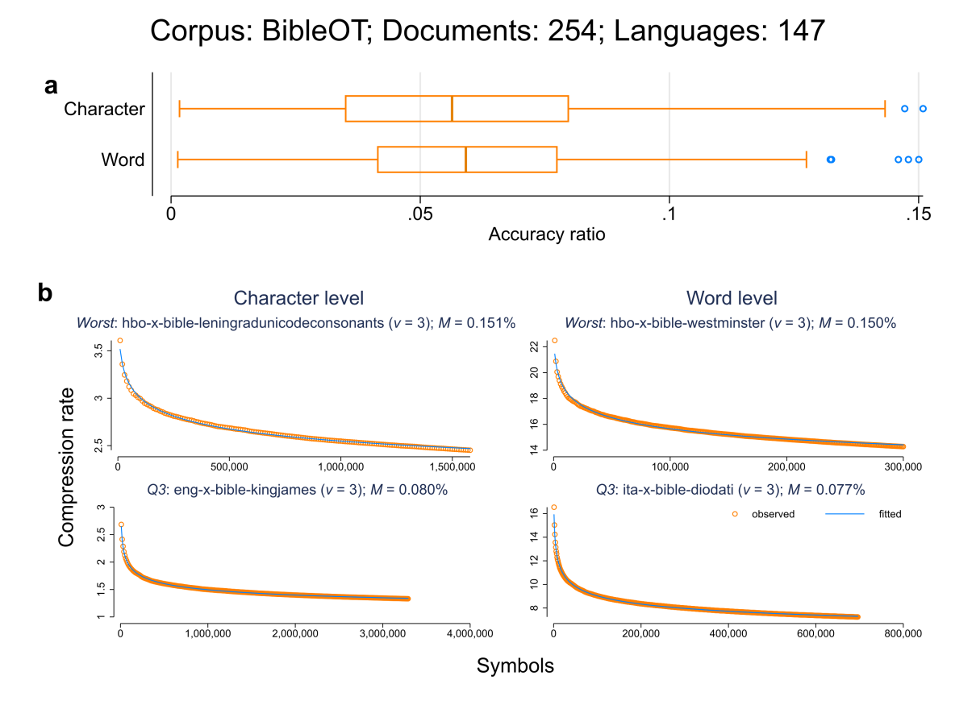
Supplementary Figure 3 | Corpus – BibleOT. Cf. Supplementary Figure 2 for a description of the content.

WatchtowerV1 (parallel)
The data are also part of the PBC (2014). This part contains a total of 311 unique translations of some introductory texts of the Jehovah’s Witnesses’ official web site (Cysouw & Wälchli 2007). The texts are provided in a similar format as the BibleNT data (cf. section S3.2.1). We extracted 3,230 verses that are available in 142 different translations: 960 from the Bible Teach ("bh") section (872 from the articles section and 88 from the appendix section) and 2,270 from the My Book of Bible Stories ("my") section. A list of the extracted verses is available as part of the published code (cf. section S4). The verse order for every translation is randomly shuffled in a fully parallel way. With a chunk size of 100 on the level of words and 1,000 on the level of characters, we compressed a total of 279,549 different substrings. Supplementary Figure 4 visualizes the model fits.
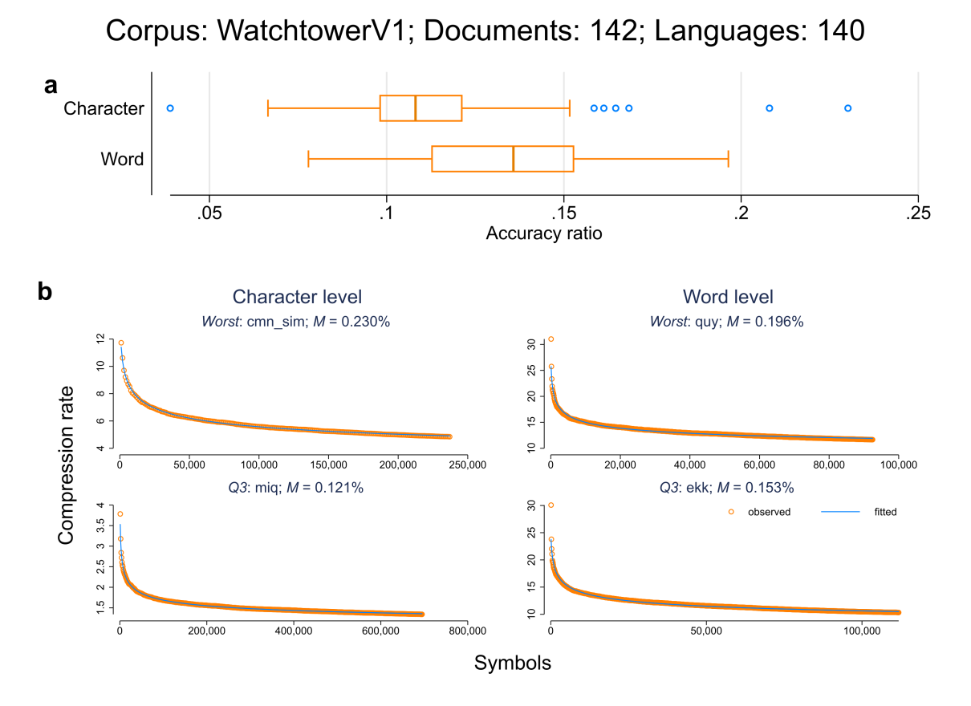
Supplementary Figure 4 | Corpus – WatchtowerV1. Cf. Supplementary Figure 2 for a description of the content.

WatchtowerV2 (parallel)
In addition to the WatchtowerV1 version (cf. S3.2.3), we discovered that there are 93 verses that are available for 265 translations in 260 unique languages. All verses belong to a brochure entitled "What Does God Require of Us?" As for the WatchtowerV1 version, the verse order for every translation is randomly shuffled in a fully parallel way. With a chunk size of 5 on the level of words and 50 on the level of characters, we compressed a total of 570,764 different substrings. Supplementary Figure 5 visualizes the model fits.
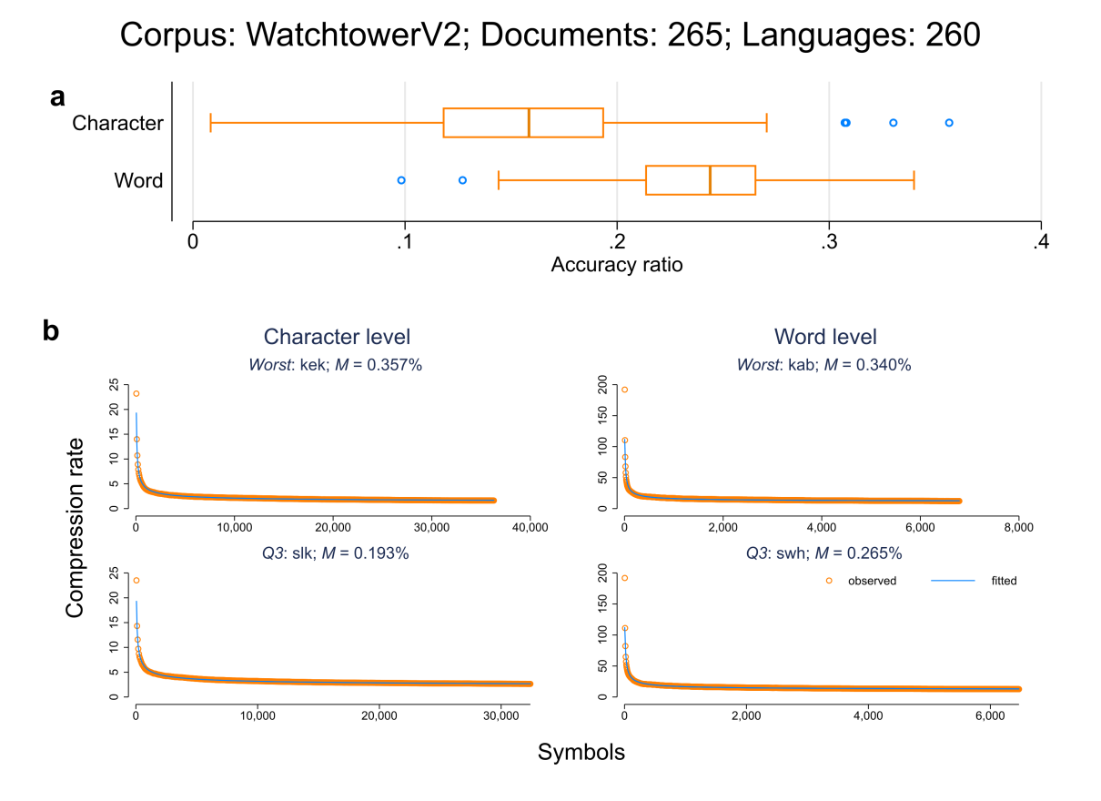
Supplementary Figure 5 | Corpus – WatchtowerV2. Cf. Supplementary Figure 2 for a description of the content.

Quran (parallel)
We downloaded 43 different Quran translations from http://tanzil.net/trans/. The verse order for every translation is randomly shuffled in a fully parallel way. With a chunk size of 100 on the level of words and 1,000 on the level of characters, we compressed a total of 119,947 different substrings. Supplementary Figure 6 visualizes the model fits.
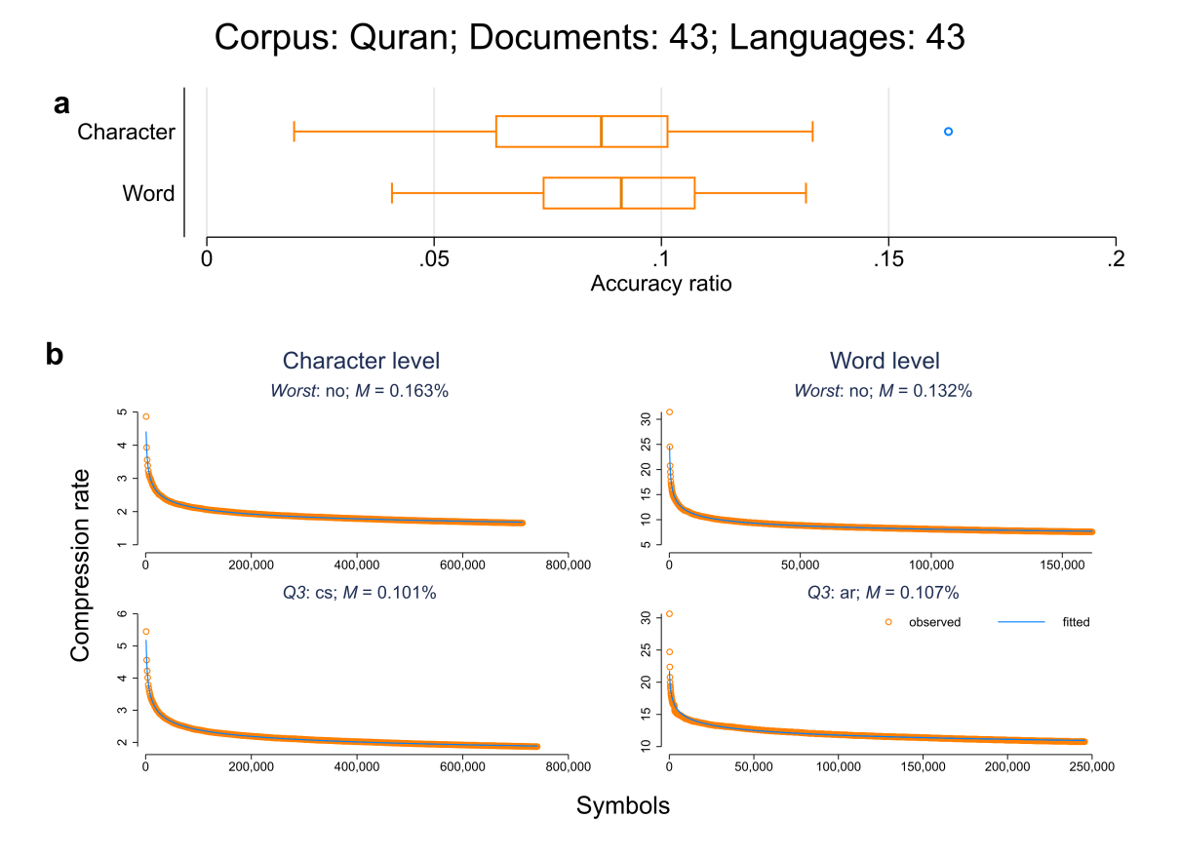
Supplementary Figure 6 | Corpus – Quran. Cf. Supplementary Figure 2 for a description of the content.

News/Web/Wikipedia crawls

GlobalVoices (comparable)
According to Wikipedia, the NGO Global Voices "is an international community of writers, bloggers and digital activists that aim to translate and report on what is being said in citizen media worldwide." (https://en.wikipedia.org/wiki/Global_Voices_(NGO)). Raw text files of all articles in 46 different languages were downloaded from http://casmacat.eu/corpus/global-voices.html (version: 2018Q4). Of those 46 languages, only languages with at least 1,000 lines were kept. For the resulting 40 languages, we randomly sampled 1,000 sentences per language.
With a chunk size of 10 on the level of words and 100 on the level of characters, we compressed a total of 123,792 different substrings. Supplementary Figure 7 visualizes the model fits.
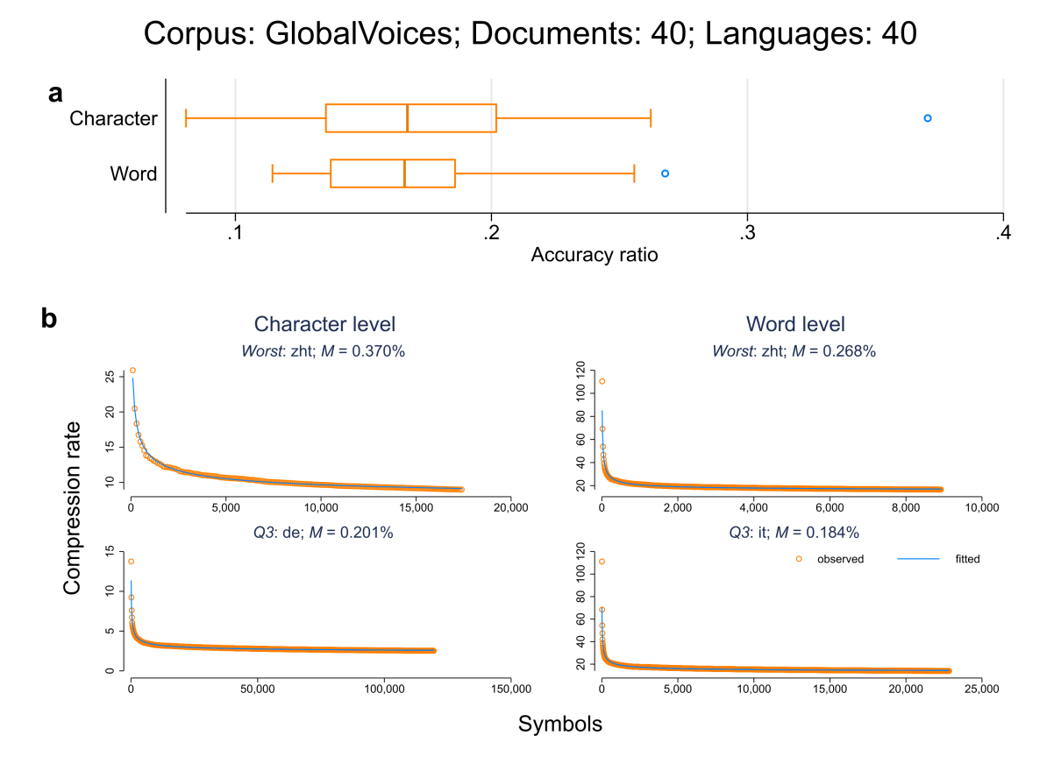
Supplementary Figure 7 | Corpus – GlobalVoices. Cf. Supplementary Figure 2 for a description of the content.

LCCnews/ LCCweb/ LCCwiki (comparable)
Plain text files were downloaded from https://wortschatz.uni-leipzig.de/en/download. The Leipzig Corpora Collection (LCC) presents corpora in the same format from comparable sources. Here we focus on three collections that we name as follows (i) LCC_{news}, i.e. text material of crawled newspapers available online, (ii) LCC_{web}, i.e. text material crawled from randomly chosen web pages, and (iii) LCC_{wikipedia}, i.e. text material from Wikipedia dumps. For each corpus and for each available language we downloaded all texts files ending with "_10k-sentences" each consisting of 10,000 randomly shuffled sentences. In total LCC_{news} consists of 112 different texts, LCC_{web} consists of 87 texts and LCC_{wikipedia} consists of 171 texts.
With a chunk size of 1,000 on the level of words and 10,000 on the level of characters, we compressed a total of 112,618 different substrings. Supplementary Figure 8 visualizes the model fits.
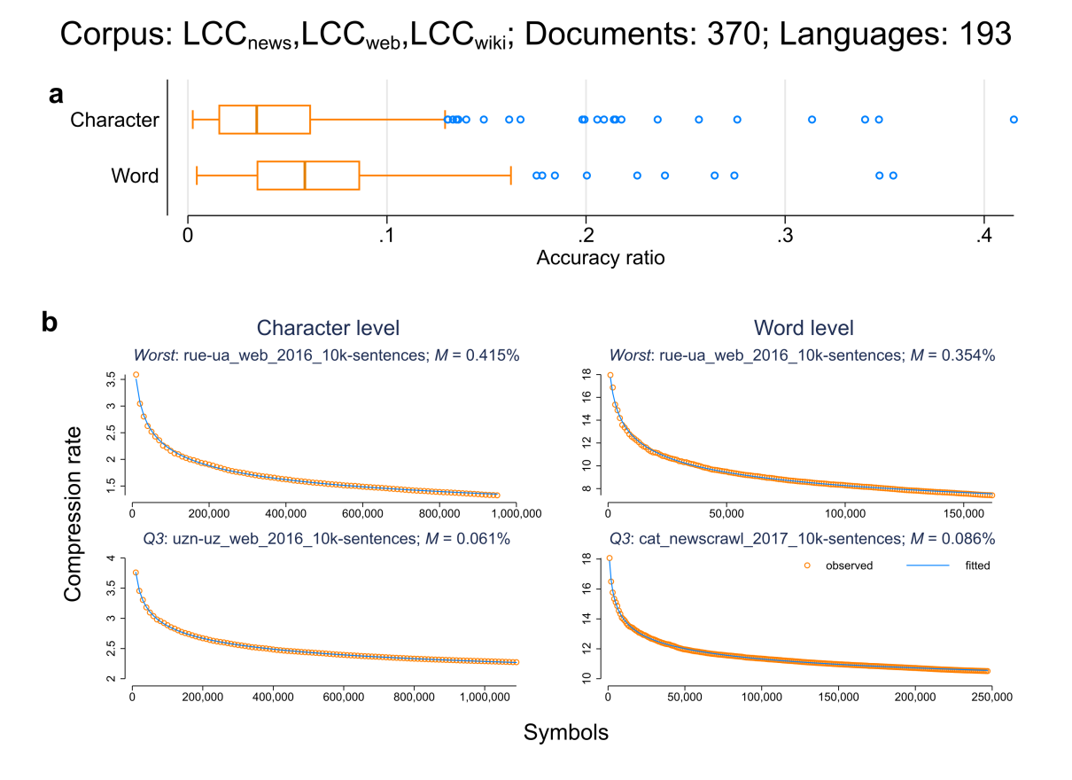
Supplementary Figure 8 | Corpus – LCC. Cf. Supplementary Figure 2 for a description of the content.

Legalese texts

UDHR (parallel)
We downloaded a total of 452 parallel translations of the Universal Declaration of Human Rights (UDHR) from https://unicode.org/udhr/. With a chunk size of 10 on the level of words and 100 on the level of characters, we compressed a total of 142,027 different substrings. Supplementary Figure 9 visualizes the model fits.
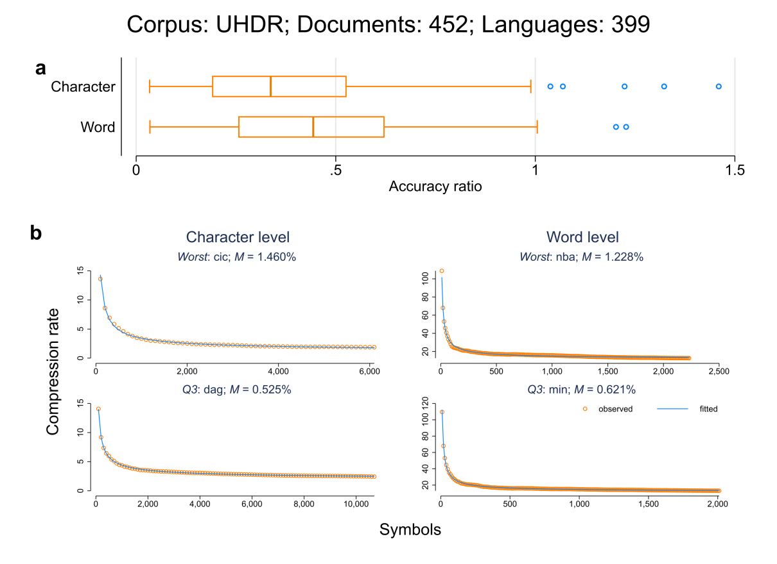
Supplementary Figure 9 | Corpus – UDHR. Cf. Supplementary Figure 2 for a description of the content.

EUconst (parallel)
Parallel data in Unicode plain text format was downloaded from http://opus.nlpl.eu/EUconst.php, i.e. a parallel corpus collected from the European Constitution. We downloaded all parallelly aligned sentence-pairs for two languages (Tiedemann 2012) where the second language is Czech ("cs" ISO-639-2). We then used the Czech sentences as the key variable to align all 21 available languages, i.e. we pivoted via Czech (Aulamo et al. 2020). In total, we extracted 4,944 sentences that are available in all translations. The sentence order for every translation is randomly shuffled in a fully parallel way. With a chunk size of 100 on the level of words and 1,000 on the level of characters, we compressed a total of 33,004 different substrings. Supplementary Figure 10 visualizes the model fits.
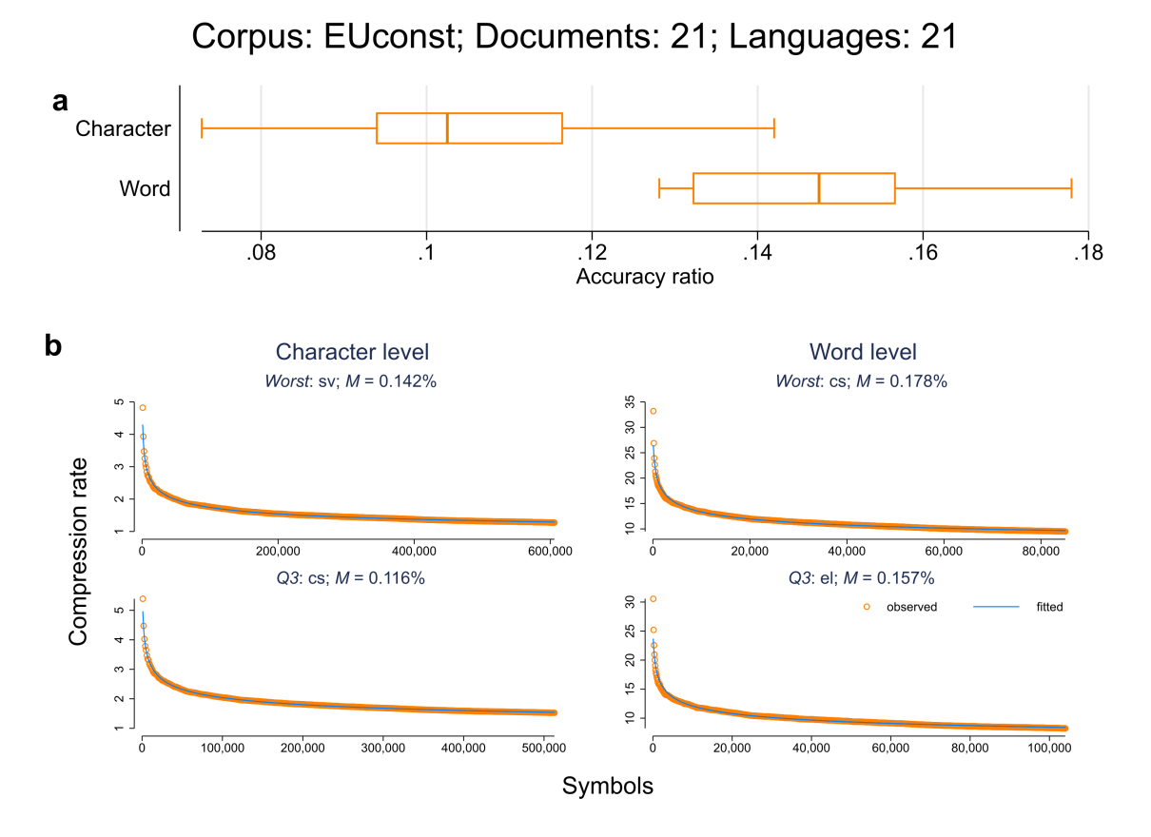
Supplementary Figure 10 | Corpus – EUconst. Cf. Supplementary Figure 2 for a description of the content.

Europarl (parallel)
Parallel data in Unicode plain text format was downloaded from http://opus.nlpl.eu/Europarl.php, i.e. a parallel corpus extracted from the European Parliament web site by Philipp Koehn (http://www.statmt.org/europarl/ ). We downloaded all parallelly aligned sentence-pairs for two languages (Tiedemann 2012) where the second language is Bulgarian ("bg" ISO-639-2).We then used the Bulgarian sentences as the key variable to align all 21 available languages. In total, we extracted 192,735 sentences that are available in all translations. The sentence order for every translation is randomly shuffled in a fully parallel way. With a chunk size of 1,000 on the level of words and 10,000 on the level of characters, we compressed a total of 175,852 different substrings. Supplementary Figure 11 visualizes the model fits.
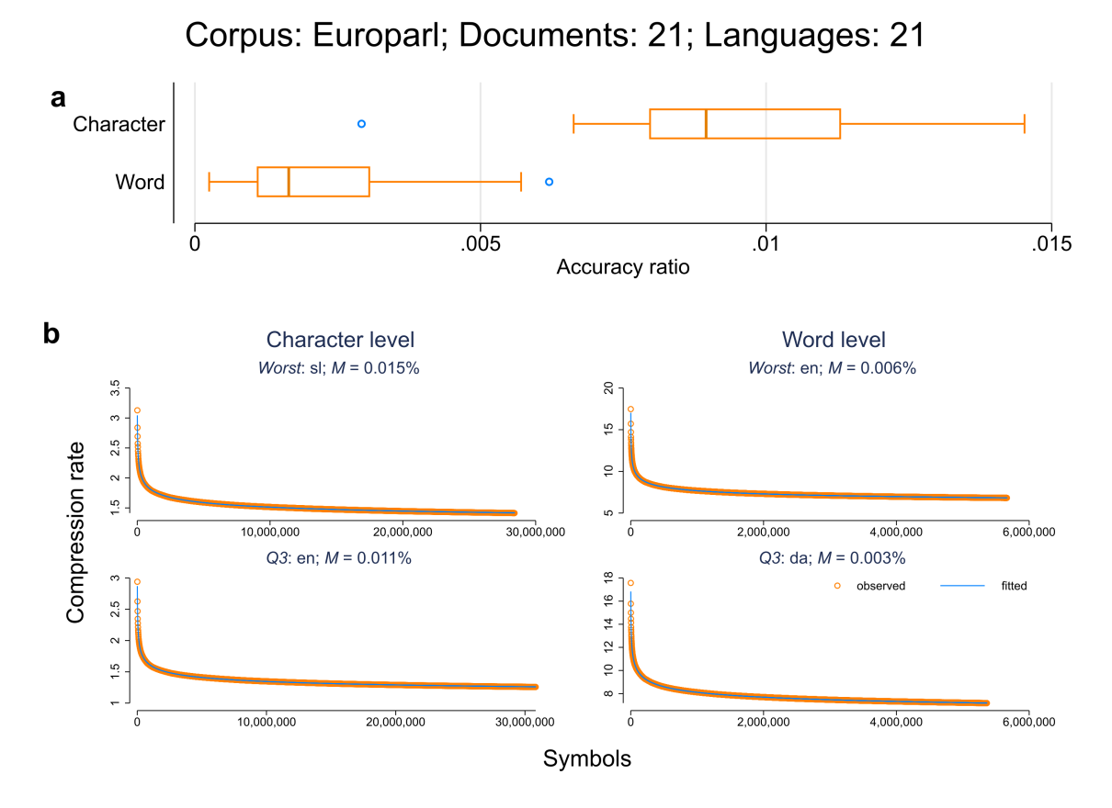
Supplementary Figure 11 | Corpus – Europarl. Cf. Supplementary Figure 2 for a description of the content.

EUmed (parallel)
Parallel data in Unicode plain text format was downloaded from http://opus.nlpl.eu/EMEA.php, i.e. a parallel corpus made out of PDF documents from the European Medicines Agency that "is an agency of the European Union in charge of the evaluation and supervision of medicinal products" (https://en.wikipedia.org/wiki/European_Medicines_Agency). The texts contain a lot of information on the prescription and (therapeutic) use of drugs, e.g. "if serum ferritin falls consistently below 500 µg/ l, an interruption of treatment should be considered (see section 4.4)". We downloaded all parallelly aligned sentence-pairs for two languages (Tiedemann 2012) where the second language is Bulgarian ("bg" ISO-639-2).We then used the Bulgarian sentences as the key variable to align all 22 available languages. In total, we extracted 174,227 sentences that are available in all translations. The sentence order for every translation is randomly shuffled in a fully parallel way. With a chunk size of 1,000 on the level of words and 10,000 on the level of characters, we compressed a total of 112,669 different substrings. Supplementary Figure 12 visualizes the model fits.
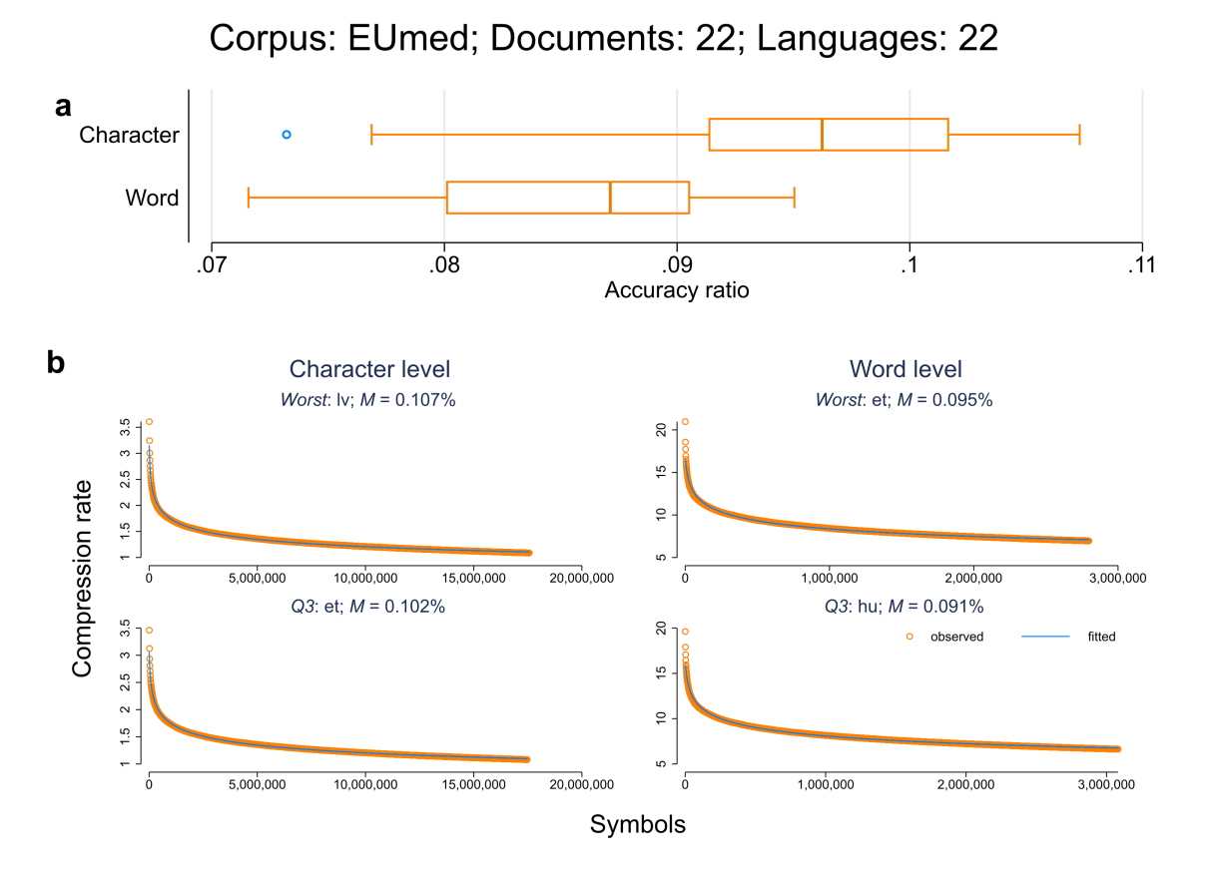
Supplementary Figure 12 | Corpus – EUmed. Cf. Supplementary Figure 2 for a description of the content.

UNPC (parallel)
Parallel data in Unicode plain text format was downloaded from http://opus.nlpl.eu/UNPC.php (Source: https://cms.unov.org/UNCorpus), i.e. a parallel corpus compiled by (Ziemski, Junczys-Dowmunt & Pouliquen 2016) that is "composed from United Nations documents published by the original data creator. The parallel corpus presented consists of manually translated UN documents from the last 25 years (1990 to 2014)" (Ziemski, Junczys-Dowmunt & Pouliquen 2016). We downloaded all parallelly aligned sentence-pairs for two languages (Tiedemann 2012) where the second language is Arabic ("ar" ISO-639-2). We then used the Arabic sentences as the key variable to align all 6 available languages. We initially extracted 12,303,784 sentences that are available in all translations. The sentence order for every translation is randomly shuffled in a fully parallel way. Since every word type is replaced by one unique Unicode symbol (cf. S3.1) and because there are only 1,112,064 valid Unicode symbols, preliminary analyses indicated that we could only keep the first 11,073,405 sentences on the level of words. Since the software package that we used to prepare the textual data (Stata 14.2) can only store strings up to 2,045 bytes and because that limited was reached after the first 4,723,010 sentences for the Russian data on the level of characters, we truncated the texts of the other five available languages at this point, too.
Further preliminary analyses revealed that due to the text length, the memory limit of the PPMd model (2 gigabytes) was reached at some point for all but one text. At this point, the tree in which the contextual statistics are stored is discarded and rebuilt from scratch (Mahoney 2013). To avoid this, we manually selected the maximum possible 7-zip PPMd order (cf. S3.1) for which the model memory limit was not reached per document and symbol type.
Again due to the text length, we compressed the texts every 50,000 symbols for the first 1,000,000 symbols, and then compressed the rest of the texts every 500,000 symbols on both the character and the word level. In total, we compressed a total of 13,919 different substrings. Supplementary Figure 13 visualizes the model fits.
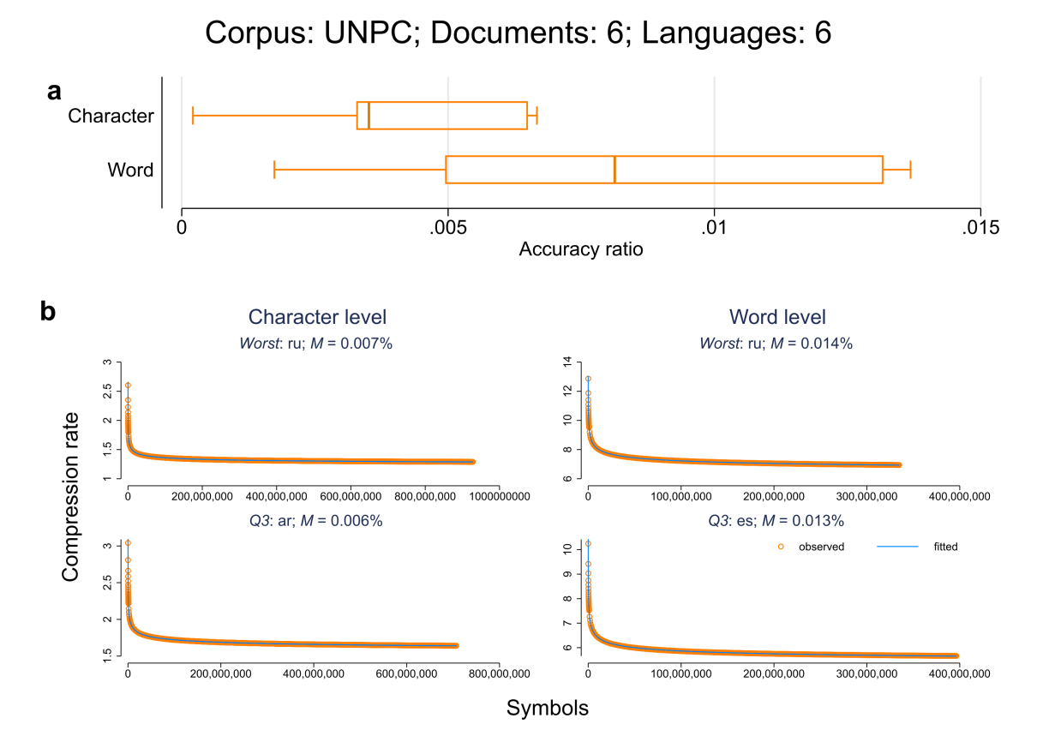
Supplementary Figure 13 | Corpus – UNPC. Cf. Supplementary Figure 2 for a description of the content.

Subtitles

MSub01 – MSub13 (parallel)
The data were downloaded from https://github.com/levshina/ParTy-1.0. The ParTy corpus (Levshina 2016) contains subtitles for the following thirteen movies:
- MSub01: Amelie
- MSub02: Avatar
- MSub03: Black Swan
- MSub04: Bridge of Spies
- MSub05: Das Leben der Anderen
- MSub06: Frozen
- MSub07: Gone Girl
- MSub08: Grand Budapest Hotel
- MSub09: Imitation game
- MSub10: Inception
- MSub11: Ironlady
- MSub12: Noah
- MSub13: Spectre
According to http://www.natalialevshina.com/corpus.html, all files were downloaded from the online repositories opensubtitles.org, subscene.com and ted2srt.org and aligned automatically. Each sentence for each document was randomly shuffled. In total, we used 269 documents in 43 different languages. With a chunk size of 10 on the level of words and 100 on the level of characters, we compressed a total of 336,250 different substrings. 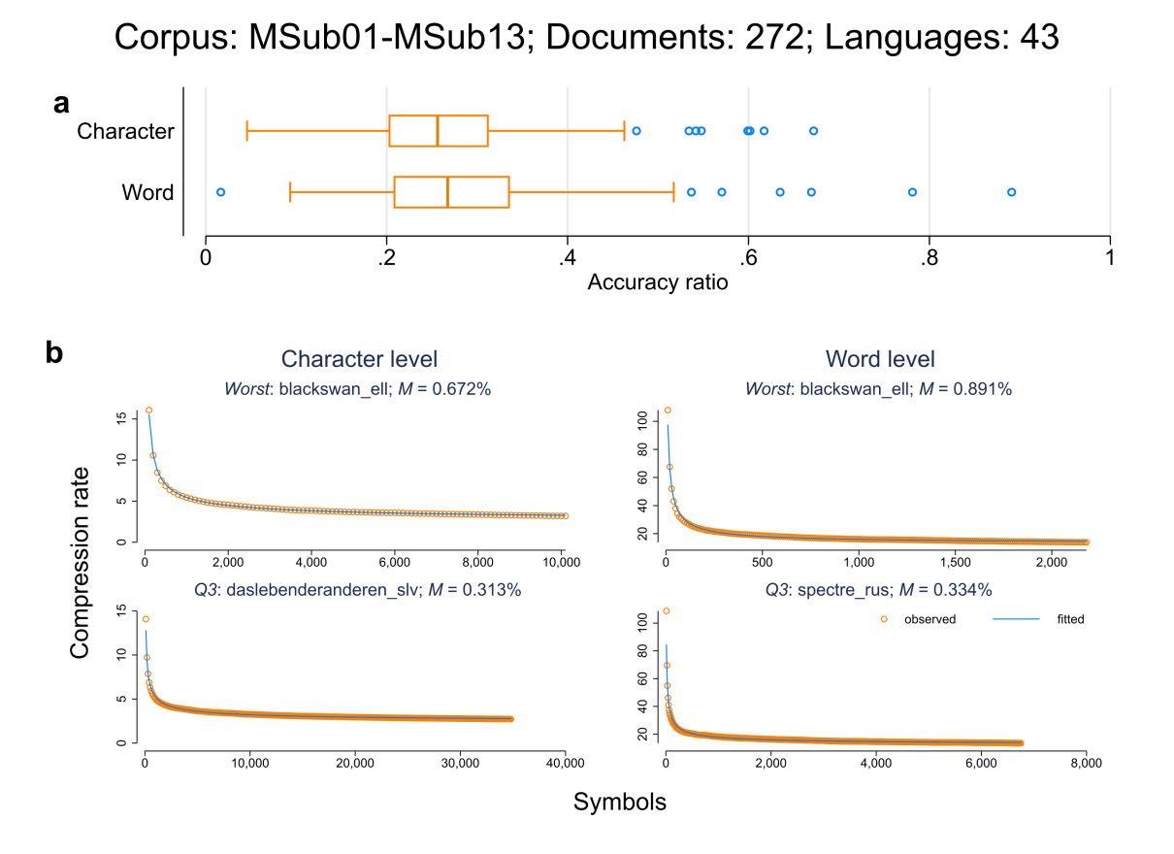
Supplementary Figure 14 visualizes the model fits.
Supplementary Figure 14 | Corpus – MSub01 – MSub13. Cf. Supplementary Figure 2 for a description of the content.

TEDt01 – TEDt09 (parallel)
TED is a media organization that posts short talks "online for free distribution under the slogan 'ideas worth spreading'" (https://en.wikipedia.org/wiki/TED_(conference)). In a collaborative effort, “TED talks” also offers subtitles by using the subtitling platform https://amara.org/en/. We downloaded plain text data from https://amara.org/en/teams/ted/videos/ for talks that have (i) the largest number of completed subtitles in different languages and (ii) are reasonably long. We selected the following nine talks:
- TEDt01: Bring on the learning revolution
- TEDt02: Do schools kill creativity
- TEDt03: Doing the impossible cutting through fear Dan Meyer TEDxMaastricht
- TEDt04: Modern Warrior Damien Mander at TEDxSydney
- TEDt05: My philosophy for a happy life Sam Berns at TEDxMidAtlantic
- TEDt06: Secondary sugar kills Laurent Adamowicz TEDxYouthBeaconStreet
- TEDt07: Speak to the heart Marleen Laschet TEDxTrondheim
- TEDt08: Success is a continuous journey
- TEDt09: Why is x the unknown
In total, we used 436 documents in 80 different languages. With a chunk size of 5 on the level of words and 50 on the level of characters, we compressed a total of 271,913 different substrings. Supplementary Figure 15 visualizes the model fits.
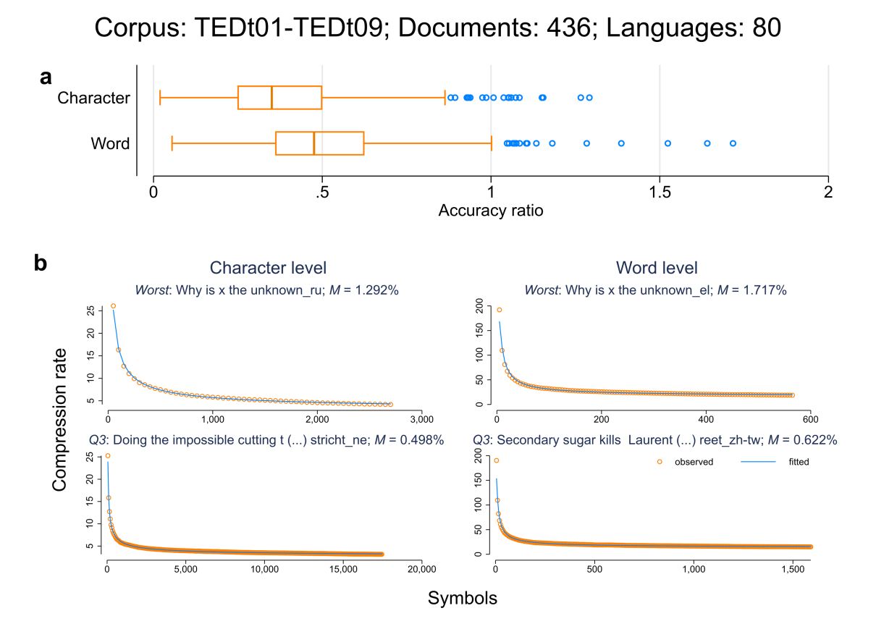
Supplementary Figure 15 | Corpus – TEDt01 – TED09. Cf. Supplementary Figure 2 for a description of the content.

Other

Ubuntu (comparable)
Parallel data in Unicode plain text format was downloaded from http://opus.nlpl.eu/Ubuntu.php, a corpus of Ubuntu localization files (source: https://translations.launchpad.net), containing translations for sentences and phrases displayed by computer applications, such as "allow packages from unauthenticated sources". We downloaded all parallelly aligned sentence-pairs for two languages (Tiedemann 2012) where the second language is English ("en" ISO-639-2).
Of those 207 languages, only languages with at least 1,000 lines were kept. For the resulting 86 languages, we randomly sampled 1,000 sentences per language. The sentence order for every translation is randomly shuffled. In total, we used 86 documents in 86 different languages. With a chunk size of 5 on the level of words and 50 on the level of characters, we compressed a total of 162,127 different substrings. Supplementary Figure 15 visualizes the model fits.
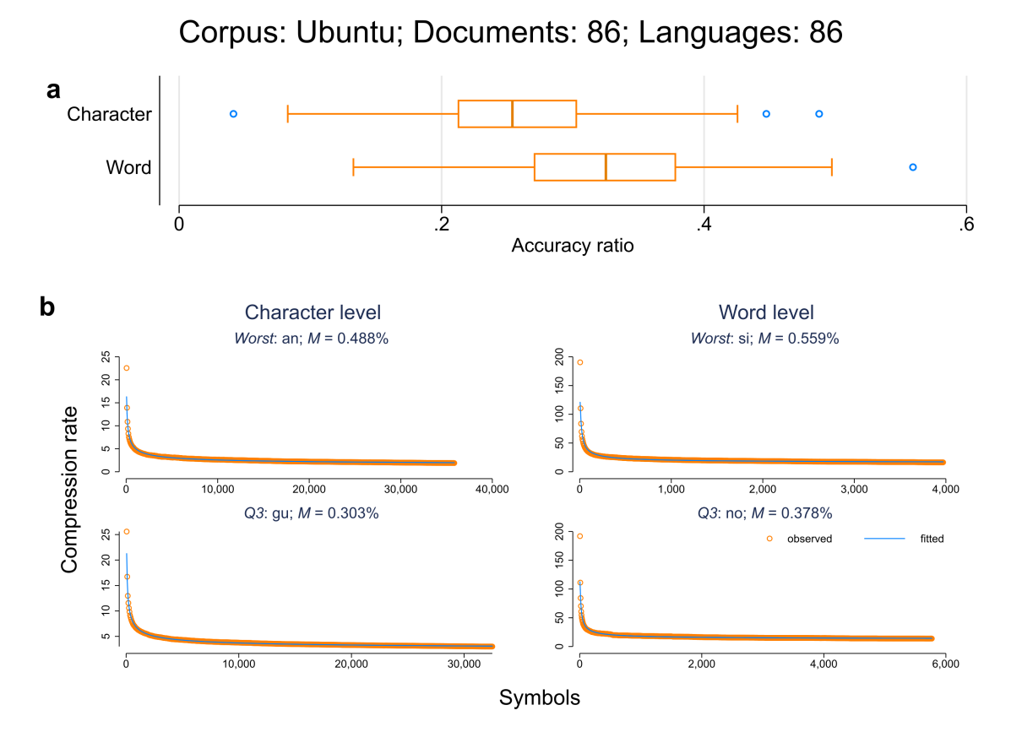
Supplementary Figure 16 | Corpus – Ubuntu. Cf. Supplementary Figure 2 for a description of the content.

GoogleT (parallel)
We downloaded the following excerpt from the book "Aldono al la Dua Libro de l’ Lingvo Internacia" in the constructed language Esperanto, written by its inventor L.L. Zamenhof (downloaded from http://esperanto.davidgsimpson.com/librejo/index.html on 09/04/2019):
"En mia unua libro mi petis ĉiujn amikojn de l' lingvo internacia esprimi ilian juĝon pri la lingvo, kiun mi proponis, montri al mi ĉiujn erarojn, kiujn ili trovis en ĝi, kaj ĉiujn plibonigojn, kiujn ili povas proponi, kaj helpi min tiel doni al la lingvo la plej bonan formon, ĉar la finan formon mi intencis doni al la "Lingvo Internacia" ne pli frue ol en la fino de l' jaro 1888, pripensinte kaj provinte antaŭe ĉiujn juĝojn kaj proponojn, kiuj estus senditaj al mi ĝis tiu tempo. En la "Dua Libro" mi diris, ke por fari la lingvon libera de ĉiuj personaj eraroj, estus dezirata, ke ia instruita societo prenu en siajn manojn la sorton de l' lingvo kaj, aŭskultinte la konsilojn de kompetentaj personoj, ĝi donu al la lingvo la finan formon, kiu estus egale ordona por mi, kiel por ĉiu alia amiko de l' lingvo internacia. Nun mi kun la plej granda ĝojo povas sciigi ĉiujn amikojn de l' lingvo internacia, ke mia deziro ne restis vana. Ankoraŭ en la fino de l' jaro 1887, t.e. ankoraŭ antaŭ la ricevo de mia libreto, la Amerika Filozofia Societo en Filadelfio (The American Philosophical Society) elektis komitaton por pripensi kaj decidi la demandon, ĉu lingvo internacia estas necesa, ĉu ĝi estas kreebla, kaj kiel ĝi devas esti. La frukto de l' laboroj de la komitato estis jena decido: ke lingvo internacia estas kreebla, ke ĝi estas necesa, ke ĝi devas havi gramatikon la plej simplan kaj naturan, kun la plej simpla ortografio, kaj fonologio, kaj la vortoj devas esti agrablaj por la orelo; ke la vortaro devas esti kreita el vortoj pli malpli rekoneblaj por la plej gravaj civilizitaj popoloj; ke la fina formo de tia lingvo devas esti la frukto de l' laboroj ne de unu persono, sed de la tuta instruita mondo. Sur la fondo de ĉio supre dirita, la "Amerika Filozofia Societo" decidis dissendi al ĉiuj instruitaj societoj la proponon fari internacian kongreson de instruituloj por decidi la finan formon de lingvo tutmonda. Tiel la leganto vidas, ke ne sciante ankoraŭ pri mia laboro, la "Amerika Filozofia Societo" venis al tiuj samaj decidoj pri lingvo tutmonda, al kiuj mi venis, kaj ke la principoj, kiujn la "Amer. Fil. Societo" ellaboris por la lingvo teorie, estas pli malpli egalaj al tiuj, kiujn mi efektivigis praktike. Tial ĝi estas tute natura, ke ricevinte mian libreton jam en la fino de siaj laboroj, la komitato trovis, ke mia lingvo estas sufiĉe proksima al la idealo, kiun ĝi ellaboris teorie. Jen kion diras pri la "Lingvo internacia" sinjoro Henry Phillips, Jr (unu el la tri personoj, el kiuj estis farita la komitato por decidi la demandon pri lingvo tutmonda): "La plej nova propono al la publiko kaj ĝis nun la plej simpla kaj la plej racionala, estas la "Lingvo internacia," kreita de d-ro S* el Varsovio. La principoj, sur kiuj ĝi estas fondita, estas en la tuto maleraraj; ĝia vortaro ne estas kreita laŭ la persona volo kaj juĝo de l' aŭtoro, sed prenita el la lingvoj franca, germana kaj angla kaj en parto el la latina, kaj ĝi enhavas la vortojn, kiuj estas similaj en tiuj lingvoj; estas faritaj kelkaj ŝanĝoj pro la bonsoneco. Pro tio kaj pro ĝia gramatiko la lingvo estas mirinde facila por lerni, prezentante neniajn el la kalejdoskopaj rompaĵoj kaj ŝiraĵoj de la Volapük'. La gramatiko de tiu lingvo estas el la plej simplaj, tiel simpla, kiel en nia propra lingvo, kaj la reguloj por la kreado de vortoj estas tiel klaraj kaj tiel facilaj, ke la vortaro el radikvortoj povas esti farita tre malgranda ..." Rakontinte mallonge la tutan konstruon de l' "Lingvo internacia" kaj ĝian gramatikon, kaj montrinte kelkajn punktojn, kiuj laŭ lia juĝo devus esti ŝanĝitaj, sinjoro H. Ph. finas: "D-ro S*, kiu skribas sub la nomo de d-ro Esperanto, estas tre modesta en siaj postuloj kaj proponas sian lingvon al la publika kritiko tra la tempo de unu jaro, antaŭ ol li donos al ĝi la finan formon. Post tiu fina trarigardo kaj ŝanĝo li volas prezenti ĝin por la publika uzado. Li petas siajn legantojn promesi lerni la lingvon nur tiam, se 10,000,000 personoj estos donintaj tian saman promeson."

We then machine-translated this excerpt using https://translate.google.com on 09/04/2019 into all available languages. In total, we translated the excerpt into 102 different languages. With a chunk size of 5 on the level of words and 50 on the level of characters, we compressed a total of 22,643 different substrings. Supplementary Figure 17 visualizes the model fits.
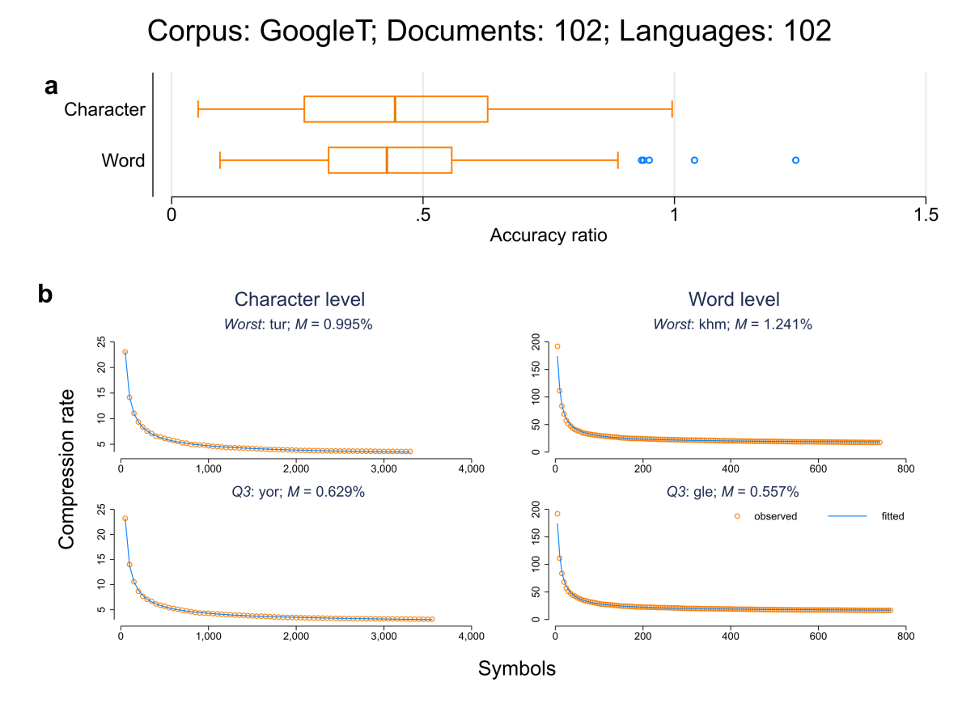
Supplementary Figure 17 | Corpus – GoogleT. Cf. Supplementary Figure 2 for a description of the content.

TatoebaV1 (comparable)
According to Wikipedia, "Tatoeba is a free collaborative online database of example sentences geared towards foreign language learners" (https://en.wikipedia.org/wiki/Tatoeba). Raw data for 340 different languages were downloaded from https://tatoeba.org/deu/downloads. An example sentence in the constructed language Toki Pona is "kulupu ante pi soweli Kane li mute." For this version (V1), we only kept languages with at least 100 available sentences. For the resulting 183 languages, we randomly sampled 100 sentences per language. With a chunk size of 5 on the level of words and 50 on the level of characters, we compressed a total of 35,116 different substrings. Supplementary Figure 18 visualizes the model fits.
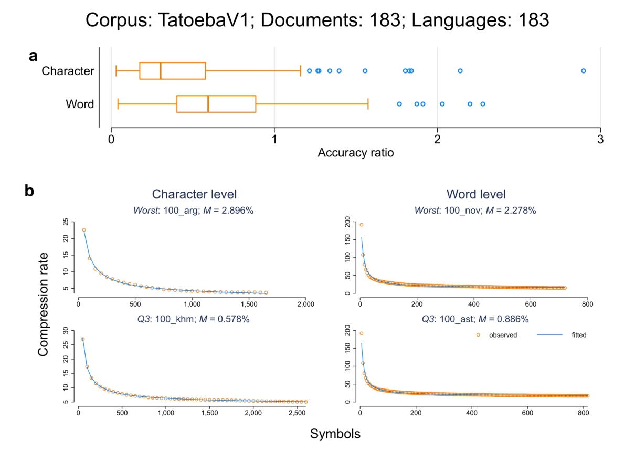
Supplementary Figure 18 | Corpus – TatoebaV1. Cf. Supplementary Figure 2 for a description of the content.

TatoebaV2 (comparable)
After generating the first version described in the last section, we used the remaining sentences to generate a second version. Here we only kept languages with a least 500 available sentences. For the resulting 123 languages, we randomly sampled 500 sentences per language. With a chunk size of 5 on the level of words and 50 on the level of characters, we compressed a total of 124,128 different substrings. Supplementary Figure 19 visualizes the model fits.
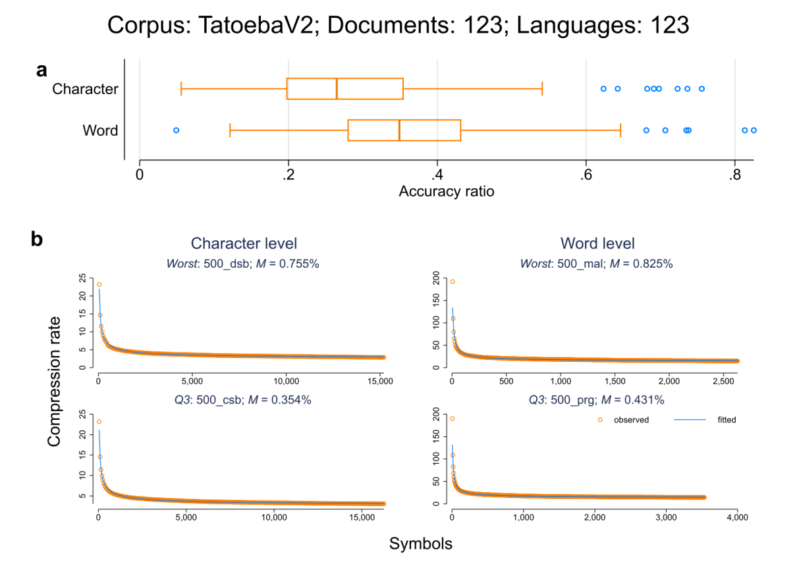
Supplementary Figure 19 | Corpus – TatoebaV2. Cf. Supplementary Figure 2 for a description of the content.

Wordlist: Crúbadán
The Crúbadán project aims at creating text corpora for a large number of (especially under-resourced) languages via web-crawling (Scannell 2007), often based on Bible translations or Wikipedia entries. Since no full text is provided, we downloaded all zip files by first generating lists of all available documents by extracting the document "writingsystems.csv" for all available scripts via
http://crubadan.org/writingsystems.csv?sEcho=1&iSortingCols=1&iSortCol_0=4&sSortDir_0=asc&sSearch_4=`script' where "`script'" is replaced by one of the following scripts: Arab, Armn, Beng, Cans, Cher, Copt, Cyrl, Cyrs, Deva, Ethi, Geor, Glag, Grek, Gujr, Guru, Hans, Hant, Hebr, Jpan, Kali, Khmr, Knda, Kore, Laoo, Latg, Latn, Limb, Lisu, Mlym, Mong, Mymr, Nkoo, Ogam, Orya, Saur, Shaw, Sinh, Syrc, Taml, Telu, Tfng, Tglg, Thaa, Thai, Tibt, Vaii, Yiii. After aggregating the lists, we downloaded all zip files from http://crubadan.org/files/. We then kept all word frequency lists for which there is at least one available line of information in the document `bcp'-words.txt where "`bcp'" stands for an adjusted BCP-47 language code, e.g. "omw-x-aat" stands for the language "Aatasara" spoken in Papua New Guinea. In total, we arrived at 2,216 word frequency lists for a total of 1,943 different languages. Using the available word frequency information, we calculated the Gibbs-Shannon entropy (cf. Methods: equation (1)) on the word level. Since most frequency lists are only based on a very limited number of documents (simply due to the fact that for such languages those documents "may very well represent the totality of all electronic documents in existence" (Scannell 2007)), we use both the text length and the number of documents as control variables in what follows. In addition, we noted that in 103 cases (4.65%), the available word frequency lists are truncated, i.e. word types with a frequency lower than some threshold level are excluded from the list. Therefore, we generated an additional variable that indicates whether the corresponding word frequency list is truncated (yes/no) and that variable then serves as a control in what follows.

Code and data
Code and data are available at https://osf.io/f5mke/. Speaker community size estimates and genealogical/geographical classifications are taken from Bentz et al. (2018) whose data are in turn based on data from Ethnologue, 17th edition (Simons & Fennig 2013) and Glottolog (Hammarström, Forkel & Haspelmath 2019). Range size estimates are taken from Amano et al. (2014), based on data from Ethnologue, 16th edition (Simons & Fennig 2009). We thank Christian Bentz for additionally providing us with country information from Ethnologue, 17th edition (Simons & Fennig 2013), the last openly available version of the Ethnologue (Bentz et al. 2018).
To calculate an entropic index of linguistic diversity per country, we used the language-in-country table from the Ethnologue Global Dataset, 20th edition (Simons & Fennig 2017). For a country in which J different first languages are used, linguistic diversity is calculated as:
 | $$H_{D}=-\sum_{j=1}^{J}{\left(\frac{S_{j}}{\sum_{j=1}^{J}{S_{j}}}\right)}*\log_{2}\left(\frac{S_{j}}{\sum_{j=1}^{J}{S_{j}}}\right)$$ | [S1]
where j = 1, 2, 3, … J denote the different languages spoken in the corresponding country, S_{j} denotes the estimated population of first-language users of language j and $\sum_{j=1}^{J}{S_{j}}$ is the sum of all first-language users. In analogy to Methods: equation (1), H_{D} can be understood as measuring the average number of guesses needed to correctly predict the first language of a person randomly drawn from the corresponding country. If all persons in a country use the same first language, H_{D} reaches its minimum of zero, indicating zero linguistic diversity. H_{D} reaches its maximum of log₂(J) if all first languages are used by the same number of persons.
The following additional environmental variables were taken from Bentz et al. (2018): latitude, altitude, climatic information, distance to water. Latitude was transformed to measure the absolute distance from 15° north as suggested by Bentz (2016) who presents surprising evidence for a Low-Complexity-Belt, i.e. a geo-spatial pattern of languages that are located just above the equator and which “exhibit lower complexity than languages further away from the equator”. Climatic information consists of two variables, Climate PC1 and Climate PC2, that are based on a Principal Component Analysis presented in Supplementary Methods 5 of Bentz et al. (2018). Climate PC1 can be interpreted as discriminating between hot and stable climates on the one hand and cold and variable climates on the other hand, while Climate PC2 discriminates between hot, dry and variable climates on the one hand and cold, wet and stable climates on the other hand, cf. Table 4 of Bentz et al. (2018). Distance to water is defined as the minimum distance to the nearest ocean, lake or river, cf. Supplementary Methods 6 of Bentz et al. (2018).
Regarding potential caveats and problems of assigning environmental variables to individual languages in order to reflect local grouping structure, see (Bentz et al. 2018; Jaeger et al. 2011).
Writing system information was taken from the Crúbadán project (cf. S3.7, variable "script").
For the Crúbadán word frequency lists, the information as listed in the file writingsystems.csv was used (cf. cf. S3.7). For all other documents, we used the variable "ISO" to prepare a list of all different writing systems per language. For languages with only one available writing system in the csv file, the corresponding writing system was directly assigned to each document in the corresponding language. For languages with more than one available writing system, we manually selected the correct writing system for each document. In addition, we manually selected writing systems for documents without available information.
Data preparation, management and analysis were done in Stata 14.2 (StataCorp 2015). Commented code is available at https://osf.io/f5mke/, folder: Stata Code. A replication of the key results was done in R (R Core Team 2021), the corresponding scripts are available at https://osf.io/f5mke/, folder: R Code. Supplementary Table 4 lists and describes the variables included in the final dataset that is available as a csv file ("textcomp_data.csv") at https://osf.io/f5mke/, folder: Data.
Note that K_{obs} was not calculated as K_{obs} = r · L. While L is the full length of the corresponding document, r is calculated as${R(X_{1}^{Γ})}/{\left(Γ\right)}$, where $Γ=\left\lfloor L/m\right\rfloor · m$ and $R(X_{1}^{Γ})$ corresponds to the number of bits that the PPM algorithm needs to compress the document from chunk 1 to chunk $\left\lfloor L/m\right\rfloor$. The latter term corresponds to the last available full segment that depends on the pre-defined chunk size m (only if L mod m = 0, K_{obs} = r · L; in all other cases, the last incomplete segment is dropped). Accordingly, we calculate K_{obs} = $R(X_{1}^{Γ})$. K_{ext}, on the other hand, can be calculated as h · L.

Supplementary Table 4: Description of the dataset that is available as a csv file as part of Data S1 ("textcomp_data.csv"). 1st column: Variable name. 2nd column: Variable type (string/numeric). 3rd column: Description. 4th column: Value labels (if applicable).
Name | Type | Description | Values
corpus | string | Name of the corpus | cf. Supplementary Table 3; column 1
corpus_type | string | Type of source corpus | parallel,  comparable,  word frequency list
version | string | version for which the quantities r, A, h, b, H and K_{obs} were calculated (cf. section S4) | full, truncated
type | string | Symbolic level: "char_level" for characters, "word_level" for words, "BPE" for byte pair encoding (only for BibleOT) | char_level, word_level, BPE
script | string | Writing system | 4-letter code
ISO | string | Language specific ISO 639-3 code | 3-letter code
docname | string | Name of the document for which the quantities are calculated | -
language_name | string | Name of the language | -
family | string | Name of the language family | -
macroarea | string | Name of the macro-area | -
country | string | Name of the country | -
r_c | numeric | Compression rate (denoted as r in the text) | -
h_unigram | numeric | Gibbs-Shannon entropy (cf. Methods: equation (1), denoted as H in the text) | -
h_extrapol | numeric | Estimated extrapolated entropy rate (cf. Methods: equation (5) and equation (6), denoted as h in the text) | -
A | numeric | Proportionality constant from the ansatz function (cf. Methods: equation (5)) | -
b | numeric | Learning difficulty (cf. Methods: equation (5), denoted as b in the text). | -
K_obs | numeric | observed compressed length (see above) | -
K_ext | numeric | extrapolated compressed length (cf. section S4) | -
length | numeric | Length of the document in symbols | -
N_chunks | numeric | Number of compressed substrings of the document | -
N_docs | numeric | Number of crawled documents for which the corresponding word list in the Crúbadán data was generated (cf. S3.7) | -
trunc_yes | numeric | Binary indicator indicating if the corresponding word list in the Crúbadán data is truncated (1) or not (0) (cf. section S3.7) | 0, 1
ppmd_order | numeric | Order of the 7-zip PPMd model | -
q3_r_c | numeric | Compression rate for the first ≈ 25% of the document (see section S7) | -
q2_r_c | numeric | Compression rate for the first ≈ 50% of the document (see section S7) | -
q1_r_c | numeric | Compression rate for the first ≈ 75% of the document (see section S7) | -
iterations | numeric | Number of iterations needed for Methods: equation (6) to converge | -
acc_ratio | numeric | Accuracy ratio (cf. Methods: equation (8)) in % | -
length_BPE | numeric | Length in BPE-symbols (cf. Methods: BPE-CMIX; only for BibleOT)) | -
rate_modelBPE | numeric | Compressed length of the mapping of sub-word units to byte symbols in bits (cf. Methods: BPE-CMIX only for BibleOT)) | -
rate_dataBPE | numeric | Compressed length of the BP-encoded symbol sequence in bits (cf. Methods: BPE-CMIX; only for BibleOT)) | -
Pop | numeric | Speaker population size (cf. section S4) | -
Rangesize | numeric | Geographical range size (cf. section S4) | -
latitude | numeric | Latitude (cf. section S4) | -
longitude | numeric | Longitude (cf. section S4) | -
climate_PC1 | numeric | climate_PC1 (cf. section S4) | -
climate_PC2 | numeric | climate_PC2 (cf. section S4) | -
log_water | numeric | Distance to water (logged) (cf. section S4) | -
log_altitude | numeric | Altitude (logged) (cf. section S4) | -
log_range | numeric | Geographical range size (logged) | -
log_pop | numeric | Speaker population size (logged) | -
H_diversity | numeric | Per country diversity index (cf. section S4 and Eq. [S1]) | -
log_docs | numeric | Number of crawled documents (logged) for which the corresponding word list in the Crúbadán data was generated (cf. section 0) | -
log_length | numeric | Text length (logged) based on which the corresponding word list in the Crúbadán data was generated (cf. section S3.7) | -
lat_dist | numeric | Transformed latitude measuring the absolute distance from 15° north (cf. section S4) | -

Regarding the variable "version": there are two versions, (i) a full version and (ii) a truncated version for all corpora expect for the Crúbadán word frequency lists and the BPencoded data (Methods: BPE-CMIX). For version (i), quantities r, A, h, b, H and K_{obs} were calculated for the whole corresponding text. As written in the main part of the paper, most, if not all, quantities in the context of word frequency distributions vary systematically with the text length (Baayen 2001; Tweedie & Baayen 1998; Koplenig, Wolfer & Müller-Spitzer 2019). As a check, we therefore prepared a truncated version (ii) by first computing $Ϡ_{c}$ that denotes the minimum length in symbols per corpus and per type. We then calculated the aforementioned quantities based on the first $Ϡ_{c}$ symbols for each available text.
Each series of compression rates is available as a zipped file ("zipped_rates.zip") at https://osf.io/f5mke/, folder: Data. It consists of two column csv files (tab separated) where the first column lists the length of the uncompressed substring in symbols (words/characters) and the second column lists the size of the compressed string in bits. In correspondence to Supplementary Table 4, each file is labelled as name_docname_symboltype, for example the csv file "WatchtowerV2_yor_char_level.csv" is based on the corpus "WatchtowerV2" and the document name "yor" (i.e. the language Yoruba spoken in West Africa) on the level of characters; the second line of the file reads as 50 tab 1232 indicating that the compressed size of the first 50 characters is 1,232 bits.

Coverage
Ethnologue (Simons & Fennig 2017) list 7,099 different living languages. Aggregating all native speakers (variable "L1_Users") for all languages for which we have available data (excluding macro-languages) and dividing the resulting quantity by the number of native speakers for all languages (calculated as the sum of the "L1_Users" variable) results in a coverage of 90.72%. Around 54% of all languages (3,866) have a standardized written representation. Excluding macro-languages again, we have available information for 45.86% of those languages.

Correlation matrix
To generate the correlation matrix for Figure 4 all quantities were first averaged by corpus and symbol type for languages with more than one available document per corresponding corpus. We considered the three following variables: h, r and L. In addition, we also used information from the Crúbadán project that is available for a large number of (especially under-resourced) languages. Because no full texts are available, we estimated Gibbs-Shannon entropy (cf. Methods: equation (1)) on the level of words based on the available word frequency information and call the resulting variable H_{Crubadan}.
For all corpus pairs and both within and across both symbolic levels, we calculated Spearman correlation coefficients between all combinations of variables, corpora and symbol types where each observation is one language as identified by the corresponding ISO code. All correlations were then stored in a matrix. Based on this matrix, the correlogram was produced with the help of the Stata module heatplot (Jann 2019). To reduce dimensions, we then subjected the matrix of correlation coefficients to principal-component factor analysis. The factor analysis retained 31 factors of which the first two factors account for 38.80% and 11.42% of the total variance in the correlation matrix.

Correlations between entropy rates and learning difficulty
To further evaluate the positive correlation between the entropy rate h and the learning difficulty b (cf. Figure 2d), we additionally calculated the compression rate r for the first half of each document t, i.e. for a document that is split $\left\lfloor L/m\right\rfloor$ chunks, we calculate r at $\left\lfloor {\left\lfloor L/m\right\rfloor }/2\right\rfloor$ and call the resulting quantity $r_{Q2}$. Correspondingly, let $r_{full}$ denote the compression rate at $\left\lfloor L/m\right\rfloor$. For each t, we then computed the ratio between those two quantities, i.e. $₦_{Q2}={r_{full}}/{r_{Q2}}$. $₦_{Q2}$ can be seen as a descriptive measure of learning speed where higher values are indicative of faster learning: for example, a value of $₦_{Q2}$≈ .5 implies that the second half of the text improves PPM’s ability to predict by a factor of ≈ 2, whereas a value of $₦_{Q2}$≈ .66 implies that PPM’s prediction accuracy is only improved by a factor of ≈ 1.5. If the second half of the text does not improve PPM’s ability to predict at all, $r_{full}$ ≈ $r_{Q2}$ and thus $₦_{Q2}$≈ 1. In addition, we calculated r at both the first (≈ 25% of t) and the third quartile (≈ 75% of t) and call the resulting quantities $₦_{Q1}$ and $₦_{Q3}$.
If the results presented in Figure 2d hold, we expect to observe a positive statistical association between h and both $₦_{Q1}$, $₦_{Q2}$ and $₦_{Q3}$, because for documents that are harder to predict in the limit (higher h), learning should be faster, i.e., after PPM has been trained on part of the input, it is already able to make predictions with accuracy more similar to the prediction accuracy of PPM trained on the full input (higher $₦$). Supplementary Figure 20 shows that this is indeed the case. Consistently, the correlation strength tends to become weaker as the amount of training data increases (e.g. correlations tend to be weaker for $₦_{Q3}$ compared to $₦_{Q1}$) as learning speed is most evident in the initial part of the document (see, e.g., Figure 2a, Figure 2b, Supplementary Figure 1 – Supplementary Figure 19).

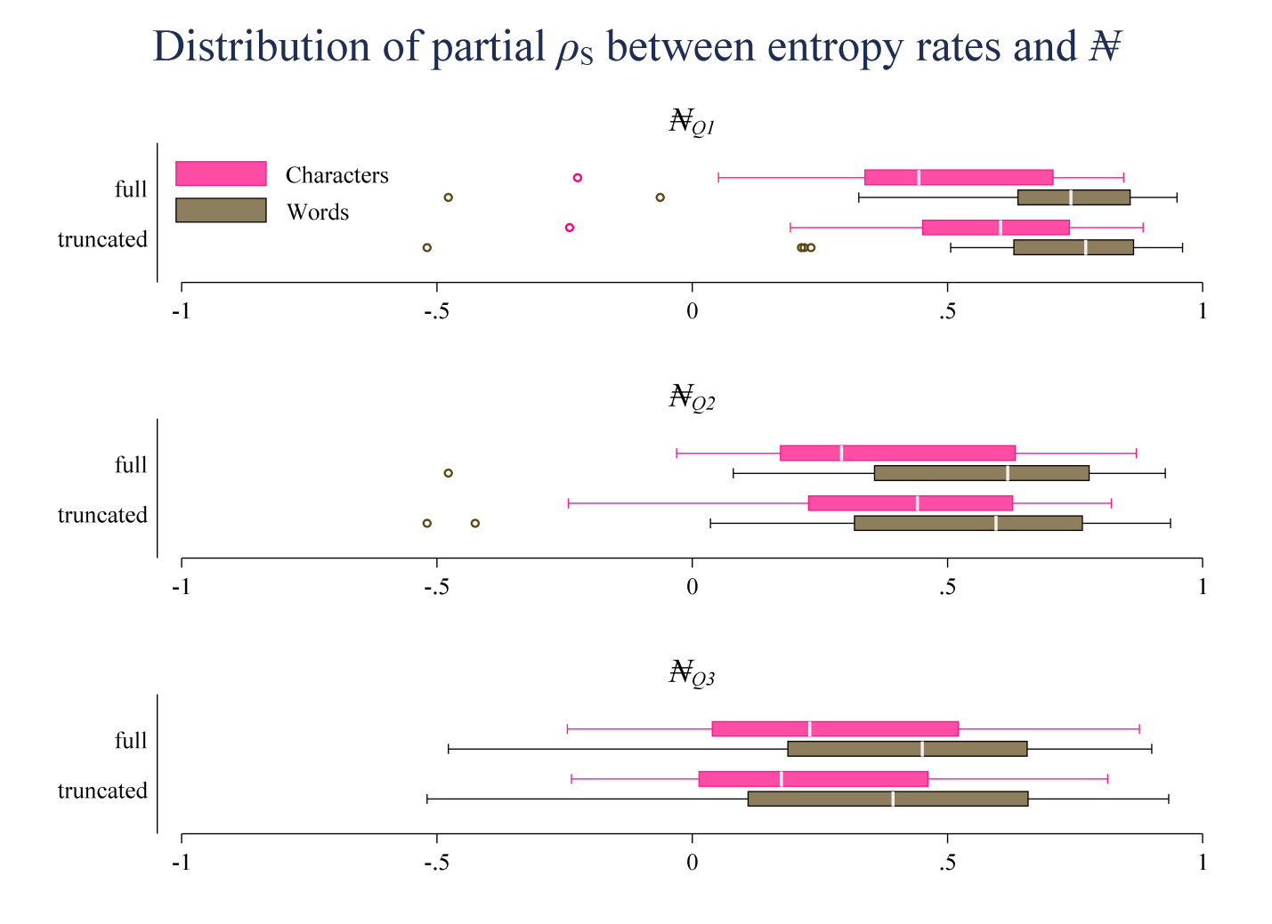
Supplementary Figure 20 | Relationship between h and ₦. For each corpus, on both symbolic levels (characters/words) and for both the full and the truncated variant (see section S4), we calculated the partial Spearman correlation between $₦_{Q1}$, $₦_{Q2}$ and $₦_{Q3}$ (described above) and the entropy rate h, after removing the effect of the message length L. Since, as written above, higher values for $₦$ are indicative of faster convergence, a positive correlation between h and $₦$ supports the idea that documents that are harder to predict (i.e. higher h) are faster to learn to predict (i.e. higher $₦$).

Relative standard deviations for h and r
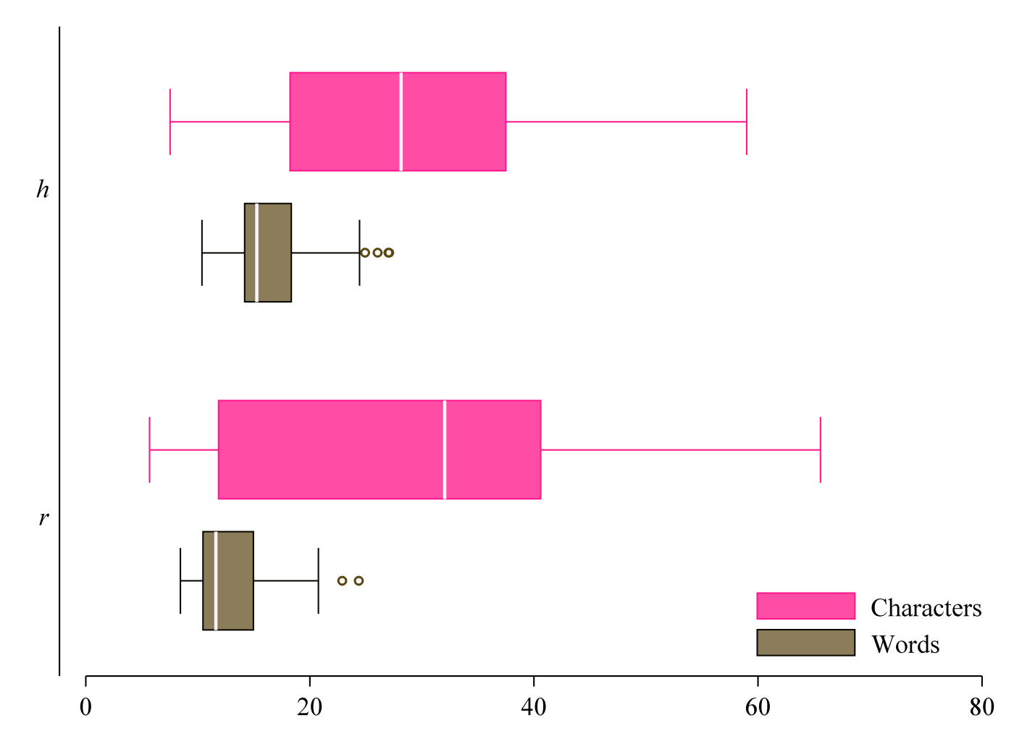
Supplementary Figure 21 | Relative standard deviations (SD) for entropy rates (“h”) and compression rates (“r”) are calculated per corpus and symbol type as the ratio of the standard deviation to the mean (in %). The figure shows that the variability in h is smaller for words than for characters. In 65% of all 40 corpora, the relative SD for h is lower for words than for characters. If we only look at the 50% of corpora with the most available documents (at least 38 individual documents per corpus), then 75% of those 20 corpora display a lower relative SD for words. For r the corresponding percentages are 70% of all corpora and 90% for the 20 largest ones (in terms of available documents).

Evaluating the similarity of complexity rankings

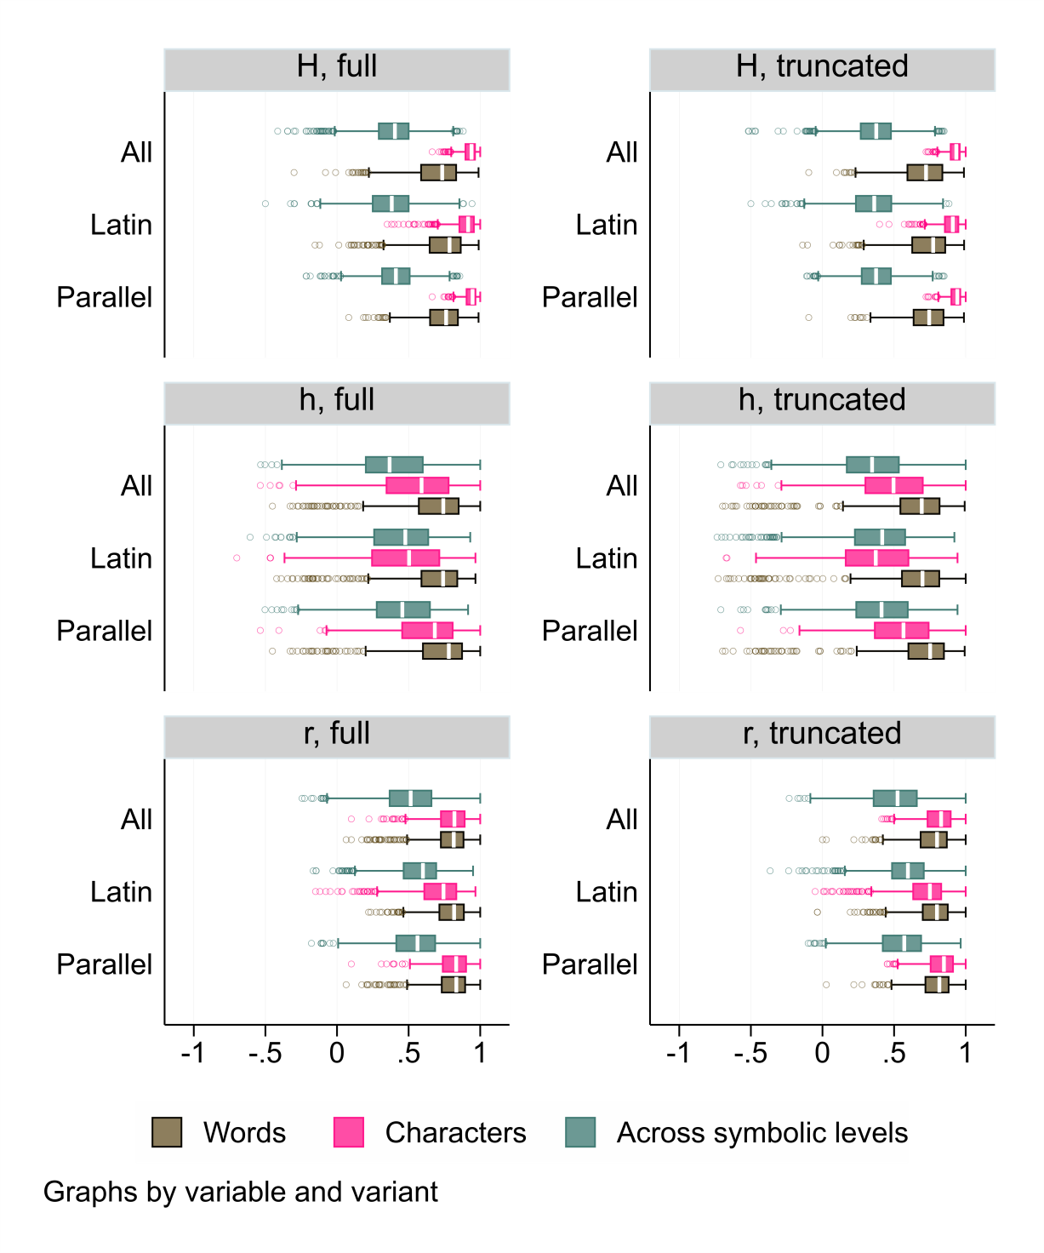
Supplementary Figure 22 | Testing the similarity of complexity rankings. Distribution of pairwise Spearman correlations for H, h and r between all corpus pairs and on/across both symbolic levels (words/characters) for (i) all corpora, (ii) documents that use Latin script and (iii) restricted to fully parallel corpora and for both (a) the full and (b) the truncated variant (see section S4). NB: In each case, computations of ρs were restricted to pairs with at least 5 available shared languages. The plots for H include correlations between H and H_{Crubadan.}

Comparing predictability across languages
As written in the main part of the paper, the small amount of variance explained by K_{obs} and K_{ext} could be the result of the influence of different writing systems (e.g. logographic vs. alphabetic systems) that can have a strong effect on the level of characters (see Figure 2a). If we only include LMMs where both the outcome and the predictor are computed on the level of words, both $R_{med}^{2}$= 2.37% for K_{obs} and $R_{med}^{2}$= 3.01% for K_{ext} are very low compared to all other variables ($R_{med}^{2}$= 26.02% for length, $R_{med}^{2}$= 59.47% for r, $R_{med}^{2}$= 43.41% for h and $R_{med}^{2}$= 37.65% for H). To further test this, we calculated the ratio between (i) the number of times the computed coefficient of determination for the original model was higher than the corresponding coefficient for the permuted model and (ii) the number of times it was lower or equal. If there is no statistical relationship between $V^{c_{1}}$ and $V^{c_{2}}$, we should expect that the ratio is roughly 1. Therefore, the higher the ratio, the stronger the statistical relationship between the two variables.
On the level of words, we find that the ratio is very low for both K_{ext} and K_{obs} (1.54 and 1.68) compared to all other variables (10.76 for length, 17.07 for h, 24.16 for H and 210.71 for r).

Testing different compression algorithms
Supplementary Table 5 | Evaluating three different compression algorithms. 1st column: symbol type. 2nd column: document name (corpus base: EUconst, cf. S3.4.2). 3rd – 5th column: compressed length R in bytes for PPMd, PAQ8l and CMIX. 7th – 8th column: time Ͳ needed for compression in seconds for PPMd, PAQ8l and CMIX. Values in parentheses show the percentage ratio of the value to the corresponding PPMd value, e.g. R_{PAQ8l}/ R_{PPMd} | Values are rounded for illustration purpose only.
 | translation | R_{PPMd} | R_{PAQ8l} | R_{CMIX} | Ͳ_{PPMd} | Ͳ_{PAQ8l} | Ͳ_{CMIX}
Characters | cs | 97,889(100%) | 93,812(96%) | 88,810(91%) | 0.56(100%) | 55.65(9,867%) | 2,417.27(428,595%)
Characters | da | 91,485(100%) | 87,881(96%) | 83,103(91%) | 0.58(100%) | 62.03(10,732%) | 2,402.39(415,638%)
Characters | de | 107,288(100%) | 102,820(96%) | 96,541(90%) | 0.45(100%) | 72.98(16,111%) | 2,971.08(655,867%)
Characters | el | 110,621(100%) | 102,887(93%) | 94,513(85%) | 0.80(100%) | 111.30(13,929%) | 5,658.78(708,233%)
Characters | en | 92,920(100%) | 88,594(95%) | 83,669(90%) | 0.45(100%) | 63.14(13,938%) | 2,470.39(545,340%)
Characters | es | 96,594(100%) | 92,113(95%) | 86,075(89%) | 0.47(100%) | 85.55(18,279%) | 3,297.09(704,507%)
Characters | et | 96,832(100%) | 91,992(95%) | 87,479(90%) | 0.34(100%) | 53.95(15,684%) | 2,338.24(679,719%)
Characters | fi | 99,180(100%) | 94,056(95%) | 89,210(90%) | 0.58(100%) | 75.92(13,135%) | 2,643.03(457,272%)
Characters | fr | 94,596(100%) | 89,863(95%) | 84,156(89%) | 0.56(100%) | 62.03(11,018%) | 2,956.86(525,197%)
Characters | ga | 101,003(100%) | 96,610(96%) | 91,022(90%) | 0.45(100%) | 72.97(16,108%) | 2,718.98(600,217%)
Characters | hu | 110,552(100%) | 105,105(95%) | 99,183(90%) | 0.58(100%) | 81.08(14,027%) | 3,410.19(589,998%)
Characters | it | 95,917(100%) | 91,083(95%) | 85,772(89%) | 0.45(100%) | 62.36(13,766%) | 2,904.77(641,229%)
Characters | lt | 97,239(100%) | 92,780(95%) | 87,805(90%) | 0.56(100%) | 60.06(10,668%) | 2,663.88(473,158%)
Characters | lv | 94,495(100%) | 89,866(95%) | 85,050(90%) | 0.58(100%) | 50.44(8,726%) | 2,210.50(382,439%)
Characters | mt | 97,260(100%) | 92,173(95%) | 86,769(89%) | 0.58(100%) | 61.17(10,583%) | 2,994.38(518,058%)
Characters | nl | 100,079(100%) | 95,825(96%) | 90,704(91%) | 0.56(100%) | 65.97(11,717%) | 2,857.31(507,515%)
Characters | pl | 102,597(100%) | 98,132(96%) | 92,411(90%) | 0.56(100%) | 61.94(11,001%) | 2,412.88(428,575%)
Characters | pt | 83,482(100%) | 80,058(96%) | 75,087(90%) | 0.45(100%) | 48.36(10,675%) | 2,070.78(457,126%)
Characters | sk | 100,880(100%) | 96,708(96%) | 91,288(90%) | 0.56(100%) | 57.77(10,279%) | 2,254.45(401,148%)
Characters | sl | 104,722(100%) | 100,175(96%) | 94,067(90%) | 0.58(100%) | 53.19(9,202%) | 2,775.20(480,139%)
Characters | sv | 96,634(100%) | 92,490(96%) | 87,785(91%) | 0.58(100%) | 60.84(10,508%) | 3,228.81(557,653%)
Words | cs | 100,953(100%) | 92,526(92%) | 89,724(89%) | 0.48(100%) | 32.54(6,723%) | 1,405.97(290,491%)
Words | da | 92,555(100%) | 85,186(92%) | 82,340(89%) | 0.56(100%) | 41.23(7,362%) | 1,471.57(262,780%)
Words | de | 108,209(100%) | 99,787(92%) | 96,422(89%) | 0.45(100%) | 43.89(9,689%) | 1,736.75(383,389%)
Words | el | 107,355(100%) | 98,182(91%) | 94,910(88%) | 0.45(100%) | 43.11(9,516%) | 1,721.97(380,125%)
Words | en | 95,103(100%) | 88,137(93%) | 84,635(89%) | 0.45(100%) | 45.95(10,122%) | 1,749.44(385,339%)
Words | es | 99,833(100%) | 92,069(92%) | 88,456(89%) | 0.34(100%) | 44.53(12,945%) | 1,927.91(560,438%)
Words | et | 100,516(100%) | 91,432(91%) | 88,943(88%) | 0.36(100%) | 35.45(9,848%) | 1,387.56(385,434%)
Words | fi | 101,887(100%) | 92,257(91%) | 89,819(88%) | 0.34(100%) | 31.41(9,130%) | 1,163.80(338,313%)
Words | fr | 98,342(100%) | 90,502(92%) | 87,071(89%) | 0.45(100%) | 43.55(9,613%) | 1,877.67(414,497%)
Words | ga | 105,001(100%) | 96,953(92%) | 93,323(89%) | 0.34(100%) | 44.42(12,913%) | 2,082.86(605,482%)
Words | hu | 116,367(100%) | 106,342(91%) | 102,902(88%) | 0.45(100%) | 44.22(9,761%) | 1,785.98(394,257%)
Words | it | 101,032(100%) | 92,921(92%) | 89,628(89%) | 0.34(100%) | 37.09(10,783%) | 1,743.98(506,972%)
Words | lt | 102,814(100%) | 93,612(91%) | 90,961(88%) | 0.36(100%) | 37.42(10,424%) | 1,343.33(374,187%)
Words | lv | 99,626(100%) | 91,306(92%) | 88,409(89%) | 0.45(100%) | 41.36(9,130%) | 1,501.20(331,391%)
Words | mt | 103,441(100%) | 94,928(92%) | 91,867(89%) | 0.34(100%) | 37.76(11,039%) | 1,530.66(447,563%)
Words | nl | 100,515(100%) | 93,070(93%) | 89,459(89%) | 0.45(100%) | 47.81(10,555%) | 1,875.30(413,973%)
Words | pl | 105,732(100%) | 96,907(92%) | 93,853(89%) | 0.34(100%) | 43.88(12,754%) | 1,862.20(541,338%)
Words | pt | 85,521(100%) | 78,714(92%) | 75,903(89%) | 0.34(100%) | 33.16(9,638%) | 1,487.17(432,318%)
Words | sk | 104,137(100%) | 95,509(92%) | 92,478(89%) | 0.34(100%) | 39.17(11,387%) | 1,614.19(469,240%)
Words | sl | 110,066(100%) | 101,039(92%) | 97,793(89%) | 0.45(100%) | 42.56(9,396%) | 1,798.20(396,955%)
Words | sv | 97,810(100%) | 89,981(92%) | 86,971(89%) | 0.47(100%) | 41.05(8,752%) | 1,733.39(369,593%)

We used the EUconst corpus (see S3.4.2) to evaluate the performance of two different compression algorithms in comparison to 7-zip PPMd. We used two state-of-the-art algorithms, PAQ8l (Mahoney 2005) and CMIX v19 (Knoll 2021). The order of the PPMd model was determined as described above (see S3.1). For PAQ8l, option “-8” was selected to achieve the best compression level. For CMIX, option “n” was selected to compress without preprocessing. In addition, no dictionary was used for pretraining. Supplementary Table 5 shows that both PAQ8l and CMIX achieve better compression lengths than PPMd at the expense of being much slower: on average, compression lengths achieved by PAQ8l on the level of characters are 95.32% the compression lengths achieved by PPMd and 91.80% on the level of characters. For CMIX, corresponding quantities are 89.81% on the level of characters and 88.73% on the level of words. Compared to PPMd, PAQ8l needs – on average – 12,378.88% more computation time on the level of characters and 10,070.53% on the level of words to achieve this level of compression. For CMIX, corresponding quantities are 531,315.50% on the level of characters and 413,527.30% on the level of words.
It is worth pointing out that the Spearman correlations between all three compression lengths are very high on both symbolic levels (all ρ_{s} > 0.979). This supports the results presented in the main part of the paper (cf. Figure 6).

Differences across populations
Note that in the main part of the paper and here, the unigram entropy H was calculated for both symbolic levels based on Methods: equation (1). Further note that languages where information regarding the grouping variables or regarding a speaker population estimate was missing were dropped from the analyses. Due to the limited number of available languages, the UNPC corpus was dropped from these analyses.
The following tables show analyses that are supplementary to Table 2. Supplementary Table 6 shows the LMM results where only fully parallel results are included. The results are qualitatively very similar compared to the unrestricted analyses (cf. Table 2).

Supplementary Table 6 | Results of LMMs that use speaker population size (logged) as fixed effect and (crossed) random intercepts for language, language family, macro-area, country and corpus. Only fully parallel corpora are considered. See Table 2 for a description of the content.
Outcome | Symbol | $${\hat{β}}_{1}$$ | p_{parametric} | $$R_{LMM(m)}^{2}$$ | $$R_{LMM(c)}^{2}$$ | N | AIC_{r} | AIC_{f} | ΔAIC | Permutation test
Entropy rate | Characters | 0.040 | <.000001 | 0.57 | 88.82 | 3,220 | 6668.0 | 6655.1 | 12.9 | 0 of 1,000 (0.000)
Entropy rate | Words | 0.049 | <.000001 | 1.11 | 89.81 | 3,220 | 6318.9 | 6304.7 | 14.2 | 8 of 1,000 (0.008)
Compression rate | Characters | 0.068 | <.0000001 | 1.61 | 94.06 | 3,220 | 4925.4 | 4821.7 | 103.7 | 0 of 1,000 (0.000)
Compression rate | Words | 0.063 | <.0000001 | 1.69 | 94.43 | 3,220 | 5162.0 | 5131.2 | 30.9 | 19 of 1,000 (0.019)
Unigram entropy | Characters | 0.032 | <.00001 | 0.47 | 94.06 | 3,220 | 4394.0 | 4384.7 | 9.3 | 76 of 1,000 (0.076)
Unigram entropy | Words | 0.059 | <.0000001 | 2.01 | 87.67 | 3,220 | 6161.2 | 6136.1 | 25.1 | 3 of 1,000 (0.003)
Message length | Characters | -0.062 | <.0000001 | 1.50 | 87.57 | 3,220 | 7034.0 | 7005.8 | 28.2 | 2 of 1,000 (0.002)
Message length | Words | -0.071 | <.0000001 | 1.94 | 88.68 | 3,220 | 7098.7 | 7068.5 | 30.2 | 4 of 1,000 (0.004)

As explained in Methods: Differences across populations, outcomes were standardized per corpus. Standardization-per-corpus effectively reduces the strong corpus-specific influence due to differences in content and especially text length. For example, corpora like UDHR or the subtitle corpora have median lengths of only a couple of thousand words, while corpora like BibleOT, BibleNT, Europarl, EUmed or UNPC are several million words long (see Supplementary Table 3). Since we are interested in finding out if x systematically affects the relative location of y within different corpora, standardization also makes sense from a theoretical perspective. In Supplementary Table 7, we show that logging outcomes instead of standardizing also supports the conclusions.

Supplementary Table 7 | Results of LMMs that use speaker population size (logged) as fixed effect and (crossed) random intercepts for language, language family, macro-area, country, corpus and writing system. Here, the outcome variables are logged instead of standardized per corpus. See Table 2 for a description of the content.
Outcome | Symbol | $${\hat{β}}_{1}$$ | p_{parametric} | $$R_{LMM(m)}^{2}$$ | $$R_{LMM(c)}^{2}$$ | N | AIC_{r} | AIC_{f} | ΔAIC | Permutation test
Entropy rate | Characters | 0.011 | <.0000001 | 0.27 | 95.75 | 3,849 | -2914.3 | -2932.5 | 18.2 | 1 of 1,000 (0.001)
Entropy rate | Words | 0.015 | <.0000001 | 0.52 | 96.31 | 3,849 | -2675.4 | -2697.2 | 21.8 | 16 of 1,000 (0.016)
Compression rate | Characters | 0.013 | <.0000001 | 0.80 | 96.71 | 3,849 | -6460.1 | -6535.0 | 74.9 | 0 of 1,000 (0.000)
Compression rate | Words | 0.016 | <.0000001 | 1.53 | 95.35 | 3,849 | -5164.7 | -5202.9 | 38.1 | 24 of 1,000 (0.024)
Unigram entropy | Characters | 0.002 | <.005 | 0.16 | 96.68 | 3,849 | -14750.9 | -14746.3 | -4.6 | 25 of 100 (0.250)
Unigram entropy | Words | 0.007 | <.0000001 | 1.82 | 92.39 | 3,849 | -10538.4 | -10576.0 | 37.6 | 10 of 1,000 (0.010)
Message length | Characters | -0.013 | <.0000001 | 0.03 | 99.63 | 3,849 | -2677.0 | -2701.9 | 24.9 | 0 of 1,000 (0.000)
Message length | Words | -0.016 | <.0000001 | 0.05 | 99.62 | 3,849 | -2181.6 | -2203.1 | 21.5 | 4 of 1,000 (0.004)

Supplementary Table 8 demonstrates that the results do not support the idea that several environmental variables (within-country linguistic diversity, geographical range, altitude, climate, distance to water resources, latitude) also predict entropy/efficiency (see S4 for details).

Supplementary Table 8 | Results of LMMs that use geographical range size (logged), H_{D}, altitude, Climate (PC1), Climate (PC2), distance-to-water and latitude (measured as absolute distance to 15° north) as (separate) fixed effect and (crossed) random intercepts for language, language family, macro-area, country, corpus and writing system (N = 3,597). 1st column: predictor (fixed), 2nd column: outcome variable (standardized per corpus); abbreviations: h – entropy rate; r – compression rate; H – unigram entropy; H_{Cru} – unigram entropy based on the Crúbadán data; L – message length. 3rd column: symbol type. 4th column: estimated β₁. 5th column: p-value based on parametric significance tests. 6th column: marginal R² of the model, i.e. explained variance by the predictor (%). 7th column: conditional R² of the model, i.e. explained variance by both the fixed factor and the random intercepts (%). 8th column: number of cases; 9th column: AIC of the reduced model, i.e. a LMM with no fixed factor but only the random intercepts. 10th column: AIC of the full model. 11th column: difference in AIC, i.e. AIC_{r} – AIC_{f}. 12th column: Result of the permutation test, i.e. count of $\left|{{\hat{β}}_{1}^{*}}/{{\hat{σ}}_{{\hat{β}}_{1}^{*}}}\right|≥\left|{{\hat{β}}_{1}}/{{\hat{σ}}_{{\hat{β}}_{1}}}\right|$ in relation to the number of repetitions. The p-value in parentheses is calculated as that count divided by the number of repetitions. NB: If the p-value after 100 repetitions was below .1, the test was re-run with 1,000 repetitions.
Pred. | Out. | Symbol | $${\hat{β}}_{1}$$ | p_{parametric} | $$R_{LMM(m)}^{2}$$ | $$R_{LMM(c)}^{2}$$ | N | AIC_{r} | AIC_{f} | ΔAIC | Permutation test
Altitude | h | Characters | -0.011 | 0.3756 | 0.01 | 88.92 | 3,709 | 7528.2 | 7536.3 | -8.1 | 36 of 100 (0.360)
Altitude | h | Words | 0.030 | 0.0780 | 0.08 | 88.51 | 3,709 | 7451.5 | 7456.8 | -5.3 | 62 of 100 (0.620)
Altitude | r | Characters | -0.027 | <.01 | 0.05 | 94.35 | 3,709 | 5497.8 | 5500.4 | -2.6 | 35 of 1,000 (0.035)
Altitude | r | Words | 0.024 | 0.1375 | 0.05 | 93.31 | 3,709 | 6182.8 | 6189.0 | -6.2 | 51 of 100 (0.510)
Altitude | H | Characters | -0.005 | 0.6718 | 0.00 | 94.35 | 3,709 | 4736.7 | 4745.6 | -9.0 | 87 of 100 (0.870)
Altitude | H_{Cru} | Words | 0.027 | 0.1819 | 33.38 | 89.83 | 1,841 | 5255.7 | 5261.9 | -6.2 | 30 of 100 (0.300)
Altitude | H | Words | 0.035 | <.05 | 0.13 | 85.73 | 3,709 | 7428.0 | 7431.9 | -3.9 | 24 of 100 (0.240)
Altitude | L | Characters | 0.051 | <.005 | 0.22 | 83.28 | 3,709 | 8442.6 | 8440.9 | 1.7 | 31 of 1,000 (0.031)
Altitude | L | Words | 0.010 | 0.5855 | 0.01 | 86.36 | 3,709 | 8397.7 | 8405.6 | -7.9 | 51 of 100 (0.510)
Climate (PC1) | h | Characters | -0.001 | 0.8777 | 0.00 | 89.08 | 3,849 | 7816.7 | 7826.2 | -9.5 | 77 of 100 (0.770)
Climate (PC1) | h | Words | -0.065 | <.000001 | 1.98 | 87.84 | 3,849 | 7757.4 | 7743.1 | 14.3 | 11 of 100 (0.110)
Climate (PC1) | r | Characters | -0.023 | <.005 | 0.17 | 94.32 | 3,849 | 5699.0 | 5700.3 | -1.2 | 16 of 100 (0.160)
Climate (PC1) | r | Words | -0.068 | <.0000001 | 2.03 | 92.97 | 3,849 | 6438.9 | 6420.8 | 18.1 | 45 of 1,000 (0.045)
Climate (PC1) | H | Characters | -0.012 | 0.1442 | 0.07 | 94.38 | 3,849 | 4888.8 | 4896.4 | -7.7 | 14 of 100 (0.140)
Climate (PC1) | H_{Cru} | Words | -0.057 | <.00001 | 1.83 | 85.59 | 3,849 | 7676.8 | 7667.0 | 9.8 | 28 of 1,000 (0.028)
Climate (PC1) | H | Words | -0.075 | <.0000005 | 34.71 | 89.38 | 1,914 | 5432.3 | 5416.9 | 15.4 | 26 of 1,000 (0.026)
Climate (PC1) | L | Characters | 0.017 | 0.1621 | 0.11 | 84.89 | 3,849 | 8784.7 | 8791.8 | -7.1 | 49 of 100 (0.490)
Climate (PC1) | L | Words | 0.055 | <.0001 | 1.19 | 86.32 | 3,849 | 8732.8 | 8727.5 | 5.4 | 19 of 100 (0.190)
Climate (PC2) | h | Characters | 0.012 | 0.2865 | 0.02 | 89.20 | 3,849 | 7816.7 | 7824.7 | -8.0 | 29 of 100 (0.290)
Climate (PC2) | h | Words | -0.017 | 0.2748 | 0.05 | 88.33 | 3,849 | 7757.4 | 7764.7 | -7.3 | 78 of 100 (0.780)
Climate (PC2) | r | Characters | 0.004 | 0.6445 | 0.00 | 94.51 | 3,849 | 5699.0 | 5708.3 | -9.3 | 53 of 100 (0.530)
Climate (PC2) | r | Words | -0.022 | 0.1449 | 0.09 | 93.23 | 3,849 | 6438.9 | 6445.4 | -6.5 | 61 of 100 (0.610)
Climate (PC2) | H | Characters | -0.023 | <.05 | 0.10 | 94.43 | 3,849 | 4888.8 | 4893.3 | -4.5 | 25 of 1,000 (0.025)
Climate (PC2) | H_{Cru} | Words | -0.038 | <.05 | 0.33 | 86.01 | 3,849 | 7676.8 | 7679.2 | -2.4 | 29 of 100 (0.290)
Climate (PC2) | H | Words | -0.011 | 0.5581 | 33.48 | 89.68 | 1,914 | 5432.3 | 5440.2 | -7.8 | 45 of 100 (0.450)
Climate (PC2) | L | Characters | -0.021 | 0.1440 | 0.07 | 85.59 | 3,849 | 8784.7 | 8791.2 | -6.5 | 70 of 1,000 (0.070)
Climate (PC2) | L | Words | 0.007 | 0.6681 | 0.01 | 86.53 | 3,849 | 8732.8 | 8741.0 | -8.1 | 73 of 100 (0.730)
Distance to water | h | Characters | -0.010 | 0.5786 | 0.00 | 89.08 | 3,849 | 7816.7 | 7824.6 | -8.0 | 58 of 100 (0.580)
Distance to water | h | Words | -0.001 | 0.9657 | 0.00 | 88.38 | 3,849 | 7757.4 | 7765.3 | -7.9 | 92 of 100 (0.920)
Distance to water | r | Characters | -0.028 | <.05 | 0.03 | 94.45 | 3,849 | 5699.0 | 5703.6 | -4.6 | 113 of 1,000 (0.113)
Distance to water | r | Words | -0.002 | 0.9028 | 0.00 | 93.25 | 3,849 | 6438.9 | 6446.9 | -7.9 | 89 of 100 (0.890)
Distance to water | H | Characters | 0.011 | 0.4322 | 0.01 | 94.45 | 3,849 | 4888.8 | 4896.8 | -8.0 | 41 of 100 (0.410)
Distance to water | H_{Cru} | Words | 0.010 | 0.7089 | 33.33 | 89.69 | 1,914 | 5432.3 | 5439.7 | -7.3 | 60 of 100 (0.600)
Distance to water | H | Words | 0.010 | 0.6220 | 0.01 | 85.93 | 3,849 | 7676.8 | 7684.5 | -7.7 | 54 of 100 (0.540)
Distance to water | L | Characters | 0.053 | <.05 | 0.11 | 85.08 | 3,849 | 8784.7 | 8786.4 | -1.7 | 26 of 100 (0.260)
Distance to water | L | Words | 0.023 | 0.3192 | 0.02 | 86.57 | 3,849 | 8732.8 | 8739.5 | -6.7 | 45 of 100 (0.450)
Latitude | h | Characters | 0.006 | <.01 | 0.53 | 88.67 | 3,849 | 7816.7 | 7822.3 | -5.6 | 18 of 100 (0.180)
Latitude | h | Words | 0.002 | 0.4829 | 0.13 | 88.28 | 3,849 | 7757.4 | 7768.5 | -11.1 | 69 of 100 (0.690)
Latitude | r | Characters | 0.008 | <.00001 | 1.01 | 94.13 | 3,849 | 5699.0 | 5693.0 | 6.0 | 58 of 1,000 (0.058)
Latitude | r | Words | 0.003 | 0.4128 | 0.17 | 93.18 | 3,849 | 6438.9 | 6449.8 | -10.8 | 64 of 100 (0.640)
Latitude | H | Characters | 0.005 | <.05 | 0.45 | 94.33 | 3,849 | 4888.8 | 4896.9 | -8.1 | 42 of 100 (0.420)
Latitude | H_{Cru} | Words | 0.008 | <.05 | 33.95 | 89.55 | 1,914 | 5432.3 | 5439.8 | -7.5 | 19 of 100 (0.190)
Latitude | H | Words | -0.000 | 0.8946 | 0.01 | 86.00 | 3,849 | 7676.8 | 7688.3 | -11.5 | 78 of 100 (0.780)
Latitude | L | Characters | -0.012 | <.00005 | 2.97 | 82.90 | 3,849 | 8784.7 | 8779.6 | 5.1 | 31 of 1,000 (0.031)
Latitude | L | Words | -0.008 | <.05 | 1.14 | 86.34 | 3,849 | 8732.8 | 8739.9 | -7.1 | 33 of 100 (0.330)
Ling. diversity | h | Characters | 0.024 | 0.1580 | 0.07 | 89.38 | 3,597 | 7237.7 | 7244.2 | -6.5 | 30 of 100 (0.300)
Ling. diversity | h | Words | -0.020 | 0.5805 | 0.06 | 88.62 | 3,597 | 7229.0 | 7235.5 | -6.5 | 67 of 100 (0.670)
Ling. diversity | r | Characters | -0.041 | <.01 | 0.19 | 94.63 | 3,597 | 5250.6 | 5252.0 | -1.4 | 14 of 100 (0.140)
Ling. diversity | r | Words | -0.046 | 0.2245 | 0.32 | 93.39 | 3,597 | 6024.9 | 6030.1 | -5.2 | 65 of 100 (0.650)
Ling. diversity | H | Characters | 0.001 | 0.9690 | 0.00 | 94.38 | 3,597 | 4574.5 | 4582.5 | -8.0 | 95 of 100 (0.950)
Ling. diversity | H_{Cru} | Words | -0.038 | 0.3054 | 0.28 | 86.42 | 3,597 | 7141.2 | 7146.8 | -5.7 | 61 of 100 (0.610)
Ling. diversity | H | Words | -0.116 | <.05 | 30.99 | 90.02 | 1,785 | 5044.6 | 5045.3 | -0.7 | 22 of 100 (0.220)
Ling. diversity | L | Characters | 0.017 | 0.4827 | 0.04 | 85.56 | 3,597 | 8156.3 | 8163.3 | -7.1 | 44 of 100 (0.440)
Ling. diversity | L | Words | 0.039 | 0.2926 | 0.21 | 86.44 | 3,597 | 8211.5 | 8217.2 | -5.7 | 38 of 100 (0.380)
Range size | h | Characters | 0.024 | <.01 | 0.14 | 89.06 | 3,710 | 7500.2 | 7502.9 | -2.7 | 5 of 1,000 (0.005)
Range size | h | Words | 0.033 | <.005 | 0.35 | 88.46 | 3,710 | 7481.2 | 7482.3 | -1.1 | 28 of 100 (0.280)
Range size | r | Characters | 0.048 | <.0000001 | 0.56 | 94.41 | 3,710 | 5388.6 | 5350.8 | 37.8 | 0 of 1,000 (0.000)
Range size | r | Words | 0.046 | <.00005 | 0.65 | 93.33 | 3,710 | 6217.2 | 6210.1 | 7.1 | 11 of 100 (0.110)
Range size | H | Characters | 0.006 | 0.4119 | 0.01 | 94.52 | 3,710 | 4680.2 | 4689.3 | -9.2 | 39 of 100 (0.390)
Range size | H_{Cru} | Words | 0.084 | <.0000001 | 34.47 | 90.09 | 1,856 | 5235.9 | 5208.8 | 27.1 | 4 of 1,000 (0.004)
Range size | H | Words | 0.039 | <.001 | 0.61 | 85.63 | 3,710 | 7439.6 | 7437.2 | 2.4 | 13 of 100 (0.130)
Range size | L | Characters | -0.028 | <.05 | 0.21 | 85.05 | 3,710 | 8443.8 | 8446.7 | -2.9 | 9 of 1,000 (0.009)
Range size | L | Words | -0.039 | <.005 | 0.43 | 86.56 | 3,710 | 8434.4 | 8433.7 | 0.7 | 36 of 1,000 (0.036)
Next, we tested whether speaker population size is associated with the observed compressed length K_{obs} or the extrapolated compressed length K_{ext}. Supplementary Table 9 presents the results.

Supplementary Table 9 | Results of LMMs that use speaker population size (logged) as fixed effect and (crossed) random intercepts for language, language family, macro-area, country, corpus and writing system. See Table 2 for a description of the content. NB.: empty cells in the 12th column indicate that the corresponding (full and/or reduced) models did not converge. Abbreviations: K_{ext} – extrapolated compressed length; K_{obs} – observed compressed length.
Out. | Version | Symbol | $${\hat{β}}_{1}$$ | p_{parametric} | $$R_{LMM(m)}^{2}$$ | $$R_{LMM(c)}^{2}$$ | N | AIC_{r} | AIC_{f} | ΔAIC | Permutation test
K_{ext} | all | Characters | -0.019 | <.05 | 0.37 | 28.61 | 3,849 | 10540.7 | 10546.4 | -5.7
K_{ext} | all | Words | 0.000 | 0.9709 | 0.00 | 36.17 | 3,849 | 10620.1 | 10629.6 | -9.5
K_{ext} | parallel | Characters | -0.047 | <.000005 | 2.27 | 34.20 | 3,220 | 8665.8 | 8654.5 | 11.3
K_{ext} | parallel | Words | -0.021 | <.05 | 0.42 | 37.73 | 3,220 | 8811.8 | 8817.3 | -5.5
K_{obs} | all | Characters | -0.006 | 0.5975 | 0.03 | 49.33 | 3,849 | 10248.4 | 10257.3 | -8.9 | 29 of 100 (0.290)
K_{obs} | all | Words | -0.003 | 0.7554 | 0.01 | 55.78 | 3,849 | 10361.1 | 10370.2 | -9.1 | 62 of 100 (0.620)
K_{obs} | parallel | Characters | -0.023 | <.05 | 0.47 | 52.09 | 3,220 | 8452.5 | 8457.8 | -5.3 | 105 of 1,000 (0.105)
K_{obs} | parallel | Words | -0.020 | 0.0805 | 0.30 | 57.34 | 3,220 | 8619.4 | 8625.5 | -6.1 | 97 of 1,000 (0.097)

Finally, we included covariates in our crossed-effects models, outcomes (r, h, H or L) were standardized per corpus and we ran separate models both for (i) all available data points and (ii) with a restriction to fully parallel corpora. Each (initial) model contains (i) a fixed effect for the (logged) speaker population size, (ii) random intercepts for language, writing system, language family, macro-area and corpus and (iii) random slopes for corpus, language family, macro-area and writing system. Extending Methods: equation (16) to allow for random slopes yields the following model structure:
 | $$y_{tkmgwi}=β_{0}+κ_{0k}+μ_{0m}+ς_{0g}+ϖ_{0w}+ι_{0i}+\left(β_{1}+ς_{1g}+μ_{1m}+ϖ_{1w}\right)·x_{tkmgwi}+ε_{tkmgwi}$$ | [S2]
for t = 1,…, T different texts, k = 1,…, K corpora, m = 1,..., M macro-areas, g = 1,…, G language families, w = 1,…, W writing systems and i = 1,…, I languages, all i.i.d. and independently.
Supplementary Table 10 | Results of LMMs that use (i) speaker population size (logged) as fixed effect and (ii) initial models containing (crossed) random intercepts for language, language family, macro-area, corpus and writing system and (iii) random slopes for corpus, language family, macro-area and writing system. 1st column: outcome variable; abbreviations: h – entropy rate; r – compression rate; H – unigram entropy; H_{Cru} – unigram entropy based on the Crúbadán data; L – message length. 2nd column: symbol type. 3rd column: version (all – all available documents, parallel – only fully parallel corpora). 4th column: number of cases. 5th column: estimated β₁. 6th column: p-value based on parametric significance tests. 7th column: included (crossed) random effects. 8th column: included random slopes. 9th column: indicator if convergence to a global maximum has been achieved (yes/no).
Out. | Symbol | Version | N | $${\hat{β}}_{1}$$ | p_{parametric} | Random effects | Random slopes | Converged
h | Characters | all | 3,849 | 0.084 | <.000005 | corpus, language, family, macro-area | language family, macro-area, corpus | yes
h | Characters | parallel | 3,220 | 0.072 | <.00005 | corpus, language, family, macro-area | language family, macro-area, corpus | yes
h | Words | all | 3,849 | 0.078 | <.000005 | corpus, language, writing system, language family, macro-area | language family, macro-area, corpus | yes
h | Words | parallel | 3,220 | 0.069 | <.00005 | corpus, language, writing system, language family, macro-area | language family, macro-area, corpus | yes
r | Characters | all | 3,849 | 0.075 | <.0001 | corpus, language, family, macro-area | language family, macro-area, corpus | yes
r | Characters | parallel | 3,220 | 0.067 | <.005 | corpus, language, family, macro-area | language family, macro-area, corpus | yes
r | Words | all | 3,849 | 0.089 | <.0005 | corpus, language, writing system, language family, macro-area | language family, macro-area, corpus | no
r | Words | parallel | 3,220 | 0.087 | <.001 | corpus, language, writing system, language family, macro-area | language family, macro-area, corpus | yes
H | Characters | all | 3,849 | 0.050 | <.05 | corpus, language, family, macro-area | language family, macro-area, corpus | yes
H | Characters | parallel | 3,220 | 0.006 | 0.6801 | corpus, language, writing system, language family, macro-area | language family, macro-area, corpus | yes
H | Words | all | 3,849 | 0.087 | <.0005 | corpus, language, writing system, language family, macro-area | language family, macro-area, corpus | yes
H_{Cru} | Words | all | 1,914 | 0.165 | <.00001 | language, writing system, language family, macro-area | language family, macro-area, writing system | yes
H | Words | parallel | 3,220 | 0.085 | <.005 | corpus, language, writing system, language family, macro-area | language family, macro-area, corpus | yes
L | Characters | all | 3,849 | -0.054 | <.001 | corpus, language, family, macro-area | language family, macro-area, corpus | yes
L | Characters | parallel | 3,220 | -0.034 | <.05 | corpus, language, writing system, language family, macro-area | language family, macro-area, corpus | no
L | Words | all | 3,849 | -0.060 | <.05 | corpus, language, family, macro-area | language family, macro-area, corpus | no
L | Words | parallel | 3,220 | -0.065 | <.001 | corpus, language, writing system, language family, macro-area | language family, macro-area, corpus | yes

Again, $x$denotes the (logged) speaker population size. The random intercepts per corpus, language, macro-area, writing system and language family are denoted as $κ_{0k}$,$ι_{0i}$, $μ_{0m}$,$ϖ_{0w}$ and $ς_{0g}$, while $κ_{1k}$, $μ_{1m}$,$ϖ_{1w}$and $ς_{1g}$ denote random slopes per corpus, macro-area, writing system and language family. Models were fitted by REML with gradient-based maximization first. If gradient-based maximization did not converge, models were re-fitted with EM with a maximum of 100 iterations after which we accepted any solution. Since convergence turned out to be difficult for this model structure, we simplified as follows: if the model above produced an error message, we simplified the model structure by removing the random slope for writing system. We then also removed the random intercept for writing system. If this model structure still produced an error message, we also removed the random slope for corpus. Supplementary Table 10 shows that the parametric p-values are below .05 in all but one of the 17 models. In 75% of those models, the p-value is below .005. The results are qualitatively very similar to the analyses without random slopes and thus support the overall conclusions.

It is important to emphasize that statistical models make assumptions and "the reliability of results obtained from a model depends on to what extent the assumptions of the model are met" (Jaeger et al. 2011). Given the inherent complexity of both our dataset (see Figure 1) and the model structures that we fitted in this section, testing the assumptions can be difficult (Jaeger et al. 2011). All in all, we nonetheless believe that our analyses support the existence of a relationship between speaker population size and the efficiency-complexity (or length-entropy) trade-off due to several reasons:
- To account for the relatedness between documents and languages, we included several random effects in a linear mixed effects modelling framework. This is important, because "multilevel models compromise between pooled and unpooled estimates, with the relative weights determined by the sample size in the group and the variation within and between groups." (Gelman & Hill 2007) – here complete pooling would mean that potential group indicators (e.g. language family or writing system) are not included in the model, while no pooling would mean to fit separate models within each group. Both approaches do not seem justified: on the one hand, the first approach would ignore obviously existing genealogical and geographic relationships between within groups. On the other hand, the second approach overstates variation between grouping factors, i.e. it overfits the data within groups (Gelman & Hill 2007). Therefore, we believe Jaeger et al. (2011) are right to claim that "[m]ixed models hence promise to be a particularly useful tool for quantitative typological research, as typological research frequently faces serious challenges from data sparseness and additional data are difficult or impossible to gather".
- We used three different approaches (parametric, information-theoretic and non-parametric permutation) to evaluate our models and tested whether (i) different restrictions on our database (all documents vs. fully parallel only) and (ii) different transformations of the outcome variables (standardized per corpus vs. logged) affect the results, see Table 2, Supplementary Table 6 and Supplementary Table 7. For both (i) and (ii), all three approaches support both (a) the existence of a positive statistical relationship between entropic variables and speaker population size and (b) the existence of a negative statistical relationship between length and speaker population size. In addition, comparatively high conditional R²-values (Nakagawa & Schielzeth 2013) , i.e. variance explained by the entire models (both fixed and random factors) indicate that much of the variability in the data can be explained by our models. While, rather expectedly, most variability resides in the random effects (Nakagawa & Schielzeth 2013), marginal R²-values show a small but consistent influence of speaker population size.
- The parametric test also supports this conclusion if we allow the effect of speaker population size to vary across grouping factors (Supplementary Table 10).
- Further analyses do not support the existence of a relationship between entropy and length on the one hand and several other environmental variables on the other hand (Supplementary Table 8). This indicates that the approaches do not support the inclusion of just any predictor.
- As a complement to (4.), Supplementary Table 9 shows that our approaches do not support a relationship between just any outcome and speaker population size as predictor.
- In the section below (S13), we show that the results also tend to hold within individual corpora once we account for the fact that parallel corpora that consist of only a very limited number of documents tend to be biased towards languages with more speakers.
- Compared to parametric tests, permutation tests have important advantages. Importantly, they make fewer assumptions. For example they do not assume normally distributed errors, homoscedasticity and random sampling (Winkler et al. 2014). For each reduced model that forms the basis of permuting residuals, we used the standardized residuals to visually inspect the error distributions for potential trends or patterns (Rabe-Hesketh & Skrondal 2012). While all distributions approach normality upon visual inspection, we noted that in most cases, there are few outliers (around 1% have an absolute standardized residual > 3) which is not surprising given the complexity of our database as explained above. To the best of our knowledge, systematic reviews regarding potential problems due to such outliers do not exist yet. In addition, while permutation tests including the Freedman-Lane approach have been thoroughly tested for complex general linear models (Winkler et al. 2014), the only applications of the Freedman-Lane method for linear mixed models that we are aware of are Koplenig (2021) and Koplenig (2019). We refer the reader to Koplenig (2021; section 3 of the ancillary material), where (i) it is demonstrated that the permutation test is able to correctly classify true null hypotheses (i.e. 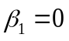) as such and (ii) it is shown, by artificially inflating the influence of different grouping factors in a simulation scenario, that the Freedman-Lane permutation test is also able to control for this variation between groups. For the present analyses, we believe that these results strengthen the conclusion that the relationship between the entropy-length trade-off and speaker population size cannot be "regarded as some sort of artifact [but] require[s] a more substantial explanation" (Freedman & Lane 1983). While we do not, of course, believe that speaker population size directly impacts the entropy-length trade-off, we believe that speaker population size is a proxy that is – to a certain extent – collinear with a covariate that belongs in the true model, i.e. moderates the entropy-length trade-off. Finding suitable candidates for such covariates is an interesting avenue for future research.

Individual regressions
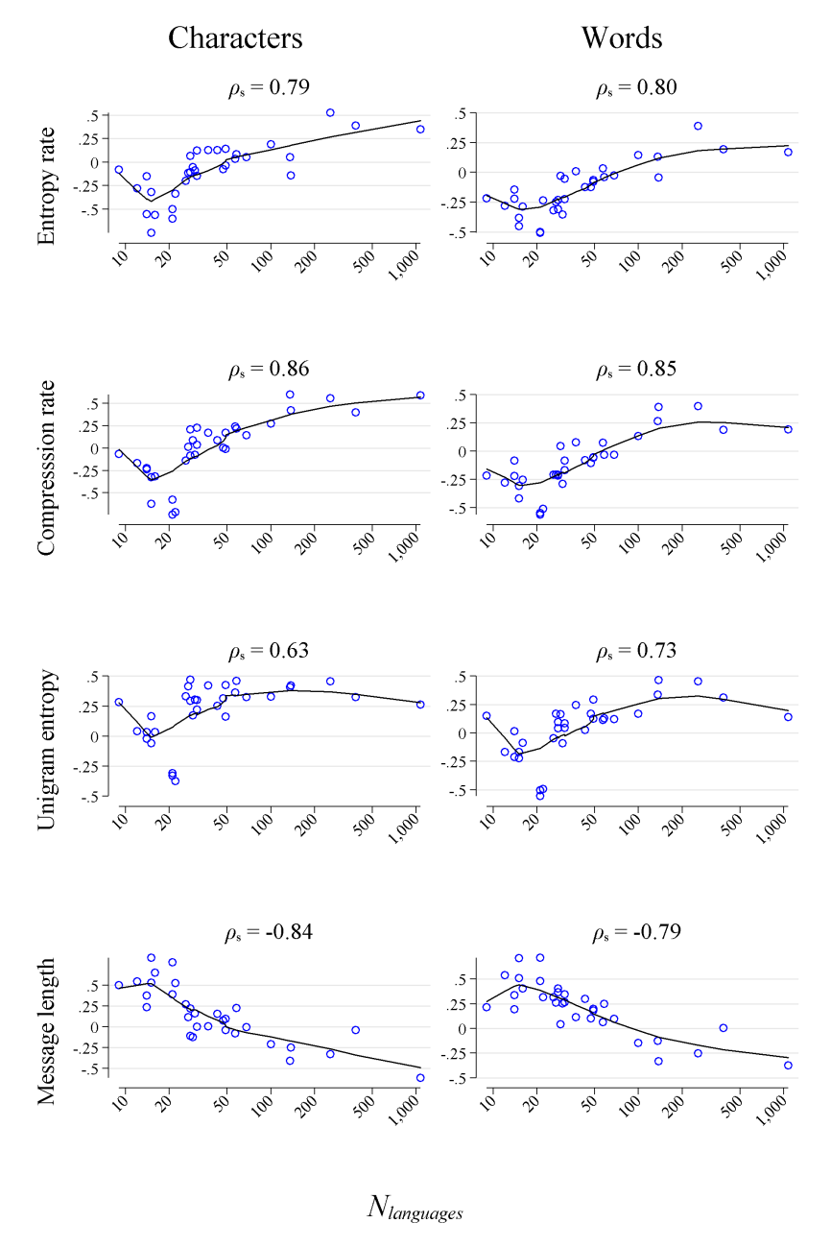
Supplementary Figure 23 | Spearman correlations between speaker population size and the following four variables: h – the entropy rate, r – the compression rate, H – the unigram entropy and the L – the message length as a function of the number of languages that the corpus consists of, denoted as N_{languages}. Each blue circle represents the correlation for one parallel corpus as explained in section S13 (ρ_{s} denote the Spearman’s correlation coefficients between the correlation coefficients and N_{languages}; solid lines depict locally weighted scatterplot smoothers based on regressions of yvar on xvar).

For the following analyses, we used 32 fully parallel corpora and used all languages for which there was available information on speaker population size. We randomly sampled one data point per language (ISO), per symbol type and per corpus.
Per corpus, we then calculated the Spearman correlation between population size and one of the following four variables: h, r, H and L. On the level of characters, we find that the median correlations are -0.08 for h, 0.02 for r, 0.30 for H and 0.10 for L. On the level of words, the corresponding quantities are -0.15 for h, -0.11 for r, 0.10 for H and 0.25 for L. At first glance, this clearly seems to both question one of our main conclusions that languages with more speakers tend to be more complex but also tend to produce shorter messages and contradict the strong pairwise intra-correlations (see Figure 4). However, as mentioned above, most parallel corpora only consist of a very limited number of documents (see Supplementary Table 3). This is important because smaller corpora tend to be biased towards languages with more speakers. For example the Spearman correlation between the number of available languages N_{languages} in a corpus and the median speaker population size of that corpus amounts to -0.55. To see why this is important, we plotted each correlation coefficient against N_{languages} in Supplementary Figure 23. For corpora consisting of only a small number of languages, there seems to be a tendency in the opposite direction, i.e. lower complexity but longer documents. Only for corpora with a higher number of documents, the conclusion of higher complexity but shorter messages holds. It is important to emphasize that results based on corpora that consist of several hundred documents are much more reliable than results based on a corpus consisting of only a handful of documents. Correspondingly, if we calculate median correlations for all corpora that consist of at least 75 different languages (N = 6), the resulting median correlations are 0.27 for h, 0.49 for r, 0.37 for H and -0.29 for L on the level of characters and 0.16 for h, 0.23 for r, 0.33 for H and -0.20 for L on the level of words. To further illustrate this, we replicated an analysis presented in Koplenig (2021) for our dataset. Here, we calculated all correlation coefficients, but replaced each variable value by its corresponding counterpart found in the BibleNT corpus. For example, the original Europarl corpus consists of 21 languages. For 20 of those languages, we also have available information in the BibleNT corpus. Based on information for those 20 languages, the Spearman correlation between speaker population size and the four different variables is calculated again. Supplementary Figure 24 shows that the results qualitatively strongly resemble the results based on the original data shown in Supplementary Figure 23.
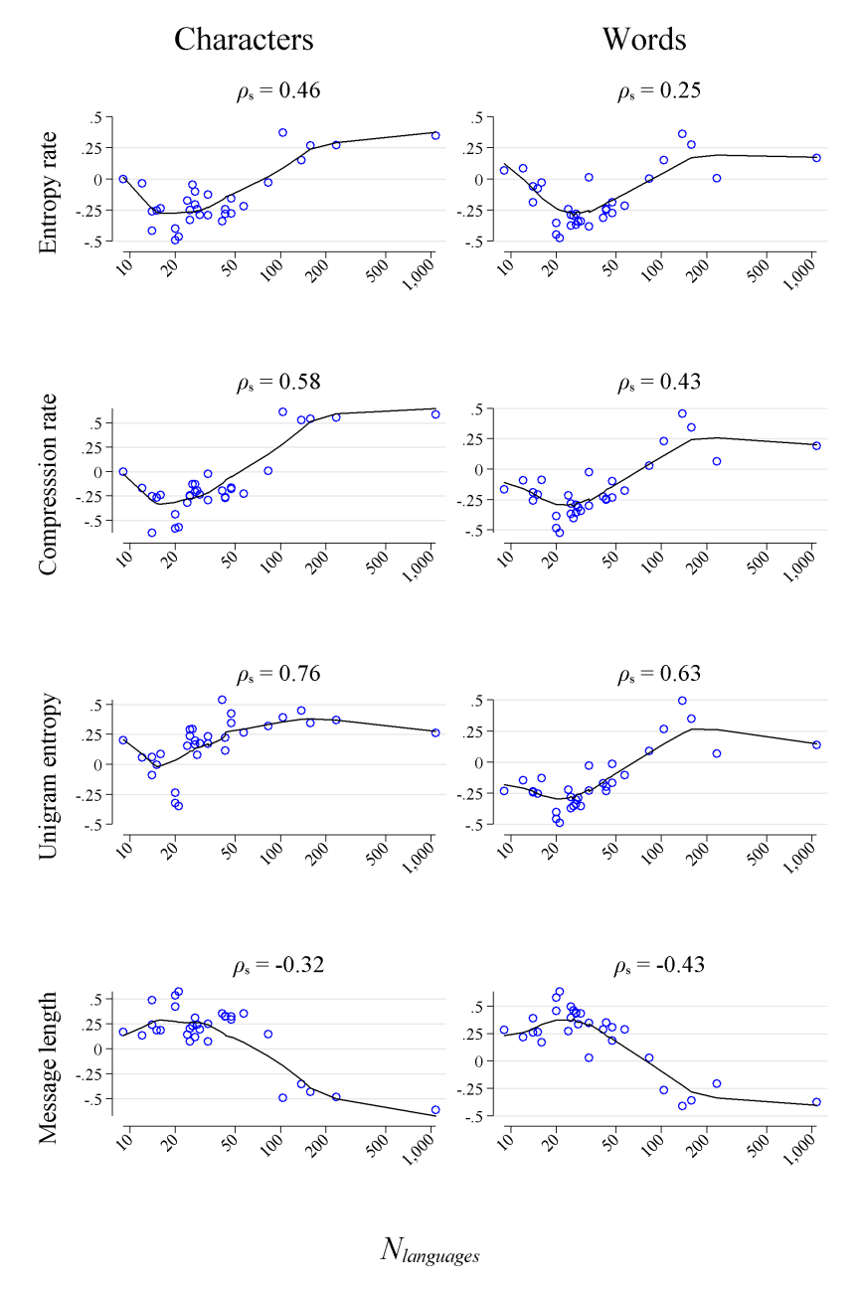
Supplementary Figure 24 | For a description see Supplementary Figure 23. Here, for each corpus, each variable value is replaced by its corresponding counterpart found in the BibleNT corpus.

To drive home our point, we conducted a rolling correlation analysis. Here, we used the BibleNT corpus and kept all languages for which there was available speaker population size information. We sampled one translation per language and per symbol type and ranked all available languages in relation to their speaker population, i.e. the language with the most speakers is assigned rank 1, the language with second most speakers is assigned rank 2 and so on. We then repeatedly calculated the Spearman correlation coefficients between population size and either h, r or L with growing window size, i.e. we first calculated coefficients for the ten languages with the lowest ranks, then for the first eleven ranks, and so on, finishing the calculations using all available languages. As a baseline, we first re-ran the whole analysis ten times where languages were randomly ranked each time. Per rank, we then generated median values.
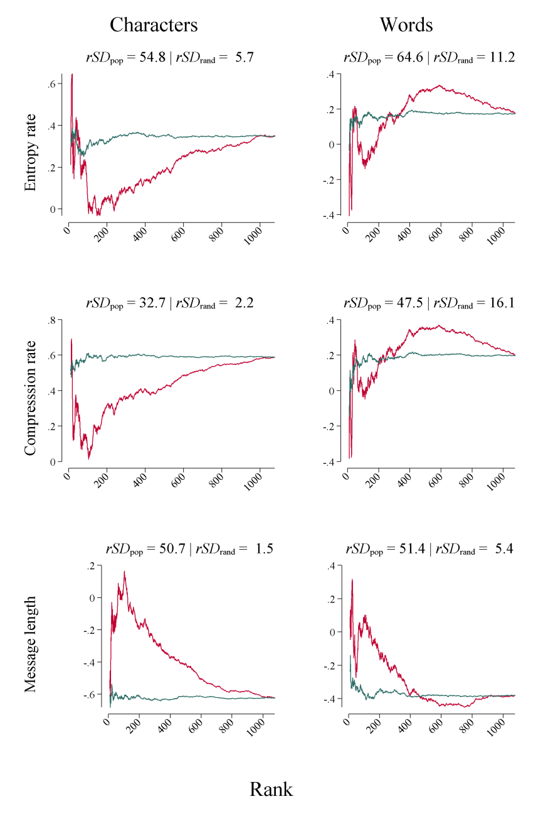
Supplementary Figure 25: Rolling correlation analysis. Corpus base – BibleNT. Languages are either ranked in descending order according to the estimated speaker population size (cranberry lines) or randomly ranked (emerald lines). For each rank z (starting at 10), we calculated Spearman correlation coefficients between speaker population sized and (i) the entropy rate, (ii) the compression rate and (iii) the message length for the first z languages, i.e. the z languages with the most speakers. rSD_{pop} / rSD_{rand} denote the relative standard deviations (in %) for the series with speaker population based ranks / randomly ranks calculated as standard deviation of the series divided by its mean. In all cases, rSD_{pop} $≫$ rSD_{rand}.

Supplementary Figure 25 visualizes the results: on both symbolic levels, the relationship between entropy/length and speaker population size is clearly moderated by the population rank. Or put differently, if we base our analysis only on languages with many speakers, there seems to be a tendency in the opposite direction that was already mentioned above, i.e. lower complexity but longer documents (but see fn. 37). However, as soon as we start to include languages that are spoken by smaller communities, this apparent tendency quickly vanishes.
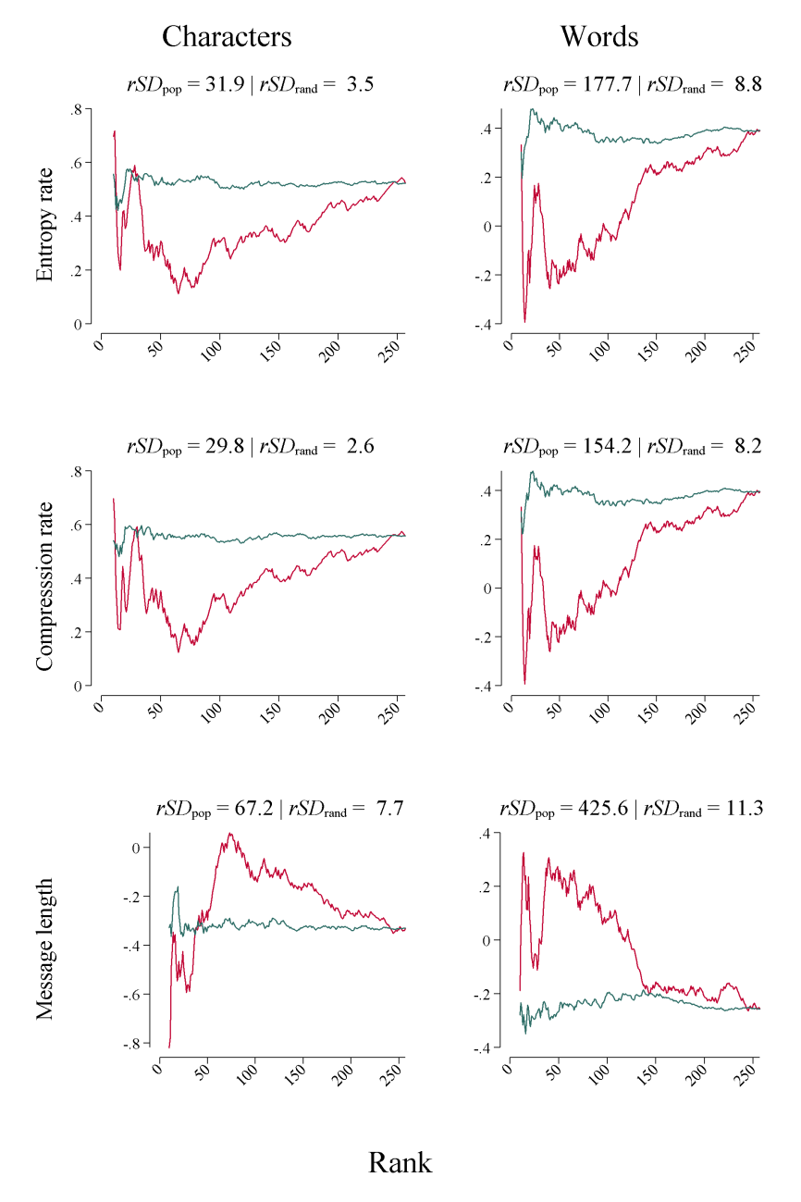
Supplementary Figure 26 | Rolling correlation analysis. Corpus base – WatchtowerV2 (cf. S3.2.4). Again, rSD_{pop} $≫$ rSD_{rand} in all cases.

In Supplementary Figure 26, we replicated this analysis based on the WatchtowerV2 corpus. The results are qualitatively very similar. Like Koplenig (2021), we conclude that parallel corpora with more translations in different languages (including languages with smaller speaker communities) would support an empirical link between complexity/length and speaker community size.
This has important ramifications for any quantitative typological investigation since it demonstrates that biased samples can lead to potentially incorrect conclusions as already discussed by Koplenig (2019).

References
Amano, T., B. Sandel, H. Eager, E. Bulteau, J.-C. Svenning, B. Dalsgaard, C. Rahbek, R. G. Davies & W. J. Sutherland. 2014. Global distribution and drivers of language extinction risk. Proceedings of the Royal Society B: Biological Sciences 281(1793). 20141574–20141574. https://doi.org/10.1098/rspb.2014.1574.
Aulamo, Mikko, Umut Sulubacak, Sami Virpioja & Jörg Tiedemann. 2020. OpusTools and Parallel Corpus Diagnostics. In Proceedings of the 12th Language Resources and Evaluation Conference, 3782–3789. Marseille, France: European Language Resources Association. https://www.aclweb.org/anthology/2020.lrec-1.467.
Baayen, R. Harald. 2001. Word Frequency Distributions. Dordrecht: Kluwer Academic Publishers.
Bentz, Christian. 2016. The Low-complexity-belt: Evidence For Large-scale Language Contact In Human Prehistory? In S. G. Roberts, C. Cuskley, L. McCrohon, L. Barceló-Coblijn, O. Fehér & T. Verhoef (eds.), The Evolution of Language: Proceedings of the 11th International Conference (EVOLANGX11). Online at http://evolang.org/neworleans/papers/93.html.
Bentz, Christian, Dimitrios Alikaniotis, Michael Cysouw & Ramon Ferrer-i-Cancho. 2017. The Entropy of Words—Learnability and Expressivity across More than 1000 Languages. Entropy 19(6). 275. https://doi.org/10.3390/e19060275.
Bentz, Christian, Dan Dediu, Annemarie Verkerk & Gerhard Jäger. 2018. The evolution of language families is shaped by the environment beyond neutral drift. Nature Human Behaviour 2(11). 816–821. https://doi.org/10.1038/s41562-018-0457-6.
Bornstein, Marc H., Justin Jager & Diane L. Putnick. 2013. Sampling in developmental science: Situations, shortcomings, solutions, and standards. Developmental Review 33(4). 357–370. https://doi.org/10.1016/j.dr.2013.08.003.
Cysouw, Michael & Bernhard Wälchli. 2007. Parallel texts: using translational equivalents in linguistic typology. Language Typology and Universals 60(2). 95–99. https://doi.org/10.1524/stuf.2007.60.2.95.
Ebeling, W. & G. Nicolis. 1991. Entropy of Symbolic Sequences: The Role of Correlations. Europhysics Letters (EPL). IOP Publishing 14(3). 191–196. https://doi.org/10.1209/0295-5075/14/3/001.
Freedman, David A. & David Lane. 1983. Significance testing in a nonstochastic setting. In A Festschrift for Erich L. Lehmann, 185–208. Belmont, CA: Wadsworth.
Gelman, Andrew & Jennifer Hill. 2007. Data analysis using regression and multilevel/hierarchical models (Analytical Methods for Social Research). New York: Cambridge University Press.
Goldhahn, Dirk, Thomas Eckart & Uwe Quasthoff. 2012. Building Large Monolingual Dictionaries at the Leipzig Corpora Collection: From 100 to 200 Languages. In Proceedings of the Eighth International Conference on Language Resources and Evaluation (LREC’12), 759–765. Istanbul, Turkey: European Language Resources Association (ELRA). http://www.lrec-conf.org/proceedings/lrec2012/pdf/327_Paper.pdf.
Greene, William H. 2003. Econometric analysis. 5. ed., internat. ed. Upper Saddle River, NJ: Prentice-Hall.
Hammarström, Harald, Robert Forkel & Martin Haspelmath. 2019. Glottolog 3.2. Jena. https://glottolog.org/ accessed 2020-01-20.
Jaeger, T. Florian, Peter Graff, William Croft & Daniel Pontillo. 2011. Mixed effect models for genetic and areal dependencies in linguistic typology. Linguistic Typology 15(2). (27 June, 2018).
Jann, Ben. 2019. HEATPLOT: Stata module to create heat plots and hexagon plots. https://ideas.repec.org/c/boc/bocode/s458598.html.
Johnson, Paul C.D. 2014. Extension of Nakagawa & Schielzeth’s R2GLMM to random slopes models. Methods in Ecology and Evolution 5(9). 944–946. https://doi.org/10.1111/2041-210X.12225.
Knoll, Byron. 2021. CMIX. https://www.byronknoll.com/cmix.html (3 February, 2022).
Koplenig, Alexander. 2018. Stata tip 129: Efficiently processing textual data with Stata’s new Unicode features. Stata Journal 18(1). 287–289.
Koplenig, Alexander. 2019. Language structure is influenced by the number of speakers but seemingly not by the proportion of non-native speakers. Royal Society Open Science 6(2). 181274. https://doi.org/10.1098/rsos.181274.
Koplenig, Alexander. 2021. Quantifying the efficiency of written language. Linguistics Vanguard 7(s3). 20190057. https://doi.org/10.1515/lingvan-2019-0057.
Koplenig, Alexander, Sascha Wolfer & Carolin Müller-Spitzer. 2019. Studying Lexical Dynamics and Language Change via Generalized Entropies: The Problem of Sample Size. Entropy 21(5). https://doi.org/10.3390/e21050464. http://www.mdpi.com/1099-4300/21/5/464.
Levshina, Natalia. 2016. Verbs of letting in Germanic and Romance languages: A quantitative investigation based on a parallel corpus of film subtitles. Languages in Contrast 16(1). 84–117. https://doi.org/10.1075/lic.16.1.04lev.
Mahoney, M. 2005. Adaptive weighing of context models for lossless data compression. In. Florida Tech. https://cs.fit.edu/~mmahoney/compression/cs200516.pdf.
Mahoney, Matt. 2013. Data Compression Explained. Dell Inc. http://mattmahoney.net/dc/dce.html (20 September, 2018).
Mayer, Thomas & Michael Cysouw. 2014. Creating a Massively Parallel Bible Corpus. In Nicoletta Calzolari (Conference Chair), Khalid Choukri, Thierry Declerck, Hrafn Loftsson, Bente Maegaard, Joseph Mariani, Asuncion Moreno, Jan Odijk & Stelios Piperidis (eds.), Proceedings of the Ninth International Conference on Language Resources and Evaluation (LREC’14). Reykjavik, Iceland: European Language Resources Association (ELRA).
Montemurro, Marcelo A. & Damián H. Zanette. 2011. Universal Entropy of Word Ordering Across Linguistic Families. (Ed.) Michael Breakspear. PLoS ONE 6(5). e19875. https://doi.org/10.1371/journal.pone.0019875.
Moscoso del Prado Martín, Fermín. 2011. The mirage of morphological complexity. In Proceedings of Quantitative Measures in Morphology and Morphological Development. Center for Human Development, UC San Diego. http://csjarchive.cogsci.rpi.edu/proceedings/2011/papers/0836/paper0836.pdf.
Nakagawa, Shinichi & Holger Schielzeth. 2013. A general and simple method for obtaining R2 from generalized linear mixed-effects models. (Ed.) Robert B. O’Hara. Methods in Ecology and Evolution 4(2). 133–142. https://doi.org/10.1111/j.2041-210x.2012.00261.x.
R Core Team. 2021. R: A Language and Environment for Statistical Computing. Vienna, Austria: R Foundation for Statistical Computing. https://www.R-project.org/.
Rabe-Hesketh, S. & Anders Skrondal. 2012. Multilevel and longitudinal modeling using Stata. 3rd ed. College Station, Tex: Stata Press Publication.
Scannell, Kevin P. 2007. The Crúbadán Project: Corpus building for under-resourced languages. In Proceedings of the 3rd Web as Corpus Workshop: Building and Exploring Web Corpora, vol. 4, 5–15. http://cs.slu.edu/~scannell/pub/wac3.pdf.
Schürmann, Thomas & Peter Grassberger. 1996. Entropy estimation of symbol sequences. Chaos: An Interdisciplinary Journal of Nonlinear Science 6(3). 414. https://doi.org/10.1063/1.166191.
Simons, Gary F. & Charles D. Fennig. 2009. Ethnologue: Languages of the World 16th edition. Dallas, Texas: SIL International. http://www.ethnologue.com.
Simons, Gary F. & Charles D. Fennig. 2013. Ethnologue: Languages of the World 17th edition. Dallas, Texas: SIL International. http://www.ethnologue.com.
Simons, Gary F. & Charles D. Fennig. 2017. Ethnologue Global Dataset, Twentieth edition. https://www.ethnologue.com/sites/default/files/Ethnologue-20-Global%20Dataset%20Doc.pdf.
Snijders, T. A. B. & R. J. Bosker. 1999. Multilevel analysis: an introduction to basic and advanced multilevel modeling. London ; Thousand Oaks, Calif: Sage Publications.
StataCorp. 2015. Stata Statistical Software. StataCorp: StataCorp.
Takahira, Ryosuke, Kumiko Tanaka-Ishii & Łukasz Dębowski. 2016. Entropy Rate Estimates for Natural Language—A New Extrapolation of Compressed Large-Scale Corpora. Entropy 18(10). 364. https://doi.org/10.3390/e18100364.
Tiedemann, Jörg. 2012. Parallel Data, Tools and Interfaces in OPUS. In LREC’12 Proceedings, 2214–2218. Istanbul, Turkey: ELRA.
Tweedie, Fiona J. & R. Harald Baayen. 1998. How Variable May a Constant be? Measures of Lexical Richness in Perspective. Computers and the Humanities 32(5). 323–352.
Unicode Consortium. 2019. Unicode Text Segmentation. Unicode® Standard Annex #29. http://www.unicode.org/reports/tr29/#Word_Boundaries (23 July, 2019).
Winkler, Anderson M., Gerard R. Ridgway, Matthew A. Webster, Stephen M. Smith & Thomas E. Nichols. 2014. Permutation inference for the general linear model. NeuroImage 92. 381–397. https://doi.org/10.1016/j.neuroimage.2014.01.060.
Ziemski, Micha\l, Marcin Junczys-Dowmunt & Bruno Pouliquen. 2016. The United Nations Parallel Corpus v1.0. In Proceedings of the Tenth International Conference on Language Resources and Evaluation (LREC’16), 3530–3534. Portorož, Slovenia: European Language Resources Association (ELRA). https://www.aclweb.org/anthology/L16-1561.

Dash-separated words (e.g. “presidency-in-office”) are treated as one word.
Note that 63,487 of the 1,112,063 (5.71%) available Unicode symbols are less than 4 bytes long. This is due to historical reasons, for example, all 127 characters with a length of 1 byte all belong to the 128 characters of the American Standard Code for Information Interchange (ASCII) character encoding standard that is based on the “English” alphabet. Since we randomly assign unique Unicode symbols to word types, this variation-in-length should not systematically affect the results. To test this, we used the Quran corpus (see section S3.2.5) and only used the 1,048,576 Unicode symbols with a length of 4 bytes for the replacement procedure and then re-ran the analyses on the level of words. As expected, the Spearman correlation between the original version and the 4-bytes-only version is 0.9998 for r and 0.9974 for h. Further note that we show in Figure 6a,b that our results also hold for lemmatized texts. Perhaps more importantly, the fact that ASCII characters have shorter byte lengths could imply that our results could systematically be biased for languages that predominantly use ASCII characters, especially English. To test this, we replicated the compression for the N = 43 languages of the Quran corpus on the level of characters and replaced each unique original character by a unique 4-byte Unicode symbol. We find that the Spearman correlation between the original version and the 4-bytes-only version is 0.9539 for r and 0.9259 for h. If we only include the N = 21 languages that use ASCII characters (defined as corresponding documents where at least one of the first 1,000 characters is any character from a, b, …, z), the Spearman correlation for r is 0.9935. The correlation coefficient is still high but a little lower for h with ρ_{s} = 0.8558. However, the difference between the correlation coefficient for this restricted dataset and the correlation coefficient for all available documents is not significant (z = -1.236; p = .2163).
With o = 2 being the minimum and o = 32 the respective maximum order. We tested the following possible values: 2, 3, 4, 5, 6, 7, 8, 9, 10, 12, 14, 16, 18, 20, 24, 28, 32. The following command line syntax was used: 7z a -t7z -m0=PPMd -mx9 -mo=o -ms=off -mmem=2000m -mmt=off "directory\output_archive.7z" "directory\input_text.txt".
The question whether different translations of the Bible can be considered translational equivalents is discussed in Koplenig (2021).
The ansatz function is separately fitted to each of the five different versions and estimated parameters are averaged per translation. Note that in the final dataset, both for the number of iterations needed for convergence and for the accuracy ratio the maximum across the five different versions is reported.
When there was more than one text file available for a given language, we downloaded the newest one. Around 50% of the texts come from the 2016 version.
Duplicate lines were removed.
Duplicate lines were removed.
A sentence from the English data.
Duplicate lines were removed.
Regarding h, the results for this corpus are a clear outlier with a median value of 0.093 on the level of characters and .610 on the level of words compared to 1.266 and 7.688 for all other corpora. However, the texts contain a lot of standardized formulaic and repetitive phrases, e.g. "read the package leaflet" occurs 165 times and "can be taken with or without food" occurs 90 times in the English version. Therefore, such a small value for an extrapolation to infinity seems to make perfect sense.
Duplicate lines were removed.
H was only calculated on the level of words for this corpus.
A sentence from the English data.
We removed sentences that contained English terminology and sentences that contained the following symbols: -f -s -h -u -t -a -i -o : > / url } ubuntu checksum _ << % "nothing selected" string launchpad @ hhtp fonts insertinsert u+0025 palette script gnome server. In addition, "sentences" that consist of only one word and duplicate lines were removed.
We classified "Arabic" as ISO "arb", "Chinese" as "cmn", "Yiddish" as "ydd" and "Punjabi" as "pan".
The English translation in Tatoeba is as follows: "There are lots of different types of dogs." Since Toki Pona has no ISO code, we chose the (unassigned) ISO code "tok" to label it in our data.
Put differently, the sentences sampled for the V1 version were removed from the raw data.
For example, 37.5% of all available frequency lists are generated on the basis of one or two documents.
For example, the word frequency list for English is generated based on 7,780 documents. The list is truncated at 2, so word types with a frequency of one are excluded. In total, 68 lists are truncated at 2, 30 lists are truncated at 3 and 5 lists are truncated at 4.
Since the total number of words is listed on the An Crúbadán page, another possibility would have been to estimate the frequency mass of the excluded word types using basic properties of word frequency distributions (Baayen 2001). For example, in the case of a word list truncated at 2: if the total number of words listed on the An Crúbadán page were 2,000 and the word frequency sum in the corresponding list were 1,000, then we would immediately know that 1,000 word types with a frequency of 1 need to be added to the word frequency list. However, we noted that in 41 cases the word frequency sum for the available lists is greater than the frequency sum mentioned on the An Crúbadán page. Take for example the language Moose Cree: http://crubadan.org/languages/crm. Here, the listed word frequency sum ("available words") is 114,304, however, in the crm.zip data file, the sum amounts to 126,524. Therefore, we ultimately decided against this estimation strategy.
We used additional latitude/longitude information provided from the Crúbadán project (cf. section S3.7) for Figure 1a.
Individual do-files are organized in a separate do-file called "_master.do". This do-file can be used to re-create the whole project from scratch. To convert and modify figures (e.g. for adding transparency), we used Inkscape 0.92.4 and ImageMagick-7.0.11.
Corresponding cells are empty.
Subsequent validity checks revealed that "BibleNT_deu-x-bible-hoffnung_v1_char_level.csv" contains several errors (at l = 371,000 and l = 625,000; l = 792,000 and l = 832,000), where 7-zip crashed during data preparation. Since this problem affected only 4 of 1,145 data points (0.35%), we did not correct the error, but left the corresponding compression rate series as-is.
The same logic was used to produce Figure 3 and Supplementary Figure 22, i.e. we generated 2 (full vs. truncated) × 2 (all scripts vs. Latin-only) = 4 different matrices.
To put this further into perspective, the median pairwise Spearman correlation between H_{Crubadan} based on the Crúbadán word frequency information and h estimated for each of the 40 corpora on the level of words is ρ_{med} = 0.51 and ρ_{med} = 0.30 on the level of characters. Figure 4b visualizes one such correlation. If we partial-out the length and the number of documents based on which the Crúbadán word frequency information is calculated (see section S3.7 and fn. 30), the results remain qualitatively highly comparable (partial ρ_{med} = 0.49 for words; partial ρ_{med} = 0.26 for characters). In a similar vein, the median correlation between H_{Crubadan} and r is ρ_{med} = 0.61 for words and ρ_{med} = 0.46 for characters (corresponding partial correlations: ρ_{med} = 0.58 for words; ρ_{med} = 0.38 for characters) and the median correlation between H_{Crubadan} and L is ρ_{med} = -0.48 for words and ρ_{med} = -0.29 for characters (corresponding partial correlations: ρ_{med} = -0.47 for words; ρ_{med} = -0.38 for characters). This demonstrates that it is appropriate to use H_{Crubadan} in what follows, for example as an outcome for the LMMs where we test for a potential influence of the estimated speaker population size (see section S10).
In total, we have 2 symbolic levels (words/characters) × 3 variables (h, r and L) × 40 corpora = 240 variables + H_{Crubadan} = 241 variables.
In the main part of the paper, this quantity is denoted as just r.
Partial Spearman correlations are computed by first ranking $₦$, h and L. The ranked variables are then used to calculate partial Pearson correlations (Greene 2003: 37).
Aditionally we used the truncated version (see S4) to rule out a potential estimation bias due to text length (Baayen 2001; Tweedie & Baayen 1998; Koplenig, Wolfer & Müller-Spitzer 2019). For h, r and H we re-ran the LMM models on both symbolic levels. Again, models were fitted by REML with gradient-based optimization. Compared to Table 2, the results are qualitatively identical with all ${\hat{β}}_{1}$-coefficients $≫$ 0 and all p_{parametric} < 0.00001 in all six cases.
As above, H based on the Crúbadán data was not standardized and models did not include a random effect or a random slope for corpus but fixed effects for text length, available number of documents (both logged) and a binary variable indicating whether the word frequency list is truncated (no/yes).
Initial experiments revealed that the inclusion of random slopes and intercepts for country resulted in non-convergence, so those effects were dropped from the model specifications. In addition, note that speaker population size does not vary within languages, so including a random slope for language does not make sense. Note that we did not conduct additional permutation tests since it is unclear what to permute in this case. Similar arguments can be made for the calculation of ΔAIC-values. Further note that calculating effect sizes based on Nakagawa and Schielzeth (2013) is only defined for random intercept models, but in reference to Snijder and Bosker (1999), Nakagawa and Schielzeth (2013) argue that effect sizes obtained for random slope models will be very close to those of random intercept models, where the same fixed effects are included; also see Johnson (2014).
In a similar vein, a relationship between speaker population size and H measured on the level of characters is also only weakly supported by our approaches.
The corresponding plots are available at https://osf.io/f5mke/, folder: Data as a zip file ("standardized_residuals_plots.zip"). Note that for the random slopes models, where we only evaluated using the parametric approach, we also inspected the residuals for heteroscedasticity as outlined by Bornstein et al. (2013). Both normality and homoscedasticity seem to be "within acceptable limits" (Jaeger et al. 2011) for the (fixed) predictor speaker population size in all but one model (for H computed based on the Crúbadán data, there seem to be a moderate to strong violation of homoscedasticity, all corresponding plots are also available at https://osf.io/f5mke/, folder: Data as a zip file ("error_dist_rand_slopes_plots.zip")). Jaeger et al. (2011) show that it is difficult to assess assumptions across all different levels of all different grouping factors. As argued below, permutation tests have the great advantage in this context that they do not assume normally distributed errors and homoscedasticity.
Due to the limited number of available languages, the UNPC corpus (see S3.4.5) was dropped from these analyses.
To test this question, we generated the following three balanced subsets: (i) Religious: this subset contains all languages for which there is available data in all of the following 4 corpora: BibleNT, BibleOT, Quran and WatchtowerV1; (ii) TEDs: this subset contains all languages for which there is available data in one of the nine TED talk corpora. 13 languages fulfil this criterion; (iii) MSubs: this subset contains all languages for which there is available data in all of the following 11 corpora: MSub01 MSub02 MSub03 MSub04 MSub06 MSub09 MSub10 MSub11 MSub12 MSub13. Per subset, we then randomly sampled one language per corpus and symbol type and kept all languages for which there was available information regarding speaker population size, language family, writing system and country. For the Religious subset 16 languages fulfilled these criteria, 11 for the MSub subset and 12 for the TEDs subset. The corresponding median speaker population sizes were 26.35M for the Religious subset, 29.90M for the MSub subset and 24.80M for the TEDs subset. We then conducted separate LMMs per symbolic type (characters/words) with the following three outcomes: h, r and L. For each outcome we ran three different models, where the outcome was (i) unlogged, (ii) logged or (iii) standardized per database. We fitted crossed-effects models where the outcome was regressed on a fixed effect for the log of speaker population size and (crossed) random intercepts for corpus, language, language family, writing system and country. In total, we ran 54 different models: 3 subsets (Religious/MSub/TEDs) x 2 symbol types (characters/words) x 3 outcomes (h/r/L) x 3 outcome transformations (unlogged/logged/standardized). Models were fitted by REML and with EM only, since convergence was not achieved with a gradient-based method for several models. We accepted any solution after a maximal number of EM iterations of 10,000; 40.74% of all the models converged to the optimal solution. While all 18 models with L as outcome point in the direction of a positive relationship between message length and speaker population size, only 10 models for h as outcome and 11 models for r as outcome yielded the corresponding negative relationship between complexity and speaker population size. In addition, only in two cases did the influence of speaker population size reach statistical significance at p < .05; in 90% of all cases, the parametric p-value was above .21.
Non-available languages are excluded.

