Additional file 2 of manuscript:

Two bifunctional β-xylosidase /α-L-arabinofuranosidases from GH43 with different structures in the xylan degradation strain of Paenibacillus physcomitrellae XB displayed the similar xylo-oligosaccharides degradation ability

Xiao Jie Zhang, Su Wang, Zhi Ling Chen, Yan Hong Li*
College of Life Sciences, Capital Normal University, Beijing 100048, China

* Corresponding author:
Yan Hong Li, College of Life Sciences, Capital Normal University, Xisanhuan North Road #105, Haidian District, Beijing 100048, China. E-mail: liyh@cnu.edu.cn

Table S1 The genomic characteristics f of strain Paenibacillus physcomitrellae XB

Genome characters | P. physcomitrellae XB
Genome Size (bp)  Gene Number (#)  GC Content (mol%)  Genes encoding protein | 4,828,665  4371  51.87  4198
Genome Accession No. | CP022584.1
Genes annotated by COG database | 3517
Genes annotated by GO database | 3146
Genes annotated by KEGG database | 1873
Genes annotated by CAZy database | 210

Table S2 Primers used in the quantitative real-time PCR and expression vector construction of xylanolytic related genes of strain XB
Primers | Primers sequence (5’-3’) | Target gene | Application
recA_F | GACGCGCTTTGAAATTCTACTCTA | recA | RT-qPCR
recA_R | CATGCGCCGCTCTTGTCG | recA | RT-qPCR
0002_F | GCTCGGCGCCGTTTGATTAC | Pph_0002 | RT-qPCR
0002_R | CGCGGCGGCTTCCTTCCAGA | Pph_0002 | RT-qPCR
0602_F | ATGACGGGCCGGACAATGAC | Pph_0602 | RT-qPCR
0602_R | CACGTGCCGGGAAGAATAAATAAT | Pph_0602 | RT-qPCR
0648_F | AACGGGTATTTGGCTTTCTATGGA | Pph_0648 | RT-qPCR
0648_R | GTTGCTGCCGATCGGTCTCTTC | Pph_0648 | RT-qPCR
0706_F | CCCGGACGGCGAACCTTACG | Pph_0706 | RT-qPCR
0706_R | ACAACGGGCACCTTATCCAGCACA | Pph_0706 | RT-qPCR
1610_F | CGGGGGAAGTGGACCAGACAGGA | Pph_1610 | RT-qPCR
1610_R | GCCCCGGCGCCATTTTCAC | Pph_1610 | RT-qPCR
1651_F | ATCGCGGCGCATTTGTGT | Pph_1651 | RT-qPCR
1651_R | TCGGGGCGGTAAGCAGGAC | Pph_1651 | RT-qPCR
1668_F | ATGCGTCCTGCCTATTATGCT | Pph_1668 | RT-qPCR
1668_R | TCGCCGGACGTTTGACCT | Pph_1668 | RT-qPCR
2078_F | AGGCGGCGGAAAAATTGGCTATGT | Pph_2078 | RT-qPCR
2078_R | GCTCGGCTCCGCTGTTCA | Pph_2078 | RT-qPCR
2344_F | TGCGCAGAAGGAGGGACCGTTTAT | Pph_2344 | RT-qPCR
2344_R | GGCGTTTCGACCAAGGCACCAT | Pph_2344 | RT-qPCR
3259_F | TTATCCGGGAGGCAACTTCGTGTC | Pph_3259 | RT-qPCR
3259_R | CAGGTTGCGGGCTTCGTCTACTCC | Pph_3259 | RT-qPCR
3723_F | GCACCCACCCATATCGAACACAAC | Pph_3723 | RT-qPCR
3723_R | TCCCCAGCCGCCGTAGTAGAGATA | Pph_3723 | RT-qPCR
4538_F | TGCATCCGGGTTGGCGACTATTAT | Pph_4538 | RT-qPCR
4538_R | TCGGAGCCGGTTTGTTTGATTGA | Pph_4538 | RT-qPCR
P0602F | CGGGATCCATGAATTCTAAAATTCCTGTTCCG | Pph_0602 | Expression vector construction
P0602R | CCGCTCGAGTGGATGGATACGGATCAATCGT | Pph_0602 | Expression vector construction
P2344F | GGAATTCATGCAAATCGAAAATCCAGTG | Pph_2344 | Expression vector construction
P2344R | CCGCTCGAGTGTTTTTTTCAAGCTCTTTATAG | Pph_2344 | Expression vector construction

Table S3 The predicted protein features of Ppxyl43A and Ppxyl43B
Features | Ppxyl43A | Ppxyl43B
General features
Gene ID | Pph_0602 | Pph_2344
Nucleotide No. (nt) | 987 | 1629
Protein ID in strain XB | WP_094092920.1 | WP_094094306.1
No. of amino acid | 329 | 543
Predicted MW (kDa) | 36.9 | 62.3
SecP score (SecretomeP 2.0a) | 0.91 | 0.84
Model built by SWISS-MODEL
Template | 5glk.1.A (65.09%)
  5zqj.1.A (57.71%)
Predicted Model | 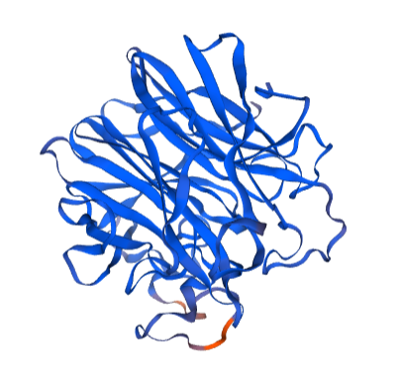 | 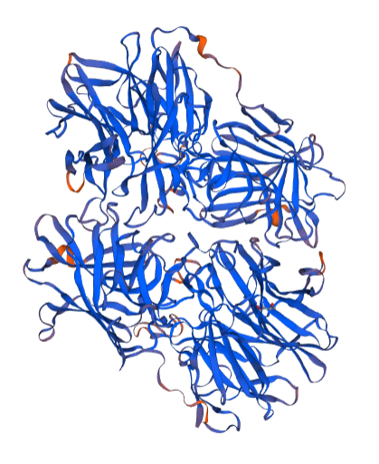
Predicted structure by InterPro Scan
Homologous Superfamily | Glycosyl hydrolase, five-bladed beta-propellor domain superfamily (4-326)  IPR023296 | Glycosyl hydrolase, five-bladed beta-propellor domain superfamily (2-324) IPR023296
Unintegrated | β-1,4- Xylosidase (EUROFUNG) related (PTHR43772:SF2)  cd18619 (11-322)  GH43_CoXyl43_like | β-Xylosidase related (PTHR42812:SF12)  cd09000 (5-303)  GH43_SXA-like
C-terminal Domain | NA | Beta-xylosidase, C-terminal Concanavalin A-like domain  GH43_C2 (334-537)  IPR041542
Chemical substrate binding site | 20 (Asp), 51 (Tyr), 53 (Met), 88 (Trp), 89 (Ala), 139 (Ile), 140 (Asp), 158 (Leu), 159 (Trp), 227 (E Glu), 275 (Trp), 276 (Thr), 278 (His), 305 (Arg) | 14 (Asp), 31 (Phe), 73 (Trp ), 74 (Ala), 126 (Phe), 127 (Asp), 187 (Glu ), 249 (His), 288 (Arg)
Active site | 20 (Asp) , 140 (Asp) , 227 (Glu) | 14 (Asp), 127 (Asp), 187 (Glu)

