Supplemental Information
Projected Increase in Fast-Growing and Slow-Dissipating El Niño Events in the 21st Century
Hosmay Lopez¹, Sang-Ki Lee¹, Dongmin Kim^{2,1}, Andrew T. Wittenberg³, and Sang-Wook Yeh⁴
¹Atlantic Oceanographic and Meteorological Laboratory, NOAA, Miami, FL
²Cooperative Institute for Marine and Atmospheric Studies, University of Miami, Miami, FL
³Geophysical Fluid Dynamics Laboratory, NOAA, Princeton, NJ
⁴Department of Marine Science and Convergent Technology, Hanyang University, Ansan, Korea

Figures S1, S2, S3, S4, S5, S6, S7, and S8

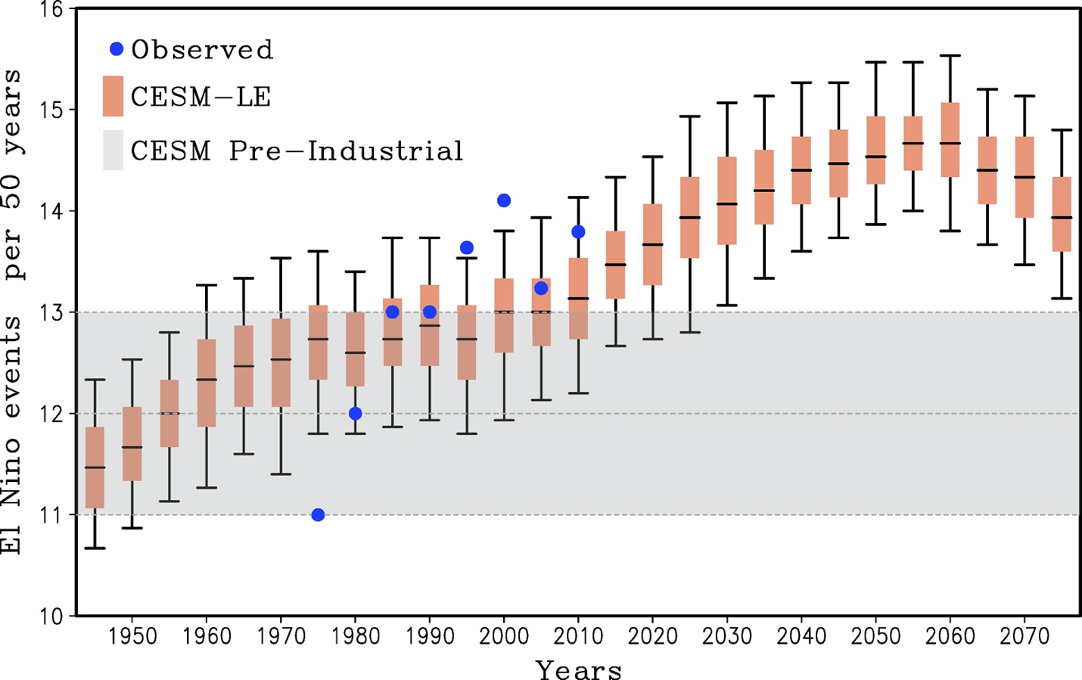
Figure S1. Temporal evolution of a 50-year running averaged number of El Niño events from observations (blue dots) and CESM-LE simulation (box and whisker). The box (whisker) denotes the interquartile (5th-95th percentile) range computed from randomly selecting 15 out of the 30 ensemble members 1000 times and repeating the event count. The gray interval denotes the natural variability range, computed from a 1100-year pre-industrial simulation of CESM by randomly selecting 50-year periods for the event count. The 21C projections are from the RCP8.5 scenario.

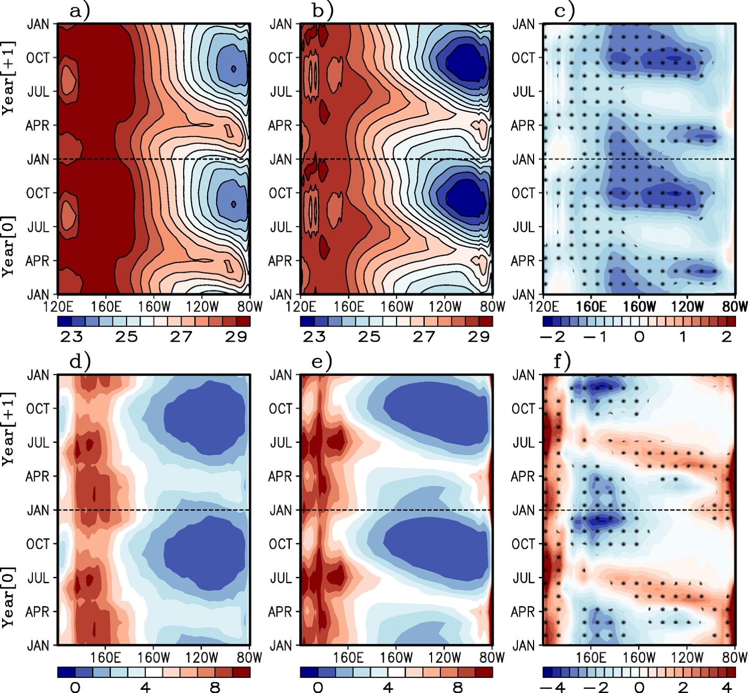
Figure S2. Two-year repeated monthly climatology of (top row) sea surface temperature [°C] for a) observed, b) CESM 20th Century, and c) CESM-20th Century minus observed. Similarly, d), e), and f) show the precipitation climatology [mm/day]. All variables were meridionally averaged from 5°S-5°N along the Pacific Ocean for the 1979-2000 (1951-2000) period for observed (CESM) respectively. Stipples in c) and f) indicate where the differences are statistically significant above a 95th percentile threshold using a student-T test.

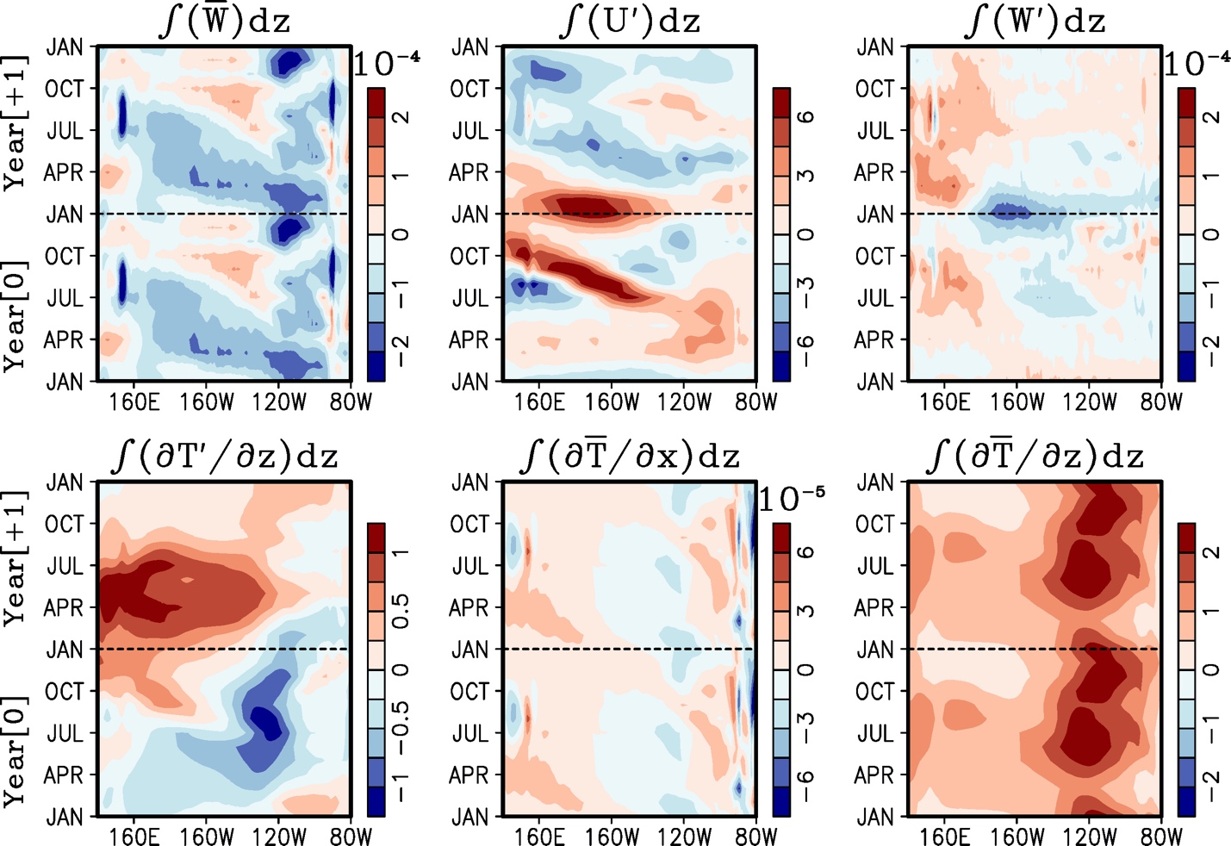
Figure S3 Composite difference between the 21st minus the 20th Century changes in temperature and velocity contributions to the thermocline (left-column), zonal advective (middle-column), and Ekman (right-column) feedback components during El Niño events. The x-axis represents longitude across the Pacific Ocean and y-axis represents time from January of the onset year (Year 0) to December of the decay year (Year 1). The composite is meridionally averaged from 5°S to 5°N.

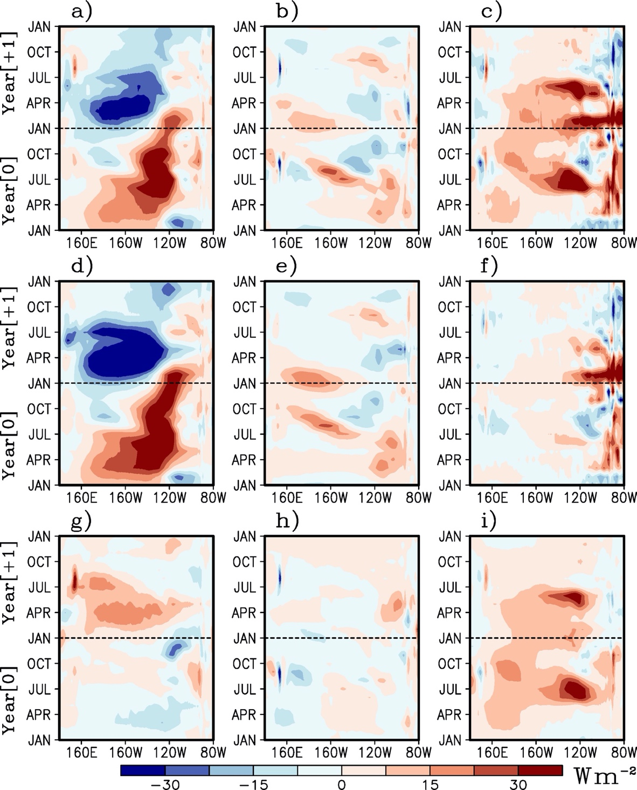
Figure S4 Same as Fig. S3, but for the composite difference between the 21st minus the 20th Century of a) thermocline, b) zonal advective, and c) Ekman feedbacks. Similarly, d), e) and f) show the contribution of projected changes in anomalies to each feedback while keeping the mean state to that of the 20th Century mean state (i.e., overbar terms in eq. 1 are from the 20th Century period while primes are for each respective Century). Similarly, g), h), and i) correspond to the contribution of projected mean state changes to each feedback if computed from just 20th Century anomalies (e.g., prime terms in eq. 1 are from 20th Century while the overbar terms are for their respective century).

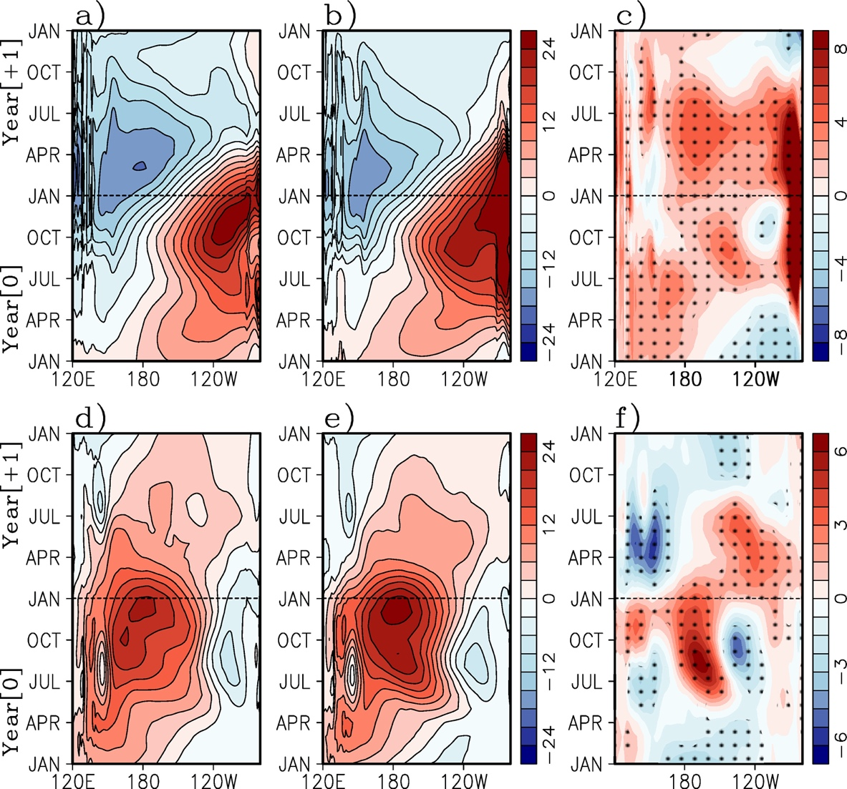
Figure S5. Same as Fig. S3 but for (top) composite of monthly thermocline depth anomaly [m] for El Niño events for a) the 20th Century, b) 21st Century, and c) the 21st minus 20th Century difference. Similarly, d), e), and f) show the composite monthly zonal wind stress anomalies [10⁻² Nm⁻²]. The x-axis represents longitude across the Pacific Ocean and y-axis represents time from January of the onset year (Year 0) to December of the decay year (Year 1). The composite is meridionally averaged from 5°S to 5°N. Hatching on panels c) and f) indicate statistical significance at the 95% confidence level using a Student's t-test.

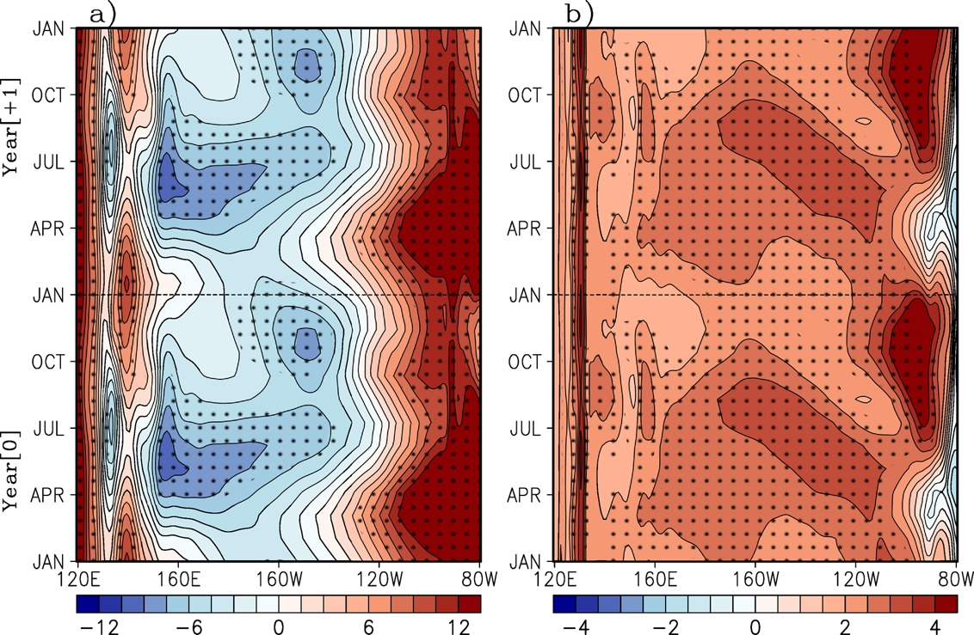
Figure S6. Two-year repeated monthly climatology of the differences in the 21st minus the 20th Century mean states of a) thermocline depth [m] and b) amplitude of the thermocline (i.e., sharpness) as measured by $\frac{∂T}{∂z}$ at the thermocline depth [10⁻² °C/m]. Hatching indicates statistical significance at the 95% confidence level using a Student's t-test.

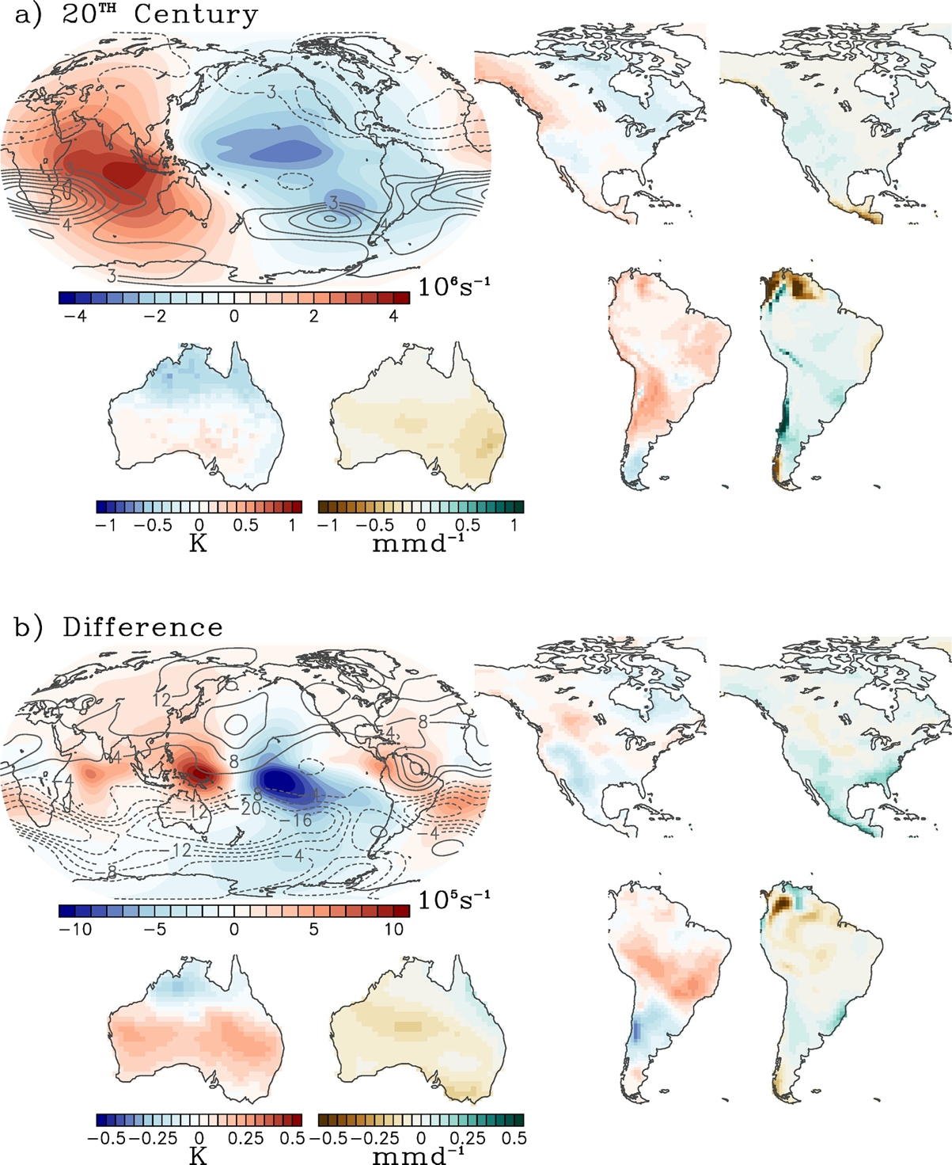
Figure S7. a) June-July-August (JJA of the growth year) global composite anomalies of 200hPa streamfunction (contour, interval 10⁶ s⁻¹) and 200hPa velocity potential (color, 10⁶ s⁻¹) during late 20th Century El Niño events. Also showing the regional impacts on 2-meter reference temperature (K) precipitation (mm/day) for North America, South America, and Australia. Similarly, b) show the differences between 21C minus 20C composites. Negative streamfunction (velocity potential) indicates counter-clockwise (divergent) flow. Contour interval is 4x10⁵ s⁻¹ (10⁵ s⁻¹) for the streamfunction (velocity potential).

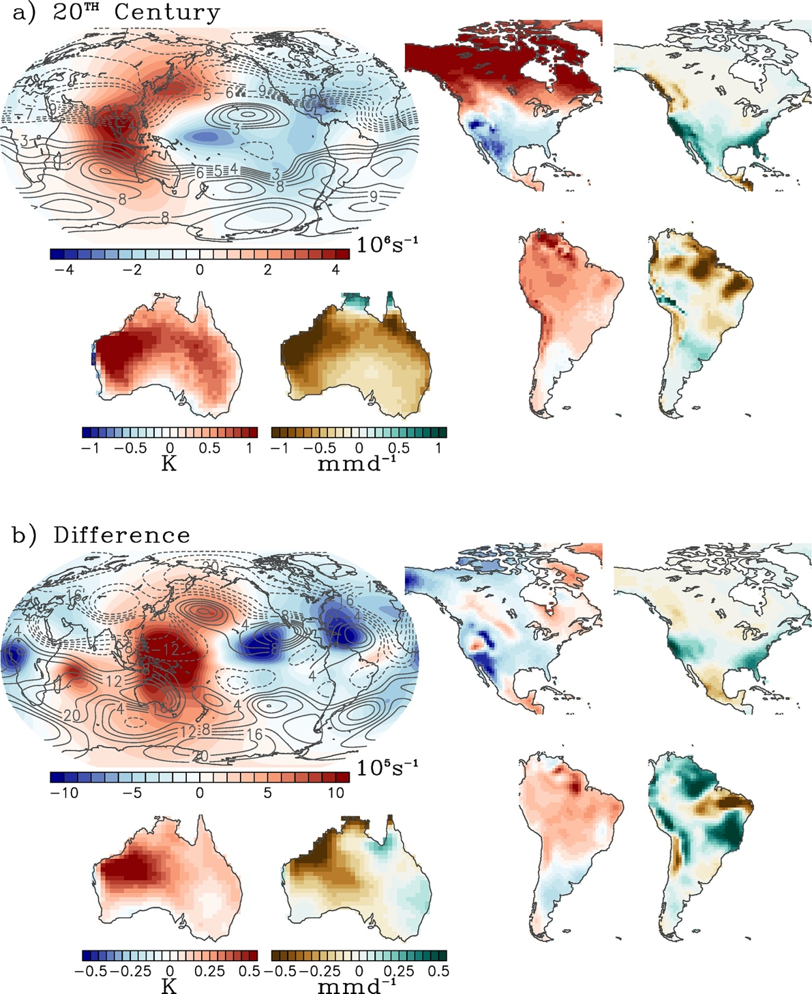
Figure S8. Same as S7 but for January-February-March (JFM of the demise year).

