Contextual Prediction Errors Reorganize Episodic Memories in Time
Supplementary Information

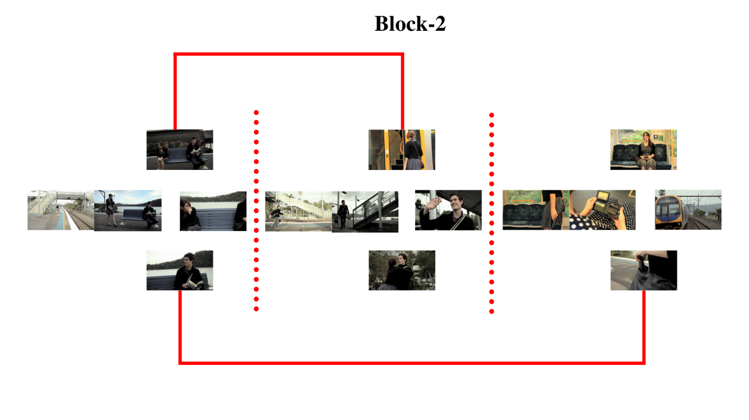
Supplementary Fig. 1 | Memory performance of segments. We also conducted another experimental block, Block-2 after the main block (Block-1, which was the sequence memory test). Here, instead of screenshots from adjacent segments as seen on Block-1, segments under the same Stimulus category (Old, New, PrePE) were tested for temporal order over longer scales (between 25s – 200s). This was employed to measure the temporal order judgements of the segments themselves rather than the (associational) episodic sequence encoding strength within an event. Experiment design illustrated above is for the Substitution condition.
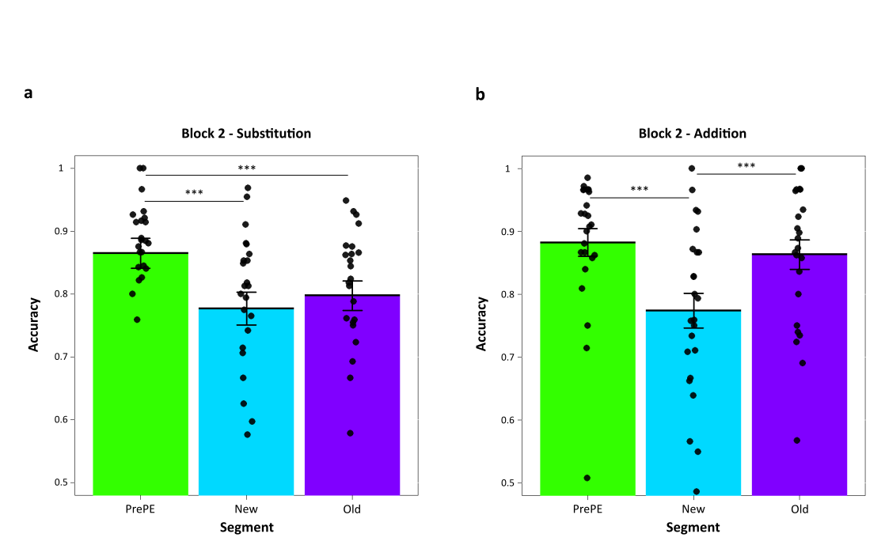
Supplementary Fig. 2 | Block-2 Accuracy. Memory performance in participants increased compared to Block-1 sequence memory since it is easier to recall temporal order as the gap between events are longer¹. a, In Substitution, PE segments (New) did not differ significantly (t ₍₂₃₎ = -0.89, p = 0.38, 95% CI [-0.068 0.027], BF = 0.31, d = .17) from Old segments suggesting the memories of segments over larger time scales compared to sequential association were driven by how many times the segments were encountered in the context of the movie. Since both segments were seen only once (in each Day), memory performances were similar in this Condition. b, In Addition, Old segments had significantly more memory performance than New segment confirming that repeated viewings of the former were indeed driving this (t ₍₂₃₎ = -4.28, p = 0.0002, 95% CI [-0.132 -0.046], BF = 110.03, d = .72). This strongly suggested that the temporal effect of prediction errors were in the sequential ordering of adjacent episodes within their event contexts. PrePE segment was treated as a control. Dots represent individual participant performance. Error bars represent standard error of the mean.

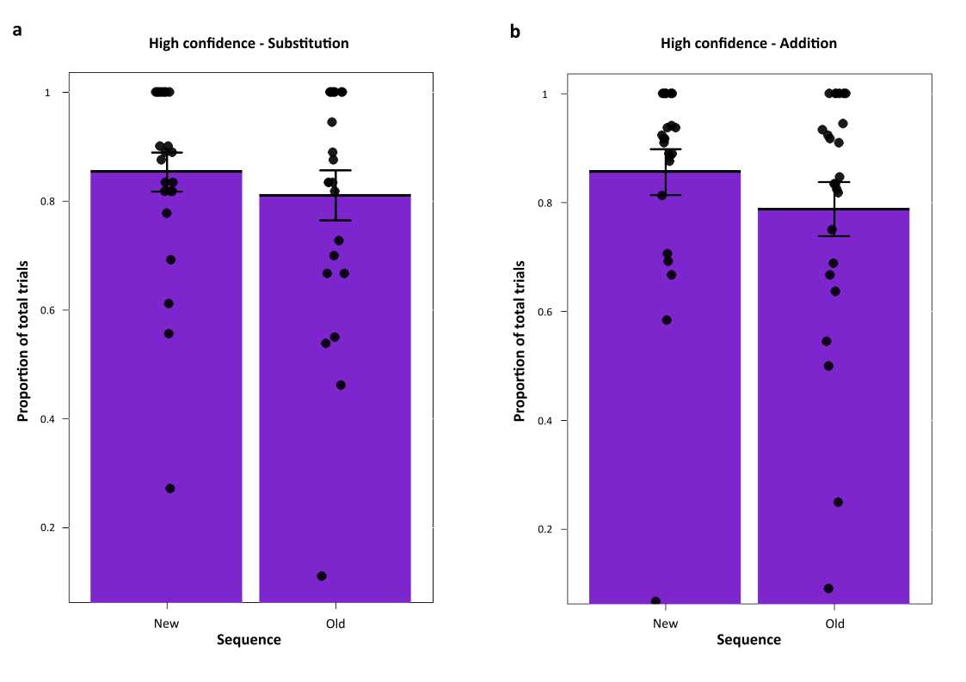
Supplementary Fig. 3 | Proportion of High confidence responses. Proportion of subjective High confidence responses as described in the main results. No significant changes were observed in the measured number of High confidence hits between New and Old sequences in a, Substitution (t₍₂₃₎ = 1.26, p = 0.218, 95% CI [-0.027 0.113], BF = 0.43 , d = .21) and b, Addition (t₍₂₃₎ = 1.15, p = 0.26, 95% CI [2.42 15.36], BF = 0.38, d = .30). Dots represent individual participant’s proportion of High confidence hits. Error bars represent standard error of the mean.

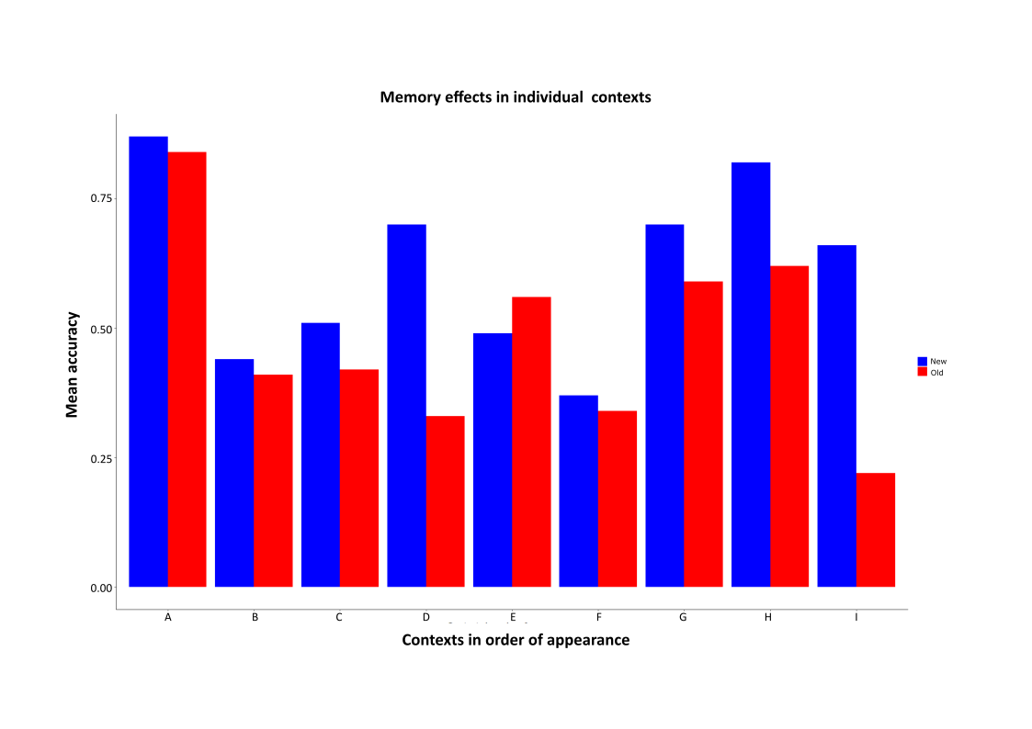
Supplementary Fig. 4 | Ruling out explanations of segment content in the movie influencing the memory effects. In order to rule out any effects of content playing a role in mediating the main results, we performed a context-by-context analysis of the two sequences. The figure depicts Substitution with all the contexts in both movies averaged into one. Y-axis represents these contexts in the order of appearance in the movies. In all but one of the contexts we found consistent results of New segments (Blue) having better accuracy over Old segments (Red), showing that the content of the movie did not play a role. Both segments had a wide range of different content such that any consistent preference for one segment can only be due the prediction errors associated with it.

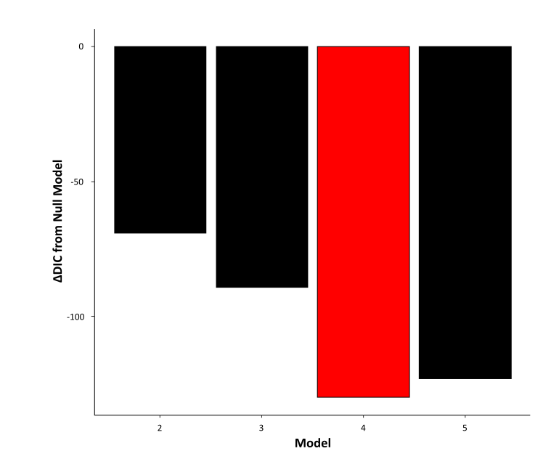
Supplementary Fig. 5 | In addition to a null model, we compared different models in which drift-rate v, Boundary a was allowed to vary with Stimuli (Old vs New sequence) and Subjective Confidence (High, Low). Nondecision time T_{er} varied with the Condition (Addition, Substitution). The best fitting model used in the analysis had the least DIC score (See Table below). This model had the drift-rate set to vary with both Stimuli and Confidence, and the Boundary set to vary with Stimuli.

Supplementary Table 1:

Model | Drift rate, v | Boundary, a | Nondecision time, T_{er} | DIC
1 | Null | Null | Null | 2761
2 | Stimuli | Stimuli | Condition | 2692
3 | Stimuli | Stimuli, Confidence | Condition | 2672
4 | Stimuli, Confidence | Stimuli | Condition | 2631
5 | Stimuli, Confidence | Stimuli, Confidence | Condition | 2638

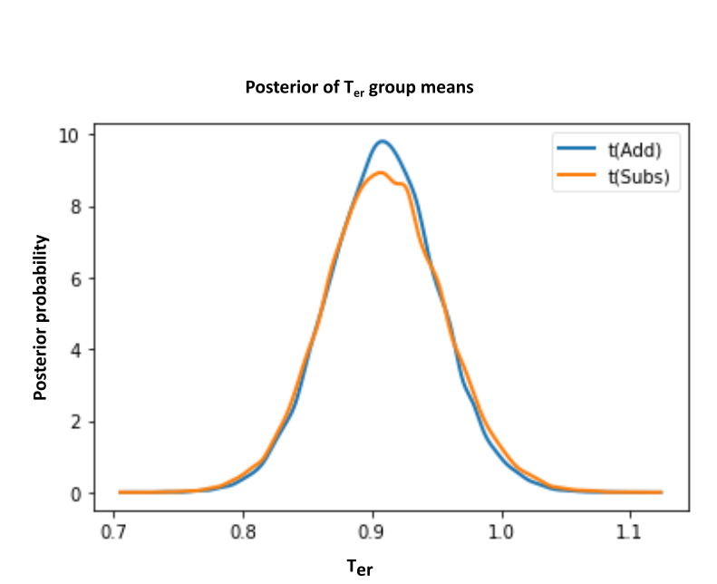

Supplementary Fig. 6 | Posterior density plots of the group means non-decision times (T_{er}) showing no difference between the two conditions. T_{erSubstitution} group means = 0.91, HDI [0.82 – 0.99], T_{erAddition} group means = 0.91, HDI [0.83 – 0.99], p = 0.498. Participants’ sensory encoding and motor preparation times for the sequence recall were not different between movie segments viewed in Substitution and Addition.

