Supporting Information should be included here (for submission only; for publication, please provide Supporting Information as a separate PDF file).

Supporting Information

Co-assembled Perylene/GO Photosensitive Heterobilayer for Efficient Neuromorphics
He-Shan Zhang^{1,‡}, Xue-Mei Dong^{1,‡}, Zi-Cheng Zhang¹, Ze-Pu Zhang¹, Chao-Yi Ban¹, Zhe Zhou¹, Cheng Song¹, Shi-Qi Yan², Qian Xin², Ju-Qing Liu^{1*}, Yin-Xiang Li^{1*}, Wei Huang^{1,3,4*}
¹Key Laboratory of Flexible Electronics (KLOFE) & Institute of Advanced Materials (IAM), Jiangsu National Synergetic Innovation Center for Advanced Materials (SICAM), Nanjing Tech University (NanjingTech), 30 South Puzhu Road, Nanjing 211816, China.
²Shandong Technology Center of Nanodevices and Integration, School of Microelectronics, Shandong University, Jinan 250100, China
³State Key Laboratory for Organic Electronics and Information Displays & Institute of Advanced Materials (IAM), Nanjing University of Posts & Telecommunications, 9 Wenyuan Road, Nanjing 210023, China
⁴Frontiers Science Center for Flexible Electronics, Xi’an Institute of Flexible Electronics (IFE) and Xi’an Institute of Biomedical Materials & Engineering, Northwestern Polytechnical University, 127 West Youyi Road, Xi'an 710072, China
* iamjqliu@njtech.edu.cn (J. Q. Liu); E-mail: vc@nwpu.edu.cn (W. Huang.); iamyxli@njtech.edu.cn (Y. X. Li)
[‡] These authors contributed equally to this work.

Experimental Section
Preparation of graphene oxide, perylene crystal and perylene/GO heterobilayer: GO in this work were synthesized via the modified Hummer method, as described in previous report. Perylene was received from Aladdin and used without further purification. To fabricate the 2 mg mL⁻¹ GO/methanol solution, the prepared GO was dissolved in methanol solvent, fully dissolved, ultrasonic, centrifugal. To fabricate the perylene crystals, 150 µL 1 mg mL⁻¹ perylene/toluene solution was dropped on the water solution surface (15 mL) in a weighing bottle (50×35 mm). To fabricate the perylene/GO heterostructure, 150 µL 1 mg mL⁻¹ perylene/toluene solution was dropped on the water solution surface (15 mL) with 50 µL 2 mg mL⁻¹ GO/methanol solution in a weighing bottle (50×35 mm). Then the weighing bottles was placed in a reaction tank and maintained at room temperature, enabling the slow evaporation of toluene. After the full evaporation of the organic solvent, large-area perylene/GO heterostructures were formed on the water solution surface.

Characterizations of GO, perylene crystal and heterobilayer: POM (NIKON, LV100ND), SEM (JSM-7800F) and AFM (Park, XE-70) were used to characterize the morphologies and structures of perylene/GO heterostructure. UV–vis absorption spectra were recorded on a UV-1780 spectrophotometer. The growth of perylene on GO were confirmed by Raman spectroscopy measurement using a Renishaw 2000 CCD spectrometer coupled to an Olympus BH-2 confocal microscope, and using the 633 nm line of a He-Ne laser as the excitation source to avoid absorption and resonance effects. The powder X-ray diffraction (XRD) patterns were performed on a Rigaku Smartlab X-ray diffractometer. The operating 2θ angle ranges from 5 to 30 Å, with the step length of 0.02 Å. The transmission electron microscopy (TEM) and selected-area electron diffraction (SAED) studies were performed in a USA FEI TF20, operating at an accelerating voltage of 200 kV.

Heterobilayer transfer and device preparation: The as-synthesized heterobilayer could be readily transferred from the water solution surface to the target substrate. Steam 80 nm Au onto a washed 300 nm SiO₂/Si substrate to form an electrode with a channel of 50 μm with the help of a custom-made mask. The target substrate (300 nm SiO₂/Si wafer with electrodes) was inserted obliquely into the water solution near the bottom of the heterostructure, followed by lifting the heterostructure from the solution surface. Then, the sample was put on a hot plate and dried at 50 ℃ to dry.

Photoresponse measurements (both dynamic and static): All electrical and optical measurements are made through Keithley 4200 SCS semiconductor parameter analyzer under ambient conditions. Light pulses with different irradiation intensities, frequencies and wavelengths come from high-power LED drivers (THORLABS, DC2200 Terminal) and a series of LED sources covering ultraviolet, visible, and near-infrared (THORLABS, M365L3, M455L4, M530L4, M590L4, M625L4, M680L4, M970L4, M1050L2, M1300L3, M1550L3). The light source system is mounted in the Keithley 4200 SCS shielding box to avoid interference from external light.
The optoelectronic characteristics of the device were measured through Keithley 4200 SCS: to measure the photocurrent generated by the device, different bias voltages are applied through the probe to two terminals of the device. The effects of different modes of light pulse on photocurrent were investigated by time-current mode. By adjusting the irradiation intensity of light source, photodetector and optical synapse performance can be both explored. The optical response of artificial vision arrays is studied by studying the synaptic response of each synaptic device to different optical signals. Multiple control groups were established in the tests by adjusting the illumination conditions, including the duration of light, pulse frequency, radiation intensity and the number of pulses.

Weight Updating Method: The hand-written digital graph (28×28 pixels) in the MINST dataset was converted into 784-dimensional vector (x₀-x₇₈₃) and entered into 784 input layer neurons. The current neurons are converted to the output neurons (γ₀-γ₉ corresponds to the output value of the numbers 0-9 respectively) by the SIGMOD function and the weight and bias of each edge. The calculation rules are expressed as
$$γ=σ\left(∑x_{i,j}W_{j,k}+b\right)$$
Here, x_{i, j} was the vector value of the j^{th} neuron at layer i, W_{j, k} was the weight connecting x_{i, j} to the neuron at the next layer, and b was the bias value. Sigmoid was chosen as the activation function $σ()$. After the calculation, the weight was updated by the difference between the realistic output value γ_{r} and the expected output value γ_{e}. Here, the weight value W was represented by the different conductive states G_{n} of the photosynapse device. The calculation method of ΔW was based on the characteristic parameters of the photosynapse device. The calculation is based on the following formula
$G_{n+1}=G_{n}+△G=G_{n}+α_{p}e^{-β\frac{G_{n}-G_{min}}{G_{max}-G_{n}}}$ (Potentiation)
$G_{n+1}=G_{n}+△G=G_{n}-α_{d}e^{-β\frac{G_{n}-G_{min}}{G_{max}-G_{n}}}$ (Depression)
Here, G_{n} represented the conductivity of synaptic devices in the nth states, G_{n+1} represented conductivity after update. Further, parameters α and β represented the step size of the conductance change and the nonlinearity (NL) value, respectively. The NL values for the potentiation and depression were calculated by fitting LTP/LTD curves in Figure S18. The mini-batch gradient descent algorithm was used to update the weight by backpropagation. The above simulation process was realized by code written in Pyhton language.

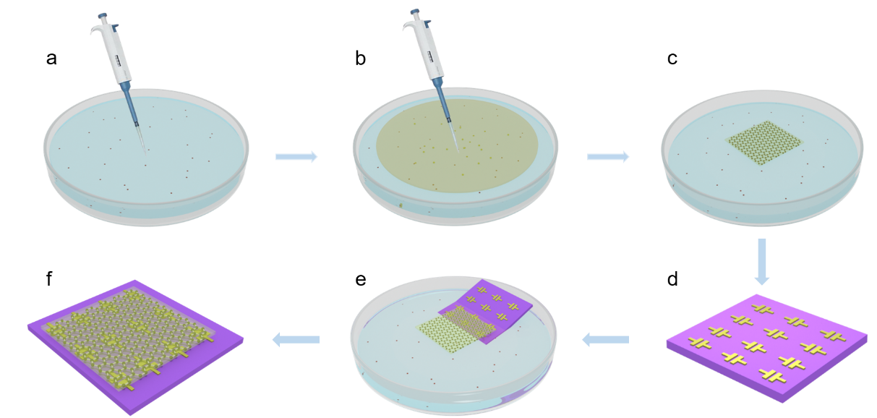
Figure S1. The schematic diagrams of growing perylene/GO heterostructure and corresponding device. a) Dropping GO solution onto water surface, b) Dropping perylene solution onto water surface with GO solution, c) large self-assembled heterostructure on water surface, d) Steam Au electrode deposition on SiO₂/Si substrate, e) Transfer the perylene/GO heterostructure to the substrate with Au, f) Device diagram of perylene/GO heterostructure.

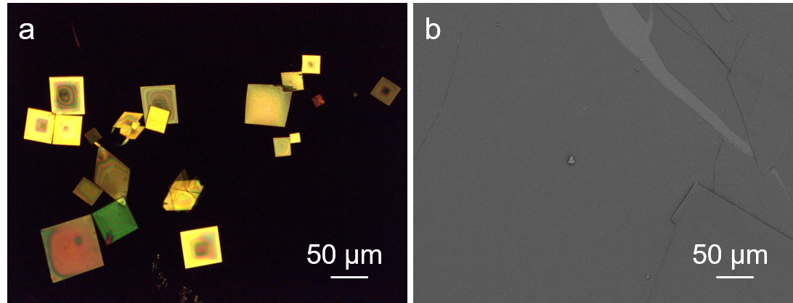
Figure S2. Crystal growth contrast experiment. a) POM image of perylene crystal without GO solution. b) SEM image of perylene/GO heterostructure. With the addition of GO solution, larger two-dimensional perylene crystals could be obtained. On the one hand, GO nanosheets provided site induction to promote the growth of molecular crystals, and on the other hand, electrostatic adsorption and hydrogen bonding between oxygen-containing functional groups and organic molecules further accelerated the growth.

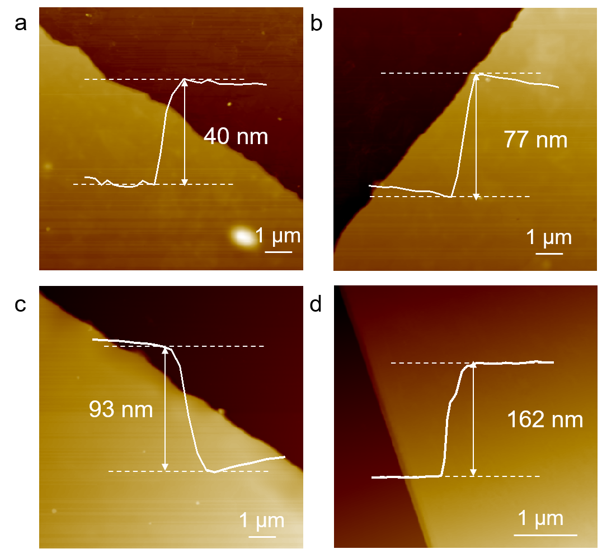
Figure S3. Heterostructure thickness regulation. AFM images of perylene/GO heterostructure with the different thicknesses. By co-self-assembly with 50, 150, 300, 500 µL GO solution, a) 40 nm, b) 77 nm, a) 93 nm, a) 162 nm thick perylene/GO heterostructure was formed.

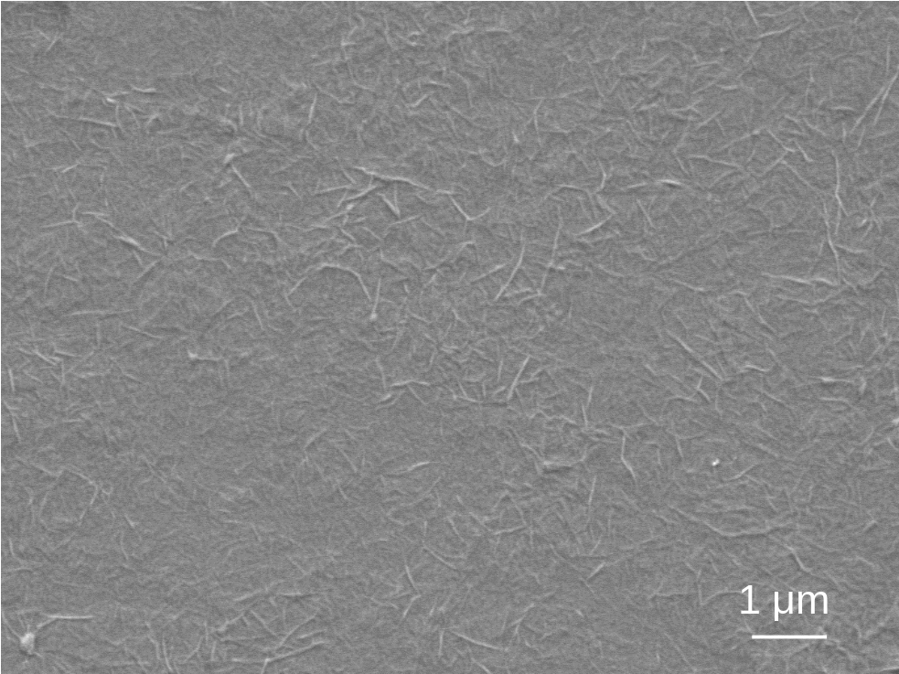
Figure S4. Morphology of pure GO film. SEM image of GO transferring to the SiO₂/Si substrate after the toluene solvent evaporates.

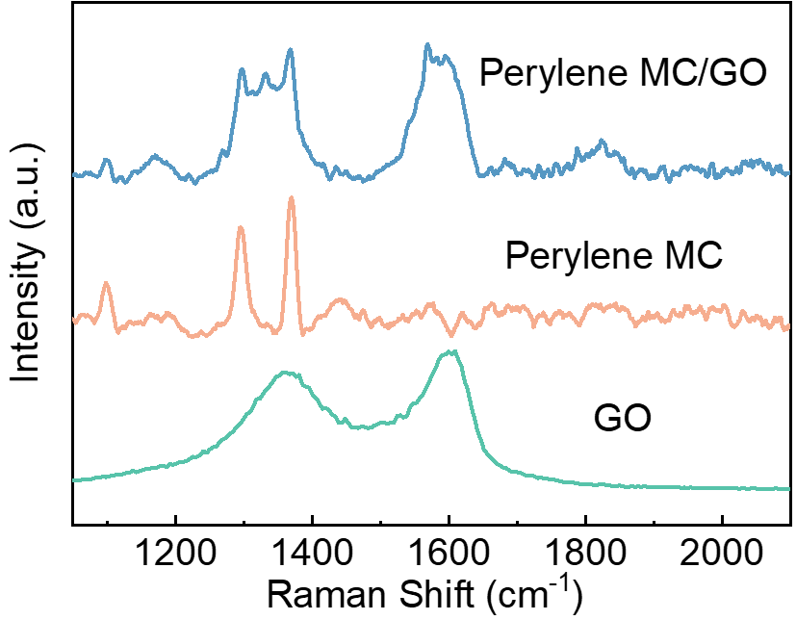
Figure S5. Raman spectrum of GO, perylene molecular crystal (MC) and perylene/GO heterobilayer, respectively.

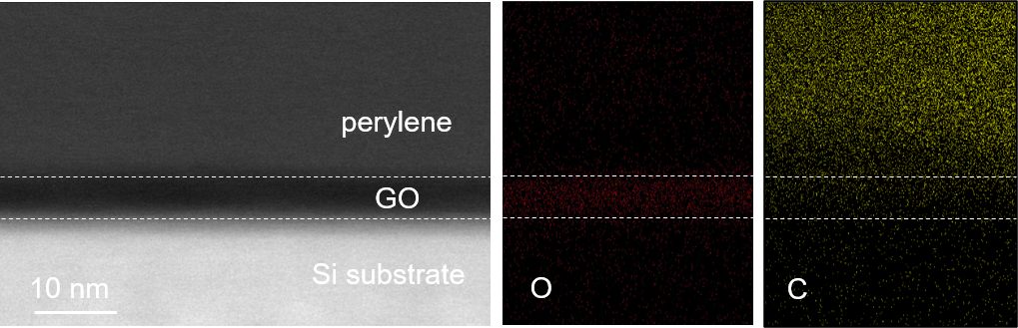
Figure S6. Cross-sectional STEM image and corresponding EDS images of perylene/GO heterostructure film transferred onto a Si substrate.

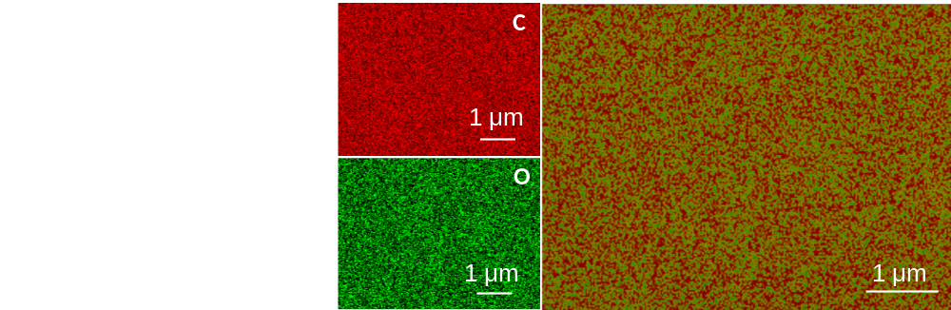
Figure S7. SEM images of perylene/GO heterostructure with the upper layer of GO and element mapping of C and O using EDS on SEM.

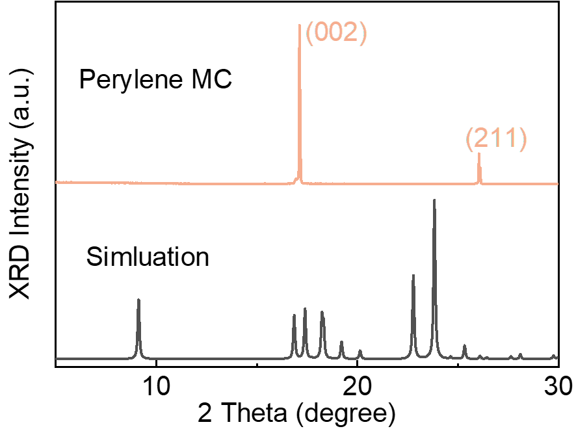
Figure S8. XRD patterns of perylene crystal (top) and the simulated XRD based on the single crystal data (bottom). The XRD patterns shows the two-dimensional crystal structure of co-self-assembled perylene, which possesses good photoelectric properties and fast response time.

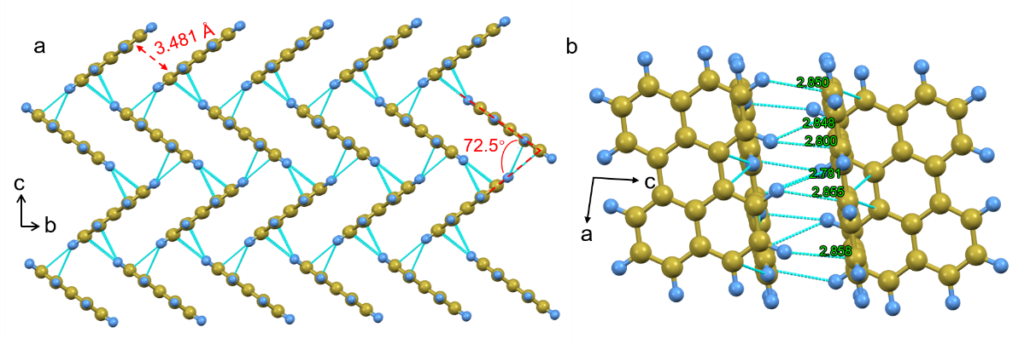
Figure S9. Intermolecular interactions in perylene crystal.

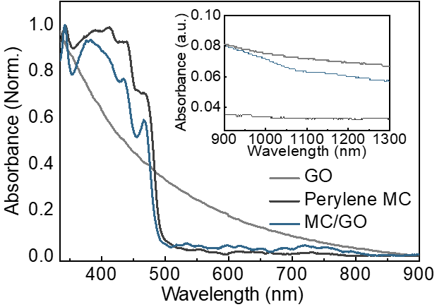
Figure S10. UV-visible to NIR absorption spectrum of GO, perylene crystal and perylene/GO heterobilayer. The inset is the NIR absorption spectrum of the three substances.

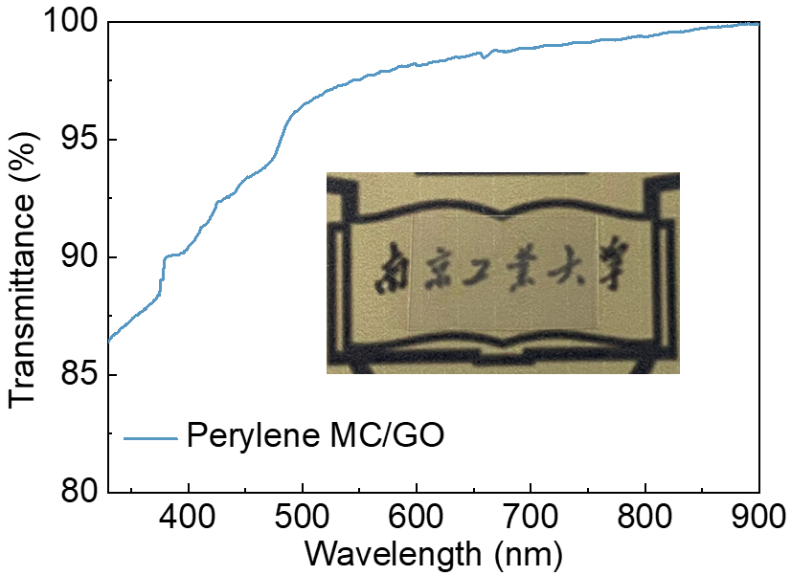
Figure S11. Optical transmission spectrum of perylene/GO heterobilayer on quartz substrate. The heterobilayer has a transmittance of about 85% in the visible range, and the pattern Chinese characters below is clearly visible with nearly no color variation.

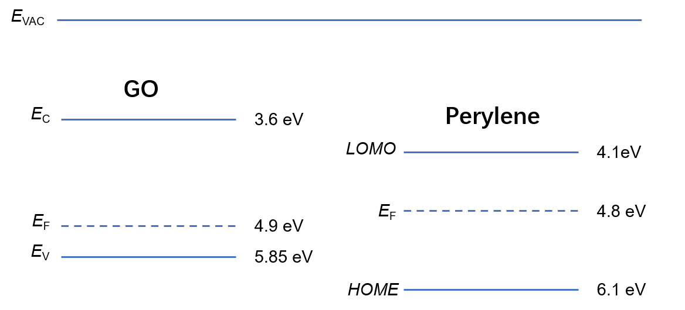
Figure S12. Band structure of GO and Perylene. The Fermi energy level positions and valence band positions of GO and perylene are calculated by UV photoelectron spectroscopy (UPS). According to the existing reports^{1, 2}, the band gap width and conduction band position are deduced, and finally the band structures of the two bands were determined.

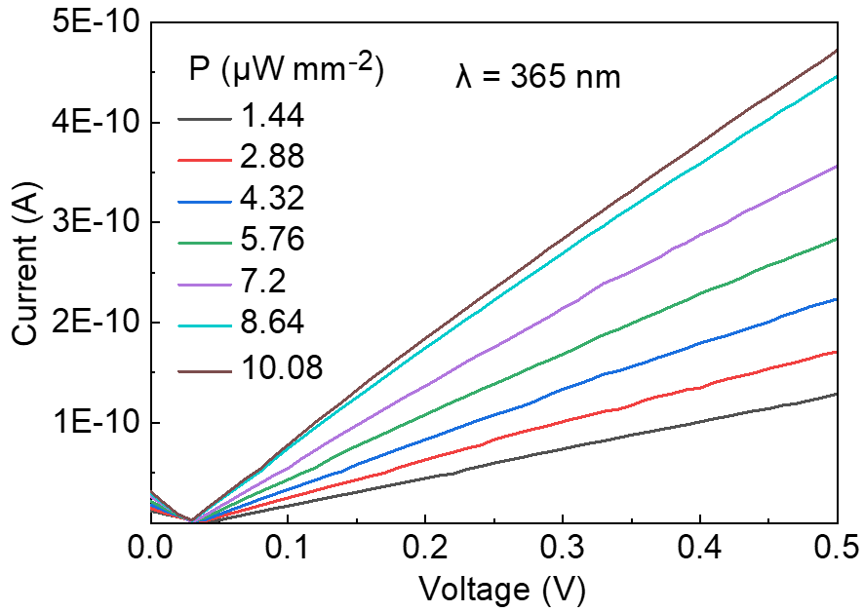
Figure S13. I-V characterization curves under different light power at 365 nm. At a sweep voltage of 0 to 0.5 V, a significant current increase occurs as the light intensity increases from 1.44 to 10.08 µW mm⁻²

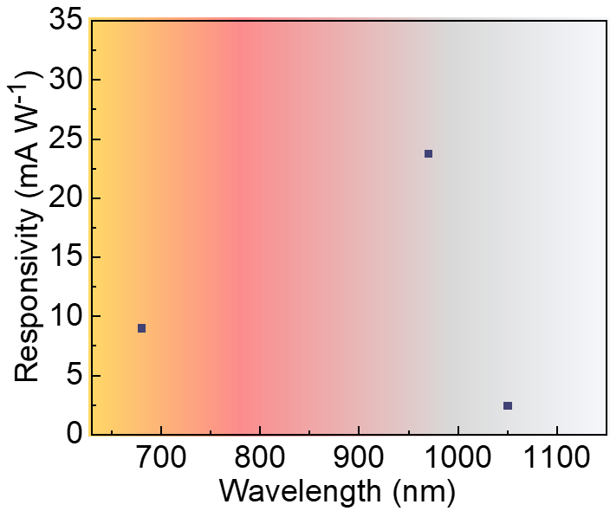
Figure S14. Photoresponsivity as a function of light wavelength in the near infrared region. The photoresponsivity of the heterobilayer at 970 nm is even comparable to that of the ultraviolet area due to the absorption of GO material in the infrared region.

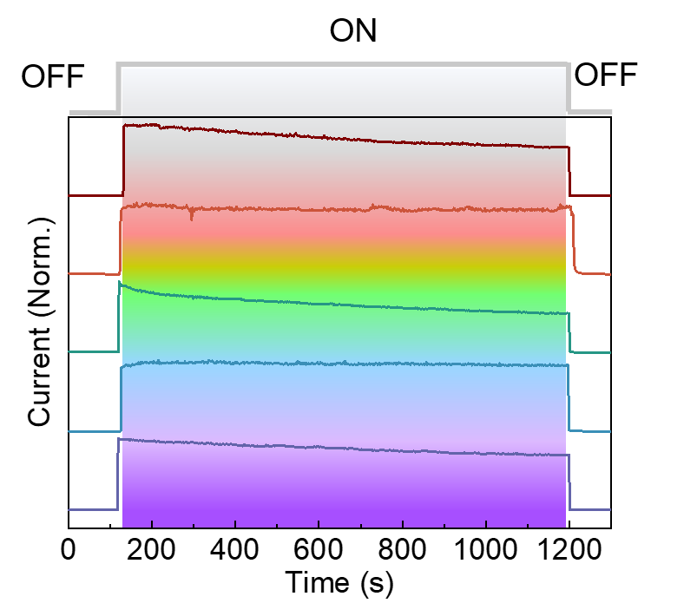
Figure S15. The photoresponse times under various excitation wavelengths have a good consistency, indicating a significant photovoltaic-effect-dominated mechanism (V_{b} = 1 V).

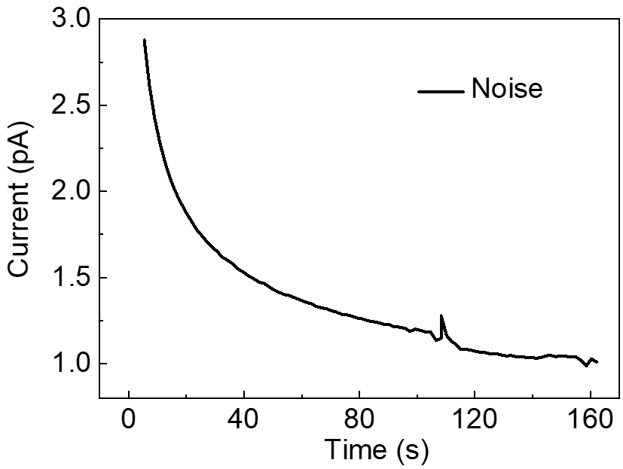
Figure S16. Noise current. The current of the device in a dark environment with V_{b} = 1 V. The current gradually decreases under bias voltage and stabilizes around 1 Pa, and the ultra-small noise provides excellent light detection performance for the device.

Table S1. The performances of heterostructure based photodetectors.
Materials | D* (Jones) | R (A W^{–1}) | t | λ (nm) | I_{on}/I_{off} | Voltage (V) | Current (A) | Power  (W) | Ref.
Graphene/Perovskite/Graphene | 3.4×10¹⁰ | 0.53 | / | 400-700 | 10 | 3 | 10⁻⁷ | 3×10⁻⁷ | 3
Al Nanostructure/ZnO | / | 11.98 | 0.79 s | 365 | 10⁴ | 10 | 2.8×10⁻⁵ | 2.8×10⁻⁴ | 4
Graphene/Bi₂Te₃ | / | 35 | 8.7 ms | 532-1550 | 1 | 1 | 2.5×10⁻⁵ | 2.5×10⁻⁵ | 5
MoS₂/SWCNTs | / | 0.1 | 15 μs | 650-1000 | 10⁴ | 5 | 4.5×10⁻⁵ | 2.25×10⁻⁴ | 6
Graphene/Silicon | / | 0.13 | / | 1550-2750 | 30 | 1.5 | 6×10⁻⁷ | 9×10⁻⁷ | 7
Graphene/Ta₂O₅/Graphene | / | 1 | 10 ms | 532-3200 | 10 | 1 | 3×10⁻⁵ | 3×10⁻⁵ | 8
C8-BTBT/Graphene | / | 1.57×10⁴ | 25 ms | 355 | / | 0.1 | 2.2×10⁻⁶ | 2.2×10⁻⁷ | 9
Bi₂Te₃/Si | 2.5×10¹¹ | 1 | 100 ms | 635 | 10 | 5 | 2×10⁻⁵ | 10⁻⁴ | 10
PdSe₂/Perovskite | ~10¹³ | 0.313 | 3.5 μs | 200-1550 | 10⁴ | 5 | 15×10⁻⁶ | 7.5×10⁻⁵ | 11
WSe₂/SnS₂ | 1.29×10¹³ | 244 | 0.2 s | 550-750 | 10⁴ | 1 | 10⁻⁸ | 10⁻⁸ | 12
GaSe/GaSb | 2.2×10¹² | 0.115 | 30 μs | 400-1800 | 10³ | 1 | 1.4×10⁻³ | 1.4×10⁻³ | 13
MoS₂/α-MoO₃-x | 1.7×10¹⁴ | 1.9×10⁵ | 95μs | 405-638 | 10⁷ | 1 | 10⁻⁵ | 10⁻⁵ | 14
ZnO/Ga₂O₃ | 6.29×10¹² | 9.7×10⁻³ | 100 μs | 200-280 | 10⁵ | 2 | 2×10⁻⁶ | 4×10⁻⁶ | 15
MoS₂/WS₂ | / | 1.42 | / | 633 | 10³ | 1 | 3×10⁻⁷ | 3×10⁻⁷ | 16
MoS₂/Graphene/WSe₂ | 10¹⁴ | 10⁴ | 53.6 μs | 500-2500 | 10³ | 1 | 1.2×10⁻⁶ | 1.2×10⁻⁶ | 17
GaTe/MoS₂ | 8.4×10¹³ | 21.83 | 7 ms | 473 | 10³ | 1 | 4.5×10⁻⁸ | 4.5×10⁻⁸ | 18
PdSe₂/MoS₂ | 8.21×10⁹ | 42.1 | 74.5 ms | 10.6 μm | 1 | 1 | 10⁻⁵ | 10×10⁻⁶ | 19
IGZO/ZnO NRs | 8.21×10¹⁶ | 4.9×10⁵ | / | 400 | 9.5×10⁵ | 60 | 10⁻⁶ | 6×10⁻⁵ | 20
Chlorophyll/PDPP4T | 6×10¹⁵ | 2×10⁶ | / | / | 2.7×10⁶ | 60 | 10⁻⁶ | 6×10⁻⁵ | 21
C8-BTBT/CH₃NH₃PbI₃ NPs | 2.09×10¹² | 1.72×10⁴ | / | 252-780 | 2×10⁵ | 50 | 2×10⁻⁵ | 10⁻³ | 22
This Work | 5.01×10¹⁶ | 0.112 | 50 ms | 250-1300 | 10³ | 1 | 10⁻⁹ | 10⁻⁹

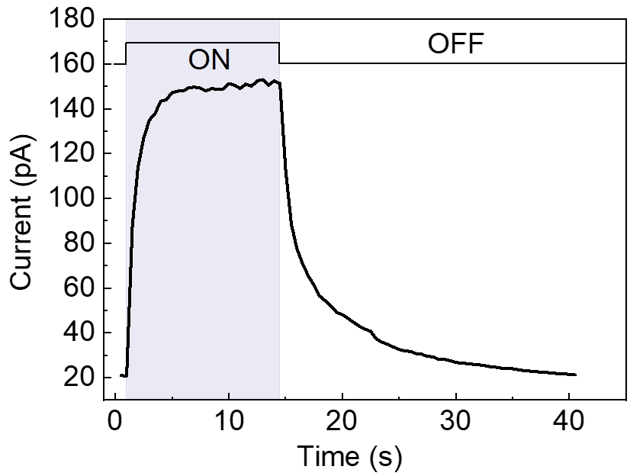
Figure S17. Typical photoelectric switching characteristics of the device under 0.144 μW mm⁻² UV light with V_{b} = 1 V.

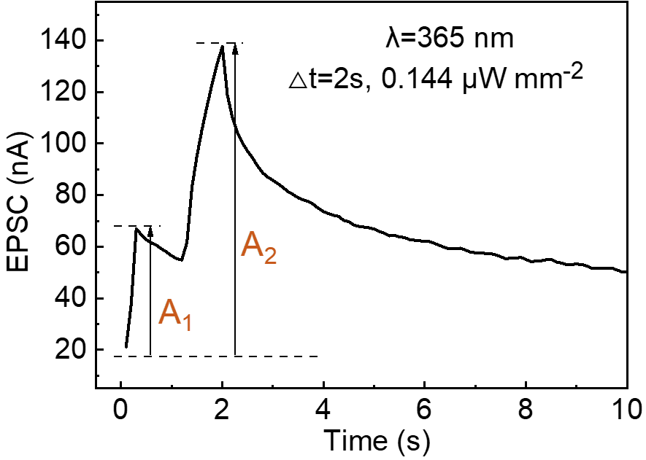
Figure S18. Typical paired-pulse facilitation (PPF) behavior of photonic synaptic device (V_{b} = 1 V). PPF in biological nerve systems refers to an increase in the postsynaptic potential induced by an impulse that occurs immediately after another. PPF is generated by a rise in presynaptic Ca²⁺ concentration, which causes additional synaptic vesicles carrying neurotransmitters to be released. In this device, the ratio of A₂/A₁ is defined as the PPF index.

Table S2. Comparison of the maximum PPF index value of artificial synapses.
Device | Active material | PPF index | Ref.
transistor | IGZO/chitosan | 137% | 23
transistor | PQT₁₂-CsPbBr₃ QDs/SiO₂ | 132% | 24
transistor | CsPbBr₃/PMMA/pentacene | 130% | 25
transistor | POx/BP/SiO₂ | 155% | 26
transistor | IGZO/HfZrOx | 140% | 27
Electrolyte-gated transistor | Indium-zinc oxide thin film | 180% | 28
Electrolyte-gated transistor | PEO/P3HT core-sheath NWs | 162% | 29
Electrolyte-gated transistor | Multilayer MoO₃ nanoflake | 114% | 30
Electrolyte-gated transistor | Indium-tungsten oxide thin film | 190% | 31
Organic field-effect transistors | P3HT thin film | 190% | 32
Organic electrochemical transistor | PEDOT:PSS thin film | 185% | 33
Memristor | Conjugated polyelectrolyte film | 145% | 34
Memristor | Mesoporous silica | 128% | 35
Photonic flash memory | Evaporated pentacene thin film | 130% | 25
Quasi-2DEGs photonic synapses | InGaO₃(ZnO)₃ superlattice NWs | 210% | 36
Two-terminal | ITO/Nb:SrTiO₃ | 144% | 37
Two-terminal | Au/LSNO | 138% | 38
Two-terminal | ZnO1-x/AlOy | 170% | 39
Two-terminal | In₂O₃/ZnO/FTO | 180% | 40
This Work | perylene/GO | 214%

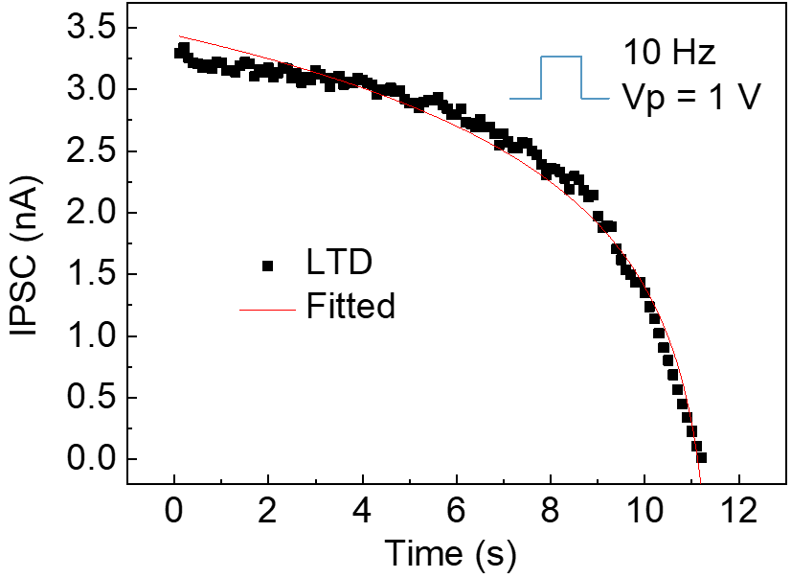
Figure S19. Inhibitory postsynaptic potential behavior under pulsed voltage (1 V 10 Hz) after illumination. The device's photocurrent reaches 3.26 nA when exposed to strong light. Pulse voltage is provided to both ends of the device at this time, and the current is suppressed from nA to pA levels.

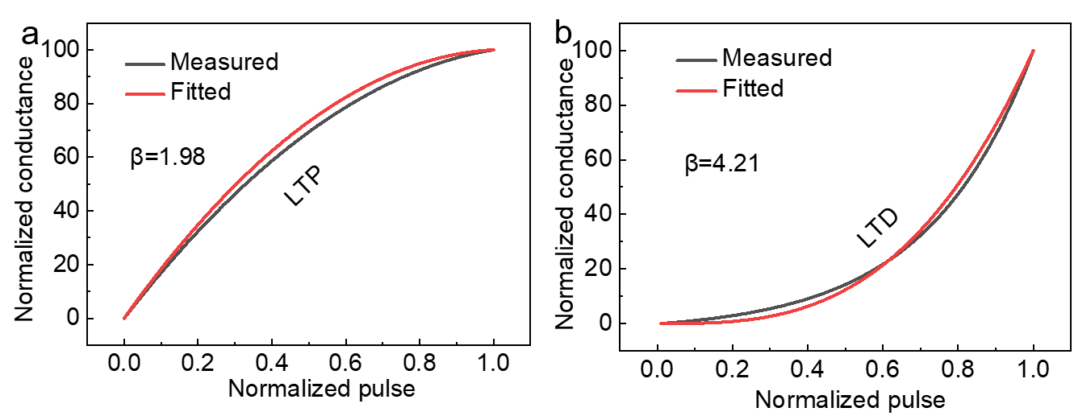
Figure S20. Nonlinearity analysis of LTP/LTD curves. a). Fitting curves of b LTP at β_{P} = 1.98 using the extracted parameters given in Figure 4c. b). Fitting curves of b LTD at β_{D} = 4.21 using the extracted parameters given in Figure S19.

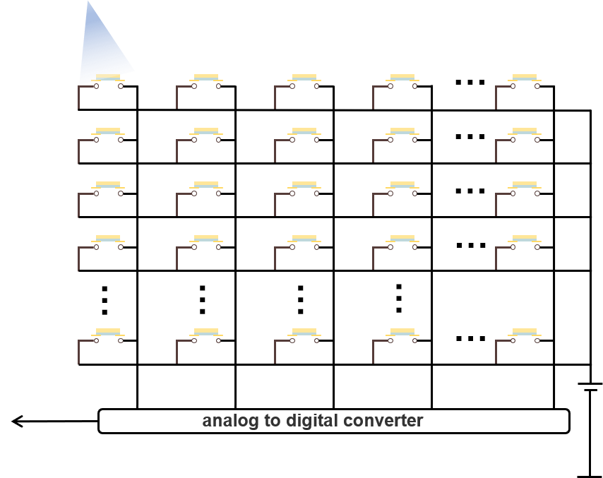
Figure S21. Schematic of the hardware implementation of the light-derived neural network by using the photosynapse at each intersection.

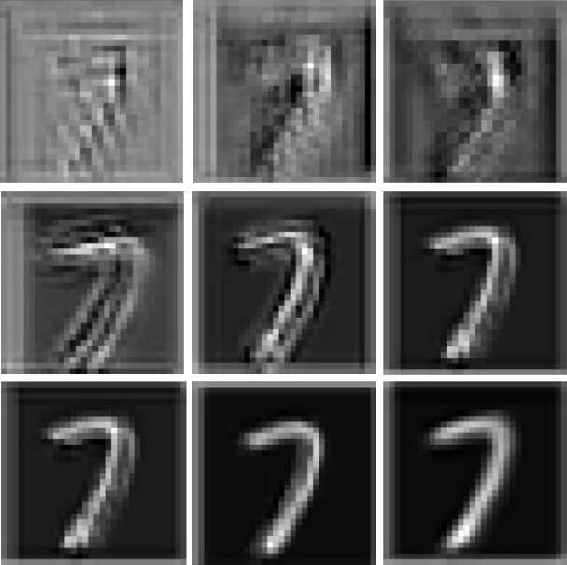
Figure S22. Results of a number ‘7’ in the initial state and after training processes.

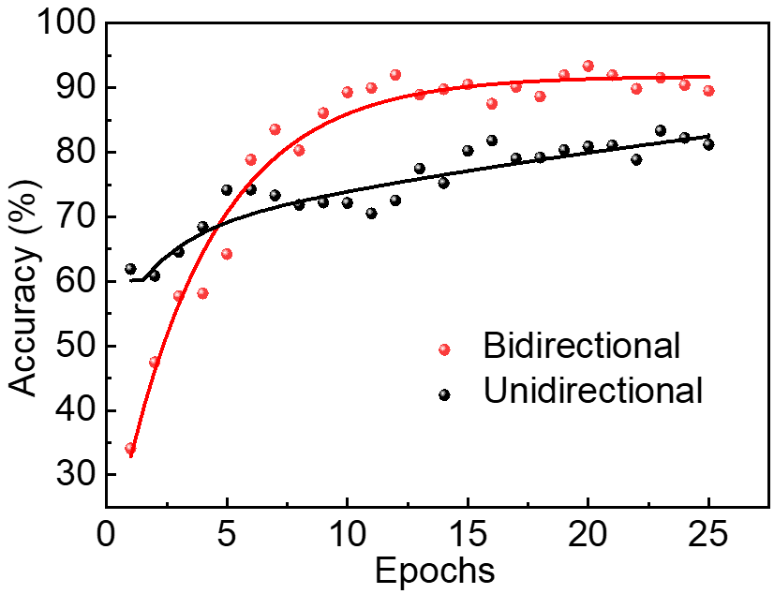
Figure S23. Bidirectional and unidirectional number recognition accuracy in the training epochs.

1. Pookpanratana SJ, et al. Electronic properties and structure of single crystal perylene. Org Electron 61, (2018).
2. Liu J, Xue Y, Gao Y, Yu D, Durstock M, Dai L. Hole and electron extraction layers based on graphene oxide derivatives for high-performance bulk heterojunction solar cells. Adv Mater 24, 2228-2233 (2012).
3. Alamri AM, Leung S, Vaseem M, Shamim A, He J-H. Fully Inkjet-Printed Photodetector Using a Graphene/Perovskite/Graphene Heterostructure. IEEE Trans Electron Devices 66, 2657-2661 (2019).
4. Liu S, et al. Self-Assembled Al Nanostructure/ZnO Quantum Dot Heterostructures for High Responsivity and Fast UV Photodetector. Nanomicro Lett 12, 114 (2020).
5. Qiao H, et al. Broadband photodetectors based on graphene–Bi₂Te₃ heterostructure. ACS Nano 9, 1886-1894 (2015).
6. Jariwala D, et al. Gate-tunable carbon nanotube-MoS₂ heterojunction p-n diode. Proc Natl Acad Sci U S A 110, 18076-18080 (2013).
7. Wang X, Cheng Z, Xu K, Tsang HK, Xu J-B. High-responsivity graphene/silicon-heterostructure waveguide photodetectors. Nat Photonics 7, 888-891 (2013).
8. Liu CH, Chang YC, Norris TB, Zhong Z. Graphene photodetectors with ultra-broadband and high responsivity at room temperature. Nat Nanotechnol 9, 273-278 (2014).
9. Liu X, et al. Epitaxial Ultrathin Organic Crystals on Graphene for High-Efficiency Phototransistors. Adv Mater 28, 5200-5205 (2016).
10. Yao J, Shao J, Wang Y, Zhao Z, Yang G. Ultra-broadband and high response of the Bi₂Te₃-Si heterojunction and its application as a photodetector at room temperature in harsh working environments. Nanoscale 7, 12535-12541 (2015).
11. Zeng LH, et al. Multilayered PdSe₂/Perovskite Schottky Junction for Fast, Self-Powered, Polarization-Sensitive, Broadband Photodetectors, and Image Sensor Application. Adv Sci 6, 1901134 (2019).
12. Zhou X, et al. Tunneling Diode Based on WSe₂/SnS₂ Heterostructure Incorporating High Detectivity and Responsivity. Adv Mater 30, (2018).
13. Wang P, et al. Arrayed Van Der Waals Broadband Detectors for Dual-Band Detection. Adv Mater 29, (2017).
14. Feng S, et al. An ultrasensitive molybdenum-based double-heterojunction phototransistor. Nat Commun 12, 4094 (2021).
15. Zhao B, et al. An Ultrahigh Responsivity (9.7 mA W⁻¹ ) Self-Powered Solar-Blind Photodetector Based on Individual ZnO-Ga₂O₃ Heterostructures. Adv Funct Mater 27, (2017).
16. Huo N, Kang J, Wei Z, Li S-S, Li J, Wei S-H. Novel and Enhanced Optoelectronic Performances of Multilayer MoS2-WS2Heterostructure Transistors. Adv Funct Mater 24, 7025-7031 (2014).
17. Long M, et al. Broadband Photovoltaic Detectors Based on an Atomically Thin Heterostructure. Nano Lett 16, 2254-2259 (2016).
18. Wang F, et al. Tunable GaTe-MoS₂ van der Waals p-n Junctions with Novel Optoelectronic Performance. Nano Lett 15, 7558-7566 (2015).
19. Long M, et al. Palladium Diselenide Long-Wavelength Infrared Photodetector with High Sensitivity and Stability. ACS Nano 13, 2511-2519 (2019).
20. Tao Z, Liu X, Lei W, Chen J. High sensitive solar blind phototransistor based on ZnO nanorods/IGZO heterostructure annealed by laser. Mater Lett 228, 451-455 (2018).
21. Yang B, et al. Bioinspired Multifunctional Organic Transistors Based on Natural Chlorophyll/Organic Semiconductors. Adv Mater 32, e2001227 (2020).
22. Xu X, et al. Dual-Band, High-Performance Phototransistors from Hybrid Perovskite and Organic Crystal Array for Secure Communication Applications. ACS Nano 13, 5910-5919 (2019).
23. Yang Y, He Y, Nie S, Shi Y, Wan Q. Light stimulated IGZO-based electric-double-layer transistors for photoelectric neuromorphic devices. IEEE Electron Device Lett 39, 897-900 (2018).
24. Wang K, Dai S, Zhao Y, Wang Y, Liu C, Huang J. Light‐stimulated synaptic transistors fabricated by a facile solution process based on inorganic perovskite quantum dots and organic semiconductors. Small 15, 1900010 (2019).
25. Wang Y, et al. Photonic synapses based on inorganic perovskite quantum dots for neuromorphic computing. Adv Mater 30, 1802883 (2018).
26. Tian H, et al. Anisotropic black phosphorus synaptic device for neuromorphic applications. Adv Mater 28, 4991-4997 (2016).
27. Kim MK, Lee JS. Synergistic Improvement of Long-Term Plasticity in Photonic Synapses Using Ferroelectric Polarization in Hafnia-Based Oxide-Semiconductor Transistors. Adv Mater 32, e1907826 (2020).
28. Zhu LQ, Wan CJ, Guo LQ, Shi Y, Wan Q. Artificial synapse network on inorganic proton conductor for neuromorphic systems. Nat Commun 5, 1-7 (2014).
29. Xu W, Min S-Y, Hwang H, Lee T-W. Organic core-sheath nanowire artificial synapses with femtojoule energy consumption. Sci Adv 2, e1501326 (2016).
30. Yang CS, et al. A synaptic transistor based on quasi-2D molybdenum oxide. Adv Mater 29, 1700906 (2017).
31. Wan C, et al. An artificial sensory neuron with tactile perceptual learning. Adv Mater 30, 1801291 (2018).
32. Zang Y, Shen H, Huang D, Di CA, Zhu D. A dual-organic-transistor-based tactile-perception system with signal-processing functionality. Adv Mater 29, 1606088 (2017).
33. Gkoupidenis P, Schaefer N, Garlan B, Malliaras GG. Neuromorphic functions in PEDOT: PSS organic electrochemical transistors. Adv Mater 27, 7176-7180 (2015).
34. Xu W, et al. Ultrasensitive artificial synapse based on conjugated polyelectrolyte. Nano Energy 48, 575-581 (2018).
35. Li B, et al. Mediating short-term plasticity in an Artificial memristive synapse by the orientation of silica mesopores. Adv Mater 30, 1706395 (2018).
36. Meng Y, et al. Artificial visual systems enabled by quasi-two-dimensional electron gases in oxide superlattice nanowires. Sci Adv 6, eabc6389 (2020).
37. Gao S, et al. An oxide Schottky junction artificial optoelectronic synapse. ACS Nano 13, 2634-2642 (2019).
38. Zhao L, et al. An artificial optoelectronic synapse based on a photoelectric memcapacitor. Adv Electron Mater 6, 1900858 (2020).
39. Hu D-C, Yang R, Jiang L, Guo X. Memristive Synapses with Photoelectric Plasticity Realized in ZnO_{1–x}/AlO_{y} Heterojunction. ACS Appl Mater Interfaces 10, 6463-6470 (2018).
40. Kumar M, Abbas S, Kim J. All-oxide-based highly transparent photonic synapse for neuromorphic computing. ACS Appl Mater Interfaces 10, 34370-34376 (2018).

