Supplementary Information

Engineering Volumetric hiPSC-derived Skeletal Muscle Tissue Implants for Regenerate Medicine using 3D Bioprinting

Yasamin A. Jodat†, Ting Zhang†, Ziad Al Tanoury, Tom Kamperman, Kun Shi, Yike Huang, Adriana C. Panayi, Yori Endo, Xichi Wang, Jacob Quint, Adnan Arnaout, Kiavash Kiaee, Shabir Hassan, Junmin Lee, Angel Flores Huidobro Martinez, Sofia Lara Ochoa, Kangju Lee, Michelle A. Calabrese, Alessandro Carlucci, Ali Tamayol, Indranil Sinha, Olivier Pourquie, Su Ryon Shin*

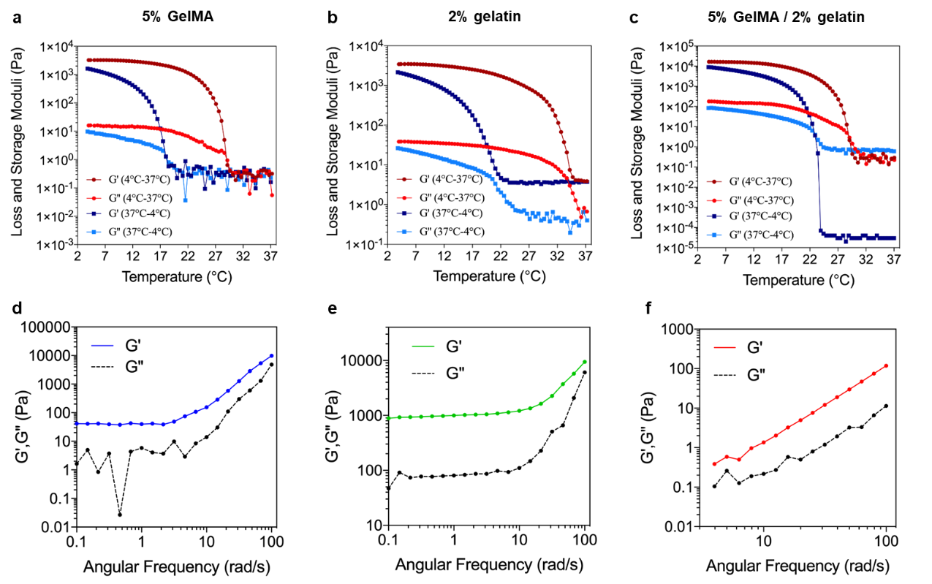

Figure S1. Rheological characterization of inks and embedding baths. (a-c) Temperature sweep analysis of 5% (w/v) GelMA, 2% (w/v) gelatin, and 5% (w/v) / 2% (w/v) GelMA / gelatin. (d-f) Frequency sweep analyses at room temperature showed separated elastic and viscous shear moduli for each gelled solution, corroborating that these materials behave solid-like across a wide temperature range. At higher frequencies, inertial effects cause an upturn in the dynamic moduli. ^{81 81 81 81 [81]}

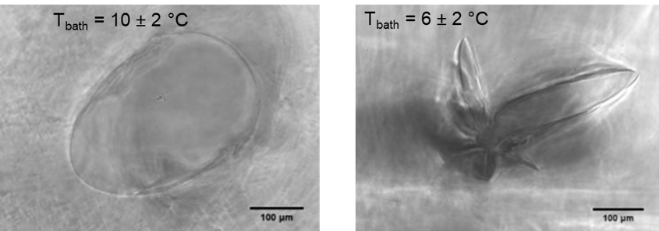
Figure S2. Cross section view of the printer channel at different support bath temperatures. Circularity of the printed channel is maintained at temperatures between ~8 °C and 18 °C, while printing at lower temperatures resulted in poor printing shape fidelity.

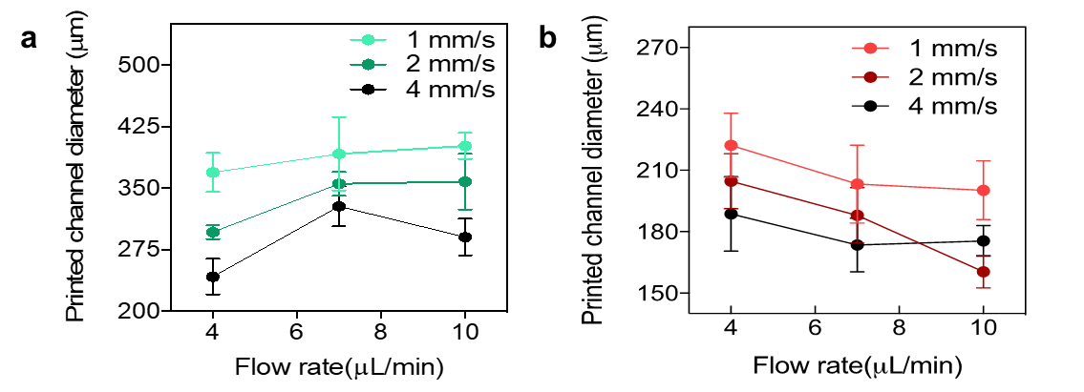
Figure S3. Controlling printed fiber diameter. The diameter of printed fibers consisting of (a) gelatin and (b) a mixture of GelMA and gelatin could be controlled by tuning the ink flow rate and nozzle translational speed (n=4 for both experiments). With gelatin, increasing the ink flow rate resulted in an increased channel diameter, while increasing the nozzle translation speed resulted in a decreased channel diameter. Also printed fiber diameter when using ink consisting of gelatin / GelMA mixtures negatively correlated with the nozzle speed.

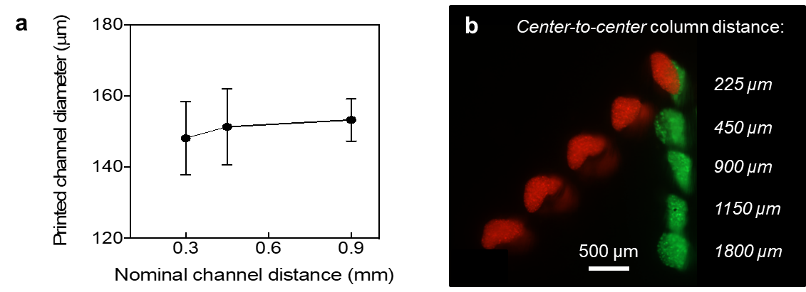
Figure S4. Controlling inter-channel printing distance. (a) Printing fidelity (i.e., variation in print diameter) was not significantly affected by the inter-channel distance (n=4), (b) which could indeed be reduced to approximately one channel diameter before printed channels started to overlap.

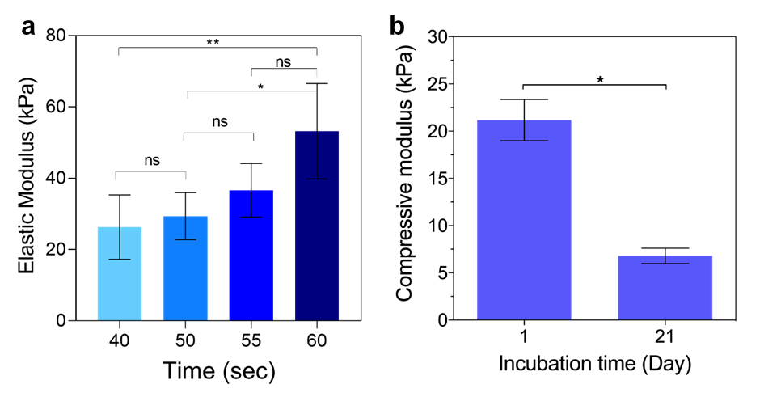
Figure S5. Elastic modulus of the 5% GelMA support bath. (a) Elastic modulus of the embedding bath was measured after preparation of the bath at different UV exposure times. Time values represent total UV exposure duration. The construct was flipped upside down halfway through the exposure. 55s was selected as the optimal condition as it reflected more closely to the native tissue elastic modulus. ‘ns’: p>0.7099; ‘*’: p<0.0183; ‘**’: p<0.0082; Tukey's multiple comparisons test ; n=4. (b) Elastic modulus of the bath on day 1 and day 21 of culture, representing stiffness degradation over the course of culture. ‘*’: p<0.0313; Wilcoxon test; n=6.

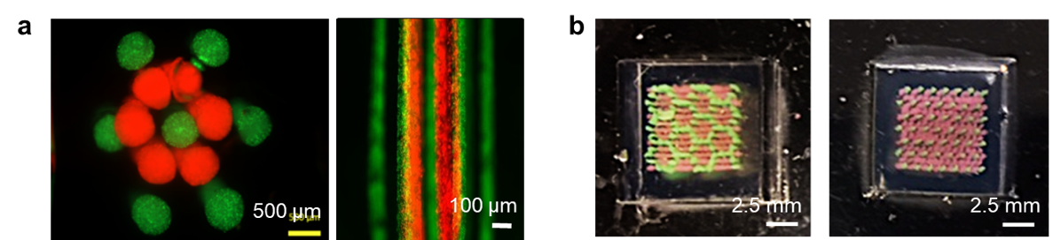
Figure S6. Dual ink bioprinting of muscle and vasculature geometry. Flower patterns were printed using food dye to represent the printability of muscle bundle architecture.

Figure S7. (a) Photographs of coaxial nozzles with two different sheath and core sizes. (b) Diameter of the printed microfiber channels at core, sheath and circle area using two configurations of coaxial nozzles (n=5).

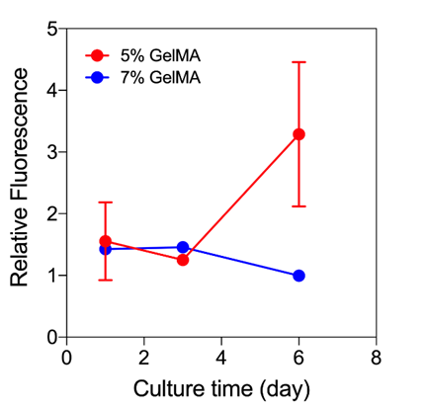
Figure S8. Proliferation of HUVECs in different concentration of supporting bath. GFP-labelled HUVECS were embedded and cultured in 5% (w/v) and 7% (w/v) GelMA supporting bath constructs and were imaged at different timepoints of culture. Lower concentration of GelMA exhibited elevated HUVEC proliferation capacity after 3 days of culture (n=3).

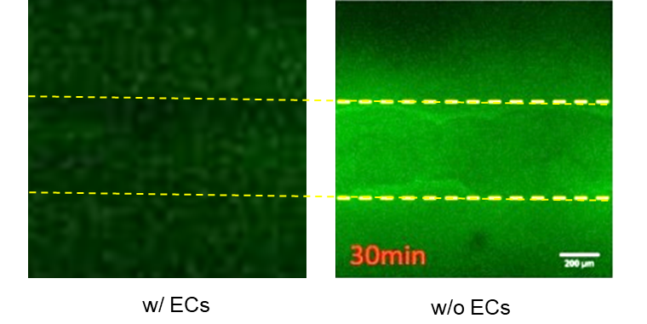
Figure S9. Effect of HUVECs in the bulk construct on diffusion properties. Perfusable GelMA constructs that were also seeded with 37.5 x 10⁶ cells/ml HUVECs showed increased permeability for 70 kDa dextran-FITC.

Figure S10. Optimizing the bioink for hiPSC-MPCs. (a) Muscle bioink consisted of 2% (w/v) gelatin enriched with different concentrations of GelMA. (b) The GelMA concentration had a significant effect on hydrogel stiffness. ‘*’: p<0.048; Ordinary one-way ANOVA ; n=3 (c) Degradation of the 2% gelatin / 7.5% GelMA construct in cell culture media for three weeks resulted in approximately 2-fold stiffness reduction. ‘*’: p<0.0191; unpaired t test; n=3
Figure S11. Differentiation procedure for hiPSC-MPCs. Undifferentiated hiPSC lines were differentiated to muscle progenitor populations following previous protocols. hiPSC-MPCs were then encapsulated in bioinks and bioprinted. Differentiation was induced on day 2 of bioprinting (day 23 of hiPSC differentiation) and was continued until the constructs were fixed for in vitro characterization or were implanted in VML animal models for in vivo studies.

Figure S12. Encapsulation of hiPSC-MPCs in 7.5% GelMA hydrogel. (a) Light microscope images after different days of culture and adding differentiation medium. (b) Confocal microscopy images with Titin/DAPI and MyHC/DAPI immunostaining within 10-15 days post induction.

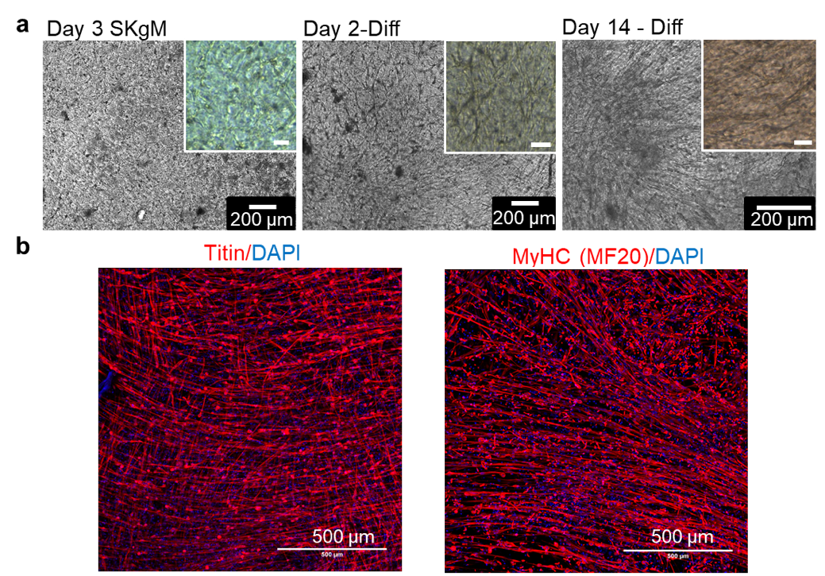
Figure S13. Encapsulation of hiPSC-MPCs in 7.5% GelMA hydrogel. (a) Light microscope images after different days of culture and adding differentiation medium. (b) Confocal microscopy images with Titin/DAPI and MyHC/DAPI immunostaining within 10-15 days post induction.

Figure S14. Live (green) and dead (red) staining of bioprinted human hiPSC-MPCs 6 days after differentiation induction. The cells maintained high viability and grew inside the patterned channels. Some dead cells were found in the inner section of the channels were oxygen transport was suboptimal due to lower perfusion.

Figure S15. Proliferation of bioprinted C2C12 cells inside 5% gelMA baths. (a) Cell proliferation was found to be higher in groups fabricated with perfusable channels compared to the group that did not contain perfusable vessels as confirmed by F-actin (green) and DAPI (blue) staining of the channels. (b) The group fabricated with perfusable vessels exhibited higher proliferation after 4 days of culture.

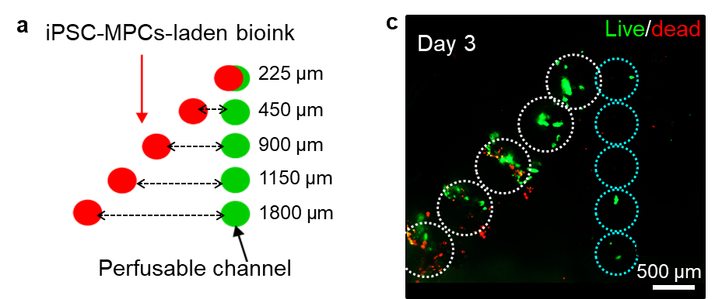
Figure S16. Optimizing distance between cell fibers and perfusable channels. (a,b) Based on a live/dead assay, an inter-channel distance of 450 µm between the muscle channel and perfusable channel was chosen to be optimal for hiPSC-MPC survival. This experiment revealed that the distance between perfusable channels and printed muscle fibers can be as large as ~450 µm while fully supporting the viability of printed hiPSC-MPCs. The viability began to decrease at larger distances from the perfusion channels.

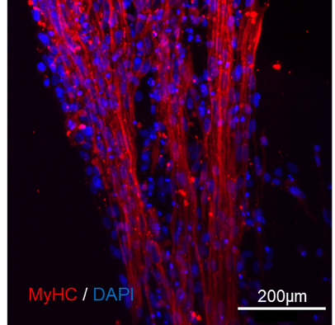
Figure S17. MyHC expression indicated muscle fiber maturation. High expression of myosin heavy chain (MyHC) after 10 days of culture in the bioprinted hiPSC-laden constructs fabricated with perfusable vessels revealed high muscle fusion and muscle alignment across the bioprinted constructs.
Figure S18. FFT analysis of the 3D bioprinted iPSC-MPC laden channels. (a) F-actin stained channels inside the constructs without (Top) and with (bottom) 3D bioprinted perfusable channels as imaged by z-stack confocal microscopy. (b) FFT plot of the fiber alignment inside the channels using ImageJ. (c) Histograms of the FFT alignment within the channels and the angle of orientation with respect to the channel.

Figure S19. High expression of sarcomeric alpha-actinin (red) and DAPI (blue) after 10 days of culture in the bioprinted hiPSC-laden constructs fabricated (a) without and (b) with HUVEC-coated perfusable vessels revealed high muscle fusion and muscle alignment across the bioprinted constructs.

Figure S20. Differentiation of iPSC-MPCs inside the bioprinted channels and bulk iPSC-MPCs-laden support bath. (a) After 10 days of differentiation, the cells showed high expression of alpha actinin (red) and elongated muscle fibers inside the bioprinted channels and inside the bulk hydrogel. (b) The expression of alpha actinin was found higher on the edges of the channels near the bottom of the construct. This observation can be related to high level of oxygen diffusion near the edges of the channels and the edges of the construct. The constructs expressed high levels of F actin (green) and proliferation regardless of the location of the cells inside the constructs

Figure S21. Mechanical characterization of 3D printed constructs. (a) Compressive modulus of the 3D printed constructs with muscle fibers ink (2% (w/v) gelatin/7.5% GelMA) and hollow channel ink (5% (w/v) gelatin) after 1 day and 30 days in vitro culture. ‘ns’: p > 0.4482; paired t test; n=3 (b) Compressive modulus and (c) elongation at break of the non-printed construct (photocured 5% (w/v) GelMA support matrix) and 3D printed constructs with muscle fibers ink (2% (w/v) gelatin/7.5% GelMA) and hollow channel ink (5% (w/v) gelatin) after 30 days in vitro culture. ‘ns’: p > 0.3886; unpaired t test; n=3.

Figure S22. Characterization of the control groups for the subcutanoeus study. Control groups included (a) acellular bioprinted perfusable channels in an acellular supporting bath (G3), and (b) non-bioprinted bulk hydrogels with HUVECs embedded in the supporting bath prior to cross-linking (G4). Both control grous were characterized with H&E markers and immunostained with human CD31 (red) and rat CD31 (green) staining after 1 week and 3 weeks of in vivo culture. Images show the stained section in the cross-section of the bioprinted channel (a(ii)) and bulk hydrogel (b(ii)) as well as near the interface of implant and host tissue (a(iii) and b(iii)). In G3, murine vascular networks developed around the implanted construct (a (iii)), but the progress of infiltration was relatively slower compared to pre-endothelialized constructs (G1, Figure 5f (iii)).

Figure S23. Assessment of host and implant vascularization within subcutaneously implanted constructs. The 3D bioprinted perfusable constructs (no muscle cells) seeded with HUVECs (G1) were implanted subcutaneously and harvested after 3 weeks of culture. The constructs were integrated inside the subcutanous pocket of the rats covered by the host tissue (a). The harvested samples were stained (b) with human CD31 (red) and rat CD31 (green) and exhibited high expression of both antibodies inside the HUVEC-seeded perfusable channels and on the edges of the construct.

Figure S24: VML model regenerative capacity of various control groups in the implanted constructs. Expression of myosin heavy chain (MyHC) and Pax7 in (a) injury models with no hydrogel treatment, (b (i-ii)) in injury models undergone implantation with bulk GelMA hydrogel. No hiPSC-MPCs were embedded inside the hydrogels. (b (iii)) shows the expression of mouse CD31 in the bulk GelMA constructs four weeks after implantation. (b (iv)) Neuronal marker, βIII-tubulin, was also expressed in parts of the bulk hydrogel implant sites. (c) VML injury models implanted with pre-vascularized hiPSC-MPC-laden constructs (supplemented with HUVEC-seeded perfusable printed channels) at four weeks post-surgery, characterized by (i) H&E staining, (ii) Masson's trichrome, (iii) MYH3, (iv) MyHC, (v) CD31 and (vi) βIII-tubulin. The top and bottom row indicate the left and right mouse leg implants, respectively.

