HmTT2-like
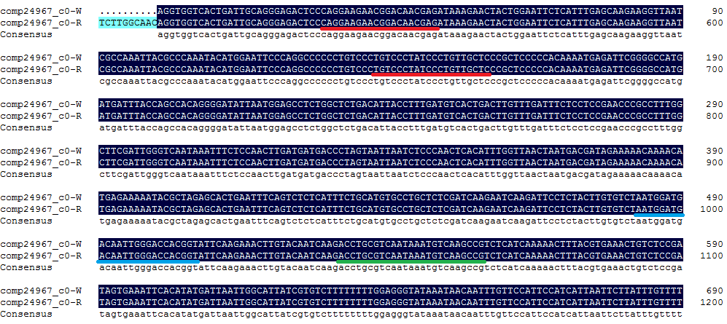

HmCYP71A8-like
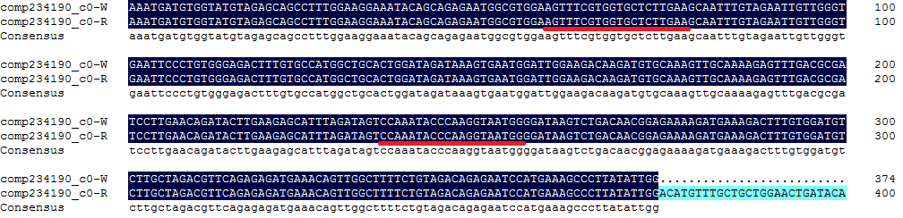

HmCYP83B1-like
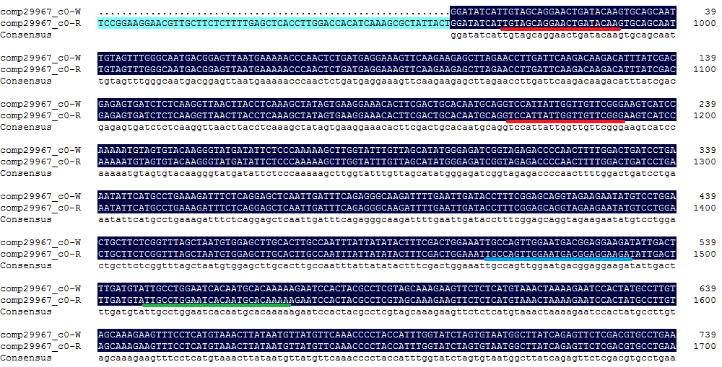

HmGmSGT2-like
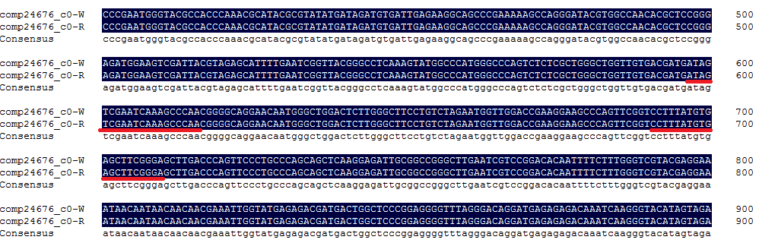

HmMYB12-like
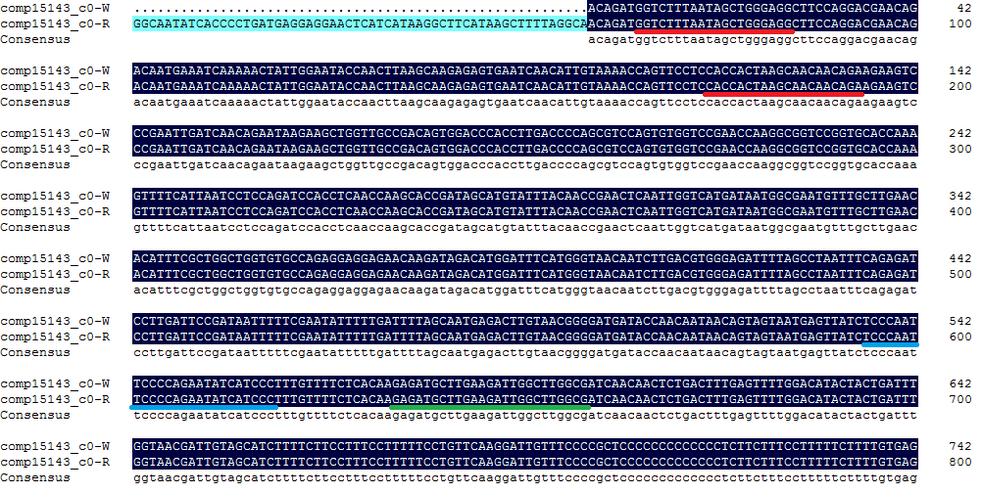

HmMYBC1-like
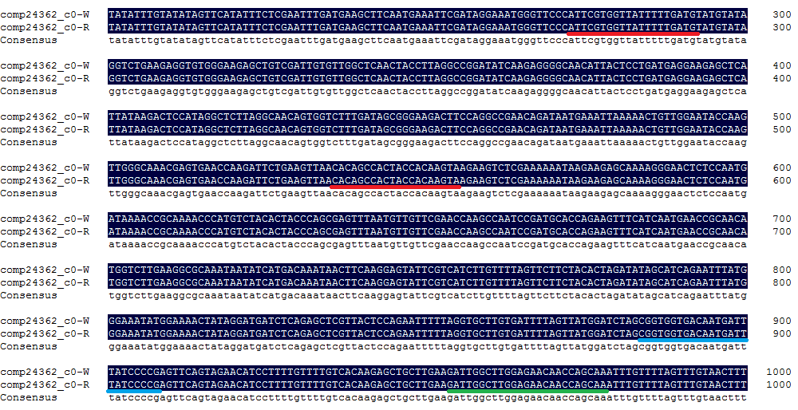

HmMYB2-like
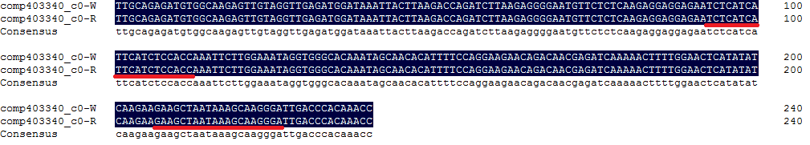

HmMYB315-like
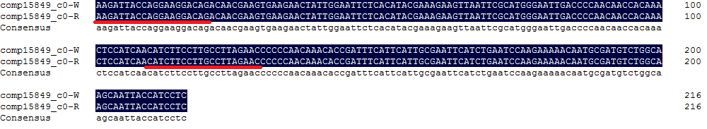

Hpcyt P450-like3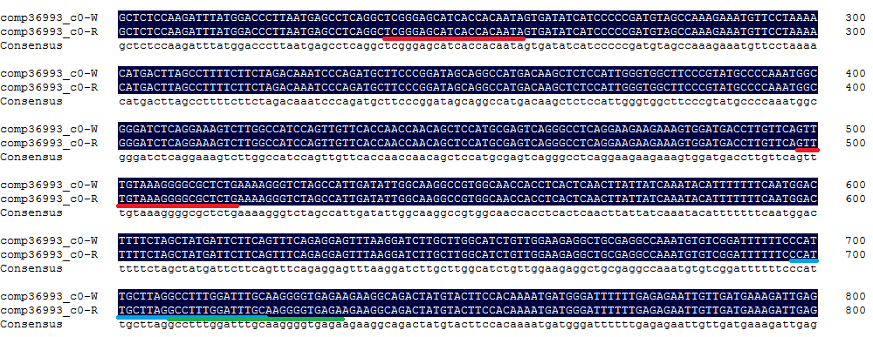

Hpcyt P450-like2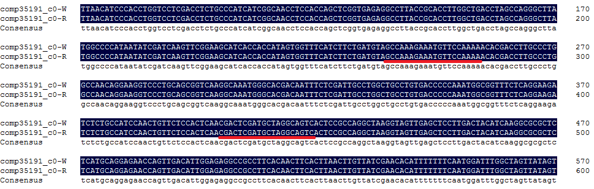

HmTPST-like 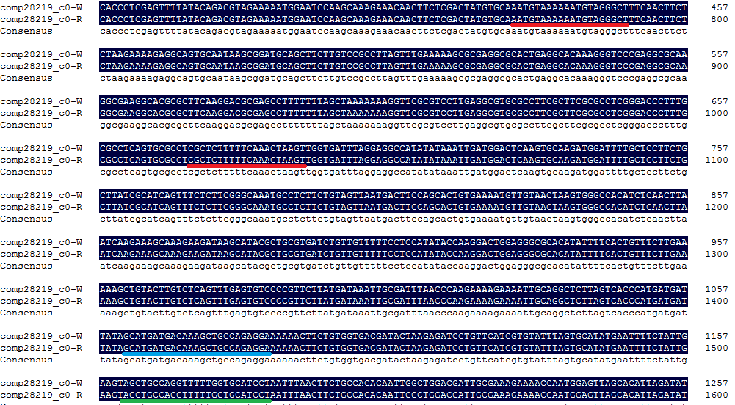

HmSPL6-like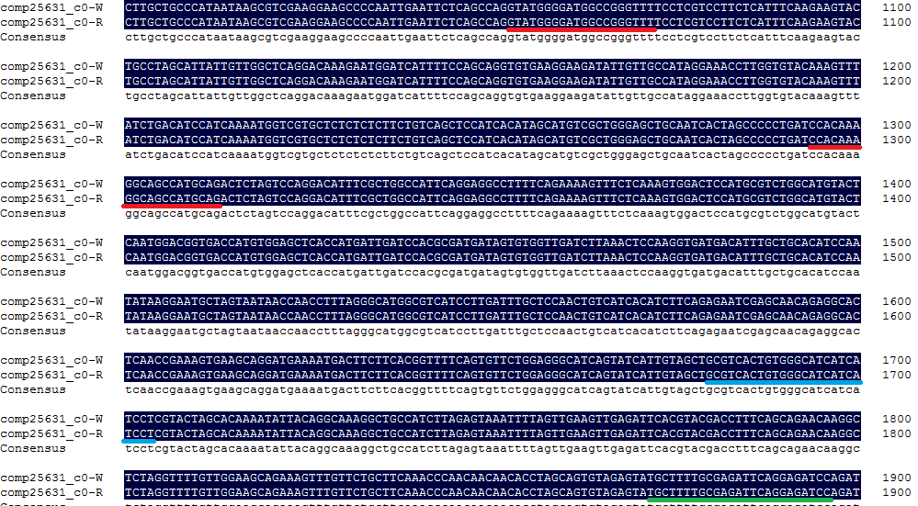

HmWDTC1-like
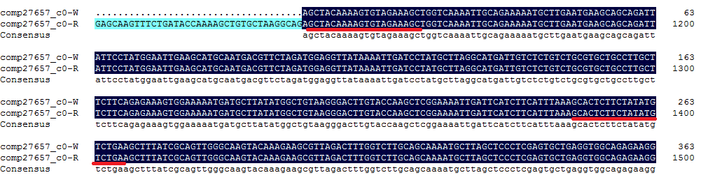

HmBHLH155-like
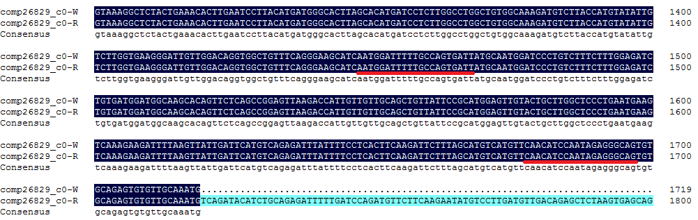
HmSPL16-like
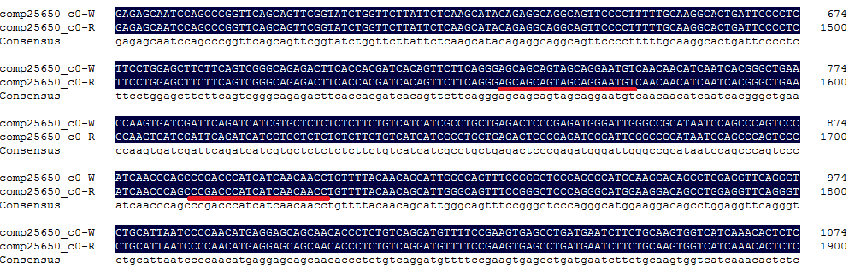
HmSEC-like
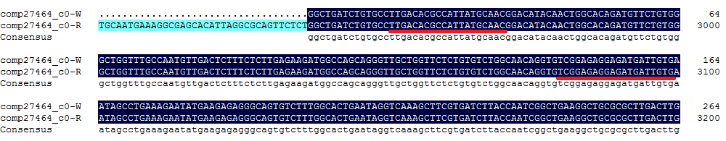
HmMYB330-like
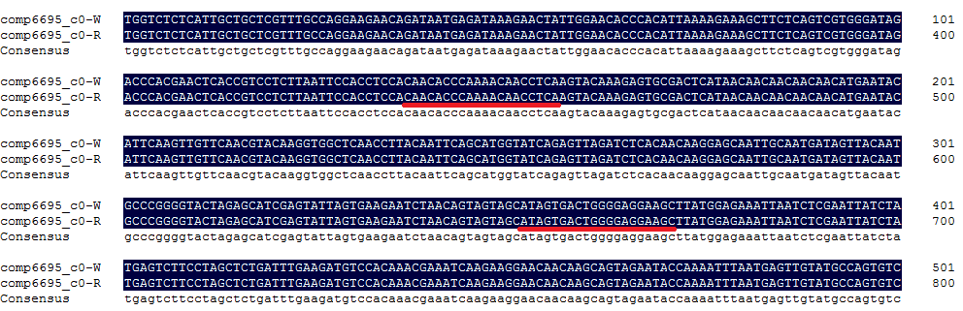
FIGURE S5 | The sequences of 17 target genes from the two pitaya cultivars.
‘-W’, ‘Guanhuabai’ pitaya. ‘-R’, ‘Guanhuahong’ pitaya. Red lines indicate sequence of target genes primers for real-time PCR. Green lines indicate outer specific primers for nested PCR. Blue lines indicate inner specific primers for nested PCR.

