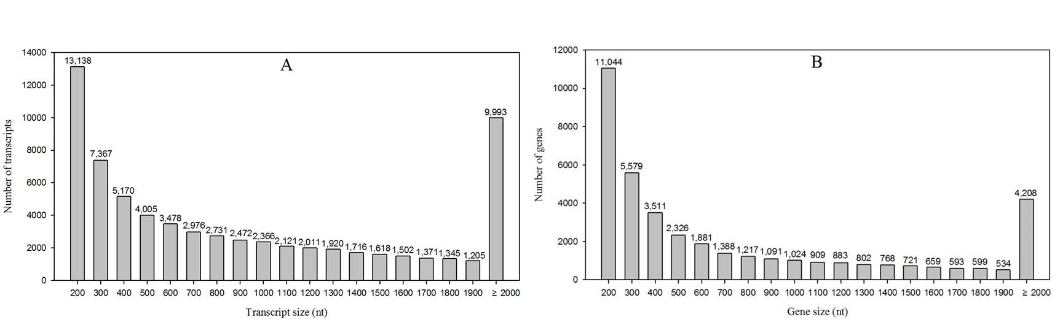
FIGURE S2 | The length distributions of assembled transcripts and genes.
A, The length distributions of transcripts; B, The length distributions of genes.

