Supplementary Information
Table of Contents
1. Supplementary Tables 2
Table S1 2
Table S2 3
Table S3 4
2. Supplementary Figures 6
Figure S1 6
Figure S2 7
Figure S3 8
Figure S4 9
Figure S5 10
3. References 11

Supplementary Tables

Table S1. Data from the patient and control children
available | Adipose tissue samples |  |  |  |  |  | Gene expression data from PBL |  |  |  |  | PBMCs RNA  sequencing
 | Patient | Ctr 1 | Ctr 2 | Ctr 3 | Ctr 4 | Ctr 10 | Patient | Ctr 5 | Ctr 6 | Ctr 7 | Ctr 8 | Patient | Ctr 9
Anthropometric data
Age (years) | 12.4 | 17.4 | 13.3 | 11.8 | 12.7 | 14.7 | 14.1 | 16 | 12.8 | 12.3 | 15.0 | 15.0 | 46.2
Sex | female | female | male | female | female | male | female | female | female | female | female | female | female
Height (cm) /  Height SDS | 181 / 3.4 | 176 / 1.3 | 156 / 0.0 | 158 / 0.7 | 160 / 0.3 | 163 / -1.0 | 183 / 2.9 | 167 / 0.1 | 186 / 3.8 | 163 / 1.0 | 183 / 2.7 | 183 / 2.8 | 173
BMI (kg/m²) /  BMI SDS | 47.6 / 3.7 | 40.5 / 3.7 | 25.5 / 1.8 | 31.4 / 2.7 | 29.7 / 2.4 | 22.2 / 0.8 | 37.8 / 3.2 | 33.1 / 2.8 | 44.7 / 3.6 | 31.0 / 2.6 | 38.6 / 3.3 | 39.7 / 3.4 | 19.0
Surgery | gastric bypass | gastric bypass | removal 8P | implan-tation 8P | implan-tation 8P | implan-tation 8P | --- | --- | --- | --- | --- | --- | ---
Location | abdomen | abdomen | femur | knee | knee | knee | --- | --- | --- | --- | --- | --- | ---

Ctr, control; SDS, standard deviation score; BMI, body mass index; 8P, eight plate; PBL, peripheral blood leukocytes; PBMCs, peripheral blood mononuclear cells.
Table S2. Variants strongly associated with red hair according to Morgan et al.¹ in the patient and her father
Gene | Variant ID | Effect | Associated with red hair | Patient | Father
MC1R | rs1805006 | D84E | A | C/C | C/C
MC1R | rs1805007 | R151C | T | C/C | C/C
MC1R | rs1110400 | I155T | C | T/T | T/T
MC1R | rs1805009 | D294H | C | G/G | G/G
MC1R | rs1805008 | rg160Trp or R160W | T | C/C | C/C
MC1R | rs34357723 | 97kb from the 5' end of MC1R | T | C/C | C/C
MC1R | rs368507952 | R306H | A | G/G | G/G
MC1R | rs200000734 | R213W | T | C/C | C/C
MC1R | rs201326893 | Y152X | A | C/C | C/C
MC1R | rs11547464 | R142H | A | G/G | G/G
MC1R | rs3212379 | upstream | T | C/C | C/C
MC1R | rs34474212 | S83P | C | T/T | T/T
MC1R | rs34158934 | T95M | T | C/C | C/C
MC1R | rs555179612 | I182Hfs | TC | C/C | C/C
RALY/ASIP | rs6059655 | non-coding | A | G/G | G/G

The affected gene, variant ID, effect and the allele associated with red hair is shown, together with the genotypes of the patient and her father. MC1R, melanocortin receptor 1; RALY, RALY heterogeneous nuclear ribonucleoprotein; ASIP, agouti-signaling protein.
Table S3. Primer sequences
Target | Primer, forward | Primer, reverse | Probe/SYBR green
Gene expression
ACTB | CGAGCGCGGCTACAGCTT | CCTTAATGTCACGCACGATTT | ACCACCACGGCCGAGCGG
ADIPOQ | GGC CGT GAT GGC AGA GAT | CCT TCA GCC CCG GGT ACT | CGATGTCTCCCTTAGGACCAATAAGACCTGG
AP2 | GCTTTTGTAGGTACCTGGAAACTTG | ACA CTG ATG ATC ATG TTA GGT TTG G | CCTGGTGGCAAAGCCCACTCCTCAT
ASIP | CAACTCCTCTGTGAACCTACTGGAT | TGCCGATCTGTTTGGATTTCT | CCCTTCTGTCTCTATTGTGGCGCTGAAC
CXCR4 | CACCGCATCTGGAGAACCA | GCCCATTTCCTCGGTGTAGTT | SYBR green
FOXA2 | GGGAGCGGTGAAGATGGA | TCATGTTGCTCACGGAGGAGTA | SYBR green
ITCH | TaqMan Assay Hs00395201_m1
MESP | CTGCCTGAGGAGCCCAAGT | GCAGTCTGCCAAGGAACCA | SYBR green
MIXL | CCGAGTCCAGGATCCAGGTA | CTCTGACGCCGAGACTTGG | SYBR green
NANOG | CCTTCCTCCATGGATCTGCTT | CTTGACCGGGACCTTGTCTTC | SYBR green
Nestin | GTCTCAGGACAGTGCTGAGCCTTC | TCCCCTGAGGACCAGGAGTCTC | SYBR green
OCT4 | CAATTTGCCAAGCTCCTGAAG | AAAGCGGCAGATGGTCGTT | SYBR green
PAX6 | TCTTTGCTTGGGAAATCCG | CTGCCCGTTCAACATCCTTAG | SYBR green
PPARG | GATCCAGTGGTTGCAGATTACAA | GAGGGAGTTGGAAGGCTCTTC | TGACCTGAAACTTCAAGAGTACCAAAGTGCAA
SOX1 | GAGAACCCCAAGATGCACAA | CCTCGGACATGACCTTCCA | SYBR green
SOX2 | CCTCCGGGACATGATCAGCATGTA | GCAGTGTGCCGTTAATGGCCGTG | SYBR green
SOX17 | GGCGCAGCAGAATCCAGA | CCACGACTTGCCCAGCAT | SYBR green
T | CAACCTCACTGACGGTGAAAAA | ACAAATTCTGGTGTGCCAAAGTT | SYBR green
TBP | TTGTAAACTTGACCTAAAGACCATTGC | TTCGTGGCTCTCTTATCCTCATG | AACGCCGAATATAATCCCAAGCGGTTTG
gDNA copy numbers
ACTB | CGAGCGCGGCTACAGCTT | CCTTAATGTCACGCACGATTT | SYBR green
ITCH-ASIP fusion | TGGAGAAAAGGAATCATCAGAGGA | GTGGTGAGCAAGGGACGTTTCAGC | SYBR green

Sequences are given in 5’ to 3’ direction. As dye/quencher FAM/TAMRA or HEX/TAMRA was used. If SYBR green was used this is indicated in the last column. ACTB, beta actin; ADIPOQ, adiponectin; AP2, adipocyte protein 2; ASIP, agouti-signaling protein; CXCR4, C-X-C Motif Chemokine Receptor 4; FOXA2, Forkhead Box A2; ITCH, itchy E3 ubiquitin protein ligase; ITCH-ASIP fusion, unique sequence of the ITCH-ASIP fusion gene; MESP, Mesoderm Posterior BHLH Transcription Factor; MIXL, Mix Paired-Like Homeobox; NANOG, Nanog Homeobox; OCT4, POU Class 5 Homeobox 1; PAX6, Paired Box 6; PPARG, peroxisome proliferator-activated receptor gamma; SOX1, SRY-Box Transcription Factor 1; SOX2, SRY-Box Transcription Factor 2; SOX17, SRY-Box Transcription Factor 17; T, T-Box Transcription Factor T; TBP, TATA-box binding protein.

Supplementary Figures

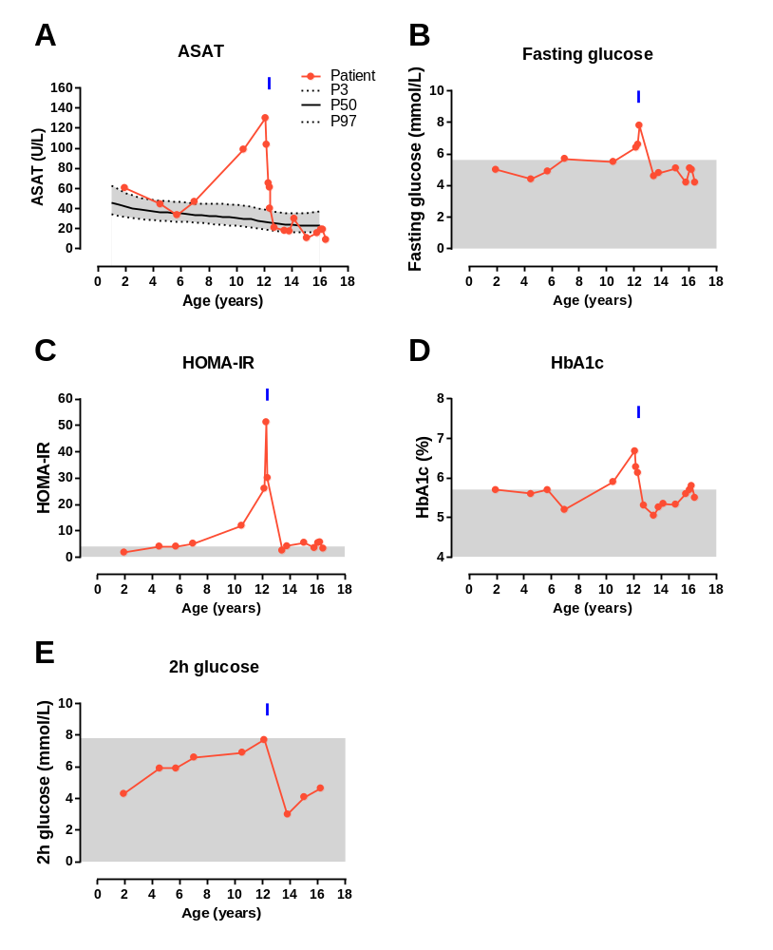
Figure S1. Liver and metabolic parameters of the patient
(A) Serum levels of aspartate aminotransferase (ASAT) are indicated with the 3rd (P3), 50th (P50), and 97th (P97) percentile according to Bussler et al.². (B) fasting glucose, (C) Homeostatic Model Assessment for Insulin Resistance (HOMA-IR), (D) glycated haemoglobin (HbA1c), and (E) 2 hour (2h) glucose levels are presented. The blue arrow marks the time point of bariatric surgery of the patient at the age of 12.4 years. Reference ranges in (B)-(E) are set according to the American Diabetes Association³ or Allard et al.⁴.
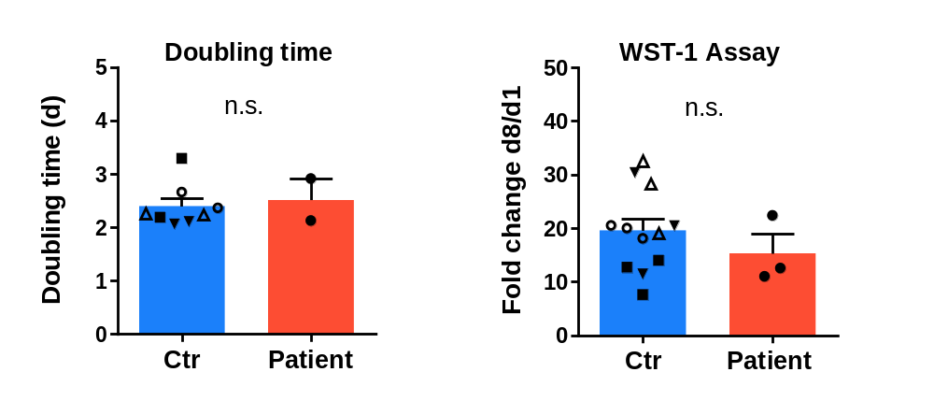
Figure S2. Proliferative potential of SVF cells from the patient and control children
(A) Doubling time of subcutaneous stromal vascular fraction (SVF) cells from the patient and control children (Ctr, n=4) is shown as mean with standard error from n=2 experiments (cells were seeded at day 49 and 71 of cultivation; measured in 5 technical replicates). (B) Cell viability was assessed by WST-1 assay in n=3 experiments (cells were seeded at day 49, 71, and 89 of cultivation; measured in 5 replicates) shown as mean fold change (with standard error) of absorbance of day 8 of proliferation in relation to day 1 of proliferation. Statistical significance was assessed using Student’s t-test. n.s.; not significant.
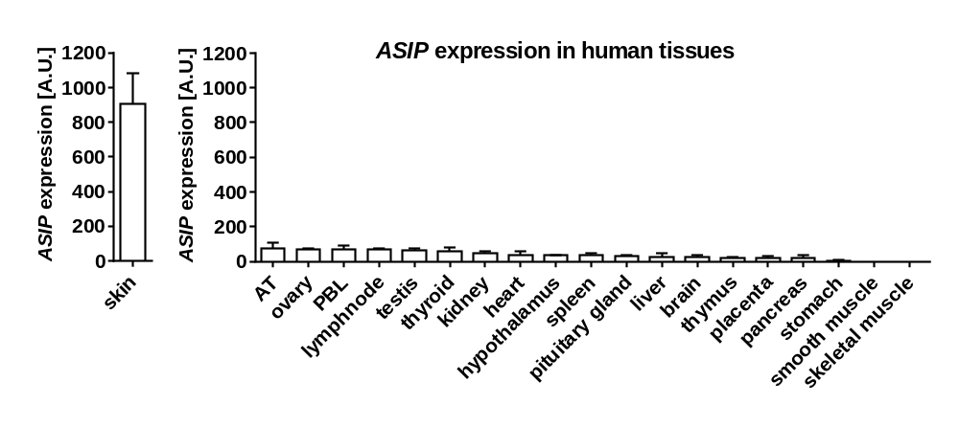
Figure S3. ASIP expression in human tissues
Gene expression of agouti-signaling protein (ASIP) in human tissues normalized to expression of β-actin and TATA-box-binding protein. Data is presented as mean with standard error of 3 technical replicates.
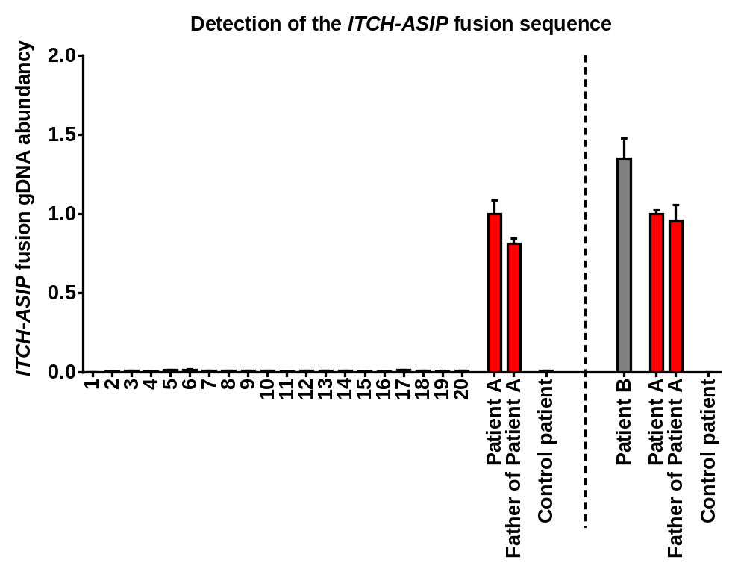

Figure S4. Screening of patients with obesity and red hair color for ASIP mutations
Copy numbers of the ITCH-ASIP fusion sequence were normalized to the copy numbers of beta-actin. Samples from the index patient (patient A) and her father were used as positive controls, a control patient without ASIP mutation and ectopic ASIP expression as negative control. Patients 1-20 are part of the cohort of Peter Kühnen, University of Berlin with patients originally suspected for POMC-deficiency; patient B was identified in the outpatient clinic of the Hospital for Children and Adolescents, University of Leipzig.
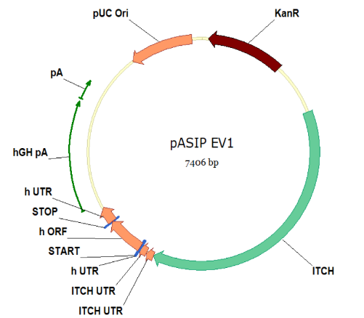
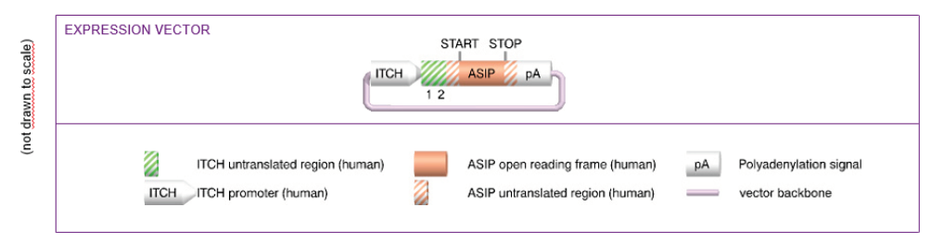

Figure S5. Taconic expression vector containing the ITCH-ASIP fusion mRNA sequence under control of the ITCH promoter
A scheme of the plasmid including the legend and the plasmid map of the construct is shown.

References
1. Morgan MD, Pairo-Castineira E, Rawlik K, et al. Genome-wide study of hair colour in UK Biobank explains most of the SNP heritability. Nat Commun 2018;9:5271.
2. Bussler S, Vogel M, Pietzner D, et al. New pediatric percentiles of liver enzyme serum levels (alanine aminotransferase, aspartate aminotransferase, γ-glutamyltransferase): Effects of age, sex, body mass index, and pubertal stage. Hepatology 2018;68:1319-30.
3. Yang Y-K, Ollmann MM, Wilson BD, et al. Effects of recombinant agouti-signaling protein on melanocortin action. Mol Endocrinol 1997;11:274-80.
4. Allard P, Delvin EE, Paradis G, et al. Distribution of fasting plasma insulin, free fatty acids, and glucose concentrations and of homeostasis model assessment of insulin resistance in a representative sample of Quebec children and adolescents. Clin Chem 2003;49:644-9.

