Electronic Supplementary Information

An AIE-Active Probe for Detection and Bioimaging of pH Values Based on Lactone Hydrolysis Reaction

Qiao Li, Zhigang Niu, Xuying Nan, Enju Wang

Key Laboratory of Tropical Medicinal Resource Chemistry of Ministry of Education,
Key Laboratory of Tropical Medicinal Plant Chemistry of Hainan Province,
College of Chemistry & Chemical Engineering, Hainan Normal University, Haikou, 571158, China

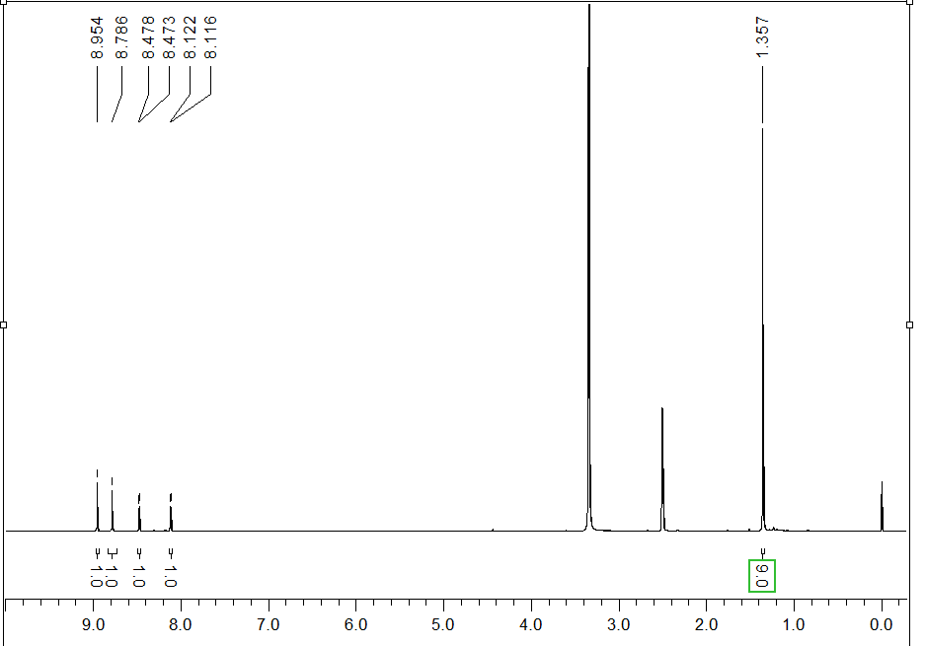
Fig. S1 ¹H NMR spectrum of TCC (400 MHz, DMSO-d6)

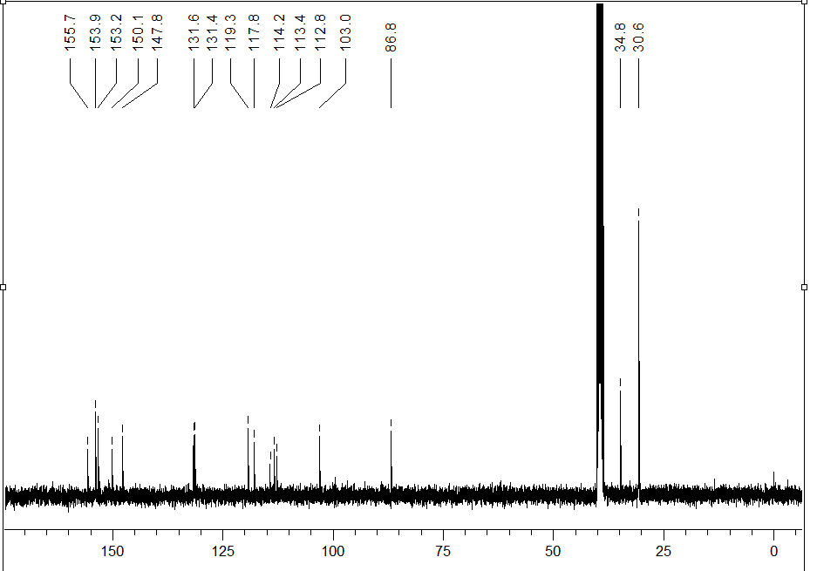
Fig. S2 ¹³C NMR spectrum of TCC (100 MHz, DMSO-d6)

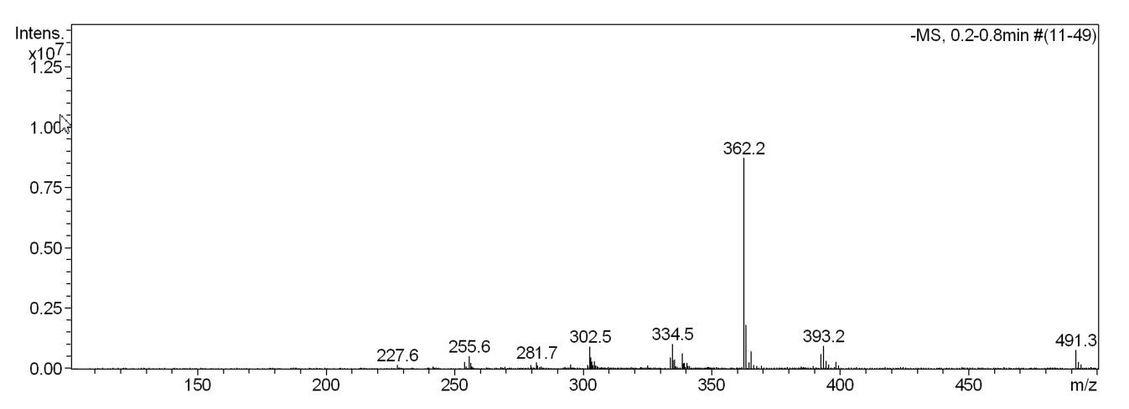
Fig. S3 ESI-MS spectrum of TCC in negative ion mode
m/z calculated for [M+AcO⁻] 362.1, found 362.2

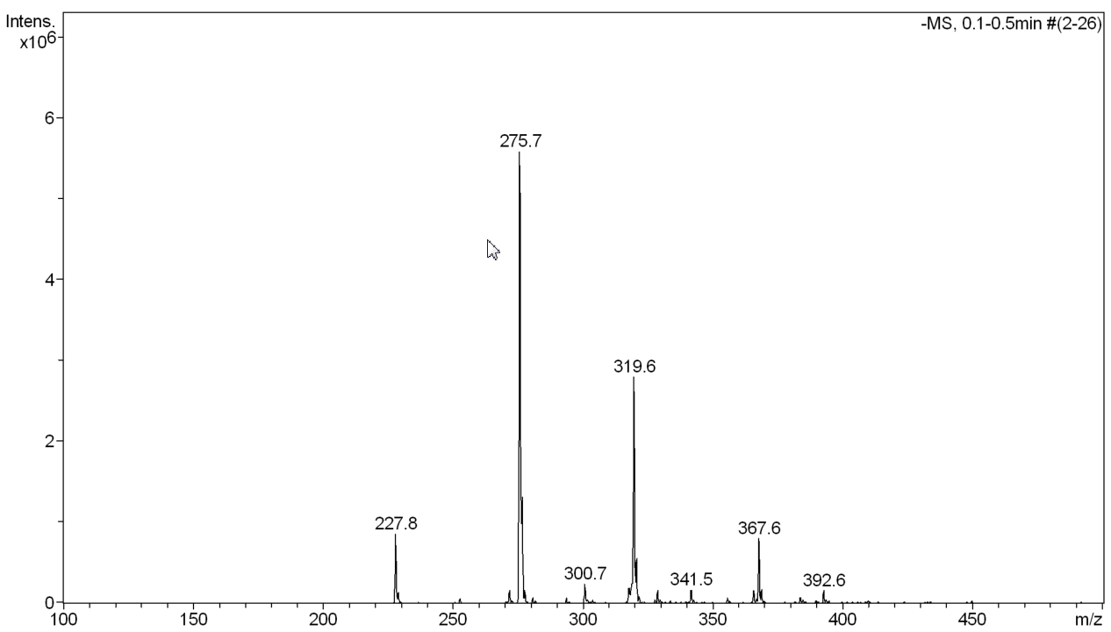

Fig. S4 ESI-MS spectrum of TCHC in negative ion mode
m/z: calculated for [M-H]⁻ 320.1, found 319.6;
calculated for [M-CO₂-H]⁻ 276.1, found 275.7

Table S1. Crystal data and structure refinement for TCC
Empirical formula | C₁₈ H₁₃ N₃ O₂
Formula weight | 303.31
Temperature/K  Wavelength/ Å | 293(2)  0.71073
Crystal system | Monoclinic,
Space group | P2₁/c
a/Å | 17.336(3)
b/Å | 6.2501(14)
c/Å | 14.670(3)
α/° | 90
β/° | 96.34(2)
γ/° | 90
Volume/Å³ | 1579.8(6)
Z | 4
Calculated density | 1.275 Mg/m³
Absorption coefficient | 0.086 mm⁻¹
F(000) | 632
Radiation | MoKα (λ = 0.71073)
Theta range for data collection /° | 2.794 to 30.100
Limiting indices  Reflections collected/unique | -16 ≤ h ≤ 24, -8 ≤ k ≤ 4, -20 ≤ l ≤ 19  8875 / 3980 [R_{int} = 0.0414]
Independent reflections | 3988 [R_{int} = 0.0266, R_{sigma} = 0.0377]
Data/restraints/parameters  Completeness to θ=25.242 | 3980 / 0 / 211  99.9 %
Goodness-of-fit on F² | 1.064
Final R indexes [I≥2σ (I)] | R₁ = 0.0729, wR₂ = 0.2101
Final R indexes [all data] | R₁ = 0.1206, wR₂ = 0.2582
Largest diff. peak/hole / e Å⁻³ | 0.555/ -0.314

