Early diabetes aggravates renal ischemia/reperfusion-induced acute kidney injury
¹Mariana Charleaux de Ponte, ¹Vanessa Gerolde Cardoso, ¹Juliana Martins Costa-Pessoa, and ¹Maria Oliveira-Souza
¹Laboratory of Renal Physiology, Department of Physiology and Biophysics, Institute of Biomedical Sciences, University of Sao Paulo, Sao Paulo, Brazil.

Supplementary Info File

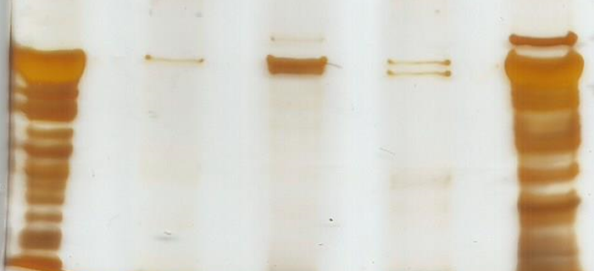
Sham
IR
STZ
STZ/IR
Alb
66 kDa
M

Supplementary Figure 1 C: Effects of renal ischemia/reperfusion in control and STZ-treated mice on albuminuria. Representative full-length gel is presented. IR: ischemia/reperfusion; Alb: albumin; M: marker; Sham, Sham-operated; IR, ischemia reperfusion; STZ, streptozotocin.

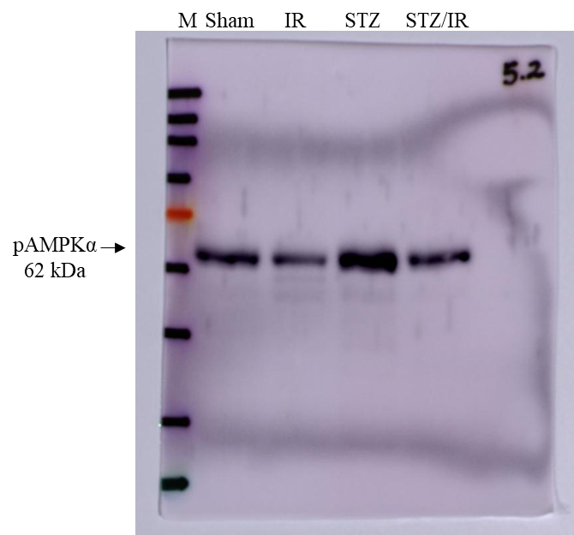
Supplementary Figure 3 A: Effects of renal ischemia/reperfusion in control and STZ-treated mice on phosphorylated AMPKα protein expression. M: marker; Sham, Sham-operated; IR, ischemia reperfusion; STZ, streptozotocin.

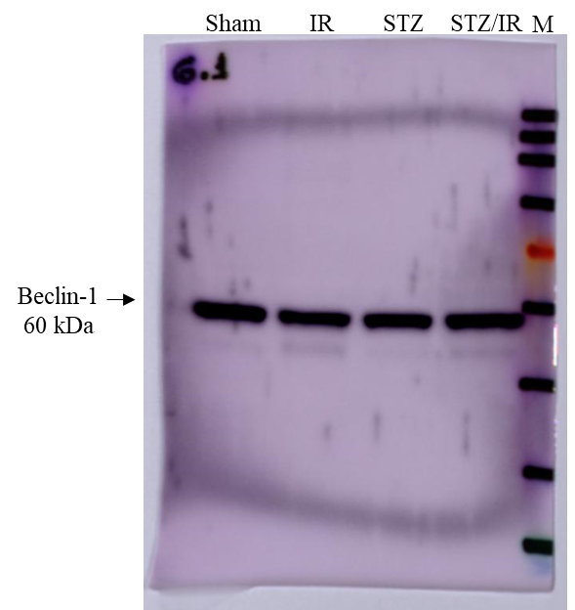

Supplementary Figure 3 A: Effects of renal ischemia/reperfusion in control and STZ-treated mice on Beclin -1 protein expression. M: marker; Sham, Sham-operated; IR, ischemia reperfusion; STZ, streptozotocin.

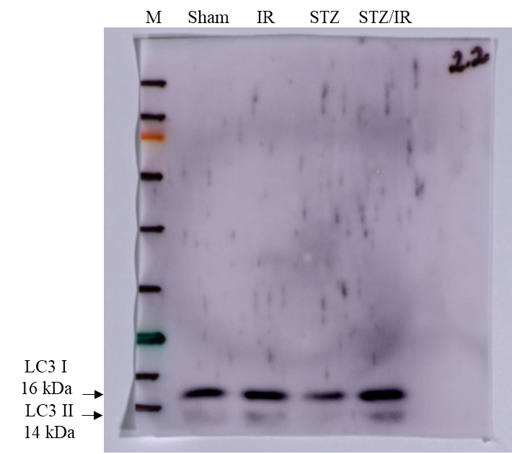

Supplementary Figure 3 A: Effects of renal ischemia/reperfusion in control and STZ-treated mice on LC3 I and LC3 II protein expression. M: marker; Sham, Sham-operated; IR, ischemia reperfusion; STZ, streptozotocin.

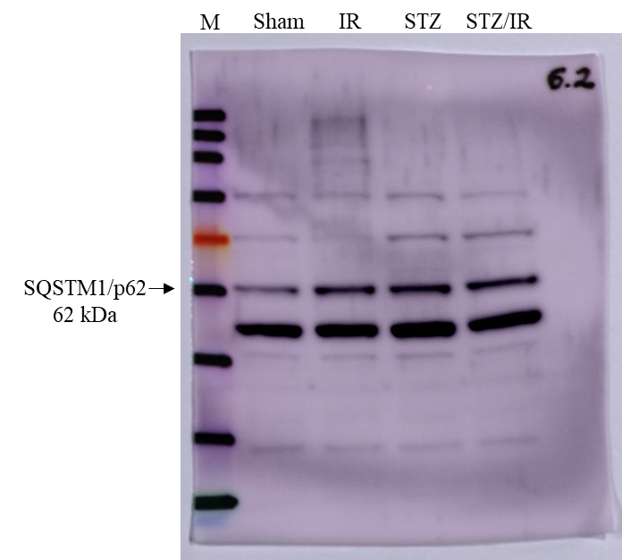

Supplementary Figure 3 A: Effects of renal ischemia/reperfusion in control and STZ-treated mice on SQSTM1/p62 protein expression. M: marker; Sham, Sham-operated; IR, ischemia reperfusion; STZ, streptozotocin.

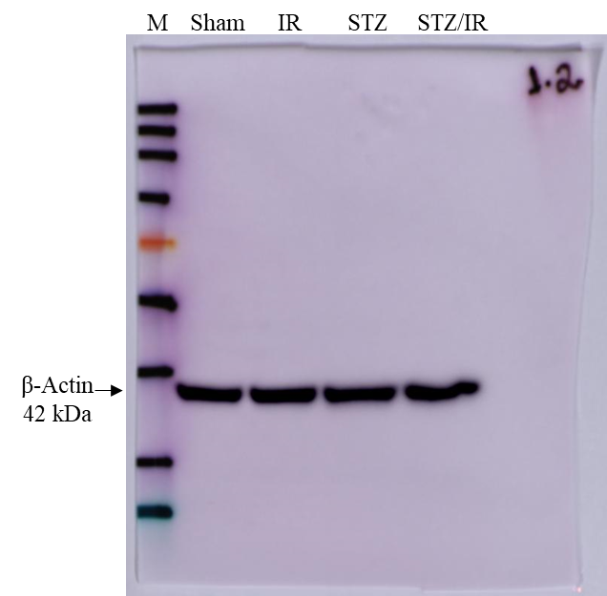

Supplementary Figure 3 A: Effects of renal ischemia/reperfusion in control and STZ-treated mice on β-actin protein expression. M: marker; Sham, Sham-operated; IR, ischemia reperfusion; STZ, streptozotocin.

