Supporting information for
Biogenic Synthesis and Congo Red Dye Removal, Cytotoxic, Antioxidant and Antimicrobial Activities of supermagnetic Fe₃O₄ Nanoparticles Using Plantago lanceolata L. Leaf Extracts

Semih GÖKDAĞ¹, Fatma CAF², Fulya DOĞANER¹, Bülent KAYA^{3*}, Adnan AYNA⁴, Gürkan AYKUTOĞLU³

Affiliations
¹Faculty of Sciences and Arts, Molecular Biology and Genetics Department, University of Aksaray, 68000 Turkey
²Vocational School of Food, Agriculture and Livestock, University of Bingöl,12000 Turkey
³Faculty of Sciences and Arts, Molecular Biology and Genetics Department, University of Bingöl, 12000 Turkey
⁴Faculty of Sciences and Arts, Chemistry Department, University of Bingöl, 12000 Turkey

3.2. Adsorption isotherms, adsorption kinetics, and thermodynamic analysis
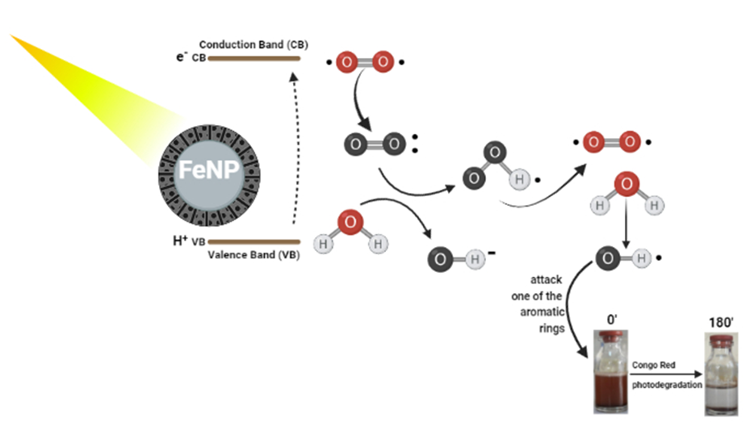
Fig. S1. The possible mechanism of dye degradation activity of PLE@FeNPs.

3.6 Antimicrobial activity

Well  arrangement | 1 | 2 | 3 | 4 | 5 | 6
Well  arrangement | 5 mg/mL | 2.5 mg/mL | 1.25 mg/mL | 0.625 mg/mL | 0.3125mg/mL | 0.15625mg/mL
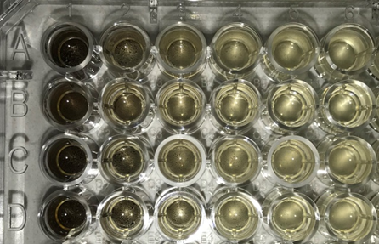

Figure S3. Photograph of plate showing antimicrobial activity of PLE@FeNPs. Well arrangement: A: Klebsiella pneumoniae, B: Escherichia coli, C: Saccharomyces cerevisiae, D: Staphylococcus aureus.
After PLE@FeNPs were applied to microorganisms, they were incubated for 24 hours. Then, measurements were taken on the ELISA device. The results are shown in Table 3.
3.2. Adsorption isotherms, adsorption kinetics, and thermodynamic analysis
Table S1: Forms of different Fe⁺³ species at various pH levels [1-3]

Fe | pH
Fe(H₂O)₆³⁺ | 1-2
Fe(OH)(H₂O)₅ ²⁺ | 2-3
Fe(OH)₂(H₂O)₄⁺ | 3-4
Fe(OH)₃ | 7-10

Table S2. Estimated kinetic parameters and isotherm models for CR adsorption on PLE@FeNPs. (Nidheesh et al. 2013, Gomattiet al. 2009, Neamtu et al.2003)

Isotherm model | Isotherm parameters | Temperature (°C)
 |  | 25 | 40
Langmuir | qm (mg g⁻¹) | 136.7989056 | 115.8748552
 | K_{L} (L mg-1 ) | 0.094432 | 0.143427
 | R_{L} | 0.174776 | 0.122379
 | R² | 0.85844 | 0.96012
Freundlich | Kf (mg g⁻¹)(L mg⁻¹)^{1/n} | 29.33054 | 22.87231
 | 1/n | 0.29108 | 0.38157
 | R² | 0.60642 | 0.9554
Temkin | B_{T} (J mol⁻¹) | 18.6799 | 27.91593
 | K_{T} (L mg⁻¹) | 3.25451846 | 0.98200296
 | R² | 0.77629 | 0.85746
Kinetic model | Kinetic parameters
Pseudo-first-order | qe _{exp} (mg/g) | 77.10702 | 67.6058
 | q_{e cal} (mg/g) | 19.91115 | 6.53002
 | k₁ (dk⁻¹) | -0.00025 | 0.000118
 | R² | 0.25751 | 0.24786
Pseudo-second-order | q_{e cal} (mg/g) | 79.11392 | 71.736
 | k₂ (mg g⁻¹ min⁻¹) | 0.001911 | 0.00207
 | qe² | 6259.013 | 5146.06
 | R² | 0.99268 | 0.98708

References
[1]. Gomathi Devi, L., Girish Kumar, S., Mohan Reddy, K., Munikrishnappa, C., 2009. Photo degradation of Methyl Orange an azo dye by Advanced Fenton Process using zero valent metallic iron: Influence of various reaction parameters and its degradation mechanism. J. Hazard. Mater. 164(2-3), 459-467. https://doi.org/10.1016/j.jhazmat.2008.08.017.
[2].Neamtu, M., Yediler, A., Siminiceanu, I., Kettrup, A., 2003. Oxidation of commercial reactive azo dye aqueous solutions by the photo-Fenton and Fenton-like processes. J. Photochem. Photobiol. A: Chem. 161(1), 87-93. https://doi.org/10.1016/S1010-6030(03)00270-3
[3]. Nidheesh, P.V., Gandhimathi, R., Ramesh, S.T., 2013. Degradation of dyes from aqueous solution by Fenton processes: a review. Environ. Sci. Pollut. Res. 20(4), 2099-2132. https://doi.org/10.1007/s11356-012-1385-z.

