Supplementary Fig 1. Meta-analysis of dietary fiber intake by BMI classification.
BMI is classified in accordance with WHO guideline (overweight/obese defined as BMI≥25 kg/m²) for studies conducted outside of Asia, and in accordance with Asia-Pacific guideline (overweight/obese defined as BMI≥23 kg/m²) for study conducted in Asia.
Supplementary Fig 2. Meta-analysis of total energy intake by BMI classification.

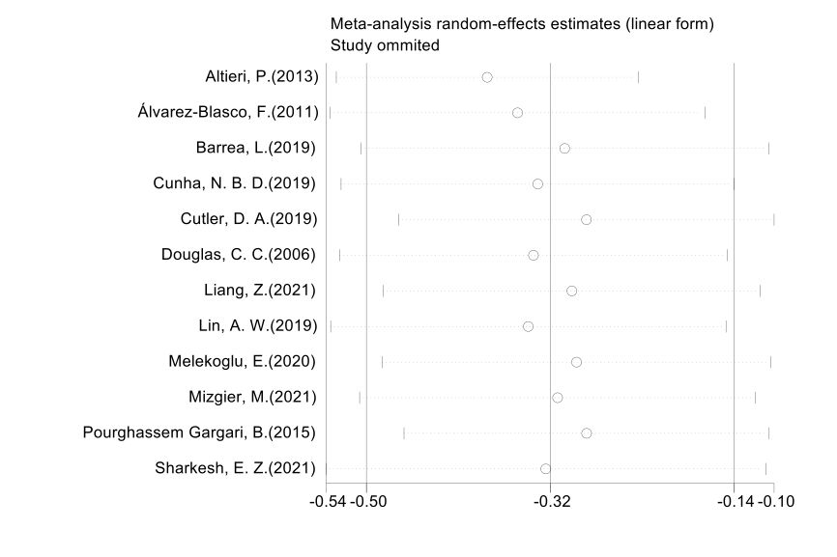
Supplementary Fig 3. Influence analysis assessing the sensitivity of the pooling result on every single study.

Supplementary Fig 4. Funnel plot of the meta-analysis comparing dietary fiber intake on studies unadjusted for total energy intake.

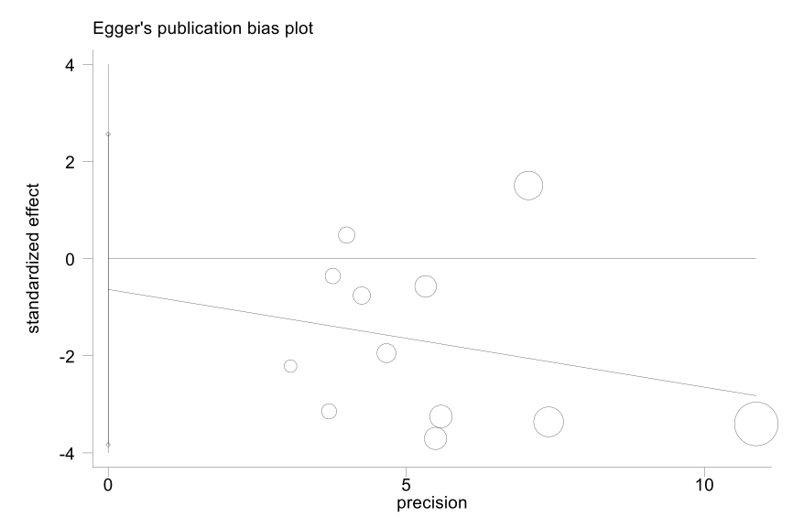
Supplementary Fig 5. Egger’s publication bias plot, with graph symbol sized by study weights.

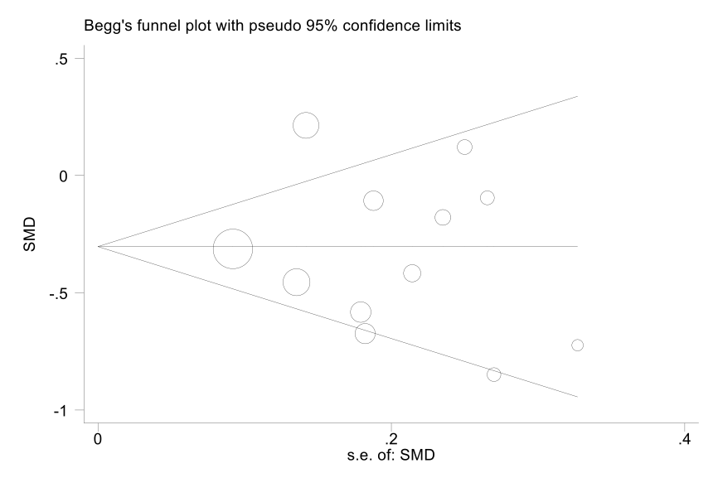
Supplementary Fig 6. Begg’s publication bias plot, with graph symbol sized by study weights.

Table S1 Newcastle-Ottawa quality assessment of the included studies
Study | Selection | Comparability | Exposure/Outcome | Summation
Case-control/ cross-sectional study
Altieri, P.(2013) |  |  |  | 7
Álvarez-Blasco, F.(2011) |  | - |  | 5
Barrea, L.(2019) |  |  |  | 6
Cunha, N. B. D.(2019) |  |  |  | 8
Eslamian, G.(2017) |  | ✵ |  | 6
Liang, Z.(2021) |  |  |  | 7
Lin, A. W.(2019) |  | - |  | 6
Melekoglu, E.(2020) |  | ✵ |  | 5
Mizgier, M.(2021) |  | ✵ |  | 6
Pourghassem Gargari, B.(2015) |  | ✵ |  | 6
Sharkesh, E. Z.(2021) |  | - |  | 5
Cohort study
Cutler, D. A.(2019) |  | - |  | 4
Douglas, C. C.(2006) |  |  |  | 6
- scoring no point in the corresponding category

