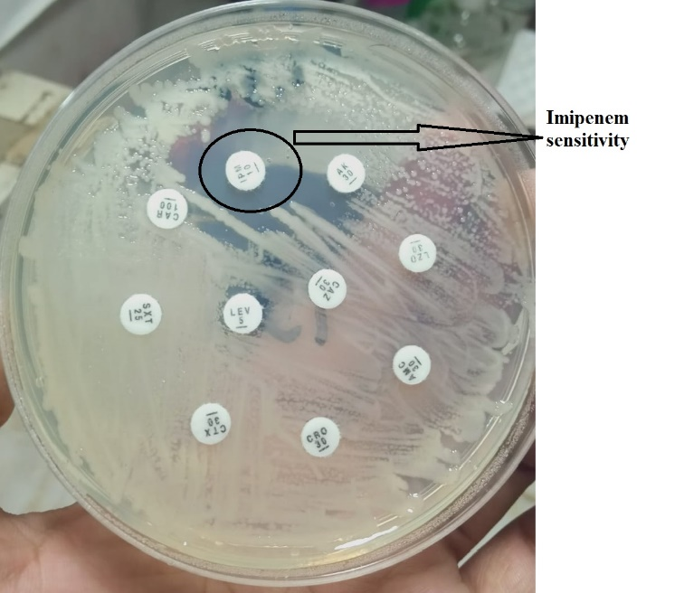 | 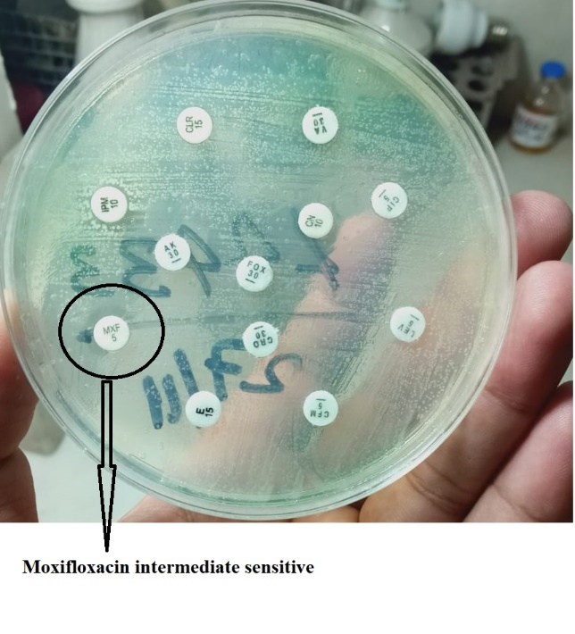
Figure 1. Imipenam Sensitivity on Culture Plate | Figure 2. Moxifloxacin Sensitivity on culture Plate
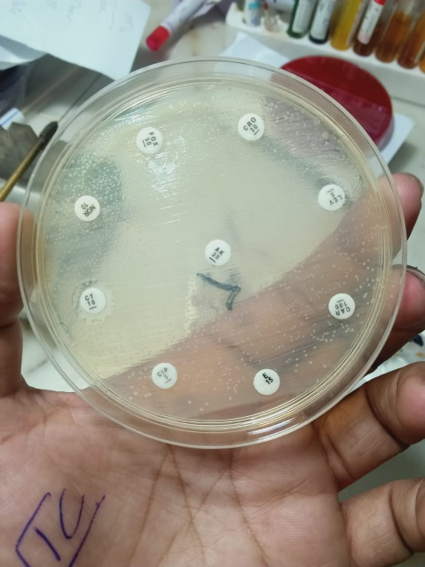 | 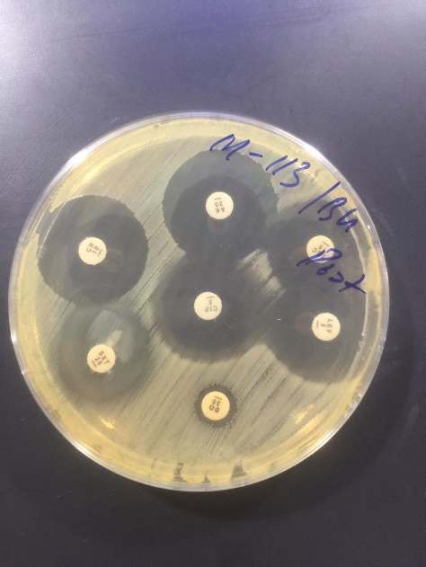
Figure 3. MDR on culture Plate | Figure 4. Trimethoprim/sulfamethoxazole Sensitivity on Culture Plate
Suplementry Data Figures

