Additional file 1
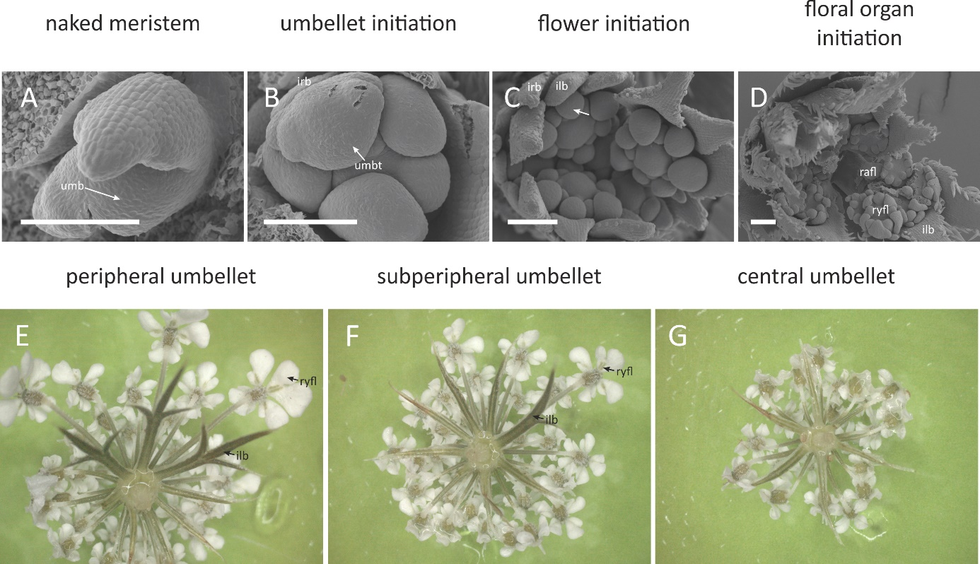
Morphogenesis of high-order pseudanthium in Daucus carota. A The incipient FUM is smaller than in terminal and first-order umbels and fractionates less umbellet meristems B Umbellets initiate in a centripetal sequence – no clear division between peripheral and central umbellets can be seen. C The intermediate promotion of pseudanthium becomes apparent. Note three large peripheral umbellets with three ray flowers each and a smaller subperipheral umbellet with a single ray flower (in the bottom-right side of the photograph) D Ray flower meristems fractionate floral organs in a group-like pattern. E Mature peripheral umbellet with three distinct ray flowers subtended by pinnatisect involucels F Subperipheral umbellet with a single, weak ray flower subtended by a asymmetrically bifid involucel. G Central umbellet with radial flowers and needle-like involucels. Abbreviations: irb – involucral bract, umbt – umbellet, ilb – involucellar bract; rafl – radial flower; ryfl – ray. Number next to abbreviation of floral organs denotes order of initiation. Scale bars = 100 µm.

