Scientific Reports
Supplementary information
Planar cell polarity protein Vangl2 interacts with protein Ap2m1 to regulate dendritic branching in cortical neurons
Misato Yasumura§, Akari Hagiwara, Yamato Hida, and Toshihisa Ohtsuka*
Department of Biochemistry, Faculty of Medicine, University of Yamanashi, Yamanashi, Japan.

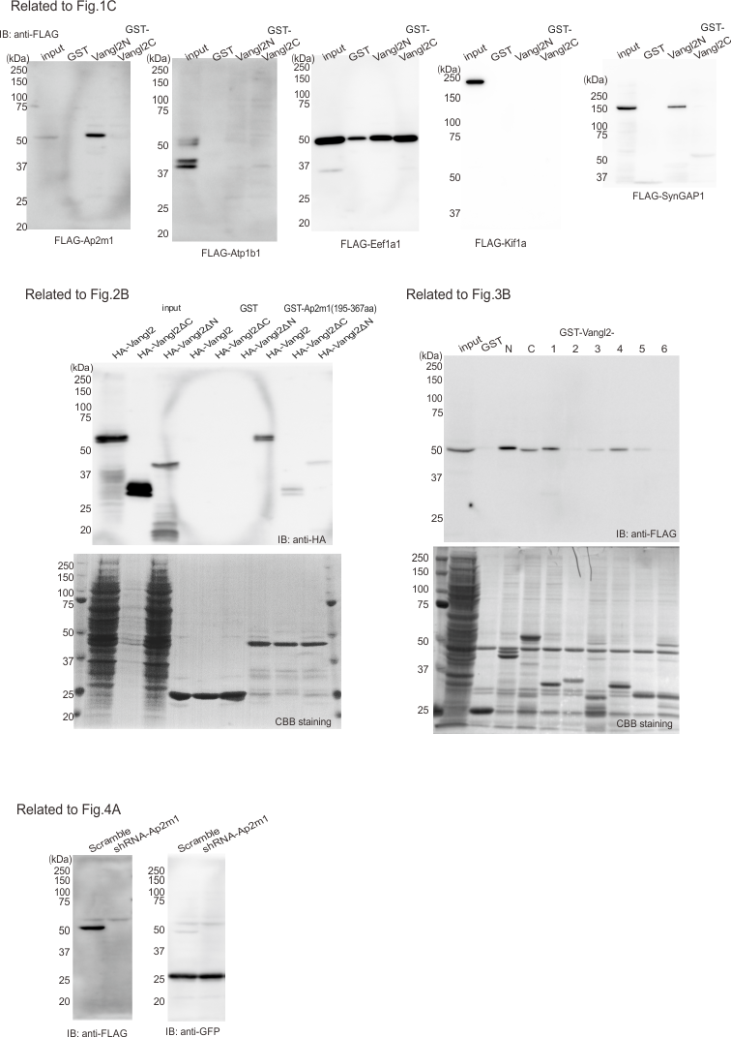
Supplementary Fig. 1 Full length western blots
The cropped blots in Fig. 1C, 2B, 3B, and 4A are shown in the full length.

