Antibacterial CM-11 Peptide Potency against the Gram-positive and Gram-negative Bacterial Membrane Models: A Molecular Dynamics Simulations Study

Reza Mirnejad¹, Mahdi Fasihi-Ramandi¹, Esmaeil Behmard², Ali Najafi¹, Mehrdad Moosazadeh Moghaddam^{3*}

¹Molecular Biology Research Center, Systems Biology and Poisoning Institute, Baqiyatallah University of Medical Sciences, Tehran, Iran
²School of advanced technologies in medicine, Fasa University of Medical Sciences, Fasa, Iran
³Applied Biotechnology Research Center, Baqiyatallah University of Medical Sciences, Tehran, Iran
SUPPLEMENTARY INFORMATION

a | b
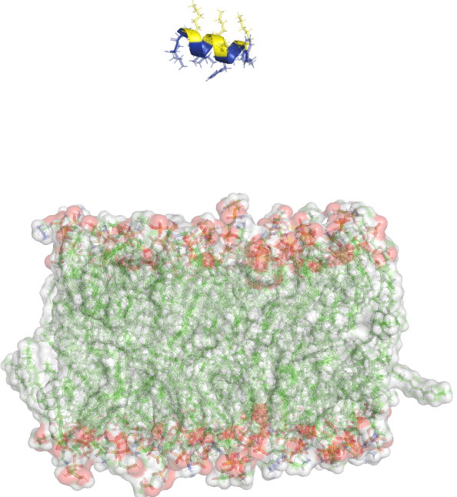 | 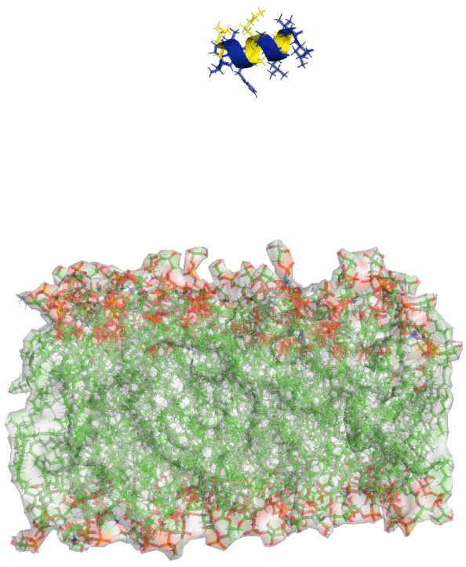
c | d
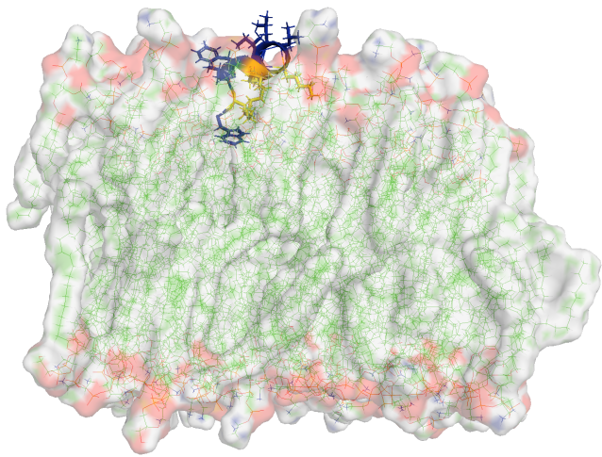 | 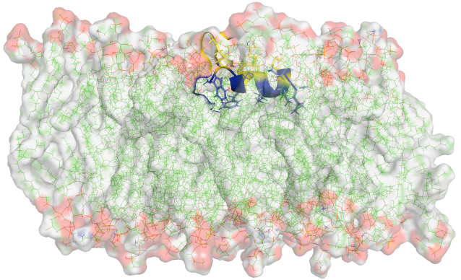
e | f
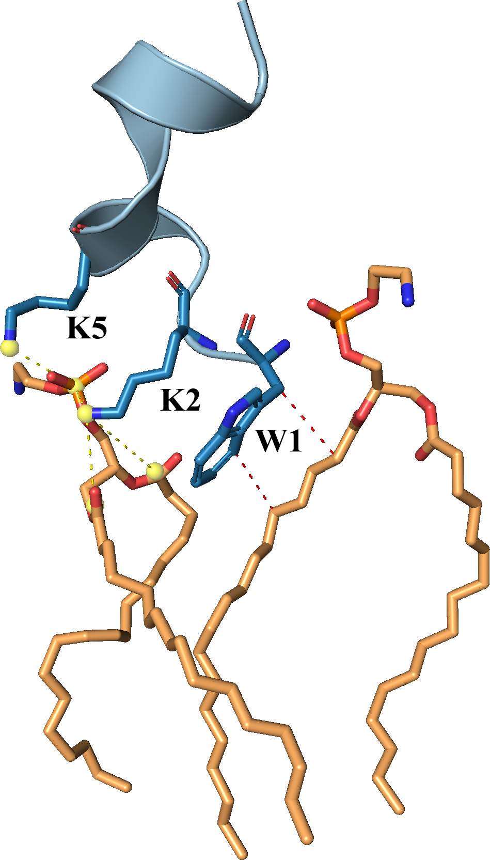 | 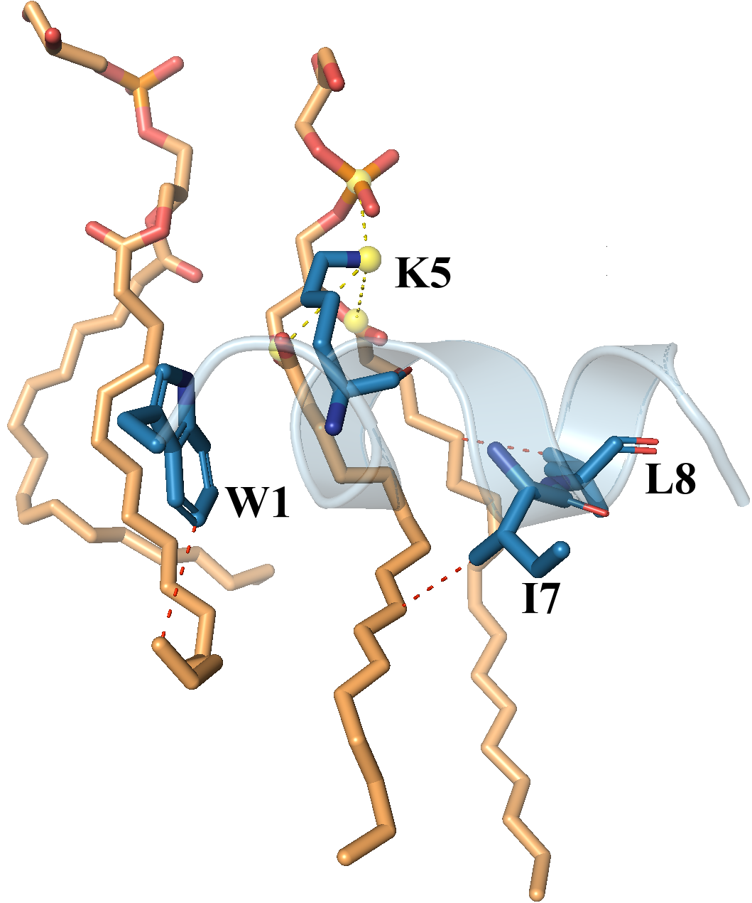

Figure S1: The CM11 peptide-membrane structures before (a (GN), b (GP)) and after MD simulation (c (GN), d (GP)). Zoom in view of residues inside of bilayer (e (GN), f (GP)). Lysine residues highlighted in blue sticks mode. Peptide highlighted in blue cartoon. Lipid molecules highlighted in wheat sticks. Hydrophobic interactions highlighted in red dashed line and saltbridges highlighted in yellow dashed line.

